Physics 132
“M” problems
Part B: Electric Fields and Forces
Note: Some of these problems are adapted or copied from published sources.
Answers to problems are at the end of this document.
MB1. Richard Feynman, a Nobel Prize-winning physicist, once noted that if two people stood an arm’s length away from each other, and each person had just 1% more electrons than protons, the force pushing them away from each other would be enough to lift the “weight” of the entire planet Earth. Do an order-of-magnitude calculation to determine whether this is true. (Hint: the fact that he won a Nobel Prize in physics is a clue that Feynman didn’t get a whole lot wrong.)
MB2. This week, Caitlin Clark and the Indiana Fever will play two games against A’ja Wilson and the Las Vegas Aces. Suppose that there are two basketballs, one in Indianapolis and one in Las Vegas. By some miracle, the basketball in Indianapolis suddenly loses all of its electrons, and the one in Las Vegas suddenly loses all of its protons. (We’ll ignore for the moment that if this actually happened, each ball would instantly blow itself to smithereens.) Do an order-of-magnitude calculation to show that the attractive force between the two balls at this distance would be so great that all of the members of both teams working together wouldn’t be strong enough to hold them apart.
MB3. The gravitational force between two objects of mass $m_{1}$ and $m_{2}$ is given by $F_{G}=\frac{Gm_{1}m_{2}}{r^{2}}$, where the gravitational constant $G=6.67×{10}^{-11} \text{N }{\text{m}}^{\text{2}}\text{/k}{\text{g}}^{\text{2}}$. In a hydrogen atom, the electron and the proton are separated by an average distance of one Bohr radius, or about $5×{10}^{-11}$ m. Which force is stronger between the hydrogen’s electron and the proton: the electrical force or the gravitational force?
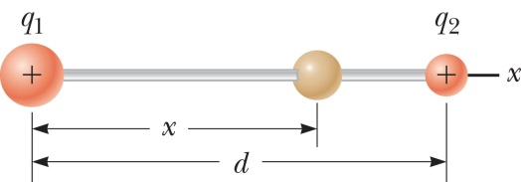
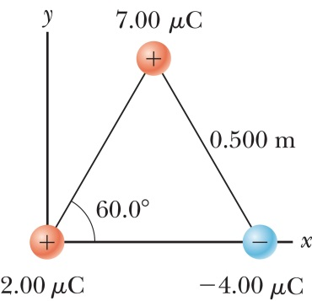
MB4. Two small balls with positive charges $q_{1}=3q$ and $q_{2}=q$ are glued to the opposite ends of a horizontal insulating rod of length $d=1.50$ m. The ball with $q_{1}$ is at the origin. A third small ball, also charged, is free to slide back and forth on the rod. (a) At what x position is the third ball at equilibrium? (b) Can that equilibrium be a stable equilibrium?
MB5. Three charged balls are on the corners of an equilateral triangle, as shown. What is the total electric force on the ball with the $7.00 μ$C charge?
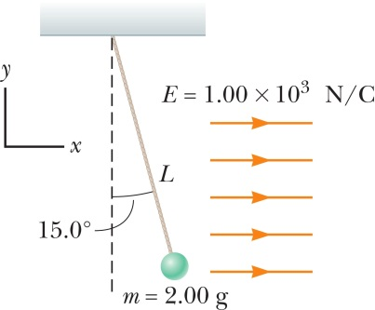
MB6. A tiny ball with mass $m=2.00$ grams hangs by a 20-cm-long string in a uniform electric field. (You don’t need to worry about where the field comes from—presumably it comes from some other charges not pictured.) The ball is in equilibrium when the string makes a $15.0°$ angle with the vertical. What is the net charge on the ball?

P
MB7. A thin, uniformly charged rod of total charge $+Q$ is bent into a $120°$ circular arc of radius R, as shown. Find the electric field at the center point P. Hint: make each bit o’ charge $dq$ have a length $ds=R dθ$, and do an integral over the angle $θ$.
MB8. Consider the problem that we did in the lab, where we found the electric field near a charged rod. Suppose you cut the rod in half and threw away the bottom part, leaving only a rod of charge $Q/2$, stretching from $y=0$ to $y=L/2$. Find the x and y components of the electric field at the point $P$.
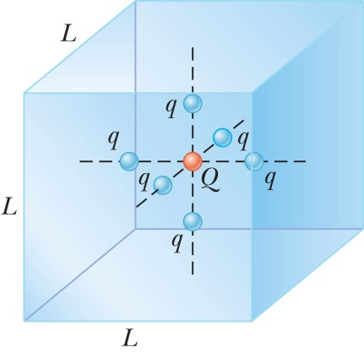
MB9. A cube with sides of length $L=0.1$ m has a particle with charge $Q=5.00 μ$C located in its exact center. There are also six more identical charged particles, each with charge $q=-1.00 μ$C, positioned symmetrically around the center as shown in the figure. Find the electric flux through one face of the cube.
MB10. An infinitely long, solid, charged cylinder of radius $R$ has a charge density per volume of $ρ$. Find the electric field at a point inside the cylinder, a distance $r$ away from its axis.
MB11. Find the electric field $\vec{E}$at a point P distance $d$ from end of a thin rod (along rod’s axis) with charge $Q$ and length $L$. (Hint: put the rod along the x-axis, with point P at the origin.)
P
MB12. (a) A question on a physics quiz asks,
“What is the electric field inside a sphere of uniform charge density 40 nC/m³ and radius $R=15$ cm, at a point 6 cm from the center.”
Should your answer be given in terms of variables, or as a number? (b) A slightly different question on a physics quiz asks
“What is the electric field inside a sphere of uniform charge density $ρ$ and radius $R$, at a point a distance $r$ from the center, where $r<R$.”
What variables should be included in your answer? (c) For the quiz question in (b), should one’s answer include the variable $Q$? (d) Rory and Esmerelda took the quiz. Esmerelda answered “$E={ρr}/{3ϵ_{0}}$.” Rory answered “${E=Qr}/{4πϵ_{0}R^{3}}$.” Which one received full credit? (e) How did Rory’s answer make his physics instructor feel? (f) Which student was accepted to graduate school in biogenetic chemical engineering science? (g) Where does Rory work? (h) Does Rory have any friends? (i) Where does Rory live? (j) Some stories have morals. What is the moral of this cautionary tale?

MB13. (a) Imagine drawing a picture of a region near several large charged particles and representing the electric field with a series of field lines. If an additional small, positively charged particle is placed in the area, will the path of that small particle follow the field lines? If you’re not sure, go ahead and make a guess. (b) The coyote is running horizontally at speed $v_{0}=12$ m/s when he runs off the edge of a 50 meter high vertical cliff. How far from the base of the cliff does the coyote land? (c) A proton ($m_{p}=1.67×{10}^{-27}$ kg, charge $+1.6×{10}^{-19}$ C) has an initial horizontal speed $v_{0}=12$0000 m/s when it enters a region between two horizontal charged plates, 0.50 cm above the lower plate. In between the two plates, there is a uniform electric field $E=980$ N/C pointing vertically down. How far from the entrance of the plates does the proton land? (d) In part c, did the path of the proton follow the field lines?
$$v_{0}$$
50 m
+ + + + + + + + + + + + + + + + +
- - - - - - - - - - - - - - - - -
0.50 cm
$$v_{0}$$
MB14. (a) Write expressions for the surface area $A$ and the volume $V$ of a sphere of radius $R$. (b) Write expressions for the surface area $A$ and the volume $V$ of a cylinder of radius $R$ and height $h$. (If you already remember these, great! If you need to look them up, fine. Either way, we’ll be needing these for class, so be sure you know them.)
MB15. A sphere of radius $R$ carries a uniform charge density, such that its total charge is $Q$. Use Gauss’ law to write the electric field $E$ at some place on the inside of the sphere, at some radius $r<R$. (Note that this is exactly the problem we did in class, except that now you are given $Q$ instead of $ρ$, so your final answer should be in terms of $Q$ as well. Don’t be like Rory from problem MB12!)

MB16. (a) An infinite plane with area-charge density $+σ$ is pictured below at the left. The numbered points 1, 2, and 3 are evenly spaced, and the plane lies midway between points 1 and 2. What is the electric field $\vec{E}$ at each of the points? Your answer should be in terms of $σ, ϵ_{0}$, the unit vector $\hat{j}$, and possibly the distance $r$. (This is a standard and familiar Gauss’ law problem.)
1
2
3
$$r$$
$$+σ$$
1
2
3
$$r$$
$$-σ$$
$+y$
direction
1
2
3
$$+σ$$
$$-σ$$

(b) In the middle figure, the positively charged plane has been replaced by another infinite plane, this time with charge density $-σ$. What is the electric field $\vec{E}$ at each of those same numbered points, again in terms of $σ, ϵ_{0}$, $\hat{j}$, and possibly $r$?

(c) The rightmost figure contains both the positive and negative plane. Now what is $\vec{E}$ at each of the points 1, 2, and 3? Hint: It’s a little tricky to do this using Gauss’ law directly, but it’s easy to do using your results of (a) and (b) and the idea of superposition.

MB17. The figure below shows a solid metal sphere at the center of a hollow metal shell. The electric fields ${\vec{E}}_{1}$ and ${\vec{E}}_{2}$ are both 15,000 N/C in magnitude, with directions as shown. What are the charges on each surface at 5, 10, and 15 cm?
5 cm
10 cm
15 cm
8 cm
17 cm
$${\vec{E}}_{1}$$
$${\vec{E}}_{2}$$

Answers:
MB2. My estimate for the force between the balls is $\sim {10}^{11}$ N. That’s about 10 billion pounds of force! (How many pounds of force do you think you could apply to the ball if you were trying to hold it back? How would your answer change if your name was A’ja Wilson?)
MB3. The electric force is about $2×{10}^{39}$ times stronger than the gravitational force!
MB4. (a) 0.951 m (b) Hmmm… depends on the signs of the charges…
MB5. 0.872 N, $30°$ below the x axis
MB6. $5.25 μ$C
MB7. $E=\frac{3\sqrt{3}Q}{8π^{2}ϵ_{0}R^{2}}$ to the right
MB8. $E_{y}=-\frac{k_{E}Q}{L}\left(\frac{1}{x}-\frac{1}{\sqrt{x^{2}+{\left(L/2\right)}^{2}}}\right)$, $E_{x}=\frac{k_{E}Q}{2x}\frac{1}{\sqrt{x^{2}+{\left(L/2\right)}^{2}}}$
MB9. $-18.8\text{ kN }{\text{m}}^{\text{2}}\text{/C}$
MB10. $E=ρr/2ϵ_{0}$
MB11. $=k_{e}\frac{Q}{d(d+L)}$ .
MB12. (a) The answer should be given as a number, because the quantities in the problem were given as numerical values.
(b) The answer should give the field $E$ in terms of only $ρ$, $R$, and $r$, plus any necessary constants like $π$ or $ϵ_{0}$, so that a numerical answer could be calculated directly if the quantities given had been written as numerical values.
(c) No, the answer should not include the variable $Q$, because it was not a variable given in the problem.
(d) Esmerelda received full credit, because she gave her answer in terms of the variables given in the problem.
(e) Rory’s physics instructor was initially merely grumpy, but subsequently became abjectly depressed and withdrew from society.
(f) Clearly, only Esmerelda was accepted. Furthermore, Rory’s graduate school application was stapled to the bulletin board in the admissions office as a pointed reminder about the importance of answering problems using only the variables given in a problem.
(g) Rory has no job; all prospective employers shunned him after learning that he had given an answer in terms of variables not given in a problem.
(h) Rory no longer has any friends. They too shunned him after learning that he had given an answer in terms of variables not given in a problem.
(i) Rory now lives in a van, down by the river. (Also acceptable: “in a park, where he begs for food from the squirrels.”)
(j) The moral of the story is that one should always give one’s answers in terms of the variables given in the problem. If the problem says “$Q$,” don’t give an answer that uses “$ρ$”. If a problem describes only lengths $L$ and $d$, don’t use a new length $x$ in your answer.
MB13. (b) 38.3 meters (c) 39.1 mm (d) Not so much. At this point, you can go back and append your answer to part (a), but do not erase all traces of your initial guess. If the later parts of this problem have refined your understanding of part (a), then so much the greater achievement!
MB15. $E=\frac{Qr}{4πϵ_{0}R^{3}}$
MB16. (a) ${\vec{E}}_{1}=+\frac{σ}{{2ϵ}_{0}}\hat{j}$, ${\vec{E}}_{2}=-\frac{σ}{{2ϵ}_{0}}\hat{j}, {\vec{E}}_{3}=-\frac{σ}{{2ϵ}_{0}}\hat{j}$ (b) ${\vec{E}}_{1}=-\frac{σ}{{2ϵ}_{0}}\hat{j}$, ${\vec{E}}_{2}=-\frac{σ}{{2ϵ}_{0}}\hat{j}, {\vec{E}}_{3}=+\frac{σ}{{2ϵ}_{0}}\hat{j}$ (c) ${\vec{E}}_{2}=-\frac{σ}{ϵ_{0}}\hat{j},$ ${\vec{E}}_{1}={\vec{E}}_{2}=0$
MB17. The three surface charges are $+10 nC, -10 nC$, and $+48 nC,$ not necessarily in that order.

