This is for scale
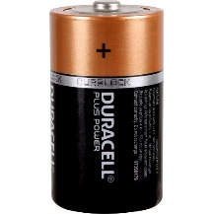
COM, VΩ
Ω
remove
note units:
Ω or kΩ

