This is for scale
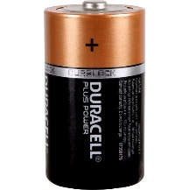
DC: use V (upper)
AC: use V (lower)
check
DC or AC
note units:
mV or V
COM, VΩ
To measure the voltage $ΔV$ between two points in a circuit:
- Configure the DMM as shown.
- Keep your circuit intact.
- Touch or connect the DMM leads to the two points.

