This is for scale
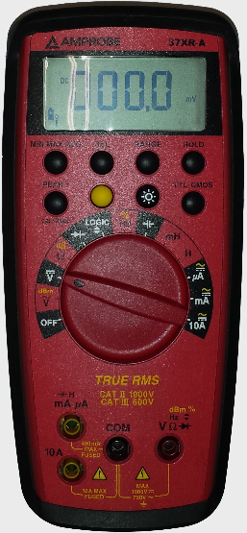
inputs:
10A, COM
selector: 10A
DC
A
DC
mV
inputs:
mA $μ$A, COM
selector: mA (or $μ$A)
inputs:
VΩ , COM
selector: V
For voltage measurements:
For current measurements:
$I>400$ mA
$I<400$ mA

