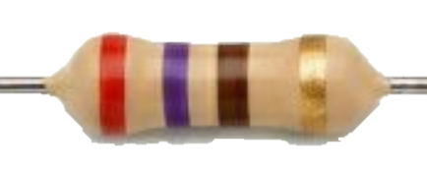
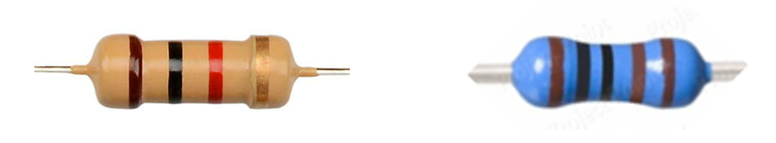
(red - vio - brn – gld)
$R=$
(brn - blk - red – gld)
$R=$
(brn - blk - blk - brn – brn)
$R=$

