# Disk scheduling

## Introduction

For week 1 assignment we have created an application which simulates different algorithms for processor scheduling. The application allows users to simulate 4 different algorithms (FCFS, SJB, Preemptive and Non-preemptive)

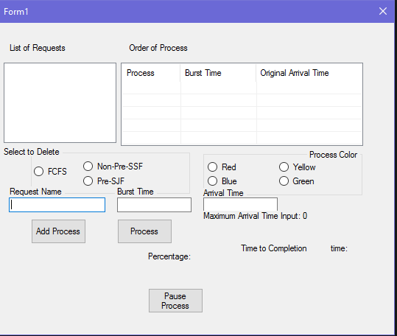

Fig 1.1

The app provides wide variety of customizations to users:

* User can add manually Burs time and Arrival time of the processes
* For better visualization user, can chose between different colors, this way each process execution can be shown in different color.
* Program calculates waiting time

## UML

I am bad at drawing

## Problems

* Existentiality

Extensibility is how the application can be developed/extended easily.

* Reusability

Reusability is how the code/class that already created can be used again.

* Maintainability

Maintainability is how the application can be maintained easily.

## Improvements

## Testing

Because processes are added manually application testing can be done very easily.

We tested our app by adding one of each process to the list and executing it. The application passed the test successfully.

We included a test project to test the algorithms, after doing the test, all algorithms passed the test.

## Reflection

We had some background in Design patterns from System Development 3, but everything was only theoretical. After doing this assignment, we learnt how useful this approach could be.