# Pattern A- Iterator

## Introduction

Provide a way to access the elements of an aggregate object sequentially without exposing its underlying representation. The abstraction provided by the iterator pattern allows you to modify the collection implementation without making any changes outside of collection

To demonstrate the use of Iterator pattern, we have created a simple Song album app.

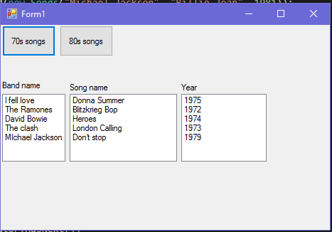

## UML

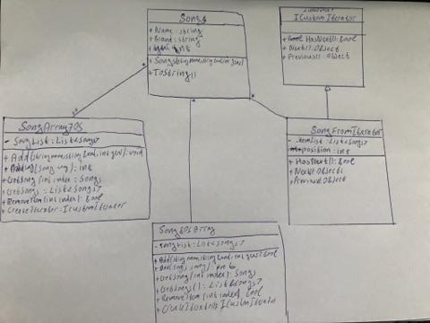

## Key features

* Provides different kind of traversal (forwards, backwards, in-order etc.)
* Keep track on several traversals.
* Does not expose the underlying representation.