# Weather Prediction

## Introduction

For week 2 DPR assignment we have created a simple Weather Prediction application. The application consists of 1 Subject (the Weather Prediction) and 2 observers.

In the image below, the 3 different Forms are shown.

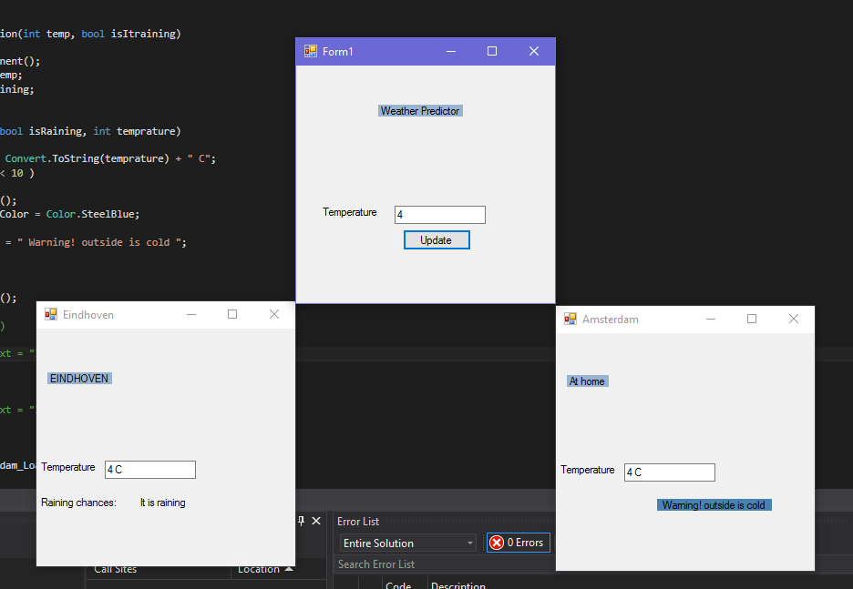

“Form1”is the Weather Predictor, user enters a temperature value and when button is pressed, Observers are notified.

“Eindhoven form is the first Observer, it shows the temperature given by the Weather Predictor and displays if it’s raining.

“At home “is the second Observer, it shows the current temperature and based on how low the temperature is displays a warning message. For example, if temperature is lower than 10 C displays “Warning, outside is cold”.

## UML

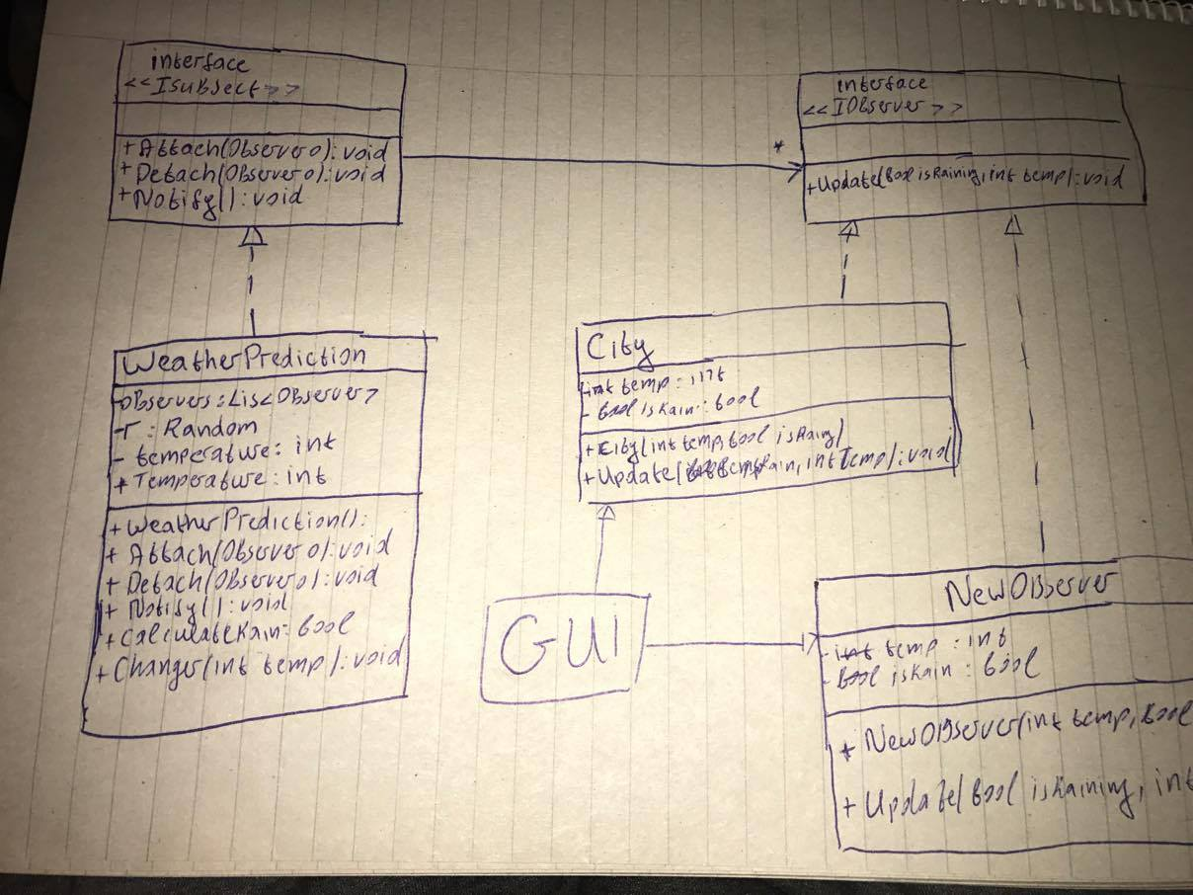

## Problems and improvements

We didn’t have enough time to implement PUSH/ PULL method. Our idea was to add an option were user can Enter a value (an hour) for which he wants to check the temperature and chance of rain. The problem is that signature of some methods must be changed, because an int Array needs to be created to store the temperature for the whole day.