# Week 3 Assignment – Decorator pattern

## Introduction

For this week assignment, we have created a Car dealership with in which user can select a car from different models (BMW Z4, I8, 2 Series Coupe etc.) and then add Accessories to it (Carbon breaks, park assist, speakers etc.). After an accessory is selected by the user, the extra costs are added to the base price of the selected car model.

The Image below shows the main screen of the app.

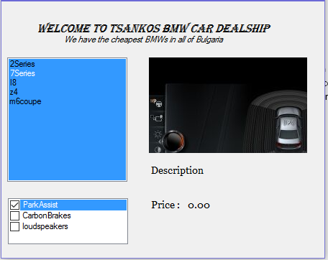

## UML

The UML includes only one type of a BWM model because they all have almost the same signature. The application also has 2 more accessories which are not included in the UML diagram because there is not enough space to added.

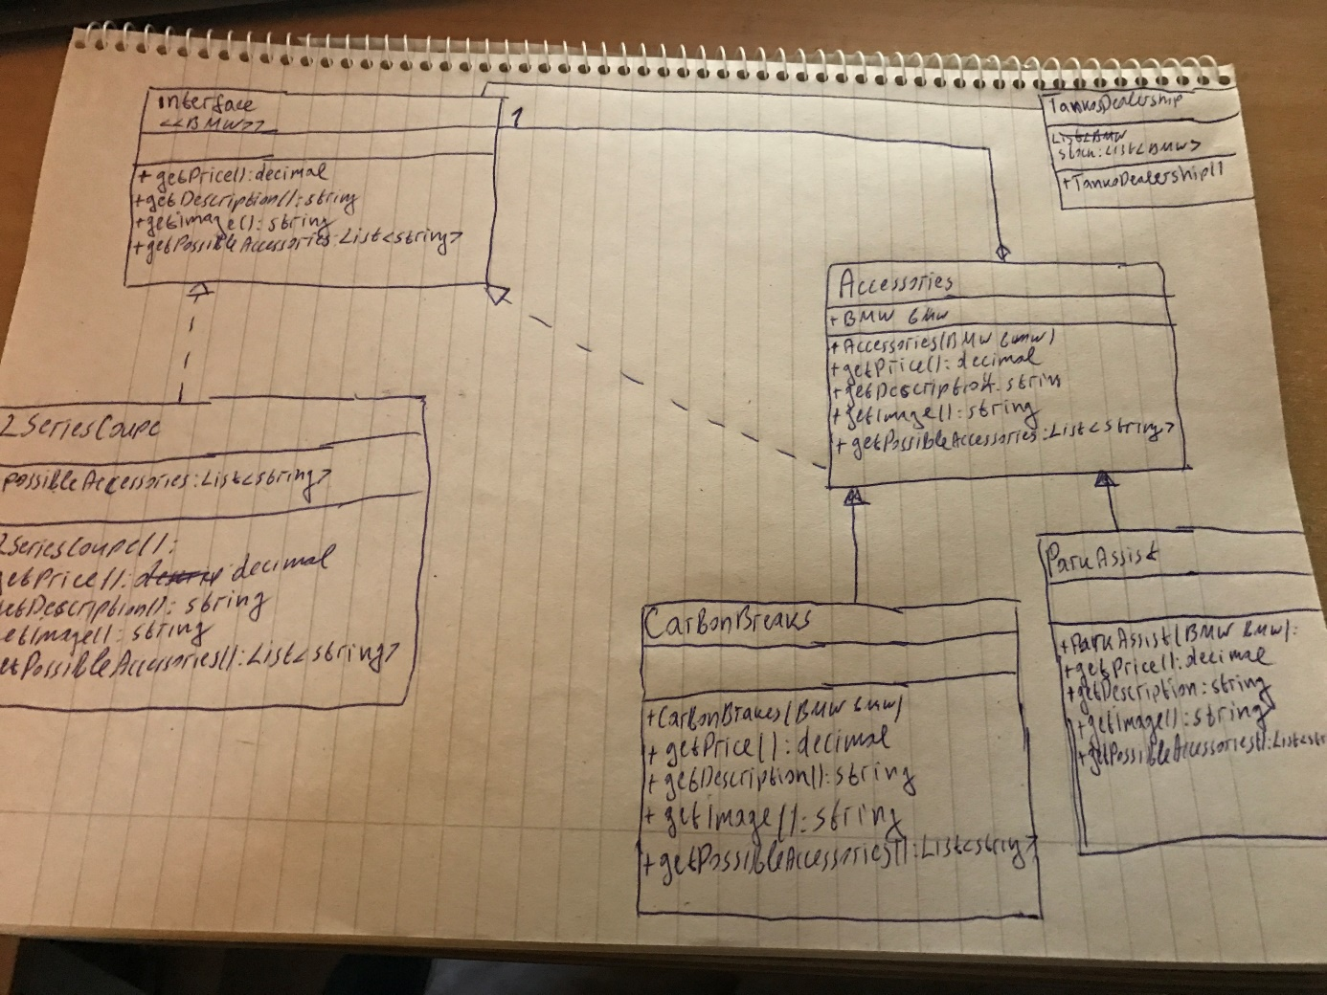

## Reflection

Decorator pattern seems to be a very smart way of solving some problems. Instead of changing every price for every accessory or component, we change only one because they are independent.