# Abstract Factory

## Introduction

For this week, we must implement Abstract Factory Pattern. To implement the parttern we created a MotorcycleDealer application.

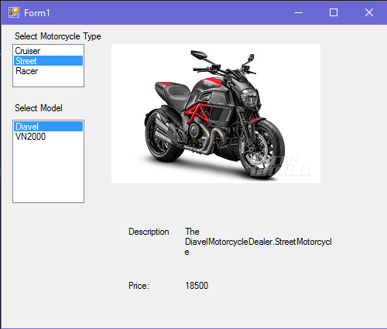

Features:

* User can select between different type of motorcycles: cruiser, street, racer.
* User can select different models.
* Gives description and price for the selected model.
* Shows picture of the selected model.

## UML

