Rural Cultivation and Atmospheric Emulation Application (RCAEA)

***User Guide***

|  |  |
| --- | --- |
| **Authors:** | Al Al-Mohaiminul Islam Khan |
|  | Mihail Hadzhinikolov |
|  | Raima Khan |
|  | Richard Dyer |
|  | Tsanko Hadzhiev |
|  | Zisis Damianidis |
|  |  |
|  |  |
| **Creation Date:** | 19/01/2017 |
| **Last Revised:** | 22/01/2017 |
| **Group Name:** | Tanks & Co.™ |
| **Version:** | 1.0 |

Table of Contents

Introduction 3

Application Interface 3

Options Details 4

Main Functions Tutorials and Examples 6

Adding and Removing Crops 6

Choosing Additional Properties 7

Running a Simulation 9

Displaying Statistics 10

Saving and Loading a Simulation 11

Troubleshooting 12

Index 12

# Introduction

This document is intended to give assistance to users who are utilizing the Rural Cultivation and Atmospheric Emulation Application (RCAEA). The user guide will contain both a written tutorial about the main functions of the RCAEA with associated images, as well as a troubleshooting section detailing possible errors or problems that may occur, along with their solutions. At the end of the document there will be an index section containing terminology that the user might not me familiar with.

# Application Interface

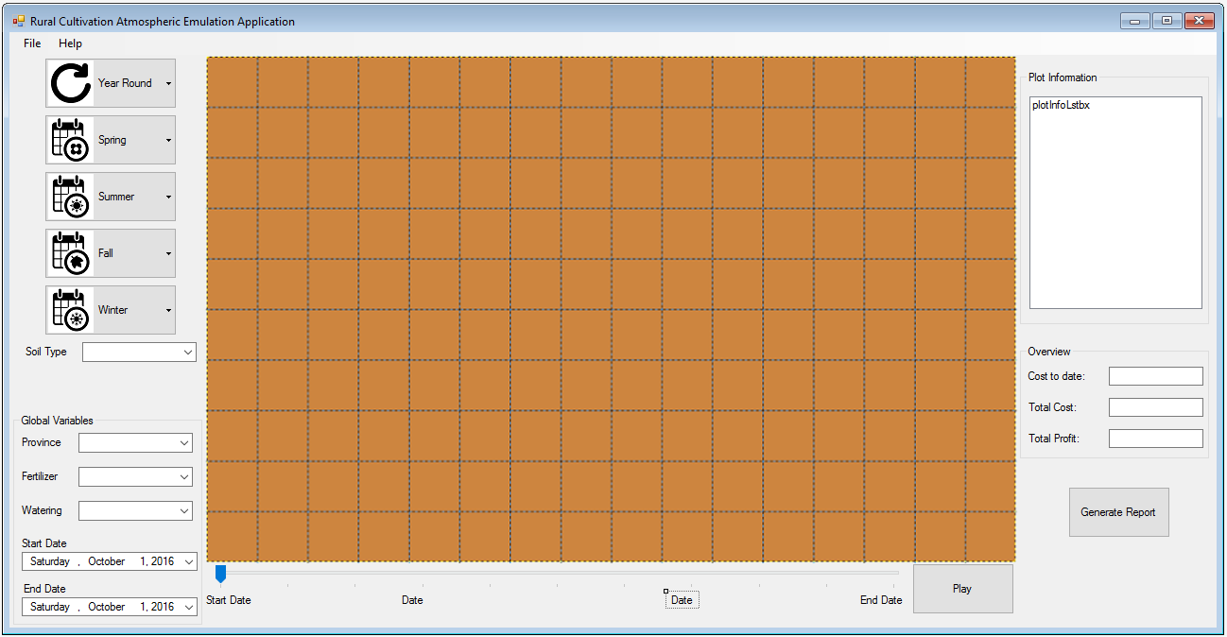

## Options Details

|  |  |
| --- | --- |
| **Interface Option** | **Description** |
| https://lh5.googleusercontent.com/atPl_EuvMpY15fr-JuPPopKYZFO9YwhmWYl9lx7tb0hpfPd04yeLYDloq5EIqEllAfWNvIJp-mUXTKK44Nea7wuOhsMM6EXte7v44M6ShSbH0Wnvb-8GpiCvCPhvuzrrqiSx3u3Z4pBmrrBWpQ | This button will show a menu with a list of crops that can grow all year round. |
| https://lh6.googleusercontent.com/AW4FWXWj0PnQM8Vs6JF8Yf4y8oJXuaWBlvVUofpK0IL_BhQLBSDaPDIYGlQBhrVoO2cAIM938zcRiKfxvnN4cHR-N9wSwiDt57cs19vpz95bMHsHhS4LQdjceHS--jsP-ypGJWhltSxbAHEYBg | This button will show a menu with a list of crops that can grow in the spring season. |
| https://lh6.googleusercontent.com/Ylrvwgye2UwKctOJZUNAmqy8jtBEyQ1UyKhetlTdwpQQTNNikLfdJPZzHpq7n_Ezi862xKMuWFmfyADuSzNJVppLWoak__1tqvPoP21ku-zvIpqR1nAiSPmPwdljXPDupMm5Pido6rdgMRQEmg | This button will show a menu with a list of crops that can grow in the summer season. |
| https://lh6.googleusercontent.com/TULD6VJIoeBrc8FwVBc0FQWXypw_pDan31hTHagfJlhovv3hNEYyc6c2x37m3NG7bG8aZ9HEcwZUbm0qKnS0LZkqDmujazd69OerKDcIa2Ky_A__Kj8LV-hMxKUlhocBJUql-4P9lZGkvgfq6g | This button will show a menu with a list of crops that can grow in the autumn season. |
| https://lh3.googleusercontent.com/E4imJ3SVHReLJ0J9riVuGJv6MMRYKub1ScbAkBUKNI5Up00uD_FYg4Z1E8d7b38_JMdFTa80PG47vKMTAmrwXpXGPEZgiKWguwUfDeF-ruUcuLMybZln4op301dk5NMNG38lHXf2zIZQyQOdZQ | This button will show a menu with a list of crops that can grow in the winter season. |
|  | These squared pieces of land are the plots. On them, the user can add/remove and grow crops. |
|  | This is the menu bar located at top of the application. It contains the "File" and "Help" options. By selecting the File option, you can choose to "Save" or "Load" a simulation. |
| https://lh6.googleusercontent.com/5ZiXVZ6PZzS1SvOvztf9pNV_BcdXEfu9FEQGe2qRzC5yvEjJo7P_OkNWXXKoqPiHt8gZJQeEhqUrNLbVioqoNaw8ASkbmVVlb7PO6Kqf-jSaq2rDyhquE59JeHj4lLmj37i4PBnoI1N5nu2niA | "Soil type" is used to select the type of soil that will be applied to the plots. |
| https://lh4.googleusercontent.com/KkU3ZWJt6M0GxPUqRXKkYpRpHQ_Smhk4jnqCnLcXPw9NT_cFfu17hBaelGzJOVBGcbaGG8CLkmftHpuKRpfbuIh3LvyCutEfQ4FU8sTHNeT9WXExsVbslLoGBQKpZqjNoedMqAvRSyLpZfW99A | Global variables affect the whole simulation and all plots.  "Province" is used for selecting the location of the field within the confinements of the Netherlands. Every province will have different weather and soil properties.  "Fertilizer" is used for selecting how much fertilizer will be used during the run time of the simulation.  "Watering" is used for selecting how much water will be used during the run time of the simulation. |
| https://lh3.googleusercontent.com/h9UoMIK1rNPP7xfBkIbKRNtS9k3GVKnmcXfVXy041Ba2661AbEFRccDy74sYgknMZqj0cWOd2-A2bqHbUKItiulkbo-EV6jLx7acwAy-76htmjgYh5ngrxiUp2bsrqZTxm1B6pRz_DMr7IpVzA | These options will be used to set the start and end dates of the simulation. |
| https://lh3.googleusercontent.com/5aGjaqemTRqW8sV6OXYFYjyFT8LHnEFTMluPErjy1_K967lRrNDmi-kbBvwAzD8JVgWS1yDY4hKfhq_UFGEwfHEU8MlSqYtsgeKtMT-I4PWQGF6MYNdSkwSbmqQCGwzDL2H5jyCQ2VPbNmhTGQ | The "Overview" section of the interface displays the "Cost to date" , "Total Cost" and "Total Profit" of the current simulation which are used to keep track of the potential income from the crops. |
|  | This progress bar can be used to quickly slide across the timeline of the simulation. The start and end dates depend on the selected choices in the "Start Date" and "End Date" options. |
| https://lh4.googleusercontent.com/GDIpbQnIXPKtRMJRDE8HyRzY8PrqrmDWdSeLuIyNG90ZVRbtBbrfcTRj1BEL6BXePtR0Ao3OMRup-YxYajDBMsA7wPnwZxxq6yB3POt_oOVu2O42P8ggr7RoD0S9aH096tOp0c0DTu-SLZmDbg | The "Play" button starts the simulation. It will also act as the "Stop"/"Pause" button when the simulation is running. |
|  | The "Plot Information" panel displays the statistics of the currently selected plot . |
| https://lh4.googleusercontent.com/L6FvZbnWbngJ1hLLnO8swig4E96Ds-gGdAWOPn2BTlggbDjd8VQh_kJ_tgjj3xFMdoUvl2RyovZtAtoyGf-b4aq9Bs5p8ro0GE_wAs9db-J-nTqKJ1f6dfvE3YSNNjBReMG218sL5Sy57MB8Qg | This button will generate an overall report of the current simulation. |

# Main Functions Tutorials and Examples

This section will help guide the user through the main functions of the RCAEA. The examples will cover the basic principles of using the application and once the user is familiar with it, he will be able to easily customise it further to suit his preference.

## Adding and Removing Crops

1. Before running a simulation crops must be added to the plots in the application To do so:
2. Select the category of crop from the left side of the screen (Seasonal or Year Round).
3. In the sub-menu chose the type of crop that you want to plant.
4. Double-Click the left mouse button on an empty plot to plant the crop. *(Figure 1)*

*Note: The default simulation time is 3 months. This can be changed and is disscussed in the next example.*

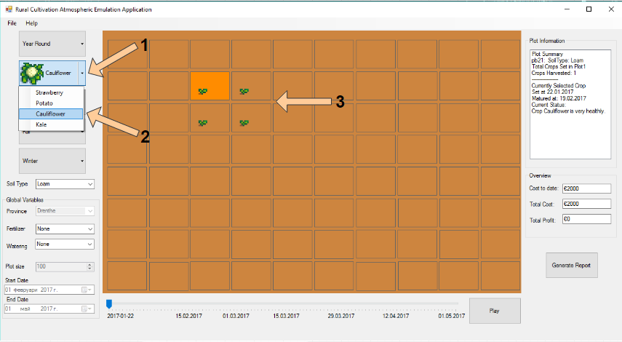

Figure 1 (Adding a Crop)

1. To remove a planted crop from a plot simply double-click the right mouse button on the occupied plot.

## Choosing Additional Properties

1. Additional properties are available that can be assigned to the crops to simulate specific scenarios that can occur. They are located beneath the crop categories and can be used to assign aditional features to the crops as well as to the plot of land itself. To apply these properties:
2. Select one of the properties below the crop categories and a drop-down menu will appear displaying all the available options.
3. Simply select the sought option and the simulation will be updated. *(Figure 2)*

*Note: The "****Global Variables****" properties affect every single plot in the current simulation while the* ***"Soil Type"*** *option only affects the selected plot.*

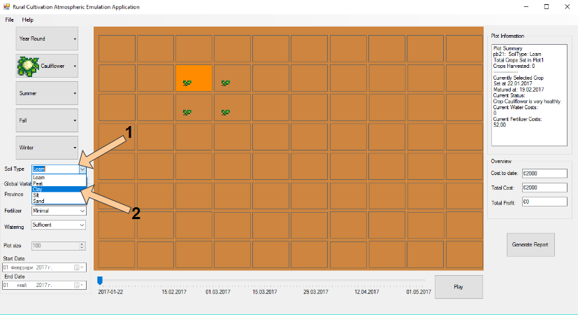

Figure 2 (Additional Properties)

1. The size of the plot can also be changed to apply to personal preferences. Doing so will affect the upkeep of the plot and price of the crop, as more quantities of it can be planted, as well as the produce of the specified plot. To do so:
2. Before proceeding to plant the chosen crop go to the **"Plot size"** option located below the **"Global Variables"** and click on the up or down arrows located next to the number displayed to increase the square meters of the plot. The size can also be typed into the text box next to it.

*Note: Plot can be adjusted between 50 and 200 square meters.*

1. Proceed to plant the crop on a chosen plot and the information will be applied to it afterwards. *(Figure 3)*

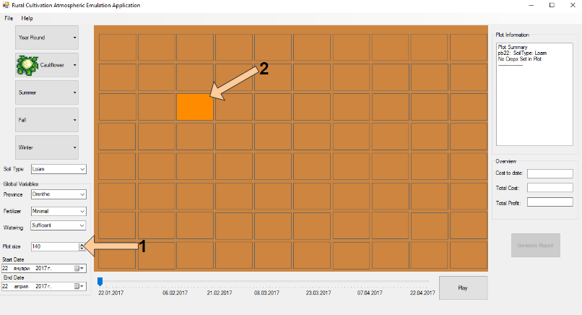

Figure 3 (Plot Size)

1. The timeline of the simulation can also be altered to encompass a specific lenght of time or to appeal to some of the seasonal crop choices available. To do so:
2. Select when the simulation will start by clicking on the date under the **"Start Date"** option to bring up a calendar and choose the specific date. *(Figure 4)*
3. Do the exact same for the **"End Date"** to choose then the simulation will end.

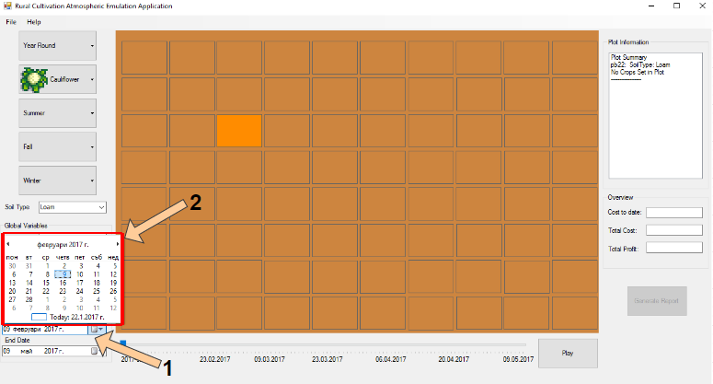*Note: The simulation must be atleast 3 months long or 3 years at maximum.*

Figure 4 (Picking Start and End Date)

## Running a Simulation

1. Running the simulation is what is used to advance the time of the simulation, which therefore advances the date and the growth of the crops. The simulation can be stopped at any time to make adjustments to the simulation, add new crops at a different date on the timeline or just an informative overview of the current stage of the simulation.
2. Once some crops have been planted, click on the **"Play"** button on the bottom of the screen to start the simulation. *(Figure 5.1)*
3. The dates will start to advance and the crops to grow until it reaches the end date. You can stop the simulation at any given time by pressing the **"Pause"** button.
4. The slider under the plots can be dragged to any given date between the specified start and end dates. All of the crops will be updated to represent their stage depending on the date chosen. *(Figure 5.2)*

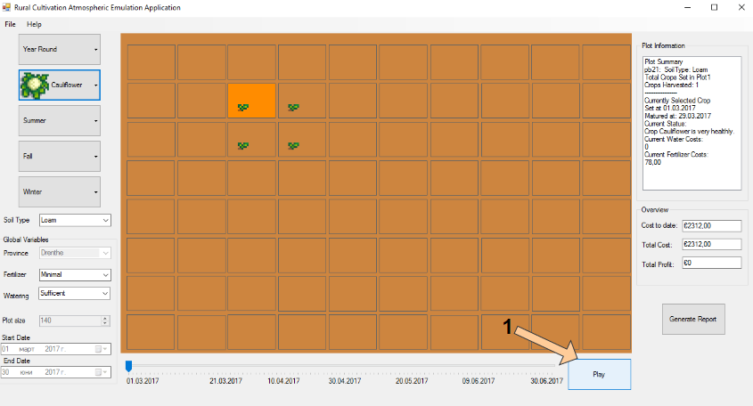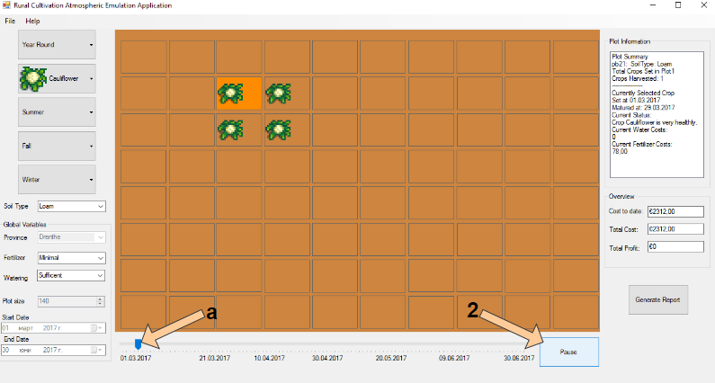

Figure 5.2 (Pausing and Slider)

Figure 5.1 (Starting a Simulation)

## Displaying Statistics

1. During the simulation additional information is available to the user for review. Such information is available for every cultivated plot. To view it:
2. Click on a cultivated plot of land and the information about will be availble in the right side of the screen in the **"Plot Information"** panel. *(Figure 6.1)*
3. During the simulation the costs and profits of it are available for reference in the **"Overview"** panel under the **"Plot Information**" panel and include the projected total cost until the currently selected date on the slider, as well as the total costs and profits of the cultivation. This can be observed in a more detailed report. To do so:
4. Click on the **"Generate Report"** button below the panels and a detailed overview of the simulation will be displayed in a new window. *(Figure 6.1)*
5. (Optional) This report can be saved for future reference. Clicking on save below the report will do so. *(Figure 6.2)*

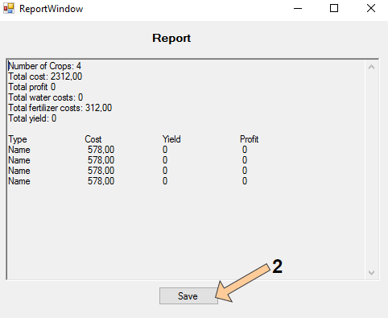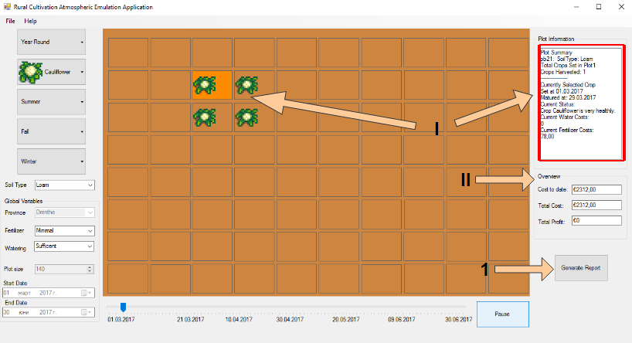*Note: This is further discussed in the next example.*

Figure 6.2 (Report Example)

Figure 6.1 (Information and Overview)

## Saving and Loading a Simulation

1. Current simulations can be saved to store different scenarios and to be able to be loaded at any given time in the future. To do so:
2. Click on the **"File"** menu in the upper left corner of the top bar. *(Figure 7.1)*
3. Click on the option you require at that moment:
4. By clicking on **"Save"** a new window will appear. Type the name with which you want to save the simulation as well as a description for it. *(Figure 7.2)*
5. 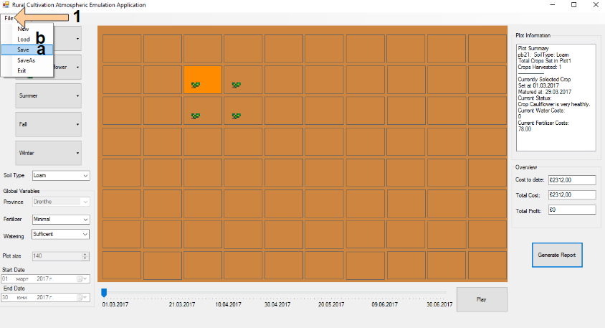By clicking on **"Load"** a new window will appear that displays all the previously saved simulations. Simply click on which one you want to load into the application. *(Figure 7.3)*

Figure 7.1 (Saving and Loading)

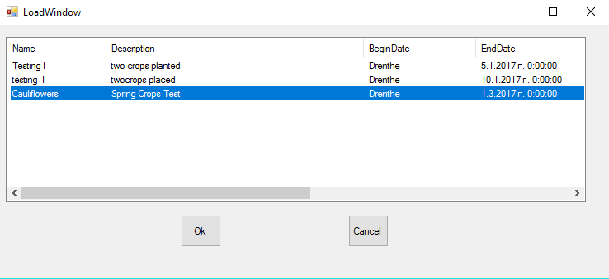

Figure 7.3 (Loading Window)

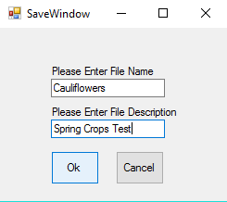

Figure 7.2 (Save Window)

1. The application can be exited by clicking on the **"X"** button in the top right corner of the screen or the exit option in the **"File"** menu in the upper left corner of the top bar. Doing so will prompt the application to ask wether you would want to save the current simulation. If you click the **"Yes"** buttonyou will be taken to the **"Save"** window.

# Troubleshooting

This section will try to tackle any problems or errors that may be encountered during the usage of the application.

1. **Crops dying because of unknown reasons.**

- Make sure to plant seasonal crops during their respective season otherwise it will be impossible for them to grow. Fertilizer, Watering and the different Provinces have effect on the crops as well.

1. **Cannot change the current province or the size of the plot.**

- Once a crop has been planted the province and the size of the plot are set and can only be changed once all the crops are removed from the plots. Each simulation takes place in only one province at a time. Saving the simulation and starting a new one also allows these properties to be set again.

1. **Application cannot connect to the database.**

- XAMPP must be running at all times while the application is open to have a connection with the database. The Apache and the MySQL modules must be started.

# Index

This part of the document will serve as an explanation of the terminology that will be used throughout the document the user may not be familiar with.

**Global Variable** – Indicates configurations that will affect every plot in the current simulation.

**Simulation** – In this document refers to the current cultivational project that is opened in the application interface.

**Slider** – Refers to the bottom bar of the application used to switch the current date of the simulation.

**Troubleshooting** – A term used to describe the process of trying to deal with a problem or error that the user might encounter.

**Database** – The term used to describe the storage where all the information of the application and the simulations is stored.

**XAMPP** – Is a web server program that allows the application to connect to the database.

**Panel** – In this document refers to a specific section of the screen that displays certain options and information.