Rural Cultivation & Atmospheric Emulation Application (RCAEA) URS document

|  |  |
| --- | --- |
| **Document:** | URS |
|  |  |
| **Authors:** | Raima Khan |
|  | Tsanko Hadzhiev |
|  | Richard Dyer |
|  | Mihail Hadzhinikolov |
|  | Zisis Damianidis |
|  | Al Al-Mohaiminul Islam Khan |
|  |  |
| **Creation Date:** | 16/09/16 |
| **Last Revised:** | 27/09/16 |
| **Group Name:** | Tanks & Co.™ |
| **Version:** | 0.2 |

## Contents

Contents 2

INTRODUCTION 3

Purpose of URS 3

Index 3

PRODUCT DESCRIPTION 4

Background Information 4

Performance 4

Users 4

Assumptions 5

REQUIREMENTS 5

Functional requirements 7

Non-Functional requirements 7

Use cases 8

Adding crops 8

Removing crops 9

Updating water resources 9

Updating fertilizers to crops 10

Simulating growth of crop: 10

Retrieving profit/loss report 10

Exit application 11

Save statistics 12

APPROVALS 12

Sign-off Sheet 12

# INTRODUCTION

## Purpose of URS

This document is the definitive specification of the user requirements for RCAEA Project to be developed by Tanks & Co.™The application allows the user to simulate cultivating specific crop(s) in an area of land during a certain length of time. By using this application they can determine when, where, and what crops to place in a specified piece of land. It will help the user make a cultivation plan for a certain area of land based on real land data. It considers regions factors such as weather whereby the user can select which outdoor agricultural crops to place in an area. The simulation will use real data on the crop and simulate its growth based on external and internal determinate factors. RCAEA will take all these factors into account and determine an estimated cost and production outcome. Data will be saved in a file which the user can load or keep for their own records.

## Index

This part of the document will serve as an explanation of the terminology that will be used throughout the document the client may not be familiar with.

**URS** – User Requirements Specification. Refers to this document which specifies what the user expects the application to be able to do.

**GUI** – Graphical User Interface. A type of User Interface that allows users to interact with the application through graphical icons and visual indicators such as secondary notation, instead of text-based user interfaces, typed command labels or text navigation.

**MoSCoW** – **M**ust have, **S**hould have, **Co**uld have and **W**ill not have. This method is a prioritization technique used to reach a common understanding with the client on the importance that is placed on the delivery of each requirement.

**Input** – In this document is referred to the configurations the user has assigned to the application.

**Functional Requirement** – Defines a function of the application or its component. A function is described as a set of inputs, the behavior, and outputs.

**Non-Functional Requirement** – A requirement that specifies criteria that can be used to judge the operation of the application, rather than specific behaviors. It is contrasted with Functional Requirements that define specific behavior or functions.

**Use Case** – A list of actions or event steps, defining the interactions between the client and the application, to achieve a goal.

**Pre-condition** – Prerequisites needed before the Use Case can be initiated.

**Trigger – Method of initiating the Use Case.**

**MSS – Main Success Scenario. Used to describe the Use Cases of the application and their primary way of completion.**

**Extension** – Used to describe deviations from the Main Success Scenario of a Use Case during a certain step and the alternative ways of executing it.

# PRODUCT DESCRIPTION

## Background Information

SIM Software Inc. is interested in adopting simulation applications and has asked for project proposals. Tanks & Co™ has a simulation proposal and they met with A representative from SIM Software’s board of management, Mr. Johnson. He has accepted their proposal for “Rural Cultivation and Atmospheric Emulation Application”.

Mr. Johnson will be the mediator and ultimately make the decision software.

## Performance

In this project we will create an application to simulate cultivating specific crop(s) in an area of land during a user determined time period. This application will allow users to grow selected crops in a simulated field that will factor multiple variables producing approximated cost and produce over the inputted time period.

## Users

This application can be used by individual production planners as well as by multi-national enterprises, primarily to strategically plan layouts, control logic and dimensions of large, complex production investments. Farmers can also use this application for deciding which crop is more beneficial for them before cultivation.

## Assumptions

Following are some assumptions for this project made by us:

* Fields for cultivation are already bought by users, therefore land costs/rent will not be accounted for.
* Crop diseases will not be factored
* We assume that the weather will follow recent years’ patterns.
* We assume that crop/water and fertilizer costs although seasonal will follow most recent prices.
* When crops are fully rip/grown they will be automatically harvested.

## Constraints

* The application will be created in C# Visual Studio.
* The application will support 25 different types of crops.
* The regions available will be within The Netherlands.
* The cultivating area will be divided into 160 plots.
* Each plot can be adjusted between 50 and 200 square meters.
* Soil selection will be applicable to all soil plots.
* Start date cannot be before the end date and 2014.
* End date cannot be 3 years from the start date, and must be at least 3 months from start dates.

## REQUIREMENTS

In the table below you can find the MOSCOW for every requirement during the project.

|  |  |  |  |  |  |
| --- | --- | --- | --- | --- | --- |
| ID | Requirement name | Must | Should | Could | Will Not |
| 101 | Add crops | V |  |  |  |
| 102 | Remove crops | V |  |  |  |
| 103 | Update fertilizer | V |  |  |  |
| 104 | Update water resources | V |  |  |  |
| 105 | Generate report | V |  |  |  |
| 106 | Soil selection | V |  |  |  |
| 107 | Display Statistics |  | V |  |  |
| 108 | Growth simulation | V |  |  |  |
| 109 | Set Date | V |  |  |  |
| 201 | Save Simulation | V |  |  |  |
| 202 | Load Simulation | V |  |  |  |
| 203 | Exit Application | V |  |  |  |
| 301 | Buying/selling land |  |  |  | V |
| 302 | Renting land |  |  |  | V |
| 303 | Encounter crop diseases |  |  |  | V |

## Functional requirements

|  |  |  |
| --- | --- | --- |
| ID | Requirement name | Description |
| 101 | Add crops | Allows user to set a crop in a plot. |
| 102 | Remove crops | Will clear a plot of land of the crop previously placed. |
| 103 | Update fertilizer | User can select several options, for how much fertilizer will be given to the crops during the run time of the simulation. |
| 104 | Update water resources | The user can select several options for how much water will be given to the crops during the run time of the simulation. |
| 105 | Generate report | A report will be generated with a description of all the crops involved in the simulation and with overall costs. |
| 106 | Soil selection | Each plot of land will have a default soil characteristic based on the region, the user can change soil properties for each plot. |
| 107 | Display Statistics | When a user selects a specific plot its statistics along with the crop set within it will be displayed. |
| 108 | Growth simulation | The growth simulation will run factoring in all the external and internal factors. |
| 109 | Set Date | The user can set the start and end date for the simulation to run. |
| 201 | Save Simulation | Will save simulation into the database. |
| 202 | Load Simulation | Will load simulation from the database. |
| 203 | Exit Application | Prompts the user if he wants to save the current simulation if he has not done so beforehand and proceeds to shut down the simulation application |
| 301 | Buying/selling land | N/A |
| 302 | Renting land | N/A |
| 303 | Encounter crop diseases | N/A |

## Non-Functional requirements

Platform compatibility

* Application should work most optimally in the Windows environment. This application should work best on the Windows platform as it was designed for such.

Usability

* The application should be user friendly and incorporate elements of good user interface design. For example, the buttons are easily recognizable and familiar to the user in terms of expressing what function the button serves easily accessible to the user.
* Program is simplified and allows the user to reach his goal without any problems. User must be able to access the program without registration, account etc.

Performance

* The application should respond within 1500milliseconds with each button click, and 4000 milliseconds when loading a report on a modern machine (Processor greater than 1Ghz).

Reliability

* In case of exception or error, the program displays info messages without crashing, allowing user to continue his work.

## GUI

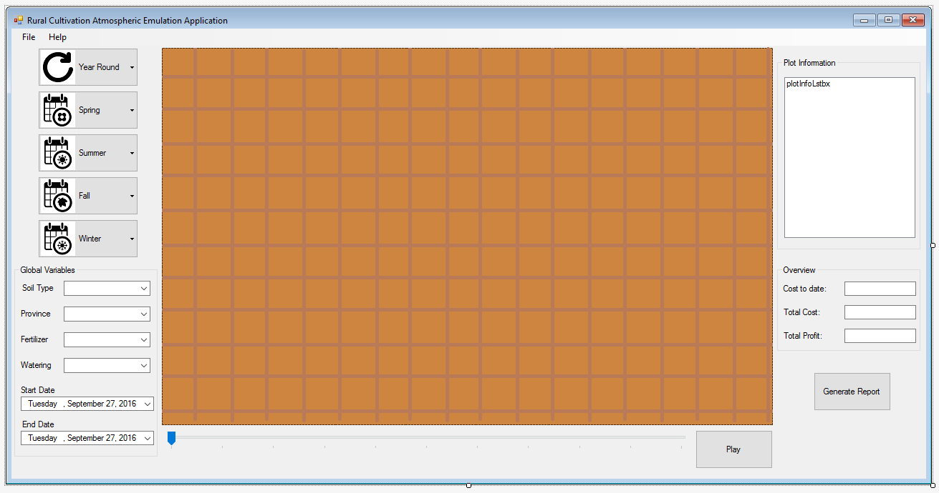

### GUI Details

|  |  |
| --- | --- |
| * **Form’s component** | **Meaning** |
|  | This split button will show context menu with list of crops that can grow all round year. |
|  | This split button will show context menu with list of crops that can grow in spring season. |
|  | This split button will show context menu with list of crops that can grow in summer season. |
|  | This split button will show context menu with list of crops that can grow in autumn season. |
|  | This split button will show context menu with list of crops that can grow in winter season. |
|  | Soil type selection dropdown box (per plot). |
|  | Global variable selection dropdown boxes for current simulation.  Province dropdown for selecting where the field is located.  Fertilizer dropdown for selecting how much fertilizer will be used.  Fertilizer dropdown for selecting how much water will be used. |
|  | These date selector will be used to set start and ends date of simulation. |
|  | These textfields display cost to date,total cost and total profit of current simulation. |
|  | This bar can be use to move across timeline of the simulation. |
|  | This button will make the simulation automatically |
|  | This button will generate general report about current simulation. |

## Use cases

All use cases have the system and user as the only actors involved. Furthermore, all the use cases are of the sea-level.

### 101: Adding crops

**MSS:**

1.    User clicks on a crop category.

2.    System displays the available crops from category.

3.    User selects specific crop.

4.    System shows selected crop in crop selection box.

5.    User selects plot where he wants to cultivate.

5.    System updates land space with the type of crop.

**Extensions:**

         5a. Land space is already occupied by another crop.

1.    System displays a warning box to user, to confirm space replacement.

2. Use-Case ends

1a. User click yes; system replaces the land space with current selected crop

1b. User clicks no

1. Use-Case continues to 5.

### 102: Removing crops

**Pre-condition:** The screen must have at least one field, cultivated with crops.

**MSS:**

1.    User willselect a plot with the right click, where he wants to remove the crop.

2.    System will show right click menu, that will display the option to delete.

3.    User clicks on the delete option from the menu.

4.    System deletes the crop from the space.

**Extensions:**

         1a. The selected plot is an empty plot.

1.user get a pop-up message.

        3a. User clicks outside of the right click menu

1. System closes right click menu
2. Use-Case ends.

### 103: Updating fertilizers to crops

**MSS:**

1.    User will click on fertilizer drop down menu.

2.    System will display the fertilizer drop down options

3.    User will click on one of the fertilizer drop down options.

**4.**System will update the current fertilizer quantity used.

### 104: Updating water resources

**MSS:**

1.    User will click on watering drop down menu.

2.    System will display the watering drop down options

3.    User will click on one of the watering drop down options.

4.System will update the current watering quantity used.

### 105: Generate report

**Pre-condition:** The screen must have at least one field, cultivated with crops.

**MSS:**

1.    User clicks on the Generate Report Button

2.    System opens second windows form, displaying the report.

**Extension:**

2a. System has errors loading the report.

1. System will display notification box describing the error.
2. User clicks ok.
3. System closes the newly created windows form.
4. Use-Case ends

### 106: Soil Selection

1. User clicks on plot.
2. System with display current plot soil type in soil type drop down box.
3. User clicks on soil type drop down box.
4. System Displays soil type options.
5. User selects one of the drop down box options.
6. System sets soil type of selected plot.

### 107: Display statistics

**Pre-condition:** The screen must have at least one field, cultivated with crops.

**MSS:**

          1. User selects a plot

              2. System displays statistics for the selected plot in the plot information panel.

**Extensions:**

1.    User clicks on an empty field

a)    Use case ends

### 108: Simulating growth of crops:

**Pre-condition:** The screen must have at least one field, cultivated with crops. Start Date and end date are filled.

**MSS:**

1.    User clicks start simulation.

2.     System changes the start button to stop button.

3.     System runs simulation from beginning to end.

**Extension:**

1a.    User scrolls on the timeline bar.

1.    System actively runs simulation according to the timeline bar position.

3a.     User clicks stop button

1. System stops running simulation
2. System changes stop button to start button.

3b.     System gets an error

1. System stops running simulation

3c. User has not entered Start and End date.

1. System will display notification that start and/or end date has not been entered.
2. Use-Case Ends.

         2.System changes stop button to start button.

         3. System displays in a message box the error.

1. User clicks ok
2. Use-Case Ends

### 109: Selecting start date and end date

**MSS:**

1.    User selects start date selector.

2.   System displays small calendar with possible dates.

3.   User selects a  start date.

4.   System closes small calendar

5.   System updates the selected date into the start date field.

6.    User selects end date selector.

7.   System displays small calendar with possible dates.

8.   User selects an end date.

9.   System closes small calendar

10.   System updates the selected date into the end date field.

11.    User selects end date.

**Extensions:**

  1a.User selects end date selector.

1. System displays small calendar with possible dates.

2.   User selects an end date from the calendar.

3.   System closes small calendar

4.   System updates the selected date into the end date field.

5.    User selects end date.

6.  Use-Case continues from 1.

      6a. User has already selected an end date.

### 201: Saving Application

**MSS:**

1.    User clicks on file

2.    System display file options

3.    User selects save

4.    System brings up the list from database.

5.    System saves data in the database.

**Extension:**

3a. User Selects data to overwrite

1.    System will ask user to confirm overwriting file.

a.    User confirms

                                                                                  i.     System connects to data-base and finds the current instance of the file to overwrite

                                                                                 ii.     System deletes the current instance of data located in the database.

                                                                               iii.     Use-Case continues from step 3

b.    User cancels overwriting

                                                                                  i.     Use-Case ends

### 202: Loading simulation

**MSS:**

1.    User go to the menu and select load

2.   User see a pop-up window from where browse the simulation file, select the file and click on open

3.    User see the loaded simulation

**Extensions:**

2.a User click on a different file rather than a simulation file and click open

                       1: User get a pop-up message about the inappropriate file format

                     2: Continue from step 2 in MSS.

### 203: Exit application

**Pre-condition:** The user has the main form of the RCAEA app open on his PC.

**Trigger:** User will click on the close button of the main form.

**MSS:**

              1.System prompts users asking if he wants to quit the application.

              2.System closes application.

# APPROVALS

## Sign-off Sheet