**PROJECT PROPOSAL**

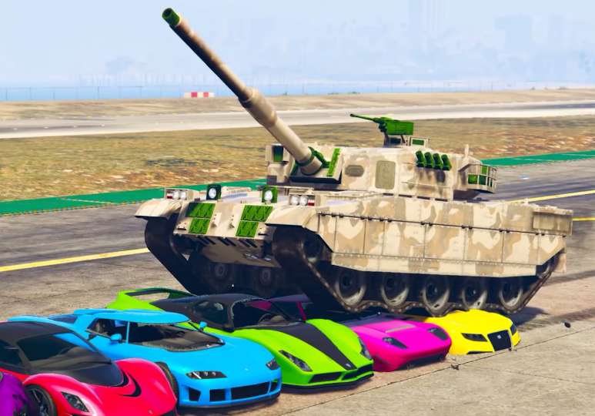

***Tanks & Co.™***

1. **PROJECT DESCRIPTION**
   * Project Title: **Tanks & Co.’s RCAEA Project**
   * Organization: Tanks & Co.™
   * Number of Participants: 6
   * Date of Implementation: 08/31
2. **Executive Summary**

The creation of an Agricultural Simulation; the application will mock a cultivation area where the user can select which crops they would like to grow in a designated region. The Application will then aid the user by simulating the most likely produce and cost outcomes based on an array of external and internal factors.

1. **Statement of the Problem**

* **Who are we?**

Tanks & Co.™ is a small software development team composed of just six developers based out of Eindhoven that crushes the competition.

* **Goals:**

We wish to develop an agricultural simulation application that SIM Software will eventually buy.

* **What?**
* The application will feature an adjustable land surface size.
* Selectable crops and regions
* The ability to scale through time.
* A database with regional weather and soil properties
* A database of crops and their properties
* The ability to select crops and the land area the user wishes to cultivate
* Calculate an estimation of produced crops
* Calculate an estimation of costs.

1. **Technical Approach**

* The Database: will hold weather patterns per month based on previous weather patterns. It will hold similar crop properties such as required growth time, amount of water needed.
* The Application: Will use the data from the database, and calculate user input along with region and crops used to produce a produce and cost estimation.
* The Design: A project Plan has been created which Tank & Co.™ will follow according to the phases entailed.

1. **DETAILED BUDGET**

|  |  |  |
| --- | --- | --- |
| **Employee** | **Description** | **Monthly Salary** |
| Richard Dyer | Project Leader | €8.000 |
| Raima Khan | Contact Person | €6.500 |
| Tsanko Hadzheiv | Minute Keeper, Designer | €350 |
| Mihail Hadzhinikolov | Software Designer | €5.500 |
| Zisis Damianidis | Software Designer | €5.500 |
| Al-Mohaiminul Islam Khan | Software Designer | €5.500 |

1. **Communication with Sponsor**

Weekly meeting with a representative from SIM Software, will ensure until the project completion.