-I would suggest that a picture of Newman be inserted on the homepage in either circled part. It would give more warmth and visual context to the whole site before one starts clicking through
-I would also suggest to find a great, appealing quote from Newman’s work and put it prominently in the blue rectangle. That quote sets the tone. It would be one that represents his main thought, his philosophy.

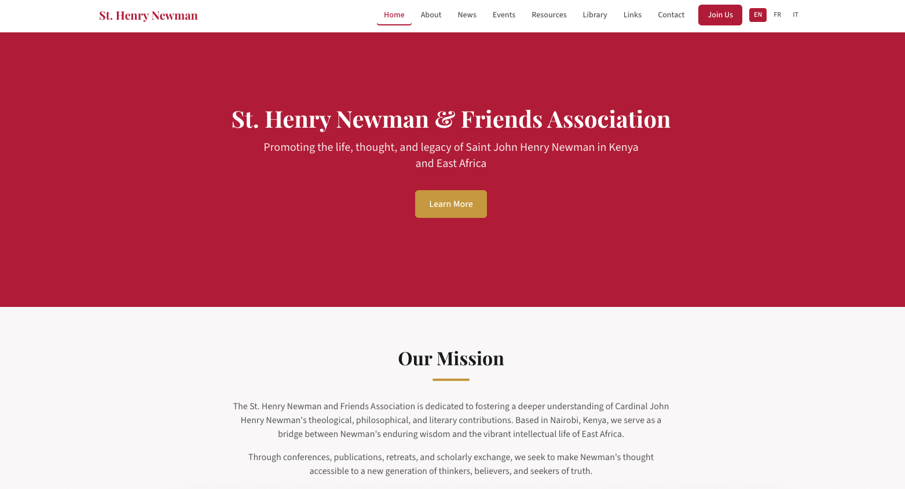
- I would expect a “Donate” button either next to the “Join us” buttomor in the upper right corner of the red banner
