CHAPTER FOUR
SYSTEM IMPLEMENTATION
This chapter reports how the blockchain-based EHR management system designed in Chapter Three was built, installed and tested. A working prototype, named ChainCare EHR, was implemented on the T-MERN stack (TypeScript, MongoDB, Express.js, React and Node.js) with Hyperledger Fabric as the permissioned ledger. Two Fabric organisations represent two levels of the Nigerian healthcare system: Hospital A, a tertiary teaching hospital, and Facility B, a primary health centre (PHC). Together they model the PHC-to-hospital referral chain described in Section 1.1. The chapter then evaluates the prototype for performance, security and usability, and compares it with a centralised system built on the existing architecture analysed in Section 3.1.

4.1 Implementation Platforms
The system was developed in three layers, each with its own tools: a presentation layer that runs in the user's browser, an application layer that exposes a REST API, and a data layer split between an off-chain database and the blockchain network. TypeScript was used in all three layers, including the smart contract, so one language and one set of data types runs from the user interface to the ledger. Table 4.1 lists every tool used, with the exact version installed.
Table 4.1: Implementation tools and versions
Layer | Tool / technology | Version | Purpose in the system
Programming language | TypeScript | 5.9.3 (API, web), 5.4.5 (chaincode) | Statically typed JavaScript used for the front end, API and chaincode
Runtime | Node.js | 22.22.0 | Executes the API server, Fabric client and chaincode
Front end | React | 18.3.1 | Component-based dashboards for patients, clinicians, auditors and administrators
Front end | Vite | 6.4.3 | Development server, production build and static web server
Application layer | Express.js | 5.2.1 | REST API routing and middleware pipeline
Application layer | Zod | 4.6.5 | Validation of every request body against a schema
Security | Helmet | 8.3.0 | HTTP security headers (content security policy, nosniff, frame denial)
Security | express-rate-limit | 8.7.0 | Limits the number of API requests per client per minute
Security | jsonwebtoken (JWT) | 9.0.3 | Signed session tokens (HS256) carrying user ID, role and organisation
Security | bcryptjs | 3.0.3 | One-way hashing of user passwords
Security | Node.js crypto module | built in | AES-256-GCM encryption of records; SHA-256 hashing for integrity
Off-chain database | MongoDB | 7.0 | Users, patient demographics and encrypted clinical records
Off-chain database | Mongoose | 9.10.4 | Object data modelling, schemas and validation for MongoDB
Blockchain platform | Hyperledger Fabric | 2.5.10 | Permissioned distributed ledger, channel and endorsement policy
Blockchain platform | Fabric CA | 1.5.13 | Issues X.509 identity certificates to each organisation
Blockchain platform | CouchDB | 3.4.2 | World-state database that supports rich JSON queries
Smart contract | fabric-contract-api / fabric-shim | 2.5.8 | Chaincode framework for consent, access control and audit logic
Blockchain client | Fabric Gateway SDK (@hyperledger/fabric-gateway) | 1.12.1 | Endorses, submits and evaluates transactions over gRPC
Containers | Docker Engine | 29.8.2 | Runs peers, orderer, CAs, CouchDB, MongoDB and the chaincode service
Testing | Jest / Node.js test runner / Supertest | 29.7.0 / built in / 7.3.1 | Unit tests (chaincode) and API integration tests
Performance testing | Hyperledger Caliper | 0.6.0 | Blockchain benchmark: throughput, latency, success rate
Performance testing | autocannon | 8.0.0 | HTTP load testing of the API
Security testing | OWASP ZAP, npm audit | 2.17.0, npm 10.9.4 | Web vulnerability scanning and dependency audit
Usability testing | Playwright, axe-core | 1.56, 4.13.0 | Scripted task timing, network throttling, WCAG 2.1 accessibility audit
Development | Visual Studio Code, Git | current | Source editing and version control

Presentation layer
The user interface is a single-page application written in React 18 and TypeScript and bundled with Vite. It has four role-based dashboards. Patients see their records, manage consent and read a log of everyone who has accessed their data. Clinicians enrol patients, open and add records, and can request emergency (break-glass) access. Auditors verify record integrity against the ledger and read the audit trail. Administrators manage staff accounts. The production build is a single 164 KB JavaScript file, which matters for clinics on slow mobile connections.

Application layer
The API runs on Node.js with Express.js. Every request passes through a chain of security middleware (Helmet headers, a CORS allow-list, a rate limiter, JWT verification, a role check and Zod validation) before it reaches a controller. Three services sit behind the controllers: a data-access service that uses Mongoose to talk to MongoDB, a crypto service that encrypts clinical payloads with AES-256-GCM and computes their SHA-256 digests, and a ledger service that talks to Hyperledger Fabric through the Fabric Gateway SDK.

Data layer
Clinical data is split between two stores. MongoDB holds the bulky data that is read often: user accounts, patient demographics and the encrypted clinical records themselves. The Fabric ledger holds the small data that must be trusted: a SHA-256 hash of every record, every consent decision and an audit event for every access attempt. Each peer keeps the current state in CouchDB, which allows JSON queries such as "all records of patient X". The chaincode (smart contract) is written in TypeScript and runs as an external service beside each peer.

4.1.1 Justification of the Implementation Platforms
The platforms were chosen for the specific demands of health records in Nigeria: strict confidentiality, several independent facilities that must share data without a single owner, limited budgets and uneven connectivity. The main reasons are as follows.
- Permissioned trust suited to healthcare. Hyperledger Fabric admits only organisations that hold certificates issued by a known certificate authority, so every transaction is tied to a named facility. Unlike public blockchains, it needs no cryptocurrency, mining or transaction fees. Its endorsement policy (both facilities must sign a transaction) prevents one hospital from rewriting shared history on its own, which directly supports the integrity objective of this study.
- One language across the stack. Writing the front end, API and chaincode in TypeScript let the same types (patient, record, consent, audit event) be checked by the compiler in every layer. This removed a class of mismatch errors between layers and shortened development. TypeScript and JavaScript developers are also far more common in the Nigerian software market than Go or Java blockchain specialists, which lowers the cost of maintaining the system.
- Off-chain storage that keeps the ledger small and fast. MongoDB stores encrypted clinical documents as flexible JSON, which fits records whose fields differ by type (a lab result looks nothing like a prescription). Only a 64-character hash goes on the ledger. By the end of testing, after more than 90,000 state entries had been written, each peer's ledger took about 349 MB of disk, while the same data stored whole on the chain would have been many times larger.
- Open source with no licence cost. Every component in Table 4.1 is free and open source. A state ministry of health or a PHC board can deploy the system without per-seat licences, which matters in a sector where budgets are the main barrier to EHR adoption (Babatope et al., 2024).
- Light, responsive interface for low-bandwidth settings. React builds a single compact bundle that the browser caches, so after the first visit only small JSON responses travel over the network. Tests under a throttled 3G profile (Section 4.4.8) showed that every task still completed in under 3.5 seconds.
- Container-based deployment and scaling. Every component runs in a Docker container, so the same network can be started on a laptop, a hospital server or a cloud host with one command. New facilities join by adding an organisation and its peer, without changing the application code.
- Mature testing and security tooling. Hyperledger Caliper, Jest, OWASP ZAP and axe-core are standard, well-documented tools. Using them made the evaluation in Section 4.4 repeatable by other researchers.

4.2 Documentation
This section documents how to install the system and configure it for use. The steps were followed on a fresh Ubuntu 24.04 machine to produce the results in this chapter.

4.2.1 System Installation
Prerequisites
The following must be installed before the system itself: Docker Engine 24 or later with Docker Compose, Node.js 22 LTS with npm, Git, cURL and jq. All other components are downloaded by the steps below.
- Install Hyperledger Fabric. Download the official installer, which fetches the Fabric samples, the command-line tools (peer, configtxgen, fabric-ca-client) and the Docker images for Fabric 2.5.10 and Fabric CA 1.5.13.
mkdir ehr && cd ehr
curl -sSLO \
https://raw.githubusercontent.com/hyperledger/fabric/main/scripts/install-fabric.sh
chmod +x install-fabric.sh
./install-fabric.sh --fabric-version 2.5.10 --ca-version 1.5.13 \
docker samples binary
- Start the blockchain network. Bring up two organisations, the Raft ordering service, a certificate authority per organisation and CouchDB state databases, then create the channel ehrchannel and join both peers to it.
cd fabric-samples/test-network
./network.sh up createChannel -c ehrchannel -ca -s couchdb
- Build and deploy the chaincode. Compile the TypeScript chaincode and deploy it as a service on both peers. Deployment approves and commits the chaincode definition under the default policy, which requires endorsement by both organisations.
cd ../../chaincode && npm install && npx tsc
cd ../fabric-samples/test-network
./network.sh deployCCAAS -c ehrchannel -ccn ehr \
-ccp ../../chaincode -ccv 1.1 -ccs 1
- Create the CouchDB index used by the patient record query, on each peer's state database.
curl -u admin:adminpw -X POST -H "Content-Type: application/json" \
http://localhost:5984/ehrchannel_ehr/_index \
-d '{"index":{"fields":["docType","patientId"]},
"ddoc":"indexPatientDoc","name":"indexPatient","type":"json"}'
- Start MongoDB.
docker run -d --name ehr-mongo -p 27017:27017 mongo:7
- Install the API and the web application.
cd ../../backend && npm install
cd ../frontend && npm install && npm run build

4.2.2 System Setup
The API is configured through environment variables, usually kept in a .env file in the backend folder. Table 4.2 lists them. Secrets in the table are development values only; in production they must come from a key vault and never from source code.
Table 4.2: API configuration (environment variables)
Variable | Default | Meaning
PORT | 4000 | Port the API listens on
LEDGER_MODE | fabric | fabric uses Hyperledger Fabric; centralised runs the baseline with all rules in MongoDB
MONGO_URI | mongodb://localhost:27017/ehr | MongoDB connection string
FABRIC_TEST_NETWORK | …/fabric-samples/test-network | Location of the organisation certificates and keys
FABRIC_CHANNEL / FABRIC_CHAINCODE | ehrchannel / ehr | Channel and chaincode names
JWT_SECRET | (development value) | Key used to sign session tokens
DATA_KEY_HEX | (development value) | 256-bit AES key for encrypting records, as 64 hex characters
RATE_LIMIT_PER_MINUTE | 300 | Maximum API requests per client per minute (0 disables it)
CORS_ORIGIN | http://localhost:5173 | Web origins allowed to call the API

With the network and database running, the system is started and loaded with demonstration accounts as follows.
cd backend
npm start # API on http://localhost:4000
npm run seed # demo staff and one patient with 4 records
cd ../frontend
npm run preview # web application on http://localhost:4173
The seed script creates the accounts in Table 4.3. Each account belongs to one facility, and the API signs that user's ledger transactions with the X.509 identity of the facility (Org1MSP or Org2MSP) issued by Fabric CA.
Table 4.3: Demonstration accounts created by the seed script (password Passw0rd!2026)
Role | Name | Email | Facility (MSP)
Administrator | Ifeoma Nwosu | admin@hospital-a.ng | Hospital A (Org1MSP)
Administrator | Bala Ibrahim | admin@facility-b.ng | Facility B (Org2MSP)
Clinician | Dr. Tunde Adeyemi (Internal Medicine) | adeyemi@hospital-a.ng | Hospital A (Org1MSP)
Clinician | Dr. Ngozi Okafor (Cardiology) | okafor@hospital-a.ng | Hospital A (Org1MSP)
Clinician | Dr. Aisha Bello (General Practice) | bello@facility-b.ng | Facility B (Org2MSP)
Clinician | Dr. Chidi Eke (Emergency Medicine) | eke@facility-b.ng | Facility B (Org2MSP)
Auditor | Emeka Obi | audit@hospital-a.ng | Hospital A (Org1MSP)
Patient | Chinwe Amadi | patient@example.ng | Facility B (Org2MSP)

Figure 4.1 shows the sign-in page. After signing in, each user is taken to the dashboard for their role. The full test suites are run with npm test in the chaincode and backend folders (Section 4.6).
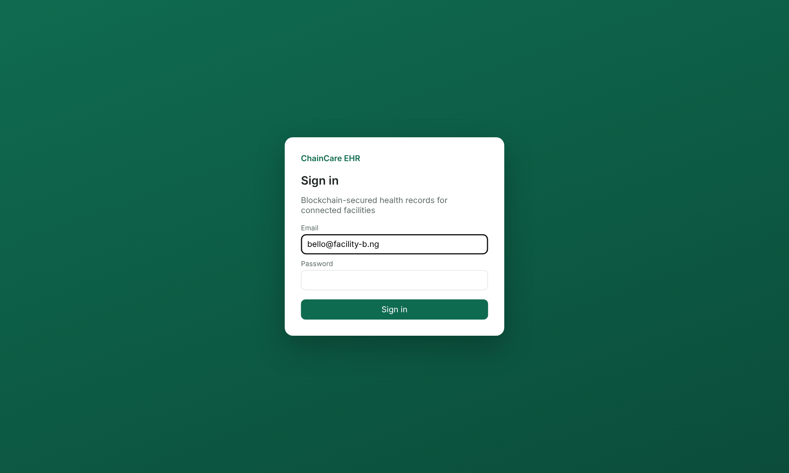
Figure 4.1: Sign-in page of the ChainCare EHR web application

4.3 Implementation Architecture
Figure 4.2 shows how the implementation tools fit together. It follows the layered design of Section 3.4, with each box replaced by the actual technology used. Requests flow from top to bottom: the browser sends HTTPS requests with a JWT to the Express API; the API checks them, encrypts or decrypts data, and then talks to MongoDB for the clinical payload and to the Fabric network for hashes, consent and audit records.
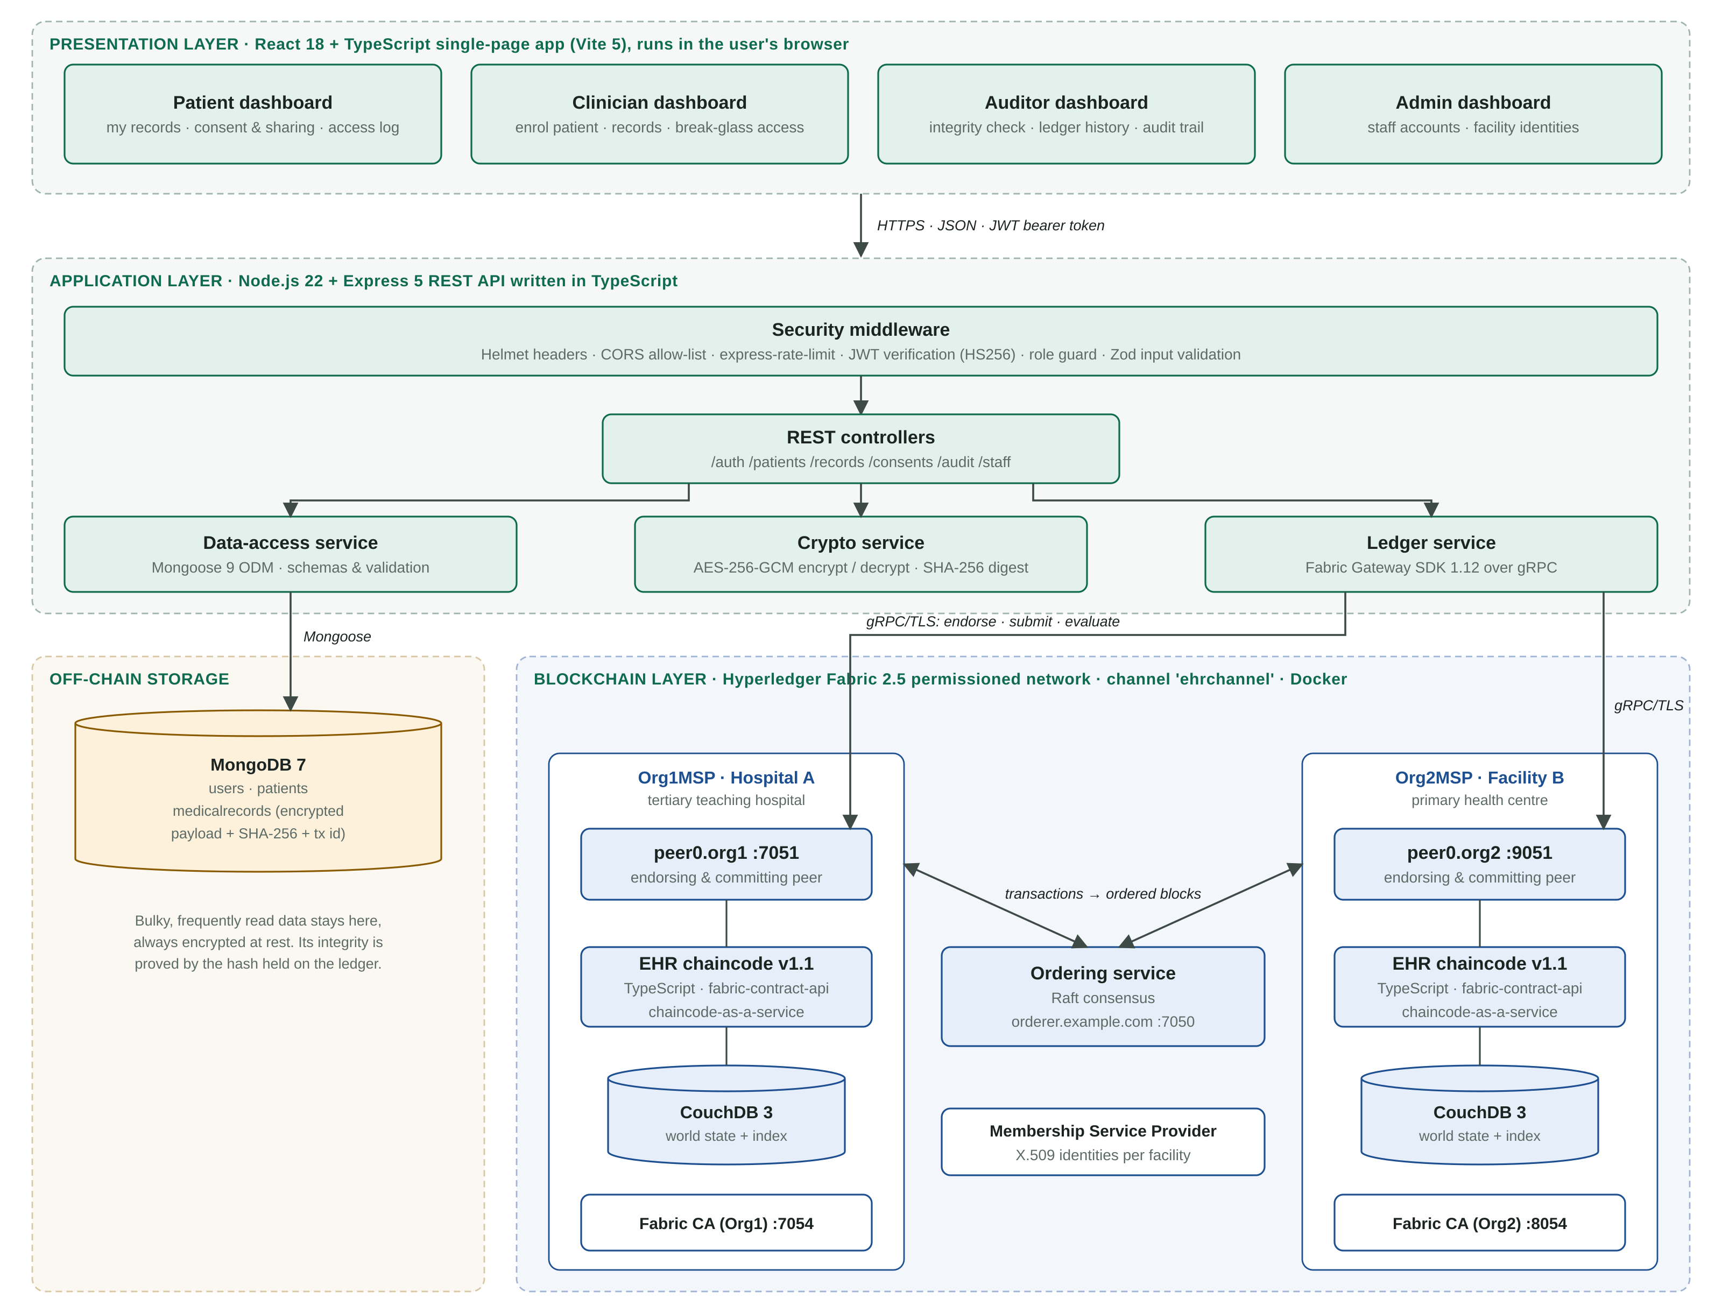
Figure 4.2: Implementation architecture of the blockchain-based EHR system
The blockchain layer has two organisations, each with one endorsing peer, a CouchDB state database, a running copy of the EHR chaincode and its own certificate authority. A Raft ordering service puts endorsed transactions into blocks and sends them to both peers. Raft tolerates crashed nodes but not malicious ones; this was judged acceptable for a consortium of licensed facilities, and Fabric 3.x offers a Byzantine fault-tolerant orderer where stronger guarantees are needed. Every write needs signatures from both organisations, so neither facility can change the ledger alone.
The EHR chaincode exposes thirteen functions, summarised in Table 4.4. Functions that change state are submitted as transactions and go through ordering. Read-only functions are evaluated on a single peer and return in milliseconds. Opening a record is deliberately a transaction rather than a read, so that every access attempt, whether allowed or denied, is written to the ledger.
Table 4.4: EHR chaincode functions
Function | Type | What it does
RegisterPatient | Write | Registers a patient under the calling facility (the home facility)
CreateRecord | Write | Anchors the SHA-256 hash of a new record; allowed for the home facility or a clinician with consent
UpdateRecordHash | Write | Anchors a new version of a record and increments its version number
AccessRecord | Write | Checks consent (owner, status, organisation, expiry, scope) and logs the decision
EmergencyAccess | Write | Break-glass access; needs a written reason and is logged as EMERGENCY
GrantAccess / RevokeAccess | Write | Patient grants or withdraws a clinician's consent, optionally limited by record type and end date
GetRecordAnchor / VerifyIntegrity | Read | Returns a record's ledger hash or checks a supplied hash against it
GetRecordHistory | Read | Every version of a record from the ledger history
QueryRecordsByPatient | Read | Paginated CouchDB query of a patient's records (50 per page)
GetAuditTrail / GetConsents | Read | The patient's audit events and consent list

Figure 4.3 traces the two most important flows through these components. When a record is created, the API encrypts it, stores the ciphertext in MongoDB and anchors its hash on the ledger; if the ledger refuses (for example, because the author has no right to write), the MongoDB copy is deleted so the two stores never disagree. When a record is opened, the chaincode decides on consent first, and only then does the API fetch the ciphertext, recompute its hash and compare it with the ledger. A mismatch stops the request with an integrity error before any data is decrypted.
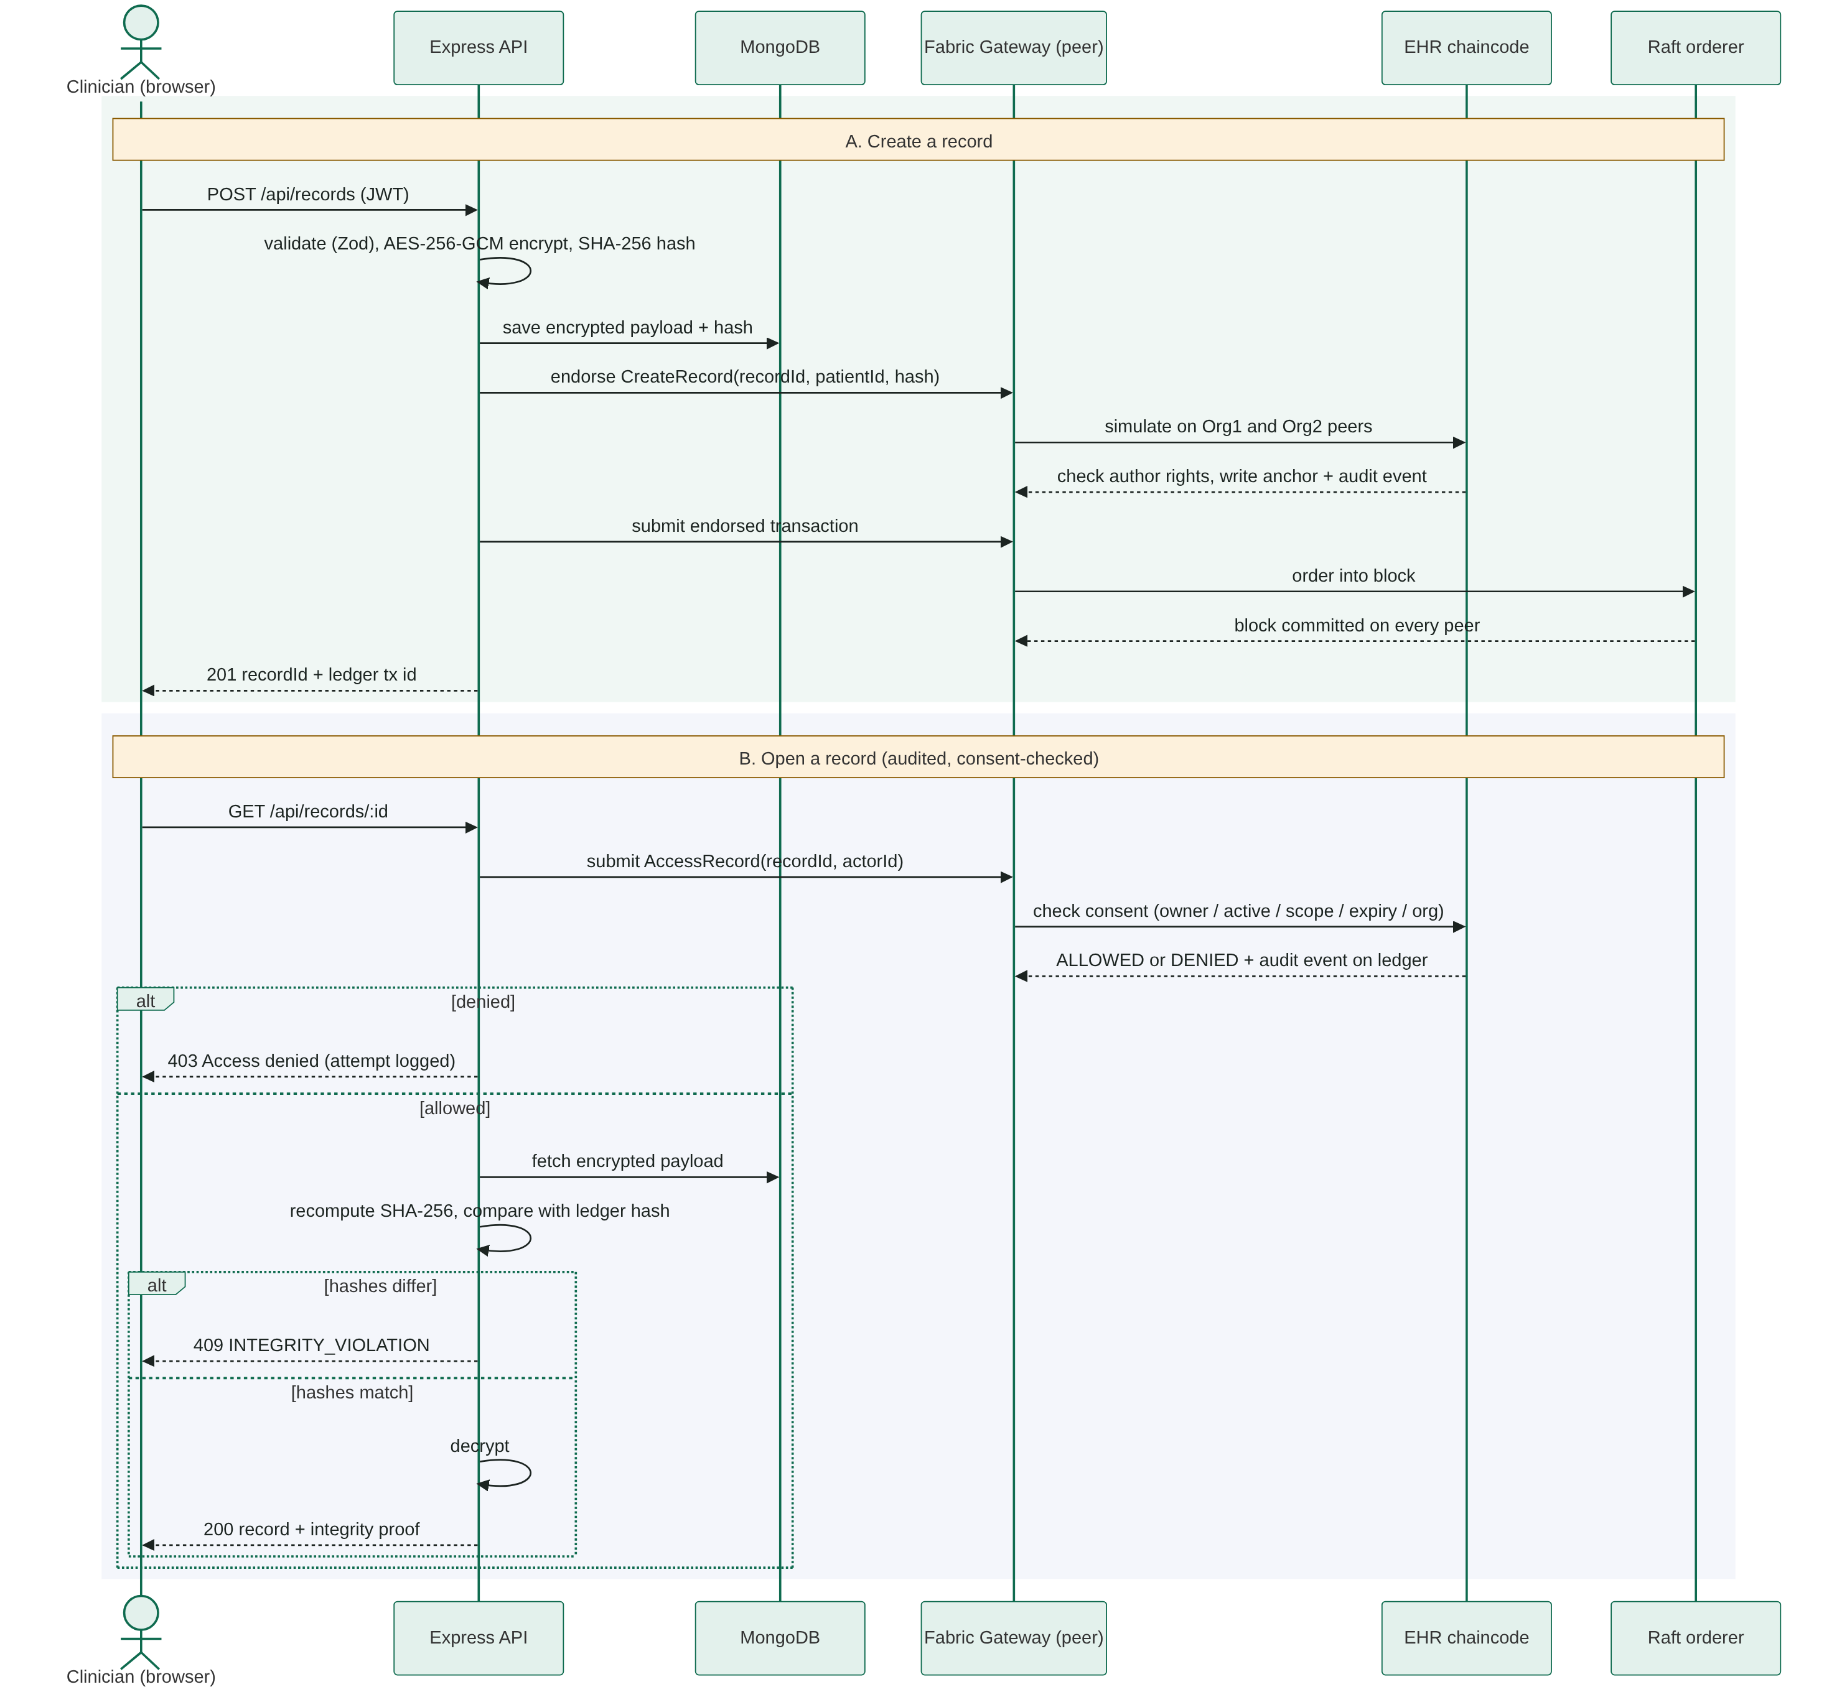
Figure 4.3: Sequence of operations for creating and opening a record

4.4 Performance Evaluation
The prototype was evaluated on four questions: how fast the blockchain layer is and how it behaves under load (Sections 4.4.2 to 4.4.4); how it compares with the existing system in speed (Section 4.4.5); how well it protects records (Section 4.4.6); and whether it works in realistic Nigerian care scenarios and is usable (Sections 4.4.7 and 4.4.8). Section 4.4.9 brings the comparison together.
The existing system used for comparison. Section 3.1 described the existing EHR architecture (Omirinlewo & Akinkuade, 2025): a centralised, cloud-hosted client-server system in which one database holds the records, the access rules and the logs, protected by firewalls and application checks. That system was not available for testing, so a baseline with the same architecture was built from the prototype's own code. Started with LEDGER_MODE=centralised, the API keeps hashes, consent and audit events in the same MongoDB database as the records and enforces the same access rules in application code. Everything else (user interface, API, encryption, validation and hardware) is identical. Any difference between the two therefore comes from where trust lives, not from implementation quality.

4.4.1 Evaluation Environment and Method
All tests ran on one virtual machine (Table 4.5), with every component in Docker on the same host. This is a deliberately modest machine, close to the server a state hospital or PHC cluster in Nigeria might realistically provision, so the figures are a lower bound rather than a best case.
Table 4.5: Evaluation environment
Item | Configuration
Processor | Intel(R) Xeon(R) Processor @ 2.10GHz, 2 virtual CPUs
Memory | 7.8 GiB RAM
Operating system | Ubuntu 24.04.5 LTS, Docker Engine 29.8.2
Fabric network | 2 organisations (Hospital A, Facility B), 1 peer each, 1 Raft orderer, 3 Fabric CAs, 2 CouchDB 3.4.2 state databases
Channel and policy | ehrchannel; endorsement by both organisations; block cut at 10 transactions or 2 s (BatchTimeout)
Off-chain database | MongoDB 7.0, single instance
Benchmark tools | Hyperledger Caliper 0.6.0 (2 workers, fixed-rate load), autocannon 8.0.0, Playwright, OWASP ZAP 2.17.0
Repetitions | Blockchain workloads: 3 independent runs of 1,000 transactions each; mean ± standard deviation reported

Six chaincode workloads were defined to cover every kind of ledger operation (Table 4.6). Each was offered at a fixed send rate of 100 transactions per second (TPS). The metrics follow the Hyperledger Performance and Scale Working Group definitions: throughput is committed transactions per second; latency is the time from submission until the transaction is committed and visible on the network; success rate is the share of transactions that commit without error. CPU and memory of each container were sampled every two seconds with docker stats.
Table 4.6: Blockchain benchmark workloads
Code | Workload | Chaincode function | Type
W1 | Create record | CreateRecord | Write (endorse, order, commit)
W2 | Read record | GetRecordAnchor | Read (evaluate on one peer)
W3 | Grant consent | GrantAccess | Write
W4 | Revoke consent | RevokeAccess | Write
W5 | Audited access | AccessRecord (consent check + audit event) | Write
W6 | Query patient records | QueryRecordsByPatient (CouchDB, paginated) | Read (rich query)

4.4.2 Blockchain Layer Performance
Table 4.7 and Figure 4.4 give the results. Across 18,000 benchmark transactions, none failed: the success rate was 100% for every workload. Reads were fast and stable: W2 kept pace with the full 100 TPS offered load at an average latency of 0.01 s. Writes were slower but just as reliable. The four write workloads committed between 57.5 and 62.1 TPS. Each write is executed and signed by both organisations, ordered into a block, and then validated and written to CouchDB on every peer one block at a time; this pipeline, not any error, sets the write rate (Section 4.4.4).
Table 4.7: Hyperledger Caliper results at an offered load of 100 TPS (mean ± SD, 3 runs)
Workload | Send rate (TPS) | Throughput (TPS) | Avg latency (s) | Max latency (s) | Success
W1 Create record | 67.3 ± 1.4 | 57.5 ± 1.1 | 2.63 ± 0.42 | 5.83 ± 1.24 | 100%
W2 Read record | 100.2 ± 0.0 | 100.1 ± 0.1 | 0.01 ± 0.00 | 0.07 ± 0.00 | 100%
W3 Grant consent | 68.1 ± 1.0 | 62.1 ± 3.6 | 2.45 ± 1.36 | 5.85 ± 2.79 | 100%
W4 Revoke consent | 64.6 ± 1.7 | 60.8 ± 2.3 | 1.75 ± 0.48 | 4.41 ± 1.39 | 100%
W5 Audited access | 67.1 ± 7.3 | 59.2 ± 7.1 | 3.07 ± 2.29 | 5.84 ± 3.25 | 100%
W6 Query patient records | 99.6 ± 0.6 | 63.6 ± 6.3 | 5.85 ± 1.31 | 9.30 ± 1.93 | 100%

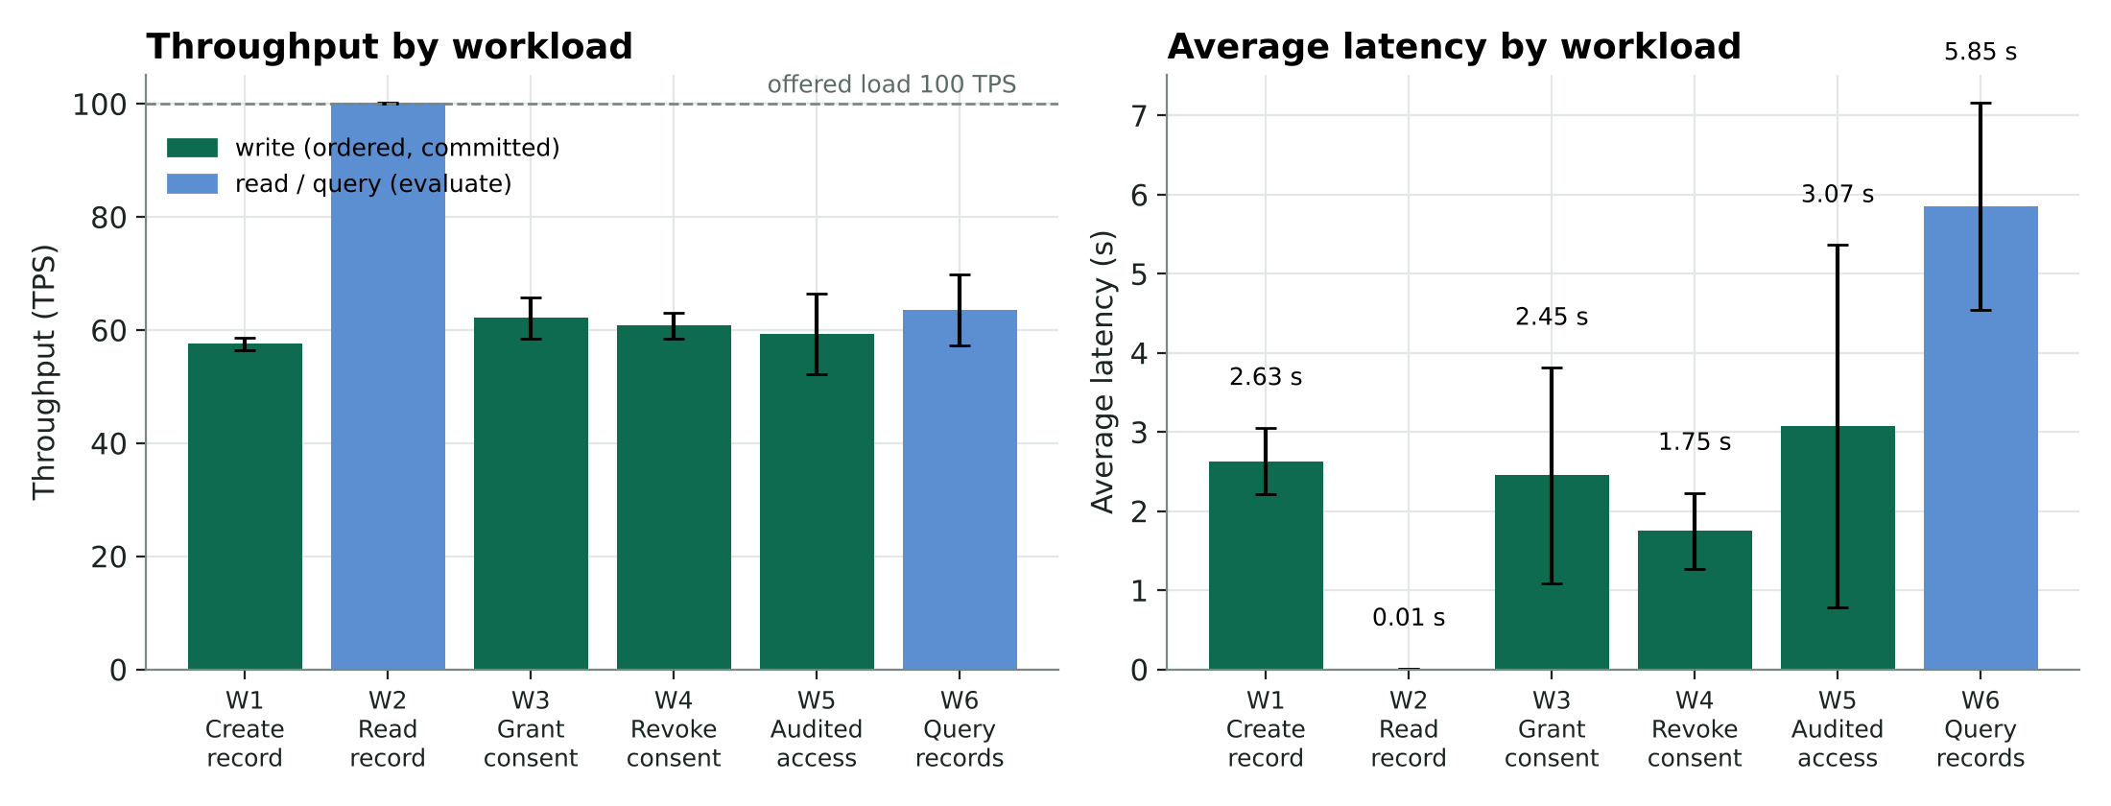
Figure 4.4: Throughput and average latency of each chaincode workload (error bars: ±1 SD)
Two design choices explain the latency figures. First, the ordering service cuts a block when it has 10 transactions or after 2 seconds, whichever comes first. Under light load a single write therefore waits about 2 seconds for its block; this is why one clinician saving one record sees roughly 2.1 s in the scenario tests (Section 4.4.7). Second, W6 runs a CouchDB query that returns up to 50 records per call; at 100 TPS it saturated CouchDB, so queries queued and average latency rose to 5.85 s. Both can be tuned: a shorter batch timeout lowers single-write latency, and in practice the record list is requested once per consultation, not 100 times a second.
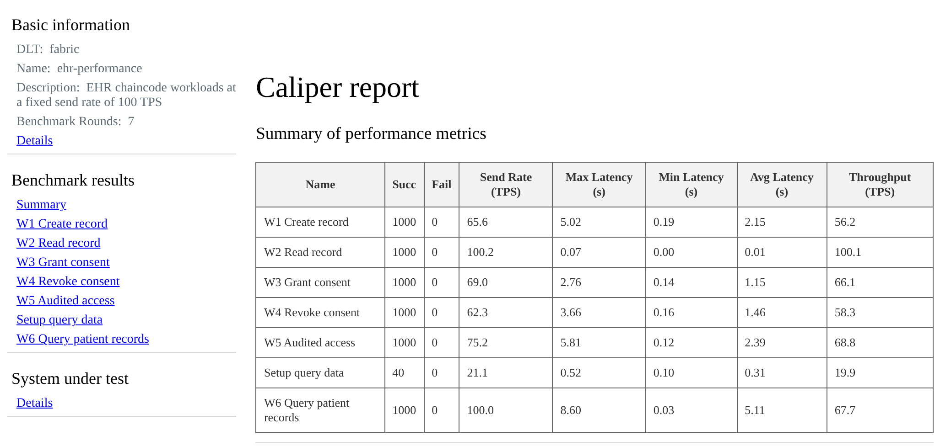
Figure 4.5: Hyperledger Caliper HTML report for one benchmark run (screenshot)

4.4.3 Scalability
To find where the system saturates, the send rate was raised step by step for 20 seconds per step: from 25 to 300 TPS for writes (W1) and from 100 to 600 TPS for reads (W2). Figure 4.6 shows the outcome. Reads tracked the offered load up to 400 TPS and levelled off at about 435 TPS, with average latency never above 0.03 s. Writes levelled off much earlier, at about 68 TPS; beyond that point extra load only lengthened the queue, and average latency reached as much as 10.8 s. No transaction failed at any step.
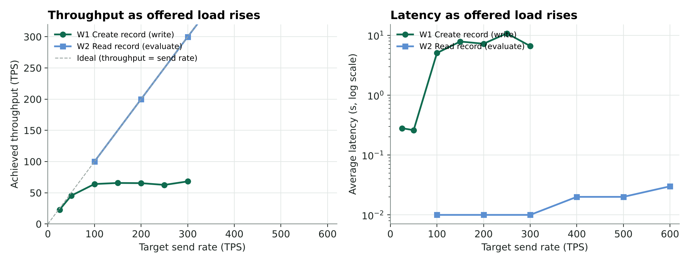
Figure 4.6: Throughput and latency as the offered load increases
To put the write ceiling in context: 68 committed writes per second is roughly 2.0 million record or consent events in an eight-hour clinic day. A busy Nigerian teaching hospital records far fewer events than that, so the capacity of even this two-core test host is well above what one facility needs. A state-wide network would add peers and organisations, and Fabric spreads endorsement across them.

4.4.4 Resource Utilisation
Table 4.8 shows CPU and memory use of each blockchain container during the write workload (W1) and the read workload (W2), over the three runs. CPU is given as a percentage of one core, so on this machine the total available is 200%. During writes the busiest component was the CouchDB of Hospital A (average 21.1%), and the seven blockchain containers together averaged 87.1%, with the rest of the processor used by the Caliper load generator and the operating system. No container ran near its limit, so the write ceiling comes from the sequential validate-and-commit step on each peer, in which CouchDB does most of the work, rather than from a lack of processor or memory. Memory use was modest: the whole blockchain layer peaked at about 1,056 MiB, so it fits comfortably on an 8 GB server alongside MongoDB and the API.
Table 4.8: CPU and memory use of the blockchain containers (3 runs)
Container | W1 avg CPU (%) | W1 peak CPU (%) | W2 avg CPU (%) | Peak memory (MiB)
Peer, Hospital A | 16.8 | 31.0 | 12.5 | 187.1
Peer, Facility B | 11.6 | 21.6 | 1.0 | 127.6
Raft orderer | 4.1 | 10.9 | 0.0 | 133.5
CouchDB, Hospital A | 21.1 | 56.4 | 7.2 | 217.3
CouchDB, Facility B | 20.5 | 44.2 | 0.3 | 160.0
Chaincode, Hospital A | 6.4 | 16.6 | 6.6 | 126.4
Chaincode, Facility B | 6.6 | 16.7 | 0.0 | 103.6

Storage was also measured at the end of testing. After more than 90,000 world-state entries the ledger on each peer occupied 349 MB and the CouchDB state database 60.9 MB, while MongoDB held all the encrypted clinical payloads in 29 MiB.

4.4.5 Comparison with the Existing System: Application Performance
The user experiences the system through the API, so both systems were load-tested at the API with 10 and then 50 concurrent users for 15 seconds per endpoint. Four endpoints were tested: creating a record, opening a record (consent check, audit, integrity check and decryption), checking a record's integrity, and listing a patient's records. Table 4.9 and Figure 4.7 give the results.
Table 4.9: API load test: proposed system (Fabric) against the existing-architecture baseline (centralised)
Endpoint and load | Fabric req/s | Fabric avg (ms) | Fabric p90 (ms) | Central req/s | Central avg (ms) | Central p90 (ms) | Errors F / C
Create record, 10 users | 40.0 | 249 | 293 | 337.5 | 29 | 39 | 0% / 0%
Create record, 50 users | 48.0 | 999 | 1,283 | 365.3 | 136 | 165 | 0% / 0%
Open record (audited), 10 users | 53.3 | 186 | 250 | 494.3 | 20 | 26 | 0% / 0%
Open record (audited), 50 users | 74.4 | 659 | 848 | 531.3 | 93 | 115 | 0% / 0%
Verify integrity, 10 users | 306.3 | 32 | 43 | 879.1 | 11 | 15 | 0% / 0%
Verify integrity, 50 users | 392.8 | 127 | 167 | 847.5 | 58 | 74 | 0% / 0%
List records, 10 users | 29.4 | 338 | 409 | 512.9 | 19 | 26 | 0% / 0%
List records, 50 users | 26.9 | 1,763 | 2,006 | 478.0 | 104 | 129 | 0% / 0%

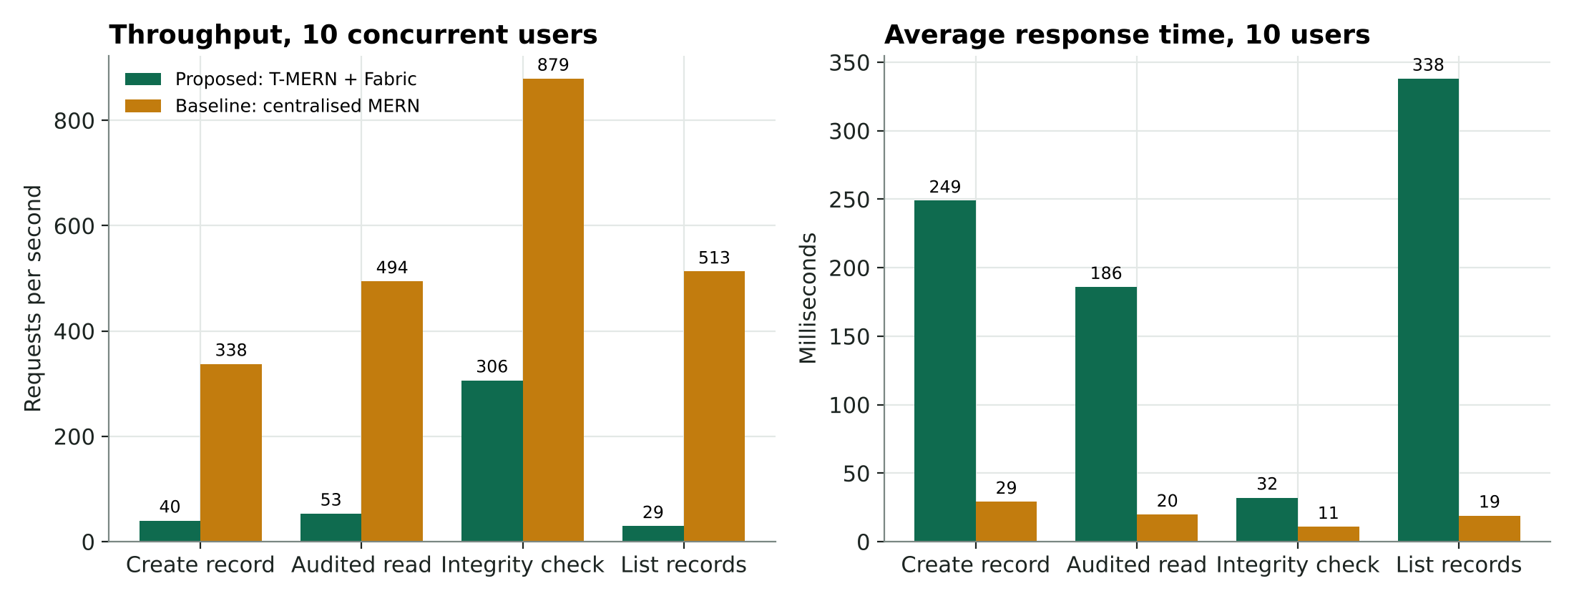
Figure 4.7: Throughput and response time of the two systems at 10 concurrent users
The centralised baseline is faster, as expected. At 10 users it created records 8.4 times faster (337.5 against 40.0 requests per second) and opened them 9.3 times faster. Its average response time for opening a record was 20 ms against 186 ms for the proposed system. This is the measured cost of putting consent and audit on a shared ledger: every write and every audited read waits for endorsement by two organisations, ordering and commit, whereas the baseline writes one row to its own database. Neither system returned errors.
The cost is acceptable for clinical work. At 10 concurrent users every operation of the proposed system averaged 338 ms or less, and even at 50 users the slowest, listing records, averaged 1.76 s. A clinician opens a handful of records per consultation, not hundreds per second. The next section shows what the extra time buys.

4.4.6 Security Evaluation
Security was tested in five ways: tampering with stored records, an access-control accuracy test, a set of attack attempts against the API, automated vulnerability scanning, and a rate-limit test. Each test ran against both systems where it applied.
a) Integrity: tampering with off-chain records
One hundred records were created in each system and then altered directly in MongoDB, simulating an attacker or insider with database access. In 50 records only the encrypted payload was changed. In the other 50 the insider also recomputed and overwrote every copy of the hash the database holds, which someone with full database rights can do. Each record was then opened through the API. Table 4.10 shows the result.
Table 4.10: Detection of tampered records
Attack | Records altered | Detected: proposed (Fabric) | Detected: centralised baseline
Payload changed only | 50 | 50 (100%) | 50 (100%)
Payload changed and stored hash rewritten by insider | 50 | 50 (100%) | 0 (0%)
Overall detection rate | 100 | 100% | 50%
Insider deletes the patient's audit log | 1 patient | Not possible: 201 events remained on the ledger | 201 events deleted without trace; 0 remained

This is the central result of the study. Both systems caught simple tampering, because both compare a record with its hash. But when the insider also rewrote the hash, the centralised system accepted every forged record as genuine, since the hash it trusts lives in the same database the insider controls. The proposed system caught all 100, because the reference hash sits on a ledger that is replicated on both facilities' peers and can only change through a transaction both of them endorse. The same holds for audit logs: in the baseline an insider erased a patient's entire access history with one database command, while the ledger offers no way to delete an entry. Figures 4.8 and 4.9 show what auditors and clinicians see when a tampered record is found.
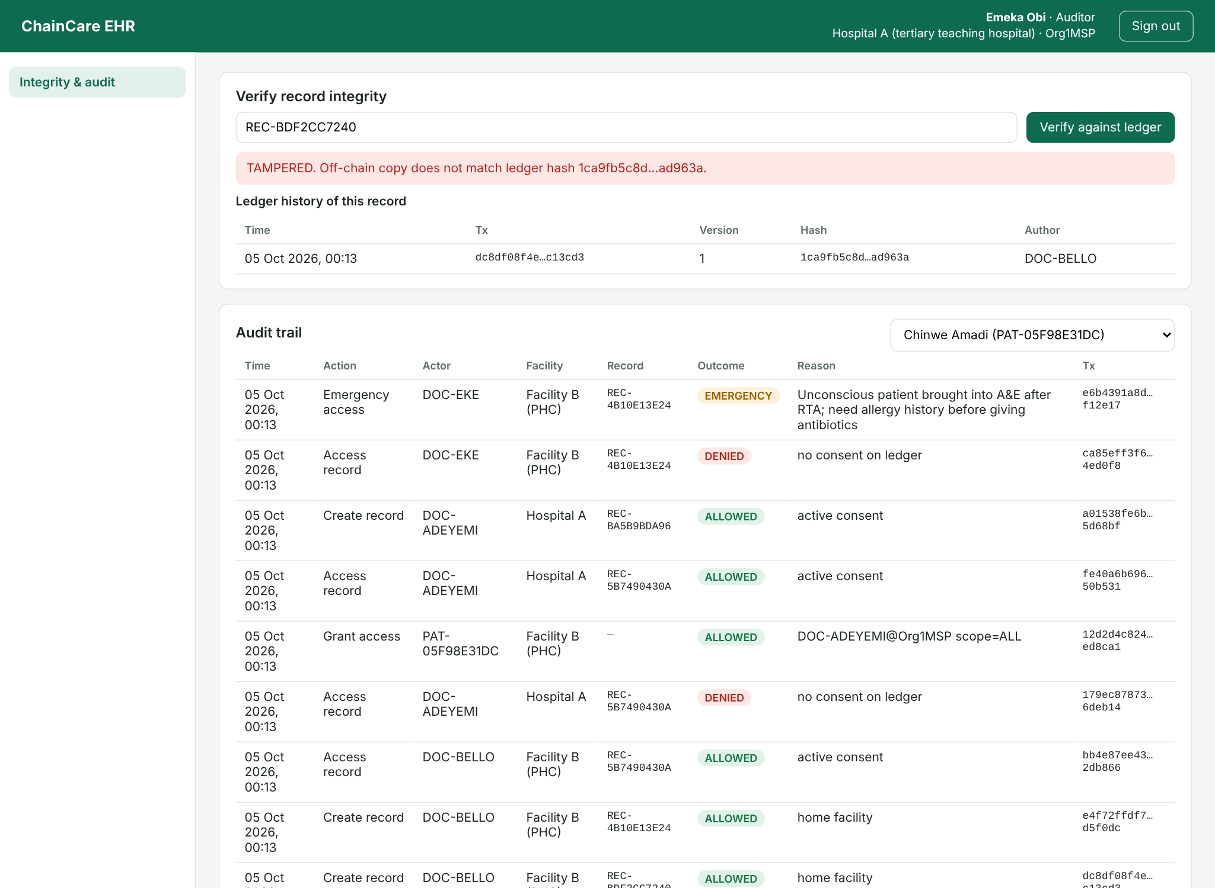
Figure 4.8: Auditor dashboard reporting a tampered record and the immutable audit trail
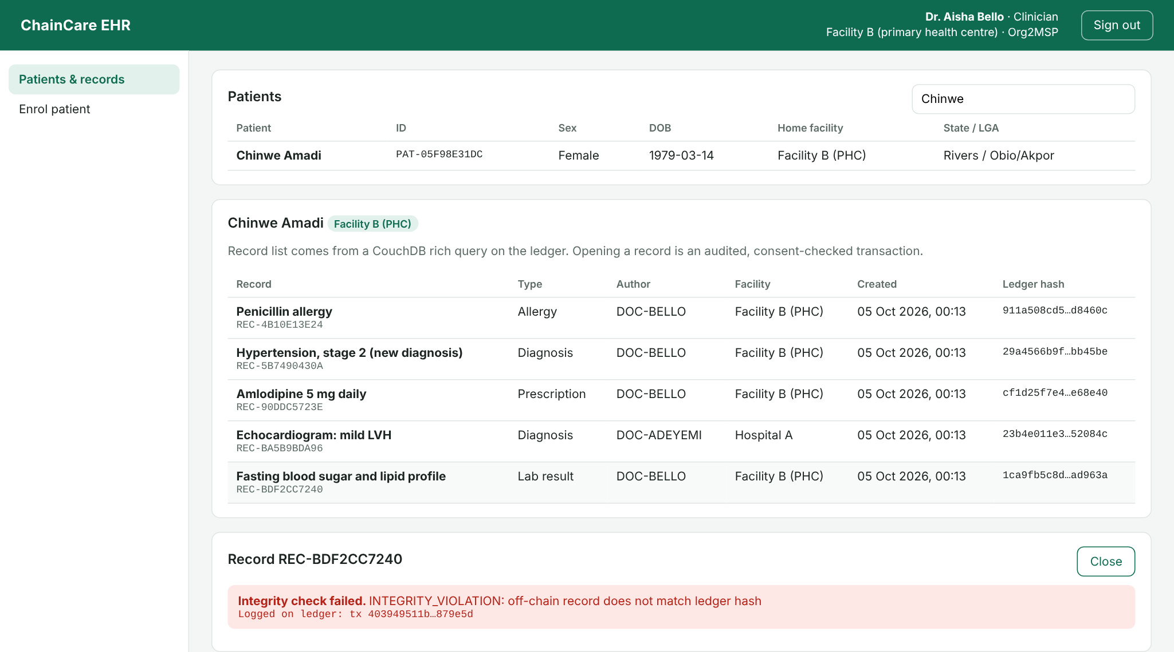
Figure 4.9: A clinician is blocked from opening the tampered record
b) Access-control accuracy
A patient was given records of four types, and seven kinds of user then made 504 randomly ordered attempts to open them: the patient, a clinician with full consent, a clinician whose consent covered lab results only, one with expired consent, one whose consent had been revoked, an auditor without consent and another patient. The expected outcome of each attempt was worked out in advance and compared with what the system did. Table 4.11 gives the confusion matrix.
Table 4.11: Access-control decisions (positive = access allowed)
Measure | Proposed (Fabric) | Centralised baseline
Requests | 504 | 504
True positives (authorised, allowed) | 163 | 154
True negatives (unauthorised, denied) | 341 | 350
False positives (unauthorised, allowed) | 0 | 0
False negatives (authorised, denied) | 0 | 0
Accuracy | 100% | 100%
False acceptance rate | 0% | 0%

Both systems made every decision correctly, with no false acceptances. This is expected, as they apply the same rules; the difference is where the rules run. In the proposed system the rules are in chaincode executed by both facilities' peers, so changing them requires a new chaincode version approved by both organisations. In the baseline they are ordinary application code that one administrator could change.
c) Attacks against the API
Thirteen common attacks were attempted on the proposed system (Table 4.12). All 13 were blocked with the correct status code.
Table 4.12: API attack tests
Attack attempted | Response | Result
No token reads a record | 401 | Blocked
Forged JWT (wrong signing key) | 401 | Blocked
JWT with alg=none | 401 | Blocked
Expired JWT | 401 | Blocked
Patient creates a clinical record | 403 | Blocked
Patient lists another patient's records | 403 | Blocked
Patient reads another patient's audit log | 403 | Blocked
Clinician grants consent on a patient's behalf | 403 | Blocked
Clinician reads the audit trail | 403 | Blocked
Clinician creates staff accounts | 403 | Blocked
NoSQL injection in login | 400 | Blocked
Malformed record hash input (schema validation) | 400 | Blocked
Emergency access without justification | 400 | Blocked

d) Vulnerability scanning
Three automated scanners were run, the problems they found were fixed, and the scans were repeated. Table 4.13 records the findings before and after.
Table 4.13: Vulnerability and accessibility findings before and after fixes
Scanner and target | Findings before | Fix applied | Findings after
npm audit: API dependencies | 3 moderate (uuid, via the load-testing tool) | Pinned uuid to the patched 11.1.1 release | 0
npm audit: web application | 2 (1 high: Vite path traversal; 1 moderate: esbuild) | Upgraded Vite 5 to 6.4.3 | 0
npm audit: chaincode | 0 | None needed | 0
OWASP ZAP: web application | 3 warnings: Content Security Policy (CSP) Not Set; Missing Anti-clickjacking; X-Content-Type-Options Missing | Added content security policy, X-Frame-Options and nosniff headers to the web server | 0 (one informational notice only)
OWASP ZAP: API | 1: CSP: Failure to Define Directive with No Fallback | Strict deny-all CSP for the JSON API; JSON 404 handler keeps headers on unknown routes | 0 (61 checks passed)
axe-core: WCAG 2.1 AA | 7 critical issues (form fields without accessible names) | Linked every form field to an accessible label | 0

e) Rate limiting
With the limit set to 100 requests per minute, 150 rapid requests from one client produced 100 normal responses and 50 "429 Too Many Requests" refusals, so the limiter blocks simple flooding and password-guessing attempts as intended.

4.4.7 Simulated Nigerian Healthcare Scenarios
Five scenarios drawn from everyday practice in the Nigerian system were run end to end through the API, ten times each for S1 to S3. Table 4.14 summarises them for both systems.
Table 4.14: Results of the simulated scenarios
Scenario | What was simulated | Proposed (Fabric) | Centralised baseline
S1 Referral from PHC to teaching hospital | Hospital A doctor tries to open a referred patient's record, is refused, the patient grants consent, the doctor opens it | Refused, then allowed in all 10 runs; whole flow 6.18 s (3 ledger transactions) | Same outcome; 12 ms
S2 Emergency (break-glass) access | A&E doctor without consent opens an unconscious patient's allergy record with a written reason | Opened in all 10 runs in 2.05 s; flagged EMERGENCY on the ledger | Opened in 4 ms; flag stored in an editable table
S3 Consent revocation | Patient withdraws a hospital's access after treatment | Revoked in 2.05 s; refused on the very next attempt in 10/10 runs | Revoked in 3 ms; refused in 10/10
S4 Insider tampering | Staff member edits a lab result directly in the database (Table 4.10) | 100% detected | 50% detected
S5 Low-bandwidth clinic | All user tasks over a throttled 3G link (1.6 Mbps, 300 ms delay) | Slowest task 3.19 s; all completed | Slowest task 1.79 s; all completed

The scenarios show that the system behaves correctly where it matters clinically. A referred patient's records reach the receiving doctor only after the patient agrees, and the whole referral flow took about 6 seconds, most of it the 2-second block interval on each of its three transactions. Emergency access never stands in the way of care, yet it always leaves a permanent, reasoned record that the patient and auditors can review. Revocation takes effect at once. The baseline produced the same outcomes faster, but its emergency flags and audit entries could be quietly edited afterwards. Figures 4.10 to 4.14 show the referral and emergency scenarios in the user interface.
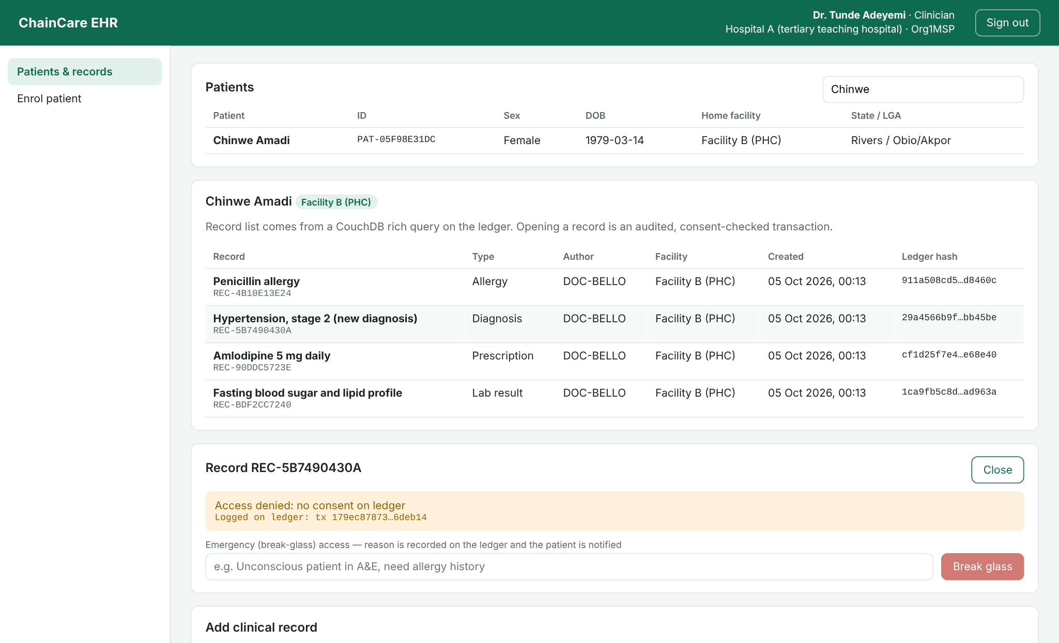
Figure 4.10: S1: the referral doctor at Hospital A is refused because no consent exists on the ledger
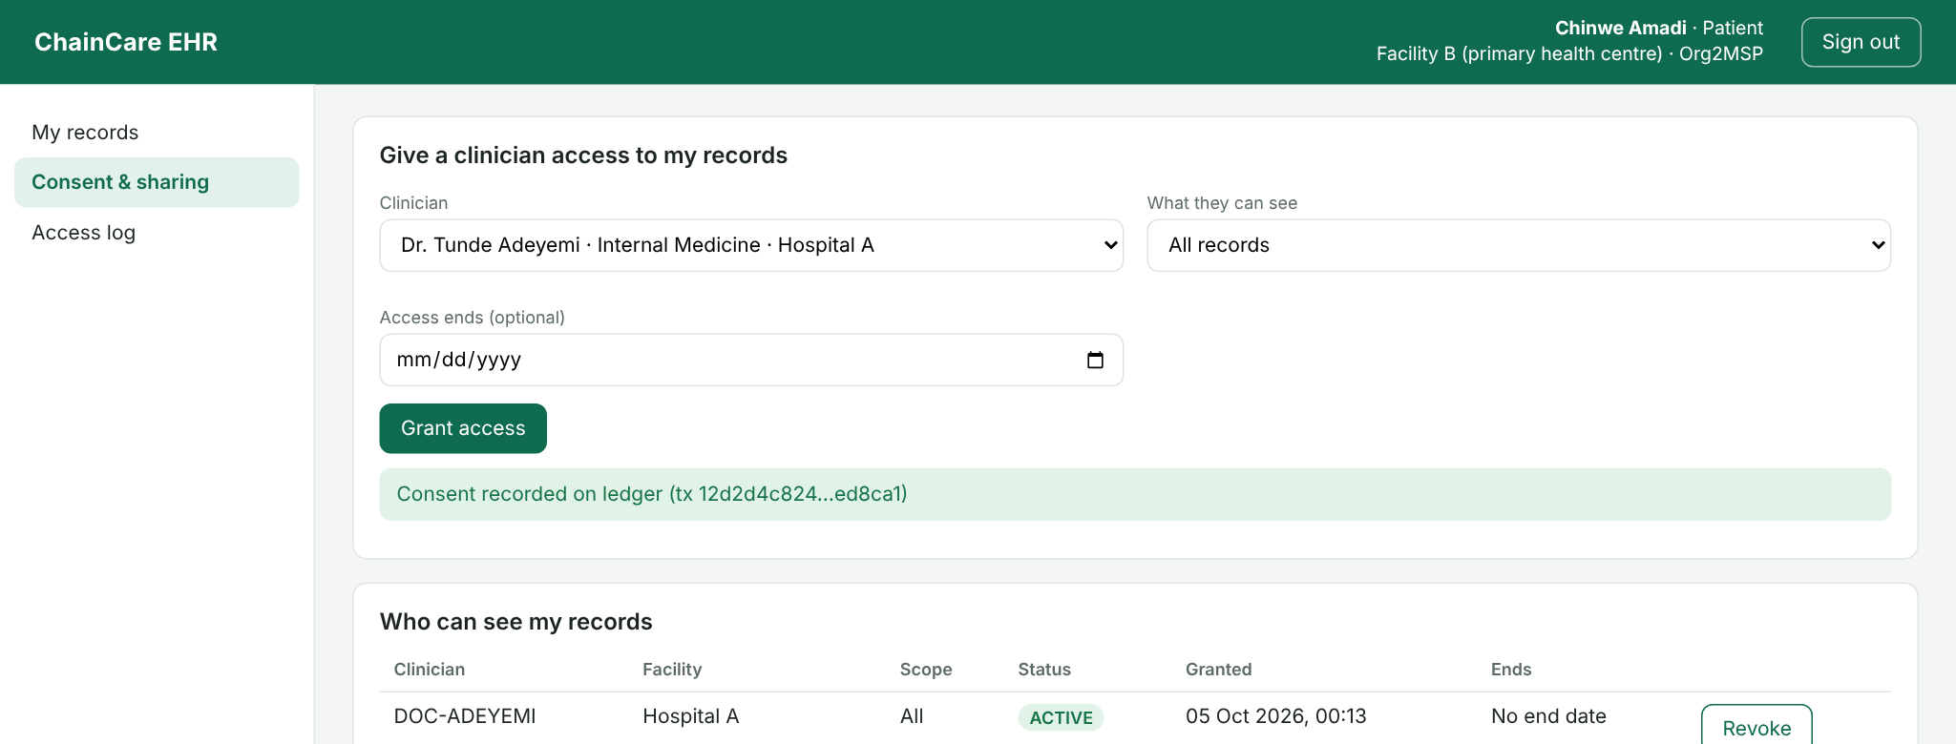
Figure 4.11: S1: the patient grants the referral doctor access from her own dashboard
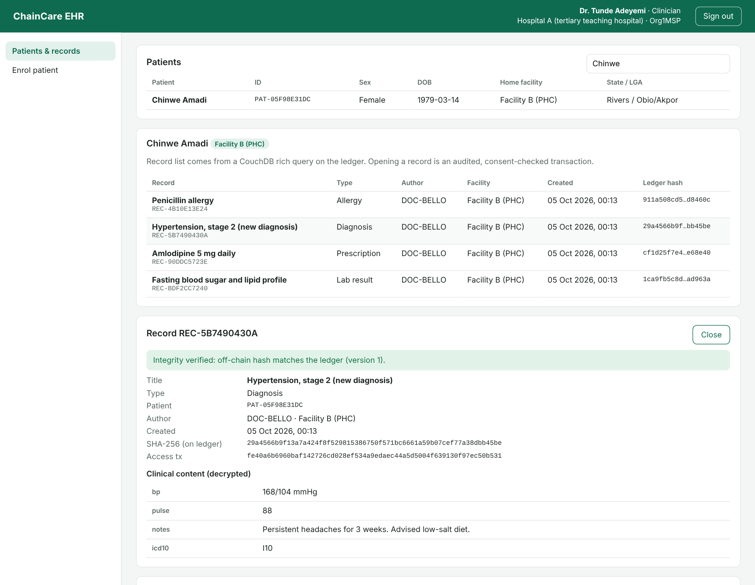
Figure 4.12: S1: with consent recorded, the referral doctor opens the record and its integrity is verified
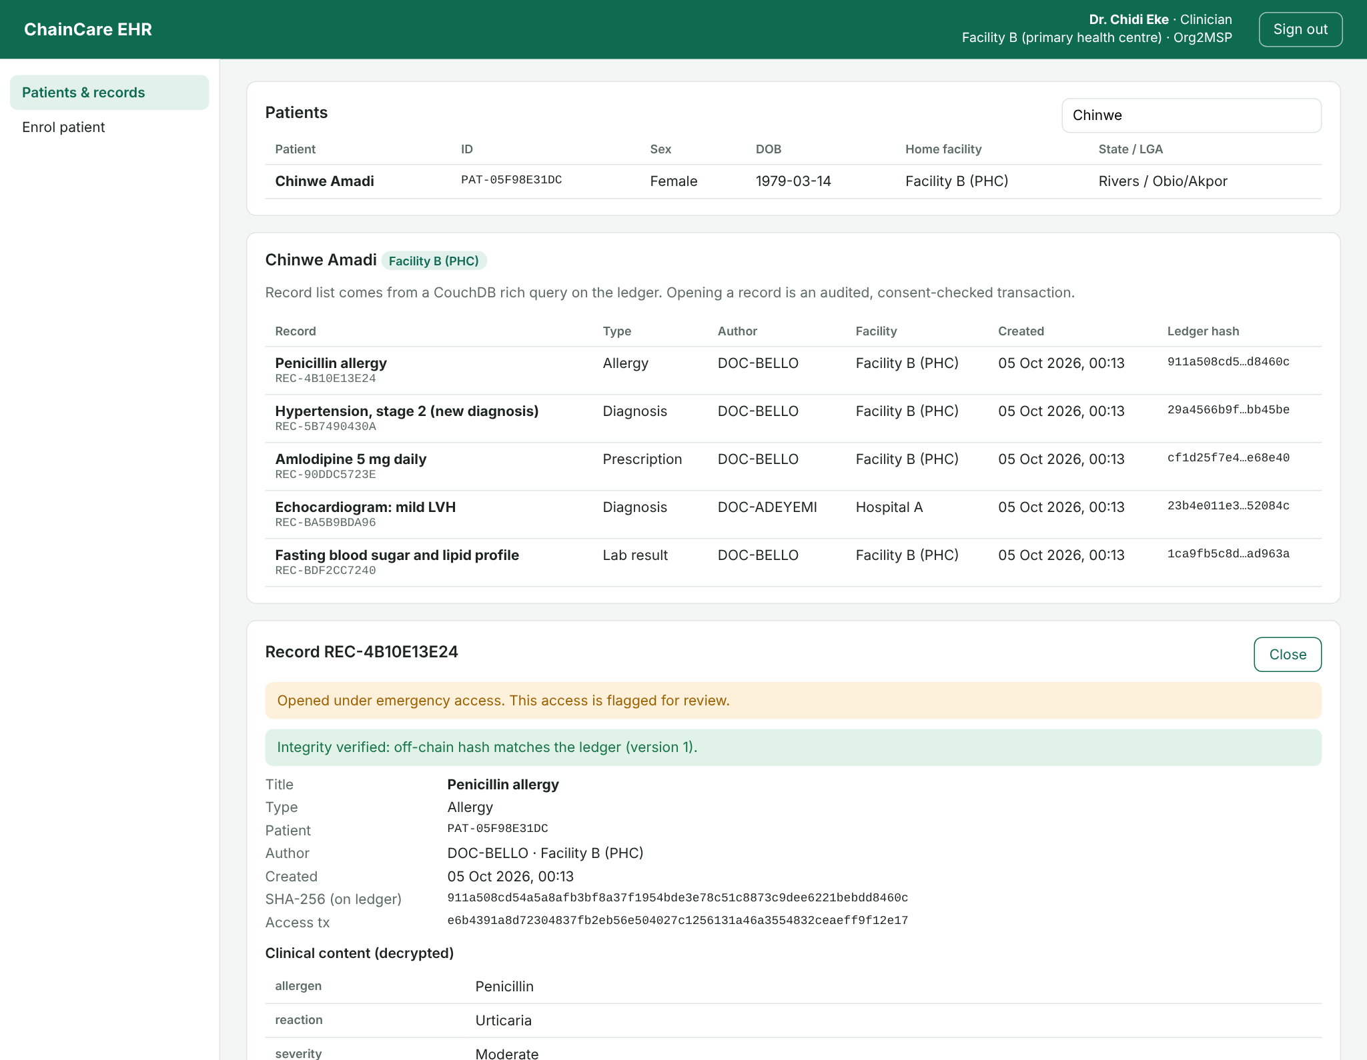
Figure 4.13: S2: emergency (break-glass) access by an A&E doctor, flagged for review
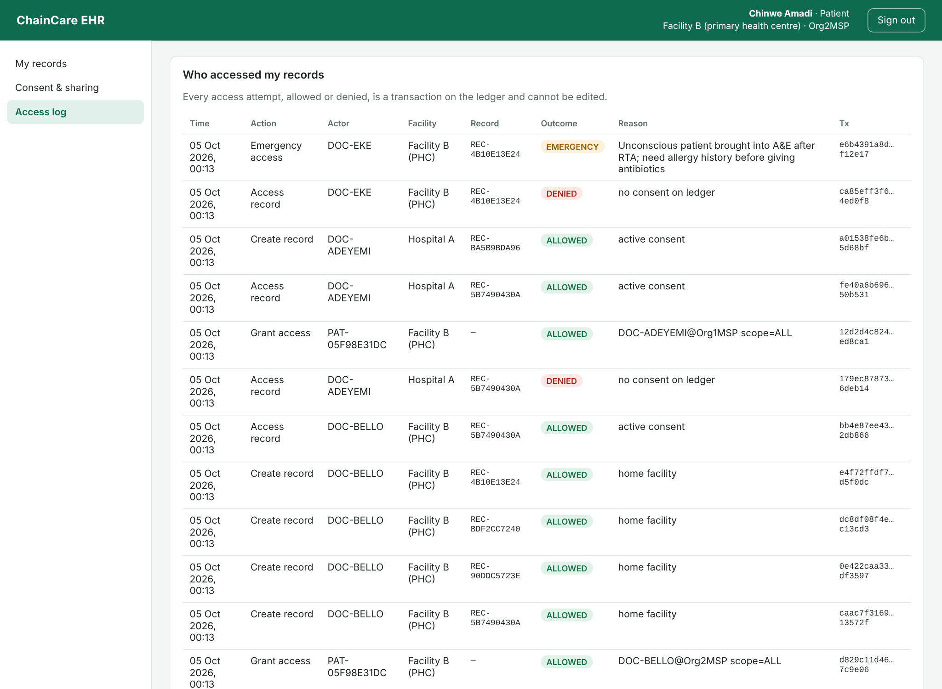
Figure 4.14: The patient's access log, showing refused, allowed and emergency accesses from the ledger

4.4.8 Usability Evaluation
Usability was assessed in two ways that can be repeated without bias: timing the five most common tasks, and auditing the interface against the Web Content Accessibility Guidelines (WCAG) 2.1 at level AA. Each task was scripted with Playwright and run three times on both systems, first on a normal connection and then over a throttled 3G profile typical of mobile internet in many parts of Nigeria (1.6 Mbps down, 0.75 Mbps up, 300 ms round trip). Table 4.15 gives the mean time to complete each task.
Table 4.15: Mean task completion time in seconds (3 runs each)
Task | Fabric, broadband | Fabric, 3G | Central, broadband | Central, 3G
Sign in (clinician) | 0.29 | 1.78 | 0.32 | 1.79
Find patient and open a record | 2.45 | 3.19 | 0.16 | 1.70
Add a clinical record | 2.37 | 2.35 | 0.09 | 0.85
Patient grants consent | 2.42 | 2.70 | 0.14 | 1.20
Patient views access log | 0.06 | 0.82 | 0.07 | 0.82

On a normal connection, tasks that write to the ledger (opening a record, adding one, granting consent) took about 2.5 seconds in the proposed system against well under half a second in the baseline; again, the difference is mostly the block interval. Over 3G the gap narrowed, because network delay then dominates both systems, and every task in the proposed system finished within 3.19 seconds. Sign-in and the access log, which need no new ledger transaction, were as fast as the baseline.
The first accessibility audit found 7 critical problems on the sign-in, clinician and patient screens: several form fields had visible labels that screen readers could not link to the field. After every field was given an accessible name, a second audit found no violations on any of the three screens. A System Usability Scale (SUS) survey of real patients and health workers was planned under Objective 4 but could not be carried out within the time of this study; it is recommended in Section 5.3 as the next step before any pilot.

4.4.9 Summary: Proposed System Compared with the Existing System
Table 4.16 brings the results together. The existing system column describes the centralised architecture of Section 3.1; where a figure is given, it was measured on the baseline that reproduces that architecture.
Table 4.16: Proposed system compared with the existing centralised system
Criterion | Existing (centralised) | Proposed (T-MERN + Fabric)
Where trust lives | One database and its administrators | Ledger replicated across facilities; changes need both to endorse
Single point of failure | Yes: central server and database | No for the ledger: each facility holds a full copy
Tamper detection (Table 4.10) | 50% | 100%
Audit trail | Editable; insider deleted 201 events unnoticed | Append-only; cannot be deleted
Patient consent | Rows in the application database | Chaincode rules executed by both facilities; scope and expiry supported
Access-control accuracy | 100% | 100%
Interoperability between facilities | Limited to one vendor's system | Shared channel; any member facility can request access with consent
Open a record, 10 users (avg) | 20 ms | 186 ms
Create a record, 10 users (req/s) | 337.5 | 40.0
Peak create-record rate at the API (50 users) | 365.3 req/s | 48.0 req/s (ledger ceiling about 68 TPS)
Software licence cost | Varies (commercial or open source) | None (all open source)

In short, the proposed system gives up raw speed in exchange for guarantees the existing architecture cannot offer: records that cannot be altered without detection, an audit trail that cannot be erased, and consent rules that no single facility or administrator can quietly change. On the evidence above, the speed it keeps is sufficient for clinical use, and the guarantees it adds address the data security, integrity and accountability problems set out in Section 1.2.

4.5 System Requirements
The requirements below come from the measurements in Section 4.4. The minimum column is the configuration on which every test in this chapter ran; the recommended column adds headroom and resilience for a facility that runs its own node in production, taking into account the unstable power and connectivity common in Nigerian health facilities.

4.5.1 Hardware Requirements
Table 4.17: Hardware requirements
Component | Minimum (as tested) | Recommended (per facility node in production)
Processor | 2 virtual CPUs (x86-64, about 2.1 GHz) | 4 or more cores
Memory (RAM) | 8 GB | 16 GB
Storage | 40 GB (Docker images 8.3 GB, ledger 349 MB per peer after testing) | 250 GB SSD, with daily off-site backup of MongoDB and the peer ledger
Network | Local network between containers | Fixed public IP or VPN between facilities; at least 10 Mbps; a second internet link as fallback
Power | Mains | Uninterruptible power supply plus inverter or solar backup for at least 4 hours
Client device | Any device with a current web browser | Desktop, laptop, tablet or Android smartphone with 2 GB RAM or more
Client connection | 3G mobile data (tested at 1.6 Mbps, 300 ms delay) | 4G or broadband

4.5.2 Software Requirements
Table 4.18: Software requirements
Category | Software | Version
Server operating system | Ubuntu Server LTS (or another Linux distribution with Docker) | 22.04 or 24.04
Container platform | Docker Engine and Docker Compose | 24 or later
Runtime | Node.js with npm | 22 LTS
Blockchain | Hyperledger Fabric peer, orderer and tools; Fabric CA | 2.5.10; 1.5.13
State database | CouchDB | 3.4
Off-chain database | MongoDB Community Server | 7.0
Application packages | Express, Mongoose, Fabric Gateway SDK, Helmet, Zod, React, Vite and others (installed by npm) | As in Table 4.1
Web browser (client) | Google Chrome, Microsoft Edge, Mozilla Firefox or Safari | Any release from the last two years
Development tools (optional) | Visual Studio Code, Git, Hyperledger Caliper, OWASP ZAP | Current releases

4.6 System Testing
The system was tested at four levels: unit tests of the smart contract, integration tests of the API, functional tests of the complete system through its user interface, and the non-functional tests already reported in Section 4.4 (performance, security, usability). All tests are automated, so they can be repeated after every change.

Unit testing of the chaincode
Fourteen unit tests exercise the EHR contract with an in-memory stand-in for the Fabric ledger, so each rule can be checked in isolation and in milliseconds. They cover registration, record anchoring, hash validation, consent granting, scoping, expiry, organisation binding, revocation, emergency access, integrity checks, versioning and the audit trail. All 14 passed (Figure 4.15), covering 74.3% of the contract's lines and 77.27% of its functions.
Table 4.19: Chaincode unit test cases
No. | Test case | Result
1 | Registers a patient under the calling organisation | Passed
2 | Rejects duplicate patient registration | Passed
3 | Home facility can anchor a record | Passed
4 | Rejects a malformed SHA-256 digest | Passed
5 | Another facility without consent cannot add a record, and the attempt is audited | Passed
6 | Only the patient can grant consent | Passed
7 | Consent allows access; revocation removes it | Passed
8 | Scoped consent covers only the named record type | Passed
9 | Expired consent is refused | Passed
10 | Consent is bound to the grantee organisation | Passed
11 | Emergency access needs a justification and is flagged | Passed
12 | Integrity check detects a changed hash | Passed
13 | Record update increments the version | Passed
14 | Audit trail lists every decision for the patient | Passed

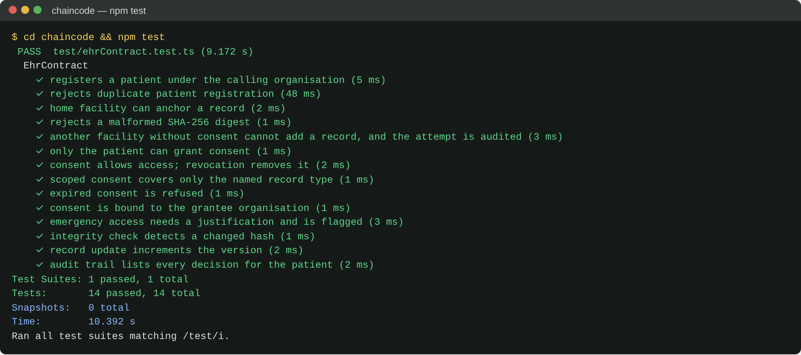
Figure 4.15: Output of the chaincode unit tests

Integration testing of the API
Fourteen integration tests send real HTTP requests to the Express application connected to a test MongoDB database. They check the crypto service, authentication, security headers, patient enrolment, encrypted storage, consent across facilities, tamper detection, role restrictions, input validation, audit visibility and pagination. All 14 passed (Figure 4.16), with 79.4% line coverage of the API source. The Fabric-specific code is exercised separately, by the benchmarks and scenario tests that run against the live network.
Table 4.20: API integration test cases
No. | Test case | Result
1 | AES-256-GCM round trip | Passed
2 | Tampered ciphertext changes the SHA-256 digest | Passed
3 | Health endpoint is public | Passed
4 | Wrong password is rejected | Passed
5 | Protected routes need a token | Passed
6 | Security headers are set | Passed
7 | Clinician enrols a patient | Passed
8 | Record is stored encrypted and readable by the enrolling clinician | Passed
9 | Clinician at another facility is denied until the patient consents | Passed
10 | Tampered off-chain record returns 409 | Passed
11 | Patient cannot create clinical records | Passed
12 | Invalid record type fails validation | Passed
13 | Audit trail is hidden from clinicians but visible to auditors | Passed
14 | Records list is paginated | Passed

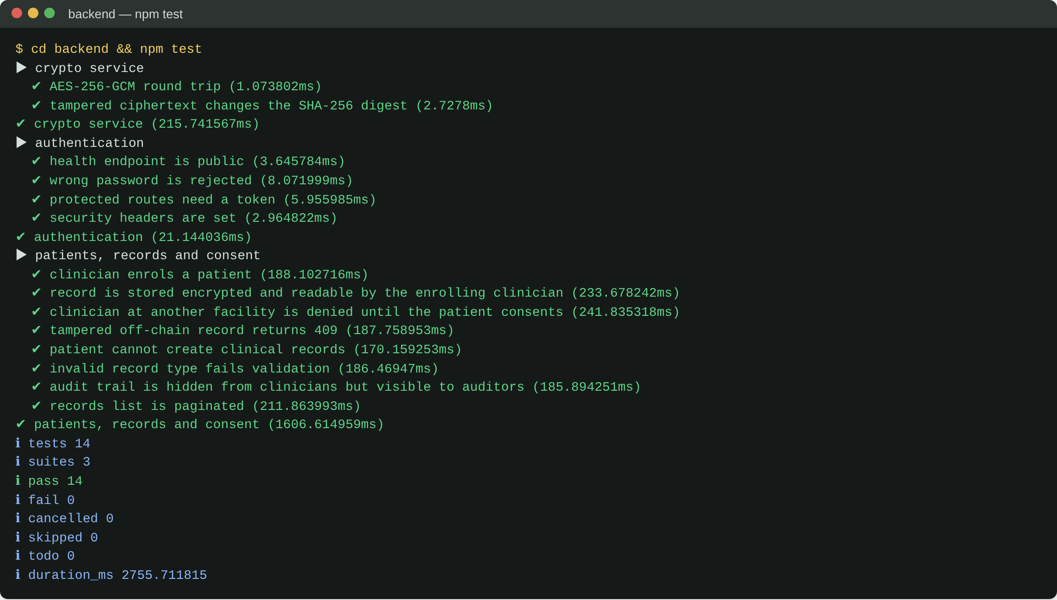
Figure 4.16: Output of the API integration tests

Functional (system) testing
Functional tests drove the finished web application in a real browser, through the production build and against the live Fabric network, using a Playwright script that acts as each type of user in turn. Table 4.21 lists the cases with the expected and observed results. Every case passed.
Table 4.21: Functional test cases
ID | Test case | Expected result | Actual result | Evidence
FT1 | Clinician signs in | Clinician dashboard for the right facility | As expected | Figure 4.1
FT2 | Clinician searches for a patient and lists records | Records listed from the ledger query with their hashes | As expected | Figure 4.17
FT3 | Clinician with consent opens a record | Decrypted record shown with "integrity verified" | As expected | Figure 4.18
FT4 | Doctor at another facility opens a record without consent | Access denied; attempt logged on the ledger | As expected | Figure 4.10
FT5 | Patient signs in and views own records | Patient dashboard lists only her records | As expected | Figure 4.19
FT6 | Patient grants consent to a clinician | Consent recorded with ledger transaction ID | As expected | Figure 4.11
FT7 | Doctor opens the record after consent | Record shown and verified | As expected | Figure 4.12
FT8 | Doctor adds a specialist record | Record encrypted, stored and hash anchored | As expected | Figure 4.20
FT9 | A&E doctor uses break-glass access with a reason | Record opens; access flagged EMERGENCY | As expected | Figure 4.13
FT10 | Patient views her access log | Allowed, denied and emergency events listed | As expected | Figure 4.14
FT11 | Auditor verifies a tampered record | "TAMPERED" reported with the ledger hash | As expected | Figure 4.8
FT12 | Clinician opens the tampered record | Blocked with an integrity error before decryption | As expected | Figure 4.9
FT13 | Administrator views staff and facility identities | Staff list with facility and MSP shown | As expected | Figure 4.21
FT14 | Patient revokes consent; doctor tries again | Access refused on the next attempt | As expected (10/10) | Table 4.14, S3

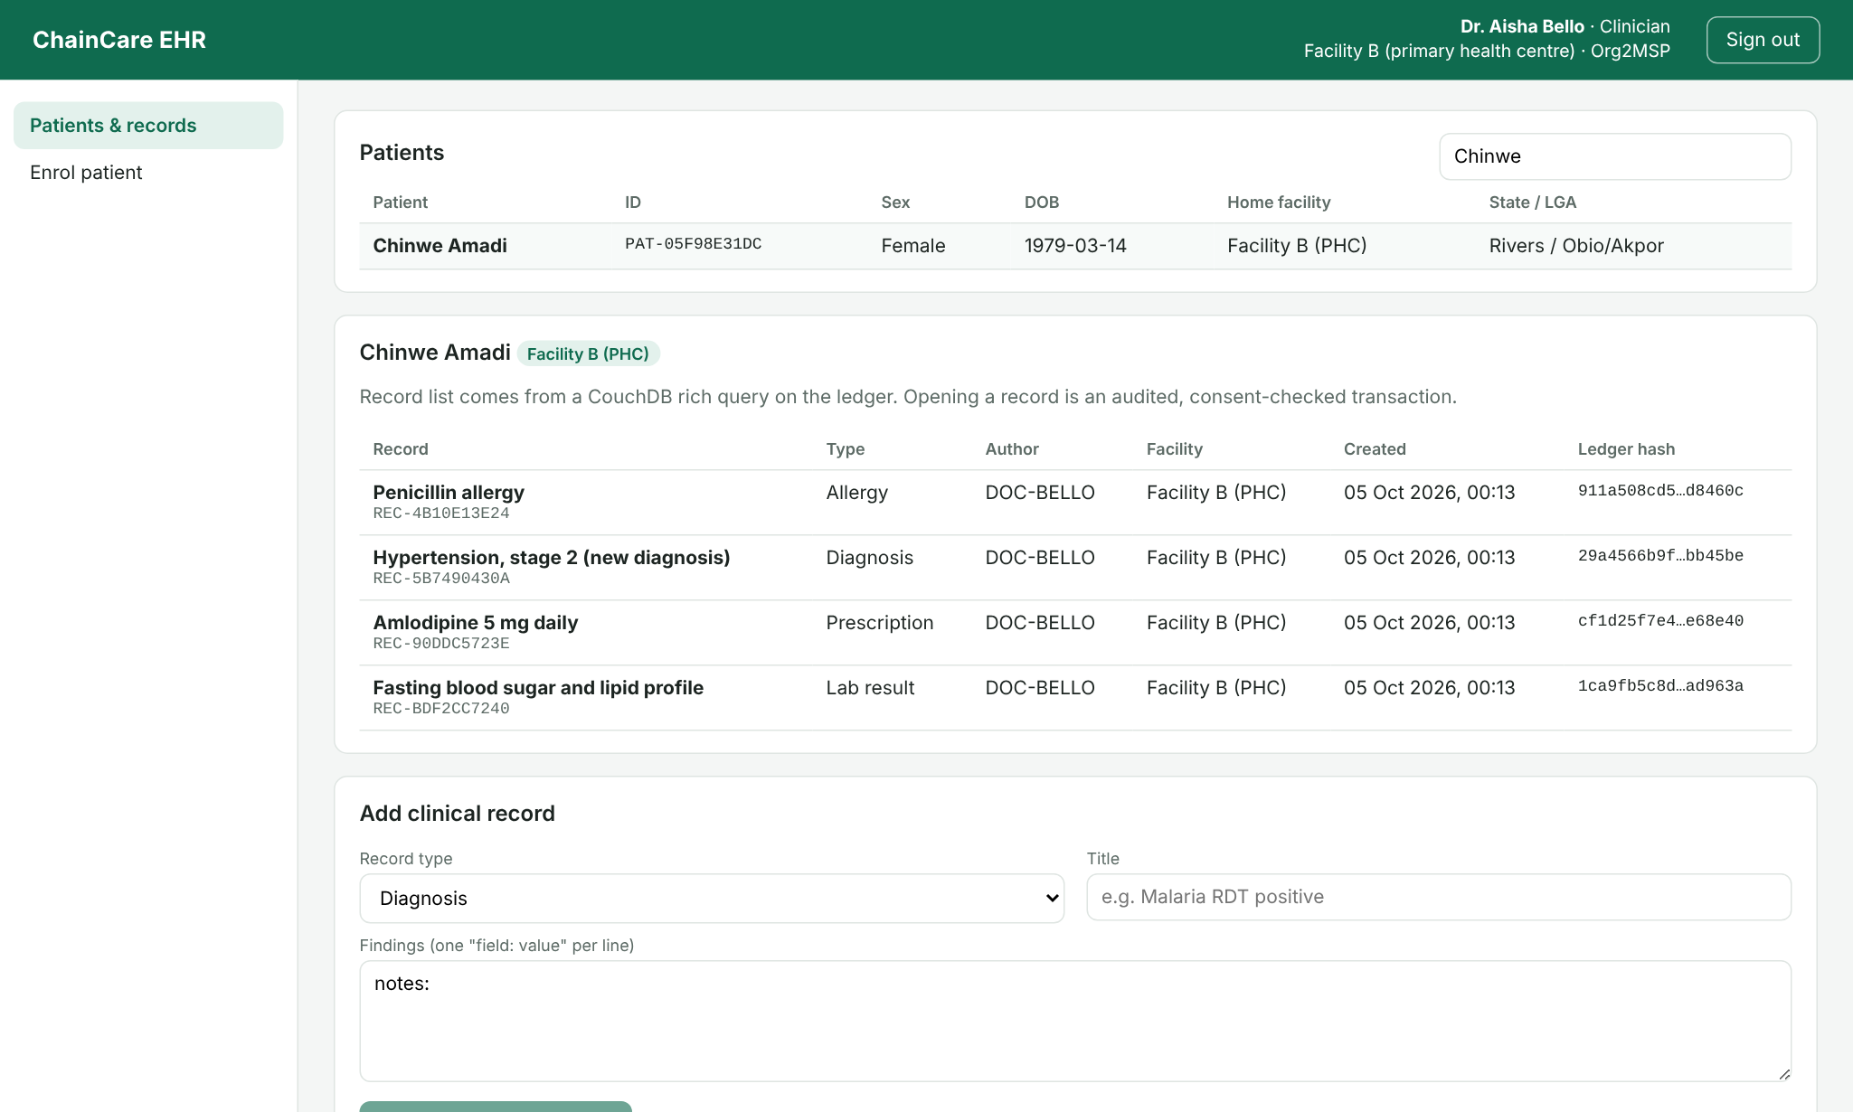
Figure 4.17: Clinician dashboard: patient search and record list from the ledger
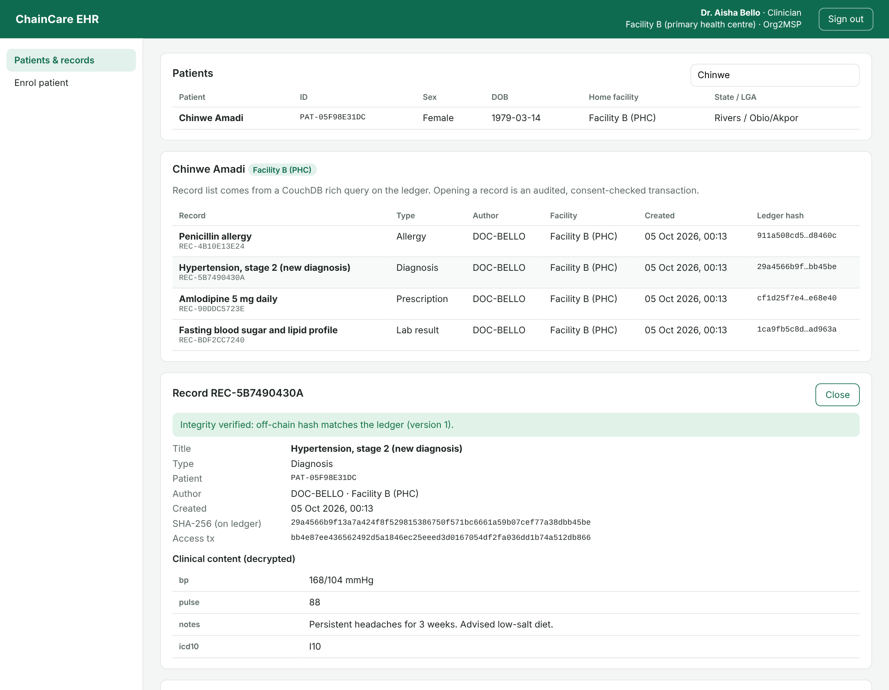
Figure 4.18: A record opened by the treating clinician, decrypted and verified against the ledger
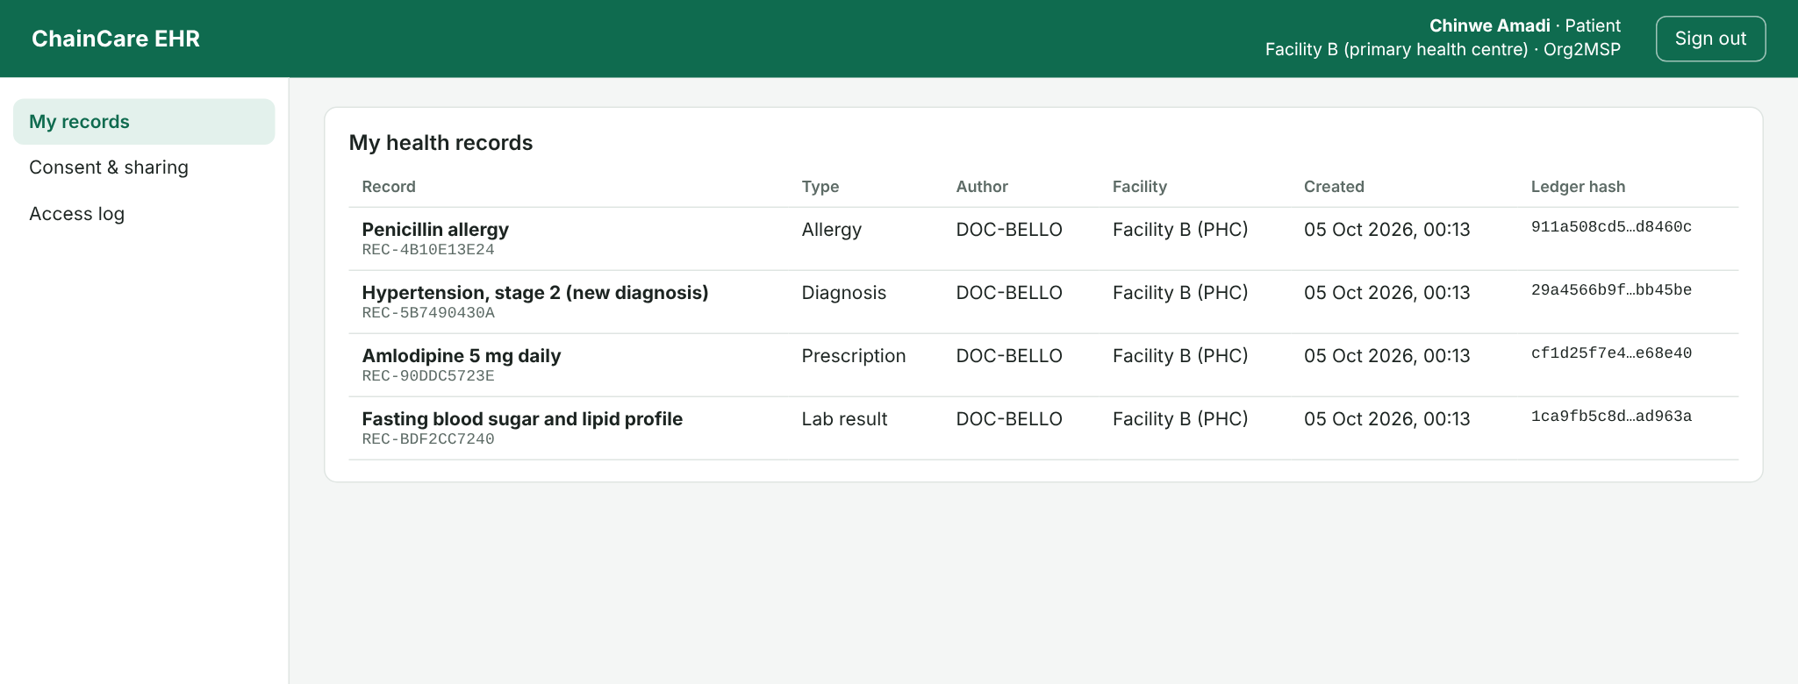
Figure 4.19: Patient dashboard: the patient's own records
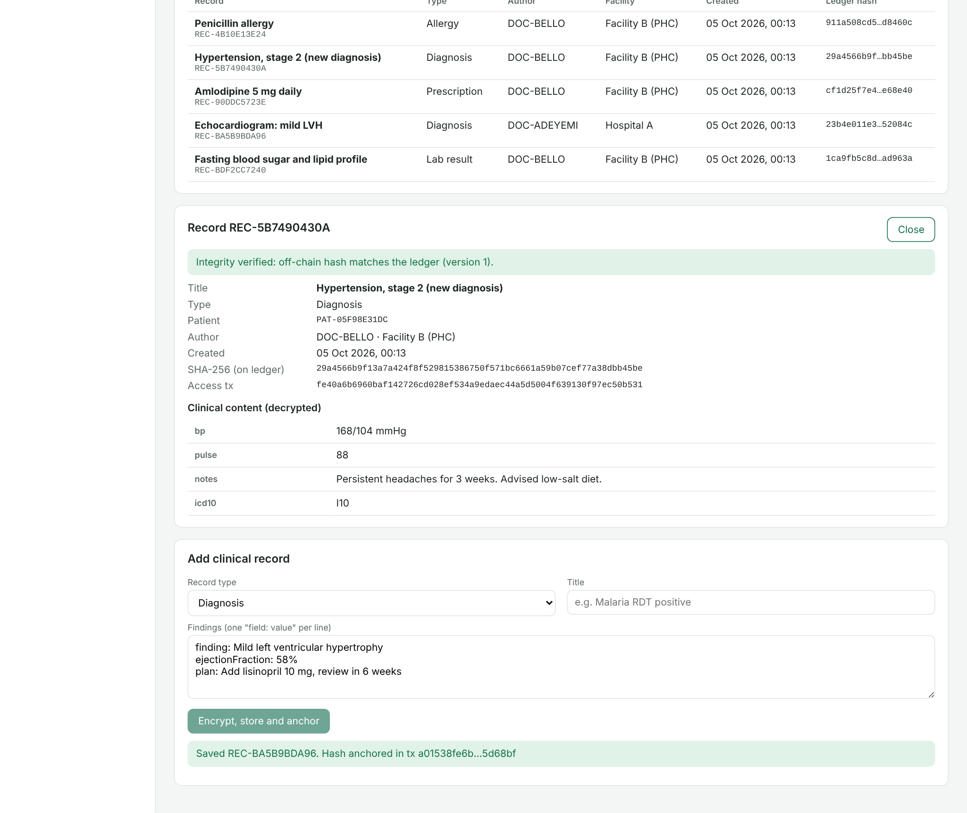
Figure 4.20: The referral specialist adds a record, which is encrypted, stored and anchored on the ledger
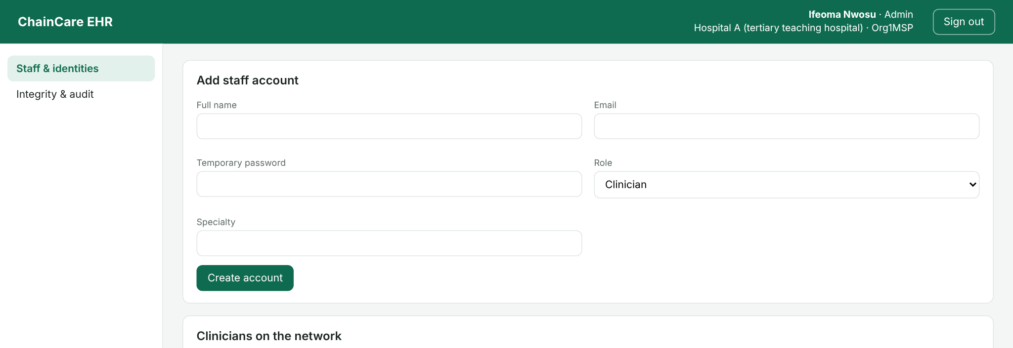
Figure 4.21: Administrator dashboard: staff accounts and facility identities

Summary of testing
Table 4.22: Summary of test results
Test level | Tool | Cases | Passed | Where reported
Unit (chaincode) | Jest | 14 | 14 | Table 4.19
Integration (API) | Node.js test runner, Supertest | 14 | 14 | Table 4.20
Functional (system) | Playwright | 14 | 14 | Table 4.21
Access control | Custom script | 504 | 504 | Table 4.11
Attack attempts | Custom script | 13 | 13 | Table 4.12
Tamper detection | Custom script | 100 | 100 | Table 4.10
Blockchain performance | Hyperledger Caliper | 18,000 transactions | 18,000 committed | Table 4.7

Testing also found and fixed real defects, which is the purpose of testing. The first version of the patient record query returned all of a patient's records in one call and timed out once a test patient had about 900 records; it was changed to return 50 records per page (chaincode version 1.1). The enrolling clinician at the patient's own facility was at first refused access because no consent existed on the ledger; enrolment now records the consent signed at registration. Scanning found missing security headers, two vulnerable development packages and unlabelled form fields, all fixed as shown in Table 4.13.

CHAPTER FIVE
SUMMARY, CONCLUSION AND RECOMMENDATIONS

5.1 Summary
Patient records in Nigeria are still kept largely on paper or in isolated electronic systems that do not talk to each other. Where electronic systems exist, they usually sit on one central server, so a single insider, breach or outage can expose, alter or remove sensitive information, and patients have little say over who sees their records. This study set out to design, build and evaluate a secure electronic health records management system for the Nigerian healthcare system using blockchain technology.
Chapter One set out the problem and five objectives. Chapter Two reviewed the theories behind the work (blockchain technology theory, cryptography theory, diffusion of innovations and the CIA triad) and the empirical literature on blockchain-based EHR systems. It found that most proposals stop at concept or simulation, that few address developing countries, and that usability and adoption receive little attention. Chapter Three analysed the existing centralised EHR architecture, identified its weaknesses and designed a layered system that keeps encrypted records off-chain and their hashes, consent and audit trail on a permissioned ledger.
Chapter Four implemented that design as a working prototype. The application layer uses the T-MERN stack: TypeScript throughout, React for the dashboards, Express.js on Node.js for the API, and MongoDB for encrypted off-chain records. Hyperledger Fabric 2.5 provides the ledger, with two organisations representing a teaching hospital and a primary health centre, a Raft ordering service, certificate authorities and a TypeScript smart contract that enforces consent and writes every access attempt to the ledger. The prototype was compared with a centralised baseline built on the existing architecture. The main findings were as follows.
- Integrity. The proposed system detected all 100 tampered records, including the 50 where an insider also rewrote the stored hash. The centralised baseline detected 50%, missing every insider forgery, and allowed an insider to erase a patient's full audit history of 201 events without trace.
- Access control. Across 504 access attempts by seven kinds of user, every decision was correct (100% accuracy, 0% false acceptance), and all 13 attack attempts on the API were blocked.
- Performance. With no failed transactions, reads ran at the full offered 100 TPS with 0.01 s latency and peaked at about 435 TPS. Writes, which need endorsement by both facilities, committed at 57.5 to 62.1 TPS on a two-core server and peaked at about 68 TPS. At the API the centralised baseline was 8.4 times faster at creating records, but every operation of the proposed system stayed within clinically acceptable times.
- Realistic use. Referral, emergency access, consent withdrawal, insider tampering and low-bandwidth use all behaved correctly. Every user task completed within 3.19 seconds over a throttled 3G connection, and the interface passed a WCAG 2.1 AA accessibility audit after fixes.

5.2 Conclusion
The study concludes that a permissioned blockchain, combined with conventional web technology, can give Nigerian health facilities a records system in which patient data is shared across institutions under the patient's control, and in which tampering and unauthorised access cannot go unnoticed. The conclusions for each objective are as follows.
- Objective 1 (architecture). A layered architecture that combines Hyperledger Fabric, SHA-256 hashing and chaincode with a T-MERN application layer and MongoDB off-chain storage was designed and proved workable. Keeping only hashes, consent and audit events on the ledger kept it small and fast while making every record verifiable.
- Objective 2 (working system). A functional EHR system was developed and run on a two-facility network modelled on the referral chain between a primary health centre and a teaching hospital. Authorised users created, stored, retrieved and shared records across the two facilities, and all functional, unit and integration tests passed.
- Objective 3 (access control). Chaincode-based access control let patients grant, limit by record type and end date, and revoke consent, while clinicians requested access and administrators managed identities. Access decisions were 100% accurate, revocation took effect at once, and emergency access was available but always recorded. This puts into practice the patient's right to confidentiality and to decide on the use of their health information under the National Health Act 2014 and the Nigeria Data Protection Act 2023.
- Objective 4 (evaluation). The system was evaluated for performance, security and usability, using simulated Nigerian scenarios. It is slower than a centralised system, chiefly because each write waits for a block, but fast enough for clinical use. Its decisive advantage is security: it detected every forgery and kept an audit trail that cannot be erased, where the centralised design failed both tests. A survey of users with the System Usability Scale is still outstanding.
- Objective 5 (integration framework). Based on these results, a framework and policy guidelines for integrating the system into Nigeria's health information system are proposed in Section 5.3. They still need to be reviewed with the Federal Ministry of Health and other stakeholders before adoption.
Overall, the trade-off is clear: some speed is given up for integrity, accountability and patient control that a single central database cannot provide. For health records, where a silently altered allergy or a hidden access can cost a life or a livelihood, that trade is worth making.

5.3 Recommendations
The following recommendations are made, in order of priority. Together they form the proposed framework for integrating a blockchain-based EHR into Nigeria's health information system.
- Pilot the system in one state before scaling. The Federal Ministry of Health and a willing state ministry (for example, Rivers State, whose referral chain this study modelled) should run a 6 to 12 month pilot linking one teaching hospital with a cluster of primary health centres. The pilot should include a System Usability Scale survey of patients and health workers and measure referral completion times against the current paper process.
- Set up a health data consortium to govern the network. A blockchain network shared by many facilities needs clear rules on who may join, who runs ordering nodes, how chaincode upgrades are approved and how disputes are settled. A consortium led by the Federal Ministry of Health, with the National Health Insurance Authority, state ministries, teaching hospitals and private facilities as members, should own these rules. Ordering nodes should be spread across federal and state bodies so that no single party controls the ledger.
- Adopt common data standards. The off-chain records should follow HL7 FHIR so that hospital management systems, laboratories and DHIS2 can exchange data with the network. Patients should be identified by the National Identification Number (NIN) issued by the National Identity Management Commission, to prevent duplicate records across facilities.
- Align with data protection law and register the system. Before deployment the operator should complete a data protection impact assessment under the Nigeria Data Protection Act 2023 and engage the Nigeria Data Protection Commission. Because ledger entries cannot be deleted, personal data must never be written to the ledger; only hashes and pseudonymous identifiers, as in this design, so that a patient's off-chain record can still be erased where the law requires.
- Tune the network for production. Each facility should run at least two peers, and the ordering service should have at least three nodes run by different organisations. The block timeout should be shortened from 2 seconds to around 250 to 500 milliseconds, which would cut the wait for single writes that dominated latency in this study. Encryption keys should be held in a hardware security module or key vault rather than in configuration files.
- Invest in infrastructure and training. Facilities need reliable power (solar or inverter backup), a stable internet link with a fallback, and basic server administration skills. Health records officers, nurses and doctors should be trained in using the system and in their duties around consent and emergency access, which supports adoption as the diffusion of innovations theory predicts.
- Make audit review routine. Emergency (break-glass) accesses and refused access attempts should be reviewed weekly by each facility's data protection officer, and patients should be notified of every access to their records, for example by SMS.

5.4 Contribution to Knowledge
This study contributes to knowledge in the following ways.
- A working, open-source implementation for a developing-country setting. Much of the literature reviewed in Chapter Two stops at conceptual models or simulations. This study delivers a complete, tested system on the T-MERN stack with Hyperledger Fabric, modelled on the Nigerian referral chain from primary health centre to teaching hospital, with installation steps that others can follow.
- A controlled comparison with the existing architecture. By running the same code in two modes, centralised and blockchain-backed, the study isolates the effect of the ledger itself. It quantifies both the cost (lower write throughput and higher latency) and the benefit (100% against 50% tamper detection and an audit trail that cannot be erased), which earlier studies rarely measure side by side.
- Evidence that the insider threat is the decisive case. The results show that a centralised system with hashing already catches crude tampering, and that the real value of blockchain in EHRs lies in defeating insiders with full database rights. This sharpens the argument for blockchain in health records beyond general claims about immutability.
- A consent model mapped to Nigerian law. The chaincode puts into practice patient-controlled, scoped and time-limited consent with recorded emergency access, in line with the National Health Act 2014 and the Nigeria Data Protection Act 2023.
- Evidence on usability in low-bandwidth conditions. The study measured task times over a throttled 3G connection and audited accessibility, addressing the gap in the literature on the usability of blockchain EHRs for resource-constrained settings.

5.5 Suggestions for Further Studies
The following areas are suggested for further research.
- A field study with real patients and health workers in several facilities, using the System Usability Scale and the Technology Acceptance Model, to measure acceptance and its drivers across Nigeria's geopolitical zones.
- Performance at national scale: a network of many organisations and peers on separate servers, with Fabric's Byzantine fault-tolerant ordering service (available from Fabric 3.0), different block settings and realistic mixed workloads.
- Integration with existing systems through HL7 FHIR, including DHIS2, the National Health Insurance Authority claims process and hospital management systems already in use in Nigeria.
- Offline-first operation for facilities with intermittent connectivity, where records are captured locally and synchronised to the ledger when a connection returns, without weakening integrity.
- Privacy-enhancing techniques such as zero-knowledge proofs and attribute-based encryption, so that consent can be checked and anonymised data shared for research and disease surveillance without revealing identities.
- A cost-benefit analysis of running the network, including hardware, power, connectivity, staffing and the savings from fewer repeated tests and better-coordinated care, to inform government funding decisions.

