**Ministerul Educaţiei și Cercetării al Republicii Moldova**

**Universitatea Tehnică a Moldovei**

**Facultatea Calculatoare, Informatică și Microelectronică**

**Laboratory work 4:**

Empirical analysis of algorithms:

Depth First Search (DFS), Breadth First Search(BFS)

Elaborated:

st. gr. FAF-213Bardier Andrei

Verified:

asist. univ. Fiștic Cristofor

Chişinău - 2023

**TABLE OF CONTENTS**

ALGORITHM ANALYSIS 3

Objective 3

Tasks: 3

Theoretical Notes: 3

Introduction: 4

Comparison Metric: 4

Input Format: 4

IMPLEMENTATION 5

Depth First Search (DFS) 5

Breadth-first search (BFS) 6

RESULTS 7

CONCLUSION 9

APPENDIX 10

# ALGORITHM ANALYSIS

## Objective

Empirical analysis of algorithms: Depth First Search (DFS), Breadth First Search(BFS)

## Tasks:

1. Implement the algorithms listed above in a programming language
2. Establish the properties of the input data against which the analysis is performed
3. Choose metrics for comparing algorithms
4. Perform empirical analysis of the proposed algorithms
5. Make a graphical presentation of the data obtained
6. Make a conclusion on the work done.

## Theoretical Notes:

An alternative to mathematical analysis of complexity is empirical analysis, which can provide useful information about the efficiency of algorithms. The stages of empirical analysis typically include:

1. Establishing the purpose of the analysis.
2. Choosing an efficiency metric, such as the number of operations executed or the execution time of the algorithm or a portion of it.
3. Defining the properties of the input data that the analysis will be based on, such as size or specific properties.
4. Implementing the algorithm in a programming language.
5. Generating multiple sets of input data.
6. Running the program for each set of input data.
7. Analyzing the obtained data.

The choice of the efficiency measure depends on the purpose of the analysis. For example, if the goal is to obtain information about the complexity class or verify a theoretical estimate, the number of operations performed is appropriate, while the execution time is more relevant if the aim is to evaluate the implementation of the algorithm.

It is important to use multiple sets of input data to reflect the different characteristics of the algorithm, covering a range of sizes and different values or configurations of input data. To obtain meaningful results, it is crucial to use input data that reflects the range of situations the algorithm will encounter in practice.

To perform empirical analysis of an algorithm's implementation in a programming language, monitoring sequences are introduced to measure the efficiency metric. If the efficiency metric is the number of operations executed, a counter is used to increment after each execution. If the metric is execution time, the time of entry and exit must be recorded. Most programming languages have functions to measure the time elapsed between two moments, and it is important to only count the time affected by the execution of the analyzed program, especially when measuring time.

After the program has been run for the test data, the results are recorded and either synthetic quantities, such as mean and standard deviation, are calculated or the results are represented graphically as pairs of points in the form of (problem size, efficiency measure).

## Introduction:

Graphs are a fundamental data structure used in computer science to model relationships between objects. A graph consists of a set of vertices (also known as nodes) and a set of edges connecting those vertices. Edges can be directed or undirected, and can also have weights assigned to them. Graphs are used to model a wide range of applications, such as social networks, transportation systems, and communication networks.

One of the key operations on graphs is traversal, which involves visiting all the vertices and edges in the graph in a systematic manner. Two popular algorithms for graph traversal are Depth-First Search (DFS) and Breadth-First Search (BFS).

DFS is a recursive algorithm that starts at a given vertex and explores as far as possible along each branch before backtracking. The algorithm maintains a stack of visited vertices and uses it to backtrack when it reaches a dead end. DFS is useful for a variety of applications, such as finding paths between vertices, determining if a graph is connected, and detecting cycles in a graph. DFS has a time complexity of O(V+E), where V is the number of vertices and E is the number of edges in the graph.

BFS, on the other hand, explores the graph by visiting all the vertices at the same level before moving on to the next level. BFS uses a queue to store the vertices that need to be visited and maintains a list of visited vertices to prevent revisiting the same vertex. BFS is useful for applications such as finding the shortest path between two vertices and determining the level of each vertex in the graph. BFS also has a time complexity of O(V+E).

Both DFS and BFS have their own advantages and disadvantages depending on the problem at hand. DFS is useful for problems where we want to explore as far as possible in one direction, while BFS is useful for problems where we want to explore all the neighbors of a vertex before moving on to the next level. Choosing the right algorithm can make a significant difference in the performance of a graph traversal algorithm.

## Comparison Metric:

The comparison metric for this laboratory work will be considered the time of execution of each algorithm (T(n))

## Input Format:

As input, each algorithm will receive a graph, that is actually a balanced binary tree with 32 nodes.

# IMPLEMENTATION

The algorithms will be implemented without optimization in Python and evaluated based on their completion time. The results obtained may resemble those of other similar experiments, but the specific performance in relation to the input size may vary depending on the memory specifications of the device being used.

## Depth First Search (DFS)

The Depth First Search (DFS) algorithm is a fundamental graph traversal algorithm used to explore and search a graph or a tree data structure. The DFS algorithm traverses the graph in a depth-first manner, meaning it visits the deepest vertices first before backtracking to the earlier nodes. The implementation of the DFS algorithm is typically done using a stack data structure to keep track of visited vertices and explore the next unvisited vertex.

This implementation of the DFS algorithm takes a starting vertex as its input and returns a list of all vertices in the order they were visited during the traversal. The algorithm begins by initializing an empty set to keep track of the visited vertices and a stack data structure with the starting vertex as its sole element. The while loop iterates until the stack is empty, indicating all vertices have been visited.

In each iteration, the algorithm pops the top vertex from the stack and checks if it has not been visited before. If it is a new vertex, the algorithm adds it to the visited set and appends it to the output list. The algorithm then iterates through the adjacent vertices of the current vertex and adds them to the stack if they have not been visited before. This process continues until all vertices have been visited, and the output list is returned.

Overall, this implementation of the DFS algorithm is an efficient and straightforward way to traverse a graph or a tree and can be used for various applications, such as finding a path between two vertices, detecting cycles in a graph, or generating a topological ordering of a directed acyclic graph.

The algorithm implementation:

def find_element_dfs(root, target):  
 stack = [root]  
 path = []  
 while stack:  
 node = stack.pop()  
 path.append(node.val)  
 if node.val == target:  
 return node, path  
 if node.right:  
 stack.append(node.right)  
 if node.left:  
 stack.append(node.left)  
 return None, path

## Breadth-first search (BFS)

The Breadth First Search (BFS) algorithm is another fundamental graph traversal algorithm that explores and searches a graph or a tree data structure. Unlike the DFS algorithm that traverses the graph in a depth-first manner, the BFS algorithm traverses the graph in a breadth-first manner, meaning it visits all the vertices at the same depth level before moving on to the next level.

This implementation of the BFS algorithm takes a starting vertex as its input and returns a list of all vertices in the order they were visited during the traversal. The algorithm begins by initializing an empty list to keep track of the visited vertices and a dictionary to mark all vertices as unvisited except the starting vertex. It also initializes a queue data structure with the starting vertex as its first element.

The while loop iterates until the queue is empty, indicating all vertices at the current level have been visited. In each iteration, the algorithm dequeues the first vertex from the queue, marks it as visited, and appends it to the output list. The algorithm then iterates through the adjacent vertices of the current vertex and adds them to the queue if they have not been visited before. This process continues until all vertices have been visited, and the output list is returned.

Overall, this implementation of the BFS algorithm is an efficient and reliable way to traverse a graph or a tree and can be used for various applications, such as finding the shortest path between two vertices, detecting connected components in a graph, or testing bipartiteness of a graph.

The algorithm implementation:

def find_element_bfs(root, target):  
 queue = [root]  
 path = []  
 while queue:  
 node = queue.pop(0)  
 path.append(node.val)  
 if node.val == target:  
 return node, path  
 if node.left:  
 queue.append(node.left)  
 if node.right:  
 queue.append(node.right)  
 return None, path

RESULTS

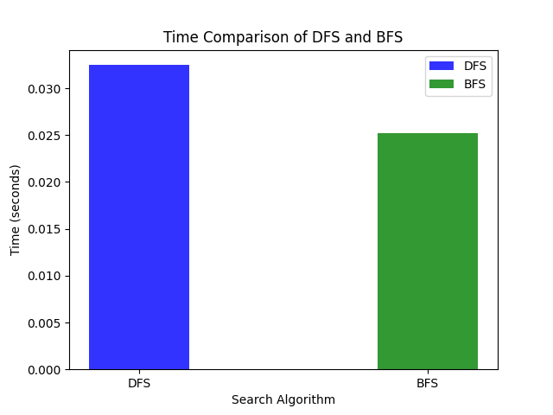

# CONCLUSION

In a balanced binary tree, both Breadth-First Search (BFS) and Depth-First Search (DFS) algorithms have a time complexity of O(n), where n is the total number of nodes in the tree.

BFS is typically used to search for the shortest path from a starting node to a target node. In a balanced binary tree, since the nodes are evenly distributed between the levels, BFS would be an efficient algorithm to find the shortest path. The worst-case scenario for BFS in a balanced binary tree would be to traverse all n nodes, which would take O(n) time.

DFS, on the other hand, is typically used to traverse the entire tree, either in pre-order, in-order, or post-order traversal. In a balanced binary tree, since the maximum depth of the tree is O(log n), the worst-case scenario for DFS would be to visit all the nodes, which would take O(n) time.

Therefore, in a balanced binary tree, both BFS and DFS have the same time complexity of O(n). However, the choice of algorithm depends on the specific task you want to accomplish. If you want to find the shortest path, then BFS is more suitable. If you want to traverse the entire tree, then DFS would be a better choice.

# APPENDIX

**Git-hub link:**

https://github.com/Ricigeroi/AA-Lab-4