MAHINDRA UNIVERSITY
School of Electrical and Computer Engineering
Programs: ECE / ECM
NETWORK ARCHITECTURE OF A MODERN DATA CENTER
Comprehensive Technical Case Study Analysis
EC3206 – Computer and Communication Networks
Academic Year: 2025–26 | III Year / II Semester
Faculty: Dr. K. Venkatasubramanian
Submission Date: 18.05.2026 | Submission Mode: PDF via OneDrive

Submitted By: | ______________________________
Roll Number: | ______________________________
Program: | ECE / ECM

Abstract
Modern data centers represent the foundational infrastructure upon which the global digital economy operates. Cloud computing platforms, artificial intelligence workloads, multimedia streaming pipelines, high-frequency financial transaction systems, and enterprise-grade communication services all depend on the continuous, reliable operation of large-scale data center networks. Hyperscale operators such as Amazon Web Services (AWS), Google Cloud Platform (GCP), and Microsoft Azure collectively manage thousands of geographically distributed data centers capable of processing billions of user requests daily with end-to-end latencies measured in single-digit milliseconds.

This report presents a rigorous technical analysis of modern data center network architecture, examining how foundational computer networking principles manifest in production-grade infrastructure. The study systematically evaluates application layer protocols—including HTTP/2, HTTPS, DNS, and SMTP—alongside transport layer mechanisms such as TCP congestion control algorithms and the emerging QUIC protocol. Network layer technologies including OSPF, BGP, VLAN segmentation, and Software Defined Networking (SDN) are discussed with reference to their specific operational roles. The report further analyzes persistent challenges including network congestion, packet loss, distributed denial-of-service threats, and horizontal scalability constraints, concluding with technically grounded proposals for next-generation improvements such as AI-driven traffic engineering, intent-based networking, and quantum-safe cryptographic frameworks.

1. Introduction
The proliferation of internet-connected devices, the exponential growth of data-intensive services, and the widespread adoption of cloud computing paradigms have fundamentally redefined the role of data centers within modern communication networks. Where traditional computing relied on isolated on-premises servers, contemporary applications are architected as globally distributed systems spanning dozens of data center regions interconnected by high-capacity optical fiber backbones.

A modern data center is not simply a collection of servers housed in a controlled environment. It is an intricate, interdependent ecosystem of compute resources, high-performance networking equipment, storage hierarchies, virtualization layers, security appliances, and software-defined management planes—all engineered to function cohesively under demanding operational conditions. The network fabric of a data center must simultaneously handle north-south traffic (external client-to-server communication) and east-west traffic (server-to-server lateral communication), with east-west flows increasingly dominating total traffic volume in distributed microservices architectures.

Understanding the networking architecture of modern data centers requires integrating knowledge across all layers of the OSI model. Application layer protocols define the semantics of communication between cloud services and end users. Transport layer mechanisms ensure reliable, ordered, and congestion-aware delivery of data streams. Network layer protocols manage logical addressing, routing decisions, and inter-domain connectivity. This report provides an integrated analysis of these layers as they function within real-world data center environments, drawing on industry practices from leading cloud providers and relevant networking standards.

2. Overview of Modern Data Centers

2.1 Classification of Data Centers
Data centers are broadly classified based on their ownership model, geographic distribution, and intended use case. Enterprise data centers are privately maintained and dedicated to supporting the internal IT workloads of a specific organization. Cloud data centers, operated by hyperscale providers such as AWS, GCP, and Azure, deliver shared infrastructure to thousands of customers simultaneously through multi-tenancy and virtualization. Colocation facilities lease physical space and power to multiple tenants who bring their own hardware. Edge data centers are compact facilities deployed geographically close to end users to minimize latency for latency-sensitive applications such as autonomous vehicles, augmented reality, and real-time analytics.

2.2 Key Operational Objectives
Regardless of classification, all modern data centers share a common set of operational requirements that drive their architectural decisions:
- High Availability: Target uptime of 99.999% (five nines), achieved through redundant hardware, failover mechanisms, and geographically distributed replica sites.
- Horizontal Scalability: The ability to expand capacity by adding commodity servers rather than upgrading monolithic systems, supporting elastic workload growth.
- Low Latency: Minimizing propagation delay and queuing delay to meet the strict latency budgets of interactive applications and financial trading systems.
- Security and Compliance: Enforcing data confidentiality, integrity, and regulatory compliance across multi-tenant, multi-jurisdiction environments.
- Energy Efficiency: Optimizing the Power Usage Effectiveness (PUE) ratio to reduce operational costs and environmental impact as data centers consume a significant fraction of global electricity.
- Fault Tolerance: Designing network paths and compute resources with no single point of failure, enabling seamless recovery from hardware and software faults.

3. Network Architecture of Modern Data Centers

3.1 Traditional Three-Tier Architecture
The conventional data center network topology followed a hierarchical three-tier model composed of the core, aggregation, and access layers. The core layer provides high-speed packet forwarding between the aggregation layer switches and the external internet or WAN backbone, typically implemented using high-capacity multi-layer switches capable of forwarding at terabit-per-second line rates. The aggregation layer, also referred to as the distribution layer, handles routing between VLANs, applies access control policies, performs load balancing, and connects multiple access layer switches. The access layer directly connects end servers and storage devices to the network fabric via 10GbE or 25GbE links.

While this architecture was sufficient for traditional north-south dominated traffic flows, it presents significant limitations in the context of modern distributed applications. The hierarchical topology creates bandwidth bottlenecks at the aggregation and core layers when east-west lateral traffic between server racks is routed through shared uplinks. Additionally, the spanning tree protocol, traditionally used to prevent broadcast loops in the access and aggregation layers, limits link utilization and slows convergence after topology changes.

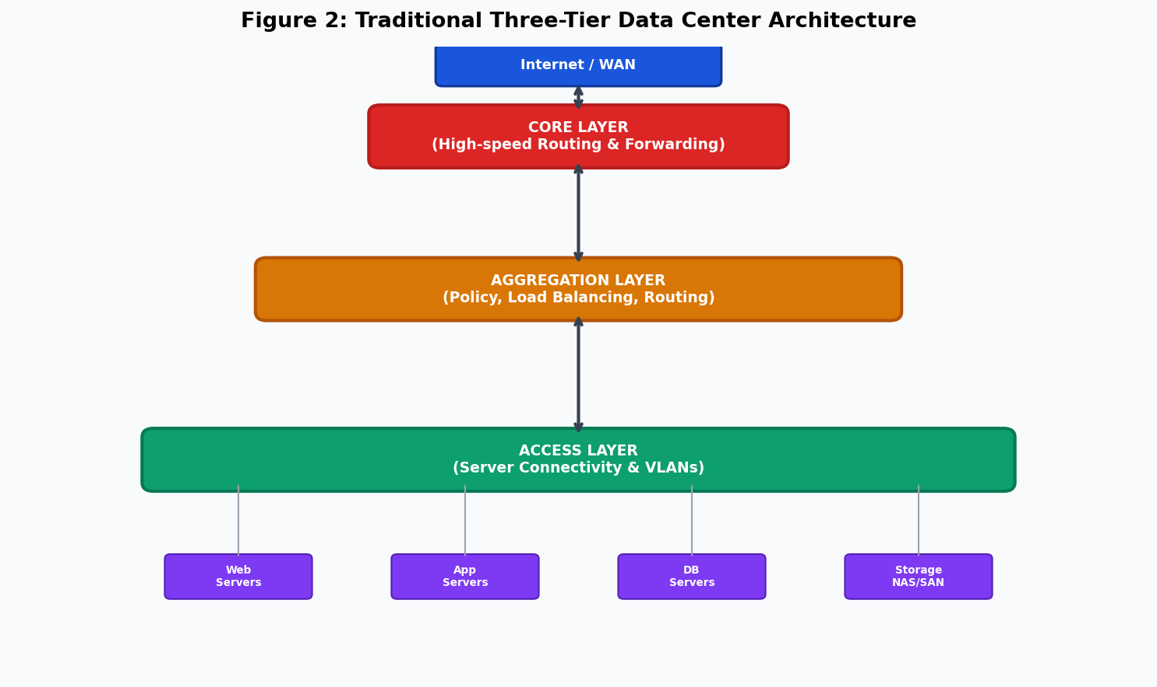
Figure 2: Traditional Three-Tier Data Center Architecture

3.2 Spine-Leaf Architecture
Contemporary hyperscale data centers have largely migrated to the Spine-Leaf (also known as Clos network) topology, which provides a flat, non-blocking architecture optimized for high-bandwidth east-west traffic. In this design, every leaf switch maintains a dedicated uplink to every spine switch, creating a full mesh of equal-cost paths. Leaf switches serve as the access layer, connecting directly to servers, storage arrays, and hypervisors. Spine switches form the high-speed core fabric and do not directly attach to servers.

This topology offers several critical advantages. Since all paths between any two leaf switches pass through exactly one spine switch, the worst-case latency is bounded and predictable. Equal-Cost Multi-Path (ECMP) routing distributes traffic across all available spine switches, maximizing bandwidth utilization without oversubscription. Adding capacity is straightforward: new leaf switches connect to all spine switches, and new servers attach to available leaf switch ports. Google's Jupiter network fabric, which underpins GCP, is a well-documented example of a large-scale Clos topology with multiple layers of aggregation blocks.

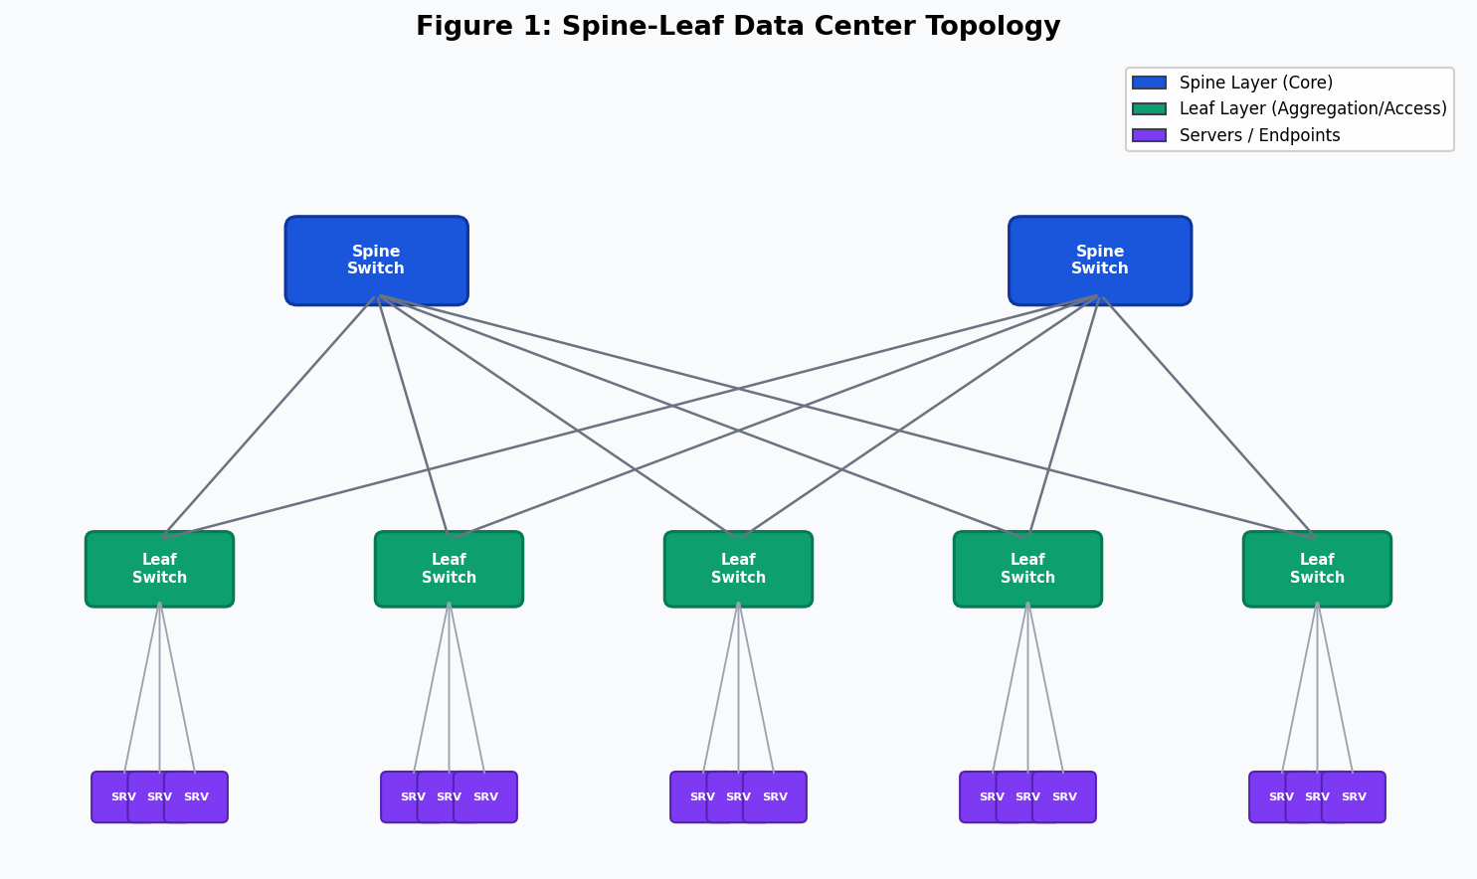
Figure 1: Spine-Leaf Data Center Topology (ECMP-enabled)

3.3 Communication Flow Model
A typical client request traversing a data center network follows a well-defined path through multiple processing layers. The client request originates from an end-user device and traverses the public internet to reach the data center's border routers. The border router performs BGP route selection and forwards packets to the firewall cluster, which inspects traffic against security policies and performs stateful connection tracking. The load balancer then distributes the incoming connection to one of the available application servers according to a configured algorithm. Within the data center fabric, the spine-leaf topology forwards the packet to the target server's leaf switch, which delivers it to the server's network interface. The server processes the request, potentially querying distributed database clusters or object storage systems via internal east-west traffic, before assembling and returning the response along the reverse path.

4. Core Networking Components

4.1 Top-of-Rack Switches
Top-of-Rack (ToR) switches are the leaf-layer devices physically located within individual server racks. They aggregate the network connections of 20 to 48 servers and provide uplinks to spine switches. Modern ToR switches operate at 25GbE or 100GbE server-facing ports with 100GbE or 400GbE uplinks. They support features including VXLAN encapsulation for overlay networking, ECMP for traffic distribution, and hardware-accelerated ACL processing for security enforcement.

4.2 Border Routers and Peering
Border routers manage the data center's connectivity to the internet and to peer networks. They participate in the Border Gateway Protocol (BGP) internet routing table, which currently exceeds 900,000 distinct prefixes. Large cloud providers operate at numerous internet exchange points (IXPs) globally, enabling direct high-bandwidth peering with major ISPs and content networks. Anycast routing is extensively used to direct users to the nearest data center region, reducing latency and increasing resilience.

4.3 Load Balancers
Load balancers are responsible for distributing incoming traffic across a pool of application servers, preventing individual servers from becoming overloaded while maintaining session continuity. Layer 4 load balancers operate at the transport layer and route connections based on IP addresses and TCP/UDP port numbers with minimal processing overhead. Layer 7 load balancers inspect application-layer content—including HTTP headers, URL paths, and cookie values—enabling sophisticated routing decisions such as directing API requests to specific microservice clusters or routing authenticated sessions to the same backend server. Common load balancing algorithms include Round Robin, Weighted Round Robin, Least Active Connections, and IP Hash.

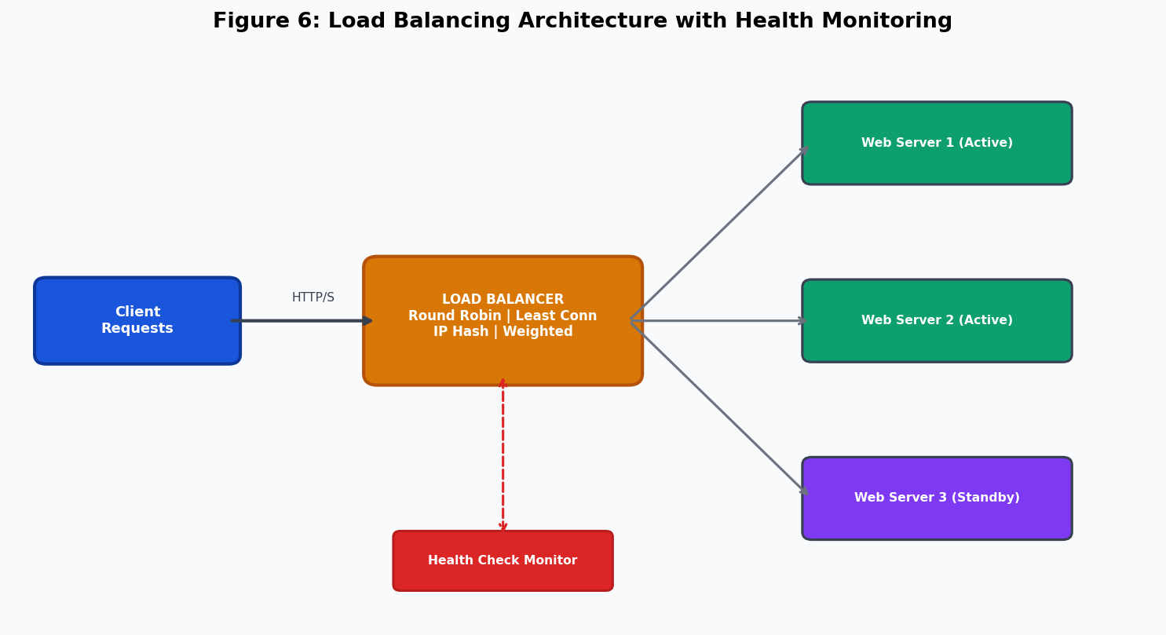
Figure 6: Load Balancing Architecture with Active Health Monitoring

4.4 Firewalls and Security Appliances
Next-generation firewalls (NGFWs) deployed at data center perimeters perform deep packet inspection, application identification, intrusion prevention, and SSL/TLS decryption. Modern NGFWs operate at 100 Gbps or higher throughput using custom ASICs to maintain inspection performance without creating network bottlenecks. Internally, distributed microsegmentation policies implemented via software-defined firewalling prevent lateral movement of threats between workloads, enforcing zero-trust principles within the data center fabric.

4.5 Storage Networking
Storage Area Networks (SANs) and Network-Attached Storage (NAS) provide centralized, high-capacity storage resources accessible to compute clusters. SANs traditionally used Fibre Channel protocols, but modern deployments increasingly use iSCSI or NVMe over Fabrics (NVMe-oF) over standard Ethernet infrastructure to reduce cost and complexity. All-NVMe storage arrays with NVMe-oF connectivity can deliver sub-100-microsecond storage latency, which is critical for latency-sensitive database workloads.

5. Application Layer Protocols

5.1 HTTP/2 and HTTP/3
HTTP remains the primary protocol for web service delivery, API communication, and cloud service access. HTTP/2, standardized in RFC 7540, introduced binary framing, multiplexed request streams over a single TCP connection, server push capabilities, and header compression using the HPACK algorithm. These improvements address the head-of-line blocking problem inherent in HTTP/1.1, where a single slow response could block all subsequent requests on the same connection. HTTP/3, built on top of QUIC rather than TCP, eliminates HOL blocking at the transport layer by providing independent multiplexed streams, enabling even lower latency in lossy network conditions.

5.2 HTTPS and TLS 1.3
HTTPS (HTTP over TLS) is mandatory for all cloud service communication involving sensitive data. TLS 1.3, standardized in RFC 8446, reduces the handshake latency to a single round-trip (1-RTT), compared to two round-trips in TLS 1.2, and supports 0-RTT resumption for reconnecting clients at the cost of certain replay-attack mitigations. The protocol mandates forward secrecy through ephemeral key exchange (ECDHE), ensuring that even if a long-term private key is compromised in the future, past recorded sessions cannot be decrypted.

5.3 DNS and Anycast
The Domain Name System translates human-readable domain names into IP addresses and plays a critical role in traffic engineering for large-scale cloud services. Authoritative DNS servers return different IP addresses to different clients based on their geographic location, effectively directing users to the nearest available data center region. Anycast routing assigns the same IP address to DNS resolver instances deployed in multiple geographic locations, with routing protocols directing each query to the topologically nearest instance. This provides both latency reduction and inherent DDoS resilience, since attack traffic is distributed across many sites rather than concentrated at a single target.

5.4 Additional Application Protocols
SMTP and IMAP enable enterprise email communication, with modern deployments enforcing TLS encryption and DKIM/SPF/DMARC authentication mechanisms to prevent spoofing and phishing. SFTP and SCP provide secure file transfer capabilities for software deployment pipelines, configuration management, and backup operations. gRPC, built on HTTP/2 with Protocol Buffers serialization, is widely used for high-performance, low-latency inter-microservice communication within data center fabrics.

Protocol | Layer | Function | Role in Data Centers
HTTP/HTTPS | Application | Web & API communication | Secure cloud service delivery; HTTPS encrypts all client-server traffic via TLS 1.3, preventing MITM attacks and credential theft
DNS | Application | Name-to-IP resolution | Distributed DNS with Anycast routing enables geo-load balancing; critical for directing users to nearest PoP
FTP / SFTP | Application | File transfer | SFTP securely deploys software, backups, and firmware images across server farms
SMTP / IMAP | Application | Email communication | Secure enterprise messaging with S/MIME encryption for inter-organizational communication
TCP | Transport | Reliable, ordered delivery | Three-way handshake, retransmission, congestion control (CUBIC, BBR) for mission-critical transactions
UDP | Transport | Low-latency transfer | Used by DNS, QUIC, streaming, and VoIP where speed outweighs occasional packet loss
QUIC | Transport | Multiplexed streams | HTTP/3 backbone; eliminates HOL blocking, supports 0-RTT resumption for ultra-fast connections
IPv4 / IPv6 | Network | Logical addressing | IPv6 supports 128-bit addressing for massive IoT and cloud scale; dual-stack deployment in transition
OSPF | Network | Interior routing | Fast convergence using Dijkstra's algorithm; ideal for intra-AS data center routing
BGP | Network | Inter-AS routing | Policy-driven path selection for internet backbone; eBGP connects cloud regions and ISPs
MPLS | Network | Traffic engineering | Label-switched paths optimize latency-sensitive east-west traffic flows across fabric
OpenFlow | Network | SDN control | Decouples control and data planes; enables programmable flow tables in SDN switches

6. Transport Layer Communication Mechanisms

6.1 TCP and the Three-Way Handshake
The Transmission Control Protocol provides reliable, ordered, full-duplex communication between endpoints. Connection establishment requires a three-way handshake: the client sends a SYN segment with its initial sequence number; the server responds with a SYN-ACK acknowledging the client's sequence number and advertising its own; the client confirms with an ACK segment. Only after this exchange is the connection in the ESTABLISHED state and data transfer can begin. TCP guarantees reliability through selective acknowledgments, retransmission of lost segments detected by timeout or triple duplicate ACKs, and in-order delivery through sequence number reordering at the receiver.

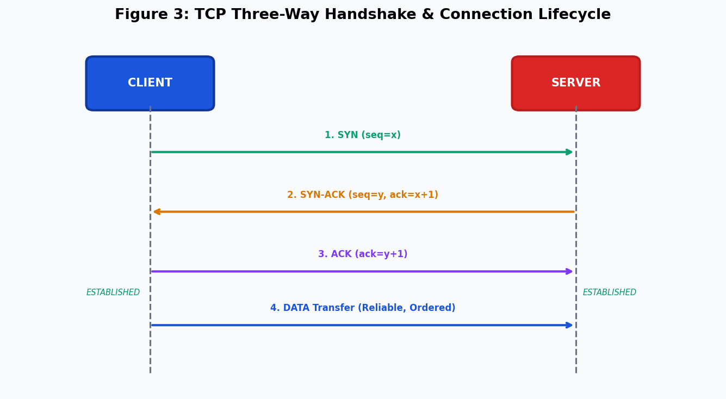
Figure 3: TCP Three-Way Handshake and Connection Lifecycle

6.2 TCP Congestion Control
TCP congestion control prevents network collapse by adapting the sender's transmission rate to available network capacity. The slow start phase begins with a congestion window (cwnd) of one maximum segment size (MSS) and doubles it each round-trip time until either a loss event is detected or a threshold (ssthresh) is reached. In the congestion avoidance phase, cwnd grows linearly by one MSS per RTT. Upon detecting packet loss via timeout, slow start restarts; upon detecting loss via triple duplicate ACKs, TCP enters fast recovery, halving cwnd and resuming linear growth. Modern data centers deploy TCP CUBIC, which uses a cubic function to grow the congestion window and achieves better throughput on high-bandwidth-delay product links. BBR (Bottleneck Bandwidth and Round-trip propagation time), developed by Google, models the network path and probes for available bandwidth without inducing queue buildup, achieving higher throughput and lower latency than loss-based algorithms.

6.3 UDP and QUIC
UDP provides connectionless, best-effort datagram delivery with minimal overhead, making it suitable for applications where occasional packet loss is acceptable and latency is paramount. DNS queries, VoIP, video streaming, and online gaming typically rely on UDP. QUIC, originally developed by Google and now standardized in RFC 9000, is a UDP-based multiplexed transport protocol that integrates TLS 1.3 encryption natively, providing 1-RTT or 0-RTT connection establishment, independent stream multiplexing, and improved connection migration to handle client IP address changes (common in mobile networks). HTTP/3 mandates QUIC as its transport, and major cloud providers have widely deployed QUIC for latency-sensitive workloads.

7. Network Layer Protocols and Routing

7.1 IP Addressing and Subnetting
Data centers typically operate dual-stack IPv4/IPv6 networks to support the global transition from IPv4 to IPv6. IPv4 addresses are organized into hierarchical subnets using CIDR notation, with internal RFC 1918 private address spaces (10.0.0.0/8, 172.16.0.0/12, 192.168.0.0/16) used for internal server addressing and NAT applied at the perimeter. IPv6 provides 128-bit addresses, eliminating NAT requirements and enabling end-to-end connectivity at cloud scale. Hyperscale providers have assigned IPv6 addresses to all internal infrastructure, supporting the projected growth of IoT devices and cloud endpoints.

7.2 OSPF for Interior Routing
Open Shortest Path First (OSPF) is a link-state Interior Gateway Protocol that enables routers within an autonomous system to maintain a synchronized topology map and independently compute shortest paths using Dijkstra's algorithm. OSPF hello packets detect neighbor adjacencies and trigger topology updates when link states change. In data center environments, OSPF is deployed to provide fast convergence after link failures, with sub-second failover achievable using Bidirectional Forwarding Detection (BFD) integrated with OSPF. OSPF areas compartmentalize the routing domain, limiting the scope of topology updates and reducing the computational burden on individual routers.

7.3 BGP for Inter-Domain Routing
Border Gateway Protocol (BGP) is the routing protocol that underpins internet connectivity. External BGP (eBGP) is used between autonomous systems—such as between a data center's network and its upstream ISPs—while internal BGP (iBGP) distributes external routing information within the data center's own autonomous system. BGP's policy-based route selection allows network operators to influence traffic paths based on business relationships, performance metrics, and traffic engineering goals. Modern hyperscale networks also use BGP internally (BGP in the data center, popularized by Facebook's experience) to manage routing within large-scale Clos fabrics, replacing OSPF in some deployments due to BGP's superior scalability and policy flexibility.

7.4 VLANs and Network Segmentation
Virtual LANs (VLANs) partition a physical network infrastructure into multiple isolated logical networks at Layer 2, providing traffic isolation between tenants or application tiers. In data centers hosting multiple customers or security zones, VLANs prevent lateral traffic visibility between segments while sharing the same physical switches and cabling. Modern data center deployments extend this concept using VXLAN (Virtual Extensible LAN), which encapsulates Layer 2 Ethernet frames within UDP packets, enabling logical network overlays to span across physical network boundaries and support millions of isolated tenant networks.

7.5 Software Defined Networking
Software Defined Networking represents a paradigm shift in network architecture by decoupling the control plane (routing decision logic) from the data plane (packet forwarding hardware). In a traditional network, each switch or router independently runs its own control plane software. In an SDN architecture, a centralized SDN controller maintains a global view of the network topology and computes optimal forwarding rules, distributing them to data plane devices via southbound APIs such as OpenFlow or NETCONF. Applications interact with the controller via northbound APIs, enabling programmatic network automation, traffic engineering, and policy enforcement without manual per-device configuration.

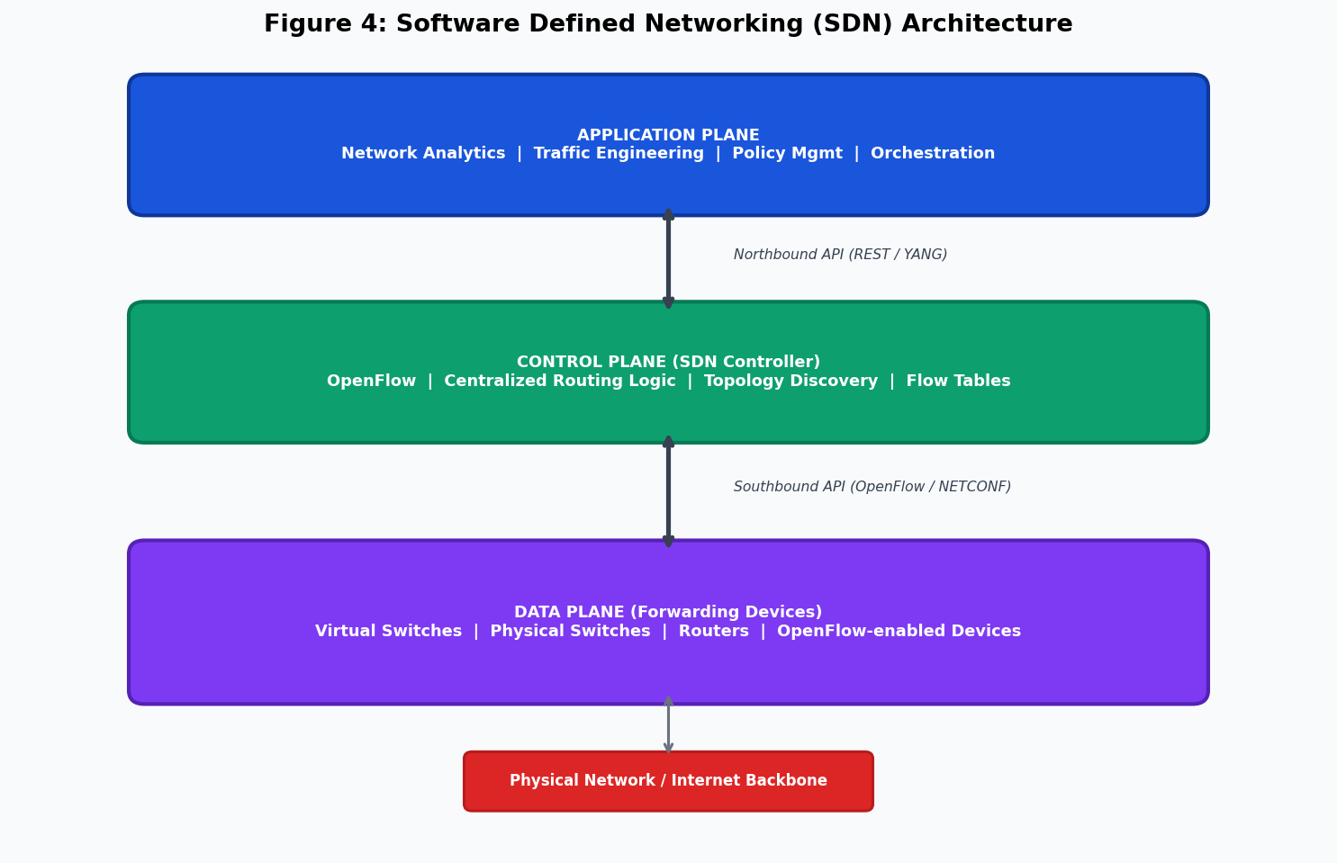
Figure 4: Software Defined Networking (SDN) Architecture with Control/Data Plane Separation

8. Congestion Control and Traffic Management

8.1 Sources and Manifestations of Congestion
Data center networks experience diverse congestion patterns driven by the bursty nature of application traffic. Incast congestion occurs when a large number of servers simultaneously respond to a single aggregating server—a pattern common in distributed storage and MapReduce workloads—overwhelming the downstream switch's ingress buffers. Elephant flows (long-duration, high-bandwidth transfers such as VM migrations or backup operations) can starve short-lived mice flows (small, latency-sensitive transactions) on shared links. Background control traffic, including routing protocol hellos, management plane polling, and distributed consensus protocols, competes with application traffic for bandwidth.

8.2 Traffic Engineering and QoS
Quality of Service mechanisms classify network traffic into priority classes and allocate bandwidth, buffer space, and processing resources accordingly. Differentiated Services Code Point (DSCP) markings in IP packet headers allow network devices to apply per-hop behaviors, ensuring that latency-sensitive traffic such as database transactions receives preferential queuing treatment over bulk data transfers. Strict Priority Queuing guarantees minimum bandwidth to high-priority queues, while Weighted Fair Queuing provides proportional sharing among lower-priority traffic classes.

Equal-Cost Multi-Path (ECMP) routing enables packets to be distributed across multiple equal-cost paths in the spine-leaf fabric, effectively multiplying available bandwidth and providing natural load distribution. Per-flow ECMP uses a hash of the 5-tuple (source IP, destination IP, source port, destination port, protocol) to deterministically map each flow to a consistent path, preventing out-of-order delivery. Modern data centers also experiment with per-packet ECMP and flowlet-based switching, which offer better bandwidth utilization at the cost of potential out-of-order packet delivery.

9. Security Challenges in Data Center Networks

9.1 DDoS Attacks and Volumetric Threats
Distributed Denial of Service attacks represent one of the most prevalent and operationally disruptive threats to data center availability. Volumetric DDoS attacks saturate network ingress links with traffic volumes that can exceed 1 Tbps, exhausting bandwidth and rendering legitimate traffic unable to reach its destination. Amplification attacks exploit UDP-based protocols with asymmetric request-response ratios—DNS amplification can achieve amplification factors exceeding 70x, and NTP monlist attacks can reach 556x—enabling attackers with limited bandwidth to generate massive attack volumes. Protocol attacks target the state tables of network devices and load balancers, exhausting connection tracking resources without necessarily consuming bandwidth.

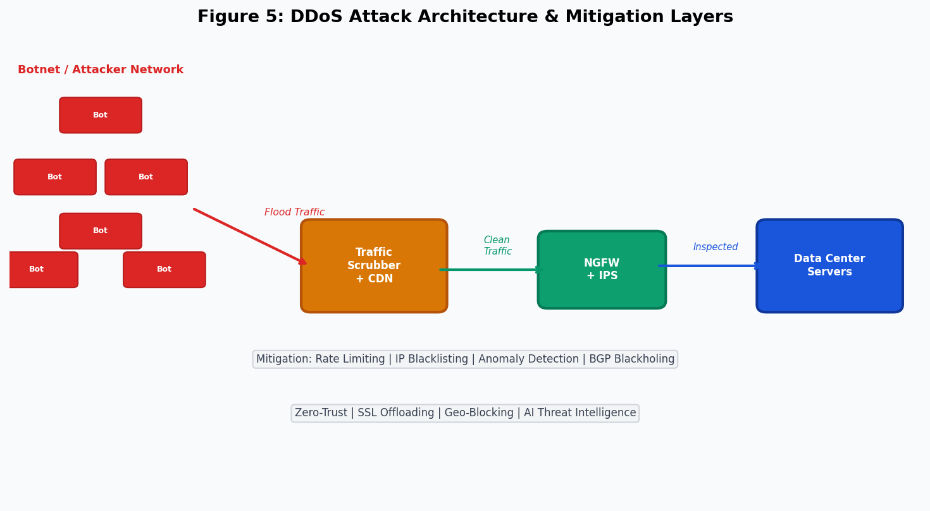
Figure 5: DDoS Attack Architecture and Multi-Layer Mitigation Strategy

9.2 Mitigation Mechanisms
Effective DDoS mitigation requires a multi-layer defense strategy. Upstream traffic scrubbing services, operated by DDoS mitigation providers such as Cloudflare, Akamai, and AWS Shield, detect and absorb attack traffic before it reaches the data center's ingress links. BGP blackholing allows operators to signal upstream ISPs to drop traffic destined for an attacked IP prefix, protecting the broader network at the cost of making the targeted service unreachable. Rate limiting, IP reputation-based filtering, and challenge-response mechanisms (such as CAPTCHA) are applied at the application layer to distinguish legitimate users from bots and attack sources.

9.3 Zero Trust Security Model
The zero trust security model operates on the principle that no user, device, or workload should be implicitly trusted based solely on its network location. Every access request must be explicitly authenticated and authorized, regardless of whether it originates from inside or outside the traditional network perimeter. In a data center context, zero trust is implemented through microsegmentation—applying granular firewall policies between individual workloads rather than relying on perimeter defenses—combined with strong identity verification using mutual TLS (mTLS) certificates for service-to-service authentication and continuous behavioral analytics to detect anomalous access patterns indicative of compromised credentials or insider threats.

9.4 Encryption and Key Management
End-to-end encryption using TLS 1.3 protects data in transit across all external communication channels. Internal traffic within the data center fabric is increasingly encrypted using IPsec or MACsec link-layer encryption to protect against insider threats and hardware-level interception. Key management infrastructure (KMI) using Hardware Security Modules (HSMs) provides tamper-resistant storage and cryptographic operations for private keys, preventing key extraction even in the event of a physical server compromise.

10. Scalability and Reliability Analysis

10.1 Virtualization and Containerization
Hardware virtualization using hypervisors such as VMware ESXi and KVM enables multiple isolated virtual machines to share a single physical server, improving resource utilization from typical bare-metal utilization rates of 10–15% to 60–80% or higher. Each VM maintains its own OS instance, network stack, and security context, providing strong isolation between workloads. Container-based virtualization using Docker and Kubernetes provides a lightweight alternative, sharing the host OS kernel across containers to reduce overhead and enable faster startup times, at the cost of weaker isolation guarantees.

10.2 High Availability and Fault Tolerance
Data center reliability is engineered across multiple redundancy layers. At the hardware level, redundant power supplies, cooling units, and network interface controllers eliminate single points of failure within individual servers. At the network level, the spine-leaf topology ensures that any single link or device failure reduces available bandwidth but does not interrupt connectivity. At the application level, services are replicated across multiple availability zones—physically isolated data center buildings within the same geographic region—with automated failover triggered by health monitoring systems when primary instances become unavailable. Active-active configurations route traffic to multiple replicas simultaneously, while active-passive configurations maintain warm standby instances ready to assume traffic within seconds of a primary failure.

10.3 Disaster Recovery
Business continuity planning for data centers involves maintaining geographically distributed replica sites capable of assuming production workloads in the event of a regional disaster. Recovery Point Objective (RPO) specifies the maximum acceptable data loss measured in time—typically zero or near-zero for financial systems. Recovery Time Objective (RTO) specifies the maximum acceptable time to restore service after an incident. Achieving aggressive RPO and RTO targets requires continuous data replication using technologies such as synchronous database replication for zero-data-loss guarantees or asynchronous replication with bounded lag for geographically distant replicas.

11. Proposed Improvements and Future Enhancements

11.1 AI-Driven Traffic Engineering
Machine learning models trained on historical traffic patterns can predict congestion events minutes in advance, enabling proactive rerouting before queues build up to the point of packet loss. Reinforcement learning agents can optimize ECMP hash seed selection and load balancer weights in real time, adapting to shifting traffic demands without manual intervention. Google has deployed AI-based cooling optimization in its data centers, reducing cooling energy consumption by 30%, and similar AI-driven optimization approaches can be applied to network resource allocation.

11.2 Edge Computing and Content Delivery
Migrating latency-sensitive processing closer to end users through edge computing deployments reduces round-trip latency for interactive applications and reduces backhaul traffic to central data centers. Content Delivery Networks (CDNs) already implement this principle for static content, caching popular objects at hundreds of globally distributed points of presence. Extending this model to stateful application logic using Mobile Edge Computing (MEC) within 5G network infrastructure enables sub-10-millisecond latency for applications such as autonomous vehicles, industrial automation, and augmented reality.

11.3 Intent-Based Networking
Intent-based networking (IBN) abstracts network management to the level of high-level business policies—"ensure that financial transaction traffic receives latency below 5ms" or "isolate healthcare workloads from general internet traffic"—and automatically translates these policies into device-level configurations. IBN systems continuously verify that the network's actual behavior matches the expressed intent, triggering automated remediation when deviations are detected. This approach reduces operational complexity, minimizes human configuration errors, and enables more agile response to changing business requirements.

11.4 Quantum-Safe Cryptography
The anticipated development of cryptographically relevant quantum computers within the next decade poses a fundamental threat to the RSA and elliptic curve cryptosystems currently protecting data center communications. The National Institute of Standards and Technology (NIST) has finalized the first post-quantum cryptographic standards in 2024, including the CRYSTALS-Kyber algorithm for key encapsulation and CRYSTALS-Dilithium for digital signatures. Data center operators should begin planning hybrid classical-quantum cryptographic deployments that maintain compatibility with existing systems while providing resistance to quantum attacks, ensuring that data encrypted today cannot be harvested and decrypted by future quantum computers.

11.5 Green Data Centers
Data centers currently account for approximately 1–2% of global electricity consumption, and this figure is projected to grow significantly with the expansion of AI training workloads. Green data center initiatives focus on improving PUE through advanced cooling technologies including liquid immersion cooling, direct-to-chip liquid cooling, and free-air cooling in suitable climates. Renewable energy procurement through Power Purchase Agreements (PPAs) enables operators to match their consumption with clean energy generation. Hardware efficiency improvements in server processors, network ASICs, and storage media contribute additional energy savings per unit of work performed.

12. Conclusion
Modern data center networks represent one of the most technically sophisticated achievements of contemporary engineering, integrating principles from networking protocol design, distributed systems, hardware architecture, and security engineering into coherent operational infrastructure. This report has examined the evolution from traditional three-tier hierarchical designs to the flat, non-blocking spine-leaf topologies that characterize hyperscale deployments, analyzing how each architectural decision is driven by specific operational requirements.

The analysis of application, transport, and network layer protocols demonstrates that no single protocol or mechanism is sufficient in isolation; rather, reliable and performant data center operation emerges from the careful integration of complementary technologies. HTTP/3 and QUIC address transport-layer limitations in lossy networks. TCP's congestion control algorithms prevent network collapse under high load. OSPF and BGP provide fast, scalable routing within and between autonomous systems. SDN enables centralized, programmable control of the network fabric. Together, these technologies provide the foundation upon which cloud computing services deliver billions of transactions daily.

Looking forward, the data center networking landscape will be shaped by the convergence of artificial intelligence-driven automation, edge computing architectures, intent-based networking paradigms, and post-quantum cryptographic standards. Organizations that invest in understanding and implementing these next-generation technologies will be positioned to meet the networking demands of an increasingly data-dependent global economy.

Appendix A: Evaluation Rubric
Component | Evaluation Focus | Weightage
Technical Understanding | Clarity of core networking concepts and correctness of protocol explanation | 25%
Analysis & Problem Solving | Depth of analysis, logical reasoning, and interpretation of system challenges | 25%
Application of Concepts | Relevance and accuracy in mapping theory to practical scenarios | 20%
Diagrams & Presentation | Effectiveness of visual representations and report clarity | 10%
Innovation & Improvements | Practicality, depth, and originality of technical recommendations | 10%
Formatting & References | Document organization, academic writing standards, and citations | 10%

13. References
- Tanenbaum, A. S., & Wetherall, D. J. (2021). Computer Networks (6th ed.). Pearson Education.
- Forouzan, B. A. (2022). Data Communications and Networking (5th ed.). McGraw-Hill Education.
- Stallings, W. (2022). Data and Computer Communications (11th ed.). Pearson Education.
- Arregoces, M., & Portolani, M. (2004). Data Center Fundamentals. Cisco Press.
- RFC 9000 – QUIC: A UDP-Based Multiplexed and Secure Transport. IETF, 2021.
- RFC 8446 – The Transport Layer Security (TLS) Protocol Version 1.3. IETF, 2018.
- RFC 7540 – Hypertext Transfer Protocol Version 2 (HTTP/2). IETF, 2015.
- RFC 793 – Transmission Control Protocol. IETF, 1981.
- RFC 791 – Internet Protocol. IETF, 1981.
- Singh, A., et al. (2015). Jupiter Rising: A Decade of Clos Topologies and Centralized Control in Google's Datacenter Network. ACM SIGCOMM Computer Communication Review, 45(4), 183–197.
- Greenberg, A., et al. (2009). VL2: A Scalable and Flexible Data Center Network. ACM SIGCOMM.
- NIST (2024). Post-Quantum Cryptography Standardization. National Institute of Standards and Technology.
- Cisco Systems (2024). Data Center Design and Architecture Guide. Cisco Validated Designs.
- AWS Architecture Center (2024). Amazon Web Services Well-Architected Framework. Amazon Web Services, Inc.
- Google Cloud (2024). Google Cloud Networking Overview. Google LLC.
- Microsoft Azure (2024). Azure Data Center Infrastructure Documentation. Microsoft Corporation.
- IEEE 802.1Q – Bridges and Bridged Networks (VLANs). IEEE Standards Association.
- RFC 4271 – A Border Gateway Protocol 4 (BGP-4). IETF, 2006.
- RFC 2328 – OSPF Version 2. IETF, 1998.
- Cardwell, N., et al. (2016). BBR: Congestion-Based Congestion Control. ACM Queue, 14(5).

