Interface Control
Version <1.0>
<09/04/2013>

VERSION HISTORY
Version # | Implemented  By | Revision  Date | Approved  By | Approval  Date | Reason
1.0 | < Rick> | <09/04/13> | <name> | <mm/dd/yy> | <reason>

Table of Contents
Interface overview
1.is_login 4
2.user_profile 5
3.User_Submission 6

1.Is_login
Is_login
Interface Type | Interface Url |  |  | Description |  |  |  |  |  | Page Location
<Post> | </function_all/ > |  |  | <Determine whether login> |  |  |  |  |  | < skoda_submission_Layer >
Parameter name |  |  |  |  | Parameter value |  |  |  |  | Parameter Required
Fun_type |  |  |  |  | Is_login |  |  |  |  | Y
Response Name |  |  | Response Status |  |  |  | Response Description | Response Format |  |  |  | Response Sample
state |  | 1 |  |  |  | Login Success |  |  | <Json> |  | {"state":"1","message":"suc"}
state |  | 0 |  |  |  | Login Failure
state |  | -1 |  |  |  | Host Error
message |  | suc |  |  |  | Description about login status
message |  | failure |  |  |  | Description about login status
message |  | error |  |  |  | Description about login status

2.User_Profile
User_Profile
Interface Type | Interface Url |  |  | Description |  |  |  |  |  | Page Location
<Post> | </function_all/ > |  |  | <User information> |  |  |  |  |  | < skoda_submission_Layer >
Parameter name |  |  |  |  | Parameter value |  |  |  |  | Parameter Required
Fun_type |  |  |  |  | user_profile |  |  |  |  | Y
Response Name |  |  | Response Status |  |  |  | Response Description | Response Format |  |  |  | Response Sample
state |  | 1 |  |  |  | Get User profile Success |  |  | <Json> |  | {"state":"1",  "message":"suc",  "profile":[  "username":"",  "headpic":"",  "typenum":""]}
state |  | 0 |  |  |  | Get User profile Failure
state |  | -1 |  |  |  | Host Error
username |  | <eg:”rick”> |  |  |  | User Name
headpic |  | <eg:”/images/01.jpg” > |  |  |  | User Head Picture url
Typenum |  | <eg:”1” > |  |  |  | Type of user
message |  | suc |  |  |  | Description about login status
message |  | failure |  |  |  | Description about login status
message |  | error |  |  |  | Description about login status

3.User_Submission
User_submission
Interface Type | Interface Url |  |  | Description |  |  |  |  |  | Page Location
<Post> | </function_all/ > |  |  | <User submission> |  |  |  |  |  | < skoda_submission_Layer >
Parameter name |  |  |  |  | Parameter value |  |  |  |  | Parameter Required
Fun_type |  |  |  |  | user_submission |  |  |  |  | Y
Draw_pic |  |  |  |  | <byte> |  |  |  |  | Y
Draw_name |  |  |  |  | <eg:”01”> |  |  |  |  | Y
Draw_desc |  |  |  |  | <eg:”fly skoda”> |  |  |  |  | Y
User_ Inspie |  |  |  |  | <eg:”01”>[“01/02/03/04/05/06”] |  |  |  |  | Y
User_Talent<”camp”> |  |  |  |  | <eg:”01”>[“01/02/03”] |  |  |  |  | Y
Head_pic |  |  |  |  | <byte> |  |  |  |  | N
User_name |  |  |  |  | <eg:”rick”> |  |  |  |  | N
Type_num |  |  |  |  | <eg:”01”> |  |  |  |  | N
Response Name |  |  | Response Status |  |  |  | Response Description | Response Format |  |  |  | Response Sample
state |  | 1 |  |  |  | Upload User profile Success |  |  | <Json> |  | {"state":"1",  "message":"suc"}
state |  | 0 |  |  |  | Upload User profile Failure
state |  | -1 |  |  |  | Host Error
message |  | suc |  |  |  | Description about login status
message |  | failure |  |  |  | Description about login status
message |  | error |  |  |  | Description about login status

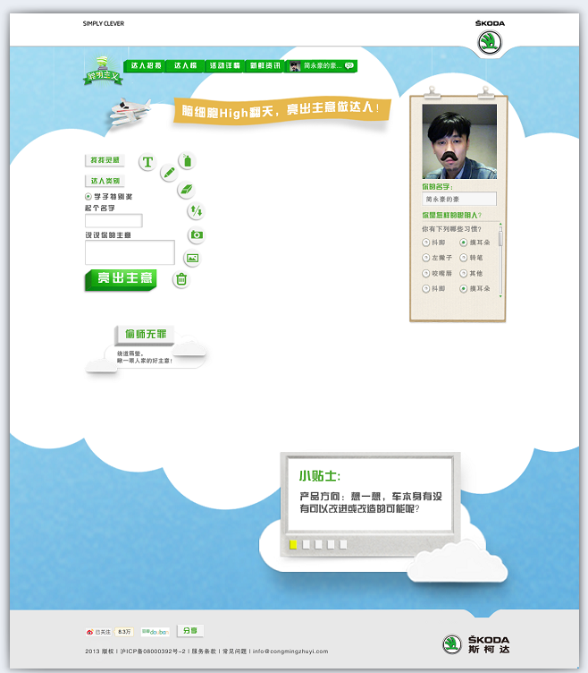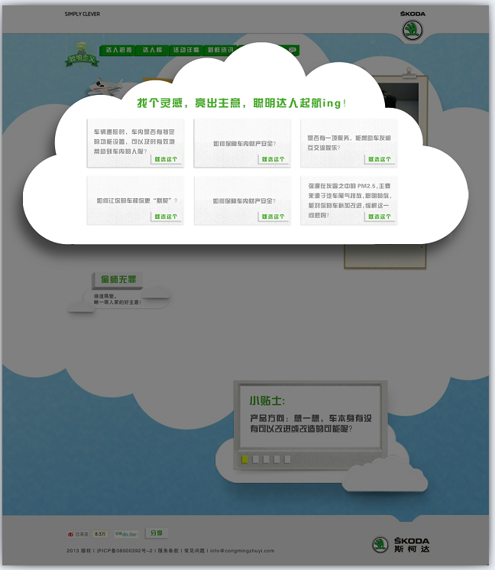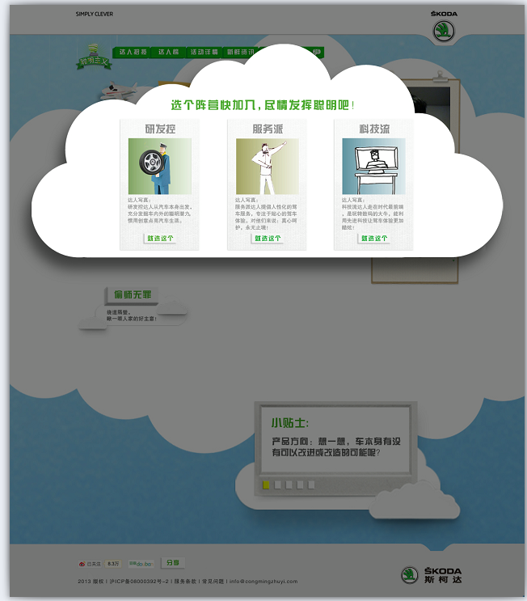
Draw_pic
Draw_name
Draw_desc
Head_pic
Type_num
User_name
User_ Inspie
User_Talent

Glossary
Term | Definition

