1. Final precision, recall and F1 score on the testing dataset.

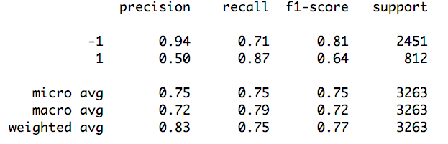

1. ROC curve (as image) on the testing dataset.

(Label 1 with probability 1, Label -1 with probability 0)

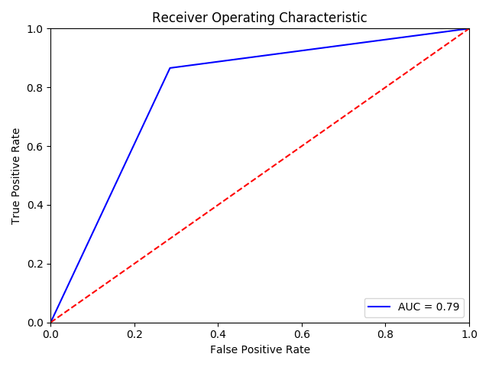

(Using my define to_prob() function for convert [1,0,1,0] result to probability)

