Complete CMSC203 Assignment 2 Implementation (Documentation)
Class: CMSC203 CRN 20798
Program: Assignment #2
Instructor: Professor Ahmed Tarek
Summary of Description: This program defines a Patient class and a Procedure class, then uses a driver class to read one patient and three procedures from the keyboard, display them, and display the total charges of the three procedures with two decimal places and comma separators.
Due Date: 09/30/2026
Integrity Pledge: I pledge that I have completed the programming assignment independently. I have not copied the code from a student or any source.

Part 1: Pseudo Code
Patient class
Declare fields: firstName, middleName, lastName, streetAddress, city, state, zip, phone, emergencyName, emergencyPhone
No-arg constructor: set all fields to empty strings
Constructor(first, middle, last): set the three name fields; other fields empty
Constructor(all 10 values): set every field
Accessor and mutator for each field
buildFullName: return first + " " + middle + " " + last
buildAddress: return street + " " + city + " " + state + " " + zip
buildEmergencyContact: return emergencyName + " " + emergencyPhone
toString: return name, address, phone, emergency contact using the three build methods

Procedure class
Declare fields: procedureName, procedureDate, practitioner, charges (double)
No-arg constructor: strings empty, charges 0.0
Constructor(name, date): set name and date; other fields default
Constructor(name, date, practitioner, charges): set every field
Accessor and mutator for each field
toString: return all four values separated by tabs, charges with two decimals

PatientDriverApp class
main:
Prompt for and read patient first, middle, last name
Create patient with the name constructor
Prompt for and set street, city, state, ZIP, phone, emergency name and phone
Procedure 1: create with no-arg constructor; prompt for and set all four attributes
Procedure 2: prompt for name and date; create with name/date constructor;
prompt for and set practitioner and charges
Procedure 3: prompt for all four values; create with the full constructor
(For every charges prompt: repeat until a valid, non-negative number is entered)
displayPatient(patient)
displayProcedure(procedure1), displayProcedure(procedure2), displayProcedure(procedure3)
total = calculateTotalCharges(procedure1, procedure2, procedure3)
Print total with a $ sign, commas, and two decimal places
Print "The program was developed by a Student: <Name> <M#> <Due date>"
displayPatient(patient): print patient.toString()
displayProcedure(procedure): print procedure.toString()
calculateTotalCharges(p1, p2, p3): return p1.charges + p2.charges + p3.charges

Part 2: Comprehensive Test Plan
Cases 1, 2, and 4 use valid input. Case 3 includes invalid charges (letters and a negative number) to check that the program re-prompts instead of crashing.
Cases | Input | Expected Output | Actual Output | Did Test Pass?
Case 1 | Patient: John Michael Smith, 123 Main Street, Gaithersburg, MD, 20877, 301-123-4567, emergency Jane Smith 240-555-0199  Blood Test 06/12/2026 Dr. Alice Brown 150.50  X-Ray 06/15/2026 Dr. Carlos Diaz 275.25  Physical Exam 06/20/2026 Dr. Emily Chen 99.99 | Patient info and all three procedures displayed  Total Charges: $525.74 | Patient info and procedures displayed as expected  Total Charges: $525.74 | Yes
Case 2 | Patient: Maria Elena Garcia, 4500 Georgia Avenue, Silver Spring, MD, 20910  MRI Scan, charges entered as 1,250.00  Surgery, charges entered as $8,400.75  Physical Therapy, charges 325.5 (one decimal) | Charges accepted with comma and $ sign  Each charge shown with two decimals  Total Charges: $9,976.25 | Charges: $1,250.00, $8,400.75, $325.50  Total Charges: $9,976.25 | Yes
Case 3 (invalid input) | Patient: Tom A Lee, 9 Oak Lane, Rockville, MD, 20850  Procedure 1 charges: "abc", then "-20", then 35  Procedure 2 charges: 25.00  Procedure 3 charges: 40 | "abc" rejected with an error message and re-prompt  "-20" rejected with an error message and re-prompt  35 accepted  Total Charges: $100.00 | "Invalid amount" shown for abc  "Charges cannot be negative" shown for -20  Total Charges: $100.00 | Yes
Case 4 (zero and large values) | Patient: Ava Rose Nguyen, 1 Elm Court, Bethesda, MD, 20814  Consultation charges 0  Lab Panel charges 75  Ultrasound charges 1000 | $0.00 accepted as valid  Total Charges: $1,075.00 | Charges: $0.00, $75.00, $1,000.00  Total Charges: $1,075.00 | Yes

Part 3: Screenshots
- One screenshot of the application running from the command prompt line.
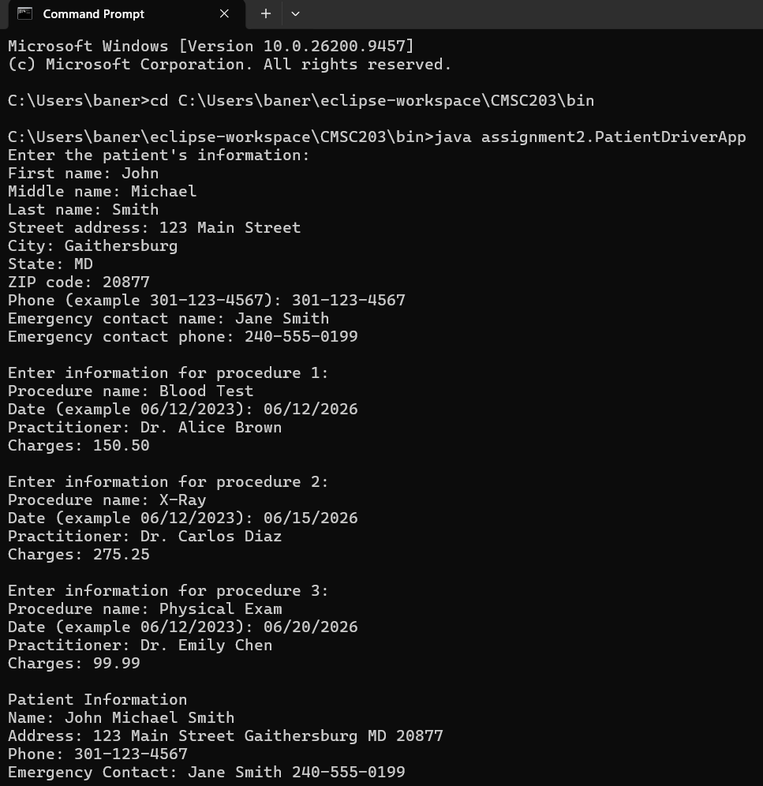
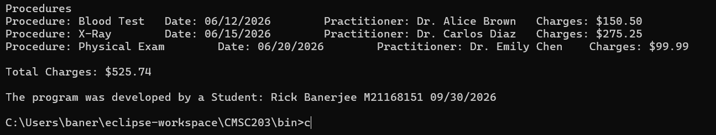

- One screenshot of the application running in your IDE.
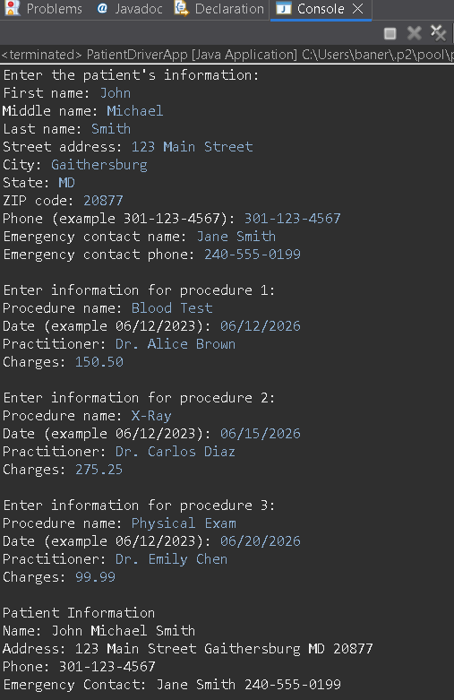
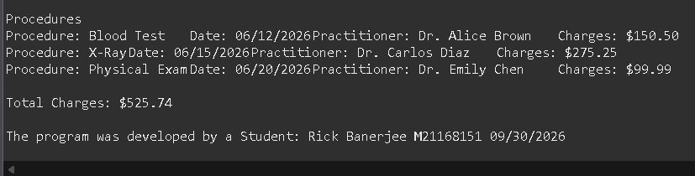
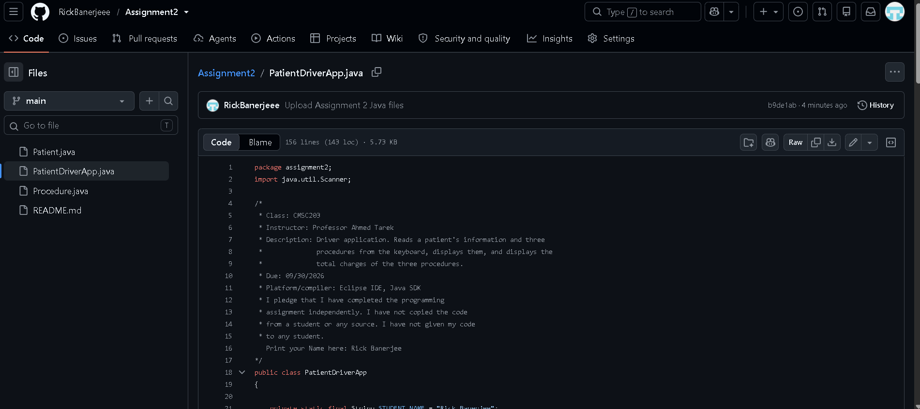
- Screen shot of Java file (Assignment1.java) in your GitHub repository.

UML Diagram
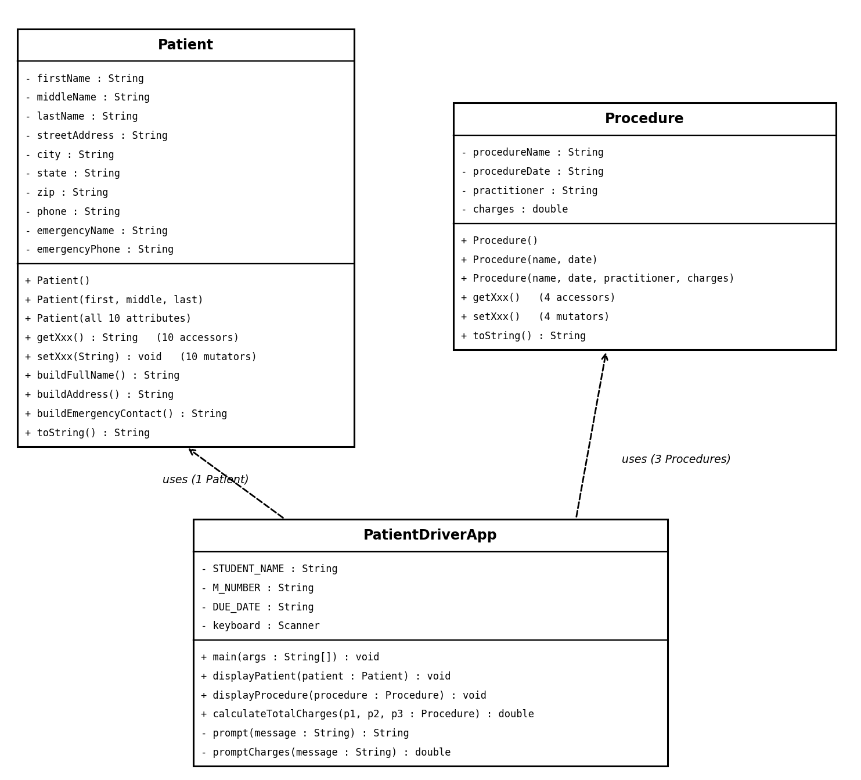
PatientDriverApp depends on Patient (one instance) and Procedure (three instances). Patient and Procedure do not depend on each other.

Lessons Learned

What have you learned?
I learned how to design classes using private fields, multiple constructors, accessors, and mutators. I also learned how constructor chaining with this(...) can help reuse code instead of repeating the same statements in multiple constructors. Another thing I learned was how helper methods such as buildFullName, buildAddress, and buildEmergencyContact can keep the toString() method shorter and easier to read. I also learned how to format monetary values using printf and %,.2f.
What did you struggle with?
The hardest part was keeping track of which constructor to use for each of the three Procedure objects and remembering to set the remaining attributes afterward. Handling invalid keyboard input for the procedure charges was also challenging at first. I was able to solve this by using a loop with try/catch and Double.parseDouble() so the program could continue asking for a valid amount.
What would you do differently on your next project?
On my next project, I would write the test plan and pseudocode before starting the coding. I would also test each class as I completed it instead of waiting until the end. Finally, I would start the assignment earlier so I have enough time to review the program and double-check the submission requirements.
What parts of this assignment were you successful with, and what parts (if any) were you not successful with?
I was successful with creating the Patient and Procedure classes, connecting them through the driver program, and getting the required output. All four of my test cases passed. One area I could improve is validating the date and phone number formats. Currently, the program accepts those values as plain text rather than checking whether they follow a specific format.
Additional resources/links/videos
Course textbook (Pearson Revel), Oracle Java documentation for String.format and Scanner, and class notes.

Check List
Check List: <Provide answers to the column Y/N or N/A >:

# |  | Y/N | Comments
 | Assignment files:
 | - FirstInitialLastName_ Assignment#_Moss.zip | Y
 | - FirstInitialLastName_Assignment#.docx/.pdf | Y
 | - Source java files | Y
 | Program compiles | Y
 | Program runs with desired outputs related to a Test Plan | Y
 | Documentation file:
 | - Comprehensive Test Plan | Y
 | - Screenshots related to the Test Plan | Y
 | - Screenshots of your GitHub account with submitted Assignment# (if required) | Y
 | - UML Diagram (if required) | Y
 | - Algorithms/Pseudocode (if required) | Y
 | - Flowchart (if required) | Not required
 | - Lessons Learned | Y
 | - Checklist is completed and included in the Documentation | Y

