Version: V0.6

Politieke historie web app

Plan van aanpak voor de politieke historie web app

HJ B

2022

Inhoudsopgave

Document management 2

Inleiding 3

Project description 3

Hard & Software requirements 3

Project idea 4

Website main(April, 2022) 4

Website Login(April, 2022) 4

Task index 5

Functional design(F.O.) 6

Use case diagram 6

User stories & Acceptation requirements 7

Epic A 7

Epic B 7

Graphical design 9

Screen design(login page) 9

Screen design(Main page) 10

Graphical screen design decisions 11

# Document management

|  |  |  |
| --- | --- | --- |
| **Version** | **Description** | **Date & time** |
| V0.1 | Document setup. | 21-04-2022 16:00 |
| V0.2 | Created task index & document management. | 27-04-2022 18:55 |
| V0.3 | User stories and acceptation criteria written for Epic A. | 29-04-2022 19:20 |
| V0.4 | User stories and acceptation criteria written for Epic B. | 30-04-2022 18:16 |
| V0.5 | Screen designs made for both epic A & B. | 03-05-2022 20:06 |
| V0.6 | Updated the graphical design | 04-05-2022 00:45 |

# Inleiding

## Project description

This document is the first iteration of the political history web app, the idea for this application I have had for some years now. This document will consist of a Plan of attack(PvA, plan van aanpak) and the functional design(F.O ,functioneel ontwerp).

The plan of attack will consist of the general idea for the application based on the idea interview, furthermore a task index will be made in order to track progress.

The functional design will consist of

* 1: Use case
* 2: Use case diagram
* 3:User stories
* 4:Acceptation criteria
* 5:Graphical design
* 6:Screen design
* 7:Decision index

the FO parts will be build using the above list of parts in order to build a logical and sound FO.

After the creation of the PvA and FO a TO(Technical design) could be made but is not a necessity, if the decision to write a TO has been made the TO will be explained in the section below this one.

## Hard & Software requirements

|  |  |  |
| --- | --- | --- |
| **Software** | **Implementation status** | **Description** |
| GitHub remote repository | Done(21-04-2022) | Version control system |
| GitHub local repository | Done(21-04-2022) | Version control system |
| Gitbash CMD | Done(21-04-2022) | Version control system |
| Xamp control panel | Done(21-04-2022) | Local online webservice |
| MySQL workbench | Done(21-04-2022) | SQL programming system |
| Php storm | Done(21-04-2022) | PHP programming system |
| IntelliJ IDEA | Done(21-04-2022) | Java programming system |
| Balsamiq wireframes | Done(21-04-2022) | Screen design system |
| Visual studio 2019 | Done(21-04-2022) | Programming modification |
| Visual paradigm | Done(21-04-2022) | Documentation editor |
| **Hardware** | **Implementation status** | **Description** |
| Desktop-UJTGGCQ | Done(19-04-2022) | Computer screen |
| Intel(R) Core(TM) i7-7800X CPU | Done(19-04-2022) | Computer core |
| 16.0 GB RAM | Done(19-04-2022) | Computer memory |
| x64 Processor | Done(19-04-2022) | Computer processor |
| Liquid cooling system | Done(19-04-2022) | Computer cooler |

# Project idea

## Website main(April, 2022)

**Epic A:** The user can access the webpage by using the URL: ***

The user can view a timeline of a nation’s history, the user has an overview of the “Head of the government”, “Head of the nation”, composition of major legislative bodies(like senate and house of representatives) and there chairman/women. All of this will be displayed in 1 horizontal Collom, underneath this Collom an actual horizontal timeline in years can be seen.

## Website Login(April, 2022)

**Epic B:** The user has the ability to log into his own account with which the user can sent a request for modification of the displayed information, the request will then have to be approved by the project leader.

The user can access the login page via a button in the upper right corner of the main website, The user is navigated to the login page, the user will have to fill in a username and password. If the user does not have an account yet the user can create one on the same page by switching from “Login” to “create account”, the user will have to fill in a unique username, password and fill in the account creation code supplied by the project leader.

# Task index

|  |  |  |  |
| --- | --- | --- | --- |
| Task | Required time | Time spend | Date completed |
|  |  |  |  |
|  |  |  |  |
|  |  |  |  |
|  |  |  |  |

# Functional design(F.O.)

## Use case diagram

(April, 2022) The main website will have 1 actor that will be able to have access to all functionalities presently. The basic functionalities of the user at this stage will be:

* Viewing the timeline
* Loging in the site
* Creating an account

This use case diagram may be expanded over time as more use cases are written, in that case a new Alinea with a date will be written underneath this text.

## User stories & Acceptation requirements

### Epic A

* **US01: The user has opened the main webpage and can view a timeline at the bottom of the page, from one specific year to another.**
  + **A:** *A horizontal line is visible at the bottom of the webpage.*
  + **B:** *A series of small vertical lines are visible, crossing the horizontal line.*
  + **C:** *A Series of long vertical lines are visible, crossing the horizontal line*.
  + **D:** *A set of 3 small vertical lines is visible between every 2 long vertical lines.*
  + **E:** *A year number is visible underneath every long vertical line.*
* **US02: The user has opened the main webpage and can view a horizontal table of information about a nations political history.**
  + **A:** *A horizontal rectangle is visible running parallel with the timeline.*
  + **B:** *A horizontal rectangle within the first is visible, containing an head of state title.*
  + **C:** *A horizontal rectangle within the first is visible, containing an head of gov title.*
  + **D:** *A horizontal rectangle within the first is visible, containing an 1e chamber chairman/women title and name.*
  + **E:** *A horizontal rectangle within the first is visible, containing an 1e chamber seat distribution + corresponding party/organisation colour.*
  + **F:**  *A horizonal rectangle within the first is visible, containing an 2e chamber chairman/women title and name.*
  + **G:** *A horizontal rectangle within the first is visible, containing an 2e chamber seat distribution + corresponding party/organisation colour.*
  + **H (Optional)*:*** *A horizontal rectangle within the first is visible, containing an vote distribution corresponding to the last head of state referendum(General election).*

### Epic B

* **US03: The user has opened the main webpage and clicked on login, the login page is displayed and the user can login into an account.**
  + **A:** *A horizontal rectangle is visible on the main webpage top.*
  + **B:** *A functional button is located on the main webpage upper top right corner.*
  + **C:** *A new webpage is opened when the login button is clicked.*
  + **D:** *The login page contains a username text field and label.*
  + **E:** *The login page contains a password text field and label.*
  + **F:** *The login page contains a login button beneath the 2 text fields.*
  + **G:** *The login page contains a create account button beneath the previous button.*
  + **H:** *If the username and password combination is correct and the login button is pressed re-open the main webpage.*
  + **I:** *When logged into a account the login button on the main web page upper right top is changed to the account username.*
  + **J:** *When clicked on the username a dropdown menu opens downwards.*
* **US04: The user has opened the main webpage and clicked on login, the login page is displayed and the user can create an new account.**
  + **A:** *On the login page when the user has clicked on the create account button, a create account code text field and label are added.*
  + **B:** *On the login page when the user has clicked on the create account button, the login button changes to the create button.*
  + **C:** *On the login page when the user has clicked on the create account button, the create account button is changed to login account.*
  + **D:** *On the login page when the user has clicked on the create account button, a second password text field and label are added.*
  + **E:** *If the user has filled in the username text field, password text fields and the create account code text field correctly, a “Account creation successful!” label will be shown.*
  + **F:** *If the user has not filled in the username text field, password text fields and the create account code text field correctly, a “Fil in the required fields correctly” label will be shown.*
  + **G:** *If the user has successfully created a new account the user will be navigated to the login page*
* **US05: The user when logged in, can switch to edit mode and sent a request for modification of the displayed information to the project leader.**
  + **A:** *The main webpage contains an edit button at the upper left corner.*
  + **B:** *The main webpage contains a circle around the edit button.*
  + **C:** *The edit button is only visible when logged into an existing account.*
  + **D:** *If the edit button is pressed all labels displaying information are changed to text fields.*
  + **E:** *When the edit button is pressed the edit button is changed to the save button.*
  + **F:** *If the save button is pressed the changed information is saved and sent to the database.*

## Graphical design

### Screen design(login page)

### Screen design(Main page)

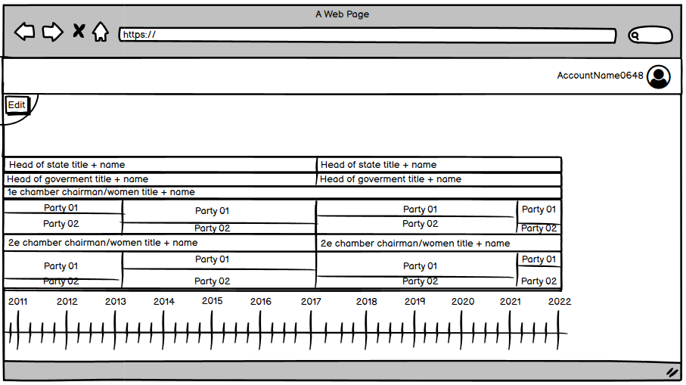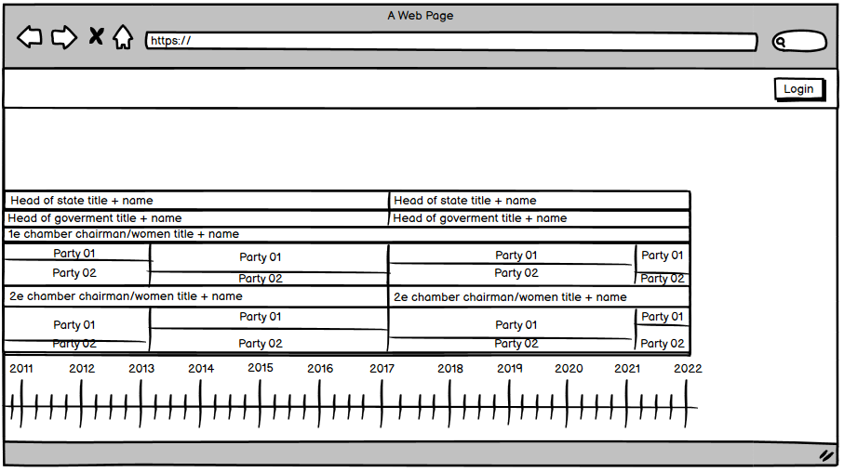

### Graphical screen design decisions

The main webpage aesthetic will be one of a professional, logical and clearly historical timeline.

Colour will not be widely used and only applied as a alternative to text or accentuation of the timelines historical aesthetic.

Situations where colour will be applied are:

* Inner border of the head of state title card according to party affiliation
* Inner border of the head of government title card according to party affiliation
* Inner border of the 1e chamber chairman/women title card according to party affiliation
* Inner border of the 2e chamber chairman/women title card according to party affiliation
* Inner border of the opposition party in the 1e chamber seat distribution card
* Inner border of the opposition party in the 2e chamber seat distribution card
* Slashed background of the government party in the 1e chamber seat distribution card
* Slashed background of the government party in the 2e chamber seat distribution card