***Developmental changes in children’s drawings of objects: a large-scale observational study***

Bria Long, Judy Fan, Zixian Chai, & Michael C. Frank

Children draw prolifically from an early age, providing a rich source of insight into their emerging understanding of the world around them. We capitalize on this opportunity to build a large-scale database of children’s drawings of common object categories, with the broad goal of understanding how changes in drawings may relate to changes in how children represent the diagnostic properties of these categories. Previously, we have found that drawings produced by older children (7-10 years) tend to be more recognizable to adult viewers than drawing produced by younger children (3-6 years; Long, Fan, & Frank, 2018). Here we explore the hypothesis that such developmental changes reflect an increasing ability to emphasize the relevant visual distinctions between object categories that support successful recognition.

We installed a free-standing drawing station in a local science museum, and invited children to play a simple drawing game. Each participant sat at a table-mounted touchscreen display. On each trial, a video of an experimenter verbally prompted children to draw a particular object category (e.g., “What about a dog? Can you draw a dog?”); children had up to 30 seconds to complete their drawings with their fingers. So far, 1447 participants aged 2-10 years have contributed 7326 drawings from 16 object categories (airplane, bike, car, boat, chair, couch, house, cup, bowl, phone, person, bird, dog, fish, rabbit, tree). Raw drawing data were conservatively screened for task compliance using a combination of manual and automated procedures (i.e., excluding blank drawings, pure scribbles, and drawings containing words), resulting in the exclusion of 8.8% of drawings.

To quantify visual discriminability between drawings, we use a modern computer vision algorithm (Simonyan & Zisserman, 2014) to measure their representations in a high-level visual feature space known to support visual object categorization of both drawings and photographs of objects (Fan, Yamins, & Turk-Browne, 2018). For each age group and object category, we computed the mean feature vector (*center*), as well as the root-mean-squared deviation of drawings from the category center (*dispersion)*. Next, for each pair of object categories within each age, we used these estimates of the category center and dispersion to compute a high-dimensional analogue of d-prime. Overall, we found that the visual discriminability between all categories increased throughout childhood, plateauing around 7 years of age (mean d-prime across category pairs, 2-yrs, *M*=0.3, 3-yrs, *M*=0.27, 4-yrs, *M*=0.35, 5-yrs, *M*=0.42, 6-yrs, *M*=0.45, 7-yrs, *M*=0.49, 8-yrs, *M*=0.49, 9-yrs, *M*=0.51).

As children get older, they are increasingly able to produce drawings of objects that distinguish categories from one another. Future work will expand this dataset and analysis to a broader range of object categories as well as examine how changes in children’s drawings parallel developments in their explicit knowledge about which features (e.g., long ears) tend to be diagnostic of which categories (e.g., rabbits). More generally, we hope that this dataset will help shed light on broad developmental changes in how children express what they are learning.

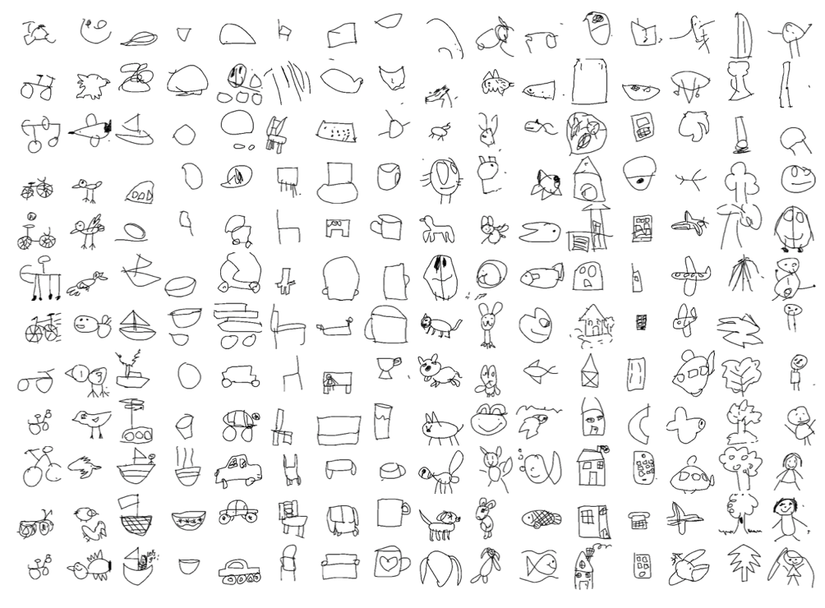*Figure 1.* Example drawings from our 16 categories by children made at the station. Drawings within each category are ordered by the age of the drawer from youngest (top) to oldest (bottom) child.

***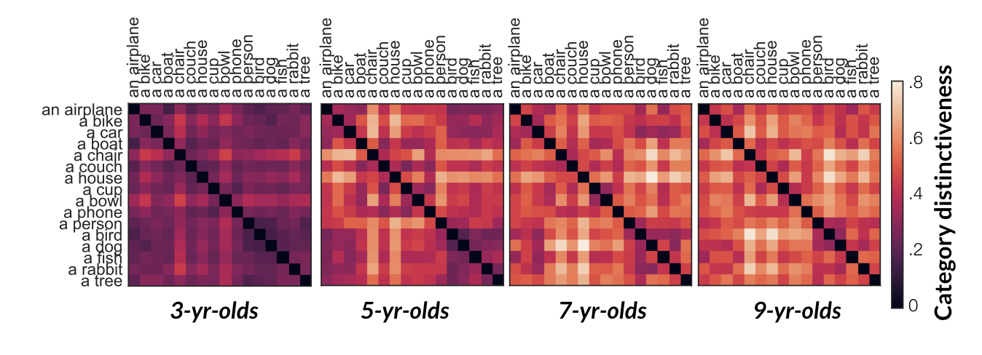****Figure 2.* Pairwise category distinctiveness for drawings made by 3-, 5-, 7-, and 9-year-olds; darker values present pairs of categories that have more overlapping representations this feature space;lighter values represent pairs of categories with more distinctive representations.