***The role of memory in children’s drawings***

Bria Long, Judy Fan, Yi Feng, Zixian Chai, & Michael C. Frank

Children’s drawings of object categories (e.g., rabbit, cat) become more recognizable as they get older, including visual features that distinguish these categories from one another (e.g., longer ears when drawing a rabbit; Long, Fan, & Frank, 2018). Why might younger children not include these diagnostic features? Perhaps younger children have a harder time explicitly recalling what objects in these categories typically look like. To test this hypothesis, we examined whether children would draw more recognizable versions of objects when they were provided with a visual reminder.

Sixty children 4-7 years of age were randomly assigned to one of three conditions: in the *semantic* condition, children were prompted only with a verbal cue (e.g., “Can you draw a rabbit?”); in the *working memory* condition, they heard the same verbal cue and also briefly viewed (5s) a picture of a prototypical exemplar from this category; in the *perception* condition, children were instructed to draw the exemplar depicted in the same picture (e.g., “Can you draw this rabbit in this picture?”), Children drew with their fingers on a digital tablet and familiarized themselves with the interface at the beginning of each session by tracing three simple shapes. Next, they drew five real-world objects (i.e., cup, shoe, rabbit, cat, train) in a random order; completing each drawing in 30s or less. The recognizability of children’s drawings was assessed by measuring how often naive adult participants (*N*=30 raters per image, N=90 adults total) could correctly identify which category the drawing meant to depict (out of 22 alternatives, including the 5 actual objects and 17 foil objects).

The proportion of adults who recognized each drawing was modeled in a linear mixed-effects model as a function of children’s age (in years) and drawing condition (semantic vs. working memory vs. perception), with random slopes for objects and random intercepts for participants. Consistent with prior work, we found a strong effect of age; older children produced more recognizable drawings (b = 0.362, SE =0.064, z = 5.632, p =0.001). Overall, we did not find that children produced more recognizable drawings in the perception (accuracy=0.291) or working memory conditions (0.366) than the semantic condition (0.403). However, we found an interaction between age and condition (b=0.127, SE=0.061, z= 2.095, p=0.041), reflecting greater age-related variation in recognizability in the perception condition. While adults produce more recognizable drawings when provided with visual cues (Fan, Yamins, & Turk-Browne, 2018), younger children did not. Future work will seek to replicate this interaction using a broader age range and set of visual categories. Taken together, this work suggests that younger children did not use the visual reminders to include more category-diagnostic features in their drawings, and thus that a memory retrieval failure may not fully explain age-related changes in the recognizability of children’s drawings.

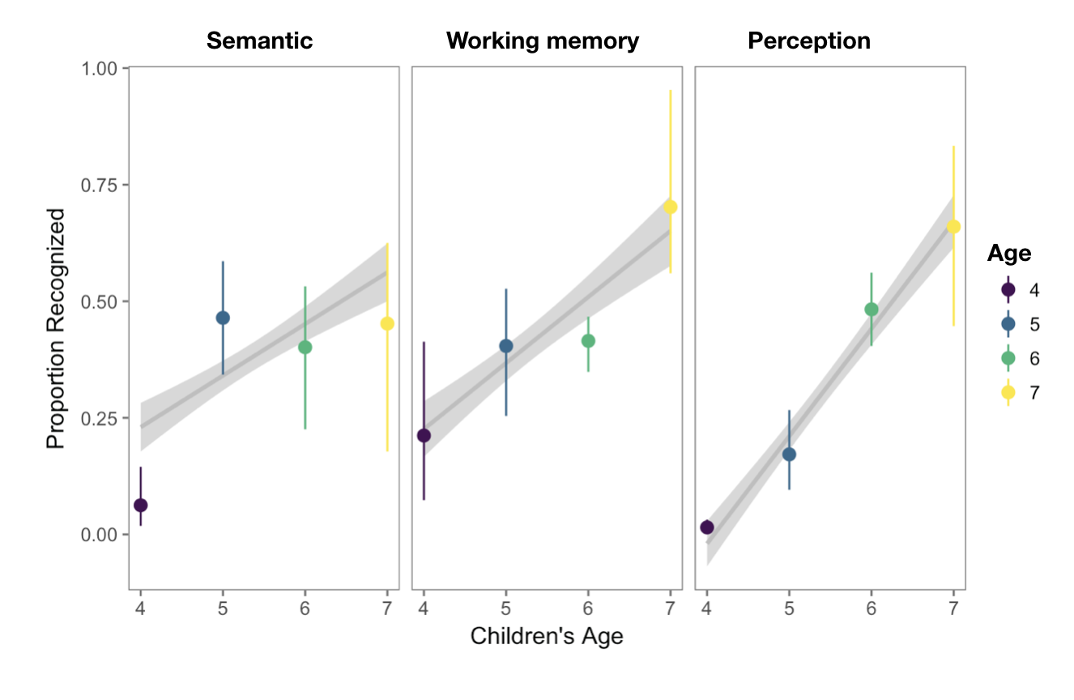

*Figure 1.*Proportion of children’s drawings that were recognized as a function of the children’s age group and the drawing condition. Error bars represent 95% bootstrapped confidence intervals; lines represent model predictions from a linear mixed-effect model. All analyses are available at the public repository for this manuscript: <https://osf.io/8s7qy/>

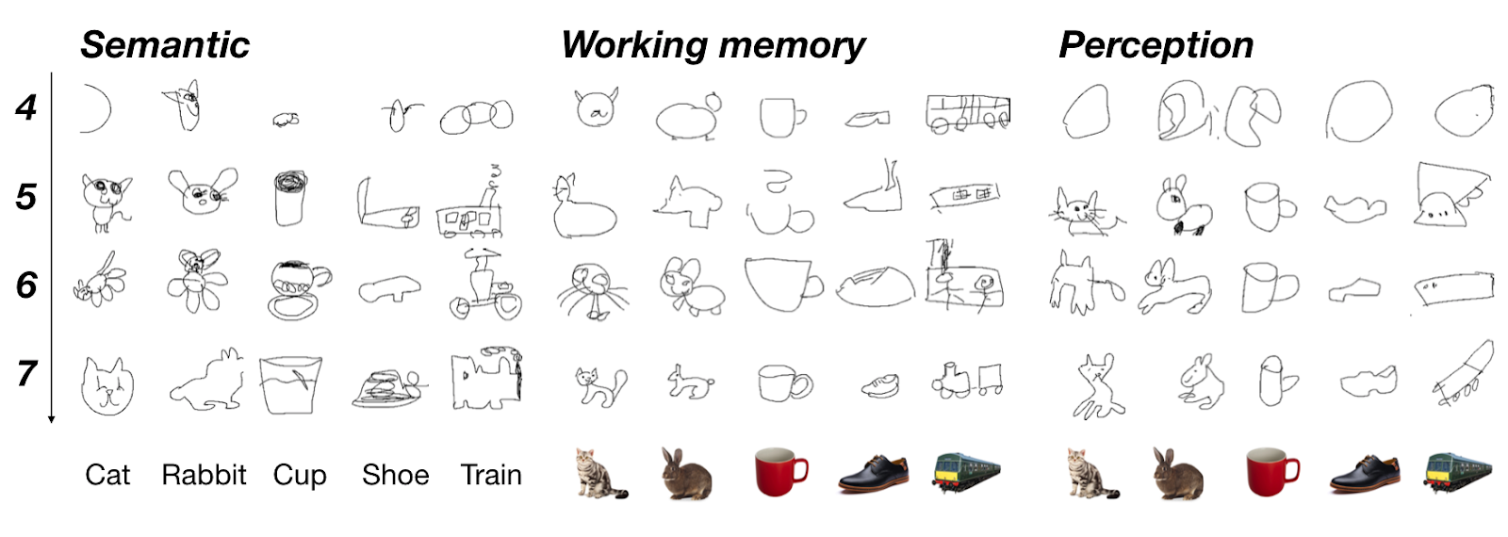

*Figure 2.*Example drawings in each condition ordered by age and category; the photo cues used in the working memory and perception condition are shown below these drawings.