***Children’s drawings increasingly reflect relevant visual distinctions between categories***

Children draw prolifically from an early age, providing a rich source of insight into their emerging understanding of the world. To understand how changes in drawings relate to changes in how children represent the diagnostic visual properties of these categories, we build a large-scale database of children’s drawings of common object categories with the. Here, we explore the hypothesis that developmental changes in the recognizability of children’s drawings reflect an increasing ability to emphasize the relevant visual distinctions between object categories.

We installed a free-standing drawing station in a local science museum, and invited children to play a simple drawing game on a touchscreen display. On each trial, a video of an experimenter verbally prompted children to draw a particular object category (e.g., “What about a dog? Can you draw a dog?”); children had up to 30 seconds to complete their drawings with their fingers. So far, 1447 participants aged 2-10 years have contributed 7326 drawings from 16 object categories. Raw drawing data were conservatively screened for task compliance, resulting in the exclusion of 8.8% of drawings.

We use a modern computer vision algorithm to measure drawings’ representations in a high-level visual feature space (VGG-19 embeddings) known to support visual object categorization of both drawings and photographs of objects. For each drawing, we trained a logistic regression using the features from all other sketches and their target categories and used the weights from this classifier to predict the category membership of the left-out drawing. We found that classification accuracy increased with children’s age, and that these gains in classification were not accounted for low-level covariates (time spent drawing, ink used, number of strokes).

As children get older, they are increasingly able to produce drawings of objects that distinguish categories from one another. (more again)

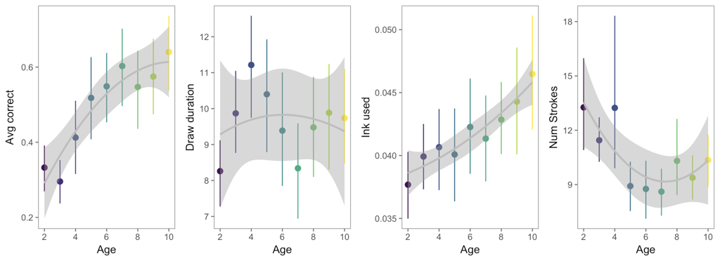

***Figure 1.*** Classification accuracy (A), amount of time spent drawing in second (B), the amount of ink used (i.e., mean intensity of the drawings) (C), and the number of strokes used (D) are plotted as a function of children’s age.

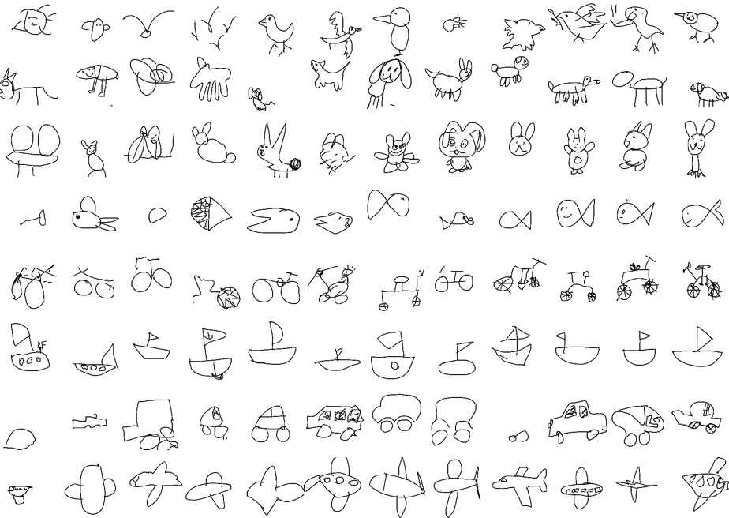

***Figure 2.***Randomly sampled drawings from eight categories ordered by the probability that the sketch was assigned to the correct target category; all sketches depicted here were correctly classified.