IFC Alignment Geometry Implementation Guide
  - A developer’s guide to IFC4x3 alignment geometry
Revision: 14 Oct 2026
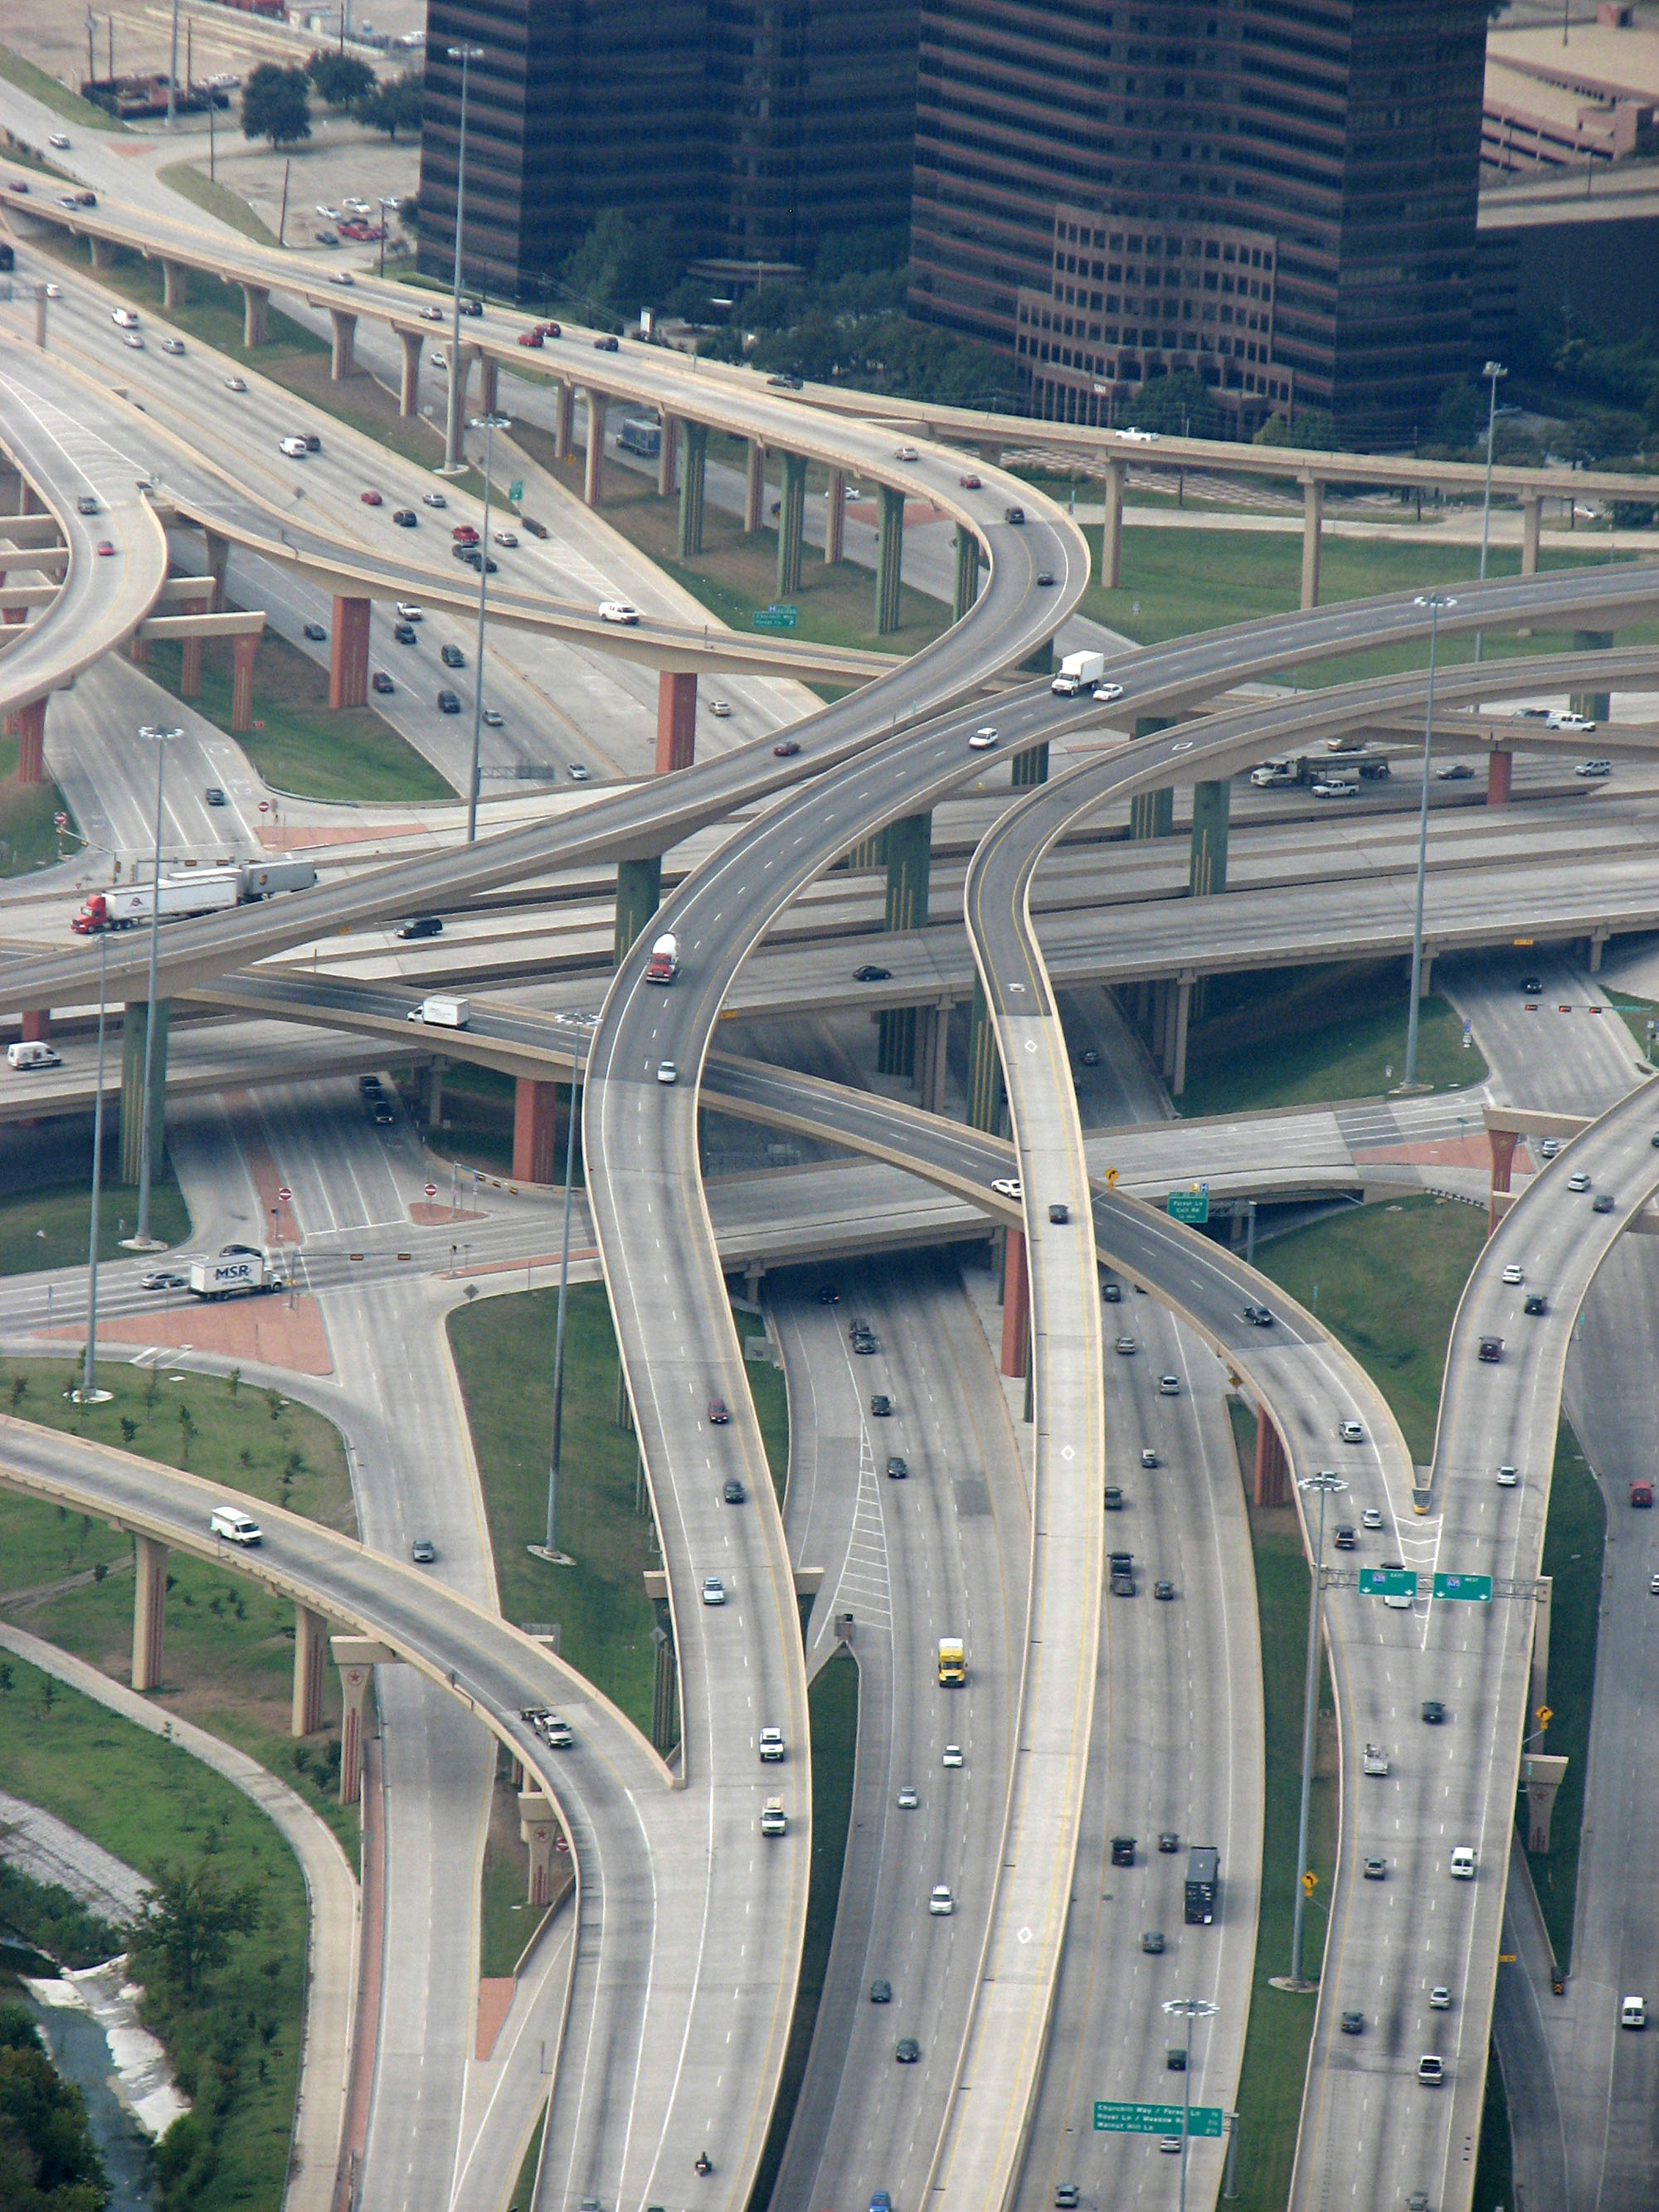
High Five Interchange at the intersection of I-635 and U.S. Route 75 in Dallas, Texas
Photo by austrini — CC BY 2.0 via Wikimedia Commons

Foreword
IfcAlignment, and the related geometric concepts, are new to the IFC 4x3 specification. By expanding IFC into the infrastructure domain, an entirely new audience has been summoned into the buildingSMART community. I am one of those new arrivals.
The IFC specification is highly technical and written with the expectation that the reader already has substantial IFC experience. There is no hand-holding for the newcomer, and industry guidance documents for the infrastructure and alignment aspects of IFC 4x3 are scarce.
My entry point was a practical one: I wanted to view the IFC4x3 models I was exporting from PGSuper, the prestressed concrete bridge design application at the heart of the BridgeLink software suite. No IFC viewer I could find was capable of rendering the alignment geometry correctly, so I built one by enhancing the IfcOpenShell toolkit to evaluate alignment geometry which enabled Blender/Bonsai to render alignment models.
As a bridge engineer with more than 35 years of experience at the Washington State Department of Transportation, I am well versed in highway alignment geometry as it is practiced in bridge and transportation engineering. Even so, I was completely overwhelmed by how alignment geometry is represented in the IFC specification. Things like railway alignments with cant and polynomial spiral transition curves were new to me. Developing working code required considerable research, hand calculations, and implementation experimentation across the many aspects of IFC alignment geometry.
This guide grew out of that experience. I have spent my career building tools that make complex engineering knowledge accessible and actionable — from prestressed concrete design software to recommended practices for girder stability. This document is written in that same spirit: to capture what I have learned about IFC 4x3 alignment geometry and provide practical guidance for developers implementing it in their own applications. I hope it saves others the many hours of confusion I experienced, because in the end, IFC is about interoperability. We all need a shared understanding of infrastructure alignment concepts and geometry to successfully exchange information.
Some sections of this guide were drafted with the assistance of an AI writing tool. All technical content — the mathematics, the IFC schema interpretations, and the implementation guidance — has been reviewed and verified by the author.
Richard Brice, PE

Revision Log
Date | Description | By
30 Jun 2026 | Chapter 8 revised and expanded: reorganized offset/unreachable-points content into §8.2.1, added §8.2.2 (Stationing and DistanceAlong) and §8.3.3 (Linear Placement Example), and updated/added several figures. | R. Brice
6 Jul 2026 | Chapter 8 cleanup following the 30 Jun restructuring: removed an unused figure, fixed stale cross-references, and regenerated Figure 8.2.1-1. | R. Brice
7 Jul 2026 | Chapter 8 §8.2/§8.3 rewritten to separate IfcAxis2PlacementLinear’s Location and Orientation roles, anchored on BasisCurve’s tangent; fixed Figure 8.1.2-2 units, and added a §12.3.4 vertical-offset test case. | R. Brice
8 Jul 2026 | Chapter 9 §9.5.2 example reworked with a non-zero starting station to clarify Station vs. DistanceAlong; Figure 9.5.2-1 extended with IfcAlignment, a second IfcRelPositions, and a starting-station referent; §9.6 checklist updated. | R. Brice
9 Jul 2026 | Chapter 9 updated to cover the Product Span Positioning concept. | R. Brice
10 Jul 2026 | §9.5 rewritten per ISO 19148 §6.2.12.1. | R. Brice
13 Jul 2026 | §9.5.3 simplified: IfcAnnotation removed from the intersection-referent correlation pattern. | R. Brice
15 Jul 2026 | §10.5.4 expanded to cover cross-section/string-line redundancy. | R. Brice
17 Jul 2026 | Chapter 10 expanded to cover an additional guide-curve rooting and tag scoping technique, with examples and figures updated to match. | R. Brice
31 Jul 2026 | Chapter 10 §10.5 restructured around bSI-InfraRoom/IFC-Specification#118 (the guide-curve mechanism’s origin issue) | R. Brice
1 Aug 2026 | Added §9.3.4 (Key-Point Referents) and §9.5.2 (IfcRelInterfersElements) | R. Brice
5 Aug 2026 | §9.3.4 corrected: key-point referents nest to IfcAlignment (Concept Template 4.1.4.4.3 Object Nesting) | R. Brice
13 Oct 2026 | Helmert test data corrected. The HELMERTCURVE test cases (horizontal and cant, all unit variants) and the BPaimio–Kupittaa real-world alignment were generated with an IfcOpenShell defect. The second half of each Helmert curve was placed using the heading at the x coordinate the integration had reached, θ(x), instead of the heading at arc length s, θ(s). Every Helmert curve therefore had a heading kink at its midpoint and ended away from the curve its design parameters describe. The geometry IFC, semantic terminator segments, reference CSVs and plots have been regenerated. Implementations validated against the old Helmert reference data will now differ from it by up to about 2.2 cm (0.071 ft) in position and 4.35 × 10⁻⁴ rad in direction at the end of the curve (100 m transition from R 300 m to R 1000 m). The difference is zero over the first half of the curve and grows over the second half. An implementation that matched the old data reproduced the defect; one that follows §2.7 now matches. The real-world 3D reference CSVs are now sampled at every metre instead of at 100 equal intervals. The §2.7.2/§2.7.3 worked example’s parent-curve position, normalization matrix and raw-spiral integrals were also corrected; these were arithmetic errors unrelated to the defect. | R. Brice
13 Oct 2026 | Test set and example models regenerated with the current IfcOpenShell. Cant transitions that start with the left rail canted (right-hand exit and arc-to-arc transitions, and all right-hand Viennese bends) had their cross-slope axis leaning the wrong way, and the second half of each Helmert cant transition started half way in sine rather than half way in angle between the start and end cross slopes. Implementations validated against the old cant reference data will now differ from it in the Axis/cross-track columns, by up to 0.213 where the lean was reversed; positions and the horizontal and vertical reference data are unchanged. Stationing referents no longer have an IfcRelPositions to the alignment (§9.3). In the example models the starting referent is now placed on the alignment curve instead of at the world origin, and offset-curve alignments carry their own stationing referent. The FHWA key-point referents are renamed to the "E-Line 119+56.79 (P.C.)" form (§9.3.4). The §4.5 Helmert cant worked example now places the second half at the interpolated cross slope, 1.517361336 rad, instead of 1.517437677 rad, matching the regenerated data; §4.5.3 is recomputed, and its trim-start elevation (0.04 m, not 0.16 m), trim-start cross slope and interpolation formula are corrected. | R. Brice
13 Oct 2026 | §4.1.3/§4.2 cant evaluation algorithm aligned with IfcOpenShell: the end cross slope is that of the next segment’s Placement.Axis; the placement’s Y is normalized; the parent-curve frame uses RefDir and Axis as computed, without re-orthogonalizing; and the trim-start translation is local (0). The §4.5.3 worked example now reproduces IfcOpenShell’s evaluation of the test set to 1e-16. | R. Brice
13 Oct 2026 | Chapter 4 cant worked examples (§4.3, §4.4, §4.6-§4.10) recomputed with the §4.2 algorithm. Each now reproduces IfcOpenShell’s evaluation of the corresponding test set file and the mapping excerpts match the test set. Corrected along the way: hand-derived vectors that disagreed with the matrices, §4.4’s parent-curve elevation (IfcClothoid has no constant term, so D(0) = 0), §4.6’s start elevation (0, not 0.08 m), §4.9’s end cross slope, and §4.10’s vertical matrix (swapping rows and columns of a flat-grade M_v gives the identity). §4.13 gains two checklist items. | R. Brice
13 Oct 2026 | Cant and spiral reference data regenerated with a corrected IfcOpenShell. The cant slope along the track (the RefDir of the cant frame) for IfcClothoid, IfcCosineSpiral and IfcSineSpiral parent curves was L times too small, so the LINEARTRANSITION, COSINECURVE and SINECURVE cant reference CSVs change in their RefDir and cross-track columns by up to 1.6e-3. IfcOpenShell now also integrates spiral positions more accurately, so spiral positions in the horizontal, cant 3D and real-world reference CSVs change by up to 1.3e-5 m and now agree with an independent evaluation to the CSVs’ rounding. The test set IFC files are unchanged. | R. Brice
14 Oct 2026 | §4.2 cant frame corrected. The slope of the deviating elevation was placed in the lateral ($y$) component of RefDir, which turned RefDir sideways instead of pitching it, and the frame was not orthonormal. The frame is now a rotation: the cross section is pitched by the slope of the deviating elevation and rolled by the cross slope, so RefDir is the tangent of the 3D curve and Axis is exactly perpendicular to the railheads. Step 5 combines the grade and the cant slope as one slope. The worked examples (§4.3–§4.10), checklist items 7–8 and the notation are updated, and IFC_Spec_Issues_Summary.md #37 records that IFC4x3 does not define this frame. | R. Brice
14 Oct 2026 | Test set regenerated with the corrected cant frame. The cant reference CSVs now give RefDir_dx, RefDir_dy, RefDir_dz, Axis_dx, Axis_dy and Axis_dz; RefDir_dy is computed and checked to be exactly 0, and the slope of the deviating elevation is in RefDir_dz. Direction columns of the cant and cant 3D CSVs change by up to 1.9e-3; positions do not change. The cant 3D frames are now orthonormal and RefDir follows the 3D curve. The same regeneration corrects the test set IFC files: the end points of horizontal spirals (up to 4.2e-6 m; now within 3e-14 of the exact curve), the midpoint placement of Helmert curves (up to 1.8e-7 m) and the vertical segment distances of the survey-foot parabolic arc cases (up to 1.5e-6 ft). | R. Brice

Table of Contents
Chapter 1 — IFC Alignment Concepts 1
Chapter 2 — Horizontal Alignments 10
Chapter 3 — Vertical Alignments 51
Chapter 4 — Cant Alignments 69
Chapter 5 — Offset Curves 110
Chapter 6 — Approximate Alignment Geometry 117
Chapter 7 — Alignments Reusing Horizontal Layout 119
Chapter 8 — Linear Placement 125
Chapter 9 — Referents and Stationing 140
Chapter 10 — Sectioned Surfaces and Solids 163
Chapter 11 — Precision and Tolerance 188
Chapter 12 — Alignment Geometry Testset 192
Chapter 13 — References 207
Appendix A — LandXML to IFC Conversion 209

Notation
Scalars and Parameters
Arc-Length and Distance
Symbol | Definition
$$s$$ | Arc-length parameter along the parent curve
$$s_{0}$$ | Arc-length at the start of the trim; equals SegmentStart
$$L$$ | Segment length; equals SegmentLength
$$l$$ | Horizontal distance from the segment start; evaluation variable in vertical and cant sections
$$d$$ | Distance measured along the horizontal IfcCompositeCurve
$$d_{0}$$ | Distance along at the trim start; $d_{0}=x(s_{0})$
$$h_{l}$$ | Horizontal length of a vertical segment; equals HorizontalLength
Angles
Symbol | Definition
$$θ(s)$$ | Bearing angle at arc-length $s$ in the horizontal plane
$$θ(l)$$ | Tangent angle at horizontal distance $l$; grade angle $\tan^{-1}(g(l))$ in the vertical plane; slope of deviating elevation $\tan^{-1}(D^{'}(l))$ in the cant plane
$$θ_{0}$$ | Tangent angle at the trim start $s_{0}$
$$θ_{p}$$ | Tangent angle of IfcCurveSegment.Placement.RefDirection
$$θ_{v}$$ | Grade direction angle; $θ_{v}=\tan^{-1}(dy_{v}/dx_{v})$
$$ϕ$$ | Cross-slope angle; angle from the transverse $y$-axis to the Axis vector
$$ϕ_{s}, ϕ_{e}$$ | Cross-slope angle at the start and end of a cant segment
$$ϕ_{p}$$ | Cross-slope angle of IfcCurveSegment.Placement.Axis
$$ε$$ | Pitch correction in the cant 3D composition; $ε=\tan^{-1}(g+D^{'})-\tan^{-1}(g)-\tan^{-1}(D^{'})$ (Section 4.2, Step 5)
$$Δ$$ | Sweep angle of a circular arc; angle subtended at the center by the arc from the trim start to an evaluation point
$$Δ_{0}$$ | Angular position of the trim-start point on the parent circle; angle from the circle’s positive $x$-axis to the radius vector at the trim start (Section 3.4)
$$Δ_{pc}$$ | Radial angle at the evaluation point on the parent circle; $Δ_{pc}=Δ_{0}-Δ$ for a clockwise segment, $Δ_{0}+Δ$ for counter-clockwise (Section 3.4)
Curvature and Radius
Symbol | Definition
$$κ(s)$$ | Curvature at arc-length $s$; $κ=1/R$
$$κ_{s}$$ | Curvature at the segment start; $κ_{s}=1/R_{s}$
$$κ_{e}$$ | Curvature at the segment end; $κ_{e}=1/R_{e}$
$$R$$ | Radius of curvature
$$R_{s}$$ | Radius at the segment start; equals StartRadiusOfCurvature
$$R_{e}$$ | Radius at the segment end; equals EndRadiusOfCurvature
$$f$$ | Cumulative change in curvature over the segment; $f=L(1/R_{e}-1/R_{s})$
Grade
Symbol | Definition
$$g(s)$$ | Gradient (slope) at arc-length $s$
$$g_{s}$$ | Gradient at the segment start; equals StartGradient
$$g_{e}$$ | Gradient at the segment end; equals EndGradient
Position and Elevation
Symbol | Definition
$$x(s), y(s)$$ | Coordinates of the parent curve at arc-length $s$
$$x_{0}, y_{0}$$ | Parent curve position at the trim start $s_{0}$
$$x_{p}, y_{p}$$ | Placement location; equals IfcCurveSegment.Placement.Location
$$z$$ | Elevation (vertical $y$-coordinate mapped to 3D $z$)
$$z_{0}$$ | Elevation at the trim start; equals StartHeight
$$C_{x}, C_{y}$$ | Center coordinates of a circular arc parent curve
$$c$$ | Chord length from the trim start to an evaluation point
Cant (Deviating Elevation)
Symbol | Definition
$$D(s)$$ | Deviating elevation at arc-length $s$; vertical offset of the track centerline from the gradient curve
$$D_{0}$$ | Deviating elevation at the trim start; $D_{0}=D(s_{0})$
$$D_{s}, D_{e}$$ | Deviating elevation at the segment start and end; $D_{s}=(D_{sl}+D_{sr})/2$
$$D_{sl}, D_{sr}$$ | Left and right cant elevation at the segment start; equals StartCantLeft, StartCantRight
$$D_{el}, D_{er}$$ | Left and right cant elevation at the segment end; equals EndCantLeft, EndCantRight
$$D_{p}$$ | Deviating elevation component of IfcCurveSegment.Placement.Location
$$ΔD$$ | Change in deviating elevation over the segment; $ΔD=D_{e}-D_{s}$
$$D_{rh}$$ | Rail head distance; center-to-center distance between railheads; equals RailHeadDistance
$$β_{s}$$ | Cross-slope ratio at the segment start; $β_{s}=(D_{sr}-D_{sl})/D_{rh}$
$$β_{e}$$ | Cross-slope ratio at the segment end; $β_{e}=(D_{er}-D_{el})/D_{rh}$
$$h_{cg}$$ | Gravity centerline height; height of the vehicle center of gravity above the rail plane; equals GravityCenterLineHeight
$$cf$$ | Cant factor; $cf=-420 (h_{cg}/L)(β_{e}-β_{s})$; scales the Viennese Bend polynomial coefficients
Spiral Curve Coefficients
Symbol | Definition
$$A$$ | Clothoid constant
$$u$$ | Clothoid unit parameterization parameter; $u=s / |A\sqrt{π}|$
$$A_{i}$$ | Dimensional polynomial coefficient (with units) for spiral and parabolic curves
$$a_{i}$$ | Normalized (dimensionless) polynomial coefficient prior to scaling
$$A_{i1}, A_{i2}$$ | Coefficient $A_{i}$ for the first and second halves of a Helmert segment

Vectors
Symbol | Definition
$$dx, dy$$ | Horizontal tangent direction components; $dx=cosθ$, $dy=sinθ$
$$dx_{p}, dy_{p}$$ | Tangent direction components at the placement; $dx_{p}=cosθ_{p}$, $dy_{p}=sinθ_{p}$
$$dx_{v}, dy_{v}$$ | Grade direction components from $M_{v}$; $dx_{v}=cosθ_{v}$, $dy_{v}=sinθ_{v}$
$${RefDir}_{p}$$ | Reference direction of IfcCurveSegment.Placement; equals Placement.RefDirection
$${Axis}_{p}$$ | Axis direction of IfcCurveSegment.Placement; equals Placement.Axis
$$X_{p}, Y_{p}, Z_{p}$$ | Orthonormal basis vectors of the placement frame

Matrices
All matrices are $4×4$ homogeneous transformation matrices. Column 4 carries position; columns 1–3 carry the frame orientation.
Symbol | Definition
$$M_{CSP}$$ | Curve segment placement matrix; constructed from IfcCurveSegment.Placement; maps the trimmed segment into the alignment coordinate system
$$M_{N}$$ | Normalization matrix; translates the trim-start point to the origin and rotates the tangent to align with the positive $x$-direction
$$M_{PC}$$ | Parent curve matrix at the evaluation point; encodes $x(s)$, $y(s)$, and $θ(s)$
$$R_{x}(ϕ)$$ | Cant roll matrix; rotates the cross section by the cross-slope angle $ϕ$ about $x$ (Section 4.2, Step 4)
$$P(θ)$$ | Cant pitch matrix; rotates the cross section by $θ$ about $y$ so that RefDir follows the slope of the deviating elevation (Section 4.2, Step 4)
$$M_{h}$$ | Horizontal placement matrix; $M_{h}=M_{CSP} M_{N} M_{PC}$
$$M_{v}$$ | Vertical placement matrix; $M_{v}=M_{CSP} M_{N} M_{PC}$ in the (distance-along, elevation) plane
$$M_{v}^{'}$$ | Modified vertical matrix; rows 2 and 3 of $M_{v}$ swapped, distance-along component zeroed, for multiplication with $M_{h}$
$$M_{v}^{″}$$ | Orientation-only form of $M_{v}^{'}$; column 4 set to $(0,0,0,1)^{T}$ for use in the cant 3D composition
$$M_{c}$$ | Cant placement matrix; rotation $P(θ_{l}) R_{x}(ϕ(l))$ and position (distance along, deviating elevation) in column 4 (Section 4.2)
$$M_{c}^{'}$$ | Modified cant matrix; deviating elevation moved from row 2 to row 3, distance-along component zeroed, for multiplication
$$M_{c}^{″}$$ | Orientation-only form of $M_{c}^{'}$; column 4 set to $(0,0,0,1)^{T}$ for use in the cant 3D composition
$$M_{3D}$$ | Full 3D placement matrix combining horizontal and vertical; $M_{3D}=M_{h} M_{v}^{'}$
$$M_{3Dcant}$$ | Full 3D placement matrix combining horizontal, vertical, and cant; $M_{3Dcant}=M_{h} M_{v}^{″} P(ε) M_{c}^{″}$ plus the position offsets
$$I$$ | $4×4$ identity matrix

Chapter 1 — IFC Alignment Concepts

1.0 Introduction
IFC4x3 ADD2, published as ISO 16739-1:2024 [1], is the current IFC standard and includes full support for infrastructure alignment geometry. Despite the standard’s publication, software adoption has lagged — not because the standard is new, but because implementation guidance has been scarce. This guide addresses that gap by documenting the relevant concepts and mathematics a software developer needs to implement alignment-based geometry.
If you are unfamiliar with infrastructure alignment geometry, information is available in a multitude of highway engineering, rail engineering, and surveying texts. A concise primer is available in the US Federal Highway Administration (FHWA), Bridge Geometry Manual [2], Chapters 1 - 5 and Appendix B.
The IFC specification identifies concept templates as the mechanism for mapping semantic alignment representations to their geometric counterparts. The concept templates — covering aggregation to project, alignment layout nesting, and the four alignment geometry variants (horizontal; horizontal+vertical; horizontal+vertical+cant; segments) — provide the minimum information required to properly structure alignment semantic and geometric entities an IFC model. The partial concept templates that cover individual curve segment geometry types, however, are sparse: they show class relationships but provide no mathematical equations or parameter mappings. This guide fills that gap. Its coverage extends beyond curve geometry to encompass the full scope of IFC alignment implementation: the parametric equations for horizontal, vertical, and cant curve segments (Chapters 2–4); offset curves (Chapter 5); approximate polyline representations (Chapter 6); alignments that share a common horizontal layout (Chapter 7); linear placement of objects along an alignment (Chapter 8); referents and stationing, including station equations (Chapter 9); alignment-based physical geometry — sectioned surfaces and solids (Chapter 10); precision and tolerance guidance (Chapter 11); examples and validation data (Chapter 12); and references (Chapter 13). LandXML-to-IFC conversion is covered in Appendix A. This guide assumes the reader has a basic working knowledge of IFC — familiarity with the schema structure, entity relationships, and how IFC files are organized.

1.1 Horizontal Alignment
A horizontal alignment typically consists of straight lines called tangents (or tangent runs) that are connected by horizontal curves. The curves are usually circular arcs. Easement or transition curves in the form of spirals can be used to provide gradual transitions between tangents and circular curves. The horizontal alignment is a plan view curvilinear path in a Cartesian coordinate system aligned with East and North. Positions along an alignment, measured along the plan view projection of the 3D alignment curve, are typically denoted with stations (also called chainage in British and Australian practice; the two terms are used interchangeably throughout this guide).

1.2 Vertical Alignment
A vertical alignment (often referred to as the vertical profile by civil engineers) consists of straight sections of grade lines connected by vertical curves. The vertical curves are typically parabolas, though sometimes circular arcs or clothoid curves are used. A vertical alignment is defined along the curvilinear path of a horizontal alignment in a 2D “Distance Along Horizontal Alignment, Elevation” coordinate system. Combined, the horizontal and vertical alignments define a 3D curve. This combination of two 2D curves is sometimes referred to as a 2.5D or 2+1D geometry. The IFC specification notes that contemporary alignment design almost always implements this 2.5D approach, with precision varying based on management priorities, design era, and available software tools.

1.3 Cant Alignment
When a rail vehicle traverses a horizontal curve, centrifugal force acts laterally on passengers and cargo. Tilting the track cross-section — raising the outer (high) rail above the inner (low) rail — converts part of that lateral force into a downward component, improving ride comfort and permitting higher operating speeds through curves. This tilt is called cant (or superelevation).
Cant is measured as the height difference (deviating elevation) between the two rail heads, perpendicular to the track. The low (inner-curve) rail is the conventional pivot for rotation; the high (outer-curve) rail rises by the cant amount.
A cant alignment is structured similarly to the horizontal and vertical alignments: constant-cant zones — corresponding to the circular arc sections of the horizontal alignment, where cant is held at a fixed value — are connected by cant transitions that ramp over the length of the horizontal transition spiral. Transitions may be linear or may follow the same non-linear curve families used for horizontal spirals.
Like the vertical alignment, the cant alignment is defined in a two-dimensional profile: distance along the horizontal alignment on one axis, cant value on the other. The cant profile encodes not only a deviating elevation but also the cross slope of the rail head, fully defining the rotated cross-section. This profile is then layered onto the combined horizontal and vertical alignment to produce a full 3D alignment curve incorporating cross-sectional banking.

1.4 Semantic Definition (Business Logic)
The semantic definition of alignment allows for the alignment to be described as close as possible to the terminology and concepts used in a business context. Examples include horizontal, vertical and cant layouts, stationing, and anchor points for domain specific properties such as design speed, cant deficiency, superelevation transitions, and widenings.
Specialized applications can analyze alignments using the semantic information. Alignments can be evaluated against design criteria such as speed requirements, sight distances, and maximum gradient, to name a few.
Importantly, the semantic and geometric representations are independent and can be used and exchanged separately. A proper IFC file may contain only the semantic definition without any geometric representation, which is common in early design stages when geometry has not yet been computed.
An IfcAlignment may be defined with a horizontal layout only, a horizontal and vertical layout, or a full horizontal, vertical, and cant layout. Each layout type is composed through an IfcRelNests relationship: IfcAlignmentHorizontal, IfcAlignmentVertical, and IfcAlignmentCant are nested within the IfcAlignment as applicable. Each layout is in turn composed of one or more IfcAlignmentSegment entities, also through IfcRelNests. The IfcAlignmentSegment models the segment design parameters in a subtype of IfcAlignmentParameterSegment: IfcAlignmentHorizontalSegment, IfcAlignmentVerticalSegment, or IfcAlignmentCantSegment, depending on the layout. The semantic definition model is shown in Figure 1.4-1.
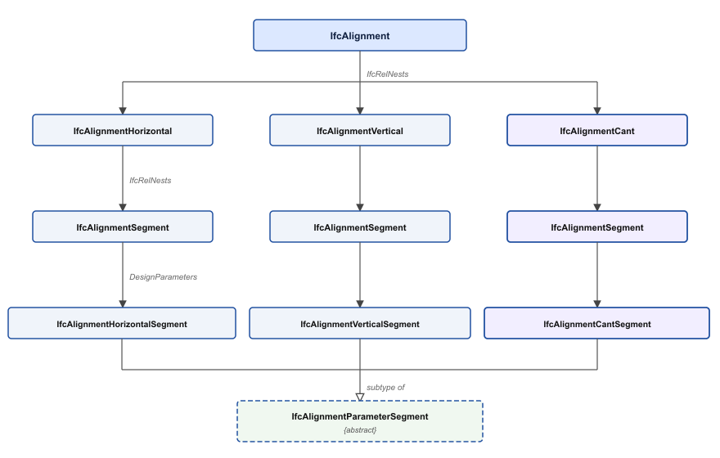
Figure 1.4-1 Semantic alignment model
IfcRelNests.RelatedObjects is an ordered collection, so the layout sub-objects have a defined sequence within the nest. The IFC specification does not state this order explicitly, but it can be inferred from the diagrams in the IfcAlignment documentation (§5.4.3.1.5): IfcAlignmentHorizontal precedes IfcAlignmentVertical, which precedes IfcAlignmentCant.
The ordering of IfcAlignmentSegment instances within each layout’s nest is similarly unspecified by the schema. For IfcAlignmentHorizontalSegment the only logical order is start to end. For IfcAlignmentVerticalSegment and IfcAlignmentCantSegment, positional order could theoretically be derived from the StartDistAlong attribute regardless of list order, but relying on this is unnecessarily complex. Segments should always be ordered start to end in IfcRelNests.RelatedObjects.
An interesting caveat of the alignment layout entities (IfcAlignmentHorizontal, IfcAlignmentVertical, and IfcAlignmentCant) is that the last IfcAlignmentSegment.DesignParameters must be zero length. If a geometric representation is provided, then its corresponding last segment must also be zero length. For a continuous composition of segments, the end of one segment is at the same location as the start of the next segment. The zero-length segment is intended to provide the end point of the last segment. See §2.12 for full implementation details.
Aggregation to project. IfcAlignment is a mandatory participant in the IFC spatial structure. Every alignment must be aggregated to IfcProject — directly, or indirectly through a parent alignment — via an IfcRelAggregates relationship. An alignment not connected to the project is invalid.
Referencing to site. Because an alignment typically traverses multiple administrative or physical sites, IfcAlignment associates with IfcSite using IfcRelReferencedInSpatialStructure rather than IfcRelContainedInSpatialStructure. The referenced-in relationship is non-exclusive: a single alignment may be referenced by every IfcSite it crosses. This is the key distinction between containment (one element, one spatial zone) and referencing (one element, many zones).

1.5 Geometric Representation

1.5.1 Overview
Section 4.1.7.1.1 of the IFC4x3 specification indicates that the valid representations of IfcAlignment are:
- IfcCompositeCurve as a 2D horizontal alignment (represented by its horizontal alignment segments), without a vertical layout.
- IfcGradientCurve as a 3D horizontal and vertical alignment (represented by their alignment segments), without a cant layout.
- IfcSegmentedReferenceCurve as a 3D curve defined relative to an IfcGradientCurve to incorporate the application of cant.
- IfcOffsetCurveByDistances as a 2D or 3D curve defined relative to an IfcGradientCurve or another IfcOffsetCurveByDistances.
- IfcPolyline or IfcIndexedPolyCurve as a 3D alignment by a 3D polyline representation (such as coming from a survey).
- IfcPolyline or IfcIndexedPolyCurve as a 2D horizontal alignment by a 2D polyline representation (such as in very early planning phases or as a map representation).
The RepresentationIdentifier and RepresentationType values required by the IFC concept templates for each alignment geometry variant are listed in Table 1.5.1-1.
Alignment variant | Curve entity | RepresentationIdentifier | RepresentationType
Horizontal only | IfcCompositeCurve | 'Axis' | 'Curve2D'
Horizontal + Vertical | IfcCompositeCurve (plan view) | 'FootPrint' | 'Curve2D'
Horizontal + Vertical | IfcGradientCurve (3D) | 'Axis' | 'Curve3D'
Horizontal + Vertical + Cant | IfcCompositeCurve (plan view) | 'FootPrint' | 'Curve2D'
Horizontal + Vertical + Cant | IfcSegmentedReferenceCurve (3D) | 'Axis' | 'Curve3D'
Table 1.5.1-1 — Required RepresentationIdentifier and RepresentationType for each alignment geometry variant
IfcGradientCurve and IfcSegmentedReferenceCurve inherit from IfcCompositeCurve. These curves consist of a sequence of segments defined by IfcCurveSegment. The mathematical computations for IfcCurveSegment geometry are the primary focus of Chapters 2 - 4.
IfcPolyline and IfcIndexedPolyCurve produce approximate, discrete geometry rather than exact parametric curves. They arise in survey-derived alignments and early planning contexts. Their use, limitations, and incompatibility with the full semantic alignment definition are discussed in Chapter 6. The IFC specification does not indicate the proper RepresentationIdentifier or RepresentationType; by analogy with the parametric curve variants, 'Axis' with either 'Curve2D' or 'Curve3D' is appropriate.
IfcOffsetCurveByDistances is treated in Chapter 5. Again, the representation identifier and representation type are not indicated in the specification. The most logical choice is to match the BasisCurve.

1.5.2 Understanding Geometric Representation of Alignment
The semantic definition of an alignment and its geometric representation carry overlapping information — both describe segment types, lengths, and radii — but they serve different consumers. The semantic representation encodes design intent in domain vocabulary: a horizontal segment typed as CLOTHOID with a StartRadiusOfCurvature of infinity, an EndRadiusOfCurvature of 300 m, and a SegmentLength of 100 m tells a design application what the engineer specified and enables evaluation against standards for minimum radius, design speed, and sight distance. The geometric representation encodes the computed mathematical form: the exact start coordinates, the tangent bearing at each point, and parametric equations that yield position and direction at any arc-length along the curve — the form that a rendering engine, clash-detection tool, or quantity-takeoff calculation requires.
The geometric representation of IfcAlignment consists of one or more IfcShapeRepresentation instances: a plan-view 2D curve and, where vertical or cant geometry is present, a 3D curve. These are illustrated in Figure 1.5.2-1.
Geometrically, the horizontal alignment is defined by an IfcCompositeCurve and the vertical alignment is defined by an IfcGradientCurve. The horizontal alignment is the basis curve for the vertical alignment.
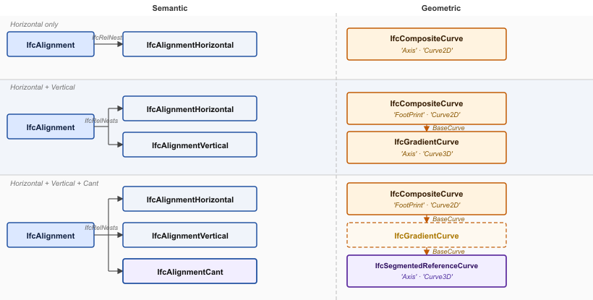
Figure 1.5.2-1 Geometric representation variants for the three alignment constructs (H, H+V, H+V+C). The dashed IfcGradientCurve box in the H+V+C row appears as a BaseCurve intermediate only — it is not itself a shape representation.
The geometric elements are modeled with IfcCurveSegment. IfcCurveSegment cuts a segment from a parent curve and places it in the alignment coordinate system. A horizontal circular arc is modeled with an IfcCurveSegment that cuts an arc from an IfcCircle. Figure 1.5.2-2 shows an alignment consisting of a tangent run (red) and a horizontal curve (green). The line and curve segments are cut from their IfcLine and IfcCircle parent curves, respectively. The process of defining a parent curve, cutting a segment from that curve, and placing the cut segment into the alignment is repeated to define the entire horizontal alignment. All the horizontal alignment IfcCurveSegment objects are then combined to create an IfcCompositeCurve to complete the plan view geometric representation of the horizontal alignment.
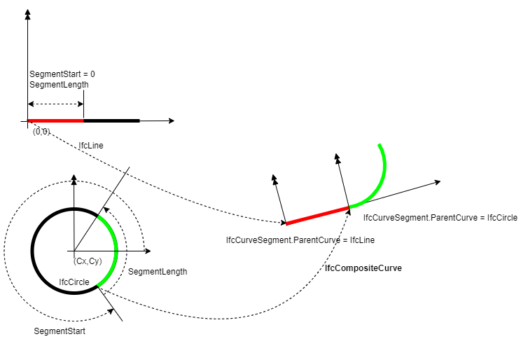
Figure 1.5.2-2 Illustration of parent curves and their placement with IfcCurveSegment.Placement
A similar process is used to create the vertical alignment. IfcCurveSegment instances trim geometry from parent curves and combine end to start to create an IfcGradientCurve. IfcGradientCurve is a sub-type of IfcCompositeCurve with the additional attribute BaseCurve. The segments of the gradient curve are placed in a 2-dimensional plane in a “distance along the horizontal alignment, elevation” coordinate system. The IfcGradientCurve uses the horizontal alignment IfcCompositeCurve as its base curve.
IfcSegmentedReferenceCurve is also a sub-type of IfcCompositeCurve. It defines a deviating elevation and rail head cross slope along the base curve. The base curve is typically an IfcGradientCurve. The “distance along” coordinate is along the gradient curve’s base curve, which is the horizontal alignment curve.

1.5.2.1 Curve segment geometry
When defining curve segment geometry with an IfcCurveSegment, the location and orientation of the parent curve are not particularly important. The IfcCurveSegment.Placement defines the location of the start point of the trimmed curve as well as the orientation of the tangent at the start of the trimmed curve. In the example above, the IfcLine parent curve starts at (0,0) and progresses in horizontal direction, but the tangent segment of the alignment starts at a specific (X,Y) position and is oriented in a North-East direction. The IfcCurveSegment.Placement attribute establishes this position and orientation.

1.5.2.2 Vertical and Cant Curve Extents
For IfcGradientCurve and IfcSegmentedReferenceCurve the segments do not need to start or end at the same location of their base curve. These curves can be shorter or longer than the horizontal alignment. This is illustrated in Figure 1.5.2.2-1 where the blue curve is the full horizontal curve and the orange curve is the portion of the horizontal curve coinciding with the vertical curve. The IfcGradientCurve (#770) has the IfcCompositeCurve (#657) as its base curve. The placement of the first IfcCurveSegment (#771) in the IfcGradientCurve is defined by IfcAxis2Placement2D (#777) with Location as IfcCartesianPoint (#778). The first segment is located at a distance of 250.0036 along the horizontal IfcCompositeCurve at an elevation of 145.3129 m. The IFC specification does not provide guidance on how to define complete 3D geometry in the regions of the horizontal alignment that do not overlap with the vertical or cant curves.
#657=IFCCOMPOSITECURVE((#658,#671,#684,#697,#710,#723,#736,#749,#762),.F.)
#770=IFCGRADIENTCURVE((#771,#784,#796,#809,#821,#834,#846,#859,#871),.F.,#657,#887)
#771 = IFCCURVESEGMENT(.CONTSAMEGRADIENTSAMECURVATURE., #777, IFCLENGTHMEASURE(0.),
IFCLENGTHMEASURE(40.0002408172751), #780);
#777 = IFCAXIS2PLACEMENT2D(#778, #779);
#778 = IFCCARTESIANPOINT((250.003634293681, 145.312908277025));
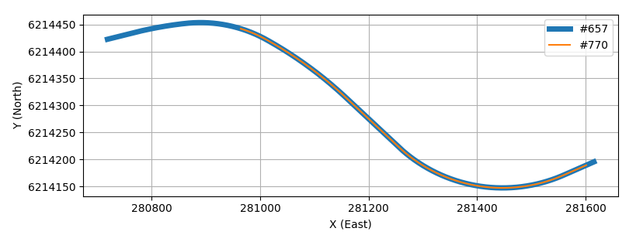
Figure 1.5.2.2-1 — Example of IfcGradientCurve with a start location and length different than the IfcCompositeCurve BaseCurve.

1.6 Reference Implementation and Segment Mapping
Chapters 2, 3, and 4 discuss the mapping of the semantic definition of alignment segments (IfcAlignmentSegment subtypes) to their corresponding geometric representation (IfcCurveSegment.ParentCurve). In general, the mapping formulas are given without derivation and have been developed from the reference implementation, EnrichIFC4x3, published at IFC-Rail-Unit-Test-Reference-Code/EnrichIFC4x3/EnrichIFC4x3/business2geometry at master · bSI-RailwayRoom/IFC-Rail-Unit-Test-Reference-Code (github.com) [3].
The cant segment mappings in the EnrichIfc4x3 reference implementation are incorrect. These errors are documented in Chapter 4, which presents corrected formulas and explains why the reference implementation is incorrect.

1.7 Units of Measure
Unless otherwise specified, the following unit conventions apply throughout this guide:
Quantity | Unit
Length, distance, elevation, offset, cant | meter (m)
Spiral and polynomial coefficients ($A$, $A_{0}$, $A_{1}$, …) | meter (m)
Curvature ($κ=1/R$) | reciprocal meter (m⁻¹)
Angles (bearings, grade angles, cross-slope angles) | radian (rad)
Gradient (vertical slope) | dimensionless ratio (m/m)
Table 1.7-1 — Unit conventions used throughout this guide
Gradient is expressed as a decimal rise-over-run value — 0.02 represents a 2% grade — not as a percentage or angle.

Chapter 2 — Horizontal Alignments

2.0 Introduction
The geometric representation of a horizontal alignment is accomplished with an IfcCompositeCurve. The composite curve consists of a sequence of IfcCurveSegment entities whose geometry is defined by a parent curve. This section defines the mathematical relationships and equations for each parent curve type and the algorithm for evaluating points on those curves.
Table 2.0-1 maps each IfcAlignmentHorizontalSegment.PredefinedType to its corresponding parent curve type.
Business Logic (IfcAlignmentHorizontalSegment.PredefinedType) | Geometric Representation (IfcCurveSegment.ParentCurve)
LINE | IfcLine
CIRCULARARC | IfcCircle
CLOTHOID | IfcClothoid
CUBIC | IfcPolynomialCurve
HELMERTCURVE | IfcSecondOrderPolynomialSpiral
BLOSSCURVE | IfcThirdOrderPolynomialSpiral
COSINECURVE | IfcCosineSpiral
SINECURVE | IfcSineSpiral
VIENNESEBEND | IfcSeventhOrderPolynomialSpiral
Table 2.0-1 — Mapping of business logic to geometric representation for horizontal alignment
This chapter covers:
- The three-step evaluation algorithm for computing position and tangent direction at any point on a horizontal curve segment.
- Parametric equations and geometry mapping examples for all nine curve types in Table 2.0-1.
- The zero-length closing segment required at the end of every IfcCompositeCurve.

2.1 Conventions
Each curve is parameterized by arc-length $s$, where $s=0$ at the start of the parent curve. The start and end radii $R_{s}$ and $R_{e}$ are taken from IfcAlignmentHorizontalSegment.StartRadiusOfCurvature and EndRadiusOfCurvature; a value of zero indicates infinite radius (zero curvature, i.e. a straight line). Radii follow a positive-left sign convention: a positive value indicates curvature to the left of the direction of travel; a negative value indicates curvature to the right. The segment length $L$ is IfcAlignmentHorizontalSegment.SegmentLength. The tangent angle $θ(s)$ is measured from the positive $x$-axis; its cosine and sine form the RefDirection of the curve at $s$.
The $x$ and $y$ coordinates of all horizontal parent curves are defined by the integrals:
$$x(s)=∫cosθ(s) ds y(s)=∫sinθ(s) ds$$

2.2 Curve Segment Evaluation Algorithm
This algorithm evaluates the 2D position and tangent direction of a point on an IfcCurveSegment in the alignment coordinate system. Let $s_{0}$ = SegmentStart and $s$ = the arc-length parameter of the point to evaluate, where $s_{0}≤s<s_{0}+SegmentLength$.

Step 1 — Form the curve segment placement matrix $M_{CSP}$
$M_{CSP}$ places the trimmed segment into the alignment coordinate system. It is constructed directly from IfcCurveSegment.Placement, where $(x_{p},y_{p})$ is the Location and $θ_{p}$ is the bearing of the RefDirection.
$$M_{CSP}=\left[\begin{matrix}cosθ_{p} & -sinθ_{p} & 0 & x_{p} \\ sinθ_{p} & cosθ_{p} & 0 & y_{p} \\ 0 & 0 & 1 & 0 \\ 0 & 0 & 0 & 1\end{matrix}\right]$$

Step 2 — Evaluate the parent curve at the trim start and form the normalization matrix $M_{N}$
Compute the position $(x_{0},y_{0})$ and tangent angle $θ_{0}$ of the parent curve at $s_{0}$. This establishes the frame of the parent curve at the point where trimming begins.
$M_{N}$ simultaneously translates the trim-start point to the origin and rotates so that the tangent at $s_{0}$ aligns with the positive $x$-direction.
$$M_{N}=\left[\begin{matrix}cosθ_{0} & sinθ_{0} & 0 & -x_{0}cosθ_{0}-y_{0}sinθ_{0} \\ -sinθ_{0} & cosθ_{0} & 0 & x_{0}sinθ_{0}-y_{0}cosθ_{0} \\ 0 & 0 & 1 & 0 \\ 0 & 0 & 0 & 1\end{matrix}\right]$$

Step 3 — Evaluate and map each point
For the point at arc-length $s$, compute the parent curve position $(x(s),y(s))$ and tangent angle $θ(s)$ and form:
$$M_{PC}=\left[\begin{matrix}cos(θ(s)) & -sin(θ(s)) & 0 & x(s) \\ sin(θ(s)) & cos(θ(s)) & 0 & y(s) \\ 0 & 0 & 1 & 0 \\ 0 & 0 & 0 & 1\end{matrix}\right]$$
Apply the normalization and placement in sequence:
$$M_{h}=M_{CSP}M_{N}M_{PC}$$
The position of the point in the alignment coordinate system is the fourth column of $M_{h}$, and its tangent direction is the first column. Numerical examples of this algorithm are given in Sections 2.3 through 2.11.

2.3 Line
A tangent run is geometrically represented with a segment trimmed from an IfcLine parent curve.

2.3.1 Parent Curve Parametric Equations
The curve tangent angle and curvature are given by the following equations
$$θ(t)=θ$$
$$κ(t)=0$$
The point on line equation can be parameterized with a unit parameterization where the parameter $u$ ranges from $0$ to $1$ over the full extent of the curve, independent of its physical length.
$$λ(u)=C+L\left(\int_{0}^{u=1}{cos\left(θ(t)\right)}dt x, \int_{0}^{u=1}{sin\left(θ(t)\right)}dt y\right)$$
It can also be parameterized with an arc length parameterization where the parameter $u$ equals the distance along the line in units of length, so $u=s$.
$$λ(u)=C+\left(\int_{0}^{u=L}{cos\left(θ(t)\right)}dt x, \int_{0}^{u=L}{sin\left(θ(t)\right)}dt y\right)$$
Other parent curve types can also be parameterized by unit value or arc length. However, the polynomial spirals do not have a well defined unit value parameterization. For this reason, the IFC specification mandates that all parameterization for alignment geometry be by arc length. For IfcCurveSegment, the SegmentStart and SegmentLength attributes must be of type IfcLengthMeasure. See Section 8.9.3.28 IfcCurveSegment, Informal Proposition 1.
This matters because IfcCurveSegment.SegmentStart and IfcCurveSegment.SegmentLength are of type IfcCurveMeasureSelect, which can be either IfcParameterValue (a dimensionless scalar based on unit value) or IfcLengthMeasure (a physical length).

2.3.2 Semantic Definition to Geometry Mapping
Mapping of the semantic definition of the linear segment to the geometric definition is described with the following example.
Given a horizontal alignment segment is a line segment starting at point (500,2500), bearing in the direction S 57 E (5.70829654085293 radian) and has a length of 1956.785654.
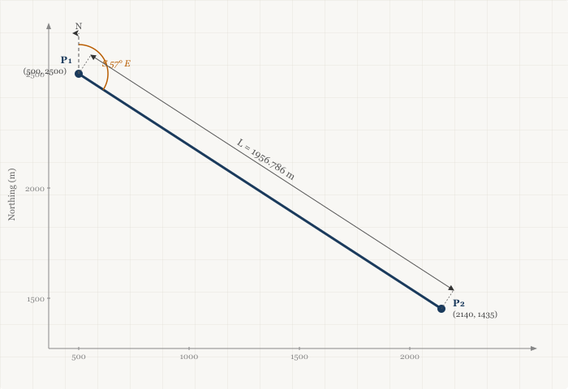
Figure 2.3.2-1 Tangent segment
The semantic definition of this segment is:
#31=IFCCARTESIANPOINT((500.,2500.));
#32=IFCALIGNMENTHORIZONTALSEGMENT($,$,#31,5.70829654085293,0.,0.,1956.785654,$,.LINE.);
The geometric representation is an IfcLine. The line can be defined in different ways and is generally not important, as will be shown in the example below. IfcLine is an infinitely long line that passes through a specified point at some direction in the X-Y plane. A valid, but unnecessarily complex parent curve is shown in Figure 2.3.2-2. The IfcLine passes through point (1000,-800) and is directed at 135° from the x-axis. The IfcCurveSegment trim starts 100 m from (1000,-800) and the trimmed segment has a length of 1956.796 m.
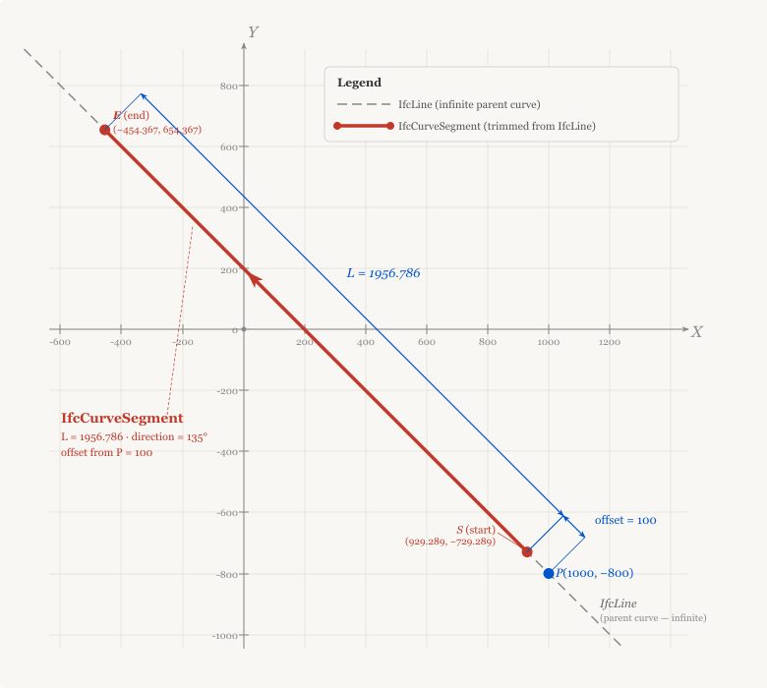
Figure 2.3.2-2 IfcLine at arbitrary placement
Figure 2.3.2-2 represents a valid parent curve definition and implementations must be prepared to properly interpret this parent curve geometry. This guide defines general algorithms to accommodate this geometry.
In practice, it is far easier to define the parent curve passing through point (0,0) and in the direction of the X-axis. The trimming can begin at the origin as shown in Figure 2.3.2-3.
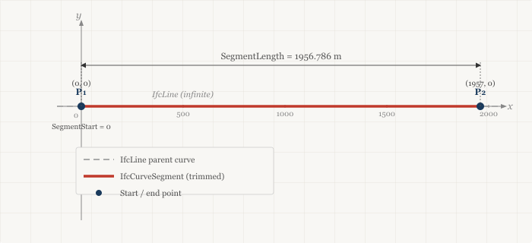
Figure 2.3.2-3 IfcLine parent curve at origin
The parent curve definition is:
#51=IFCCARTESIANPOINT((0.,0.));
#52=IFCDIRECTION((1.,0.));
#53=IFCVECTOR(#52,1.);
#54=IFCLINE(#51,#53);
IfcCurveSegment defines the portion of the line used and how it is placed and oriented in the X-Y plane.
IfcCurveSegment.SegmentStart defines where the parent curve trimming begins. It can be anywhere along the line. It is easiest to begin the trimming at the origin but could be anywhere. The SegmentStart attribute is 0.0 in this case.
IfcCurveSegment.SegmentLength defines where the parent curve trimming ends relative to SegmentStart. This is the length of the curve we want to trim. The SegmentLength attribute is 1956.785654 for this example.
The SegmentStart and SegmentLength attributes trim a portion of the IfcLine parent curve, which is oriented in the direction (1,0) with origin at (0,0).
The trimmed portion of the curve needs to be placed and oriented into the horizontal alignment. The tangent segment begins at (500,2500) and runs in the direction 5.70829654085293 radian.
From the segment direction,
$$dy=sin(5.70829654085293)=-0.54374144087698$$
$$dx=cos(5.70829654085293)=0.839252789970355$$
The segment placement is
#31=IFCCARTESIANPOINT((500.,2500.));
#49=IFCDIRECTION((0.839252789970355,-0.54374144087698));
#50=IFCAXIS2PLACEMENT2D(#31,#49);
The IfcCurveSegment is defined as:
#55=IFCCURVESEGMENT(.CONTSAMEGRADIENT.,#50,IFCLENGTHMEASURE(0.),IFCLENGTHMEASURE(1956.785654),#54);

2.3.3 Compute Point on Curve
Compute the position matrix for a point 1500 m from the start of the curve segment.

Step 1 — Form the curve segment placement matrix $M_{CSP}$
From the IfcCurveSegment.Placement:
$$x=500,y=2500$$
$$dx =0.839252789970355, dy =-0.54374144087698$$
$$M_{CSP}=\left[\begin{matrix}0.839252789970355 & 0.54374144087698 & 0 & 500 \\ -0.54374144087698 & 0.839252789970355 & 0 & 2500 \\ 0 & 0 & 1 & 0 \\ 0 & 0 & 0 & 1\end{matrix}\right]$$

Step 2 — Evaluate the parent curve at the trim start and form the normalization matrix $M_{N}$
Because the parent curve is located at (0,0) in the direction (1,0), $x_{0}=0,y_{0}=0,θ_{0}=0$.
Since $x_{0}=0$, $y_{0}=0$, and $θ_{0}=0$, $M_{N}=I$.

Step 3 — Evaluate and map each point
Evaluate the parent curve at $u=1500$
$$λ(u)=C+\left(\int_{0}^{u}{cos\left(θ(t)\right)}dt x, \int_{0}^{u}{sin\left(θ(t)\right)}dt y\right)$$
$$θ(1500)=\tan^{-1}\left(\frac{0}{1}\right)=0$$
$$x=0+cos(0)\int_{0}^{1500}{dt}=0+1(1500 m-0 m)=1500 m$$
$$y=0+sin(0)\int_{0}^{1500}{dt}=0+0(1500 m-0 m)=0 m$$
Though it is much easier to use the following calculation
$$x(u)=p_{x}+u(dx)$$
$$y(u)=p_{y}+u(dy)$$
$$x=0+1(1500)=1500$$
$$y=0-0(1500)=0$$
$$M_{PC}=\left[\begin{matrix}1 & 0 & 0 & 1500 \\ 0 & 1 & 0 & 0 \\ 0 & 0 & 1 & 0 \\ 0 & 0 & 0 & 1\end{matrix}\right]$$
The resulting position matrix is
$$M_{h}=M_{CSP}M_{N}M_{PC}$$
$$M_{h}=\left[\begin{matrix}0.839252789970355 & 0.54374144087698 & 0 & 500 \\ -0.54374144087698 & 0.839252789970355 & 0 & 2500 \\ 0 & 0 & 1 & 0 \\ 0 & 0 & 0 & 1\end{matrix}\right]I\left[\begin{matrix}1 & 0 & 0 & 1500 \\ 0 & 1 & 0 & 0 \\ 0 & 0 & 1 & 0 \\ 0 & 0 & 0 & 1\end{matrix}\right]$$
$$M_{h}=\left[\begin{matrix}0.83925279 & 0.54374114 & 0 & 1758.879185 \\ -0.54374114 & 0.83925279 & 0 & 1684.3878387 \\ 0 & 0 & 1 & 0 \\ 0 & 0 & 0 & 1\end{matrix}\right]$$

2.4 Circular Arc
Circular alignment curves are geometrically represented by an arc trimmed from an IfcCircle parent curve.

2.4.1 Parent Curve Parametric Equations
The curve tangent angle, curvature, and point on the curve are given by the following equations
$$θ(s)=\frac{s}{R}$$
$$κ(s)=\frac{1}{R}$$
$$x(s)=∫cos\left(θ(s)\right)ds=Rsin\left(θ(s)\right)$$
$$y(s)=∫sin\left(θ(s)\right)ds=R\left(1-cos\left(θ(s)\right)\right)$$

2.4.2 Semantic Definition to Geometry Mapping
IfcCircle is defined by its center (IfcCircle.Position) and radius (IfcCircle.Radius).
Consider a horizontal curve segment that starts at (0,0), has a radius of 300 m, and an arc length of 100 m. The semantic definition is
#28 = IFCCARTESIANPOINT((0., 0.));
#29 = IFCALIGNMENTHORIZONTALSEGMENT($, $, #28, 0., 300., 300., 100., $, .CIRCULARARC.);
The parent curve can be defined as follows:
#45 = IFCCIRCLE(#46, 300.);
#46 = IFCAXIS2PLACEMENT2D(#47, #48);
#47 = IFCCARTESIANPOINT((0., 300.));
#48 = IFCDIRECTION((0., -1.));
This is a circle centered at point (0,300) with the local X-axis aligned with the negative global Y-axis as shown in Figure 2.4.2-1.
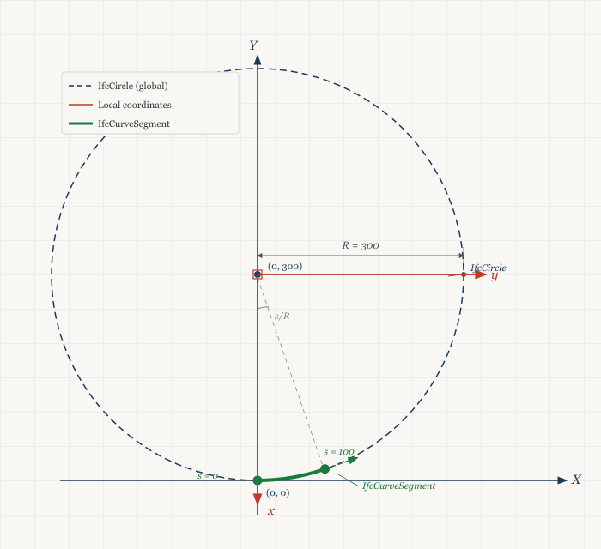
Figure 2.4.2-1 — Curve segment trimmed from an IfcCircle parent curve
The parent curve is placed such that a trim starting at 0.0 is at (0,0) and the tangent is in the direction (1,0).
The curve segment is defined by its placement at a segment trimmed from the parent curve starting at 0.0 for a length of 100.0 along the curve.
#36 = IFCCURVESEGMENT(.CONTINUOUS., #42, IFCLENGTHMEASURE(0.),IFCLENGTHMEASURE(100.), #45);
#42 = IFCAXIS2PLACEMENT2D(#43, #44);
#43 = IFCCARTESIANPOINT((0., 0.));
#44 = IFCDIRECTION((1., 0.));

2.4.3 Compute Point on Curve
Compute the placement matrix for a point 50 m from the start of the curve segment.

Step 1 — Form the curve segment placement matrix $M_{CSP}$
$$M_{CSP}=I$$

Step 2 — Evaluate the parent curve at the trim start and form the normalization matrix $M_{N}$
The trim begins where the local x-axis of the circle intersects the circumference. The circle is centered at (0,300) with radius = 300 and the local x-axis is in the direction of the global y-axis. This puts the trim start point at $x_{0}=0,y_{0}=0$ and the tangent direction (1,0) with $θ_{0}=0$
Since $x_{0}=0$, $y_{0}=0$, and $θ_{0}=0$, $M_{N}=I$.

Step 3 — Evaluate and map each point
Compute point on parent curve at $u=50$
$$θ(s)=\frac{s}{R}=\frac{50}{300}$$
$$d_{x}=cos(θ(s))=cos\left(\frac{50}{300}\right)=0.98614323$$
$$d_{y}=sin(θ(s))=sin\left(\frac{50}{300}\right)=0.16589613$$
$$x(s)=Rsin\left(θ(s)\right)=300sin\left(\frac{50}{300}\right)=49.76883981$$
$$y(s)=R\left(1-cos\left(θ(s)\right)\right)=300\left(1-cos\left(\frac{50}{300}\right)\right)=4.1570305$$
$$M_{PC}=\left[\begin{matrix}0.98614323 & -0.16589613 & 0 & 49.76883981 \\ 0.16589613 & 0.98614323 & 0 & 4.1570305 \\ 0 & 0 & 1 & 0 \\ 0 & 0 & 0 & 1\end{matrix}\right]$$
The resulting position matrix is
$$M_{h}=M_{CSP}M_{N}M_{PC}$$
$$M_{h}=II\left[\begin{matrix}0.98614323 & -0.16589613 & 0 & 49.76883981 \\ 0.16589613 & 0.98614323 & 0 & 4.1570305 \\ 0 & 0 & 1 & 0 \\ 0 & 0 & 0 & 1\end{matrix}\right]$$
$$M_{h}=\left[\begin{matrix}0.98614323 & -0.16589613 & 0 & 49.76883981 \\ 0.16589613 & 0.98614323 & 0 & 4.1570305 \\ 0 & 0 & 1 & 0 \\ 0 & 0 & 0 & 1\end{matrix}\right]$$

2.5 Clothoid
Spiral transition curves are geometrically represented by a segment trimmed from one of the many spiral types in IFC. IfcClothoid geometry is used for clothoid curves.

2.5.1 Parent Curve Parametric Equations
The curve tangent angle, curvature, and point on the curve are given by the following equations
$$θ(s)=\frac{π}{2}\frac{A}{\left|A\right|}s^{2}$$
$$κ(s)=\frac{A}{\left|A^{3}\right|}s$$
$$x(u)=A\sqrt{π}\int_{0}^{u}{cos\left(\frac{π}{2}\frac{A}{\left|A\right|}t^{2}\right) dt}$$
$$y(u)=A\sqrt{π}\int_{0}^{u}{sin\left(\frac{π}{2}\frac{A}{\left|A\right|}t^{2}\right) dt}$$
IFC provides a unit parametrization of clothoid curve.
$$u=\frac{s}{\left|A\sqrt{π}\right|}$$
with $-∞<u<∞$. When $θ=π/2$, $u=1.0$.
Care must be taken when evaluating clothoids because IfcCurveSegment.SegmentStart and IfcCurveSegment.SegmentLength are defined with arc length. The details are illustrated in the example calculations.

2.5.2 Semantic Definition to Geometry Mapping
Consider a horizontal clothoid segment that starts at (0,0) with a start direction of (1.0,0.0). The radii at the start and end of the segment are 300 and 1000, respectively. The arc length of the segment is 100. The semantic definition is
#28 = IFCCARTESIANPOINT((0., 0.));
#29 = IFCALIGNMENTHORIZONTALSEGMENT($, $, #28, 0., 300., 1000., 100., $, .CLOTHOID.);
From the semantic definition, compute the clothoid constant, $A$
$$R_{s}=300, R_{e}=1000, L=100$$
$$f=\frac{L}{R_{e}}-\frac{L}{R_{s}}=\frac{100}{1000}-\frac{100}{300}=-0.23333$$
$$A=\frac{L}{{\left|f\right|}^{\frac{1}{2}}}\frac{f}{\left|f\right|}=\frac{100}{{\left|-0.23333\right|}^{\frac{1}{2}}}\frac{-0.23333}{\left|-0.23333\right|}=-207.0196678$$
Place the parent curve at (0,0) with a tangent direction of (1,0)
#45 = IFCCLOTHOID(#46, -207.019667802706);
#46 = IFCAXIS2PLACEMENT2D(#47, $);
#47 = IFCCARTESIANPOINT((0., 0.));
The curve segment starts where the radius is 300. A positive radius indicates a counter-clockwise curve which is a curve towards the left. The distance from the origin where this radius occurs can be computed from the curvature equation. The curvature at the start is 1/300 and the clothoid constant is -207.0196678. Solve for distance from origin.
$$κ(s)=\frac{A}{\left|A^{3}\right|}s$$
$$\frac{1}{300}=\frac{-207.0196678}{\left|-{207.0196678}^{3}\right|}s$$
$$s=-142.8571429$$
Figure 2.5.2-1 shows the parent curve clothoid with the segment having $κ_{s}=\frac{1}{300}$ and $κ_{e}=\frac{1}{1000}$ highlighted. This is the segment that IfcCurveSegment must trim from the parent curve. The negative clothoid constant results in the parent curve in quadrants 2 and 4. The curvature is positive in quadrant 2. For this reason, the SegmentStart attribute is negative. From this starting point, the trimming progresses to a larger radius, which is towards the origin. For this reason SegmentLength is a positive value. If the trimming were to progress to a smaller radius, SegmentLength would be a negative value. The SegmentStart and SegmentLength attributes can be positive and negative values in any combination. This is true for all parent curve types.
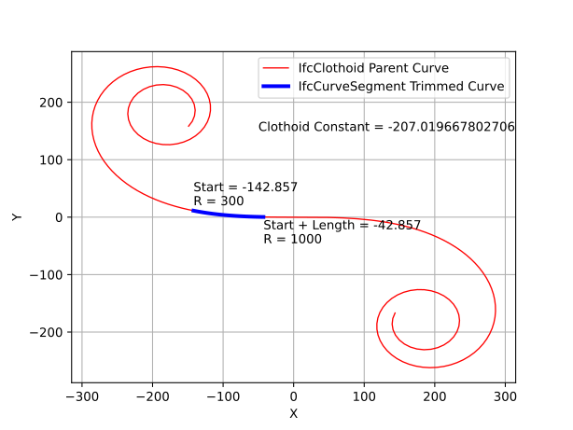
Figure 2.5.2-1 — IfcCurveSegment trimmed from an IfcClothoid parent curve
Place the curve segment at (0,0) with the tangent in the direction (1,0).
#42 = IFCAXIS2PLACEMENT2D(#43, #44);
#43 = IFCCARTESIANPOINT((0., 0.));
#44 = IFCDIRECTION((1., 0.));
Define the curve segment
#36 = IFCCURVESEGMENT(.CONTINUOUS., #42, IFCLENGTHMEASURE(-142.857142857143), IFCLENGTHMEASURE(100.), #45);

2.5.3 Compute Point on Curve
Compute the placement matrix for a point 50 m from the start of the curve segment.

Step 1 — Form the curve segment placement matrix $M_{CSP}$
Represent IfcCurveSegment.Placement in matrix form. In this example, the placement is at (0,0) with RefDirection (1,0) which results in an identity matrix. This is not true in all cases.
$$M_{CSP}=I$$

Step 2 — Evaluate the parent curve at the trim start and form the normalization matrix $M_{N}$
Start by computing the point and curve tangent at the start of the parent curve trim.
Recall that the clothoid equations are in terms of a unit parameterization. Compute the parametric position on the curve.
$$u=\frac{-142.8571428}{\left|-207.0196678\sqrt{π}\right|}=-0.3893278$$
Compute the point on curve tangent direction
$$θ_{0}(-0.3893278)=\frac{π}{2}\frac{-207.0196678}{\left|-207.0196678\right|}(-0.3893278)^{2}=-0.238095237$$
and compute the point on the curve
$$x_{0}(-0.3893278)=-207.0196678\sqrt{π}\int_{0}^{-0.3893278}{cos\left(\frac{π}{2}\frac{-207.0196678}{\left|-207.0196678\right|}t^{2}\right) dt}=-142.04941746210602 m$$
$$y_{0}(-0.3893278)=-207.0196678\sqrt{π}\int_{0}^{-0.3893278}{sin\left(\frac{π}{2}\frac{-207.0196678}{\left|-207.0196678\right|}t^{2}\right) dt}=11.292042785713347 m$$
The terms of the normalization matrix are:
$$cos(-0.238095237)=0.971788979$$
$$sin(-0.238095237)=-0.235852028$$
$$-(-142.04941746210602 m)cos(-0.238095237)-(11.292042785713347 m)sin(-0.238095237)=140.705309648 m$$
$$(-142.04941746210602 m)sin(-0.238095237)-(11.292042785713347 m)cos(-0.238095237)=22.529160405 m$$
$$M_{N}=\left[\begin{matrix}cosθ_{0} & sinθ_{0} & 0 & -x_{0}cosθ_{0}-y_{0}sinθ_{0} \\ -sinθ_{0} & cosθ_{0} & 0 & x_{0}sinθ_{0}-y_{0}cosθ_{0} \\ 0 & 0 & 1 & 0 \\ 0 & 0 & 0 & 1\end{matrix}\right]=\left[\begin{matrix}0.971788979 & -0.235852028 & 0 & 140.705309648 \\ 0.235852028 & 0.971788979 & 0 & 22.529160405 \\ 0 & 0 & 1 & 0 \\ 0 & 0 & 0 & 1\end{matrix}\right]$$

Step 3 — Evaluate and map each point
Compute point and curve tangent at 50 m from the start,
$$s=-142.8571428+50=-92.8571428$$
$$u=\frac{-92.8571428}{\left|-207.0196678\sqrt{π}\right|}=-0.25306307$$
$$x(-0.25306307)=-207.0196678\sqrt{π}\int_{0}^{-0.25306307}{cos\left(\frac{π}{2}\frac{-207.0196678}{\left|-207.0196678\right|}s^{2}\right) ds}=-92.763220844871512$$
$$y(-0.25306307)=-207.0196678\sqrt{π}\int_{0}^{-0.25306307}{sin\left(\frac{π}{2}\frac{-207.0196678}{\left|-207.0196678\right|}s^{2}\right) ds}=3.1114126254443812$$
$$θ(-0.25306307)=\frac{π}{2}\frac{-207.0196678}{\left|-207.0196678\right|}(-0.25306307)^{2}=-0.100595238$$
$$dx=cos(-0.100595238)=0.994944564$$
$$dy=sin(-0.100595238)=-0.100425663$$
In matrix form
$$M_{PC}=\left[\begin{matrix}0.994944564 & 0.100425663 & 0 & -92.763220844871512 \\ -0.100425663 & 0.994944564 & 0 & 3.1114126254443812 \\ 0 & 0 & 1 & 0 \\ 0 & 0 & 0 & 1\end{matrix}\right]$$
Apply the normalization and curve segment placement to the parent curve point
$$M_{h}=M_{CSP}M_{N}M_{PC}=I\left[\begin{matrix}0.971788979 & -0.235852028 & 0 & 140.705309648 \\ 0.235852028 & 0.971788979 & 0 & 22.529160405 \\ 0 & 0 & 1 & 0 \\ 0 & 0 & 0 & 1\end{matrix}\right]\left[\begin{matrix}0.994944564 & 0.100425663 & 0 & -92.763220844871512 \\ -0.100425663 & 0.994944564 & 0 & 3.1114126254443812 \\ 0 & 0 & 1 & 0 \\ 0 & 0 & 0 & 1\end{matrix}\right]$$
$$M_{h}=\left[\begin{matrix}0.99056175921247780 & -0.13706714116038599 & 0 & 49.825200930152405 \\ 0.13706714116038599 & 0.99056175921247780 & 0 & 3.6744032279728032 \\ 0 & 0 & 1 & 0 \\ 0 & 0 & 0 & 1\end{matrix}\right]$$

2.6 Cubic Transition Curve
IfcPolynomialCurve is the geometric type for cubic transition spirals.

2.6.1 Parent Curve Parametric Equations
The approach for calculating the coordinates of a horizontal cubic curve is unique compared to the other curve types. For a horizontal alignment, the coordinate point and curve tangent angle is generally defined by parametric equations where the parameter is the distance along the curve. A cubic curve is represented with the IfcPolynomialCurve parent curve type. When IfcPolynomialCurve is used as a cubic transition curve, the $x$ coefficients are $[0,1]$ and the $y$ coefficients are $[0,0,0,A_{3}]$ resulting in a function of the form $y(x)=A_{3}x^{3}$. See 4.2.2.1.5 Cubic Transition Segment.
The distance along a curve is defined by
d=​​y'(x)2+1 dx
$$y^{'}(x)=3A_{3}x^{2}$$
d=​​9A32x4+1 dx
This equation is solved for $x$ and then $y$ can be computed. This can be accomplished with numerical methods.
- For a distance $u$ along the curve, find $x$ for $d-u=0$, within a tolerance consistent with the modeled elements. See Chapter 11 for a discussion on tolerances.
- Compute $y(x)=A_{3}x^{3}$
- Compute curve tangent slope as $\frac{dy}{dx}=3A_{3}x^{2}$

2.6.2 Semantic Definition to Geometry Mapping
Consider a horizontal cubic transition curve segment that starts at (0,0) with a start direction of 0.0. The radius at the start is infinite and the radius at the end is 300. The arc length of the segment is 100. The semantic definition is
#28 = IFCCARTESIANPOINT((0., 0.));
#29 = IFCALIGNMENTHORIZONTALSEGMENT($, $, #28, 0., 0., 300., 100., $,.CUBIC.);
Compute the polynomial curve coefficients
$$A_{0}=A_{1}=A_{2}=0$$
$$A_{3}=\frac{1}{6R_{e}L}-\frac{1}{6R_{s}L}=\frac{1}{6(300 m)(100 m)}-\frac{1}{6(∞)(100 m)}=5.55555⋅{10}^{-6} m^{-2}$$
The geometric representation is
#36 = IFCCURVESEGMENT(.CONTINUOUS., #42, IFCLENGTHMEASURE(0.), IFCLENGTHMEASURE(100.), #45);
#42 = IFCAXIS2PLACEMENT2D(#43, #44);
#43 = IFCCARTESIANPOINT((0., 0.));
#44 = IFCDIRECTION((1., 0.));
#45 = IFCPOLYNOMIALCURVE(#46, (0., 1.), (0., 0., 0., 5.55555555555556E-6), $);
#46 = IFCAXIS2PLACEMENT2D(#47, $);
#47 = IFCCARTESIANPOINT((0., 0.));
Warning: There is a flaw in the IFC Specification. IfcAlignmentHorizontalSegment indicates the cubic formula is $y=\frac{x^{3}}{6RL}$ which means the IfcPolynomialCurve.CoefficentY[3] attribute must have unit of $Length^{-2}$. This is a direct contradiction to IfcPolynomialCurve which clearly states the coefficients are real values (i.e. scalar values) with IfcReal.
Why is this a problem? The calculation of a point on the polynomial curve is different depending on how the coefficients are defined.
The parametric form of the polynomial curve is $λ(u)=(x(u),y(u),z(u))$. The polynomial curve represents real geometry so the resulting values, $x$, $y$, and $z$ must have units of $Length$.
When $u$ is parametrized as a Length measure, as required by IfcCurveSegment, the parametric terms of the polynomial equation are:
$$x(u)=\sum_{i=0}^{l}{a_{i}}u^{i}$$
$$y(u)=\sum_{j=0}^{m}{b_{j}}u^{j}$$
$$z(u)=\sum_{k=0}^{n}{c_{k}}u^{k}$$
For $x$, $y$, and $z$ to have values in $Length$ measure, the implicit unit of measure of the coefficients must be:
$Length^{(1-i)}$ for $a_{i}$ $Length^{(1-j)}$ for $b_{j}$ $Length^{(1-k)}$ for $c_{k}$
When $u$ is parametrized as a scalar, as required by IfcPolynomialCurve, the parametric terms of the polynomial equation are:
$$x(u)=L\sum_{i=0}^{l}{a_{i}}u^{i}$$
$$y(u)=L\sum_{j=0}^{m}{b_{j}}u^{j}$$
$$z(u)=L\sum_{k=0}^{n}{c_{k}}u^{k}$$
The parameter $u$ and the coefficients are scalar so they must be multiplied with the curve length $L$ to result in values of Length.
The equations for $x$, $y$, and $z$ differ depending on the parameterization.
Concept Template 4.2.2.1.5 Cubic Transition Segment and IfcAlignmentHorizontalSegment provide clear direction (not withstanding typographical errors) that IfcPolynomialCurve is to be evaluated as $y=CoefficientsY[3]x^{3}$ which dictates that $CoefficientsY[3]$ must be in units of $Length^{-2}$ and must be encoded in the IfcPolynomialCurve.CoefficientY attribute as an IfcReal.
An official Implementation Agreement does not appear to exist; however, this interpretation is consistent with discussions on GitHub [4].

2.6.3 Compute Point on Curve
Compute the curve coordinates at a distance along the curve, $u=100$

Step 1 — Form the curve segment placement matrix $M_{CSP}$
Represent IfcCurveSegment.Placement in matrix form. In this example, the placement is at (0,0) with RefDirection (1,0) which results in an identity matrix.
$$M_{CSP}=I$$

Step 2 — Evaluate the parent curve at the trim start and form the normalization matrix $M_{N}$
Because the parent curve is located at (0,0) in the direction (1,0), $x_{0}=0,y_{0}=0,θ_{0}=0$.
Since $x_{0}=0$, $y_{0}=0$, and $θ_{0}=0$, $M_{N}=I$.

Step 3 — Evaluate and map each point
Compute point and curve tangent at 100 m from the start.
From the IfcPolynomialCurve definition,
X Coefficients = ($0m^{1}$, $1m^{0}$)
Y Coefficients = ($0m^{1}$, $0m^{0}$, $0m^{-1}$, $5.55555⋅{10}^{-6}m^{-2}$)
$$y(x)=\left(5.55555⋅{10}^{-6}m^{-2}\right)x^{3}$$
Find $x$ such that
$$\left|d-u\right|=\left|\int_{0}^{x}{\left(\sqrt{{\left(y^{'}(x)\right)}^{2}+1}\right)}dx-u\right|<{10}^{-4}≈0$$
$$y^{'}(x)=3\left(5.55555⋅{10}^{-6}m^{-2}\right)x^{2}$$
Solve numerically
$$x=99.72593255m$$
Check solution
$$d=\int_{0}^{99.72593255 m}{\sqrt{{\left(3⋅(5.55555⋅{10}^{-6}m^{-2})(x m)^{2}\right)}^{2}+1}}dx=100 m$$
Compute y
$$y(x)=(5.55555⋅{10}^{-6}m^{-2}{)(99.72593255 m)}^{3}=5.5100 m$$
The tangent vector at $u=100 m$ along the curve is
$$y^{'}(99.72593255 m)=3\left(5.55555⋅{10}^{-6}m^{-2}\right)(99.72593255 m)^{2}=0.165753$$
Normalizing the tangent vector
$$dx=\frac{1}{\sqrt{1^{2}+{0.165753}^{2}}}=0.986539$$
$$dy=\frac{0.165753}{\sqrt{1^{2}+{0.165753}^{2}}}=0.1635219$$
The resulting matrix is
$$M_{PC}=\left[\begin{matrix}0.986539 & -0.1635219 & 0 & 99.72593255 \\ 0.1635219 & 0.986539 & 0 & 5.5100 \\ 0 & 0 & 1 & 0 \\ 0 & 0 & 0 & 1\end{matrix}\right]$$
Apply the normalization and curve segment placement to the parent curve point
$$M_{h}=M_{CSP} M_{N} M_{PC}=I I\left[\begin{matrix}0.986539 & -0.1635219 & 0 & 99.72593255 \\ 0.1635219 & 0.986539 & 0 & 5.5100 \\ 0 & 0 & 1 & 0 \\ 0 & 0 & 0 & 1\end{matrix}\right]$$
$$M_{h}=\left[\begin{matrix}0.986539 & -0.1635219 & 0 & 99.72593255 \\ 0.1635219 & 0.986539 & 0 & 5.5100 \\ 0 & 0 & 1 & 0 \\ 0 & 0 & 0 & 1\end{matrix}\right]$$

2.7 Helmert Transition Curve
The Helmert curve is unique in that it is semantically defined as a single layout segment (IfcAlignmentHorizontalSegment) but geometrically defined with two curve segments (IfcCurveSegment), each representing half of the transition curve. The parent curve for a helmert transition curve is IfcSecondOrderPolynomialSpiral.

2.7.1 Parent Curve Parametric Equations
The curve tangent angle and curvature are given by the following equations
$$θ(t)=\frac{t^{3}}{3A_{2}^{3}}+\frac{A_{1}}{2\left|A_{1}^{3}\right|}t^{2}+\frac{t}{A_{0}}$$
$$κ(t)=\frac{1}{A_{2}^{3}}t^{2}+\frac{A_{1}}{\left|A_{1}^{3}\right|}t+\frac{1}{A_{0}}$$
The polynomial coefficients carry a second subscript to indicate first half, $1$, and second half, $2$. For example, $A_{21}$ is coefficient $A_{2}$ for the first half and $A_{02}$ is coefficient $A_{0}$ for the second half.
First Half
$$a_{01}=\frac{L}{R_{s}}, A_{01}=\frac{L}{\left|a_{0}\right|} \frac{a_{0}}{\left|a_{0}\right|}$$
$$a_{11}=0, A_{11}=0$$
$$a_{21}=2f, A_{21}=\frac{L}{{\left|a_{2}\right|}^{\frac{1}{3}}} \frac{a_{2}}{\left|a_{2}\right|}$$
Second Half
$$a_{02}=-f+\frac{L}{R_{s}}, A_{02}=\frac{L}{\left|a_{0}\right|} \frac{a_{0}}{\left|a_{0}\right|}$$
$$a_{12}=4f, A_{12}=\frac{L}{{\left|a_{1}\right|}^{\frac{1}{2}}} \frac{a_{1}}{\left|a_{1}\right|}$$
$$a_{22}=-2f, A_{22}=\frac{L}{{\left|a_{2}\right|}^{\frac{1}{3}}} \frac{a_{2}}{\left|a_{2}\right|}$$

2.7.2 Semantic Definition to Geometry Mapping
Consider a horizontal Helmert transition curve segment that starts at (0,0) with a start direction of (1,0). The radius at the start is infinite and the radius at the end is 300. The arc length of the segment is 100. The semantic definition is
#28 = IFCCARTESIANPOINT((0., 0.));
#29 = IFCALIGNMENTHORIZONTALSEGMENT($, $, #28, 0., 0., 300., 100., $, .HELMERTCURVE.);
Compute the curve parameters
$$L=100 m$$
$$R_{s}=∞$$
$$R_{e}=300 m$$
$$f=\frac{L}{R_{e}}-\frac{L}{R_{s}}=\frac{100}{300}-\frac{100}{∞}=0.33333$$
First Half
$$a_{01}=\frac{100}{∞}=0, A_{0}=0$$
$$a_{11}=0, A_{11}=0$$
$$a_{21}=2(0.33333)=0.66667, A_{2}=\frac{100 m}{{\left|0.66667\right|}^{\frac{1}{3}}}\frac{0.66667}{\left|0.66667\right|}=114.4714255 m$$
The geometric representation of the first half is
#36 = IFCCURVESEGMENT(.CONTSAMEGRADIENTSAMECURVATURE., #42, IFCLENGTHMEASURE(0.), IFCLENGTHMEASURE(50.), #45);
#37 = IFCLOCALPLACEMENT($, #38);
#38 = IFCAXIS2PLACEMENT3D(#39, $, $);
#39 = IFCCARTESIANPOINT((0., 0., 0.));
#42 = IFCAXIS2PLACEMENT2D(#43, #44);
#43 = IFCCARTESIANPOINT((0., 0.));
#44 = IFCDIRECTION((1., 0.));
#45 = IFCSECONDORDERPOLYNOMIALSPIRAL(#46, 114.471424255333, $, $);
#46 = IFCAXIS2PLACEMENT2D(#47, $);
#47 = IFCCARTESIANPOINT((0., 0.));
Note: when a polynomial coefficient is zero, the correspond term is unused and coded as $ in the IFC entity
Second Half
$$a_{02}=-0.33333+\frac{100}{∞}=-0.33333, A_{0}=\frac{100 m}{\left|-0.33333\right|}\frac{-0.33333}{\left|-0.33333\right|}=-300 m$$
$$a_{12}=4(0.33333)=1.33333, A_{1}=\frac{100 m}{{\left|1.33333\right|}^{\frac{1}{2}}}\frac{1.33333}{\left|1.33333\right|}=86.602540378 m$$
$$a_{22}=-2(0.33333)=-0.66667, A_{2}=\frac{100 m}{{\left|-0.66667\right|}^{\frac{1}{3}}}\frac{-0.66667}{\left|-0.66667\right|}=-114.4714255 m$$
Figure 2.7.2-1 shows the first and second half parent curves, without any adjustments.
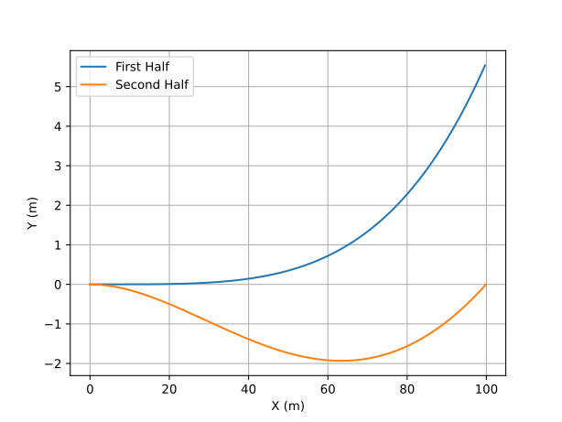
Figure 2.7.2-1 First and second half of parent curves, without placement adjustments

Two-level placement for the second half
IfcCurveSegment evaluation normalizes the parent curve at SegmentStart, then applies the curve segment Placement. For the second half, SegmentStart = L/2, so the second half parent curve’s value at $t=L/2$ is the normalization origin. The second half parent curve’s own Position attribute is therefore set so that the point at $L/2$ exactly matches the endpoint of the first half.
With this alignment the normalization cancels the offset, and the curve segment Placement supplies only the world-space join position.
Level | Attribute | Purpose
IfcSecondOrderPolynomialSpiral.Position | $$(x_{p}, y_{p}, θ_{p})$$ | Shift/rotate the raw spiral so its value at $t=L/2$ equals $(x_{1},y_{1},θ_{1})$
IfcCurveSegment.Placement | World-space join point | Place the normalized second-half curve at the correct position in the composite curve
Table 2.7.2-1 — Two-level placement for the second Helmert half
Finding the parent curve Position
Evaluate the raw second half spiral (with Position at origin) at $t=L/2$ to obtain $(x_{2},y_{2},θ_{2})$. The rigid-body transform that maps this to $(x_{1},y_{1},θ_{1})$ is
$$θ_{p}=θ_{1}-θ_{2}=0.0277777777-(-0.0277777777)=0.05555555$$
$$x_{p}=x_{1}-x_{2}cosθ_{p}+y_{2}sinθ_{p}=49.997244-49.966385cos(0.0555556)+(-1.735658)sin(0.0555556)=0.011573 m$$
$$y_{p}=y_{1}-x_{2}sinθ_{p}-y_{2}cosθ_{p}=0.347204-49.966385sin(0.0555556)-(-1.735658)cos(0.0555556)=-0.694298 m$$
$$dx_{p}=cos(θ_{p})=cos(0.055555555)=0.998457$$
$$dy_{p}=sin(θ_{p})=sin(0.055555555)=0.055527$$
Figure 2.7.2-2 shows the same first and second half parent curves, with the origin of the second half curve translated $(x_{p},y_{p})$ and rotated so that the curve tangent is $(dx_{p},dy_{p})$
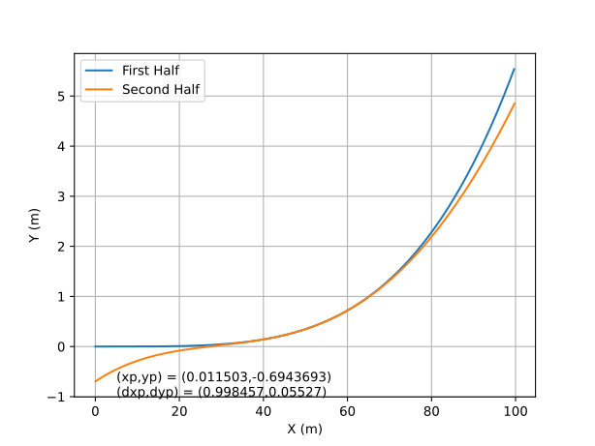
Figure 2.7.2-2 — First and second half parent curves with second half curve positioned
Finding the curve segment Placement
The Placement is the world-space position and direction at the join point, obtained by rotating $(x_{1},y_{1})$ by the overall segment start direction $θ_{s}$ and translating by the start point $(x_{s},y_{s})$:
$$x_{join}=x_{s}+x_{1}cosθ_{s}-y_{1}sinθ_{s}$$
$$y_{join}=y_{s}+x_{1}sinθ_{s}+y_{1}cosθ_{s}$$
$$θ_{join}=θ_{s}+θ_{1}$$
For the example with $θ_{s}=0$:
$$x_{join}=0.0+49.99724cos(0.0)-0.347204sin(0.0)=49.99724 \text{m}$$
$$y_{join}=0.0+49.99724sin(0.0)+0.347204cos(0.0)=0.347204 \text{m}$$
$$θ_{join}=0.0+0.02777777=0.02777777 \text{rad}$$
The RefDirection of the curve segment Placement is $(cosθ_{join}, sinθ_{join})$:
$$cosθ_{join}=cos(0.02777777)=0.999614$$
$$sinθ_{join}=sin(0.02777777)=0.027774$$
The geometric representation of the second half
#48 = IFCCURVESEGMENT(.CONTINUOUS., #49, IFCLENGTHMEASURE(50.), IFCLENGTHMEASURE(50.), #52);
#49 = IFCAXIS2PLACEMENT2D(#50, #51);
#50 = IFCCARTESIANPOINT((49.9972443634885, 0.347204361427475));
#51 = IFCDIRECTION((0.999614222337484, 0.0277742056705088));
#52 = IFCSECONDORDERPOLYNOMIALSPIRAL(#53, -114.471424255333, 86.6025403784439, -300.);
#53 = IFCAXIS2PLACEMENT2D(#54, #55);
#54 = IFCCARTESIANPOINT((0.0115725277555399, -0.694297741112199));
#55 = IFCDIRECTION((0.998457186998745, 0.0555269820047339));
Figure 2.7.2-3 shows the trimmed and positioned first and second half parent curves resulting in the full Helmert transition curve.
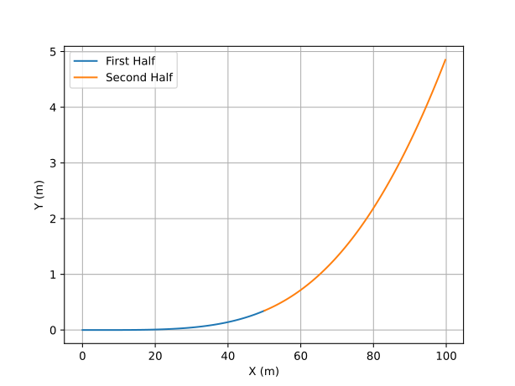
Figure 2.7.2-3 — Final Helmert transition curve

2.7.3 Compute Point on Curve
Compute the curve coordinates at a distance along the curve, $u=100$ (the end of the full Helmert segment).
The point falls in the second half ($50<u≤100$). The parent curve parameter is $t=\text{SegmentStart}+(u-50)=50+50=100$.

Step 1 — Form the curve segment placement matrix $M_{CSP}$
The curve segment Placement for the second half is at $(x_{join},y_{join})=(49.9972, 0.347204)$ with direction $θ_{join}=0.027778 \text{rad}$:
$$M_{CSP}=\left[\begin{matrix}0.999614 & -0.027774 & 0 & 49.9972 \\ 0.027774 & 0.999614 & 0 & 0.347204 \\ 0 & 0 & 1 & 0 \\ 0 & 0 & 0 & 1\end{matrix}\right]$$

Step 2 — Evaluate the second half parent curve at SegmentStart and form the normalization matrix $M_{N}$
The second half parent curve has Position at $(x_{p},y_{p})=(0.011573, -0.694298)$ with direction $θ_{p}=0.055556 \text{rad}$. This was chosen so that the parent curve at $t=L/2=50$ yields $(x_{1},y_{1},θ_{1})=(49.9972, 0.347204, 0.027778)$ — the endpoint of the first half.
$M_{N}$ maps $(x_{1},y_{1},θ_{1})$ to the origin with the $x$-axis tangent direction:
$$M_{N}=\left[\begin{matrix}cosθ_{1} & sinθ_{1} & 0 & -x_{1}cosθ_{1}-y_{1}sinθ_{1} \\ -sinθ_{1} & cosθ_{1} & 0 & x_{1}sinθ_{1}-y_{1}cosθ_{1} \\ 0 & 0 & 1 & 0 \\ 0 & 0 & 0 & 1\end{matrix}\right]$$
$$M_{N}=\left[\begin{matrix}0.999614 & 0.027774 & 0 & -49.987600 \\ -0.027774 & 0.999614 & 0 & 1.041563 \\ 0 & 0 & 1 & 0 \\ 0 & 0 & 0 & 1\end{matrix}\right]$$

Step 3 — Evaluate and map each point
Evaluate the second half parent curve at $t=100$. The raw spiral (before applying Position) uses $(A_{02}, A_{12}, A_{22})=(-300, 86.6025, -114.4714)$:
$$θ_{raw}(t)=\frac{t^{3}}{3(-114.4714)^{3}}+\frac{86.6025}{2\left|{86.6025}^{3}\right|}t^{2}+\frac{t}{-300}$$
$$θ_{raw}(100)=-0.22222+0.66666-0.33333=0.11111 \text{rad}$$
$$x_{raw}=\int_{0}^{100}{cos}θ_{raw}(t) dt=99.8942275 \text{m}$$
$$y_{raw}=\int_{0}^{100}{sin}θ_{raw}(t) dt=-0.00146897 \text{m}$$
Note: These integrals have no closed form and must be evaluated numerically. The values above are converged to better than ${10}^{-12} \text{m}$. A production implementation’s integrator may be less precise. For example, IfcOpenShell evaluates $(x_{raw},y_{raw})=(99.8942272, -0.0014677)$, about $1.3×{10}^{-6} \text{m}$ from the converged values. Expect agreement between implementations, and with the test set in Chapter 12, at the ${10}^{-6} \text{m}$ level for a 100 m Helmert curve, not to the last printed digit.
Apply the parent curve Position $(x_{p},y_{p},θ_{p})$:
$$x_{pos}=x_{p}+x_{raw}cosθ_{p}-y_{raw}sinθ_{p}=0.011573+99.8942275(0.998457)-(-0.00146897)(0.055527)=99.751763 \text{m}$$
$$y_{pos}=y_{p}+x_{raw}sinθ_{p}+y_{raw}cosθ_{p}=-0.694298+99.8942275(0.055527)+(-0.00146897)(0.998457)=4.851061 \text{m}$$
$$θ_{pos}(100)=θ_{p}+θ_{raw}(100)=0.055556+0.11111=0.16\overline{6} \text{rad}$$
Note: $θ_{pos}(100)=\frac{1}{6}=\frac{L}{2R_{e}}=\frac{100}{2×300}$, confirming the total tangent angle change matches a Clothoid with the same endpoints.
Form $M_{PC}$ from the parent curve point at $t=100$:
$$M_{PC}=\left[\begin{matrix}cosθ_{pos} & -sinθ_{pos} & 0 & x_{pos} \\ sinθ_{pos} & cosθ_{pos} & 0 & y_{pos} \\ 0 & 0 & 1 & 0 \\ 0 & 0 & 0 & 1\end{matrix}\right]=\left[\begin{matrix}0.986143 & -0.165896 & 0 & 99.751763 \\ 0.165896 & 0.986143 & 0 & 4.851061 \\ 0 & 0 & 1 & 0 \\ 0 & 0 & 0 & 1\end{matrix}\right]$$
Apply normalization and curve segment placement:
$$M_{h}=M_{CSP} M_{N} M_{PC}$$
$$M_{h}=\left[\begin{matrix}0.999614 & -0.027774 & 0 & 49.9972 \\ 0.027774 & 0.999614 & 0 & 0.347204 \\ 0 & 0 & 1 & 0 \\ 0 & 0 & 0 & 1\end{matrix}\right]\left[\begin{matrix}0.999614 & 0.027774 & 0 & -49.987600 \\ -0.027774 & 0.999614 & 0 & 1.041563 \\ 0 & 0 & 1 & 0 \\ 0 & 0 & 0 & 1\end{matrix}\right]\left[\begin{matrix}0.986143 & -0.165896 & 0 & 99.751763 \\ 0.165896 & 0.986143 & 0 & 4.851061 \\ 0 & 0 & 1 & 0 \\ 0 & 0 & 0 & 1\end{matrix}\right]$$
$$M_{h}=\left[\begin{matrix}0.98614323 & -0.16589613 & 0. & 99.75176345 \\ 0.16589613 & 0.98614323 & 0. & 4.85106052 \\ 0 & 0 & 1 & 0 \\ 0 & 0 & 0 & 1\end{matrix}\right]$$

2.8 Bloss Transition Curve
IfcThirdOrderPolynomialSpiral is the geometric type for Bloss transition spirals.

2.8.1 Parent Curve Parametric Equations
The curve tangent angle and curvature are given by the following equations
$$θ(t)=\frac{A_{3}}{4\left|A_{3}^{5}\right|}t^{4}+\frac{1}{3A_{2}^{3}}t^{3}+\frac{A_{1}}{2\left|A_{1}^{3}\right|}t^{2}+\frac{t}{A_{0}}$$
$$κ(t)=\frac{A_{3}}{\left|A_{3}^{5}\right|}t^{3}+\frac{t^{2}}{A_{2}^{3}}+\frac{A_{1}}{2\left|A_{1}^{3}\right|}t+\frac{1}{A_{0}}$$

2.8.2 Semantic Definition to Geometry Mapping
Consider a horizontal Bloss transition curve segment that starts at (0,0) with a start direction of 0.0. The radius at the start is infinite and the radius at the end is 300. The arc length of the segment is 100. The semantic definition is
#28 = IFCCARTESIANPOINT((0., 0.));
#29 = IFCALIGNMENTHORIZONTALSEGMENT($, $, #28, 0., 0., 300., 100., $, .BLOSSCURVE.);
Compute the polynomial spiral parameters
$$L=100 m$$
$$R_{s}=∞$$
$$R_{e}=300 m$$
$$f=\frac{L}{R_{e}}-\frac{L}{R_{s}}=\frac{100}{300}-\frac{100}{∞}=0.33333$$
$$a_{0}=\frac{L}{R_{s}}=\frac{100}{∞}=0$$
$$A_{0}=\frac{L}{\left|a_{0}\right|}\frac{a_{0}}{\left|a_{0}\right|}=0$$
$$A_{1}=0$$
$$a_{2}=3f=3(0.33333)=1$$
$$A_{2}=\frac{L}{{\left|a_{2}\right|}^{\frac{1}{3}}}\frac{a_{2}}{\left|a_{2}\right|}=\frac{100}{{\left|1\right|}^{\frac{1}{3}}}\frac{1}{\left|1\right|}=100 m$$
$$a_{3}=-2f=-2(0.33333)=-0.66667$$
$$A_{3}=\frac{L}{{\left|a_{3}\right|}^{\frac{1}{4}}}\frac{a_{3}}{\left|a_{3}\right|}=\frac{100 m}{{\left|-0.66667\right|}^{\frac{1}{4}}}\frac{-0.66667}{\left|-0.66667\right|}=-110.668192 m$$
#36 = IFCCURVESEGMENT(.CONTINUOUS., #42, IFCLENGTHMEASURE(0.), IFCLENGTHMEASURE(100.), #45);
#42 = IFCAXIS2PLACEMENT2D(#43, #44);
#43 = IFCCARTESIANPOINT((0., 0.));
#44 = IFCDIRECTION((1., 0.));
#45 = IFCTHIRDORDERPOLYNOMIALSPIRAL(#46, -110.668191970032, 100., $, $);
#46 = IFCAXIS2PLACEMENT2D(#47, $);
#47 = IFCCARTESIANPOINT((0., 0.));

2.8.3 Compute Point on Curve
Compute the curve coordinates at a distance along the curve, $u=50$

Step 1 — Form the curve segment placement matrix $M_{CSP}$
Represent IfcCurveSegment.Placement in matrix form. In this example, the placement is at (0,0) with RefDirection (1,0) which results in an identity matrix.
$$M_{CSP}=I$$

Step 2 — Evaluate the parent curve at the trim start and form the normalization matrix $M_{N}$
Because the parent curve is located at (0,0) in the direction (1,0), $x_{0}=0,y_{0}=0,θ_{0}=0$.
Since $x_{0}=0$, $y_{0}=0$, and $θ_{0}=0$, $M_{N}=I$.

Step 3 — Evaluate and map each point
Compute point and curve tangent at 50 m from the start.
$$x=\int_{0}^{50}{cosθ(s)} ds=49.9962109$$
$$y=\int_{0}^{50}{sinθ(s)} ds=0.416638875$$
$$θ(50)=\frac{-110.668192}{4\left|-{110.668192}^{5}\right|}(50)^{4}+\frac{1}{3(100)^{3}}(50)^{3}=0.03125$$
$$dx=cos\left(0.03125\right)=0.999512$$
$$dy=sin\left(0.03125\right)=0.031245$$
In matrix form
$$M_{PC}=\left[\begin{matrix}0.999512 & -0.031245 & 0 & 49.9962109 \\ 0.031245 & 0.999512 & 0 & 0.416638875 \\ 0 & 0 & 1 & 0 \\ 0 & 0 & 0 & 1\end{matrix}\right]$$
Apply the normalization and curve segment placement to the parent curve point
$$M_{h}=M_{CSP}M_{N}M_{PC}=I I\left[\begin{matrix}0.999512 & -0.031245 & 0 & 49.9962109 \\ 0.031245 & 0.999512 & 0 & 0.416638875 \\ 0 & 0 & 1 & 0 \\ 0 & 0 & 0 & 1\end{matrix}\right]$$
$$M_{h}=\left[\begin{matrix}0.999512 & -0.031245 & 0 & 49.9962109 \\ 0.031245 & 0.999512 & 0 & 0.416638875 \\ 0 & 0 & 1 & 0 \\ 0 & 0 & 0 & 1\end{matrix}\right]$$

2.9 Cosine Transition Curve
IfcCosineSpiral is the geometric type for cosine transition spirals.

2.9.1 Parent Curve Parametric Equations
The curve tangent angle and curvature are given by the following equations
$$κ(t)=\frac{1}{A_{0}}+\frac{1}{A_{1}}cos\left(\frac{π}{L}t\right)$$
$$θ(t)=\frac{1}{A_{0}}t+\frac{L}{πA_{1}}sin\left(\frac{π}{L}t\right)$$

2.9.2 Semantic Definition to Geometry Mapping
Consider a horizontal cosine transition curve segment that starts at (0,0) with a start direction of 0.0. The radius at the start is infinite and the radius at the end is 300. The arc length of the segment is 100. The semantic definition is
#28 = IFCCARTESIANPOINT((0., 0.));
#29 = IFCALIGNMENTHORIZONTALSEGMENT($, $, #28, 0., 0., 300., 100., $, .COSINECURVE.);
Compute the cosine spiral parameters
$$R_{s}=∞, R_{e}=300 m, L=100 m$$
$$f=\frac{L}{R_{e}}-\frac{L}{R_{s}}=\frac{100}{300}-\frac{100}{∞}=0.33333$$
Constant Term:
$$a_{0}=0.5f+\frac{L}{R_{s}}=0.5(0.33333)+\frac{100}{∞}=0.16667$$
$$A_{0}=\frac{L}{\left|a_{0}\right|}\frac{a_{0}}{\left|a_{0}\right|}=\frac{100 m}{\left|0.16667\right|} \frac{0.16667}{\left|0.16667\right|}=600 m$$
Cosine Term:
$$a_{1}=-0.5f=-0.5(0.33333)=-0.16667$$
$$A_{1}=\frac{L}{\left|a_{1}\right|}\frac{a_{1}}{\left|a_{1}\right|}=\frac{100}{\left|-0.16667\right|} \frac{-0.16667}{\left|-0.16667\right|}=-600 m$$
#36 = IFCCURVESEGMENT(.CONTINUOUS., #42, IFCLENGTHMEASURE(0.), IFCLENGTHMEASURE(100.), #45);
#42 = IFCAXIS2PLACEMENT2D(#43, #44);
#43 = IFCCARTESIANPOINT((0., 0.));
#44 = IFCDIRECTION((1., 0.));
#45 = IFCCOSINESPIRAL(#46, -600., 600.);
#46 = IFCAXIS2PLACEMENT2D(#47, $);
#47 = IFCCARTESIANPOINT((0., 0.));

2.9.3 Compute Point on Curve
Compute the curve coordinates at a distance along the curve, $u=100$

Step 1 — Form the curve segment placement matrix $M_{CSP}$
Represent IfcCurveSegment.Placement in matrix form. In this example, the placement is at (0,0) with RefDirection (1,0) which results in an identity matrix.
$$M_{CSP}=I$$

Step 2 — Evaluate the parent curve at the trim start and form the normalization matrix $M_{N}$
Because the parent curve is located at (0,0) in the direction (1,0), $x_{0}=0,y_{0}=0,θ_{0}=0$.
Since $x_{0}=0$, $y_{0}=0$, and $θ_{0}=0$, $M_{N}=I$.

Step 3 — Evaluate and map each point
Compute point and curve tangent at 100 m from the start.
$$θ(t)=\frac{1}{600}t-\frac{100}{600π}sin\left(\frac{π}{100}t\right)$$
$$x=\int_{0}^{100}{cosθ(t)} dt=99.7485 m$$
$$y=\int_{0}^{100}{sinθ(t)} dt=4.9458 m$$
$$θ(100)=\frac{1}{600}100-\frac{100}{600π}sin\left(\frac{π}{100}100\right)=\frac{1}{6}=0.1666667$$
$$dx=cos\left(\frac{1}{6}\right)=0.98614$$
$$dy=sin\left(\frac{1}{6}\right)=0.16589$$
In matrix form
$$M_{PC}=\left[\begin{matrix}0.98614 & -0.16589 & 0 & 99.7485 \\ 0.16589 & 0.98614 & 0 & 4.9458 \\ 0 & 0 & 1 & 0 \\ 0 & 0 & 0 & 1\end{matrix}\right]$$
Apply the normalization and curve segment placement to the parent curve point
$$M_{h}=M_{CSP}M_{N}M_{PC}=I I \left[\begin{matrix}0.98614 & -0.16589 & 0 & 99.7485 \\ 0.16589 & 0.98614 & 0 & 4.9458 \\ 0 & 0 & 1 & 0 \\ 0 & 0 & 0 & 1\end{matrix}\right]$$
$$M_{h}=\left[\begin{matrix}0.98614 & -0.16589 & 0 & 99.7485 \\ 0.16589 & 0.98614 & 0 & 4.9458 \\ 0 & 0 & 1 & 0 \\ 0 & 0 & 0 & 1\end{matrix}\right]$$

2.10 Sine Transition Curve
IfcSineSpiral is the geometric type for sine transition spirals.

2.10.1 Parent Curve Parametric Equations
The curve tangent angle and curvature are given by the following equations
$$κ(t)=\frac{1}{A_{0}}+\frac{A_{1}}{\left|A_{1}\right|}{\left(\frac{1}{A_{1}}\right)}^{2}t+\frac{1}{A_{2}}sin\left(\frac{2π}{L}t\right)$$
$$θ(t)=\frac{1}{A_{0}}t+\frac{1}{2}\left(\frac{A_{1}}{\left|A_{1}\right|}\right){\left(\frac{t}{A_{1}}\right)}^{2}-\frac{L}{2πA_{2}}\left(cos\left(\frac{2π}{L}t\right)-1\right)$$
$$x=\int_{0}^{L}{cosθ(t)} dt$$
$$y=\int_{0}^{L}{sinθ(t)} dt$$

2.10.2 Semantic Definition to Geometry Mapping
Consider a horizontal sine transition curve segment that starts at (0,0) with a start direction of 0.0. The radius at the start is infinite and the radius at the end is 300. The arc length of the segment is 100. The semantic definition is
#28 = IFCCARTESIANPOINT((0., 0.));
#29 = IFCALIGNMENTHORIZONTALSEGMENT($, $, #28, 0., 0., 300., 100., $, .SINECURVE.);
Compute the sine spiral parameters
$$R_{s}=∞, R_{e}=300 m, L=100 m$$
$$f=\frac{L}{R_{e}}-\frac{L}{R_{s}}=\frac{100}{300}-\frac{100}{∞}=0.33333$$
Constant Term:
$$a_{0}=\frac{L}{R_{s}}=\frac{100}{∞}=0$$
$$A_{0}=\frac{L}{\left|a_{0}\right|}\frac{a_{0}}{\left|a_{0}\right|}=0$$
Linear Term:
$$a_{1}=f=0.33333$$
$$A_{1}=\frac{L}{{\left|a_{1}\right|}^{\frac{1}{2}}}\frac{a_{1}}{\left|a_{1}\right|}=\frac{100}{{\left|0.33333\right|}^{\frac{1}{2}}}\frac{0.33333}{\left|0.33333\right|}=173.2050808 m$$
Sine Term:
$$a_{2}=-\frac{1}{2π}f=-\frac{1}{2π}(0.33333)=-0.053051647$$
$$A_{2}=\frac{L}{\left|a_{2}\right|}\frac{a_{2}}{\left|a_{2}\right|}=\frac{100}{\left|-0.053051647\right|}\frac{-0.053051647}{\left|-0.053051647\right|}=-1884.955592 m$$
#36 = IFCCURVESEGMENT(.CONTINUOUS., #42, IFCLENGTHMEASURE(0.), IFCLENGTHMEASURE(100.), #45);
#42 = IFCAXIS2PLACEMENT2D(#43, #44);
#43 = IFCCARTESIANPOINT((0., 0.));
#44 = IFCDIRECTION((1., 0.));
#45 = IFCSINESPIRAL(#46, -1884.95559215388, 173.205080756888, $);
#46 = IFCAXIS2PLACEMENT2D(#47, $);
#47 = IFCCARTESIANPOINT((0., 0.));

2.10.3 Compute Point on Curve
Compute the curve coordinates at a distance along the curve, $u=100$

Step 1 — Form the curve segment placement matrix $M_{CSP}$
Represent IfcCurveSegment.Placement in matrix form. In this example, the placement is at (0,0) with RefDirection (1,0) which results in an identity matrix.
$$M_{CSP}=I$$

Step 2 — Evaluate the parent curve at the trim start and form the normalization matrix $M_{N}$
Because the parent curve is located at (0,0) in the direction (1,0), $x_{0}=0,y_{0}=0,θ_{0}=0$.
Since $x_{0}=0$, $y_{0}=0$, and $θ_{0}=0$, $M_{N}=I$.

Step 3 — Evaluate and map each point
Compute point and curve tangent at 100 m from the start.
$$θ(t)=\frac{1}{2}{\left(\frac{t}{173.2050808}\right)}^{2}+\frac{100}{2π(1884.955592)}\left(cos\left(\frac{2π}{100}t\right)-1\right)$$
$$x=\int_{0}^{100}{cosθ(t)} dt=99.75698 m$$
$$y=\int_{0}^{100}{sinθ(t)} dt=4.70132 m$$
$$θ(100)=\frac{1}{2}{\left(\frac{100}{173.2050808}\right)}^{2}+\frac{100}{2π(1884.955592)}\left(cos\left(\frac{2π}{100}100\right)-1\right)=\frac{1}{6}=0.1666667$$
$$dx=cos\left(\frac{1}{6}\right)=0.98614$$
$$dy=sin\left(\frac{1}{6}\right)=0.16589$$
In matrix form
$$M_{PC}=\left[\begin{matrix}0.98614 & -0.16589 & 0 & 99.75698 \\ 0.16589 & 0.98614 & 0 & 4.70132 \\ 0 & 0 & 1 & 0 \\ 0 & 0 & 0 & 1\end{matrix}\right]$$
Apply the normalization and curve segment placement to the parent curve point
$$M_{h}=M_{CSP}M_{N}M_{PC}=I I\left[\begin{matrix}0.98614 & -0.16589 & 0 & 99.75698 \\ 0.16589 & 0.98614 & 0 & 4.70132 \\ 0 & 0 & 1 & 0 \\ 0 & 0 & 0 & 1\end{matrix}\right]$$
$$M_{h}=\left[\begin{matrix}0.98614 & -0.16589 & 0 & 99.75698 \\ 0.16589 & 0.98614 & 0 & 4.70132 \\ 0 & 0 & 1 & 0 \\ 0 & 0 & 0 & 1\end{matrix}\right]$$

2.11 Viennese Transition Curve
The Viennese Bend is a transition spiral developed for high-speed railway applications. Unlike every other transition curve type in this guide — all of which define horizontal geometry purely from geometric parameters (start radius, end radius, and arc length) — the Viennese Bend incorporates vehicle dynamics: its curvature variation is shaped by the superelevation (cant) transition that accompanies it. The result is a curve that simultaneously satisfies continuity requirements for curvature, cant, and their first derivatives, producing lower lateral jerk experienced by passengers.
IfcAlignmentHorizontalSegment.GravityCenterLineHeight is required for VIENNESEBEND but is optional for all other horizontal segment types. The associated cant segment (IfcAlignmentCantSegment with PredefinedType = VIENNESEBEND) must span the same horizontal length.
The IFC geometric type is IfcSeventhOrderPolynomialSpiral.

2.11.1 Parent Curve Parametric Equations
The curve tangent angle and curvature are given by the following equations
$$θ(s)=\frac{A_{7}}{8\left|A_{7}^{9}\right|}s^{8}+\frac{1}{7A_{6}^{7}}s^{7}+\frac{A_{5}}{6\left|A_{5}^{7}\right|}s^{6}+\frac{1}{5A_{4}^{5}}s^{5}+\frac{A_{3}}{4\left|A_{3}^{5}\right|}s^{4}+\frac{1}{3A_{2}^{3}}s^{3}+\frac{A_{1}}{2\left|A_{1}^{3}\right|}s^{2}+\frac{1}{A_{0}}s$$
$$κ(s)=\frac{A_{7}}{\left|A_{7}^{9}\right|}s^{7}+\frac{1}{A_{6}^{7}}s^{6}+\frac{A_{5}}{\left|A_{5}^{7}\right|}s^{5}+\frac{1}{A_{4}^{5}}s^{4}+\frac{A_{3}}{\left|A_{3}^{5}\right|}s^{3}+\frac{1}{A_{2}^{3}}s^{2}+\frac{A_{1}}{\left|A_{1}^{3}\right|}s+\frac{1}{A_{0}}$$

2.11.2 Semantic Definition to Geometry Mapping
Consider a horizontal Viennese Bend transition curve segment that starts at (0,0) with a start direction of 0.0. The radius at the start is infinite and the radius at the end is 300. The arc length is 100. The Gravity Center Line Height is 1.8 (this optional parameter is required for the Viennese Bend). The semantic definition is
#28 = IFCCARTESIANPOINT((0., 0.));
#29 = IFCALIGNMENTHORIZONTALSEGMENT($, $, #28, 0., 0., 300., 100., 1.8, .VIENNESEBEND.);
Viennese Bend transition curves are unique in that the horizontal geometry of the curve depends on the cant. For the example, the cant segment horizontal length is 100, the start cant is 0.0 and the end cant is 0 at the left rail and 0.1 at the right rail. The semantic definition is
#64 = IFCALIGNMENTCANTSEGMENT($, $, 0., 100., 0., 0., 0., 0.1, .VIENNESEBEND.);
$h_{cg}$ = Gravity Center Line Height = IfcAlignmentHorizontalSegment.GravityCenterLineHeight
$D_{rh}$ = Rail Head Distance = IfcAlignmentCant.RailHeadDistance
$D_{sl}$ = IfcAlignmentCantSegment.StartCantLeft
$D_{el}$ = IfcAlignmentCantSegment.EndCantLeft
$D_{sr}$ = IfcAlignmentCantSegment.StartCantRight
$D_{er}$ = IfcAlignmentCantSegment.EndCantRight
$β_{s}=\frac{(D_{sr}-D_{sl})}{D_{rh}}$, Start Cross Slope
$β_{e}=\frac{(D_{er}-D_{el})}{D_{rh}}$, End Cross Slope
$cf=-420.\left(\frac{h_{cg}}{L}\right)\left(β_{e}-β_{s}\right)$, Cant Factor
Compute the polynomial spiral parameters
$$R_{s}=∞, R_{e}=300 m, L=100 m$$
$$f=\frac{L}{R_{e}}-\frac{L}{R_{s}}=\frac{100}{300}-\frac{100}{∞}=0.33333$$
$$β_{s}=\frac{(0.-0.)}{1.5}=0.0$$
$$β_{e}=\frac{0.1-0.0}{1.5}=0.066667$$
$$cf=-420\left(\frac{1.8}{100}\right)(0.066667-0.)=-0.504$$
Constant term
$$a_{0}=\frac{L}{R_{s}}=\frac{100}{∞}=0$$
$$A_{0}=\frac{L}{\left|a_{0}\right|}\frac{a_{0}}{\left|a_{0}\right|}=0$$
Linear term
$$a_{1}=0$$
$$A_{1}=0$$
Quadratic term
$$a_{2}=cf=-0.504$$
$$A_{2}=\frac{L}{{\left|a_{2}\right|}^{\frac{1}{3}}}\frac{a_{2}}{\left|a_{2}\right|}=\frac{100}{{\left|-0.504\right|}^{\frac{1}{3}}}\frac{-0.504}{\left|-0.504\right|}=-125.6579069 m$$
Cubic term
$$a_{3}=-4cf=-4(-0.504)=2.016$$
$$A_{3}=\frac{L}{{\left|a_{3}\right|}^{\frac{1}{4}}}\frac{a_{3}}{\left|a_{3}\right|}=\frac{100}{{\left|2.016\right|}^{\frac{1}{4}}}\frac{2.016}{\left|2.016\right|}=83.92229813 m$$
Quartic term
$$a_{4}=5cf+35f=5(-0.504)+35(0.33333)=9.1466655$$
$$A_{4}=\frac{L}{{\left|a_{4}\right|}^{\frac{1}{5}}}\frac{a_{4}}{\left|a_{4}\right|}=\frac{100}{{\left|9.1466655\right|}^{\frac{1}{5}}}\frac{9.1466655}{\left|9.1466655\right|}=64.231406 m$$
Quintic term
$$a_{5}=-2cf-84f=-2(-0.504)-84(0.33333)=-26.9919999$$
$$A_{5}=\frac{L}{{\left|a_{5}\right|}^{\frac{1}{6}}}\frac{a_{5}}{\left|a_{5}\right|}=\frac{100}{{\left|-26.9919999\right|}^{\frac{1}{6}}}\frac{-26.9919999}{\left|-26.9919999\right|}=-57.7378785 m$$
Sextic term
$$a_{6}=70f=70(0.33333)=23.33333333$$
$$A_{6}=\frac{L}{{\left|a_{6}\right|}^{\frac{1}{7}}}\frac{a_{6}}{\left|a_{6}\right|}=\frac{100}{{\left|23.33333333\right|}^{\frac{1}{7}}}\frac{23.33333333}{\left|23.33333333\right|}=63.76388134 m$$
Septic term
$$a_{7}=-20f=-20(0.33333)=-6.66666666$$
$$A_{7}=\frac{L}{{\left|a_{7}\right|}^{\frac{1}{8}}}\frac{a_{7}}{\left|a_{7}\right|}=\frac{100}{{\left|-6.66666666\right|}^{\frac{1}{8}}}\frac{-6.66666666}{\left|-6.66666666\right|}=-78.8880838 m$$
#66 = IFCCURVESEGMENT(.CONTINUOUS., #72, IFCLENGTHMEASURE(0.), IFCLENGTHMEASURE(100.), #75);
#72 = IFCAXIS2PLACEMENT2D(#73, #74);
#73 = IFCCARTESIANPOINT((0., 0.));
#74 = IFCDIRECTION((1., 0.));
#75 = IFCSEVENTHORDERPOLYNOMIALSPIRAL(#76, -78.8880838459446, 63.7638813456506, -57.7378785242934, 64.2314061308743, 83.922298125931, -125.657906854859, $, $);
#76 = IFCAXIS2PLACEMENT2D(#77, $);
#77 = IFCCARTESIANPOINT((0., 0.));

2.11.3 Compute Point on Curve
Compute the curve coordinates at a distance along the curve, $u=100$

Step 1 — Form the curve segment placement matrix $M_{CSP}$
Represent IfcCurveSegment.Placement in matrix form. In this example, the placement is at (0,0) with RefDirection (1,0) which results in an identity matrix.
$$M_{CSP}=I$$

Step 2 — Evaluate the parent curve at the trim start and form the normalization matrix $M_{N}$
Because the parent curve is located at (0,0) in the direction (1,0), $x_{0}=0,y_{0}=0,θ_{0}=0$.
Since $x_{0}=0$, $y_{0}=0$, and $θ_{0}=0$, $M_{N}=I$.

Step 3 — Evaluate and map each point
Compute point and curve tangent at 100 m from the start.
$$θ(s)=\frac{A_{7}}{8\left|A_{7}^{9}\right|}s^{8}+\frac{1}{7A_{6}^{7}}s^{7}+\frac{A_{5}}{6\left|A_{5}^{7}\right|}s^{6}+\frac{1}{5A_{4}^{5}}s^{5}+\frac{A_{3}}{4\left|A_{3}^{5}\right|}s^{4}+\frac{1}{3A_{2}^{3}}s^{3}+\frac{A_{1}}{2\left|A_{1}^{3}\right|}s^{2}+\frac{1}{A_{0}}s$$
$$x=\int_{0}^{100}{cosθ(s)} ds=99.76319823871657$$
$$y=\int_{0}^{100}{sinθ(s)} ds=4.499916129045404$$
$$θ(100)=\frac{-78.8880838}{8\left|(-78.8880838)^{9}\right|}{100}^{8}+\frac{1}{7(63.76388134)^{7}}{100}^{7}+\frac{-57.7378785}{6\left|(-57.7378785)^{7}\right|}{100}^{6}+\frac{1}{5(64.231406)^{5}}{100}^{5}+\frac{83.92229813}{4\left|(83.92229813)^{5}\right|}{100}^{4}+\frac{1}{3(-125.6579069)^{3}}{100}^{3}=\frac{1}{6}=0.1666666667$$
$$dx=cos\left(0.1666666667\right)=0.9861432315629198$$
$$dy=sin\left(0.1666666667\right)=0.16589613269344608$$
In matrix form
$$M_{PC}=\left[\begin{matrix}0.9861432315629198 & -0.16589613269344608 & 0 & 99.76319823871657 \\ 0.16589613269344608 & 0.9861432315629198 & 0 & 4.499916129045404 \\ 0 & 0 & 1 & 0 \\ 0 & 0 & 0 & 1\end{matrix}\right]$$
Apply the normalization and curve segment placement to the parent curve point
$$M_{h}=M_{CSP}M_{N}M_{PC}=I I\left[\begin{matrix}0.9861432315629198 & -0.16589613269344608 & 0 & 99.76319823871657 \\ 0.16589613269344608 & 0.9861432315629198 & 0 & 4.499916129045404 \\ 0 & 0 & 1 & 0 \\ 0 & 0 & 0 & 1\end{matrix}\right]$$
$$M_{h}=\left[\begin{matrix}0.9861432315629198 & -0.16589613269344608 & 0 & 99.76319823871657 \\ 0.16589613269344608 & 0.9861432315629198 & 0 & 4.499916129045404 \\ 0 & 0 & 1 & 0 \\ 0 & 0 & 0 & 1\end{matrix}\right]$$

2.12 Zero Length Segment
IFC Concept Templates 4.1.4.4.1.1, 4.1.4.4.1.2, 4.1.7.1.1.1, 4.1.7.1.1.2, 4.1.7.1.1.3, and 4.1.7.1.1.4 require that the final IfcAlignmentSegment nested within IfcAlignmentHorizontal, IfcAlignmentVertical, and IfcAlignmentCant has a SegmentLength of zero. A corresponding zero-length IfcCurveSegment is required in each associated geometric representation (IfcCompositeCurve, IfcGradientCurve, or IfcSegmentedReferenceCurve).
The specification imposes no constraint on which curve type backs the zero-length geometric segment. As best practice, use .LINE. (IfcAlignmentHorizontalSegment), .CONSTANTGRADIENT. (IfcAlignmentVerticalSegment), or .CONSTANTCANT. (IfcAlignmentCantSegment) as the PredefinedType of the semantic closing segment, and an IfcLine as the parent curve of the corresponding IfcCurveSegment. The placement of both the semantic and geometric closing segments must match the endpoint and end direction of the preceding segment.

2.12.1 Semantic Closing Segment
The StartPoint and StartDirection of the semantic segment are taken from the end state of the preceding segment, and SegmentLength is set to zero. One implementation strategy is to map the preceding semantic segment definition to its geometric representation as described in this chapter, as well as in Chapters 3 and 4, and evaluate it at its end point.
// Last non-zero length segment
#88=IFCCARTESIANPOINT((7790.93212831259,4006.73076454875));
#89=IFCALIGNMENTHORIZONTALSEGMENT($,$,#88,-1.23849516741382,0.,0.,2112.2850844257,$,.LINE.);
// Final segment, zero length.
#91=IFCCARTESIANPOINT((8480.,2010.));
#92=IFCALIGNMENTHORIZONTALSEGMENT($,$,#91,-1.23849516741382,0.,0.,0.,$,.LINE.);

2.12.2 Geometric Closing Segment
The zero-length IfcCurveSegment is placed at the endpoint of the alignment with its axis aligned to the end tangent direction. The parent curve is an IfcLine whose point and direction vector match that placement. SegmentStart and SegmentLength are both zero. Because the segment has zero length, the choice of IfcLine here has no geometric effect — it represents a point at the end of the alignment.
// Last non-zero length segment
#169=IFCCARTESIANPOINT((0.,0.));
#170=IFCDIRECTION((1.,0.));
#171=IFCVECTOR(#170,1.);
#172=IFCLINE(#169,#171);
#173=IFCDIRECTION((0.326219162729524,-0.945294164727599));
#174=IFCAXIS2PLACEMENT2D(#88,#173);
#175=IFCCURVESEGMENT(.CONTSAMEGRADIENTSAMECURVATURE.,#174,IFCLENGTHMEASURE(0.),IFCLENGTHMEASURE(2112.2850844257),#172);
// Final segment, zero length
#176=IFCCARTESIANPOINT((0.,0.));
#177=IFCDIRECTION((1.,0.));
#178=IFCVECTOR(#177,1.);
#179=IFCLINE(#176,#178);
#180=IFCDIRECTION((0.326219162729524,-0.945294164727599));
#181=IFCAXIS2PLACEMENT2D(#91,#180);
#182=IFCCURVESEGMENT(.DISCONTINUOUS.,#181,IFCLENGTHMEASURE(0.),IFCLENGTHMEASURE(0.),#179);

2.13 Summary and Implementation Checklist
# | Item | Notes
1 | Use IfcLengthMeasure for SegmentStart and SegmentLength on every IfcCurveSegment | Arc-length parameterization is mandatory per IFC schema Informal Proposition 1; IfcParameterValue (unit parameterization) is not valid for alignment geometry
2 | Handle negative SegmentStart and SegmentLength | A negative SegmentStart locates the trim origin on the opposite side of the parent curve’s reference point; a negative SegmentLength indicates trimming in the direction of decreasing parameter. Both can occur in any combination.
3 | For clothoid curves, convert SegmentStart from arc-length to unit parameter before evaluating | Compute $u=s/\left|A\sqrt{π}\right|$ where $A$ is the clothoid constant; the Fresnel integrals are defined in terms of $u$, not $s$
4 | Expect one IfcAlignmentHorizontalSegment with PredefinedType = HELMERTCURVE to map to two IfcCurveSegment entities | The Helmert curve is the only horizontal type where one semantic segment produces two geometric segments; evaluate the correct half based on the query distance relative to $L/2$
5 | Treat IfcPolynomialCurve coefficients as having implicit units of ${\text{Length}}^{(1-i)}$ | For a cubic curve, CoefficientsY[3] has implicit units of $m^{-2}$; evaluate as $y=b_{3}x^{3}$ where $x$ is a length. Do not multiply by curve length $L$ as you would for a unit-parameterized polynomial.
6 | Viennese Bend horizontal geometry requires GravityCenterLineHeight and a paired cant segment | IfcAlignmentHorizontalSegment.GravityCenterLineHeight is mandatory for VIENNESEBEND; the associated IfcAlignmentCantSegment with PredefinedType = VIENNESEBEND must span the same horizontal length, and its cant values enter the curvature formula via the cant factor $cf$
7 | Do not assume the parent curve is centered at the origin or aligned with the x-axis | The three-step algorithm ($M_{CSP}$, $M_{N}$, $M_{PC}$) handles arbitrary parent curve placement; SegmentStart locates where trimming begins regardless of the parent curve’s own position and orientation
8 | Apply the positive-left sign convention for radii | Positive StartRadiusOfCurvature / EndRadiusOfCurvature indicates a curve to the left of the direction of travel; negative indicates a curve to the right; zero indicates infinite radius (straight tangent)

Chapter 3 — Vertical Alignments

3.0 Introduction
The geometric representation of a vertical alignment is accomplished with IfcGradientCurve. It represents the elevation profile as a two-dimensional curve in a (distance along, elevation) coordinate system, where distance along is measured along the horizontal IfcCompositeCurve (IfcGradientCurve.BaseCurve). Combined with the horizontal alignment, the gradient curve establishes the three-dimensional geometry of the route.
Table 3.0-1 maps each IfcAlignmentVerticalSegment.PredefinedType to its corresponding parent curve type.
Business Logic (IfcAlignmentVerticalSegment.PredefinedType) | Geometric Representation (IfcCurveSegment.ParentCurve)
CONSTANTGRADIENT | IfcLine
CIRCULARARC | IfcCircle
CLOTHOID | IfcClothoid
PARABOLICARC | IfcPolynomialCurve
Table 3.0-1 — Mapping of business logic to geometric representation for vertical alignment
This chapter covers:
- The four-step evaluation algorithm: Steps 1–3 follow the same matrix composition as horizontal segments; Step 4 combines the vertical result with the horizontal placement matrix to produce a full 3D placement.
- Parametric equations and geometry mapping examples for the curve types in Table 3.0-1.
- The combined 3D evaluation that produces position, tangent, cross-track, and up-axis vectors from the IfcGradientCurve.
- Known limitation: vertical clothoid curves are not addressed in this guide.

3.1 Conventions
Each vertical segment is parameterized by arc-length $s$ along its parent curve, where $s=0$ at the start of the parent curve. The key semantic attributes are IfcAlignmentVerticalSegment.StartDistAlong (horizontal distance from the alignment start to the segment start), HorizontalLength (the horizontal projection of the segment), StartHeight (elevation at the segment start), and StartGradient and EndGradient (decimal slopes; e.g., $0.005=0.5\%$).
IfcCurveSegment.SegmentLength stores arc-length along the parent curve, not horizontal distance. The evaluator parameter is horizontal distance $l$, which must be converted to arc-length $s$ for use in the parent curve equations. For the grades typical in road and railway design ($≤5\%$), the difference is small but non-zero.
The grade angle at horizontal distance $l$ is $θ(l)=\tan^{-1}(g(l))$, where $g(l)$ is the gradient. The cosine and sine of $θ$ form the RefDirection of the vertical curve at that point.

3.2 Curve Segment Evaluation Algorithm
Steps 1–3 follow the identical procedure described in Section 2.2 for horizontal segments, substituting distance along for the horizontal $x$-coordinate and elevation for the horizontal $y$-coordinate. Let $s_{0}$ = IfcCurveSegment.SegmentStart.

Step 1 — Form the curve segment placement matrix $M_{CSP}$
$M_{CSP}$ is constructed from IfcCurveSegment.Placement, where $(d_{p},y_{p})$ is the Location (distance along, elevation) and $θ_{p}$ is the grade angle of the RefDirection.
$$M_{CSP}=\left[\begin{matrix}cosθ_{p} & -sinθ_{p} & 0 & d_{p} \\ sinθ_{p} & cosθ_{p} & 0 & y_{p} \\ 0 & 0 & 1 & 0 \\ 0 & 0 & 0 & 1\end{matrix}\right]$$

Step 2 — Evaluate the parent curve at the trim start and form the normalization matrix $M_{N}$
Compute the distance along $d_{0}=x(s_{0})$, elevation $y_{0}=y(s_{0})=\text{IfcAlignmentVerticalSegment.StartHeight}$, and grade angle $θ_{0}=θ(s_{0})$.
$M_{N}$ simultaneously translates the trim-start point to the origin and rotates so that the tangent at $s_{0}$ aligns with the positive $x$-direction.
$$M_{N}=\left[\begin{matrix}cosθ_{0} & sinθ_{0} & 0 & -d_{0}cosθ_{0}-y_{0}sinθ_{0} \\ -sinθ_{0} & cosθ_{0} & 0 & d_{0}sinθ_{0}-y_{0}cosθ_{0} \\ 0 & 0 & 1 & 0 \\ 0 & 0 & 0 & 1\end{matrix}\right]$$

Step 3 — Evaluate and map each point in the vertical plane
For the point at distance along $s$, compute $x(s)$, $y(s)$, and $θ(l)$:
$$M_{PC}=\left[\begin{matrix}cosθ(l) & -sinθ(l) & 0 & x(s) \\ sinθ(l) & cosθ(l) & 0 & y(s) \\ 0 & 0 & 1 & 0 \\ 0 & 0 & 0 & 1\end{matrix}\right]$$
$$M_{v}=M_{CSP}M_{N}M_{PC}$$
Column 4 of $M_{v}$ contains the distance along $d$ and elevation $z$ of the evaluated point. Column 1 contains $(dx_{v},dy_{v})=(cosθ_{v},sinθ_{v})$, the grade direction at that point. Step 4 is performed immediately for this point before moving to the next point.

Step 4 — Combine with the horizontal alignment point to produce the 3D placement matrix
The vertical result lives in the (distance along, elevation) plane and must be merged with the horizontal alignment to form a 3D position and orientation. The “distance along” axis corresponds to the curve tangent of the horizontal alignment and the vertical $y$ is elevation (Z in 3D).
Evaluate the horizontal placement matrix $M_{h}$ at distance $d$ along the IfcCompositeCurve. This yields the horizontal 2D position $(x_{h},y_{h})$ and the horizontal alignment tangent direction $(dx_{h},dy_{h})=(cosθ_{h},sinθ_{h})$.
$M_{v}$ is a two-dimensional matrix whose rows index the vertical frame: row 1 = distance-along, row 2 = elevation, row 3 = out-of-plane. Three modifications produce $M_{v}^{'}$, the form required for multiplication with $M_{h}$.
Column 4 — The distance-along value $d$ is replaced with zero. The horizontal position already comes from $M_{h}$; retaining $d$ would displace the point a second time along the horizontal tangent.
Rows 2 and 3 — $M_{h}$’s third row $(0, 0, 1, 0)$ passes row 3 of the right operand through unchanged into row 3 of the product. Because row 3 of $M_{3D}$ must carry the elevation (Z) component of every vector, elevation must occupy row 3 of $M_{v}^{'}$ — not row 2 as in $M_{v}$. The row semantics are therefore swapped: in $M_{v}^{'}$, row 2 is the cross-track (lateral) component and row 3 is the elevation (Z) component.
Columns 2 and 3 — The row reordering reindexes the column values and exchanges the columns. $M_{v}$ column 2, the in-plane normal $(-dy_{v}, dx_{v}, 0)$ in [d-along, elevation, out-of-plane] ordering, becomes $(-dy_{v}, 0, dx_{v})$ in [d-along, cross-track, elevation] ordering — the 3D up direction — and moves to column 3. $M_{v}$ column 3, the out-of-plane unit direction $(0, 0, 1)$, becomes $(0, 1, 0)$ — the cross-track direction — and moves to column 2.
$${M^{'}}_{v}=\left[\begin{matrix}dx_{v} & 0 & -dy_{v} & 0 \\ 0 & 1 & 0 & 0 \\ dy_{v} & 0 & dx_{v} & z \\ 0 & 0 & 0 & 1\end{matrix}\right]$$
The columns of $M_{v}^{'}$ define directions in the 3D frame local to the alignment:
- Column 1 $(dx_{v}, 0, dy_{v})$: the grade direction — $dx_{v}$ scales the contribution along the horizontal tangent; $dy_{v}$ is the elevation rate of change (Z component of the 3D tangent).
- Column 2 $(0, 1, 0)$: the cross-track direction, always lateral to the alignment and always horizontal.
- Column 3 $(-dy_{v}, 0, dx_{v})$: the “up” direction in the vertical plane of the alignment, orthogonal to the grade direction.
- Column 4 $(0, 0, z)$: the elevation offset with no horizontal displacement.
The 3D placement matrix is:
$$M_{3D}=M_{h}⋅{M^{'}}_{v}$$
Multiplying out, the columns of $M_{3D}$ are:
- Column 1 (RefDirection / 3D tangent): $(dx_{h}⋅dx_{v}, dy_{h}⋅dx_{v}, dy_{v})$ — the horizontal tangent scaled by $cosθ_{v}$, with $sinθ_{v}$ as the Z component.
- Column 2 (Y / cross-track): $(-dy_{h}, dx_{h}, 0)$ — the horizontal normal direction, unchanged from $M_{h}$.
- Column 3 (Axis / up): $(-dx_{h}⋅dy_{v}, -dy_{h}⋅dy_{v}, dx_{v})$ — orthogonal to both the 3D tangent and the cross-track direction.
- Column 4 (Location): $(x_{h}, y_{h}, z)$ — the full 3D position.
Numerical examples of Steps 1–3 are given in Sections 3.3 through 3.6. A complete worked example including Step 4 is in Section 3.7.

3.3 Constant Gradient
A constant gradient is geometrically represented with a segment trimmed from an IfcLine parent curve.

3.3.1 Parent Curve Parametric Equations
$$x(s)=p_{x}+s⋅dx$$
$$y(s)=p_{y}+s⋅dy$$
where $(p_{x}, p_{y})$ is the IfcLine origin and $dx$ and $dy$ are the direction parameters.

3.3.2 Semantic Definition to Geometry Mapping
Mapping of the semantic definition of the linear segment to the geometric definition is described with the following example.
Consider a vertical gradient at an uphill slope of 0.5 starting at point (0,10). The horizontal projection of the segment length is 100.
#44 = IFCALIGNMENTVERTICALSEGMENT($, $, 0., 100., 10., 0.5, 0.5, $, .CONSTANTGRADIENT.);
Define the direction of the IfcLine so it is horizontal
$$dx=1$$
$$dy=0$$
Define the IfcLine as passing through point (0,0)
#80 = IFCLINE(#81, #82);
#81 = IFCCARTESIANPOINT((0., 0.));
#82 = IFCVECTOR(#83, 1.);
#83 = IFCDIRECTION((1., 0.));
Place the curve segment at (0,10) with a tangent direction
$$dx=cos\left(\tan^{-1}(0.5)\right)=0.894427191$$
$$dy=sin\left(\tan^{-1}(0.5)\right)=0.44713595$$
#77 = IFCAXIS2PLACEMENT2D(#78, #79);
#78 = IFCCARTESIANPOINT((0., 10.));
#79 = IFCDIRECTION((0.894427190999916, 0.447213595499958));
IfcCurveSegment.SegmentLength is the length measured along the trimmed curve. For a horizontal length of $100 m$, the length along the curve is
$$100/0.894427190999916=111.803398874989 m$$
The curve segment is defined as
#71 = IFCCURVESEGMENT(.CONTINUOUS., #77, IFCLENGTHMEASURE(0.), IFCLENGTHMEASURE(111.803398874989), #80);

3.3.3 Compute Point on Curve
Compute the vertical placement matrix for the point at horizontal distance $l=50$ m from the start of the curve segment.

Step 1 — Form the curve segment placement matrix $M_{CSP}$
From IfcCurveSegment.Placement: $(d_{p}, y_{p})=(0, 10)$, $θ_{p}=0.463647609 \text{rad}$:
$$cosθ_{p}=cos(0.463647609)=0.894427191 sinθ_{p}=sin(0.463647609)=0.447213595$$
$$M_{CSP}=\left[\begin{matrix}0.894427191 & -0.447213595 & 0 & 0 \\ 0.447213595 & 0.894427191 & 0 & 10 \\ 0 & 0 & 1 & 0 \\ 0 & 0 & 0 & 1\end{matrix}\right]$$

Step 2 — Evaluate the parent curve at the trim start and form the normalization matrix $M_{N}$
The trim begins at $s_{0}=\text{SegmentStart}=0$. For the IfcLine through the origin with direction $(dx, dy)=(1., 0.)$:
$$d_{0}=x(0)=0 y_{0}=y(0)=0 θ_{0}=\tan^{-1}\left(\frac{dy}{dx}\right)=\tan^{-1}\left(\frac{0.}{1.}\right)=0. \text{rad}$$
$$M_{N}=\left[\begin{matrix}1 & 0 & 0 & 0 \\ 0 & 1 & 0 & 0 \\ 0 & 0 & 1 & 0 \\ 0 & 0 & 0 & 1\end{matrix}\right]$$

Step 3 — Evaluate and map each point in the vertical plane
The horizontal distance $l=50$ m is not the arc-length parameter. Convert to arc-length $s$ along the IfcLine:
$$s=s_{0}+\frac{l}{dx}=0+\frac{50}{0.894427191}=55.9016994 \text{m}$$
Evaluate the parent curve at $s=55.9016994$:
$$d=x(55.9016994)=55.9016994×1=55.9016994 \text{m}$$
$$z=y(55.9016994)=55.9016994×0=0 \text{m}$$
$$θ=0.$$
$$M_{PC}=\left[\begin{matrix}1 & 0 & 0 & 55.9016994 \\ 0 & 1 & 0 & 0 \\ 0 & 0 & 1 & 0 \\ 0 & 0 & 0 & 1\end{matrix}\right]$$
The vertical placement matrix is:
$$M_{v}=M_{CSP} M_{N} M_{PC}=\left[\begin{matrix}0.894427191 & -0.447213595 & 0 & 0 \\ 0.447213595 & 0.894427191 & 0 & 10 \\ 0 & 0 & 1 & 0 \\ 0 & 0 & 0 & 1\end{matrix}\right]\left[\begin{matrix}1 & 0 & 0 & 0 \\ 0 & 1 & 0 & 0 \\ 0 & 0 & 1 & 0 \\ 0 & 0 & 0 & 1\end{matrix}\right]\left[\begin{matrix}1 & 0 & 0 & 55.9016994 \\ 0 & 1 & 0 & 0 \\ 0 & 0 & 1 & 0 \\ 0 & 0 & 0 & 1\end{matrix}\right]$$
$$M_{v}=\left[\begin{matrix}0.894427191 & -0.447213595 & 0 & 50.000 \\ 0.447213595 & 0.894427191 & 0 & 35.000 \\ 0 & 0 & 1 & 0 \\ 0 & 0 & 0 & 1\end{matrix}\right]$$

3.4 Circular Arc
A circular vertical curve is geometrically represented with a segment trimmed from an IfcCircle parent curve.

3.4.1 Parent Curve Parametric Equations
The IfcCircle parametric equations for a vertical circular arc are identical to the horizontal case (Section 2.4.1), with $x(s)$ representing distance along the horizontal alignment and $y(s)$ representing elevation.
$$θ(s)=\frac{s}{R}$$
$$κ(s)=\frac{1}{R}$$
$$x(s)=∫cos\left(θ(s)\right)ds=Rsin\left(θ(s)\right)$$
$$y(s)=∫sin\left(θ(s)\right)ds=R\left(1-cos\left(θ(s)\right)\right)$$
where $R$ is IfcCircle.Radius and $s$ is arc length along the circle. The grade at arc length $s$ is $g(s)=tan(θ(s))$.

3.4.2 Semantic Definition to Geometry Mapping
Vertical circular arcs are tricky. The “distance along” dimension is horizontal while the IfcCurveSegment trimming parameters SegmentStart and SegmentLength are measured along the IfcCircle.
The following procedure maps the semantic parameters of a vertical circular arc to its geometric definition.
Given the following semantic definition of a vertical circular arc, create the geometric definition.
#44 = IFCALIGNMENTVERTICALSEGMENT($, $, 0., 100., 10., -5.E-1, -1., 384.773458895502, .CIRCULARARC.);
Determine the tangent slope angle at the start and end of the segment.
$$g_{start}=-0.5$$
$$θ_{start}=\tan^{-1}(g_{start})$$
$$θ_{start}=\tan^{-1}(-0.5)=-0.463648$$
$$g_{end}=-1$$
$$θ_{end}=\tan^{-1}(g_{end})$$
$$θ_{end}=\tan^{-1}(-1)=-0.785398$$
Compute the radius of the circle.
IfcAlignmentVerticalSegment.RadiusOfCurvature is optional. If provided, it should be consistent with the HorizontalLength, StartGradient and EndGradient, but is not guaranteed. For this reason, the radius is computed from the required HorizontalLength, StartGradient and EndGradient attributes. Note that in computing the radius, it is taken to be an absolute value because IfcCircle.Radius is a IfcPositiveLengthMeasure.
$$R=\left|\frac{h_{l}}{sin(θ_{start})-sin(θ_{end})}\right|$$
$$h_{l}=\text{IfcAlignmentVerticalSegment.HorizontalLength}=100.$$
$$R=\left|\frac{100}{sin(-0.785398)-sin(-0.463648)}\right|=384.773458895502$$
Compute the arc-length trimming parameters SegmentStart and SegmentLength.
For an IfcCircle with CCW parametrization and RefDirection = (1, 0), the arc-length parameter at a point where the grade angle is $θ$ depends on which half of the circle the vertical curve occupies.
If $θ_{start}<θ_{end}$ — sagging curve (lower half of circle):
$$\text{SegmentStart}=R\left(θ_{start}+\frac{3}{2}π\right)$$
If $θ_{start}>θ_{end}$ — cresting curve (upper half of circle):
$$\text{SegmentStart}=R\left(θ_{start}+\frac{1}{2}π\right)$$
In both cases:
$$\text{SegmentLength}=R(θ_{end}-θ_{start})$$
For a cresting curve $θ_{end}<θ_{start}$, so SegmentLength is negative — the segment is traversed clockwise.
For this example (cresting):
$$\text{SegmentStart}=R\left(θ_{start}+\frac{π}{2}\right)=(384.773458895502)(-0.463647609+\frac{π}{2})=426.001441657352$$
$$\text{SegmentLength}=R(θ_{end}-θ_{start})=(384.773458895502)(-0.785398-(-0.463647609))=-123.801073716741$$
Determine the placement of the trimmed curve
X = IfcAlignmentVerticalSegment.StartDistAlong = 0.0
Y = IfcAlignmentVerticalSegment.StartHeight = 10.0
$$C_{x}=Rd_{y}=384.773458895502(-0.447213595)=-172.075922$$
$$C_{y}=-Rd_{x}=-384.773458895502(0.894427191)=-344.151844$$
$$dx=cos(θ_{start})=cos(-0.463647609)=0.894427191$$
$$dy=sin(θ_{start})=sin(-0.463647609)=-0.447213595$$
The geometric representation is
#71 = IFCCURVESEGMENT(.CONTINUOUS., #77, IFCLENGTHMEASURE(426.001441657352), IFCLENGTHMEASURE(-123.801073716741), #80);
#77 = IFCAXIS2PLACEMENT2D(#78, #79);
#78 = IFCCARTESIANPOINT((0., 10.));
#79 = IFCDIRECTION((8.94427190999916E-1, -4.47213595499958E-1));
#80 = IFCCIRCLE(#81, 384.773458895502);
#81 = IFCAXIS2PLACEMENT2D(#82, #83);
#82 = IFCCARTESIANPOINT((-172.075922005613, -344.151844011225));
#83 = IFCDIRECTION((1., 0.));

3.4.3 Compute Point on Curve
Compute the vertical placement matrix for the point at horizontal distance $l=50$ m from the start of the curve segment.

Step 1 — Form the curve segment placement matrix $M_{CSP}$
From IfcCurveSegment.Placement: $(d_{p}, y_{p})=(0.,10.)$, $dx_{p}=0.894427190999916, dy_{p}=-0.447213595499958$
$$M_{CSP}=\left[\begin{matrix}0.894427190999916 & 0.447213595499958 & 0 & 0 \\ -0.447213595499958 & 0.894427190999916 & 0 & 10. \\ 0 & 0 & 1 & 0 \\ 0 & 0 & 0 & 1\end{matrix}\right]$$

Step 2 — Evaluate the parent curve at the trim start and form the normalization matrix $M_{N}$
$$Δ_{0}=\tan^{-1}\left(\frac{-344.151844011225}{-172.075922005613}\right)=1.1071487177940900$$
$$x_{0}=C_{x}+Rcos(Δ_{0})=-172.075922+384.773458895502cos(1.1071487177940900)=0$$
$$y_{0}=C_{y}+Rsin(Δ_{0})=-344.151844+384.773458895502sin(1.1071487177940900)=0$$
$$θ_{0}=Δ_{0}-\frac{π}{2}=-0.463647609$$
$$dx_{0}=cos(θ_{0})=0.89442719099991$$
$$dy_{0}=sin(θ_{0})=-0.447213595499958$$
$$M_{N}=\left[\begin{matrix}0.89442719099991 & -0.447213595499958 & 0 & 0 \\ 0.447213595499958 & 0.89442719099991 & 0 & 0 \\ 0 & 0 & 1 & 0 \\ 0 & 0 & 0 & 1\end{matrix}\right]$$

Step 3 — Evaluate and map each point in the vertical plane
Compute the vertical placement matrix for the point at horizontal distance $l=50 m$ from the start of the curve segment.
The center point of the trimmed circular arc is
$$C_{x}=-172.075922005613, C_{y}=-344.151844011225$$
From Step 2
$$x_{0}=0, y_{0}=0, θ_{0}=-0.463647609$$
Compute the chord length, $c$ between the start and end of the trimmed segment. This is accomplished by locating the point on the parent curve that corresponds to a horizontal distance of $l=50 m$. From Figure 3.4.3-1 the point on the parent curve is located using the right triangle shown. Once the point on the parent curve is known, a chord distance between the start of the trim and this point can be computed (see inset chord line detail). From here a sweep angle $Δ$ is computed and then the tangent direction at the point.
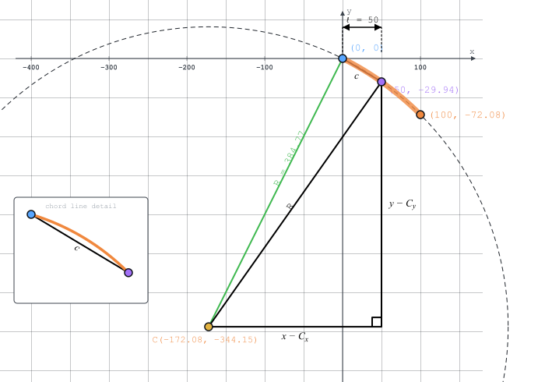
Figure 3.4.3-1 — Geometry of a vertical circular arc. The chord $c$ connects two points on the arc. The right triangle simplifies locating points on the arc. The inset highlights the distinction between the straight chord and the curved arc.
Location point on parent curve corresponding to $l=50$
$$x=x_{0}+l=0+50=50 m$$
From the right triangle
$$R^{2}=(x-C_{x})^{2}+(y-C_{y})^{2}$$
Solving for $y$,
$$y=C_{y}-\frac{L}{\left|L\right|}\sqrt{R^{2}-(x-C_{x})^{2}}=-344.151844011225-\frac{-123.801073716741}{\left|-123.801073716741\right|}\sqrt{(384.773458895502)^{2}-(50-(-172.075922005613))^{2}}=-29.933926737614911$$
Compute the chord length from the trim start to the point
$$c=\sqrt{(x-x_{0})^{2}+(y-y_{0})^{2}}=\sqrt{(50-(0))^{2}+(-29.933926737614911-10)^{2}}=58.275552077461235 m$$
Angle subtended by the trimmed segment
$$Δ=2\sin^{-1}\left(\frac{c}{2R}\right)=2\sin^{-1}\left(\frac{58.275552077461235}{2⋅384.773458895502}\right)=0.15159931828379261$$
Arc-length of the trimmed segment = $RΔ=(384.773458895502)(0.15159931828379261)=58.331394062255001$
Radial angle at $l=50 m$
$$Δ_{pc}=Δ_{0}-Δ=1.1071487177940900-0.15159931828379261=0.95554939951029738$$
Compute point on trimmed segment at $l$.
$$x_{pc}=C_{x}+Rcos(Δ_{pc})=(-172.075922005613)+384.77345889550202cos(0.95554939951029738)=50$$
$$y_{pc}=C_{y}+Rsin(Δ_{pc})=(-344.15184401122502)+384.77345889550202sin(0.95554939951029738)=-29.933926737614570$$
$$dx_{pc}=-\frac{L}{\left|L\right|}sin(Δ_{pc})=-\frac{-123.801073716741}{\left|-123.801073716741\right|}sin(0.95554939951029738)=0.81663095520043849$$
$$dy_{pc}=\frac{L}{\left|L\right|}cos(Δ_{pc})=\frac{-123.801073716741}{\left|-123.801073716741\right|}cos(0.95554939951029738)=-0.57716018834325311$$
$$M_{PC}=\left[\begin{matrix}0.81663095520043849 & 0.57716018834325311 & 0 & 50 \\ -0.57716018834325311 & 0.81663095520043849 & 0 & -29.933926737614570 \\ 0 & 0 & 1 & 0 \\ 0 & 0 & 0 & 1\end{matrix}\right]$$
The vertical placement matrix is:
$$M_{v}=M_{CSP} M_{N} M_{PC}=\left[\begin{matrix}0.894427190999916 & 0.447213595499958 & 0 & 0 \\ -0.447213595499958 & 0.894427190999916 & 0 & 10. \\ 0 & 0 & 1 & 0 \\ 0 & 0 & 0 & 1\end{matrix}\right]\left[\begin{matrix}0.89442719099991 & -0.447213595499958 & 0 & 0 \\ 0.447213595499958 & 0.89442719099991 & 0 & 0 \\ 0 & 0 & 1 & 0 \\ 0 & 0 & 0 & 1\end{matrix}\right]\left[\begin{matrix}0.81663095520043849 & 0.57716018834325311 & 0 & 50 \\ -0.57716018834325311 & 0.81663095520043849 & 0 & -29.933926737614570 \\ 0 & 0 & 1 & 0 \\ 0 & 0 & 0 & 1\end{matrix}\right]$$
$$M_{v}=\left[\begin{matrix}0.81663096 & 0.57716019 & 0. & 50. \\ -0.57716019 & 0.81663096 & 0. & -19.93392674 \\ 0 & 0 & 1 & 0 \\ 0 & 0 & 0 & 1\end{matrix}\right]$$

3.5 Clothoid
Vertical clothoid transition curves are not addressed in this guide. The available reference implementation (bSI-RailwayRoom/IFC-Rail-Unit-Test-Reference-Code) produces degenerate results for this case — the generated IFC files have zero-length vertical alignments and a clothoid constant of zero, making them unsuitable as reference material. Until a correct reference or authoritative worked example is available, the geometric mapping for IfcClothoid in a vertical context remains undocumented here. An example of a file generated from the reference implementation is https://github.com/bSI-RailwayRoom/IFC-Rail-Unit-Test-Reference-Code/blob/master/alignment_testset/IFC-WithGeneratedGeometry/GENERATED__VerticalAlignment_Clothoid_100.0_10.0_0.5_0.0_1_Meter.ifc.
The mapping from the semantic curve definition to the geometric definition is shown in this IFC coding.
// Semantic definition
#41 = IFCALIGNMENTVERTICAL('1FNFyDAJeHwv87wDZHIYI1', $, $, $, $, #89, $);
#42 = IFCALIGNMENTSEGMENT('1FNFyHAJeHwuDtwDZHIYI2', #3, $, $, $, #72, #75, #44);
#43 = IFCRELNESTS('4CGecNrjCHwxOSbERtTLTf', $, $, $, #41, (#42));
#44 = IFCALIGNMENTVERTICALSEGMENT($, $, 0., 100., 10., 5.E-1, 0., $, .CLOTHOID.);
// Geometric definition
#70 = IFCGRADIENTCURVE((#71), .F., #45, #86);
#71 = IFCCURVESEGMENT(.CONTINUOUS., #77, IFCLENGTHMEASURE(0.), IFCLENGTHMEASURE(0.), #80);
#77 = IFCAXIS2PLACEMENT2D(#78, #79);
#78 = IFCCARTESIANPOINT((0., 10.));
#79 = IFCDIRECTION((8.94427190999916E-1, 4.47213595499958E-1));
#80 = IFCCLOTHOID(#81, 0.); // <--- degenerate clothoid
#81 = IFCAXIS2PLACEMENT2D(#82, $);
#82 = IFCCARTESIANPOINT((0., 0.));

3.6 Parabolic Arc
The most common transition curve in a vertical profile is a parabola. The geometric representation is IfcPolynomialCurve. Mapping of the semantic definition to the geometric definition can be a bit tricky.

3.6.1 Parent Curve Parametric Equations
The general form of a parabola is
$$y(x)=A_{2}x^{2}+A_{1}x+A_{0}$$
where:
$A_{2}$ = (end gradient - start gradient)/(2 * horizontal length)
$A_{1}$ = start gradient
$A_{0}$ = start height
The gradient of the curve is
$$y^{'}(x)=2A_{2}x+A_{1}$$

3.6.2 Semantic Definition to Geometry Mapping
Consider a 1600 m parabolic vertical curve that starts 1200 m along the horizontal alignment. The entry grade is 1.75% and the exit grade is -1%. The elevation at the start of the curve is 121 m.
The semantic definition is
#289=IFCALIGNMENTVERTICALSEGMENT($,$,1200.,1600.,121.,0.017500000000000002,-0.01,$,.PARABOLICARC.);
Compute the polynomial curve coefficients
$$A_{0}=121. m$$
$$A_{1}=0.0175$$
$$A_{2}=\frac{-0.01-0.0175}{2⋅1600.}=-8.59375⋅{10}^{-6} m^{-1}$$
It is easiest to place the parent curve at the origin and orient it with the global coordinate system. The parent curve is defined as
#291=IFCCARTESIANPOINT((0.,0.));
#292=IFCDIRECTION((1.,0.));
#293=IFCAXIS2PLACEMENT2D(#291,#292);
#294=IFCPOLYNOMIALCURVE(#293,(0.,1.),(121.,0.017500000000000002,-8.5937500000000005E-06),$);
Note: The coefficients $A_{0}$, $A_{1}$, and $A_{2}$ must have the following unit of measure, consistent with the project units:
$$A_{0}=Length^{1}$$
$$A_{1}=Length^{0}$$
$$A_{2}=Length^{-1}$$
The coefficients of IfcPolynomialCurve expect real numbers without explicit unit of measure. This is a problem with the IFC Specification. See the discussion of IfcAlignmentHorizontalSegment and IfcPolynomialCurve for Cubic Transition Curve in Chapter 2 - Horizontal Alignments. Implicit units of measure are required for the polynomial coefficients.
The polynomial curve is trimmed using IfcCurveSegment.SegmentStart and IfcCurveSegment.SegmentLength. These parameters are measured along the length of the curve. The horizontal projection of the segment length, from IfcAlignmentVerticalSegment.HorizontalLength is $h_{l}=1600$. SegmentLength will be slightly longer because it is the distance along the curve.
The distance along a curve is
s(x)=​​((y')2+1)dx
The length along the parabolic curve is then:
s(x)=​​4A22x2+4A2A1x+A12+1dx
The solution to this integral is:
s(x)=​​ax2+bx+cdx=b+2ax4aax2+bx+c+4ac-b28a32ln2ax+b+2a(ax2+bx+c)
The length along the curve is $L_{c}=s(h_{l})-s(0.0)$.
Let $a=4A_{2}^{2} b=4A_{2}A_{1} c=A_{1}^{2}+1$
Compute the coefficients $a,b,c$, substitute curve length equation and solve. The curve length is
$$L_{c}=1600.0616641340894$$
The placement of the trimmed curve segment is noteworthy. From the IfcAlignmentVerticalSegment attributes, the parabolic segment of the vertical alignment starts at 1200 from the beginning of the horizontal alignment and is at an elevation of 121. The RefDirection vector at the start of the curve is needed as well.
The gradient is $y^{'}(x=0)=0.0175$
$$θ_{p}=\tan^{-1}(0.0175)=0.017498213869856595$$
$$dx=cos(0.017498213869856595)=0.017497320927833689$$
$$dy=sin(0.017498213869856595)=0.99984691016192495$$
The geometric representation is
#291=IFCCARTESIANPOINT((0.,0.));
#292=IFCDIRECTION((1.,0.));
#293=IFCAXIS2PLACEMENT2D(#291,#292);
#294=IFCPOLYNOMIALCURVE(#293,(0.,1.),(121.,0.017500000000000002,-8.5937500000000005E-06),$);
#295=IFCCARTESIANPOINT((1200.,121.));
#296=IFCDIRECTION((0.99984691016192495,0.017497320927833689));
#297=IFCAXIS2PLACEMENT2D(#295,#296);
#298=IFCCURVESEGMENT(.CONTSAMEGRADIENT.,#297,IFCLENGTHMEASURE(0.),IFCLENGTHMEASURE(1600.0616641340894),#294);

3.6.3 Compute Point on Curve
Compute the vertical placement matrix for the point at horizontal distance $1500$ m from the start of the alignment. This vertical alignment segments starts at $1200$ from the start of the alignment. The evaluation point is $l=1500-1200=300$ from the start of the segment.

Step 1 — Form the curve segment placement matrix $M_{CSP}$
From IfcCurveSegment.Placement: $(d_{p}, y_{p})=(1200, 121)$, $dx_{p}=0.99984691016192495$, $dy_{p}=0.017497320927833689$
$$M_{CSP}=\left[\begin{matrix}0.99984691016192495 & -0.017497320927833689 & 0 & 1200 \\ 0.017497320927833689 & 0.99984691016192495 & 0 & 121 \\ 0 & 0 & 1 & 0 \\ 0 & 0 & 0 & 1\end{matrix}\right]$$

Step 2 — Evaluate the parent curve at the trim start and form the normalization matrix $M_{N}$
Because the parent curve is located at (0,0) in the direction (1,0), $x_{0}=0, y_{0}=0, θ_{0}=0$.
Since $x_{0}=0, y_{0}=0, θ_{0}=0, M_{N}=I$

Step 3 — Evaluate and map each point in the vertical plane
Evaluate the parent curve at $x=300$
$$y(300)=(-8.59375⋅{10}^{-6}){300}^{2}+0.0175(300)+121=125.4765625$$
$$y^{'}(300)=2(-8.59375⋅{10}^{-6})300+0.0175=0.01234375$$
$$dx=\frac{1}{\sqrt{(0.01234375)^{2}+1}}=0.999923825$$
$$dy=\frac{0.01234375}{\sqrt{(0.01234375)^{2}+1}}=0.01234281$$
$$M_{PC}=\left[\begin{matrix}0.999923825 & -0.01234281 & 0 & 300 \\ 0.01234281 & 0.999923825 & 0 & 125.4765625 \\ 0 & 0 & 1 & 0 \\ 0 & 0 & 0 & 1\end{matrix}\right]$$
The vertical placement matrix is:
$$M_{v}=M_{CSP} M_{N} M_{PC}=\left[\begin{matrix}0.99984691016192495 & -0.017497320927833689 & 0 & 1200 \\ 0.017497320927833689 & 0.99984691016192495 & 0 & 121 \\ 0 & 0 & 1 & 0 \\ 0 & 0 & 0 & 1\end{matrix}\right]I\left[\begin{matrix}0.999923825 & -0.01234281 & 0 & 300 \\ 0.01234281 & 0.999923825 & 0 & 125.4765625 \\ 0 & 0 & 1 & 0 \\ 0 & 0 & 0 & 1\end{matrix}\right]$$
$$M_{v}=\left[\begin{matrix}0.9999998299568322 & -0.0005831691921746294 & 0.0 & 1500.0 \\ 0.0005831691921746294 & 0.9999998299568322 & 0.0 & 125.4765625 \\ 0 & 0 & 1 & 0 \\ 0 & 0 & 0 & 1\end{matrix}\right]$$

3.7 Combined 3D
To complete evaluation of a point on the alignment, the 2D vertical is combined with the 2D horizontal resulting in a point in 3D space.
From line example in Section 2.3, the horizontal alignment point at $1500 m$ is
$$M_{h}=\left[\begin{matrix}0.83925279 & 0.54374114 & 0 & 1758.879185 \\ -0.54374114 & 0.83925279 & 0 & 1684.3878387 \\ 0 & 0 & 1 & 0 \\ 0 & 0 & 0 & 1\end{matrix}\right]$$
From the parabolic arc example in Section 3.6, the corresponding vertical alignment point is
$$M_{v}=\left[\begin{matrix}0.9999998299568322 & -0.0005831691921746294 & 0.0 & 1500.0 \\ 0.0005831691921746294 & 0.9999998299568322 & 0.0 & 125.4765625 \\ 0 & 0 & 1 & 0 \\ 0 & 0 & 0 & 1\end{matrix}\right]$$
Step 4 — Combine with the horizontal alignment point to produce the 3D placement matrix
Modify the $M_{v}$ matrix into $M_{v}^{'}$ to put the vertical point into the same reference frame as the horizontal. Swap rows and columns 2 and 3. Set the distance along to 0.0.
$${M^{'}}_{v}=\left[\begin{matrix}dx_{v} & 0 & -dy_{v} & 0 \\ 0 & 1 & 0 & 0 \\ dy_{v} & 0 & dx_{v} & z \\ 0 & 0 & 0 & 1\end{matrix}\right]=\left[\begin{matrix}0.9999998299568322 & 0.0 & -0.0005831691921746294 & 0.0 \\ 0 & 1 & 0 & 0 \\ 0.0005831691921746294 & 0 & 0.9999998299568322 & 125.4765625 \\ 0 & 0 & 0 & 1\end{matrix}\right]$$
The 3D placement matrix is:
$$M_{3D}=M_{h}⋅{M^{'}}_{v}$$
$$M_{3D}=\left[\begin{matrix}0.83925279 & 0.54374114 & 0 & 1758.879185 \\ -0.54374114 & 0.83925279 & 0 & 1684.3878387 \\ 0 & 0 & 1 & 0 \\ 0 & 0 & 0 & 1\end{matrix}\right]\left[\begin{matrix}0.9999998299568322 & 0.0 & -0.0005831691921746294 & 0.0 \\ 0 & 1 & 0 & 0 \\ 0.0005831691921746294 & 0 & 0.9999998299568322 & 125.4765625 \\ 0 & 0 & 0 & 1\end{matrix}\right]$$
$$M_{3D}=\left[\begin{matrix}0.8391888595725846 & 0.5437414408769801 & -0.010358737485349092 & 1758.8791849555332 \\ -0.5437000211676682 & 0.8392527899703555 & 0.006711297136288405 & 1684.38783868453 \\ 0.012342809710188737 & 0.0 & 0.999923824622885 & 125.4765625 \\ 0.0 & 0.0 & 0.0 & 1.0\end{matrix}\right]$$

3.8 Zero-Length Closing Segment and IfcGradientCurve.EndPoint
The zero-length closing segment requirement described in Section 2.12 applies equally to IfcGradientCurve. The final IfcAlignmentVerticalSegment nested within IfcAlignmentVertical must have SegmentLength = 0, and the corresponding geometric counterpart in IfcGradientCurve must be a zero-length IfcCurveSegment placed at the endpoint of the profile with its tangent direction matching the end grade direction.
IfcGradientCurve.EndPoint is an optional IfcCartesianPoint attribute whose purpose overlaps with the zero-length segment: it encodes the 3D endpoint of the gradient curve, providing the same geometric information as the placement of the zero-length IfcCurveSegment. Because EndPoint is optional and the zero-length segment is required by the IFC Concept Templates, the zero-length segment is the primary, normative source of the endpoint geometry. When EndPoint is present, it must be consistent with the placement of the zero-length closing segment — a discrepancy between the two is a data error. Implementations should not rely on EndPoint as a substitute for the zero-length segment, nor assume it will be populated.

3.9 Summary and Implementation Checklist
# | Item | Notes
1 | SegmentStart and SegmentLength are arc-length parameters, but vertical segments are evaluated at horizontal distance | Convert horizontal distance $l$ to arc-length $s$ using the parent curve geometry before passing to the evaluator; for low grades the difference is small but non-zero
2 | SegmentLength is negative for crest (cresting) circular arc curves | A negative SegmentLength indicates the arc is traversed clockwise; use its absolute value for length accumulation and preserve the sign for trim direction
3 | Do not rely on IfcAlignmentVerticalSegment.RadiusOfCurvature | This attribute is optional and may be absent or inconsistent; always compute the radius from HorizontalLength, StartGradient, and EndGradient
4 | Treat IfcPolynomialCurve coefficients as having implicit units of ${\text{Length}}^{(1-i)}$ | For a parabolic arc, $A_{2}$ has implicit units of Length$​^{-1}$; evaluate as $y(x)=A_{2}x^{2}+A_{1}x+A_{0}$ where $x$ is a length
5 | When forming $M_{v}^{'}$ for Step 4, zero the distance-along component and swap rows/columns 2 and 3 | This maps elevation from the vertical plane’s row 2 to row 3 of the 3D matrix, placing it on the Z axis where $M_{h}$ expects it
6 | Include a zero-length IfcCurveSegment at the end of IfcGradientCurve; treat IfcGradientCurve.EndPoint as secondary | The zero-length segment is required by the IFC Concept Templates and is the normative endpoint; EndPoint is optional — if present, it must agree with the zero-length segment placement

Chapter 4 — Cant Alignments

4.0 Introduction
Cant (also called superelevation) is the transverse inclination of a railway track cross-section: the elevation difference between the two railheads when one rail is raised above the other. By tilting the track into a curve, cant directs a component of gravitational force inward, partially offsetting the centrifugal acceleration experienced by vehicles negotiating the curve. The result is improved ride quality, reduced wheel–rail lateral forces, and the ability to operate at higher speeds through curves without exceeding comfort or safety limits.
Cant is measured as a length — the height difference between railheads — rather than as an angle. The conversion between the two depends on track gauge. IfcAlignmentCant.RailHeadDistance supplies the center-to-center distance between railheads, which is the lever arm for this conversion.
The geometric representation of a cant alignment is accomplished with IfcSegmentedReferenceCurve. As a subtype of IfcCompositeCurve, it is an end-to-start collection of IfcCurveSegment segments. Its BaseCurve is typically an IfcGradientCurve, which supplies the combined horizontal and vertical geometry to which the cant offsets are applied to produce the full 3D track centerline.
Table 4.0-1 maps each IfcAlignmentCantSegment.PredefinedType to its corresponding parent curve type used in the geometric representation.
Business Logic (IfcAlignmentCantSegment.PredefinedType) | Geometric Representation (IfcCurveSegment.ParentCurve)
CONSTANTCANT | IfcLine
LINEARTRANSITION | IfcClothoid
HELMERTCURVE | IfcSecondOrderPolynomialSpiral
BLOSSCURVE | IfcThirdOrderPolynomialSpiral
COSINECURVE | IfcCosineSpiral
SINECURVE | IfcSineSpiral
VIENNESEBEND | IfcSeventhOrderPolynomialSpiral
Table 4.0-1 — Mapping of business logic to geometric representation for cant alignment
This chapter covers:
- The cant segment types in Table 4.0-1 and the geometric curve types that represent them.
- Parametric equations and geometry mapping examples for the curve types in Table 4.0-1.
- An algorithm for composing cant, horizontal, and vertical matrices to produce a full 3D placement frame.
- An implementation checklist in Section 4.13.

4.1 Fundamentals
Each IfcAlignmentCantSegment is parameterized by distance along the horizontal alignment. The key semantic attributes are StartDistAlong, SegmentLength (the horizontal length of the cant segment), StartCantLeft, EndCantLeft, StartCantRight, and EndCantRight. From these, the deviating elevation $D_{s}$ at the start and $D_{e}$ at the end are derived as the averages of their respective left and right rail values (Section 4.1.3). Each cant curve segment uses IfcAxis2Placement3D for its placement, in contrast to the 2D placements used for horizontal and vertical segments, because cant carries an out-of-plane cross-slope rotation.

4.1.1 Cant Transition
Cant transitions occur when the segment start elevation differs from the segment start elevation of the next segment. The left section in Figure 4.1.1-1 shows the cross section of a rail line. At the start of the segment, right rail is elevated above the left rail. The y-ordinate of IfcCurveSegment.Placement.Location indicates the deviating elevation at the centerline between rails, which is one-half the cant value at the right rail. The y-ordinate of IfcCurveSegment.Placement.Location for the next segment indicates a value of 0.0 meaning that the cant transitioned from the starting value to zero over the length of the segment. This transition is the rotation of the right rail about the left rail, and the corresponding change in deviating elevation at the centerline over the length of the segment. The cant transition is shown in the right section of Figure 4.1.1-1 as a linear transition. IfcCurveSegment.ParentCurve defines how the transition occurs. Figure 4.1.1-2 shows a non-linear transition of the centerline and right rail deviating elevations. Notice that the deviating elevation of the left rail is constant at zero because it is the point of rotation.
When the segment start elevation is the same as the start of the next segment, the deviating elevation along the length of the segment is constant. This occurs when centrifugal forces are constant or zero, in constant radius curvature and straight sections of the railway, respectively.
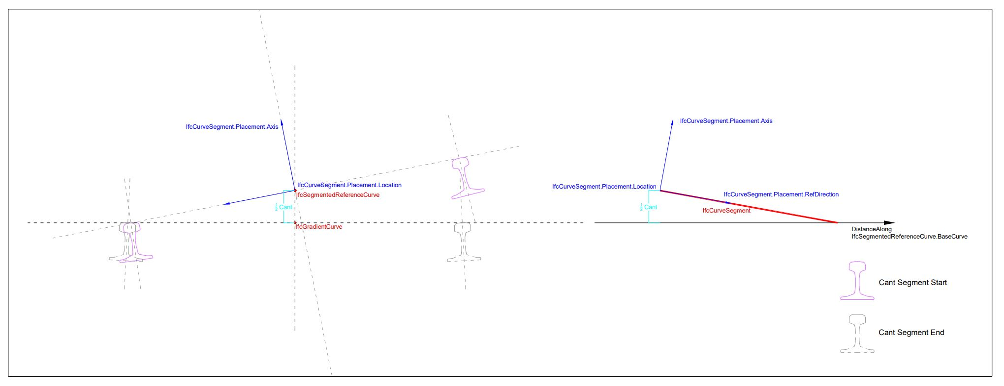
Figure 4.1.1-1 — cross section and elevation of a cant segment (source: bSI)
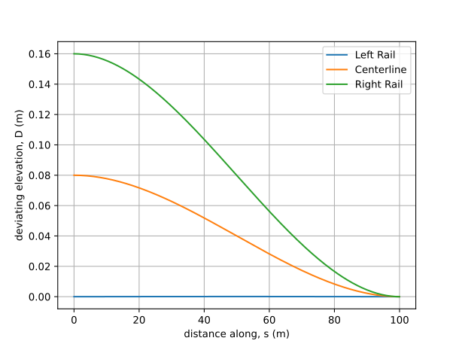
Figure 4.1.1-2 — Deviating elevation of rails
The railhead cross slope angle is defined by the IfcCurveSegment.Placement.Axis attribute. The Axis direction is generally upwards. The cross slope angle is measured from the y-axis and orients a vector that is perpendicular to the plane of the railheads. Figure 4.1.1-3 shows the cross slope angle for the transitions in Figure 4.1.1-2. The direction perpendicular to the plane of the railhead is about 1.46 rad at the start of the segment and increases to about 1.57 rad as the rotation decreases. When the left and right rails are at the same elevation the cross slope angle is $\frac{π}{2}$.
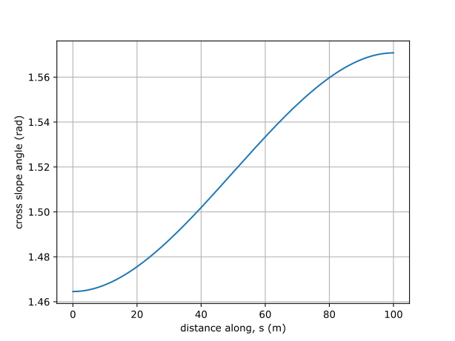
Figure 4.1.1-3 — Rail head cross slope

4.1.2 Coordinate System
Figure 4.1.1-1 illustrates the cant coordinate system.
IfcCurveSegment.Placement.RefDirection is tangent to the “distance along” the base curve in the horizontal plane, (e.g. IfcSegmentedReferenceCurve.BaseCurve => IfcGradientCurve.BaseCurve => IfcCompositeCurve).
The railway cross section is in the plane defined by Y and Z. Looking in the positive sense down the alignment, Y is towards the left and Z is upwards. The cross slope angle is measured clockwise from Y.

4.1.3 Transition Functions
The transition functions used to shape cant variation have the same functional form as functions used for horizontal transition curves: line, clothoid (linear cant), Helmert, Bloss, cosine, sine, and Viennese bend. In practice, the cant transition type always matches the horizontal transition type and segment length, though IFC does not enforce this constraint.
As an example, the horizontal tangent direction, $θ(t)$, and the radius of curvature, $κ(t)$, for a Helmert curve is a second order polynomial of the form
$$θ(t)=\frac{t^{3}}{3A_{2}^{3}}+\frac{A_{1}}{2\left|A_{1}^{3}\right|}t^{2}+\frac{t}{A_{0}}$$
$$κ(t)=\frac{1}{A_{2}^{3}}t^{2}+\frac{A_{1}}{\left|A_{1}^{3}\right|}t+\frac{1}{A_{0}}$$
The cant deviating elevation for a Helmert transition is
$$\frac{D(s)}{L^{2}}=\frac{1}{A_{2}^{3}}s^{2}+\frac{A_{1}}{\left|A_{1}^{3}\right|}s+\frac{1}{A_{0}}$$
The deviating elevation has the same functional form as the radius of curvature of the horizontal alignment segment.
In IFC, the semantic cant profile is encoded in IfcAlignmentCant and its child IfcAlignmentCantSegment entities. The geometric representation is an IfcSegmentedReferenceCurve, which evaluates the cant at every point along the alignment and, in conjunction with the horizontal alignment IfcCompositeCurve and the vertical alignment IfcGradientCurve, produces the full 3D track centerline geometry.
Each IfcCurveSegment in an IfcSegmentedReferenceCurve is evaluated in a two-dimensional coordinate system whose axes are distance along the horizontal alignment $l$ and deviating elevation $D$. The deviating elevation is the vertical offset applied to the track centerline, away from the gradient curve, to produce the correct cross-slope angle at every point along the segment.
The StartCantLeft $D_{sl}$, EndCantLeft $D_{el}$, StartCantRight $D_{sr}$, and EndCantRight $D_{er}$ attributes of IfcAlignmentCantSegment determine $D_{s}$ and $D_{e}$ as the averages of their respective left and right values:
$$D_{s}=\frac{D_{sl}+D_{sr}}{2}, D_{e}=\frac{D_{el}+D_{er}}{2} ΔD=D_{e}-D_{s}$$
The cross-slope angle $ϕ$ at a given point is not obtained directly from the parent curve equation; instead it is interpolated between the cross-slope angle of the segment’s own IfcCurveSegment.Placement.Axis and that of the next segment’s Placement.Axis, using the deviating elevation as the interpolation parameter:
$$ϕ(l)=ϕ_{s}+\left(\frac{ϕ_{e}-ϕ_{s}}{ΔD}\right)\left(D(l)-D_{s}\right)$$
$$ϕ_{s}=\cos^{-1}\left(\frac{D_{sr}-D_{sl}}{D_{rh}}\right)$$
where $ϕ_{s}$ is the cross-slope angle of this segment’s Placement.Axis, $ϕ_{e}$ is that of the next segment’s Placement.Axis (for the last segment, the zero-length closing segment of §4.12), $D_{s}$ and $ΔD$ are the deviating elevation of the parent curve at the start of the trimmed segment and its change over the segment, and $D(l)$ is the deviating elevation at $l$. The cross-slope angle $ϕ$ is the angle from the transverse $y$ axis to the projection of the Axis vector onto the Y-Z plane. In sections without cant, $ϕ=\frac{π}{2}$.
The cross-slope angle can be determined from the Axis vector as $ϕ=\tan^{-1}\left(\frac{Axis.dz}{Axis.dy}\right)$
Together, the distance along, the deviating elevation $D(l)$, and the cross-slope angle $ϕ(l)$ fully specify a 3D placement frame for the track centerline at each $l$. Section 4.2 describes an algorithm for constructing that frame and composing it with the horizontal and vertical matrices to produce a 3D position.
All examples use a railhead distance $D_{rh}=1.5 m$.

4.2 Curve Segment Evaluation Algorithm
Cant segments are evaluated in a two-dimensional “distance along, deviating elevation” $(l,D(l))$ coordinate system in which $l$ is the distance measured along the horizontal IfcCompositeCurve and $D(l)$ is the deviating elevation: the vertical offset applied to the track centerline to accommodate the cross slope. Unlike horizontal and vertical segments, each cant point also carries a cross slope angle $ϕ(l)$, making the local frame inherently three-dimensional.
The position and the frame use different coordinates. The position is $(l,D)$ in the first two rows of column 4, as in IfcCurveSegment.Placement.Location. The frame vectors use the cant coordinate system of Section 4.1.2: $x$ along the alignment, $y$ to the left and $z$ upwards. Two angles orient the frame:
- the slope of the deviating elevation along the track, $θ=\tan^{-1}(D^{'})$, pitches the cross section about $y$, so that RefDir rises with the deviating elevation;
- the cross slope $ϕ$ rolls the cross section about RefDir.
The deviating elevation is a vertical offset, so its slope appears in the $z$ component of RefDir, not the $y$ component. The frame is built as a rotation, so it is orthonormal: RefDir is tangent to the 3D curve and Axis is exactly perpendicular to the plane of the railheads. This agrees with IfcAxis2PlacementLinear, whose Axis is “the exact direction of the local Z Axis” and whose RefDirection defaults to the curve tangent.
Let $s_{0}$ = IfcCurveSegment.SegmentStart and $L$ = IfcCurveSegment.SegmentLength.

Step 1 — Read the curve segment placement
From IfcCurveSegment.Placement, $(s_{p},D_{p})$ is the Location (distance along, deviating elevation) and the start cross slope is that of the Axis:
$$ϕ_{s}=\tan^{-1}\left(\frac{Axis_{p}.dz}{Axis_{p}.dy}\right)$$
The end cross slope $ϕ_{e}$ is that of the next segment’s Placement.Axis (for the last segment, the zero-length closing segment of Section 4.12).
The placement’s RefDirection gives the sense of the segment. Its slope in the $(l,D)$ plane is not used, because the frame at every $l$ is built from $D^{'}$.

Step 2 — Evaluate the parent curve at the trim start
$$D_{s}=D(s_{0}), ΔD=D(s_{0}+L)-D(s_{0})$$

Step 3 — Evaluate the parent curve at the point under consideration, $l$
Evaluate the deviating elevation and its slope at parent curve parameter $s_{0}+l$:
$$D_{l}=D(s_{0}+l), D_{l}^{'}=D^{'}(s_{0}+l), θ_{l}=\tan^{-1}(D_{l}^{'})$$
Interpolate the cross slope (Section 4.1.3):
$$ϕ(l)=ϕ_{s}+\left(\frac{ϕ_{e}-ϕ_{s}}{ΔD}\right)(D_{l}-D_{s})$$
When $ΔD=0$, $ϕ(l)=ϕ_{s}$.

Step 4 — Compute the cant placement matrix $M_{c}$
Rotation
Roll the cross section about $x$ so that Axis makes the angle $ϕ$ with $y$, then pitch it by $θ$ about $y$. $R_{x}(ϕ)$ is the identity when $ϕ=\frac{π}{2}$ (no cant):
$$R_{x}(ϕ)=\left[\begin{matrix}1 & 0 & 0 \\ 0 & sinϕ & cosϕ \\ 0 & -cosϕ & sinϕ\end{matrix}\right], P(θ)=\left[\begin{matrix}cosθ & 0 & -sinθ \\ 0 & 1 & 0 \\ sinθ & 0 & cosθ\end{matrix}\right]$$
$$R_{c}=P(θ_{l})⋅R_{x}(ϕ(l))$$
The columns of $R_{c}$ are the frame vectors:
$${RefDir}_{l}=(cosθ_{l}, 0, sinθ_{l})$$
$$Y_{l}=(sinθ_{l}cosϕ, sinϕ, -cosθ_{l}cosϕ)$$
$${Axis}_{l}=(-sinθ_{l}sinϕ, cosϕ, cosθ_{l}sinϕ)$$
with $ϕ=ϕ(l)$. Before the pitch, Axis is $(0,cosϕ,sinϕ)$, the cross-slope direction of Section 4.1.1. The pitch tilts it back by $θ_{l}$ so that it stays perpendicular to RefDir. $Y_{l}={Axis}_{l}×{RefDir}_{l}$.
The frame depends only on $θ_{l}$ and $ϕ(l)$. It is not obtained by applying an incremental rotation, from the trim start to $l$, to the placement: when the slope at the trim start is not zero, as for a linear transition, that composition mixes the pitch and the roll and gives a frame that is neither orthonormal nor tangent to the curve.
Translation
$$T_{c}=(s_{p}+l, D_{p}+D_{l}-D_{s}, 0)$$
Assemble
$$M_{c}=\left[\begin{matrix}R_{c} & T_{c} \\ 0^{T} & 1\end{matrix}\right]$$
Step 5 is performed immediately for this point before moving to the next $l$.

Step 5 — Combine with horizontal and vertical to produce the 3D placement matrix
The cant result must be combined with the horizontal matrix $M_{h}$ (evaluated at distance $l$ along the IfcCompositeCurve) and the vertical matrix $M_{v}$ (evaluated at the same $l$). All three coordinate systems share the distance-along axis, so the positional components of $M_{v}$ and $M_{c}$ must be extracted before multiplication and added back afterward to avoid incorrectly rotating the position offsets.
Construct $M_{v}^{'}$ as described in Section 3.2.
Construct $M_{c}^{'}$ by zeroing the distance-along $l$ component in row 1, column 4 and moving the deviating elevation $D_{l}$ from row 2 to row 3 in column 4 of $M_{c}$. The rotation part is unchanged, because the frame vectors are already in $x$ along, $y$ left, $z$ up:
$${M^{'}}_{c}=\left[\begin{matrix}X.x & Y.x & Z.x & 0 \\ X.y & Y.y & Z.y & 0 \\ X.z & Y.z & Z.z & D_{l} \\ 0 & 0 & 0 & 1\end{matrix}\right]$$
Extract position vectors from each modified matrix, $M_{v}^{'}, M_{c}^{'}$, (setting row 4 to zero), then zero column 4 before multiplying:
$$P_{v}=M_{v}^{'}\text{ column 4, row 4 set to 0}=\left[\begin{matrix}0 \\ 0 \\ z \\ 0\end{matrix}\right], P_{c}=M_{c}^{'}\text{ column 4, row 4 set to 0}=\left[\begin{matrix}0 \\ 0 \\ D \\ 0\end{matrix}\right]$$
$$M_{v}^{″}=M_{v}^{'}\text{ with column 4 set to }(0,0,0,1)^{T}, M_{c}^{″}=M_{c}^{'}\text{ with column 4 set to }(0,0,0,1)^{T}$$
$M_{h}⋅M_{v}^{″}$ pitches the frame by the grade angle $\tan^{-1}g$, where $g$ is the grade at $l$ ($g=M_{v}(2,1)/M_{v}(1,1)$), and $M_{c}^{″}$ pitches it again by $θ_{l}$. Both are vertical offsets measured over the same horizontal distance, so the slope of the 3D curve is $g+D_{l}^{'}$. Its pitch is $\tan^{-1}(g+D_{l}^{'})$, which is not the sum of the two angles. Correct the difference with a pitch of
$$ε=\tan^{-1}(g+D_{l}^{'})-\tan^{-1}(g)-\tan^{-1}(D_{l}^{'})$$
$ε$ is zero on a flat grade or where the deviating elevation is constant, and small otherwise: for $g=0.04$ and $D_{l}^{'}=0.0016$, $ε=-2.66×{10}^{-6}$.
Multiply the orientation matrices, then add back both position offsets:
$$M^{'}=M_{h}⋅M_{v}^{″}⋅P(ε)⋅M_{c}^{″}$$
where $P(ε)$ is the $4×4$ form of the pitch matrix in Step 4.
$$M_{3Dcant}=M^{'}+\left[\begin{matrix}0 & 0 & 0 & P_{v.x} \\ 0 & 0 & 0 & P_{v.y} \\ 0 & 0 & 0 & P_{v.z} \\ 0 & 0 & 0 & 0\end{matrix}\right]+\left[\begin{matrix}0 & 0 & 0 & P_{c.x} \\ 0 & 0 & 0 & P_{c.y} \\ 0 & 0 & 0 & P_{c.z} \\ 0 & 0 & 0 & 0\end{matrix}\right]$$
Column 4 of the final matrix $M_{3Dcant}$ is the full 3D position of the track centerline. Column 3 is the cross-slope direction, encoding the railhead superelevation at that point.
The frame can be checked, or built directly, from the heading $β$ of $M_{h}$. With $L=(-sinβ, cosβ, 0)$, the horizontal direction to the left,
$$RefDir=\frac{(cosβ, sinβ, g+D_{l}^{'})}{\sqrt{1+(g+D_{l}^{'})^{2}}}, Axis=cosϕ L+sinϕ (RefDir×L), Y=Axis×RefDir$$
RefDir is the tangent of the 3D curve: its plan heading is that of the horizontal alignment and its slope is the grade plus the slope of the deviating elevation.
Numerical examples of Steps 1–4 are given in Sections 4.3 through 4.9. A complete worked example including Step 5 is in Section 4.10.

4.3 Constant Cant
Cant has a constant deviating elevation and cross-slope angle in rail segments between curves or in the circular portion of curves where the tracks are banked at a constant rate.
The parent curve is IfcLine. The slope-intercept form of a line is $y=mx+b$, where $m$ is the slope and $b$ is the $y$-intercept. The derivative is $y^{'}=m$, and the second derivative is $y^{″}=0$.
In the context of cant, $D(s)=y^{'}(x)$, so the deviating elevation is a constant value, $m$, and the rate of change of the deviating elevation $D^{'}(s)=y^{″}(x)=0$.

4.3.1 Parent Curve Parametric Equations
The deviating elevation and its rate of change are given by the following equations.
$$D(s)=D_{s}=D_{e}$$
$$\frac{d}{ds}D(s)=D^{'}(s)=0.0$$

4.3.2 Semantic Definition to Geometry Mapping
Consider 100 m long segment of a railway that is turning towards the left. The right rail is raised 0.16 m through the circular portion of the curve. The semantic definition is
#64 = IFCALIGNMENTCANTSEGMENT($, $, 0., 100., 0., 0., 0.16, 0.16, .CONSTANTCANT.);
$$D_{s}=\frac{0.0 m+0.16 m}{2}=0.08 m$$
$$D_{e}=\frac{0.0 m+0.16 m}{2}=0.08 m$$
$$ΔD=D_{e}-D_{s}=0.08 m-0.08 m=0.0 m$$
The parent curve has a constant deviating elevation at $0.08 m$ and a slope of $0.0$.
Define the parent curve as an IfcLine passing through (0,0) in the direction (1,0).
#96=IFCCARTESIANPOINT((0.,0.));
#97=IFCDIRECTION((1.,0.));
#98=IFCVECTOR(#97,1.);
#99=IFCLINE(#96,#98);
The IfcCurveSegment trims a segment from the parent curve. The curve segment placement must capture the cross-slope rotation between the rail heads. For this reason the placement is an IfcAxis2Placement3D (instead of IfcAxis2Placement2D used for horizontal and vertical representations).
The cross-slope at the start of the segment is
$$ϕ_{s}=\cos^{-1}\left(\frac{D_{sr}-D_{sl}}{D_{rh}}\right)=\cos^{-1}\left(\frac{0.16-0.0}{1.5}\right)=1.463926346$$
The cross slope orientation is
$$dy_{z}=cos(ϕ_{s})=cos(1.463926346)=0.106666667$$
$$dz_{z}=sin(ϕ_{s})=sin(1.463926346)=0.994294837$$
#100=IFCCARTESIANPOINT((0.,0.08,0.));
#101=IFCDIRECTION((0.,0.10666666666666667,0.99429483666678176));
#102=IFCDIRECTION((1.,0.,0.));
#103=IFCAXIS2PLACEMENT3D(#100,#101,#102);
#104=IFCCURVESEGMENT(.CONTSAMEGRADIENTSAMECURVATURE.,#103,IFCLENGTHMEASURE(0.),IFCLENGTHMEASURE(100.),#99);

4.3.3 Compute Point on Curve
Compute the placement matrix for a point $l=50 m$ from the start of the curve segment using the algorithm in Section 4.2.

Step 1 — Read the curve segment placement
$$(s_{p}, D_{p})=(0, 0.08)$$
$${Axis}_{p}=(0, 0.10666666666666667, 0.9942948366667818)$$
$$ϕ_{s}=\tan^{-1}\left(\frac{Axis_{p}.dz}{Axis_{p}.dy}\right)=1.463926346$$
The next segment’s Placement.Axis is $(0, 0.10666666666666667, 0.9942948366667818)$, so $ϕ_{e}=1.463926346$.

Step 2 — Evaluate the parent curve at the trim start
The parent IfcLine passes through $(0,0)$ in the direction $(1,0)$, so $D(s)=0$ and $D^{'}(s)=0$. The $0.08 m$ deviating elevation is carried by the placement Location.
$$s_{0}=0, D_{s}=D(0)=0 m, ΔD=D(100)-D(0)=0 m$$

Step 3 — Evaluate the parent curve at $l=50 m$
$$D_{l}=D(50)=0 m, D_{l}^{'}=D^{'}(50)=0, θ_{l}=\tan^{-1}(D_{l}^{'})=0$$
Since $ΔD=0$, $ϕ(l)=ϕ_{s}=1.463926346$.

Step 4 — Compute the cant placement matrix $M_{c}$
Rotation
$${RefDir}_{l}=(cosθ_{l}, 0, sinθ_{l})=(1, 0, 0)$$
$$Y_{l}=(sinθ_{l}cosϕ, sinϕ, -cosθ_{l}cosϕ)=(0, 0.9942948367, -0.1066666667)$$
$${Axis}_{l}=(-sinθ_{l}sinϕ, cosϕ, cosθ_{l}sinϕ)=(0, 0.1066666667, 0.9942948367)$$
Translation
$$T_{c}=(s_{p}+l, D_{p}+D_{l}-D_{s}, 0)=(0+50, 0.08+0+0, 0)=(50, 0.08, 0)$$
Assemble
$$M_{c}=\left[\begin{matrix}1 & 0 & 0 & 50 \\ 0 & 0.994294836666782 & 0.106666666666667 & 0.08 \\ 0 & -0.106666666666667 & 0.994294836666782 & 0 \\ 0 & 0 & 0 & 1\end{matrix}\right]$$

4.4 Linear Transition
A linear transition in cant is represented with an IfcClothoid.

4.4.1 Parent Curve Parametric Equations
The deviating elevation and its rate of change are given by the following equations.
$$\frac{D(s)}{L^{2}}=\frac{1}{A_{0}}+\frac{A_{1}}{\left|A_{1}^{3}\right|}s$$
$$\frac{d}{ds}D(s)=L^{2}\frac{A_{1}}{\left|A_{1}^{3}\right|}$$
$$a_{0}=D_{s}, A_{0}=\frac{L^{2/1}}{a_{0}^{1}}\frac{a_{0}}{\left|a_{0}\right|}, A_{0}=\frac{L^{2}}{a_{0}}$$
$$a_{1}=ΔD, A_{1}=\frac{L^{\frac{3}{2}}}{{\left|a_{1}\right|}^{\frac{1}{2}}}\frac{a_{1}}{\left|a_{1}\right|}$$
$A_{1}$ is the clothoid constant.

4.4.2 Semantic Definition to Geometry Mapping
Consider an alignment segment that has a clothoid transition curve towards the left. The track banks at a constantly increasing rate resulting in a linear deviation in the right rail elevation relative to the left rail. The right rail raises 160 mm over the 100 m segment length.
The semantic representation of the cant alignment is
#64 = IFCALIGNMENTCANTSEGMENT($, $, 0., 100., 0., 0., 0.16, 0., .LINEARTRANSITION.);
Compute the parent curve parameters.
$$D_{sl}=0 m D_{el}=0 m$$
$$D_{sr}=0.16 m D_{er}=0 m$$
$$D_{s}=\frac{(0.16+0)}{2}=0.08 m$$
$$D_{e}=\frac{(0+0)}{2}=0 m$$
$$ΔD=D_{e}-D_{s}=0.0-0.08=-0.08 m$$
$$a_{0}=D_{s}=0.08 m, A_{0}=\frac{(100 m)^{2}}{0.08 m}=125000 m$$
$$a_{1}=ΔD=-0.08 m A_{1}=\frac{{(100 m)}^{\frac{3}{2}}}{{\left|-0.08 m\right|}^{\frac{1}{2}}}\frac{-0.08 m}{\left|-0.08 m\right|}=-3535.533906 m$$
The clothoid parent curve is
#96=IFCCARTESIANPOINT((0.,0.));
#97=IFCDIRECTION((1.,0.));
#98=IFCAXIS2PLACEMENT2D(#96,#97);
#99=IFCCLOTHOID(#98,-3535.533905932738);
The cant segment begins with a deviating elevation of
$$D(0 m)=(100 m)^{2}\left(\frac{1}{125000}+\frac{-3535.533906}{{\left|-3535.533906\right|}^{3}}(0 m)\right)=0.08 m$$
The slope at the start of the segment is
$$D^{'}(0 m)=(100 m)^{2}\frac{-3535.533906}{\left|-{3535.533906}^{3}\right|}=-0.0008$$
$$θ_{0}=\tan^{-1}(-0.0008)=-0.00079999$$
$$dx_{x}=cos(θ_{0})=0.999999680$$
$$dy_{x}=sin(θ_{0})=-0.000799999744$$
The cross-slope at the start of the segment is
$$ϕ_{s}=\cos^{-1}\left(\frac{D_{sr}-D_{sl}}{D_{rh}}\right)=\cos^{-1}\left(\frac{0.16-0.0}{1.5}\right)=1.463926346$$
The cross slope orientation is
$$dy_{z}=cos(ϕ_{s})=cos(1.463926346)=0.106666667$$
$$dz_{z}=sin(ϕ_{s})=sin(1.463926346)=0.994294837$$
#100=IFCCARTESIANPOINT((0.,0.08,0.));
#101=IFCDIRECTION((0.,0.10666666666666667,0.99429483666678176));
#102=IFCDIRECTION((0.999999680,-0.000799999744,0.));
#103=IFCAXIS2PLACEMENT3D(#100,#101,#102);
#104=IFCCURVESEGMENT(.CONTINUOUS.,#103,IFCLENGTHMEASURE(0.),IFCLENGTHMEASURE(100.),#99);

4.4.3 Compute Point on Curve
Compute the cant placement matrix for a point $l=50 m$ from the start of the curve segment using the algorithm in Section 4.2.

Step 1 — Read the curve segment placement
$$(s_{p}, D_{p})=(0, 0.08)$$
$${Axis}_{p}=(0, 0.10666666666666667, 0.9942948366667818)$$
$$ϕ_{s}=\tan^{-1}\left(\frac{Axis_{p}.dz}{Axis_{p}.dy}\right)=1.463926346$$
The next segment’s Placement.Axis is $(0, 6.826733622844472e-12, 1.0)$, so $ϕ_{e}=1.570796327$.

Step 2 — Evaluate the parent curve at the trim start
IfcClothoid has no constant term, so the parent curve’s deviating elevation is $D(s)=L^{2}\frac{A_{1}}{\left|A_{1}^{3}\right|}s$, which is $0$ at the trim start. The $0.08 m$ deviating elevation at the start of the segment is carried by the placement Location, and only the change in $D$ from the trim start enters $M_{c}$.
$$s_{0}=0, D_{s}=D(0)=0 m, ΔD=D(100)-D(0)=-0.08 m$$

Step 3 — Evaluate the parent curve at $l=50 m$
$$D_{l}=D(50)=-0.04 m, D_{l}^{'}=D^{'}(50)=-0.0008, θ_{l}=\tan^{-1}(D_{l}^{'})=-0.0007999998293$$
$$ϕ(l)=1.463926346+\left(\frac{1.570796327-1.463926346}{-0.08}\right)(-0.04+0)=1.517361336$$

Step 4 — Compute the cant placement matrix $M_{c}$
Rotation
$${RefDir}_{l}=(cosθ_{l}, 0, sinθ_{l})=(0.99999968, 0, -0.000799999744)$$
$$Y_{l}=(sinθ_{l}cosϕ, sinϕ, -cosθ_{l}cosϕ)=(-4.272763858e-05, 0.9985726906, -0.05340954822)$$
$${Axis}_{l}=(-sinθ_{l}sinϕ, cosϕ, cosθ_{l}sinϕ)=(0.0007988578968, 0.05340956531, 0.998572371)$$
Translation
$$T_{c}=(s_{p}+l, D_{p}+D_{l}-D_{s}, 0)=(0+50, 0.08-0.04+0, 0)=(50, 0.04, 0)$$
Assemble
$$M_{c}=\left[\begin{matrix}0.999999680000154 & -4.27276385779292e-05 & 0.00079885789681383 & 50 \\ 0 & 0.998572690560395 & 0.0534095653134642 & 0.04 \\ -0.000799999744000123 & -0.0534095482224115 & 0.998572371017288 & 0 \\ 0 & 0 & 0 & 1\end{matrix}\right]$$

4.5 Helmert Curve
Like the Helmert transition spiral, the Helmert cant semantic definition maps to two IfcCurveSegment instances for the geometric representation. The parent curve is IfcSecondOrderPolynomialSpiral.

4.5.1 Parent Curve Parametric Equations
The deviating elevation and its rate of change are given by the following equations.
$$\frac{D(s)}{L^{2}}=\frac{1}{A_{2}^{3}}s^{2}+\frac{A_{1}}{\left|A_{1}^{3}\right|}s+\frac{1}{A_{0}}$$
$$\frac{d}{ds}D(s)=L^{2}\left(\frac{2s}{A_{2}^{3}}+\frac{A_{1}}{\left|A_{1}^{3}\right|}\right)$$
The polynomial coefficients carry a second subscript to indicate first half $1$, and second half $2$. For example, $A_{21}$ is coefficient $A_{2}$ for the first half and $A_{02}$ is coefficient $A_{0}$ for the second half.
In the first half of the cant transition
Constant Term:
$a_{01}=4D_{s}$,
$$A_{01}=\frac{L^{2}}{\left|a_{01}\right|}\frac{a_{01}}{\left|a_{01}\right|}$$
Linear Term:
$a_{11}=0$,
$$A_{11}=\frac{L^{\frac{3}{2}}}{{\left|a_{11}\right|}^{\frac{1}{2}}}\frac{a_{11}}{\left|a_{11}\right|}=0$$
Quadratic Term:
$a_{21}=8ΔD$,
$$A_{21}=\frac{L^{4/3}}{{\left|a_{21}\right|}^{\frac{1}{3}}}\frac{a_{21}}{\left|a_{21}\right|}$$
In the second half
Constant Term:
$a_{02}=-4ΔD+4D_{s}$,
$$A_{02}=\frac{L^{2}}{\left|a_{02}\right|}\frac{a_{02}}{\left|a_{02}\right|}$$
Linear Term:
$a_{12}=16ΔD$,
$$A_{12}=\frac{L^{\frac{3}{2}}}{{\left|a_{12}\right|}^{\frac{1}{2}}}\frac{a_{12}}{\left|a_{12}\right|}$$
Quadratic Term:
$a_{22}=-8ΔD$,
$$A_{22}=\frac{L^{\frac{4}{3}}}{{\left|a_{22}\right|}^{\frac{1}{3}}}\frac{a_{22}}{\left|a_{22}\right|}$$

4.5.2 Semantic Definition to Geometry Mapping
Consider an alignment segment that has a Helmert transition curve towards the left. The start cant is $160 mm$ and transitions to zero over $100 m$.
#64=IFCALIGNMENTCANTSEGMENT($,$,0.,100.,0.,0.,0.16,0.,.HELMERTCURVE.);
Compute the parent curve parameters
$$L=100 m$$
$$D_{sl}=0 m, D_{el}=0 m$$
$$D_{sr}=0.16 m, D_{er}=0 m$$
$$D_{s}=\frac{0+0.16 m}{2}=0.08 m$$
$$D_{e}=\frac{0+0}{2}=0. m$$
$$ΔD=0.0-0.08=-0.08 m$$
First half:
$$a_{01}=4D_{s}=4(0.08 m)=0.32 m$$
$$A_{01}=\frac{L^{2}}{\left|a_{01}\right|}\frac{a_{01}}{\left|a_{01}\right|}=\frac{(100 m)^{2}}{\left|0.32 m\right|}\frac{0.32 m}{\left|0.32 m\right|}=31250 m$$
$$a_{11}=0, A_{11}=0$$
$$a_{21}=8ΔD=8(-0.08 m)=-0.64 m$$
$$A_{21}=\frac{L^{4/3}}{{\left|a_{21}\right|}^{\frac{1}{3}}}\frac{a_{21}}{\left|a_{21}\right|}=\frac{(100 m)^{\frac{4}{3}}}{{\left|-0.64 m\right|}^{\frac{1}{3}}}\frac{-0.64 m}{\left|-0.64 m\right|}=-538.6086725 m$$
The first half parent curve IfcSecondOrderPolynomialSpiral is
#104=IFCCARTESIANPOINT((0.,0.));
#105=IFCDIRECTION((1.,0.));
#106=IFCAXIS2PLACEMENT2D(#104,#105);
#107=IFCSECONDORDERPOLYNOMIALSPIRAL(#106,-538.60867250797071,$,31250.);
Determine the first half placement and trimming.
Note: The length of the first half curve is $L_{1}=50 m$, half the length of the full Helmert transition.
The spiral coefficients $A_{01}$ and $A_{21}$ are computed from the full transition length $L=100 m$. The evaluation formula, by contrast, multiplies by the curve segment length squared — $(L_{1})^{2}=(50 m)^{2}$ — because $L_{1}=50 m$ is the trim length of the first-half curve segment. These two lengths work together by design. The $A$ coefficients fix the boundary conditions of the deviating elevation profile at $s=0$, $s=L/2$, and $s=L$ relative to the complete $100 m$ transition. Using $(L_{1})^{2}$ in the evaluation then scales those boundary conditions correctly to physical distances within the trimmed half. Substituting $A_{01}=L^{2}/a_{01}$ confirms this:
$${\left(\frac{L}{2}\right)}^{2}⋅\frac{a_{01}}{L^{2}}=\frac{a_{01}}{4}=\frac{4D_{s}}{4}=D_{s}$$
Figure 4.5.2-1 illustrates this geometrically. Each parent curve is drawn solid over the portion used by its curve segment and dashed beyond the trim boundary. The dashed extension of the first-half curve diverges from the second-half curve after $s=50 m$, confirming that the two polynomials are distinct — each is correct only within its own half.
The deviating elevation at the start of the first half transition is
$$D(0 m)=(50 m)^{2}\left(\frac{1}{31250 m}+\frac{1}{(-538.6086725 m)^{3}}(0 m)^{2}\right)=0.08 m$$
$$D^{'}(0 m)=(50 m)^{2}\left(\frac{2(0 m)}{(-538.6086725 m)^{3}}\right)=0$$
$$θ=0, dx_{x}=1,dy_{x}=0$$
The cross-slope at the start of the segment is
$$ϕ_{s}=\cos^{-1}\left(\frac{D_{sr}-D_{sl}}{D_{rh}}\right)=\cos^{-1}\left(\frac{0.16-0.0}{1.5}\right)=1.463926346$$
The cross slope orientation is
$$dy_{z}=cos(ϕ_{s})=cos(1.463926346)=0.106666667$$
$$dz_{z}=sin(ϕ_{s})=sin(1.463926346)=0.994294837$$
#108=IFCCARTESIANPOINT((0.,0.08,0.));
#109=IFCDIRECTION((0.,0.10666666666666667,0.99429483666678176));
#110=IFCDIRECTION((1.,0.,0.));
#111=IFCAXIS2PLACEMENT3D(#108,#109,#110);
#112=IFCCURVESEGMENT(.CONTSAMEGRADIENTSAMECURVATURE.,#111,IFCLENGTHMEASURE(0.),IFCLENGTHMEASURE(50.),#107);
Second half:
$$a_{02}=-4ΔD+4D_{s}=-4(-0.08 m)+4(0.08) m=0.64 m$$
$$A_{02}=\frac{L^{2}}{\left|a_{02}\right|}\frac{a_{02}}{\left|a_{02}\right|}=\frac{(100 m)^{2}}{\left|0.64 m\right|}\frac{0.64 m}{\left|0.64 m\right|}=15625 m$$
$$a_{12}=16ΔD=16(-0.08 m)=-1.28 m$$
$$A_{12}=\frac{L^{\frac{3}{2}}}{{\left|a_{12}\right|}^{\frac{1}{2}}}\frac{a_{12}}{\left|a_{12}\right|}=\frac{(100 m)^{\frac{3}{2}}}{{\left|-1.28 m\right|}^{\frac{1}{2}}}\frac{-1.28 m}{\left|-1.28 m\right|}=-883.8834765 m$$
$$a_{22}=-8ΔD=-8(-0.08 m)=0.64 m$$
$$A_{22}=\frac{L^{\frac{4}{3}}}{{\left|a_{22}\right|}^{\frac{1}{3}}}\frac{a_{22}}{\left|a_{22}\right|}=\frac{(100 m)^{\frac{4}{3}}}{{\left|0.64 m\right|}^{\frac{1}{3}}}\frac{0.64 m}{\left|0.64 m\right|}=538.6086725 m$$
Figure 4.5.2-1 shows the first and second half parent curves.
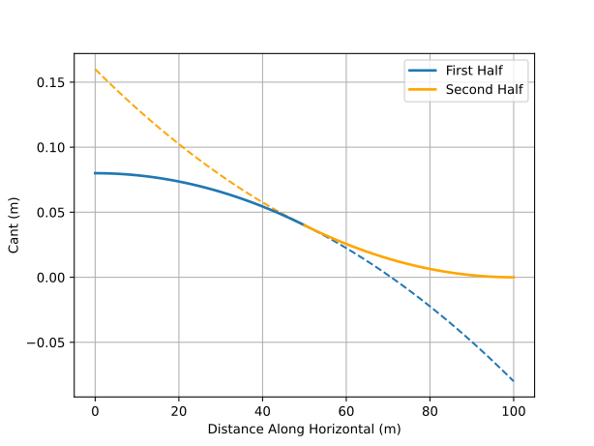
Figure 4.5.2-1 — IfcSecondOrderPolynomialSpiral parent curves. The dashed lines represent the projection of the parent curve over the full length of the semantic segment.
The second half parent curve IfcSecondOrderPolynomialSpiral is
#113=IFCCARTESIANPOINT((0.,0.));
#114=IFCDIRECTION((1.,0.));
#115=IFCAXIS2PLACEMENT2D(#113,#114);
#116=IFCSECONDORDERPOLYNOMIALSPIRAL(#115,538.60867250797071,-883.8834764831845,15625.);
Determine the second half placement and trimming.
The starting elevation of the second half is the end elevation of the first half. Use the first half parent curve to determine the start of the second half curve.
$$D(50 m)=(50 m)^{2}\left(\frac{1}{31250 m}+\frac{1}{(-538.6086725 m)^{3}}(50 m)^{2}\right)=0.04 m$$
$$D^{'}(50 m)=(50 m)^{2}\left(\frac{2⋅50 m}{(-538.6086725 m)^{3}}\right)=-0.0016$$
$$dx_{x}=\frac{1}{\sqrt{(-0.0016)^{2}+1}}=0.999998724, dy_{x}=\frac{-0.0016}{\sqrt{(-0.0016)^{2}+1}}=-0.00159999795$$
The second half starts where the first half ends. The cross slope is interpolated linearly in the deviating elevation between the start and end cross slopes of the full transition (§4.2). The deviating elevation at the end of the first half is half way between $D_{s}$ and $D_{e}$, so the cross slope there is half way, in angle, between them:
$$ϕ(50 m)=\frac{ϕ_{s}+ϕ_{e}}{2}=\frac{1.463926346+\frac{π}{2}}{2}=1.517361336$$
Note: This is not the angle whose cosine is the cant ratio at the midpoint, $\cos^{-1}\left(\frac{0.08}{1.5}\right)=1.517437677$. The two differ by $7.6×{10}^{-5} rad$. The second half’s Axis must use the interpolated angle so that the cross slope is continuous where the halves meet.
$$dy_{z}=cos(ϕ(50 m))=cos(1.517361336)=0.053409565$$
$$dz_{z}=sin(ϕ(50 m))=sin(1.517361336)=0.998572691$$
The trimming begins at $50 m$ and progresses for a length of $50 m$ for the second half segment.
#117=IFCCARTESIANPOINT((50.,0.04,0.));
#118=IFCDIRECTION((0.,0.05340956531005583,0.9985726905605775));
#119=IFCDIRECTION((0.9999987200024576,-0.0015999979520039342,0.));
#120=IFCAXIS2PLACEMENT3D(#117,#118,#119);
#121=IFCCURVESEGMENT(.CONTSAMEGRADIENTSAMECURVATURE.,#120,IFCLENGTHMEASURE(50.),IFCLENGTHMEASURE(50.),#116);

4.5.3 Compute Point on Curve
Compute the cant placement matrix for a point $75 m$ from the start of the curve segment using the algorithm in Section 4.2. $75 m$ falls in the second half of the Helmert transition, $l=75 m-50 m=25 m$.

Step 1 — Read the curve segment placement
$$(s_{p}, D_{p})=(50, 0.04)$$
$${Axis}_{p}=(0, 0.05340956531005583, 0.9985726905605775)$$
$$ϕ_{s}=\tan^{-1}\left(\frac{Axis_{p}.dz}{Axis_{p}.dy}\right)=1.517361336$$
The next segment’s Placement.Axis is $(0, 4.163336342344337e-17, 1.0)$, so $ϕ_{e}=1.570796327$.

Step 2 — Evaluate the parent curve at the trim start
The second half’s parent curve is evaluated with its own segment length, $L_{2}=50 m$ (Section 4.5.2).
$$s_{0}=50, D_{s}=D(50)=0.04 m, ΔD=D(100)-D(50)=-0.04 m$$

Step 3 — Evaluate the parent curve at $l=25 m$
$$D_{l}=D(75)=0.01 m, D_{l}^{'}=D^{'}(75)=-0.0008, θ_{l}=\tan^{-1}(D_{l}^{'})=-0.0007999998293$$
$$ϕ(l)=1.517361336+\left(\frac{1.570796327-1.517361336}{-0.04}\right)(0.01-0.04)=1.557437579$$

Step 4 — Compute the cant placement matrix $M_{c}$
Rotation
$${RefDir}_{l}=(cosθ_{l}, 0, sinθ_{l})=(0.99999968, 0, -0.000799999744)$$
$$Y_{l}=(sinθ_{l}cosϕ, sinϕ, -cosθ_{l}cosϕ)=(-1.068667682e-05, 0.9999107733, -0.01335834603)$$
$${Axis}_{l}=(-sinθ_{l}sinϕ, cosϕ, cosθ_{l}sinϕ)=(0.0007999283626, 0.0133583503, 0.9999104533)$$
Translation
$$T_{c}=(s_{p}+l, D_{p}+D_{l}-D_{s}, 0)=(50+25, 0.04+0.01-0.04, 0)=(75, 0.01, 0)$$
Assemble
$$M_{c}=\left[\begin{matrix}0.999999680000154 & -1.06866768201108e-05 & 0.000799928362629304 & 75 \\ 0 & 0.999910773257928 & 0.0133583502998086 & 0.0100000000000001 \\ -0.000799999744000119 & -0.0133583460251385 & 0.999910453286634 & 0 \\ 0 & 0 & 0 & 1\end{matrix}\right]$$

4.6 Bloss Curve
A Bloss transition in cant is represented with an IfcThirdOrderPolynomialSpiral.

4.6.1 Parent Curve Parametric Equations
The deviating elevation and its rate of change are given by the following equations.
$$\frac{D(s)}{L^{2}}=\frac{A_{3}}{\left|A_{3}^{5}\right|}s^{3}+\frac{1}{A_{2}^{3}}s^{2}+\frac{A_{1}}{2\left|A_{1}^{3}\right|}s+\frac{1}{A_{0}}$$
$$\frac{d}{ds}D(s)=L^{2}\left(\frac{3A_{3}}{\left|A_{3}^{5}\right|}s^{2}+\frac{2}{A_{2}^{3}}s+\frac{A_{1}}{2\left|A_{1}^{3}\right|}\right)$$
Constant Term
$$a_{0}=D_{s}, A_{0}=\frac{L^{\frac{2}{1}}}{{\left|a_{0}\right|}^{1}}\frac{a_{0}}{\left|a_{0}\right|}=\frac{L^{2}}{\left|a_{0}\right|}\frac{a_{0}}{\left|a_{0}\right|}$$
Linear Term
$$a_{1}=0, A_{1}=0$$
Quadratic Term
$$a_{2}=3ΔD, A_{2}=\frac{L^{\frac{4}{3}}}{{\left|a_{2}\right|}^{\frac{1}{3}}}\frac{a_{2}}{\left|a_{2}\right|}$$
Cubic Term
$$a_{3}=-2ΔD, A_{3}=\frac{L^{\frac{5}{4}}}{{\left|a_{3}\right|}^{\frac{1}{4}}}\frac{a_{3}}{\left|a_{3}\right|}$$

4.6.2 Semantic Definition to Geometry Mapping
Consider an alignment segment that has a Bloss transition curve towards the left. The cant transitions from zero to $160 mm$ over $100 m$.
#64=IFCALIGNMENTCANTSEGMENT($,$,0.,100.,0.,0.,0.,0.16,.BLOSSCURVE.);
Compute the parent curve parameters
$$D_{s}=\frac{0+0}{2}=0.0 m, D_{e}=\frac{0+0.16 m}{2}=0.08 m, ΔD=0.08-0.0=0.08 m$$
Constant Term
$$a_{0}=0 m, A_{0}=0 m$$
Linear Term
$$A_{1}=0 m$$
Quadratic Term
$$a_{2}=3(0.08 m)=0.24 m, A_{2}=\frac{(100 m)^{\frac{4}{3}}}{{\left|0.24 m\right|}^{\frac{1}{3}}}\left(\frac{0.24 m}{\left|0.24 m\right|}\right)=746.9007911 m$$
Cubic Term
$$a_{3}=-2ΔD=-2(0.08 m)=-0.16 m, A_{3}=\frac{{(100 m)}^{\frac{5}{4}}}{{\left|-0.16 m\right|}^{\frac{1}{4}}}\left(\frac{-0.16 m}{\left|-0.16 m\right|}\right)=-500 m$$
The parent curve is
#96=IFCCARTESIANPOINT((0.,0.));
#97=IFCDIRECTION((1.,0.));
#98=IFCAXIS2PLACEMENT2D(#96,#97);
#99=IFCTHIRDORDERPOLYNOMIALSPIRAL(#98,-500.0,746.90079109286057,$,$);
$$D_{0}=D(0 m)=(100 m)^{2}\left(\frac{-500 m}{\left|(-500 m)^{5}\right|}(0 m)^{3}+\frac{1}{(746.9007911 m)^{3}}(0 m)^{2}+0 m\right)=0.0 m$$
$$D^{'}(0)=0, θ_{0}=0$$
$$dx_{x}=cos(θ_{0})=1$$
$$dy_{x}=sin(θ_{0})=0$$
The cross-slope at the start of the segment is
$$ϕ_{s}=\cos^{-1}\left(\frac{D_{sr}-D_{sl}}{D_{rh}}\right)=\cos^{-1}\left(\frac{0.0-0.0}{1.5}\right)=1.57079633$$
The cross slope orientation is
$$dy_{z}=cos(ϕ_{s})=cos(1.57079633)=0.0$$
$$dz_{z}=sin(ϕ_{s})=sin(1.57079633)=1.0$$
#100=IFCCARTESIANPOINT((0.,0.,0.));
#101=IFCDIRECTION((0.,0.0,1.0));
#102=IFCDIRECTION((1.,0.,0.));
#103=IFCAXIS2PLACEMENT3D(#100,#101,#102);
#104=IFCCURVESEGMENT(.CONTSAMEGRADIENT.,#103,IFCLENGTHMEASURE(0.),IFCLENGTHMEASURE(100.),#99);

4.6.3 Compute Point on Curve
Compute the cant placement matrix for a point $l=50 m$ from the start of the curve segment using the algorithm in Section 4.2.

Step 1 — Read the curve segment placement
$$(s_{p}, D_{p})=(0, 0)$$
$${Axis}_{p}=(0, 0, 1.0)$$
$$ϕ_{s}=\tan^{-1}\left(\frac{Axis_{p}.dz}{Axis_{p}.dy}\right)=1.570796327$$
The next segment’s Placement.Axis is $(0, 0.10666666666666662, 0.9942948366667818)$, so $ϕ_{e}=1.463926346$.

Step 2 — Evaluate the parent curve at the trim start
$$s_{0}=0, D_{s}=D(0)=0 m, ΔD=D(100)-D(0)=0.08 m$$

Step 3 — Evaluate the parent curve at $l=50 m$
$$D_{l}=D(50)=0.04 m, D_{l}^{'}=D^{'}(50)=0.0012, θ_{l}=\tan^{-1}(D_{l}^{'})=0.001199999424$$
$$ϕ(l)=1.570796327+\left(\frac{1.463926346-1.570796327}{0.08}\right)(0.04+0)=1.517361336$$

Step 4 — Compute the cant placement matrix $M_{c}$
Rotation
$${RefDir}_{l}=(cosθ_{l}, 0, sinθ_{l})=(0.99999928, 0, 0.001199999136)$$
$$Y_{l}=(sinθ_{l}cosϕ, sinϕ, -cosθ_{l}cosϕ)=(6.409143223e-05, 0.9985726906, -0.05340952686)$$
$${Axis}_{l}=(-sinθ_{l}sinϕ, cosϕ, cosθ_{l}sinϕ)=(-0.001198286366, 0.05340956531, 0.9985719716)$$
Translation
$$T_{c}=(s_{p}+l, D_{p}+D_{l}-D_{s}, 0)=(0+50, 0+0.04+0, 0)=(50, 0.04, 0)$$
Assemble
$$M_{c}=\left[\begin{matrix}0.999999280000778 & 6.40914322262526e-05 & -0.00119828636590682 & 50 \\ 0 & 0.998572690560578 & 0.0534095653100558 & 0.0400000000000001 \\ 0.00119999913600094 & -0.0534095268552104 & 0.998571971589017 & 0 \\ 0 & 0 & 0 & 1\end{matrix}\right]$$

4.7 Cosine Curve
A Cosine transition in cant is represented with an IfcCosineSpiral.

4.7.1 Parent Curve Parametric Equations
The deviating elevation and its rate of change are given by the following equations.
$$\frac{D(s)}{L^{2}}=\frac{1}{A_{0}}+\frac{1}{A_{1}}cos\left(π\frac{s}{L}\right)$$
$$\frac{d}{ds}D(s)=L^{2}\left(-\frac{π}{A_{1}L}sin\left(π\frac{s}{L}\right)\right)$$
Constant term,
$$a_{0}=D_{s}+\frac{ΔD}{2}$$
$$A_{0}=L^{2}\frac{1}{a_{0}}\frac{a_{0}}{\left|a_{0}\right|}$$
Cosine term,
$$a_{1}=-\frac{1}{2}ΔD$$
$$A_{1}=L^{2}\frac{1}{a_{1}}\frac{a_{1}}{\left|a_{1}\right|}$$

4.7.2 Semantic Definition to Geometry Mapping
Consider an alignment segment that has a Cosine transition curve towards the left. The start cant is $160 mm$ and transitions to zero over $100 m$.
#64=IFCALIGNMENTCANTSEGMENT($,$,0.,100.,0.,0.,0.16,0.,.COSINECURVE.);
Compute the parent curve parameters
$$D_{s}=\frac{0+0.16}{2}=0.08 m, D_{e}=\frac{0+0 m}{2}=0. m, ΔD=0.0 m-0.08 m=-0.08 m$$
$$a_{0}=0.08 m+\frac{-0.08 m}{2}=0.04$$
$$A_{0}=(100 m)^{2}\frac{1}{0.04 m}\frac{0.04 m}{\left|0.04 m\right|}=250000 m$$
$$a_{1}=-\frac{1}{2}(-0.08 m)=-0.04 m$$
$$A_{1}=(100 m)^{2}\frac{1}{-0.04 m}\frac{-0.04 m}{\left|-0.04 m\right|}=250000 m$$
The parent curve is
#96=IFCCARTESIANPOINT((0.,0.));
#97=IFCDIRECTION((1.,0.));
#98=IFCAXIS2PLACEMENT2D(#96,#97);
#99=IFCCOSINESPIRAL(#98,250000.,250000.);
$$D(0 m)=(100 m)^{2}\left(\frac{1}{250000 m}+\frac{1}{250000 m}cos\left(π\frac{0 m}{100 m}\right)\right)=0.08 m$$
$$D^{'}(0 m)=(100 m)^{2}\left(-\frac{π}{(250000 m)(100 m)}sin\left(π\frac{0 m}{100 m}\right)\right)=0$$
$$θ_{0}=0, dx_{x}=1, dy_{x}=0$$
The cross-slope at the start of the segment is
$$ϕ_{s}=\cos^{-1}\left(\frac{D_{sr}-D_{sl}}{D_{rh}}\right)=\cos^{-1}\left(\frac{0.16-0.0}{1.5}\right)=1.463926346$$
The cross slope orientation is
$$dy_{z}=cos(ϕ_{s})=cos(1.463926346)=0.106666667$$
$$dz_{z}=sin(ϕ_{s})=sin(1.463926346)=0.994294837$$
#100=IFCCARTESIANPOINT((0.,0.08,0.));
#101=IFCDIRECTION((0.,0.10666666666666667,0.99429483666678176));
#102=IFCDIRECTION((1.,0.,0.));
#103=IFCAXIS2PLACEMENT3D(#100,#101,#102);
#104=IFCCURVESEGMENT(.CONTSAMEGRADIENTSAMECURVATURE.,#103,IFCLENGTHMEASURE(0.),IFCLENGTHMEASURE(100.),#99);

4.7.3 Compute Point on Curve
Compute the cant placement matrix for a point $l=50 m$ from the start of the curve segment using the algorithm in Section 4.2.

Step 1 — Read the curve segment placement
$$(s_{p}, D_{p})=(0, 0.08)$$
$${Axis}_{p}=(0, 0.10666666666666667, 0.9942948366667818)$$
$$ϕ_{s}=\tan^{-1}\left(\frac{Axis_{p}.dz}{Axis_{p}.dy}\right)=1.463926346$$
The next segment’s Placement.Axis is $(0, 8.326672684688674e-17, 1.0)$, so $ϕ_{e}=1.570796327$.

Step 2 — Evaluate the parent curve at the trim start
$$s_{0}=0, D_{s}=D(0)=0.08 m, ΔD=D(100)-D(0)=-0.08 m$$

Step 3 — Evaluate the parent curve at $l=50 m$
$$D_{l}=D(50)=0.04 m, D_{l}^{'}=D^{'}(50)=-0.001256637061, θ_{l}=\tan^{-1}(D_{l}^{'})=-0.0012566364$$
$$ϕ(l)=1.463926346+\left(\frac{1.570796327-1.463926346}{-0.08}\right)(0.04-0.08)=1.517361336$$

Step 4 — Compute the cant placement matrix $M_{c}$
Rotation
$${RefDir}_{l}=(cosθ_{l}, 0, sinθ_{l})=(0.9999992104, 0, -0.001256636069)$$
$$Y_{l}=(sinθ_{l}cosϕ, sinϕ, -cosθ_{l}cosϕ)=(-6.711638621e-05, 0.9985726906, -0.05340952314)$$
$${Axis}_{l}=(-sinθ_{l}sinϕ, cosϕ, cosθ_{l}sinϕ)=(0.001254842461, 0.05340956531, 0.9985719021)$$
Translation
$$T_{c}=(s_{p}+l, D_{p}+D_{l}-D_{s}, 0)=(0+50, 0.08+0.04-0.08, 0)=(50, 0.04, 0)$$
Assemble
$$M_{c}=\left[\begin{matrix}0.999999210432583 & -6.71163862108447e-05 & 0.0012548424607127 & 50 \\ 0 & 0.998572690560578 & 0.0534095653100558 & 0.04 \\ -0.00125663606923624 & -0.0534095231396033 & 0.998571902120117 & 0 \\ 0 & 0 & 0 & 1\end{matrix}\right]$$

4.8 Sine Curve
A Sine transition in cant is represented with an IfcSineSpiral

4.8.1 Parent Curve Parametric Equations
The deviating elevation and its rate of change are given by the following equations.
$$\frac{D(s)}{L^{2}}=\frac{1}{A_{0}}+\frac{A_{1}}{\left|A_{1}\right|}{\left(\frac{1}{A_{1}}\right)}^{2}s+\frac{1}{A_{2}}sin\left(2π\frac{s}{L}\right)$$
$$\frac{d}{ds}D(s)=L^{2}\left(\frac{A_{1}}{\left|A_{1}\right|}{\left(\frac{1}{A_{1}}\right)}^{2}+\frac{2π}{LA_{2}}cos\left(2π\frac{s}{L}\right)\right)$$
Constant term:
$$a_{0}=D_{s}$$
$$A_{0}=L^{2}\frac{1}{a_{0}}\frac{a_{0}}{\left|a_{0}\right|}$$
Linear term:
$$a_{1}=ΔD$$
$$A_{1}=L^{\frac{3}{2}}\frac{1}{{\left|a_{1}\right|}^{\frac{1}{2}}}\frac{a_{1}}{\left|a_{1}\right|}$$
Sine term:
$$a_{2}=-\frac{1}{2π}ΔD$$
$$A_{2}=L^{2}\frac{1}{a_{2}}\frac{a_{2}}{\left|a_{2}\right|}$$

4.8.2 Semantic Definition to Geometry Mapping
Consider an alignment segment that has a Sine transition curve towards the left. The start cant is $160 mm$ and transitions to zero over $100 m$.
#64=IFCALIGNMENTCANTSEGMENT($,$,0.,100.,0.,0.,0.16,0.,.SINECURVE.);
Compute the parent curve parameters
$$D_{s}=\frac{0+0.16}{2}=0.08 m, D_{e}=\frac{0+0 m}{2}=0. m, ΔD=0.0 m-0.08 m=-0.08 m$$
Constant term:
$$a_{0}=0.08 m$$
$$A_{0}=(100 m)^{2}\frac{1}{0.08 m}\frac{0.08 m}{\left|0.08 m\right|}=125000 m$$
Linear term:
$$a_{1}=-0.08 m$$
$$A_{1}=(100 m)^{\frac{3}{2}}\frac{1}{{\left|-0.08 m\right|}^{\frac{1}{2}}}\frac{-0.08 m}{\left|-0.08 m\right|}=-3535.533906 m$$
Sine term:
$$a_{2}=-\frac{1}{2π}(0.08 m)=-0.0127324 m$$
$$A_{2}=(100 m)^{2}\frac{1}{-0.0127324 m}\frac{-0.0127324 m}{\left|-0.0127324 m\right|}=785398.1634 m$$
The parent curve is
#96=IFCCARTESIANPOINT((0.,0.));
#97=IFCDIRECTION((1.,0.));
#98=IFCAXIS2PLACEMENT2D(#96,#97);
#99=IFCSINESPIRAL(#98,785398.16339744814,-3535.533905932738,125000.);
$$D(0 m)=(100 m)^{2}\left(\frac{1}{125000 m}+\left(\frac{-3535.533906 m}{\left|-3535.533906 m\right|}\right){\left(\frac{1}{-3535.533906 m}\right)}^{2}(0 m)+\frac{1}{785398.1634 m}sin\left(2π\frac{0 m}{100 m}\right)\right)=0.08 m$$
$$D^{'}(0 m)=(100 m)^{2}\left(\frac{-3535.533906}{\left|-3535.533906\right|}{\left(\frac{1}{-3535.533906}\right)}^{2}+\frac{2π}{(100 m)(785398.1634 m)}cos\left(2π\frac{0 m}{100 m}\right)\right)=0.$$
$$θ_{0}=0$$
$$dx_{x}=cos(θ_{0})=1$$
$$dx_{y}=sin(θ_{0})=0$$
The cross-slope at the start of the segment is
$$ϕ_{s}=\cos^{-1}\left(\frac{D_{sr}-D_{sl}}{D_{rh}}\right)=\cos^{-1}\left(\frac{0.16-0.0}{1.5}\right)=1.463926346$$
The cross slope orientation is
$$dy_{z}=cos(ϕ_{s})=cos(1.463926346)=0.106666667$$
$$dz_{z}=sin(ϕ_{s})=sin(1.463926346)=0.994294837$$
#100=IFCCARTESIANPOINT((0.,0.08,0.));
#101=IFCDIRECTION((0.,0.10666666666666667,0.99429483666678176));
#102=IFCDIRECTION((1.,0.,0.));
#103=IFCAXIS2PLACEMENT3D(#100,#101,#102);
#104=IFCCURVESEGMENT(.CONTSAMEGRADIENTSAMECURVATURE.,#103,IFCLENGTHMEASURE(0.),IFCLENGTHMEASURE(100.),#99);

4.8.3 Compute Point on Curve
Compute the cant placement matrix for a point $l=50 m$ from the start of the curve segment using the algorithm in Section 4.2.

Step 1 — Read the curve segment placement
$$(s_{p}, D_{p})=(0, 0.08)$$
$${Axis}_{p}=(0, 0.10666666666666667, 0.9942948366667818)$$
$$ϕ_{s}=\tan^{-1}\left(\frac{Axis_{p}.dz}{Axis_{p}.dy}\right)=1.463926346$$
The next segment’s Placement.Axis is $(0, 8.326672684688674e-17, 1.0)$, so $ϕ_{e}=1.570796327$.

Step 2 — Evaluate the parent curve at the trim start
$$s_{0}=0, D_{s}=D(0)=0.08 m, ΔD=D(100)-D(0)=-0.08 m$$

Step 3 — Evaluate the parent curve at $l=50 m$
$$D_{l}=D(50)=0.04 m, D_{l}^{'}=D^{'}(50)=-0.0016, θ_{l}=\tan^{-1}(D_{l}^{'})=-0.001599998635$$
$$ϕ(l)=1.463926346+\left(\frac{1.570796327-1.463926346}{-0.08}\right)(0.04-0.08)=1.517361336$$

Step 4 — Compute the cant placement matrix $M_{c}$
Rotation
$${RefDir}_{l}=(cosθ_{l}, 0, sinθ_{l})=(0.99999872, 0, -0.001599997952)$$
$$Y_{l}=(sinθ_{l}cosϕ, sinϕ, -cosθ_{l}cosϕ)=(-8.545519511e-05, 0.9985726906, -0.05340949695)$$
$${Axis}_{l}=(-sinθ_{l}sinϕ, cosϕ, cosθ_{l}sinϕ)=(0.00159771426, 0.05340956531, 0.9985714124)$$
Translation
$$T_{c}=(s_{p}+l, D_{p}+D_{l}-D_{s}, 0)=(0+50, 0.08+0.04-0.08, 0)=(50, 0.04, 0)$$
Assemble
$$M_{c}=\left[\begin{matrix}0.999998720002458 & -8.54551951135096e-05 & 0.00159771425982398 & 50 \\ 0 & 0.998572690560578 & 0.0534095653100558 & 0.04 \\ -0.00159999795200393 & -0.0534094969459435 & 0.998571412389988 & 0 \\ 0 & 0 & 0 & 1\end{matrix}\right]$$

4.9 Viennese Bend
A Viennese Bend transition in cant is represented with an IfcSeventhOrderPolynomialSpiral.

4.9.1 Parent Curve Parametric Equations
The deviating elevation and its rate of change are given by the following equations.
$$\frac{D(s)}{L^{2}}=\frac{A_{7}}{\left|A_{7}^{9}\right|}s^{7}+\frac{1}{A_{6}^{7}}s^{6}+\frac{A_{5}}{\left|A_{5}^{7}\right|}s^{5}+\frac{1}{A_{4}^{5}}s^{4}+\frac{A_{3}}{\left|A_{3}^{5}\right|}s^{3}+\frac{1}{A_{2}^{3}}s^{2}+\frac{A_{1}}{2\left|A_{1}^{3}\right|}s+\frac{1}{A_{0}}$$
$$\frac{d}{ds}D(s)=L^{2}\left(\frac{7A_{7}}{\left|A_{7}^{9}\right|}s^{6}+\frac{6}{A_{6}^{7}}s^{5}+\frac{5A_{5}}{\left|A_{5}^{7}\right|}s^{4}+\frac{4}{A_{4}^{5}}s^{3}+\frac{3A_{3}}{\left|A_{3}^{5}\right|}s^{2}+\frac{2}{A_{2}^{3}}s+\frac{A_{1}}{2\left|A_{1}^{3}\right|}\right)$$
$$D_{s}=\frac{D_{sl}+D_{sr}}{2}, D_{e}=\frac{D_{el}+D_{er}}{2}, ΔD=D_{e}-D_{s}$$
Constant Term
$$a_{0}=D_{s},A_{0}=\frac{L^{2}}{\left|a_{0}\right|}\frac{a_{0}}{\left|a_{0}\right|}$$
Linear Term
$$a_{1}=0,A_{1}=\frac{L^{\frac{3}{2}}}{{\left|a_{1}\right|}^{\frac{1}{2}}}\frac{a_{1}}{\left|a_{1}\right|}$$
Quadratic Term
$$a_{2}=0,A_{2}=\frac{L^{\frac{4}{3}}}{{\left|a_{2}\right|}^{\frac{1}{3}}}\frac{a_{2}}{\left|a_{2}\right|}$$
Cubic Term
$$a_{3}=0,A_{3}=\frac{L^{\frac{5}{4}}}{{\left|a_{3}\right|}^{\frac{1}{4}}} \frac{a_{3}}{\left|a_{3}\right|}$$
Quartic Term
$$a_{4}=35ΔD,A_{4}=\frac{L^{\frac{6}{5}}}{{\left|a_{4}\right|}^{\frac{1}{5}}} \frac{a_{4}}{\left|a_{4}\right|}$$
Quintic Term
$$a_{5}=-84ΔD,A_{5}=\frac{L^{\frac{7}{6}}}{{\left|a_{5}\right|}^{\frac{1}{6}}} \frac{a_{5}}{\left|a_{5}\right|}$$
Sextic Term
$$a_{6}=70ΔD,A_{6}=\frac{L^{\frac{8}{7}}}{{\left|a_{6}\right|}^{\frac{1}{7}}} \frac{a_{6}}{\left|a_{6}\right|}$$
Septic Term
$$a_{7}=-20ΔD,A_{7}=\frac{L^{\frac{9}{8}}}{{\left|a_{7}\right|}^{\frac{1}{8}}} \frac{a_{7}}{\left|a_{7}\right|}$$

4.9.2 Semantic Definition to Geometry Mapping
Consider a Viennese Bend cant transition on a left-hand curve where the curvature decreases — a transition from a tighter arc to an arc of larger radius. The right rail begins at 100 mm of superelevation and decreases to 30 mm over 100 m. The left rail carries no cant throughout.
#64=IFCALIGNMENTCANTSEGMENT($,$,0.,100.,0.,0.,0.10,0.03,.VIENNESEBEND.);
Compute the parent curve parameters.
$$D_{sl}=0.0 m$$
$$D_{el}=0.0 m$$
$$D_{sr}=0.1 m$$
$$D_{er}=0.03 m$$
$$D_{s}=\frac{0 m+0.1 m}{2}=0.05 m,D_{e}=\frac{0 m+0.03 m}{2}=0.015 m, ΔD=0.015-0.05=-0.035 m$$
Constant Term
$$a_{0}=0.05 m,A_{0}=\frac{(100 m)^{2}}{\left|0.05 m\right|}\frac{0.05 m}{\left|0.05 m\right|}=200000 m$$
Linear Term
$$a_{1}=0,A_{1}=0 m$$
Quadratic Term
$$a_{2}=0,A_{2}=0 m$$
Cubic Term
$$a_{3}=0,A_{3}=0 m$$
Quartic Term
$$a_{4}=35(-0.035 m)=-1.225 m,A_{4}=\frac{(100 m)^{\frac{6}{5}}}{{\left|-1.225 m\right|}^{\frac{1}{5}}} \frac{-1.225 m}{\left|-1.225 m\right|}=-241.1974890085123 m$$
Quintic Term
$$a_{5}=-84(-0.035 m)=2.94 m,A_{5}=\frac{(100 m)^{\frac{7}{6}}}{{\left|2.94 m\right|}^{\frac{1}{6}}} \frac{2.94 m}{\left|2.94 m\right|}=180.0012184608678 m$$
Sextic Term
$$a_{6}=70(-0.035 m)=-2.45 m,A_{6}=\frac{(100 m)^{\frac{8}{7}}}{{\left|-2.45 m\right|}^{\frac{1}{7}}} \frac{-2.45 m}{\left|-2.45 m\right|}=-169.87095595653895 m$$
Septic Term
$$a_{7}=-20(-0.035 m)=0.7 m,A_{7}=\frac{(100 m)^{\frac{9}{8}}}{{\left|0.7 m\right|}^{\frac{1}{8}}} \frac{0.7 m}{\left|0.7 m\right|}=185.93568367635672 m$$
The parent curve is
#97=IFCDIRECTION((1.,0.));
#98=IFCAXIS2PLACEMENT2D(#96,#97);
#99=IFCSEVENTHORDERPOLYNOMIALSPIRAL(#98,185.93568367635649,-169.87095595653892,180.00121846086768,-241.19748900851218,$,$,$,200000.);
$$D(0 m)=(100 m)^{2}\left(\frac{185.93568367635672 m}{\left|(185.93568367635672 m)^{9}\right|}(0 m)^{7}+\frac{1}{(-169.87095595653895 m)^{7}}(0 m)^{6}+\frac{180.0012184608678 m}{\left|(180.0012184608678 m)^{7}\right|}(0 m)^{5}+\frac{1}{(-241.1974890085123 m)^{5}}(0 m)^{4}+\frac{1}{200000 m}\right)=0.05 m$$
$$D^{'}(0)=0, θ_{0}=0$$
$$dx_{x}=cos(θ)=1$$
$$dx_{y}=sin(θ)=0$$
The cross-slope at the start of the segment is
$$ϕ_{s}=\cos^{-1}\left(\frac{D_{sr}-D_{sl}}{D_{rh}}\right)=\cos^{-1}\left(\frac{0.1-0.0}{1.5}\right)=1.504080178$$
The cross slope orientation is
$$dy_{z}=cos(ϕ_{s})=0.066666667$$
$$dz_{z}=sin(ϕ_{s})=0.997775303$$
#100=IFCCARTESIANPOINT((0.,0.05,0.));
#101=IFCDIRECTION((0.,0.066666666666666666,0.99777530313971774));
#102=IFCDIRECTION((1.,0.,0.));
#103=IFCAXIS2PLACEMENT3D(#100,#101,#102);
#104=IFCCURVESEGMENT(.CONTSAMEGRADIENT.,#103,IFCLENGTHMEASURE(0.),IFCLENGTHMEASURE(100.),#99);

4.9.3 Compute Point on Curve
Compute the cant placement matrix for a point $l=50 m$ from the start of the curve segment using the algorithm in Section 4.2.

Step 1 — Read the curve segment placement
$$(s_{p}, D_{p})=(0, 0.05)$$
$${Axis}_{p}=(0, 0.06666666666666667, 0.9977753031397177)$$
$$ϕ_{s}=\tan^{-1}\left(\frac{Axis_{p}.dz}{Axis_{p}.dy}\right)=1.504080178$$
The next segment’s Placement.Axis is $(0, 0.019999999999999952, 0.9997999799959989)$, so $ϕ_{e}=1.550794993$.

Step 2 — Evaluate the parent curve at the trim start
$$s_{0}=0, D_{s}=D(0)=0.05 m, ΔD=D(100)-D(0)=-0.035 m$$

Step 3 — Evaluate the parent curve at $l=50 m$
$$D_{l}=D(50)=0.0325 m, D_{l}^{'}=D^{'}(50)=-0.000765625, θ_{l}=\tan^{-1}(D_{l}^{'})=-0.0007656248504$$
$$ϕ(l)=1.504080178+\left(\frac{1.550794993-1.504080178}{-0.035}\right)(0.0325-0.05)=1.527437586$$

Step 4 — Compute the cant placement matrix $M_{c}$
Rotation
$${RefDir}_{l}=(cosθ_{l}, 0, sinθ_{l})=(0.9999997069, 0, -0.0007656247756)$$
$$Y_{l}=(sinθ_{l}cosϕ, sinϕ, -cosθ_{l}cosϕ)=(-3.318612585e-05, 0.999060157, -0.04334514397)$$
$${Axis}_{l}=(-sinθ_{l}sinϕ, cosϕ, cosθ_{l}sinϕ)=(0.0007649052086, 0.04334515667, 0.9990598642)$$
Translation
$$T_{c}=(s_{p}+l, D_{p}+D_{l}-D_{s}, 0)=(0+50, 0.05+0.0325-0.05, 0)=(50, 0.0325, 0)$$
Assemble
$$M_{c}=\left[\begin{matrix}0.999999706909309 & -3.31861258500247e-05 & 0.000764905208550319 & 50 \\ 0 & 0.999060157044173 & 0.0433451566714392 & 0.0324999999999996 \\ -0.000765624775602475 & -0.0433451439673772 & 0.999059864228941 & 0 \\ 0 & 0 & 0 & 1\end{matrix}\right]$$

4.10 Combined 3D
The cant segment result is computed with the 2D vertical and 2D horizontal to complete the evaluation of a point on the alignment. The result is a 3D point and reference frame.
Using the example horizontal Bloss curve from Section 2.8 $M_{h}$ at $s=50 m$ is
$$M_{h}=\left[\begin{matrix}0.999512 & -0.031245 & 0 & 49.9962109 \\ 0.031245 & 0.999512 & 0 & 0.416638875 \\ 0 & 0 & 1 & 0 \\ 0 & 0 & 0 & 1\end{matrix}\right]$$
Assume a vertical alignment that is flat. At $s=50 m$
$$M_{v}=\left[\begin{matrix}1 & 0 & 0 & 50 \\ 0 & 1 & 0 & 0 \\ 0 & 0 & 1 & 0 \\ 0 & 0 & 0 & 1\end{matrix}\right]$$
From the Bloss cant example in Section 4.6
$$M_{c}=\left[\begin{matrix}0.999999280000778 & 6.40914322262526e-05 & -0.00119828636590682 & 50 \\ 0 & 0.998572690560578 & 0.0534095653100558 & 0.0400000000000001 \\ 0.00119999913600094 & -0.0534095268552104 & 0.998571971589017 & 0 \\ 0 & 0 & 0 & 1\end{matrix}\right]$$

Step 5 — Combine with horizontal and vertical to produce the 3D placement matrix
Construct $M_{v}^{'}$ as described in Section 3.2: zero the distance along and swap rows and columns 2 and 3. For a flat grade $M_{v}$ has no rotation, so swapping both its rows and its columns leaves the identity:
$$M_{v}^{'}=\left[\begin{matrix}1 & 0 & 0 & 0 \\ 0 & 1 & 0 & 0 \\ 0 & 0 & 1 & 0 \\ 0 & 0 & 0 & 1\end{matrix}\right]$$
Construct $M_{c}^{'}$ by zeroing the distance-along $l$ component in row 1, column 4 and moving the deviating elevation $D$ from row 2 to row 3 in column 4 of $M_{c}$:
$$M_{c}^{'}=\left[\begin{matrix}0.999999280000778 & 6.40914322262526e-05 & -0.00119828636590682 & 0 \\ 0 & 0.998572690560578 & 0.0534095653100558 & 0 \\ 0.00119999913600094 & -0.0534095268552104 & 0.998571971589017 & 0.0400000000000001 \\ 0 & 0 & 0 & 1\end{matrix}\right]$$
Extract position vectors from each modified matrix, $M_{v}^{'}, M_{c}^{'}$, (setting row 4 to zero), then zero column 4:
$$P_{v}=M_{v}^{'}\text{ column 4, row 4 set to 0}=\left[\begin{matrix}0 \\ 0 \\ 0 \\ 0\end{matrix}\right], P_{c}=M_{c}^{'}\text{ column 4, row 4 set to 0}=\left[\begin{matrix}0 \\ 0 \\ 0.0400000000000001 \\ 0\end{matrix}\right]$$
$$M_{v}^{″}=M_{v}^{'}\text{ with column 4 set to }(0,0,0,1)^{T}, M_{c}^{″}=M_{c}^{'}\text{ with column 4 set to }(0,0,0,1)^{T}$$
$$M_{v}^{″}=\left[\begin{matrix}1 & 0 & 0 & 0 \\ 0 & 1 & 0 & 0 \\ 0 & 0 & 1 & 0 \\ 0 & 0 & 0 & 1\end{matrix}\right]$$
$$M_{c}^{″}=\left[\begin{matrix}0.999999280000778 & 6.40914322262526e-05 & -0.00119828636590682 & 0 \\ 0 & 0.998572690560578 & 0.0534095653100558 & 0 \\ 0.00119999913600094 & -0.0534095268552104 & 0.998571971589017 & 0 \\ 0 & 0 & 0 & 1\end{matrix}\right]$$
The grade is flat, $g=0$, so the pitch correction $ε=\tan^{-1}(0+D_{l}^{'})-\tan^{-1}(0)-\tan^{-1}(D_{l}^{'})=0$ and $P(ε)$ is the identity.
Multiply the orientation matrices, then add back both position offsets:
$$M^{'}=M_{h}⋅M_{v}^{″}⋅P(ε)⋅M_{c}^{″}$$
$$M^{'}=\left[\begin{matrix}0.999512 & -0.031245 & 0 & 49.9962109 \\ 0.031245 & 0.999512 & 0 & 0.416638875 \\ 0 & 0 & 1 & 0 \\ 0 & 0 & 0 & 1\end{matrix}\right]\left[\begin{matrix}1 & 0 & 0 & 0 \\ 0 & 1 & 0 & 0 \\ 0 & 0 & 1 & 0 \\ 0 & 0 & 0 & 1\end{matrix}\right]\left[\begin{matrix}0.999999280000778 & 6.40914322262526e-05 & -0.00119828636590682 & 0 \\ 0 & 0.998572690560578 & 0.0534095653100558 & 0 \\ 0.00119999913600094 & -0.0534095268552104 & 0.998571971589017 & 0 \\ 0 & 0 & 0 & 1\end{matrix}\right]$$
$$M^{'}=\left[\begin{matrix}0.9995113 & -0.03113634 & -0.002866483 & 49.99621 \\ 0.03124498 & 0.9980874 & 0.05334606 & 0.4166389 \\ 0.001199999 & -0.05340953 & 0.998572 & 0 \\ 0 & 0 & 0 & 1\end{matrix}\right]$$
$$M_{3Dcant}=\left[\begin{matrix}0.9995113 & -0.03113634 & -0.002866483 & 49.99621 \\ 0.03124498 & 0.9980874 & 0.05334606 & 0.4166389 \\ 0.001199999 & -0.05340953 & 0.998572 & 0 \\ 0 & 0 & 0 & 1\end{matrix}\right]+\left[\begin{matrix}0 & 0 & 0 & 0 \\ 0 & 0 & 0 & 0 \\ 0 & 0 & 0 & 0 \\ 0 & 0 & 0 & 0\end{matrix}\right]+\left[\begin{matrix}0 & 0 & 0 & 0 \\ 0 & 0 & 0 & 0 \\ 0 & 0 & 0 & 0.04 \\ 0 & 0 & 0 & 0\end{matrix}\right]$$
$$M_{3Dcant}=\left[\begin{matrix}0.9995113 & -0.03113634 & -0.002866483 & 49.99621 \\ 0.03124498 & 0.9980874 & 0.05334606 & 0.4166389 \\ 0.001199999 & -0.05340953 & 0.998572 & 0.04 \\ 0 & 0 & 0 & 1\end{matrix}\right]$$

4.11 Deviation from EnrichIfc4x3 Reference Implementation
The cant calculations in this section deviate from the ones performed by the EnrichIfc4x3 reference implementation. The calculations in the reference implementation, published at IFC-Rail-Unit-Test-Reference-Code/EnrichIFC4x3/EnrichIFC4x3/business2geometry at master · bSI-RailwayRoom/IFC-Rail-Unit-Test-Reference-Code (github.com), yield coefficients for sine, cosine, clothoid, and polynomial spirals that are not in units of length. The IFC specification is clear that the coefficients have units of length and are represented by IfcLengthMeasure.
The basic form of the coefficient of the $i^{th}$ term is
$$A_{i}=\frac{L^{\frac{i+2}{i+1}}}{{\left|a_{i}\right|}^{\frac{1}{(i+1)}}}\frac{a_{i}}{\left|a_{i}\right|}$$
Performing a dimensional analysis with $l$ representing term with length units, we see that the resulting coefficient $A_{i}$ has units of length.
$$\frac{l^{\frac{i+2}{i+1}}}{{\left|l\right|}^{\frac{1}{(i+1)}}}\frac{l}{\left|l\right|}=\frac{l^{\frac{i+2}{i+1}}}{l^{\frac{1}{i+1}}}=l^{\frac{i+2}{i+1}}l^{\frac{-1}{(i+1)}}=l^{\frac{i+1}{i+1}}=l$$
The error in the EnrichIfc4x3 reference implementation is illustrated by way of an example. Consider the Bloss Curve example GENERATED__CantAlignment_BlossCurve_100.0_1000_300_1_Meter.ifc.
The semantic definition of the cant transition segment is
#64=IFCALIGNMENTCANTSEGMENT($,$,0.,100.,0.,0.,0.,0.16,.BLOSSCURVE.);
The EnrichIfc4x3 reference implementation maps the semantic definition to the geometric representation as follows:
$$D_{s}=\frac{0.0+0.0}{2}=0 m, D_{e}=\frac{0.0+0.16}{2}=0.08 m, ΔD=0.08-0.0=0.08 m$$
Quadratic Term:
$$a_{2}=3ΔD=3(0.08 m)=0.24 m$$
$$A_{2}=\frac{(100 m)}{{\left|0.24 m\right|}^{\frac{1}{3}}}\left(\frac{0.24 m}{\left|0.24 m\right|}\right)=160.917897 m^{2/3}$$
Cubic Term:
$$a_{3}=-2ΔD=-0.016 m$$
$$A_{3}=\frac{100 m}{{\left|-0.16 m\right|}^{\frac{1}{4}}}\frac{-0.16 m}{\left|-0.16 m\right|}=-158.113883 m^{3/4}$$
Notice that the polynomial coefficients do not have whole length units (e.g. the units aren’t $m$).
The mapped geometric representation is
#127 = IFCTHIRDORDERPOLYNOMIALSPIRAL(#128, -158.113883008419, 160.914897434272, $, $);
Recalling from Bloss Curve example above,
Quadratic Term
$$A_{2}=\frac{(100m)^{\frac{4}{3}}}{{\left|0.24m\right|}^{\frac{1}{3}}}\left(\frac{0.24m}{\left|0.24m\right|}\right)=746.9007911 m$$
Cubic Term
$$A_{3}=\frac{{(100 m)}^{\frac{5}{4}}}{{\left|-0.16 m\right|}^{\frac{1}{4}}}\left(\frac{-0.16 m}{\left|-0.16 m\right|}\right)=-500 m$$
The polynomial coefficients have units of length as required by IFC.
The resulting geometric representation is
#127=IFCTHIRDORDERPOLYNOMIALSPIRAL(#98,-500.,746.900791092861,$,$);
Table 4.11-1 compares the third order polynomial terms.
Polynomial Term | EnrichIfc4x3 | This Guide
Constant | $0.0$ (unitless) | $$0 m$$
Linear | $$0 m^{1/2}$$ | $$0 m$$
Quadratic | $$160.91789 m^{2/3}$$ | $$746.90078 m$$
Cubic | $$-158.113883 m^{3/4}$$ | $$-500 m$$
Table 4.11-1 — Comparison of polynomial coefficients
The EnrichIfc4x3 reference implementation computes the correct value for the deviating elevation. This is because there is a compensating error in the implementation. The deviating elevation is computed as
$$D(s)=L\left(\frac{A_{3}}{\left|A_{3}^{5}\right|}s^{3}+\frac{1}{A_{2}^{3}}s^{2}\right)$$
Evaluated at $s=50 m$
$$D(50 m)=(100 m)\left(\frac{-158.113883 m^{3/4}}{\left|(-158.113883 m^{3/4})^{5}\right|}(100 m)^{3}+\frac{1}{(160.914897434272 m^{2/3})^{3}}(100 m)^{2}\right)=(100 m)(-0.0002+0.0006)=0.04 m$$
The deviating elevation as computed in this guide is
$$D(s)=L^{2}\left(\frac{A_{3}}{\left|A_{3}^{5}\right|}s^{3}+\frac{1}{A_{2}^{3}}s^{2}\right)$$
Notice that the first term is $L^{2}$, not $L$ as in the reference implementation.
$$D(50 m)=(100 m)^{2}\left(\frac{-500 m}{\left|(-500 m)^{5}\right|}(100 m)^{3}+\frac{1}{(746.90079 m)^{3}}(100 m)^{2}\right)=(100 m)^{2}(-0.000002 m^{-1}+0.000006 m^{-1})=0.04 m$$
Both approaches give the same result, however, a serious problem emerges if the EnrichIfc4x3 semantic to geometry mapping is mixed with the deviating elevation equation from this guide and vice versa. Table 4.11-2 compares the results for all the combinations of the semantic to geometry mapping and deviating elevation computations for the Bloss curve evaluated at $s=50 m$. The deviating elevation can be incorrect proportional (or inversely proportional) to the length of the segment (100 or 1/100 in this example).
Mapping | $D(s)$ Equation | $$D(50 m)$$
EnrichIfc4x3 | EnrichIfc4x3 | $$0.04 m$$
This Guide | This Guide | $$0.04 m$$
EnrichIfc4x3 | This Guide | $$4.0 m$$
This Guide | EnrichIfc4x3 | $$0.0004 m$$
Table 4.11-2 — Comparison of deviating elevation results

4.12 Zero-Length Closing Segment and IfcSegmentedReferenceCurve.EndPoint
The zero-length closing segment requirement described in Section 2.12 applies equally to IfcSegmentedReferenceCurve. The final IfcAlignmentCantSegment nested within IfcAlignmentCant must have SegmentLength = 0, and the corresponding geometric counterpart in IfcSegmentedReferenceCurve must be a zero-length IfcCurveSegment placed at the endpoint of the cant alignment with its placement matching the end cant state of the preceding segment.
The same guidance regarding EndPoint described in §3.8 applies to IfcSegmentedReferenceCurve.EndPoint: it is optional, secondary to the zero-length segment, and must be consistent with the zero-length segment placement when present.

4.13 Summary and Implementation Checklist
# | Item | Notes
1 | Use IfcAxis2Placement3D (not IfcAxis2Placement2D) for cant curve segment placements | Cant encodes a cross-slope rotation that a 2D placement cannot represent; the Axis vector carries the cross-slope angle $ϕ$ at the segment start
2 | The cross-slope angle $ϕ$ is interpolated using deviating elevation as the interpolation parameter, not arc length | The interpolation formula in Section 4.1.3 uses $D(l)-D_{s}$ as the parameter; $ϕ$ does not vary linearly with distance along the segment
3 | When forming $M_{c}^{'}$ for Step 5, zero the distance-along in column 4, row 1 and move the deviating elevation $D$ from row 2 to row 3 in column 4 | This maps the deviating elevation onto the Z axis where $M_{h}$ expects it; failure to do so incorrectly applies the translation offsets to the rotated frame
4 | Do not mix the EnrichIfc4x3 semantic-to-geometry mapping with the deviating elevation equations from this guide | EnrichIfc4x3 contains two compensating errors that yield correct results within its own implementation; mixing its coefficient mapping with this guide’s deviating elevation equation (or vice versa) breaks the cancellation and produces results off by a factor of $L$ or $1/L$ — see Section 4.11
5 | Include a zero-length IfcCurveSegment at the end of IfcSegmentedReferenceCurve; treat IfcSegmentedReferenceCurve.EndPoint as secondary | The zero-length segment is required by the IFC Concept Templates and is the normative endpoint; EndPoint is optional — if present, it must agree with the zero-length segment placement
6 | Interpolate the cross slope between the segment’s own Placement.Axis and the next segment’s Placement.Axis | The end cross slope $ϕ_{e}$ comes from the next segment’s placement (the zero-length closing segment for the last segment), not from the segment’s own design parameters (Section 4.1.3)
7 | Build the cant frame as a rotation: pitch the cross section by $θ=\tan^{-1}(D^{'})$ about $y$ and roll it by $ϕ$ about RefDir, so that $RefDir=(cosθ,0,sinθ)$ | The deviating elevation is vertical, so its slope belongs in the $z$ component of RefDir. Placing it in the $y$ component turns RefDir sideways by $θ$ instead of pitching it, and leaves a frame that is not orthonormal. Build the frame from $θ_{l}$ and $ϕ(l)$ directly, not by applying an incremental rotation to the placement (Section 4.2, Step 4)
8 | Combine the slope of the deviating elevation with the grade as one slope, $g+D^{'}$ | RefDir of $M_{3Dcant}$ is the tangent of the 3D curve, with slope $g+D^{'}$. Correct the product of the vertical and cant pitches with $P(ε)$ (Section 4.2, Step 5)

Chapter 5 — Offset Curves

5.0 Introduction
Offset curves are very common in infrastructure geometry. Some examples are:
- Edge of pavement
- Bridge girder centerlines
- Lane striping
- Utility centerline
IfcOffsetCurveByDistances defines the geometry of offset curves. It has three attributes:
- BasisCurve: The curve from which offsets are measured
- OffsetValues: Defines the offsets along the curve
- Tag (optional): An identifier for the curve, used to correlate offset curve points with positions in a variable cross-section (see Chapter 10)
A single offset value indicates a constant offset over the entire length of the curve.
If the offsets do not span the full length of the curve, the first and last offset are implicitly continued to the head and tail of the basis curve, respectively.
The IfcOffsetCurveByDistances.OffsetValues are of type IfcPointByDistanceExpression. The IfcOffsetCurveByDistances.BasisCurve and IfcPointByDistanceExpression.BasisCurve should logically reference the same curve since the offset value is defining an offset from IfcOffsetCurveByDistances.BasisCurve. However, this is not an explicitly stated requirement in the IFC specifications nor is it enforced by the bSI Validation Service [8].
The IfcOffsetCurveByDistances geometry is derived by interpolating the OffsetValues.
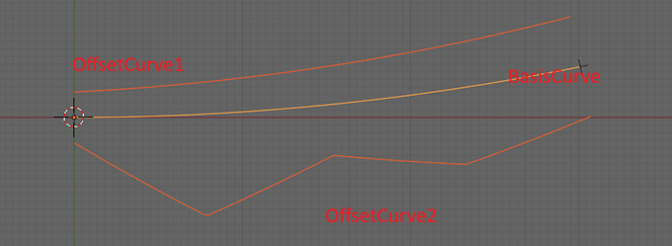
Figure 5.0-1 Offset curves
Figure 5.0-1 shows two offset curves that share a single basis curve. Offset curve 1 has different offset values defined at the start and the end of the basis curve. The start offset is 10 ft and the end offset is 20 ft. The basis curve is 100 ft long. The point on Offset curve 1 that corresponds to the mid-point of the basis curve is determined by evaluating the basis curve at 50 ft, then applying the linearly interpolated offset of 15 ft.
Offset curve 2 has several offsets. Linear interpolation is used to determine the offset from the basis curve to the offset curve between each pair of consecutive offset points.
The following IFC STEP excerpt illustrates how these two offset curves are encoded. The basis curve #20 is a circular arc.
Offset1 — left side, linearly varying:
#88=IFCPOINTBYDISTANCEEXPRESSION(IFCLENGTHMEASURE(0.),10.,$,$,#20);
#89=IFCPOINTBYDISTANCEEXPRESSION(IFCLENGTHMEASURE(200.),20.,$,$,#20);
#94=IFCOFFSETCURVEBYDISTANCES(#20,(#88,#89),$); /* Tag omitted */
The offset begins at +10 at distance 0 and increases linearly to +20 at distance 200 along the basis curve. At the midpoint of the basis curve (distance 100) the interpolated offset is +15.
Offset2 — right side, multi-point:
#102=IFCPOINTBYDISTANCEEXPRESSION(IFCLENGTHMEASURE(0.),-10.,$,$,#20);
#103=IFCPOINTBYDISTANCEEXPRESSION(IFCLENGTHMEASURE(50.),-40.,$,$,#20);
#104=IFCPOINTBYDISTANCEEXPRESSION(IFCLENGTHMEASURE(100.),-20.,$,$,#20);
#105=IFCPOINTBYDISTANCEEXPRESSION(IFCLENGTHMEASURE(150.),-30.,$,$,#20);
#106=IFCPOINTBYDISTANCEEXPRESSION(IFCLENGTHMEASURE(200.),-20.,$,$,#20);
#111=IFCOFFSETCURVEBYDISTANCES(#20,(#102,#103,#104,#105,#106),$); /* Tag omitted */
The right-side offset widens quickly from −10 to −40 over the first 50 distance units along the basis curve, then narrows to −20 at mid-curve, widens again to −30, and finishes at −20. Positive lateral offsets place the offset curve to the left of the basis curve and negative offsets to the right, measured perpendicular to the curve looking in the direction of increasing distance.
Both offset curves share the same basis curve #20. Each IfcPointByDistanceExpression also references #20 directly — the logical choice, since each offset value defines a lateral distance from that curve. The case where these two basis curve references differ is explored in §5.5.3.
The STEP excerpt above is drawn from the example models IfcOffsetCurveByDistances_2D.ifc and IfcOffsetCurveByDistances_3D.ifc, which are discussed further in §5.5.

5.1 Offset Curves and IfcAlignment
In IFC4x3, IfcOffsetCurveByDistances is a resource-layer geometric entity and cannot exist independently in a model. Validation rule IFC105 [5] requires that every resource entity be reachable from a rooted entity. In practice this means the offset curve must be assigned as the shape representation of an IfcAlignment (or another product), and that alignment must be aggregated into the project. Without this, the IFC validation service will report an IFC105 violation.
The consequence is that offset curves in IFC4x3 models are represented as alignments. This is natural: an offset alignment has its own object identity, can carry properties, can support linear placement of objects, and participates in the project’s spatial breakdown just like the basis alignment.
The example file IfcOffsetCurveByDistances_2D.ifc demonstrates this structure. The basis alignment “E-Line” and its two offsets, “Offset1” and “Offset2,” are all IfcAlignment instances aggregated under the project. Each offset alignment’s Representation references an IfcShapeRepresentation whose item is the corresponding IfcOffsetCurveByDistances.
When IfcOffsetCurveByDistances is used as a guide curve for IfcSectionedSurface or IfcSectionedSolidHorizontal, the same requirement applies with an additional complication. The guide curve is geometrically referenced by the surface or solid through the tag mechanism, and the surface or solid is itself a rooted entity — so the chain of references back to a rooted entity exists. The validation service does not trace this path, however, and still flags guide curves that are not directly assigned as a representation of a rooted entity. See §10.5.2 for the practical consequence.

5.2 Accuracy of Offset Curves
IfcOffsetCurveByDistances produces an exact geometric parallel only for lines and circular arcs with a constant offset. Even with a constant offset, transition curves have no closed-form geometric parallel — the true parallel of a Clothoid spiral, for example, is not a Clothoid. The resulting geometry is always a piecewise-linear approximation of the true offset, regardless of whether the offset is constant or varying. Accuracy improves by adding more IfcPointByDistanceExpression values at shorter intervals, densifying the approximation.
For most infrastructure applications, the linear interpolation error is small relative to construction tolerances. For applications requiring tighter accuracy — such as rail superelevation ramps or precision survey control — the approximation should be evaluated against the required tolerance and the offset point spacing adjusted accordingly.
A further consequence of the approximation is that distance along the offset curve is also approximate. When IfcOffsetCurveByDistances is used as the BasisCurve in IfcPointByDistanceExpression for IfcLinearPlacement, two independent implementations may compute different arc lengths for the same curve definition.
The arc length of IfcOffsetCurveByDistances at any given location is obtained by numerically integrating the offset curve geometry between the sample points. Because the IFC specification does not prescribe the interpolation method (see §5.3), different software may produce different intermediate curve shapes from identical OffsetValues, and therefore different arc lengths. Even if the interpolation method is agreed upon, the arc length integral has no closed form for a general offset from a spiral, so implementations must use numerical quadrature with finite precision or approximate series expansion solutions.
The consequence is that a DistanceAlong value specified against an IfcOffsetCurveByDistances does not map to a unique, reproducible point across implementations. This is in direct contrast to DistanceAlong measured along an IfcCompositeCurve or IfcGradientCurve, where arc length is determined exactly by the curve equations.
For precise linear placement, the recommended practice (discussed fully in §8.6) is to reference the parent alignment as the BasisCurve in IfcPointByDistanceExpression and use OffsetLateral to account for the transverse distance — rather than placing objects directly along the offset curve. This avoids the arc-length approximation entirely and keeps placement reproducible across software implementations.

5.3 Interpolation of Offset Values
The IFC specification does not prescribe how offset values are to be interpolated between IfcPointByDistanceExpression entries. Several methods are possible:
- Linear interpolation of offset values — the lateral offset distance is interpolated linearly between consecutive offset points, and the interpolated distance is applied perpendicular to the basis curve at each chainage. This keeps the offset curve anchored to the basis curve geometry.
- Linear interpolation between 3D points — the 3D positions of consecutive offset points are computed and connected by straight line segments. This produces a true piecewise-linear curve in space, but one that drifts away from the basis curve between offset points.
- Spline interpolation — cubic spline, B-spline, Bézier, or NURBS methods applied to either the offset values or the 3D positions, producing smoother curves but with greater implementation complexity.
Different interpolation methods produce materially different geometry from the same IfcOffsetCurveByDistances data. This is illustrated in Figure 5.3-1 which overlays a spline interpolation onto the linear interpolation from Figure 5.0-1. Without a formal implementation agreement, two compliant applications may render the same model differently.
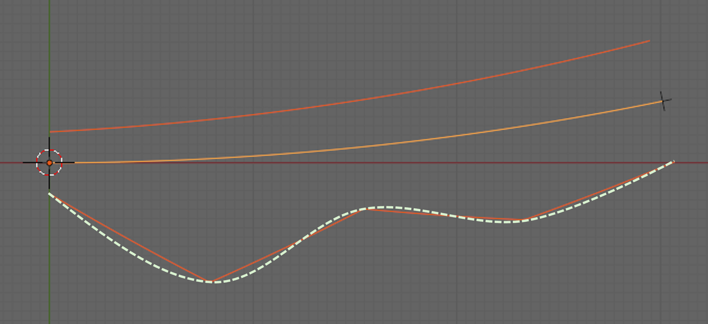
Figure 5.3-1 — Comparison of linear and spline interpolation
The recommended best practice is linear interpolation of offset values: interpolate the lateral distance at each chainage position, then apply that distance perpendicular to the basis curve. This method is the most natural given the structure of IfcOffsetCurveByDistances, produces predictable geometry, and is the least ambiguous for interchange.

5.4 The Tag Attribute
The Tag attribute of IfcOffsetCurveByDistances is an optional label that assigns an identifier to the offset curve. Its primary purpose is to correlate an offset curve with a named point in a variable cross-section definition.
IfcSectionedSurface and IfcSectionedSolidHorizontal define geometry by sweeping a series of cross-sections along a basis curve. Each cross-section can contain named control points — edge-of-pavement, top-of-rail, daylight line, and so on. The Tag on an IfcOffsetCurveByDistances matches one of those named points, allowing the surface or solid geometry to be driven by the offset curve’s lateral positions rather than by fixed cross-section ordinates. This is the mechanism by which variable-width surfaces and solids are defined in IFC4x3.
The full treatment of IfcSectionedSurface and IfcSectionedSolidHorizontal, including how Tag values are resolved against cross-section geometry, is covered in Chapter 10.

5.5 Example Models
Three example models illustrate IfcOffsetCurveByDistances in progressively more demanding configurations. The 2D and 3D variants share the same geometry and offset profiles; the difference is whether the basis curve is an IfcCompositeCurve (horizontal only) or an IfcGradientCurve (3D). The split-basis variant tests a configuration the IFC specification does not prohibit but leaves geometrically ambiguous.

5.5.1 Two-Dimensional Basis Curve
The file IfcOffsetCurveByDistances_2D.ifc contains a basis alignment and two offset alignments. The basis curve is an IfcCompositeCurve — a horizontal-only curve with no elevation component.
Validation. Both offset alignments in this model fail the validation rule IfcShapeRepresentation.CorrectItemsForType. The IfcShapeRepresentation for each offset alignment uses RepresentationType = "Curve3D", which requires its items to be 3D curves. The IfcOffsetCurveByDistances entities here are 2D because their BasisCurve is an IfcCompositeCurve — a planar horizontal curve with no elevation component. The IfcAlignment specification permits IfcOffsetCurveByDistances to represent either a 2D or 3D alignment curve, but the validation service’s CorrectItemsForType rule does not account for this — it requires Curve3D items to be 3D regardless. This is a gap in the validation service, not a conflict in the specification. It is anticipated that the next version of the buildingSMART Validation Service will not flag this as an error.

5.5.2 Three-Dimensional Basis Curve
The file IfcOffsetCurveByDistances_3D.ifc extends the 2D example by adding a flat vertical alignment to the basis alignment, making its basis curve an IfcGradientCurve. The two offset alignments are constructed to demonstrate how basis curve choice affects dimensionality and validation outcome.
Offset1 references the IfcGradientCurve as the BasisCurve in both the IfcOffsetCurveByDistances and all IfcPointByDistanceExpression offset values. Because IfcGradientCurve is a 3D curve, the resulting offset curve is 3D. Offset1 satisfies IfcShapeRepresentation.CorrectItemsForType.
Offset2 references IfcGradientCurve.BaseCurve — the underlying IfcCompositeCurve — as the BasisCurve for its offset values. IfcCompositeCurve is a 2D horizontal curve, so the resulting offset curve is 2D regardless of whether the parent alignment has a vertical component. Offset2 fails IfcShapeRepresentation.CorrectItemsForType for the same reason as the 2D example. It is anticipated that the next version of the buildingSMART Validation Serivce will not flag this as an error.
The key finding is that the dimensionality of an IfcOffsetCurveByDistances is determined by which curve object is referenced as its BasisCurve — not by the dimensionality of the alignment that owns it. Referencing an IfcGradientCurve produces a 3D offset curve; referencing its constituent IfcCompositeCurve produces a 2D one.

5.5.3 Split Basis Curves
The file IfcOffsetCurveByDistances_split_basis.ifc demonstrates the edge case described in §5.0 where IfcOffsetCurveByDistances.BasisCurve and IfcPointByDistanceExpression.BasisCurve reference different curves. The model contains two basis alignments — a circular arc and a straight line — each with a flat vertical profile and an IfcGradientCurve basis curve.
The single offset alignment has its IfcOffsetCurveByDistances.BasisCurve set to the circular arc’s IfcGradientCurve, while its IfcPointByDistanceExpression offset values reference the straight line’s IfcGradientCurve. Because the two curves have different shapes, the parameterization of the offset values is inconsistent with the curve to which they are applied.
The IFC specification does not prohibit this configuration, and the model passes all validation service checks. This is itself a gap: the split-basis configuration is semantically ambiguous and should be flagged as either an error or a best-practices violation. A future validation rule requiring that IfcOffsetCurveByDistances.BasisCurve and the BasisCurve of all its OffsetValues reference the same curve object would close this gap without breaking any legitimate use case.

Chapter 6 — Approximate Alignment Geometry

6.0 Introduction
The parametric IfcCurveSegment-based representations described in Sections 2 through 4 provide closed-form equations for position, tangent, and curvature at any arc-length along the alignment. That precision is essential when geometry drives design, construction staking, linear placement, or quantity takeoff.
Not all alignment data arrives in this form. Field surveys of existing infrastructure may produce a series of measured points rather than fitted curve parameters. Early-stage planning alignments may exist only as a sketched centerline digitized from a map. GIS systems commonly store linear features as coordinate strings. IFC accommodates these cases through two representation types: IfcPolyline and IfcIndexedPolyCurve.
Both are discrete rather than parametric: geometry is defined by a sequence of control points with linear interpolation between them. The result is a piecewise-linear approximation that encodes position only.
The IFC specification lists both types as valid IfcAlignment geometry for 2D horizontal alignments (planning and mapping contexts) and 3D alignments (survey-derived). See Section 1.5 for the complete list of valid representation types.

6.1 Geometric Forms
Both IfcPolyline and IfcIndexedPolyCurve provide simplified, approximate representations of alignment geometry. Rather than encoding the mathematical intent of the design — curve type, radius, spiral parameter — they encode only sampled positions. The two types differ in storage layout and in how much approximation they can absorb.
IfcPolyline holds geometry as an ordered list of IfcCartesianPoint instances — each vertex is a discrete entity in the model. Consecutive vertices are connected by straight line segments, so every curve in the original alignment is approximated by a series of chords. The curve accepts 2D or 3D coordinates, making it suitable for both plan-view sketches and full survey point strings.
IfcIndexedPolyCurve stores coordinates compactly in an IfcCartesianPointList2D or IfcCartesianPointList3D and references individual vertices by integer index. When the optional Segments attribute is omitted, the result is functionally identical to IfcPolyline. When Segments is provided, each entry is either an IfcLineIndex (two indices, straight segment) or an IfcArcIndex (three indices: start, a through-point on the arc, and end). Arc segments allow circular curves to be represented exactly rather than approximated by chords, reducing the number of vertices needed for a given accuracy. This makes IfcIndexedPolyCurve better suited to map-digitized or GIS-derived data where circular arcs are common but transition spirals are absent.

6.2 Alignments Without Semantic Layout
In contrast to Concept Templates 4.1.7.1.1.1 through 4.1.7.1.1.4, the IFC specification does not provide concept templates that show how IfcPolyline or IfcIndexedPolyCurve provide a geometric representation of an IfcAlignment. (The same gap applies to IfcOffsetCurveByDistances, covered in Chapter 5.)
Section 1.4 establishes that every IfcAlignmentHorizontal, IfcAlignmentVertical, and IfcAlignmentCant must terminate with a zero-length IfcAlignmentSegment. When a geometric representation accompanies the semantic definition, the corresponding last IfcCurveSegment must also be zero length.
Neither type is composed of IfcCurveSegment entities and therefore neither can satisfy the requirements for the geometric counterpart to a full alignment layout.
While IfcPolyline and IfcIndexedPolyCurve could each serve as an IfcCurveSegment.ParentCurve, they cannot produce the required zero-length closing segment. A zero-length polyline segment requires two coincident vertices; IfcPolyline WHERE rule WR1 explicitly prohibits this. IfcIndexedPolyCurve has no equivalent schema-level prohibition, but a coincident point pair produces a degenerate segment with an undefined tangent direction. In practice this means an application cannot pair a complete semantic alignment layout with a simple chorded polyline for visualization — the two are mutually exclusive in IFC4x3.
For this reason, IfcPolyline and IfcIndexedPolyCurve (as well as IfcOffsetCurveByDistances) can only represent an IfcAlignment without an accompanying semantic layout definition.

Chapter 7 — Alignments Reusing Horizontal Layout

7.0 Introduction
In infrastructure projects it is common for several alignments to share the same horizontal path. Three situations arise frequently:
Design alternatives. A corridor study fixes the horizontal alignment and evaluates multiple vertical profiles. Each profile becomes its own alignment sharing the common horizontal baseline. Comparison software can overlay the profiles without any coordinate transformation.
Existing versus proposed. When an existing road is to be reconstructed, the existing centerline may be surveyed and represented as one alignment; the proposed centerline shares the same horizontal but carries a new vertical profile.
Parallel infrastructure elements. Features that follow the same horizontal path at different elevations — top of sub-grade, finished grade, top of rail — can each be modelled as a separate alignment sharing a common horizontal. This is more precise than using IfcOffsetCurveByDistances for vertical offset, because each element carries its own parametric vertical definition rather than a sampled elevation difference.
IFC4x3 accommodates all three cases directly. Because horizontal layout is represented by discrete entities in the model, those entities can be referenced by more than one alignment. The horizontal curve is defined once and shared; each alignment then adds its own vertical and, if applicable, cant definition on top of that shared base.
The shared-horizontal pattern relies on a parent IfcAlignment that owns the common horizontal layout, and child IfcAlignment instances — each with its own vertical profile — aggregated under that parent. This parent/child structure is prescribed by Concept Template 4.1.4.4.1.2 Alignment Layout — Reusing Horizontal Layout.
This section describes the alignment layout structure for the reusing-horizontal-layout pattern, the geometric representations of the child alignments, and the open implementation questions that remain to be resolved in the specification.

7.1 Alignment Layout and Geometric Representation

7.1.1 Alignment Layout — Parent/Child Structure
The alignment layout uses a three-tier hierarchy:
- A parent IfcAlignment nests a single shared IfcAlignmentHorizontal via IfcRelNests.
- One or more child IfcAlignment instances are aggregated under the parent via IfcRelAggregates.
- Each child IfcAlignment nests its own IfcAlignmentVertical (and, for rail alignments, its own IfcAlignmentCant) via IfcRelNests.
The shared IfcAlignmentHorizontal exists exactly once in the model, owned by the parent via IfcRelNests. No child alignment nests an IfcAlignmentHorizontal of its own; they reuse the horizontal definition from the parent. The parent itself carries no vertical layout; its sole role is to hold the shared horizontal and aggregate the children. Children that require cant also nest an IfcAlignmentCant via IfcRelNests. Figure 7.1.1-1 shows the complete parent/child layout structure.
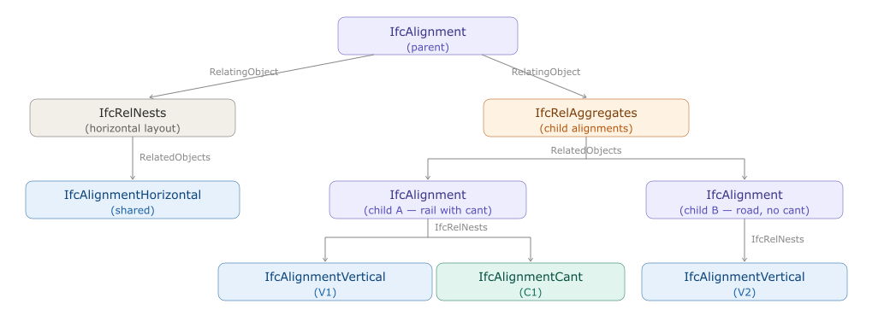
Figure 7.1.1-1 — Alignment layout for the reusing-horizontal-layout pattern.
Only the IfcAlignmentHorizontal is shared. Each child alignment owns its IfcAlignmentVertical and IfcAlignmentCant exclusively — those layout entities are never shared between children.

7.1.2 Geometric Representation — Shared BaseCurve
Each child alignment’s 3D curve references the horizontal IfcCompositeCurve through its BaseCurve attribute. IfcGradientCurve carries BaseCurve: IfcBoundedCurve as the 2D horizontal curve, and two IfcGradientCurve instances can reference the same BaseCurve entity. The horizontal geometry — typically an IfcCompositeCurve composed of IfcCurveSegment instances — exists in the model exactly once and is referenced by both gradient curves. Figure 7.1.2-1 illustrates this shared reference.
At the geometric level, IfcSegmentedReferenceCurve adds cant to a gradient curve by taking an IfcGradientCurve as its own BaseCurve. Each child alignment that needs a cant definition gets its own IfcSegmentedReferenceCurve and its own IfcGradientCurve; only the IfcCompositeCurve at the base of the chain is the shared instance, as shown in Figure 7.1.2-1:
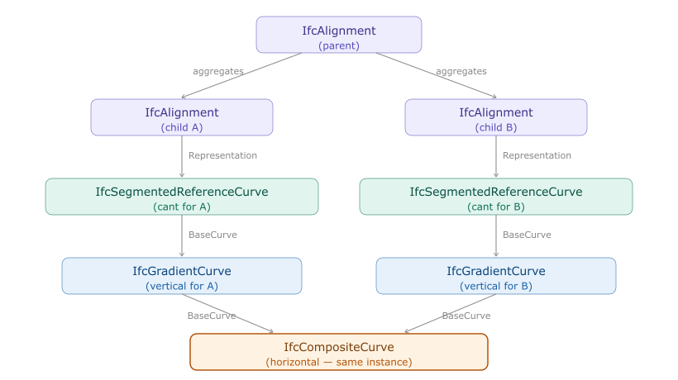
Figure 7.1.2-1 — Geometric chain for child alignments with cant. Each child alignment has its own IfcSegmentedReferenceCurve and IfcGradientCurve; the IfcCompositeCurve is the shared instance.

Shape Representation Placement
Pending resolution of the open questions in §7.2, the following placement convention is recommended based on implementation experience:
- The parent IfcAlignment entity carries the IfcCompositeCurve as its own IfcShapeRepresentation with RepresentationIdentifier = "FootPrint" and RepresentationType = "Curve2D".
- Each child IfcAlignment carries its full 3D curve as its own IfcShapeRepresentation with RepresentationIdentifier = "Axis" and RepresentationType = "Curve3D".
- This recommendation consistently relates the geometric representation to an instance of IfcAlignment.

7.2 Open Implementation Questions
The IFC4x3 specification does not yet provide a concept template for the geometric representation when reusing horizontal layout. The following questions are not resolved and remain active topics for a future normative concept template:
- Representation ownership. Should all representations be contained within the parent IfcAlignment.Representation.Representations, within each child alignment’s Representation.Representations, or split between them?
- Horizontal curve ownership. Should the IfcCompositeCurve representation of the horizontal layout be a representation on the parent IfcAlignment or on the IfcAlignmentHorizontal?
- All-or-nothing geometry. Is the presence of a geometric representation for one alignment a requirement for all alignments in the group to have geometric representations?
- Mixed representation types. Are mixed representation types valid within the same group — for example, one child alignment represented as an IfcGradientCurve and another as an IfcOffsetCurveByDistances?
Until these questions are resolved normatively, implementations should follow the convention described in §7.1.2 and document which representation placement strategy has been adopted.

7.3 Concept Template Transitions in Live Model Management
An application that maintains an IFC model incrementally — adding and removing vertical layouts as the designer works — must handle transitions between two different concept templates:
Vertical count | Required concept template
1 | CT 4.1.4.4.1.1 — Alignment Layout – Horizontal, Vertical and Cant
2 or more | CT 4.1.4.4.1.2 — Alignment Layout – Reusing Horizontal Layout
These two templates have structurally different models. CT 4.1.4.4.1.1 nests both IfcAlignmentHorizontal and IfcAlignmentVertical directly under a single IfcAlignment via IfcRelNests. CT 4.1.4.4.1.2 uses the parent/child structure described in §7.1.1: the parent nests only the IfcAlignmentHorizontal, and each vertical lives in its own child IfcAlignment aggregated under the parent. Switching between them is not additive — it requires restructuring the existing model.

7.3.1 Transitioning to Reusing Horizontal Layout
Figure 7.3.1-1 shows the CT 4.1.4.4.1.1 structure used when a single vertical is present:
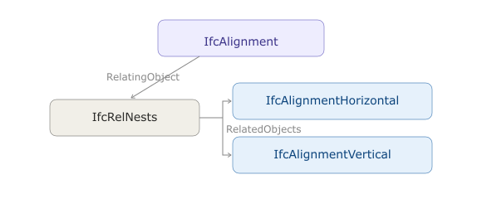
Figure 7.3.1-1 — CT 4.1.4.4.1.1: single IfcAlignmentVertical nested directly under IfcAlignment.
When a second vertical is added, the model must be restructured to CT 4.1.4.4.1.2. The IfcAlignmentVertical (V1) that was directly nested under the original IfcAlignment must be moved into a new child alignment. A second child alignment is created for V2, yielding the structure shown in Figure 7.3.1-2:
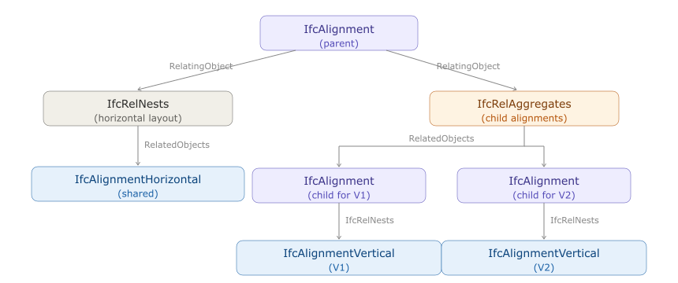
Figure 7.3.1-2 — CT 4.1.4.4.1.2: vertical layouts moved into child alignments aggregated under the parent.
The inverse transition is equally important but easier to overlook. When the designer removes a vertical layout and only one remains, the model must revert back to CT 4.1.4.4.1.1. The sole remaining IfcAlignmentVertical is re-nested directly under the alignment, the child IfcAlignment instances are dissolved, and the IfcRelAggregates relationship is removed — restoring the structure shown in Figure 7.3.1-1.

7.4 Relationship to Offset Curves
Chapter 5 describes IfcOffsetCurveByDistances, which defines a new curve laterally displaced from a basis alignment. Offset curves address a different need: they shift the curve horizontally (in plan) rather than reusing the same horizontal path at a different elevation. A left edge-of-shoulder offset and a right edge-of-shoulder offset use IfcOffsetCurveByDistances because their horizontal positions differ from the centerline. Features that share the exact same horizontal trace but differ only in elevation use the shared-horizontal-layout pattern described in this section.
The two patterns can coexist. For example, a road model might define: - The centerline as a parent IfcAlignment with a full horizontal definition, plus a child carrying the design vertical profile - The left and right edges of pavement as offset curves (lateral displacement, Chapter 5) - The sub-grade profile as another child IfcAlignment under the same parent, sharing the centerline’s horizontal but carrying an independent vertical profile (this section)

7.5 Use Cases Not Supported by Alignment - Reusing Horizontal Layout Concept Template
The following configurations arise in practice but cannot be fully represented using Concept Template 4.1.4.4.1.2 as currently defined. The IFC specification does not provide other concept templates that support these use cases.
Double-track railway. In this configuration, sometimes called the 7-line geometry in railway practice, a single central horizontal reference defines both tracks. Each track carries its own vertical profile and cant, while stationing is carried along the common central alignment. The reusing-horizontal-layout template accommodates independent verticals per child alignment, but it provides no mechanism to associate independent horizontal offsets (one track to each side of the reference) with the shared horizontal. The two tracks would require separate horizontal definitions even where they are geometrically parallel, which defeats the purpose of horizontal sharing.
Dual carriageway. A highway with a central reference alignment defining two independent carriageways faces the same problem: each carriageway has a distinct horizontal position offset from the reference, so the shared-horizontal-layout pattern does not apply. Modeling each carriageway as a child of a common parent would require the child alignments to carry their own IfcAlignmentHorizontal, which is not permitted under the concept template. IFC4x3 has no explicit concept template for dual-carriageway or multi-track configurations.

Chapter 8 — Linear Placement

8.0 Introduction
Most elements in the built environment for infrastructure works are located relative to an alignment rather than by absolute coordinates. A bridge pier, a drainage inlet, a light pole, a traffic sign — all are described in traditional engineering plans by where they fall along a road or railway centerline, how far they sit to the left or right of that centerline, and how high above (or below) a reference elevation they stand. This intuitive “station, offset, elevation” system has been the language of civil engineers for over a century.
IfcLinearPlacement is the IFC mechanism that formalizes this concept in accordance with ISO 19148 Geographic information - Linear referencing. It places and orients an object relative to a basis curve — typically an alignment curve — using an IfcPointByDistanceExpression to define the location and IfcAxis2PlacementLinear to define the axis directions.
This section covers:
- The concept of linear placement and how it maps from traditional engineering practice into IFC.
- The IFC class hierarchy: IfcLinearPlacement, IfcAxis2PlacementLinear, and IfcPointByDistanceExpression.
- How the local coordinate system is constructed at a placement point.
- Special cases: longitudinal offset for unreachable points, and placement along IfcOffsetCurveByDistances.
- ISO 19148 Linear Referencing and how its concepts relate to IFC linear placement.

8.1 Linear Placement in Practice

8.1.1 The Traditional Approach
Before examining IFC, it helps to recall how placement is expressed in conventional civil engineering plans. Two common cases illustrate the idea:
Case 1 — Bridge Pier (2D plan view). A bridge pier is located in plan by its station along the roadway alignment and its lateral offset from the centerline. A plan note might read “Pier 2 CL: Sta. 142+35.75, 12.50 ft Lt.” The elevation of the pier top is read separately from a profile view. No absolute coordinates are needed; the alignment provides the reference frame.
Case 2 — Drainage Inlet (3D). A storm drain inlet is placed at Sta. 198+12.42, offset 18.0 ft right of centerline, with its top grate set at elevation 312.75 ft (NAVD88). Here all three spatial dimensions are given: station gives position along the alignment, lateral offset gives the transverse position, and the elevation fixes the vertical position independently of the alignment profile.
Both cases share the same structure: a distance along a reference curve, plus offsets from it. IfcLinearPlacement captures exactly this structure.

8.1.2 The IFC Object Graph
The IFC classes that implement linear placement form a short chain, shown in Figure 8.1.2-1.
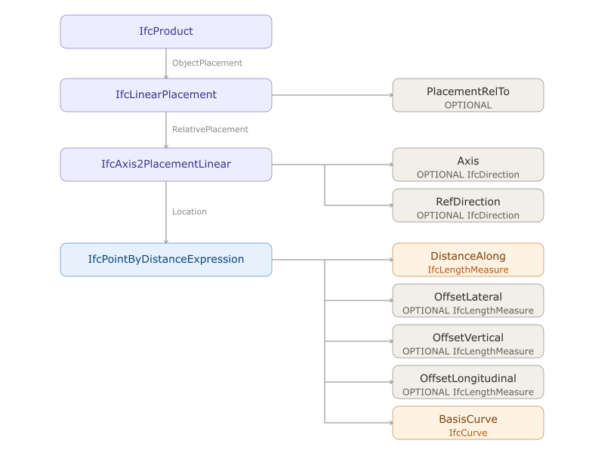
Figure 8.1.2-1 — IFC object graph for linear placement.
The PlacementRelTo attribute of IfcLinearPlacement establishes the reference context. When it is omitted, the placement is measured from the start of the basis curve defined in IfcPointByDistanceExpression. This is the standard case when the basis curve is an alignment defined in the project coordinate system.
Figure 8.1.2-2 schematically represents the linear placement of a bridge pier and a drain inlet.
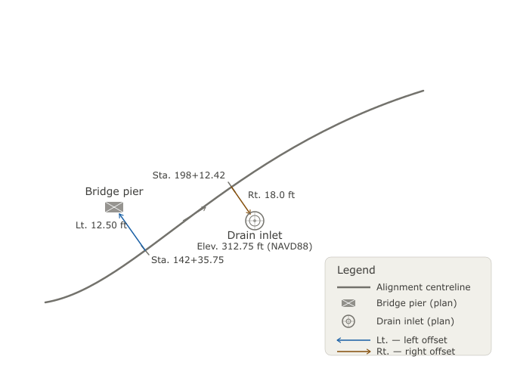
Figure 8.1.2-2 — Conceptual diagram showing a plan view of an alignment with a bridge pier placed at a station/offset and a drain inlet placed at station/offset/elevation.

8.2 IfcLinearPlacement and IfcAxis2PlacementLinear
IfcAxis2PlacementLinear performs two independent jobs:
- Location — fixing a point in space, via Location (typed IfcPoint, but constrained by a WHERE rule to be IfcPointByDistanceExpression). The point is found by walking DistanceAlong a BasisCurve and then applying up to three offsets (§8.2.1).
- Orientation — fixing the direction of the placement’s local axes, via the optional Axis and RefDirection attributes (§8.3).
These two jobs are independent. The offsets that determine Location are measured in a frame derived directly from the geometry of BasisCurve at DistanceAlong — not from whatever Axis/RefDirection values are chosen for orientation. An implementation evaluates Location the same way regardless of how, or whether, Axis and RefDirection are supplied.

8.2.1 Distance Along the Basis Curve
IfcPointByDistanceExpression class has five key attributes:
Attribute | Type | Description
BasisCurve | IfcCurve | The curve relative to which the point’s location is defined.
DistanceAlong | IfcCurveMeasureSelect | The parametric distance measured along the basis curve. Typically a plain IfcLengthMeasure.
OffsetLateral | OPTIONAL IfcLengthMeasure | Signed lateral offset. Positive to the left of the curve’s forward tangent; negative to the right (consistent with ISO 19148).
OffsetVertical | OPTIONAL IfcLengthMeasure | Signed vertical offset. Positive upward relative to BasisCurve.
OffsetLongitudinal | OPTIONAL IfcLengthMeasure | Signed offset in the tangent direction of the BasisCurve. See §8.2.1.1 for uses.
For a full 3D alignment (IfcGradientCurve or IfcSegmentedReferenceCurve), the DistanceAlong is measured along the horizontal projection of the 3D curve onto the global XY plane — that is, along the underlying IfcCompositeCurve that forms the basis of the 2.5D geometry and represents the plan view curve geometry. This is consistent with how stationing is defined in civil engineering: stationing is a horizontal measure.
The IfcPointByDistanceExpression.BasisCurve attribute is poorly named. This curve is the 3D alignment geometry curve composed from the 2D composite curves defining the 2.5D geometry. A better name for this attribute would be Directrix. This would be consistent with IfcSectionedSolidHorizontal.Directrix. The basis curve is the curve that forms the basis of the 2.5D geometry. This is the horizontal projection of IfcPointByDistanceExpression.BasisCurve onto a horizontal plane. Basis curve and IfcPointByDistanceExpression.BasisCurve are similarly named but have very different definitions. For this reason IfcPointByDistanceExpression.BasisCurve (or BasisCurve) is used when referring to the 3D curve and basis curve is used when referring to the 2D projection of the 3D curve onto a horizontal plane.
The three offsets are measured relative to a frame derived from BasisCurve itself at DistanceAlong — not relative to the Axis/RefDirection of the enclosing IfcAxis2PlacementLinear (§8.3). That curve-derived frame, shown in Figure 8.2.1-1, is defined as follows:
- Let T be the tangent to BasisCurve at DistanceAlong, pointing in the direction of increasing distance.
- OffsetLateral is measured perpendicular to T, in the horizontal plane (parallel to the global XY plane): positive to the left of T, negative to the right (ISO 19148 convention).
- OffsetVertical is measured perpendicular to T, within the vertical plane (the plane perpendicular to the global XY plane) containing T.
- OffsetLongitudinal is measured along T, applied last, from the point already displaced by OffsetLateral and OffsetVertical (see §8.2.1.1).
This is not the same as elevation. OffsetVertical is perpendicular to the tangent T, not to the global XY plane. When BasisCurve is horizontal at that point, the two happen to coincide, and OffsetVertical behaves exactly like a change in elevation. But on a graded alignment the tangent is inclined, so “perpendicular to the tangent” points partly sideways and partly up — OffsetVertical is not a pure elevation change. §8.3.3 works through a numeric example where confusing “perpendicular to the curve” with “vertical (elevation)” produces different placements.
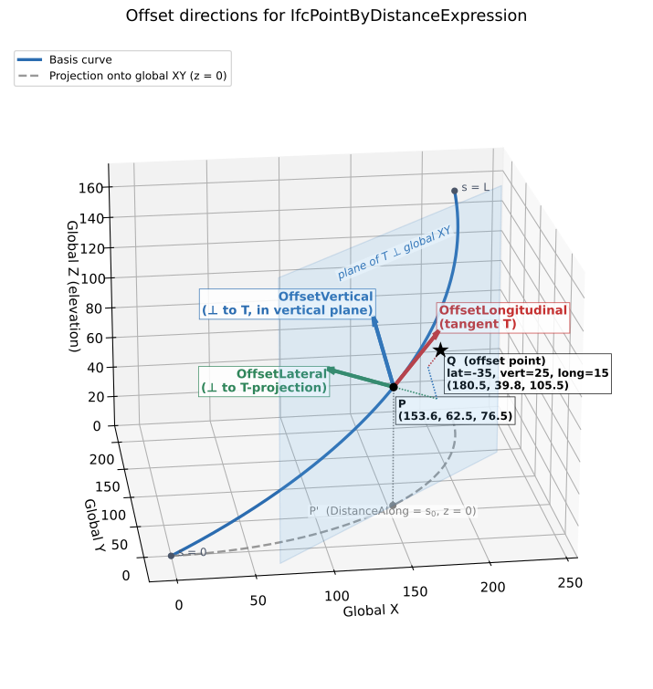
Figure 8.2.1-1 — Offset directions used by IfcPointByDistanceExpression to locate a point P on an alignment, where T is the tangent to the alignment at P: OffsetLateral measured horizontal and perpendicular to T, OffsetVertical measured in the vertical plane containing T, and OffsetLongitudinal measured along T. The dashed path shows offset point Q constructed by applying OffsetLateral, then OffsetVertical, then OffsetLongitudinal, in that order.

8.2.1.1 Longitudinal Offset and Unreachable Points
What Is an Unreachable Point?
In plane geometry, every point off a smooth curve can be reached by some combination of distance along the curve plus a perpendicular offset. However, certain geometric configurations in horizontal alignment create locations that cannot be expressed as a station plus a purely transverse offset.
The classic example is an angle point — the intersection of two tangents in a horizontal alignment where no curve has been inserted. At an angle point, the curve has a sharp corner. A point located “outside” the angle — beyond the apex — lies in a zone where the perpendicular from the curve never reaches. This is depicted in Figure 8.2.1.1-1.
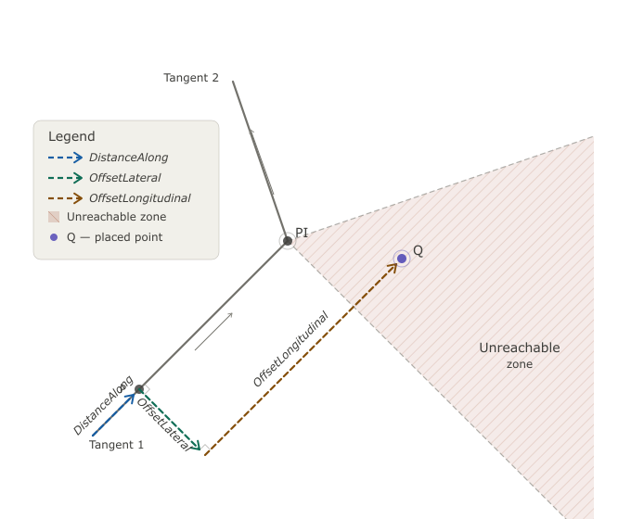
Figure 8.2.1.1-1 — Plan view showing two tangent lines meeting at an angle point (PI). The shaded region outside the angle cannot be reached by a station + lateral offset alone. An object in this region requires a longitudinal offset.
Using OffsetLongitudinal
IfcPointByDistanceExpression.OffsetLongitudinal provides the solution. A non-zero OffsetLongitudinal moves the placement point along T — the same tangent direction used to define the other offsets in §8.2.1 — after the lateral and vertical offsets are applied. The procedure is:
- Locate the point on the basis curve at DistanceAlong, establish the corresponding point on the BasisCurve, and determine tangent T at that point.
- Apply OffsetLateral perpendicular to T, in the horizontal plane.
- Apply OffsetVertical perpendicular to T, within the vertical plane containing T.
- Apply OffsetLongitudinal along T.
The resulting point is no longer “on” a perpendicular to the basis curve at DistanceAlong, but it is precisely located in 3D space.
Practical note: OffsetLongitudinal should be used only when necessary. For all ordinary station-offset placements, it should be omitted.

8.2.2 Stationing and DistanceAlong
Stationing is addressed comprehensively in Chapter 9. For the purposes of linear placement, the key point is that DistanceAlong is a geometric distance from the start of the basis curve, not a station label. These two quantities are related but not identical:
- Geometric distance begins at zero and increases continuously to the total length of the curve.
- Station value may begin at an arbitrary value (e.g., 10+00.00 = 1000 ft from some project reference), may include equation gaps or overlaps where stationing is reset, and may use different units (feet vs. meters).
When using IfcPointByDistanceExpression, supply the geometric distance, not the raw station label. If the alignment has an IfcReferent that defines the starting station, the geometric distance equals the station value minus the starting station value (adjusted for any station equations encountered along the way).

8.3 The Placement Coordinate System
§8.2 covered the first job of IfcAxis2PlacementLinear — fixing Location using offsets measured in a frame derived purely from BasisCurve’s own geometry. This section covers the second, independent job: establishing the orientation of the placement’s local axes via Axis and RefDirection. Nothing here changes how Location was computed in §8.2 — location and orientation are established independently, and an implementation must not let one influence the other.

8.3.1 Role of Axis and RefDirection
The orientation job of IfcAxis2PlacementLinear defines a local right-handed coordinate system at the placement point fixed in §8.2. Two optional attributes control that orientation:
Attribute | Role in local CS | Default
RefDirection | X-axis (forward direction) | Tangent to the 3D curve at Location
Axis | Z-axis (up direction) | See §8.3.2
The Y-axis is derived as the cross product of Axis × RefDirection (after normalization).
When Axis and RefDirection are both omitted, the implementation must supply defaults. This is the most common scenario and is described below.

8.3.2 Default Axis — An Open Issue
The ambiguity originates in how IfcAxis2PlacementLinear describes its optional attributes compared to its 3D counterpart. IfcAxis2Placement3D is explicit: its specification states that when Axis is omitted it defaults to (0, 0, 1) and when RefDirection is omitted it defaults to (1, 0, 0). No interpretation is required.
IfcAxis2PlacementLinear takes a different approach. Its specification states:
“Relative placement axes (Axis and RefDirection) are relative to the curve used for linear referencing provided in IfcPlacement.Location (IfcPointByDistanceExpression.BasisCurve), maintaining the relationship to the tangent of the curve.”
This sentence says the axes are derived from the curve, not from global coordinates. The natural reading is that RefDirection defaults to the curve tangent — which implementations broadly agree on — and that Axis defaults to something perpendicular to that tangent in the general upward direction. On a flat alignment those two readings coincide: the upward perpendicular to a horizontal tangent is (0, 0, 1). On a graded alignment they diverge: “perpendicular to the 3D tangent in the upward direction” tilts with the grade and is no longer (0, 0, 1). The specification never resolves what “upward relative to the curve” concretely means, and that silence is the source of the ambiguity. A known open issue in the buildingSMART community tracks it (see IFC4.x-IF Issue #125 and IFC4.x-development Issue #732); a proposed resolution has been submitted as IFC4.x-development Pull Request #1118 but has not yet been accepted or merged.
Two interpretations exist in practice:
- Axis = global Z = (0, 0, 1). The Z-axis is always vertical regardless of alignment slope. The X-axis follows the horizontal tangent direction even when the curve has a vertical grade. This is natural for plan-oriented placement and matches traditional station-offset-elevation thinking.
- Axis = perpendicular to the IfcPointByDistanceExpression.BasisCurve tangent, in the vertical plane containing that tangent (the plane containing the tangent that is normal to the global XY plane). The Z-axis tilts with the grade of the alignment. The local X-axis is truly tangent to the 3D curve. This reading follows directly from the curve-relative language in the specification, and produces the same orientation that IfcExtrudedAreaSolid would use when sweeping along the same path.
The connection between interpretation 2 and the broader IFC linear referencing model is not incidental. When evaluating a point along a 3D curve such as IfcGradientCurve or IfcSegmentedReferenceCurve, the resulting coordinate frame at that point is derived from the curve itself — the tangent at the evaluation distance determines the local forward direction, and the normal plane at that point governs the transverse and vertical axes. This is the frame that implementations compute when moving along a 3D alignment, as illustrated in the discussions of vertical and cant alignment geometry in Chapters 3 and 4. The perpendicular-to-3D-tangent interpretation of Axis is most consistent with that model: both derive orientation from the same 3D curve tangent, so a placement using interpretation 2 produces a frame congruent with what an implementation computes when evaluating the directrix at the same distance.
The practical consequence of this ambiguity is graphically illustrated in §10.5.6 — Figure 10.5.6-2 shows the same IfcSectionedSolidHorizontal model with Axis omitted rendered by two viewers that adopted opposite defaults, producing visibly different geometry on a 10% grade.

8.3.3 Linear Placement Example
This example evaluates an IfcLinearPlacement for an object located along an alignment. The object is to be located at a DistanceAlong of 201.0 m and a lateral offset of 2.0 m. The object is to be located 2.5 m above the alignment, measured vertically, and is to be oriented vertically. The desired placement of the object is at (201.0, 2.0, 52.75).
The horizontal alignment is straight towards the East. The vertical alignment is a constant gradient at a slope of 0.25 and starts at elevation 0.0.
The gradient parameters for a slope of $0.25$ are $d_{x}=0.9701425, d_{y}=0.2425356$.
One option is to define the object’s position relative to the gradient curve using horizontal and vertical offsets. The relevant IFC is:
#5208 = IFCGRADIENTCURVE(/*details omitted*/)
#5297 = IFCLINEARPLACEMENT($, #5303, $);
#5303 = IFCAXIS2PLACEMENTLINEAR(#5304, #5305, $);
/* Placement defined relative to gradient curve */
#5304 = IFCPOINTBYDISTANCEEXPRESSION(IFCLENGTHMEASURE(201.), 2., 2.5, $, #5208);
/* Explicitly defined Axis direction */
#5305 = IFCDIRECTION((0., 0., 1.));
The object will be oriented vertically because the IfcAxis2PlacementLinear.Axis is explicitly defined as (0,0,1). If IfcAxis2PlacementLinear.Axis is omitted, the default orientation of the object may depend on the implementation as discussed in §8.3.2.
The point on the gradient curve is:
$$x=201.0$$
$$z=(201.0)\frac{(0.2425356)}{(0.9701425)}=50.25$$
The vertical offset is perpendicular to the vertical gradient. The offset from the gradient curve point is:
$$Δx=(2.5)(-0.2425356)=-0.606$$
$$Δy=(2.5)(0.9701425)=2.425$$
The resulting placement is:
$$x+Δx=201.0-0.606=200.394$$
$$y+Δy=50.25+2.425=52.675$$
The object’s placement is (200.394, 2.0, 52.675). This is not the desired placement. The object is not in the correct location because OffsetVertical is measured perpendicular to the curve’s tangent (§8.2.1), not as a pure elevation change — on this 0.25 gradient the two are not the same.
The approach to achieve the desired placement is to use an IfcLinearPlacement.PlacementRelTo with $z=2.5$.
/* Local placement with z = 2.5. Linear placement is relative to this coordinate frame. */
#5139 = IFCLOCALPLACEMENT($, #5143);
#5140 = IFCDIRECTION((0., 0., 1.));
#5141 = IFCDIRECTION((1., 0., 0.));
#5142 = IFCCARTESIANPOINT((0., 0., 2.5));
#5143 = IFCAXIS2PLACEMENT3D(#5142, #5140, #5141);
#5208 = IFCGRADIENTCURVE(/*details omitted*/)
/* Linear placement relative to the local placement defined above. */
#5297 = IFCLINEARPLACEMENT(#5139, #5303, $);
#5303 = IFCAXIS2PLACEMENTLINEAR(#5304, #5305, $);
/* Placement defined relative to gradient curve. Note that vertical offset is omitted */
#5304 = IFCPOINTBYDISTANCEEXPRESSION(IFCLENGTHMEASURE(201.), 2., $, $, #5208);
/* Explicitly defined Axis direction */
#5305 = IFCDIRECTION((0., 0., 1.));
From before, the point on the gradient curve is:
$$x=201.0, z=50.25$$
There is no vertical offset relative to the gradient curve. However, this point is relative to a local placement with $z=2.5$. The elevation of the object is $50.25+2.5=52.75$.
The object’s placement is (201.0, 2.0, 52.75).
In this approach, the location of the object relative to the gradient curve is treated as an incremental offset from the origin of the IfcLinearPlacement.PlacementRelTo coordinate system.

8.4 Fallback Cartesian Position
IfcLinearPlacement.CartesianPosition is an optional IfcAxis2Placement3D attribute that provides a fallback geometry placement for receiving applications that do not support linear placement. An importing application that does not implement linear placement evaluation can read the stored Cartesian frame directly, without evaluating any curve geometry.
The attribute is populated by the exporting application, which evaluates RelativePlacement against the alignment geometry and stores the resulting absolute 3D frame in the project coordinate system before writing the file. The buildingSMART Validation Service treats CartesianPosition as a best-practice requirement: a file that omits it will be flagged as not conforming to best practices, and a file that includes it must pass consistency checking — the origin and axes of CartesianPosition must match the evaluated result of RelativePlacement to within model tolerance. A mismatched fallback is worse than no fallback, because it silently places the object at the wrong location for receivers that fall back to the Cartesian frame.

8.5 Linear Placement along IfcOffsetCurveByDistances
IfcOffsetCurveByDistances is an interpolated curve defined by a series of offset values measured from a basis curve. The offset values at intermediate positions are linearly interpolated between the defined sample points, forming a piecewise-linear offset profile. This is used, for example, to define a road edge line whose lateral distance from the centerline varies gradually. Offset curves are comprehensively discussed in Chapter 5.

8.5.1 The Approximate Length Problem
Because IfcOffsetCurveByDistances is a sampled, interpolated curve rather than an analytically defined curve, its arc length is only approximate. The arc length depends on the density of the sample points along the curve: more sample points produce a more accurate length estimate, but the length is never exact for a truly curved basis.
This approximation has a critical consequence for linear placement: when IfcPointByDistanceExpression.BasisCurve is an IfcOffsetCurveByDistances, the DistanceAlong value cannot be mapped to a unique, precisely determined point on the curve. Two implementations with different sampling densities may compute slightly different positions for the same DistanceAlong value.

8.5.2 Recommendations
For applications requiring precise linear placement:
- Prefer using the parent alignment (e.g., the IfcCompositeCurve representing the horizontal alignment) as the BasisCurve, and use OffsetLateral to account for any transverse offset from the centerline. This avoids the approximation problem entirely.
- If placement along an offset curve is unavoidable, document the sampling density of the IfcOffsetCurveByDistances so that receivers can evaluate the precision of derived positions.
- Do not rely on DistanceAlong values along an IfcOffsetCurveByDistances being reproducible across different software implementations.

8.6 ISO 19148 Linear Referencing

8.6.1 Background
ISO 19148 Geographic information — Linear referencing is the international standard that formalizes the concept of locating features along a linear element. IFC4x3’s infrastructure extensions draw on ISO 19148 concepts, and Pset_LinearReferencingMethod (applicable to IfcAlignment and IfcReferent) is defined in terms of ISO 19148.
Understanding the ISO 19148 model helps implementers correctly interpret DistanceAlong values, especially when data is exchanged between systems that use different linear referencing conventions.

8.6.2 Key ISO 19148 Concepts
Linear Referencing Method (LRM). An LRM defines the rules for measuring distance along a linear element. The most common types are:
LRM Type | Description | Highway Example
Absolute | Distance measured continuously from a fixed start point. | Route mileage from a state border.
Relative | Distance measured from a nominated referent (not the start). | “0.4 km past interchange 12.”
Interpolated Position | Location expressed as a fraction between two known referents. | Between mileposts 43 and 44.
Pset_LinearReferencingMethod records the LRM type (LRMType), its name (LRMName), and the units of measure (LRMUnit) for an alignment or referent element.
Referents and Milestones vs. Stationing. In European road practice, distance along a route is often expressed using kilometer posts (KP) or reference posts — physical markers at known locations. A KP system is a Relative or Reference Post LRM: distance is measured to the nearest upstream post, plus an offset. In North American highway practice, stationing is an Absolute LRM: every point on the alignment is assigned a cumulative distance from the project start, expressed as ccc+dd.dd (hundreds of feet) or in meters.
The key difference:
- Stationing (Absolute LRM): DistanceAlong in IFC closely matches the station value (after accounting for any starting station offset defined by an IfcReferent).
- KP / Reference Post (Relative LRM): DistanceAlong in IFC is always the absolute geometric distance from the curve start. A KP value must be converted to a geometric distance before use in IfcPointByDistanceExpression.

8.6.3 LRM Name Examples from ISO 19148 Annex C
ISO 19148 Annex C lists recognized LRM name aliases. Common examples include:
Name | Common Alias | Typical Region
milepoint | milepost, MP | USA, Canada
kilometer point | KP, PK | Europe, Latin America
chainage | ch | UK, Australia, India
reference post | RP | Rail, some roads
Pset_LinearReferencingMethod.LRMName should use one of these recognized names where possible for maximum interoperability.

8.6.4 Impact on DistanceAlong
Regardless of the LRM in use for labelling purposes, IfcPointByDistanceExpression.DistanceAlong is always the geometric distance from the start of BasisCurve. LRM labels (station values, KP values, etc.) are a display convention managed through IfcReferent and Pset_LinearReferencingMethod, not through DistanceAlong directly.
See Chapter 9 (Referents and Stationing) for a detailed treatment of how station labels are stored and how to convert between station labels and geometric distances.

8.7 Summary and Implementation Checklist
# | Item | Notes
1 | Use IfcLinearPlacement for all infrastructure elements located relative to an alignment. | Prefer this over IfcLocalPlacement with absolute coordinates for alignment-relative objects.
2 | Supply DistanceAlong as the geometric arc length from the start of BasisCurve. | Convert station labels to geometric distances first; use IfcReferent to record station label metadata.
3 | Use signed OffsetLateral: positive = left, negative = right. | Consistent with ISO 19148 convention.
4 | Do not assume OffsetVertical is a true elevation offset. | OffsetVertical is measured perpendicular to the curve’s tangent (§8.2.1), which only equals elevation when the alignment is flat at that point. For a true vertical (elevation) offset on a graded alignment, place the object relative to a PlacementRelTo frame instead (see the worked example in §8.3.3).
5 | Set Axis = (0,0,1) explicitly to remove ambiguity. | Do not rely on the default; the default is not unambiguously defined in the IFC schema.
6 | Use OffsetLongitudinal only for geometrically unreachable points (e.g., outside an angle point). | For all ordinary placements, omit or set to zero.
7 | Avoid using IfcOffsetCurveByDistances as BasisCurve for precise placement. | Use the parent alignment with OffsetLateral instead.
8 | Record the LRM type and units in Pset_LinearReferencingMethod on the IfcAlignment. | Required for correct interpretation of IfcReferent stationing labels.
9 | Provide CartesianPosition only when exchanging with applications that lack linear placement support; omit otherwise. | Regenerate it after any alignment geometry change; validate consistency with the buildingSMART Validation Service.

Chapter 9 — Referents and Stationing

9.0 Introduction
Chapter 8 established that IfcPointByDistanceExpression.DistanceAlong is a geometric distance — a raw arc-length measure from the start of a curve. But civil engineering practice does not communicate location this way. Engineers say “Pier 3 is at Station 14+235.75,” not “Pier 3 is 14,235.75 feet from the start of the survey baseline.” The station label is a human-readable, project-specific identifier that may begin at an arbitrary value, may use different units than the project, and may not even progress continuously along the alignment.
IfcReferent is the IFC mechanism that bridges these two worlds. It is a positioned object that attaches semantic location information — most importantly, stationing — to a specific geometric point on an alignment. It does not change the geometry; it annotates it.
IfcReferent plays two distinct roles, and this chapter is organized around them:
- What IfcReferent is and the range of uses it serves beyond stationing.
- Stationing as a concept: what a station is, why station equations (gaps and overlaps) exist, and how to convert between station labels and DistanceAlong.
- The geometric role — how a referent is attached to its own alignment: Pset_Stationing, IfcRelNests, and the nesting/placement edge cases that follow directly from that mechanism (the mixed-nesting problem, ObjectPlacement for semantic-only alignments, key-point referents marking a layout’s own segment transitions, and — per ISO 19148 — why an INTERSECTION referent is owned by one alignment rather than shared between two).
- The semantic role — how a referent labels another product’s position via IfcRelPositions, covering the single-point pattern (Product Relative Positioning) and the start/end-extent pattern (Product Span Positioning).
- How the fact that two alignments physically cross — as opposed to the station label at that location — is recorded independently of any referent, using IfcRelInterferesElements between the facilities the alignments lay out.

9.1 What Is a Referent?
IfcReferent is a subtype of IfcPositioningElement, which is itself a subtype of IfcProduct. Like any product, it has an ObjectPlacement (typically IfcLinearPlacement) that locates it geometrically on an alignment, and it can carry property sets that provide additional semantic information at that location.
The single attribute IfcReferent adds beyond its supertypes is PredefinedType (IfcReferentTypeEnum), which guides receivers on how to interpret the referent and which property sets are relevant:
- Stationing system definition (STATION). Defines the alignment’s own stationing system: the starting station or a station equation. A STATION referent is nested under IfcAlignment via IfcRelNests (§9.3.1) — it establishes stationing, it does not label another object.
- Linear referencing events (SUPERELEVATIONEVENT, WIDTHEVENT). Locations where a design parameter changes — superelevation transitions, width changes, and similar cross-section events.
- Reference markers and mileposts (REFERENCEMARKER, KILOPOINT, MILEPOINT). Physical objects in the right-of-way that are part of a real-world linear referencing system.
- Administrative boundaries (BOUNDARY). Locations where a jurisdiction, maintenance zone, or asset ownership boundary crosses the alignment.
- Intersection locations (INTERSECTION). Points where another road or route crosses the alignment.
- Position of another object (POSITION). The most common use. Gives the station label of some other product’s location — a bridge pier, a sign, a guardrail run — without defining the stationing system itself. A POSITION referent is linked to the object it labels via IfcRelPositions (§9.4).
STATION and POSITION are easy to conflate, since both carry Pset_Stationing and both resolve to a station label. The distinction is structural, not just semantic: a STATION referent is part of the alignment’s stationing system (IfcRelNests), while a POSITION referent consumes that system to label something else (IfcRelPositions) — the two are never the same referent instance.

9.2 Stationing

9.2.1 What Is a Station?
Stationing (also called chainage in British practice) is a distance-based coordinate system used to identify locations along a linear route. In North American highway practice, stations are expressed in the form ccc+dd.dd, where the number before the + is the count of hundreds of feet (or hundreds of meters in metric projects) and the digits after are the remainder. For example, Sta. 142+35.75 means 14,235.75 feet (or meters) from the project datum.
The project datum — the zero point of stationing — is defined by the first IfcReferent nested in the alignment (see §9.3.1). Stationing typically begins at a round number such as 10+00 or 100+00 rather than 0+00, to avoid negative stations at points that may be surveyed upstream of the formal project start.
Stationing is a display convention, not a geometric quantity. The geometric position of a point is fully determined by DistanceAlong in IfcPointByDistanceExpression. The station label is metadata that identifies that point to engineers and field crews in human-readable terms.

9.2.2 Why Station Equations Exist
A station equation (also called a chainage break or stationing equation) is a discontinuity in the stationing system at which the station value jumps. Equations arise in several common situations:
Realignment. When a road is realigned — a curve is straightened or a new bypass is built — the new alignment geometry is a different length than the old. Rather than re-station the entire project downstream of the change (which would invalidate all existing plan sheets, permits, and as-built records), engineers introduce a station equation at the point where the old and new alignments reconnect. The geometry changes; the stationing on the downstream portion is preserved.
Survey accumulation. Long routes are often surveyed in segments. Small differences in measurement between survey crews produce a gap or overlap at the junction point. Rather than re-survey everything, an equation is introduced.
Existing route adoption. When a new project ties into an existing road with its own stationing, an equation reconciles the two stationing systems at the junction.

9.2.3 Gap Equations
A gap equation (also called a station ahead or forward equation) occurs when stationing jumps forward. The alignment geometry is continuous, but the station number increases by more than the physical length at the equation point.
Example: The alignment arrives at a point with incoming station 142+35.75. Due to a realignment that shortened the route, the outgoing station is 145+00.00. There is a gap of 264.25 ft. A distance of 14,235.75 ft of geometry corresponds to a label of 145+00, not 142+35.75.
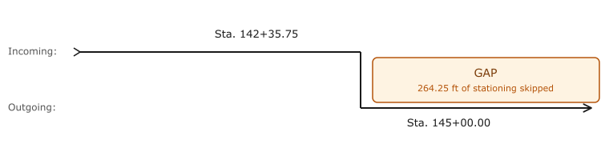
Figure 9.2.3-1 — Station gap equation. Geometry is continuous; station numbers jump forward.

9.2.4 Overlap Equations
An overlap equation (also called a station back or backward equation) occurs when stationing jumps backward. The alignment geometry is continuous, but the station number decreases at the equation point.
Example: Incoming station 78+42.10, outgoing station 76+00.00. There is an overlap of 242.10 ft. Two different geometric points — one upstream and one downstream of the equation — carry station labels between 76+00 and 78+42.
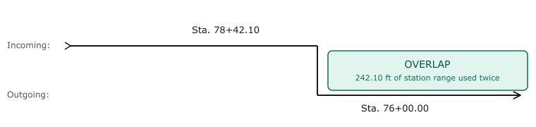
Figure 9.2.4-1 — Station overlap equation. Geometry is continuous; station numbers jump backward.

9.2.5 Effect on DistanceAlong Conversion
The presence of station equations means that you cannot convert a station label to DistanceAlong by simple subtraction of the starting station. You must account for every equation encountered between the alignment start and the point of interest.
The conversion algorithm is:
- Sort all referents on the alignment by DistanceAlong. For each referent record two values:
  - $D_{i}$: the DistanceAlong read directly from its IfcLinearPlacement
  - $S_{i}$: the outgoing station — Pset_Stationing.Station
- (Optional validation) For any referent that also carries IncomingStation, verify that $S_{i-1}+(D_{i}-D_{i-1})≈\text{IncomingStation}$. This confirms that the station count in the preceding segment matches the geometry.
- To convert a target station $S$ to DistanceAlong, find the last referent $i$ such that $S_{i}≤S$. Then:
$$\text{DistanceAlong}=D_{i}+(S-S_{i})$$
Before applying the formula, check whether the station overshoots the next referent: if a next referent exists and $S-S_{i}>D_{i+1}-D_{i}$, the station falls inside a gap — it was skipped by a forward equation — and DistanceAlong is undefined.
Figure 9.2.5-1 illustrates how the geometric distance axis and the station label axis diverge when equations are present.
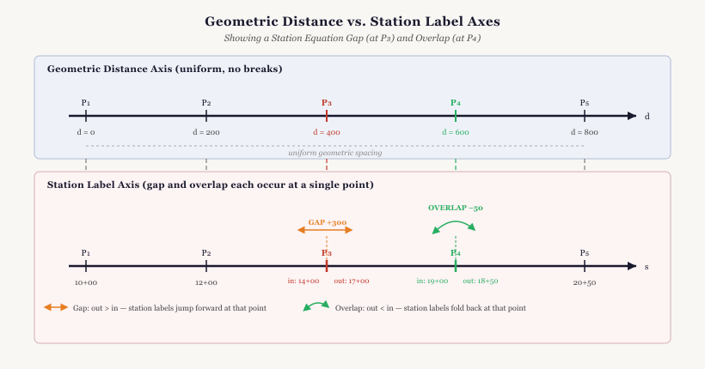
Figure 9.2.5-1 — Two-axis diagram comparing DistanceAlong (geometric distance) and station label for an alignment with one gap equation and one overlap equation.

9.2.6 Example: DistanceAlong Conversion with Gap and Overlap Equations
The table below reflects the alignment shown in Figure 9.2.5-1: five points at 200 m intervals along a generic alignment, a gap equation at P3, and an overlap equation at P4. Only P1, P3, and P4 map to actual IfcReferent instances (§9.3.1) — P1 as the starting station, P3 and P4 at the equations. P2 and P5 are ordinary points on the alignment with no referent of their own; they appear here only to anchor the geometric spacing.
Point | $D_{i}$ (m) | $S_{i}$ outgoing | IncomingStation | Note
P1 | 0 | 1000.00 (Sta. 10+00) | — | Starting station
P2 | 200 | 1200.00 (Sta. 12+00) | —
P3 | 400 | 1700.00 (Sta. 17+00) | 1400.00 (Sta. 14+00) | Gap = 300
P4 | 600 | 1850.00 (Sta. 18+50) | 1900.00 (Sta. 19+00) | Overlap = 50
P5 | 800 | 2050.00 (Sta. 20+50) | —
Between P2 and P3 — Sta. 13+00 (1300.00):
Last $i$ where $S_{i}≤1300$: P2 ($S_{2}=1200$, $D_{2}=200$).
$$\text{DistanceAlong}=200+(1300-1200)=300$$
Between P3 and P4 — Sta. 18+00 (1800.00):
Last $i$ where $S_{i}≤1800$: P3 ($S_{3}=1700$, $D_{3}=400$).
$$\text{DistanceAlong}=400+(1800-1700)=500$$
Between P4 and P5 — Sta. 19+25 (1925.00):
Last $i$ where $S_{i}≤1925$: P4 ($S_{4}=1850$, $D_{4}=600$).
$$\text{DistanceAlong}=600+(1925-1850)=675$$
Without accounting for the equations, naive subtraction gives $1925-1000=925$ — an error of 250 m. The error is the net station inflation introduced by the two equations: the gap at P3 added 300 station units with no corresponding geometry, and the overlap at P4 recovered 50, leaving a net surplus of $300-50=250$ station units.
Gap check — Sta. 15+00 (1500.00):
- P1: $S_{1}=1000≤1500$ ✓
- P2: $S_{2}=1200≤1500$ ✓
- P3: $S_{3}=1700>1500$ ✗
Last is P2 ($D_{2}=200$, $S_{2}=1200$). Before computing, check whether the station overshoots the next referent: $S-S_{2}=1500-1200=300$, but the geometric span to P3 is only $D_{3}-D_{2}=400-200=200$. Since $300>200$, Sta. 15+00 falls inside the gap — it was skipped by the forward equation at P3 and DistanceAlong is undefined. Any station between Sta. 14+00 and Sta. 16+99 produces the same result.
Implementations must handle this case gracefully — returning an error, null, or a domain-specific sentinel value rather than silently producing a geometrically meaningless DistanceAlong.
Overlap ambiguity — Sta. 18+75 (1875.00):
The overlap zone spans Sta. 18+50 (1850) to Sta. 19+00 (1900) — the range of station values that appear on both the incoming segment (P3→P4) and the outgoing segment (P4→P5). Station 18+75 falls inside this zone and resolves to two distinct geometric points:
As a point in the P3→P4 segment (before the equation): last $i$ where $S_{i}≤1875$ ignoring P4 gives P3 ($S_{3}=1700$, $D_{3}=400$):
$$\text{DistanceAlong}=400+(1875-1700)=575$$
As a point in the P4→P5 segment (after the equation): the algorithm as defined returns P4 ($S_{4}=1850$, $D_{4}=600$):
$$\text{DistanceAlong}=600+(1875-1850)=625$$
Both answers are geometrically valid. The algorithm as defined in §9.2.5 always returns the post-equation result (625 m here), silently discarding the pre-equation match. Implementations that need to resolve ambiguous overlap stations must detect the overlap zone — any $S$ where $S_{i}^{\text{outgoing}}≤S≤S_{i}^{\text{incoming}}$ at an overlap equation referent — and either return both candidate distances or apply project-specific rules to select one.

9.3 Attaching Referents to an Alignment
This section covers the geometric role of IfcReferent: how a referent is nested under, ordered along, and placed on the alignment it belongs to.

9.3.1 Defining Stationing in IFC
With the stationing concept established in §9.2, this section describes how it is encoded: IfcReferent carries the station value via Pset_Stationing, and referents are ordered along the alignment via IfcRelNests.
Stationing metadata is stored in Pset_Stationing, attached to an IfcReferent via IfcRelDefinesByProperties. The property set has three properties:
Property | Type | Description
Station | IfcLengthMeasure | The station value at this referent’s location. For the first referent, this defines the starting station of the alignment.
IncomingStation | IfcLengthMeasure | Present only at a station equation. The station value on the incoming (upstream) side of the break. The Station property holds the outgoing value immediately after the break.
HasIncreasingStation | IfcBoolean | Controls the direction of stationing. If TRUE (or absent), subsequently nested referents have increasing station values. If FALSE, they decrease. Covers reverse-stationing schemes.
The Station value is expressed in the same units as the project length unit (typically meters or feet), not in the ccc+dd.dd string form. A station of 142+35.75 ft is stored as 14235.75 with feet as the project unit.
IfcReferent instances are connected to their parent IfcAlignment through IfcRelNests. This relationship has two key properties:
- RelatingObject — the IfcAlignment (the parent).
- RelatedObjects — an ordered list of objects nested within. Referents must appear in the list in order of increasing DistanceAlong. This ordering is required by the IFC concept template (4.1.4.4.3 Object Nesting) but is not enforced by a schema WHERE rule. Implementations that read referent data should sort by DistanceAlong before processing and not assume the list arrives pre-sorted; implementations that write referent data must produce a sorted list.
The first IfcReferent in RelatedObjects defines the starting station of the alignment. Its Pset_Stationing.Station value is the station label at DistanceAlong = 0.0 of the alignment curve. As a best practice, place this referent at DistanceAlong = 0.0 so that the station origin and the geometric origin of the alignment coincide.
Figure 9.3.1-1 shows this mechanism populated with the starting-station referent (P1) and the two equation referents (P3, P4) from the §9.2.6 worked example.
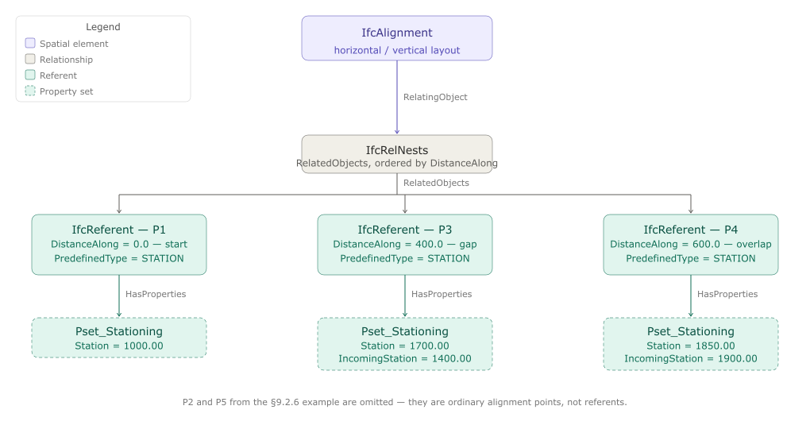
Figure 9.3.1-1 — IfcRelNests establishing the stationing order for IfcReferent instances P1, P3, and P4, with Pset_Stationing values matching the §9.2.6 worked example. P2 and P5 are omitted because they are ordinary points on the alignment, not referents — of the five points in the §9.2.6 example, only P1, P3, and P4 have a corresponding IfcReferent.

9.3.2 The Mixed-Nesting Problem
IfcRelNests is also used to attach alignment layout components (IfcAlignmentHorizontal, IfcAlignmentVertical, IfcAlignmentCant) to IfcAlignment. Both layout sub-objects and referents decompose the same parent through the same relationship type. This creates ambiguity: should layout sub-objects and referents share a single IfcRelNests instance, or should they use separate ones?
The IFC specification does not resolve this clearly. Two patterns are seen in practice:
Pattern A — Shared nest. A single IfcRelNests instance contains both layout objects and referents interleaved or grouped. This works but can make parsing complex, because consumers must distinguish layout objects from referents by type.
Pattern B — Separate nests (recommended). Two distinct IfcRelNests instances are used: one whose RelatedObjects contains only the alignment layout sub-objects, and one whose RelatedObjects contains only IfcReferent instances.
Recommendation: Use Pattern B — separate nests. This is the pattern illustrated in the existing Figure 9.3.2-1 and is more robust for software implementations. The layout nest and the referent nest are independent, and each can be processed without concern for the content of the other.
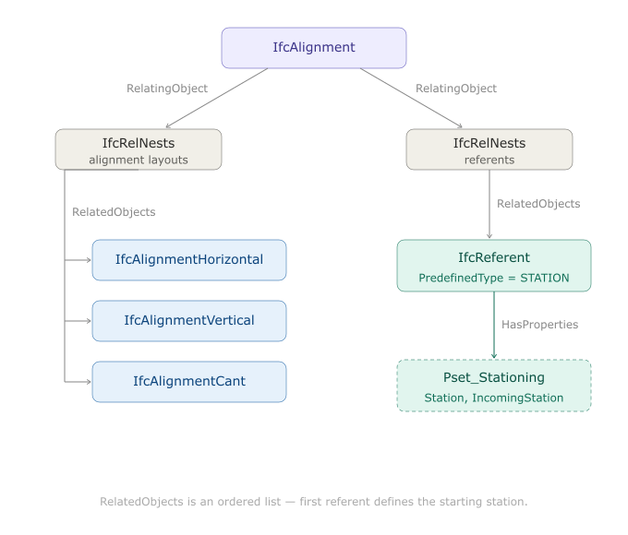
Figure 9.3.2-1 — Two IfcRelNests relationships: one for alignment layout sub-objects (horizontal, vertical, cant) and one for IfcReferent instances.

9.3.3 ObjectPlacement for IfcReferent
IfcReferent is a subtype of IfcPositioningElement, which requires an ObjectPlacement (omitting ObjectPlacement results in a bSI Validation Service error). Although the schema permits any subtype of IfcObjectPlacement, only IfcLinearPlacement is practical for referents on an alignment with geometry. IfcLocalPlacement and IfcGridPlacement carry no DistanceAlong value, so a consumer reading a model that uses these placement types has no reliable basis for ordering referents or performing station-to-distance conversions.
Two cases arise in practice:
Alignment with geometry. Use IfcLinearPlacement with IfcPointByDistanceExpression referencing the alignment’s horizontal geometric curve. The DistanceAlong value establishes the referent’s geometric position and is the basis for ordering.
Semantic-only alignment. When the alignment carries no geometric representation, IfcLinearPlacement cannot be evaluated — there is no basis curve from which to measure distance. Set IfcReferent.ObjectPlacement to the same placement instance as IfcAlignment.ObjectPlacement. Implementations that later add a geometric representation must update all referent placements accordingly; retaining the copied alignment placement after geometry is added will cause the referent’s resolved position to diverge from its geometric intent.

9.3.4 Key-Point Referents
Beyond stationing (§9.3.1) and labeling another product’s position (§9.4), a third, entirely discretionary use of IfcReferent marks the geometric transition points within the alignment’s own layout: where a line meets a curve, where one curve type gives way to another, where the layout begins and ends. On a horizontal layout these are the familiar Point of Beginning, Point of Curvature, Point of Tangency, Point of Intersection, and similar transition points; on a vertical layout, the analogous Point of Vertical Curvature, Point of Vertical Tangency, and Point of Vertical Intersection. Modeling these points as referents is a choice, not a requirement — a consumer can always re-derive a transition’s station by walking IfcAlignmentSegment/IfcCurveSegment lengths from the start of the layout. Key-point referents exist purely so that a downstream consumer — a viewer, a plan-production tool, a reviewer opening the model directly — can read these locations and their station labels without performing that walk itself.
Predefined type and relationship. A key-point referent identifies the position of a point on the alignment’s own geometry — it does not define the alignment’s stationing system, so STATION (§9.3.1) does not apply. It uses the same PredefinedType = POSITION value already introduced in §9.1 for labeling another product’s location (elaborated in §9.4.1), but the relationship pattern is different: a key-point referent is related to IfcAlignment by IfcRelNests (the geometric role, exactly like the STATION referent’s relationship to IfcAlignment in §9.3.1), not by IfcRelPositions (the semantic role used in §9.4.1 to label another product). Both flavors of POSITION referent carry Pset_Stationing; only the relationship distinguishes “this referent marks a point on the alignment’s own geometry” from “this referent labels some other product’s position.”
Nesting. Concept Template 4.1.4.4.3 Object Nesting lists IfcAlignment as RelatingObject for IfcReferent RelatedObjects — the same pairing already used for the STATION referent in §9.3.1.
- One nest per discipline. Each applicable discipline — horizontal, vertical, cant — gets its own IfcRelNests, RelatingObject = IfcAlignment, RelatedObjects = only that discipline’s key-point referents. This is independent of, but structurally identical to, the stationing nest of §9.3.1: several IfcRelNests instances can share the same RelatingObject (IfcAlignment), distinguished only by which referents each one’s RelatedObjects holds.
- Possible but discouraged: a single combined nest for all disciplines. Every horizontal, vertical, and cant key-point referent in one IfcRelNests.RelatedObjects list is schema-legal and still RelatingObject = IfcAlignment, but it reproduces the same problem Pattern A in §9.3.2 already warned against: a consumer must inspect each referent’s placement or label just to determine which discipline it belongs to, rather than being able to read that from the nest itself.
Whichever form is chosen, the key-point nest (or nests) is independent of both the horizontal/vertical/cant layout nest (§9.3.2) and the stationing nest (§9.3.1) — a third category that extends, rather than replaces, the mixed-nesting guidance of §9.3.2: layout sub-objects, key-point referents, and stationing referents all coexist under IfcAlignment.IsNestedBy, each in its own IfcRelNests.
A note on Object Nesting and the Alignment-based View MVD. Concept Template 4.1.4.4.3 is not itself tagged as part of the Alignment-based View (AbV), even though it is the only schema mechanism that establishes alignment stationing (§9.3.1) or key-point referents at all. Apply it regardless — omitting it would leave no conforming way to model stationing or key-point referents on an AbV alignment. (§9.5.2 notes a similar AbV-tagging gap for IfcConnectionGeometry.)
Naming. Name is free-form text, not a schema-constrained enumeration — nothing in IFC fixes the abbreviation vocabulary. The worked example below (§9.3.4.1) uses "{alignment name} {station string} ({abbreviation})", e.g. "E-Line 119+56.79 (P.C.)". Leading with the alignment name makes every referent nested under an alignment identifiable by its name alone, without inspecting its placement or Pset_Stationing. The abbreviations are typical of North American highway practice: P.O.B./P.O.E. for the layout’s start/end, P.C./P.T. at line-to-arc and arc-to-line transitions on the horizontal layout, and V.P.O.B./P.V.C./P.V.T./V.P.O.E. for the corresponding vertical-layout points. Other jurisdictions and agencies use different abbreviations, additional key-point types (e.g. P.I. at a line-to-line deflection, P.C.C. at an arc-to-arc transition), or different station-string formats — the guide shows one typical, commonly-seen convention, not a vocabulary implementations must reproduce.
Placement and properties. ObjectPlacement follows the same two cases already described in §9.3.3: IfcLinearPlacement/IfcPointByDistanceExpression against the layout’s curve when geometry exists, or a placement copied from the alignment itself for a semantic-only layout. Each referent carries Pset_Stationing (§9.3.1), giving it a station value in addition to its geometric position. As with other referents in this chapter, no Representation is created — placement and property data are sufficient.
Figure 9.3.4-1 shows the nesting pattern.
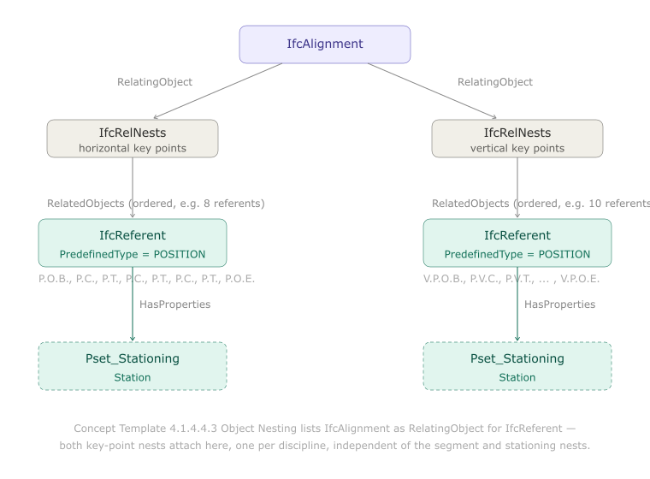
Figure 9.3.4-1 — Key-point-referent nesting: one IfcRelNests per discipline, RelatingObject = IfcAlignment, RelatedObjects = that discipline’s POSITION referents.

9.3.4.1 Worked Example: the FHWA E-Line
The FHWA Bridge Geometry Manual E-Line alignment already used as the real-world test case in Chapter 12 demonstrates this pattern: testset/real-world-alignments/FHWA_Alignment.ifc carries one IfcRelNests nested to IfcAlignment with eight POSITION referents (E-Line 100+00.00 (P.O.B.) through E-Line 223+37.07 (P.O.E.), with P.C./P.T. pairs at each of the three horizontal curves), and a second IfcRelNests, also nested to IfcAlignment, with ten POSITION referents (E-Line 100+00.00 (V.P.O.B.) through E-Line 228+00.00 (V.P.O.E.), with P.V.C./P.V.T. pairs at each of the four vertical curves) — independent of, and in addition to, the single starting-station STATION referent nested to IfcAlignment per §9.3.1. All three nests share RelatingObject = IfcAlignment, distinguished only by which referents each one’s RelatedObjects holds.

9.4 Product Positioning
This section covers the semantic role of IfcReferent: how it semantically labels the position of a product. IFC formalizes two patterns for this under Object Connectivity: Product Relative Positioning (Concept Template 4.1.5.8), which uses a single IfcReferent to label one point, and Product Span Positioning (Concept Template 4.1.5.9).
It is important to understand that IfcReferent serves two distinct roles that must not be conflated:
Geometric role. When an IfcReferent carries an IfcLinearPlacement, it has a precise geometric location on the alignment.
Semantic role. An IfcReferent can annotate the position of another object — not by moving it, but by providing a human-readable label (typically a station) that names its location. This is purely informational metadata.
The geometric location of an infrastructure element (a bridge pier, a sign, a drain inlet) is defined entirely by its own IfcObjectPlacement. An associated referent gives that location a name. Removing or changing the referent does not move the object.

9.4.1 Product Relative Positioning
The relationship between an IfcReferent and the object whose position it annotates is IfcRelPositions:
- RelatingPositioningElement — the IfcPositioningElement providing the semantic position.
- RelatedProducts — the IfcProduct instances positioned by the RelatingPositioningElement.
This is exactly the IfcRelPositions pattern defined by Concept Template 4.1.5.8, Product Relative Positioning: one positioning element, one or more related products.
Suppose the alignment’s starting station is Sta. 100+00 — that is, the first referent nested under the alignment (§9.3.1) carries Pset_Stationing.Station = 10000.0 at DistanceAlong = 0.0. A bridge pier (IfcBridgePart.PIER) is geometrically placed at DistanceAlong = 14235.75. Its station label is not 14235.75 — it is the starting station plus the distance along: 10000.0 + 14235.75 = 24235.75, i.e., Sta. 242+35.75. An IfcReferent with PredefinedType = POSITION and Pset_Stationing.Station = 24235.75 is connected to the pier via IfcRelPositions. The pier’s station label is now Sta. 242+35.75. The pier’s geometry — DistanceAlong = 14235.75 on its own IfcLinearPlacement — is entirely unaffected by the starting station value; only the label changes. However, the semantic position of the pier is incomplete. We know it is at Sta. 242+35.75 but the IfcReferent does not inform which alignment that station refers to, nor where that alignment’s stationing begins. Two further relationships resolve this. First, the IfcReferent that was the RelatingPositioningElement for the pier is now itself RelatedProducts in a second IfcRelPositions, where IfcAlignment is the RelatingPositioningElement. This ties the pier’s referent to the specific alignment it stations. Second, and independently, the alignment’s starting-station referent (Pset_Stationing.Station = 10000.0, DistanceAlong = 0.0) is nested under IfcAlignment by IfcRelNests, per §9.3.1 — this is what fixes the 10000.0 offset that turns DistanceAlong = 14235.75 into Sta. 242+35.75. The positioning relationships are shown in Figure 9.4.1-1.
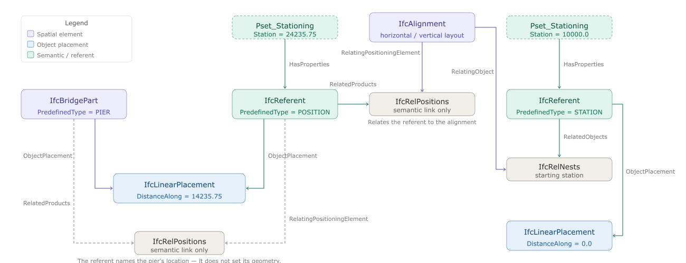
Figure 9.4.1-1 — Object graph showing an IfcBridgePart.PIER with its own IfcLinearPlacement, an IfcReferent (POSITION type) with Pset_Stationing, and the IfcRelPositions link between them. To the right, IfcAlignment is the RelatingPositioningElement for a second IfcRelPositions that has the pier’s referent as RelatedProducts, and a starting-station IfcReferent (Station = 10000.0) is nested under IfcAlignment by IfcRelNests, supplying the offset used to derive Sta. 242+35.75 from DistanceAlong = 14235.75. Below IfcRelNests, that starting-station referent has its own IfcLinearPlacement at DistanceAlong = 0.0.
Note the two different relationships an IfcReferent can have with the alignment, depending on its role: an IfcReferent that defines stationing — such as the starting-station referent or a station equation — is related to the IfcAlignment with IfcRelNests. An IfcReferent that provides the stationing value of another object — such as the pier’s referent — is related to the IfcAlignment with IfcRelPositions. This is a subtle but important distinction.

9.4.2 Product Span Positioning
Some infrastructure elements are not defined by a single point but by a linear extent — a guardrail run, a noise barrier, a pavement marking, a work-zone limit. Concept Template 4.1.5.9, Product Span Positioning, covers this case: an IfcProduct is positioned relative to two IfcReferent instances, marking the boundaries of the span, via two separate IfcRelPositions relationships — one per referent, each with the referent as RelatingPositioningElement and the product as RelatedProducts.
Example: Continuing the alignment from §9.4.1 (starting station Sta. 100+00), a guardrail run (IfcRailing) begins at Sta. 240+00 and ends at Sta. 250+00. Two IfcReferent instances, each with PredefinedType = POSITION, mark these locations, each carrying its own Pset_Stationing (Station = 24000.00 and Station = 25000.00 respectively) and its own IfcLinearPlacement. Toward the IfcRailing, Product Span Positioning applies; toward the IfcAlignment, Product Relative Positioning applies (§9.4.1). As with the single-point pattern, Pset_Stationing values on the span referents are independent of the guardrail’s own geometry — moving the guardrail’s IfcLinearPlacement does not move the referents, and vice versa.
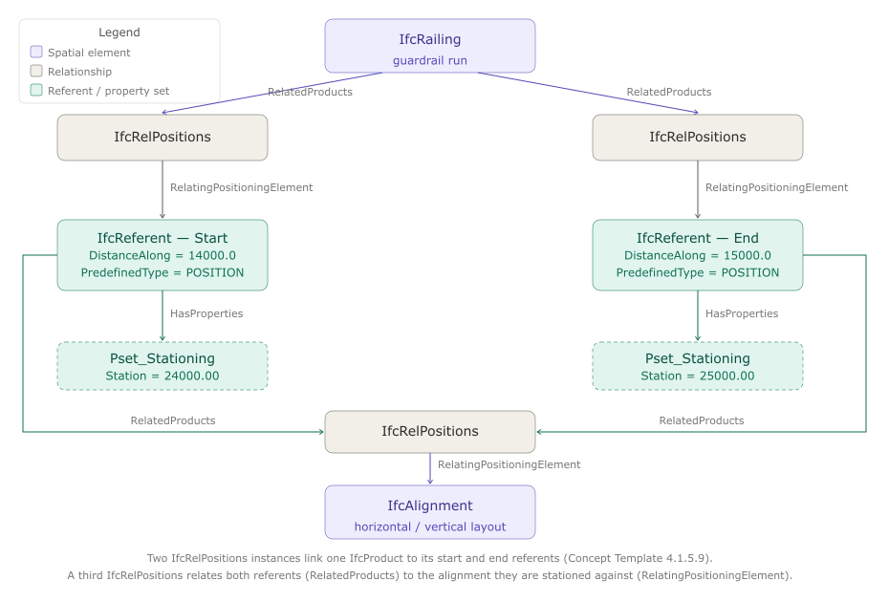
Figure 9.4.2-1 — Two concept templates combined: Product Span Positioning (two IfcRelPositions relationships linking the IfcRailing to its start and end IfcReferent instances) and Product Relative Positioning (a single IfcRelPositions linking both referents to the IfcAlignment they are stationed against).

9.5 The INTERSECTION Referent
An IfcReferent with PredefinedType = INTERSECTION marks the point where two or more routes cross. A single crossing uses two IfcReferent instances of type INTERSECTION, one per intersecting alignment, each related to its own single owning alignment by IfcRelPositions. That referent pattern (§9.5.1) only ever names a station on one alignment — it is not, by itself, a record that the two alignments cross. This section works through two related but distinct questions: how each INTERSECTION referent is owned (§9.5.1), and how the crossing itself — a fact about the two facilities, established independently of any referent — is recorded with IfcRelInterferesElements (§9.5.2).

9.5.1 Referent Ownership: One Referent Per Alignment
In each case, the IfcRelPositions has that IfcAlignment as RelatingPositioningElement and the referent as RelatedProducts — the same alignment-link pattern used for the POSITION referent’s second IfcRelPositions in §9.4.1 — and each referent carries its own Pset_Stationing.Station value in its owning alignment’s stationing. This interpretation follows directly from ISO 19148 §6.2.12.1, which IFC’s linear referencing model is built on (§8.6):
Referents are owned by a single feature. For example, the reference markers along Interstate 95 are owned by the feature that represents Interstate 95. The referent representing the intersection with First Avenue along Washington Street is owned by Washington Street if it is used to specify relative linearly referenced locations along Washington Street. The location of this referent is most likely specified with a position expression along Washington Street. A different referent can represent the intersection with Washington Street along First Avenue. This referent is owned by First Avenue and is used to specify relative linearly referenced locations along First Avenue.
Applied to that example: Washington Street’s INTERSECTION referent is placed via IfcLinearPlacement/DistanceAlong on Washington Street’s curve, carries Pset_Stationing.Station = 1000.00 (Sta. 10+00) in Washington Street’s stationing, and is related to IfcAlignment — Washington Street by its own IfcRelPositions. First Avenue’s INTERSECTION referent is an entirely separate instance: placed on First Avenue’s own curve, carrying Pset_Stationing.Station = 1200.00 (Sta. 12+00) in First Avenue’s stationing, and related to IfcAlignment — First Avenue by a second, independent IfcRelPositions. Figure 9.5-1 shows the two independent object graphs.
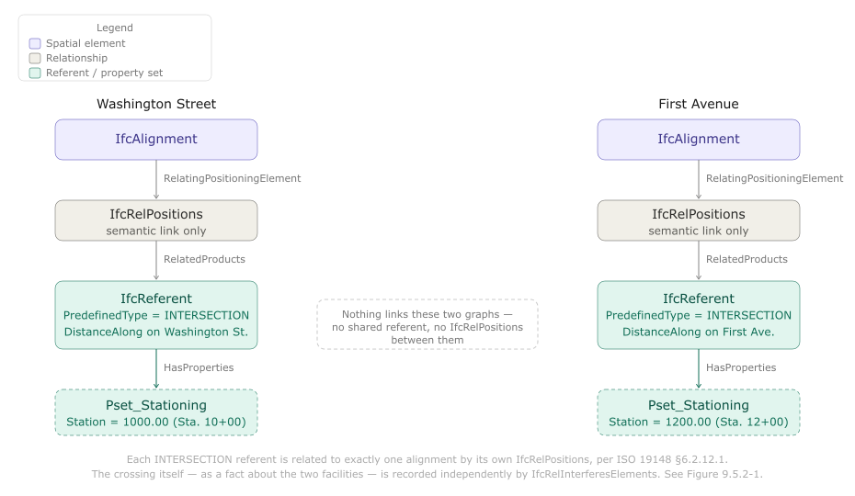
Figure 9.5-1 — Two independent INTERSECTION referents, each related to its own alignment by its own IfcRelPositions, following the same alignment-link pattern as the POSITION referent in Figure 9.4.1-1 — applied once per alignment rather than shared between two. Nothing in this graph connects the two referents or the two alignments; the fact that they cross is established separately, in §9.5.2.
This pattern scales to a multi-leg intersection without modification — one INTERSECTION referent per crossing alignment.

9.5.2 IfcRelInterferesElements: Recording That Two Facilities Cross
The referent and the IfcRelPositions instance that ties it to its owning alignment (§9.5.1) do exactly one thing: they give a name — a station — to a location on one alignment. Neither asserts anything about the alignment on the other side of the crossing. It is easy to misread two INTERSECTION referents at coincident locations as if that, by itself, recorded “these two roads cross,” but nothing in §9.5.1 relates Washington Street’s referent to First Avenue’s, or either referent to the other alignment. Whether the crossing needs to be recorded as queryable schema data — as distinct from a fact two engineers can see on a plan sheet — is answered by a relationship that has nothing to do with referents or stationing: IfcRelInterferesElements.
IfcRelInterferesElements (a subtype of IfcRelConnects) is an objectified relationship stating that two elements interfere, physically or logically, independent of either element’s own definition. Its attributes:
- RelatingElement, RelatedElement — typed IfcInterferenceSelect, meaning each must be a subtype of IfcElement or of IfcSpatialElement.
- InterferenceGeometry — optional IfcConnectionGeometry, the shape of the interference itself, expressed in RelatingElement’s object coordinate system.
- InterferenceType — optional IfcIdentifier. This is free text, not a restricted enumeration — the schema documentation offers values like Crosses, PassesOver, PassesUnder, PassesThrough, Along, and Clash only as examples a project might adopt as a convention, not as a fixed value list IFC enforces.
- ImpliedOrder — IfcLogical, indicating whether RelatingElement should be read as a source and RelatedElement as a target for the chosen InterferenceType (meaningful for a directional type like PassesOver; not meaningful for an undirected Clash).
- InterferenceSpace — optional IfcSpatialZone, the space in which the interference occurs.
IfcAlignment cannot itself be a party to this relationship. IfcAlignment is a subtype of IfcPositioningElement (via IfcLinearPositioningElement), not of IfcElement or IfcSpatialElement — the only two branches IfcInterferenceSelect accepts. That follows from what an alignment is in this schema: a positioning/reference curve, not a physical or spatial occurrence. What can carry the relationship is whatever IfcElement or IfcSpatialElement the alignment describes the layout of — typically the IfcRoad or IfcRailway facility the alignment lays out, or, where the crossing needs to be tied to a specific occurrence rather than the facility as a whole, a physical element such as a pavement course or a bridge structure.
The facility does not aggregate the alignment, either. IfcAlignment is conventionally aggregated directly under IfcProject (per the concept template in IFC 4.1.4.1.1, Alignment Aggregation To Project), and the bSI Validation Service’s SPS002 rule (Correct spatial breakdown) restricts what IfcRelAggregates may nest under an IfcRoad to other facility/space-type entities — IfcAlignment is not among them, so aggregating an alignment under a road fails validation. Instead, the road references its alignment with IfcRelReferencedInSpatialStructure — the same non-hierarchical relationship used elsewhere for an element that logically belongs to more than one spatial structure (§9.3, e.g. a multi-storey column) — with the IfcRoad as RelatingStructure and the IfcAlignment as one of its RelatedElements.
Example, continuing §9.5.1: Washington Street and First Avenue are each modeled as an IfcRoad, each referencing its respective IfcAlignment (which remains aggregated under IfcProject). The at-grade crossing is recorded independently of either INTERSECTION referent:
- RelatingElement = Washington Street (IfcRoad)
- RelatedElement = First Avenue (IfcRoad)
- InterferenceType = "Crosses"
- ImpliedOrder = FALSE — an at-grade crossing has no source/target direction
Figure 9.5.2-1 shows this alongside the IfcRelReferencedInSpatialStructure that ties each IfcRoad to its IfcAlignment.
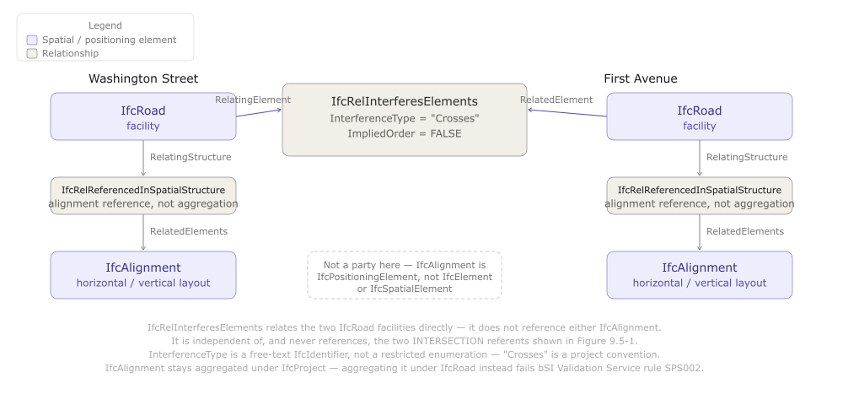
Figure 9.5.2-1 — A single IfcRelInterferesElements relating the two IfcRoad facilities. Each facility separately references the IfcAlignment that lays it out via IfcRelReferencedInSpatialStructure, not IfcRelAggregates — the alignments themselves are outside the interference relationship, since IfcInterferenceSelect does not accept IfcPositioningElement.
This IfcRelInterferesElements instance is what lets software ask “does Washington Street cross another facility, and which one?” without parsing referents or comparing coordinates. It complements, but does not replace, the two INTERSECTION referents from §9.5.1: the referents answer “at what station,” which IfcRelInterferesElements does not carry, while IfcRelInterferesElements answers “is this a real, queryable crossing,” which the referents do not assert. The two relationships never reference each other. A model can legitimately have INTERSECTION referents with no corresponding IfcRelInterferesElements (the crossing is only implied by proximity — common in low-detail concept models), or an IfcRelInterferesElements instance with no referents yet (the crossing is flagged before it has been given a station label).
A grade-separated (multi-level) crossing — a road passing over another road, or over a railway — is recorded the same way, but with a directional InterferenceType and ImpliedOrder = TRUE: InterferenceType = "PassesOver", RelatingElement = the facility physically above, RelatedElement = the facility below. Nothing about the two INTERSECTION referents changes between the at-grade and grade-separated cases — both still use the identical PredefinedType = INTERSECTION and carry no elevation information of their own — so IfcRelInterferesElements is also the only place in the model that distinguishes an at-grade crossing from a grade-separated one.
Two example files demonstrate this pattern:
- IntersectionReferent_AtGradeCrossing.ifc — two alignments crossing at a true 3D intersection, each referenced by its own IfcRoad; a single IfcRelInterferesElements between the two roads carries InterferenceType = "Crosses", ImpliedOrder = FALSE, and an IfcConnectionPointGeometry InterferenceGeometry built from the same two IfcPointByDistanceExpression instances already used by the INTERSECTION referents’ own placements, rather than duplicating the location as new IfcCartesianPoints.
- IntersectionReferent_GradeSeparatedCrossing.ifc — the same plan-view crossing, but with one alignment’s grade reversed so the two roads no longer meet in 3D; the IfcRelInterferesElements between them carries InterferenceType = "PassesOver", ImpliedOrder = TRUE, and an IfcConnectionPointEccentricity InterferenceGeometry — the same two reused points, plus EccentricityInZ recording the 30 ft vertical separation between them.
A note on InterferenceGeometry and the Alignment-based View MVD. IfcConnectionGeometry is tagged as part of the Alignment-based View (AbV), but it is abstract, and none of its five concrete descendants — including IfcConnectionPointGeometry and IfcConnectionPointEccentricity, used above — carry that tag themselves, the same kind of AbV-tagging gap noted for Object Nesting in §9.3.4. The two example files were checked against the bSI Validation Service and were not flagged as non-conforming to AbV.

9.6 Summary and Implementation Checklist
# | Item | Notes
1 | Use IfcReferent to attach station labels and other semantic location information to alignment positions. | Referents are informational overlays on geometry, not geometry themselves.
2 | Store the station value in Pset_Stationing.Station as a plain IfcLengthMeasure in project length units. | Do not store the ccc+dd.dd string — compute it from the numeric value when displaying.
3 | Set Pset_Stationing.HasIncreasingStation = FALSE only for reverse-stationing schemes. | When absent or TRUE, stationing increases in the direction of the alignment.
4 | At a station equation, provide both IncomingStation and Station on the same referent. | IncomingStation = upstream label; Station = downstream label.
5 | Do not convert station labels to DistanceAlong by simple subtraction. For each referent record $D_{i}$ and outgoing $S_{i}$; find the last $i$ where $S_{i}≤S$; then DistanceAlong $=D_{i}+(S-S_{i})$. | See §9.2.5 for the full algorithm.
6 | Before applying the conversion formula, check for a gap: if $S-S_{i}>D_{i+1}-D_{i}$, the station was skipped by a forward equation and DistanceAlong is undefined. | Return an error or sentinel value — do not silently produce a meaningless distance. See §9.2.6.
7 | Stations in an overlap zone map to two geometric points. Detect the zone ($S_{i}^{\text{outgoing}}≤S≤S_{i}^{\text{incoming}}$ at an overlap referent) and either return both candidates or apply project rules to select one. | See §9.2.6.
8 | Use separate IfcRelNests instances for alignment layout sub-objects and referents. | Mixing them in a single nest is allowed but makes parsing harder.
9 | Order referents in IfcRelNests.RelatedObjects by increasing DistanceAlong. | Required by the nesting concept template; sort defensively when reading.
10 | Place the first referent at DistanceAlong = 0.0 and set Pset_Stationing.Station to the starting station value. | Commonly a round number like 1000.00 (Sta. 10+00). For semantic-only alignments, ObjectPlacement = alignment’s placement; for geometric alignments, use IfcLinearPlacement at distance 0. Update when adding geometry.
11 | Use IfcRelPositions to link a referent to the object(s) whose station it names. | This is semantic annotation only; it does not affect geometry.
12 | An IfcReferent that provides stationing should itself be linked to its IfcAlignment via IfcRelPositions, with IfcAlignment as RelatingPositioningElement and the referent as RelatedProducts. | Without this link, a station label is ambiguous — nothing states which alignment’s stationing it belongs to. See §9.4.1, §9.4.2.
13 | For linear-extent elements (guardrails, barriers, work-zone limits) spanning between two referents, link the product to each referent with its own IfcRelPositions (Product Span Positioning, Concept Template 4.1.5.9). | Toward the alignment, several referents share a single IfcRelPositions under Product Relative Positioning (§9.4.1). See §9.4.2.
14 | Model an intersection as one INTERSECTION referent per crossing alignment (two for a simple crossing, more for a multi-leg intersection), each with its own IfcRelPositions to its own alignment and its own Pset_Stationing.Station. | Do not link one shared referent to multiple alignments — Pset_Stationing holds only one Station value. Per ISO 19148 §6.2.12.1. See §9.5.1.
15 | Record the crossing itself — as a fact about the two facilities, independent of either INTERSECTION referent — with a single IfcRelInterferesElements relating the two IfcRoad/IfcRailway (or other IfcElement/IfcSpatialElement) instances the alignments lay out. | IfcAlignment cannot be RelatingElement/RelatedElement — IfcInterferenceSelect accepts only IfcElement or IfcSpatialElement, and IfcAlignment is IfcPositioningElement. InterferenceType is a free-text IfcIdentifier, not an enumeration. Use ImpliedOrder = TRUE with a directional type (e.g. PassesOver) for grade separations; FALSE for an undirected at-grade Crosses. See §9.5.2.
16 | Keep IfcAlignment aggregated under IfcProject; link a facility (IfcRoad/IfcRailway) to the alignment it lays out with IfcRelReferencedInSpatialStructure (facility as RelatingStructure, alignment as one of RelatedElements), not IfcRelAggregates. | The bSI Validation Service’s SPS002 rule (Correct spatial breakdown) restricts what IfcRelAggregates may nest under an IfcRoad/IfcRailway to other facility/space-type entities; IfcAlignment is not among them, and aggregating it under a facility fails validation. See §9.5.2.
17 | Model InterferenceGeometry with a concrete IfcConnectionGeometry subtype — IfcConnectionPointGeometry for a coincident point, IfcConnectionPointEccentricity when the two points differ (e.g. the vertical offset at a grade separation) — reusing the alignments’ existing IfcPointByDistanceExpression points rather than duplicating coordinates as new IfcCartesianPoints. | PointOnRelatingElement/PointOnRelatedElement accept any IfcPoint, including an already-built IfcPointByDistanceExpression. See §9.5.2.
18 | Don’t be alarmed that none of IfcConnectionGeometry’s concrete subtypes are individually tagged Alignment-based View (AbV) — only the abstract supertype is. | A documentation ambiguity in the MVD, not a modeling error; confirmed against the bSI Validation Service on this guide’s example files. See §9.5.2.
19 | Key-point referents (P.C., P.T., and similar segment-transition markers) are optional. When used, give them PredefinedType = POSITION and relate them with IfcRelNests, one nest per applicable discipline, RelatingObject = IfcAlignment — not IfcRelPositions, and not STATION. | POSITION here does not mean the same relationship as the product-labeling POSITION referent of §9.4.1 — same enum value, different relationship. See §9.3.4.
20 | Don’t be alarmed that Concept Template 4.1.4.4.3 (Object Nesting) isn’t itself tagged Alignment-based View (AbV) — apply it anyway for stationing and key-point referents. | A gap in the MVD’s tagging, not a reason to avoid the concept template; the same kind of gap noted for IfcConnectionGeometry in item 18. See §9.3.4.
21 | Treat the abbreviation text used in a key-point referent’s Name as a display convention, not a schema enumeration. | The guide’s worked example uses a typical North American convention; other jurisdictions/agencies may use different abbreviations or additional key-point types. See §9.3.4.

Chapter 10 — Sectioned Surfaces and Solids

10.0 Introduction
A common approach in roadway design software is template-based modeling: define a cross-section template, apply it at regular intervals along the alignment, and interpolate the geometry between positions. For simple, uniform roadways — constant width, constant cross-slope — this works well. But most roadways are not uniform. They taper in and out; include medians that appear and disappear; require superelevation transitions; and feature traffic islands, widenings, and complex intersection geometry. For these cases, interpolating between evenly-spaced template stamps produces piecewise-linear geometry that can only approximate the intended design.
Road design software has long addressed this limitation through the concept of strings — continuous three-dimensional threads tracing significant features along the route: the edge of pavement, the shoulder break, the top of curb, the back of curb. Rather than deriving edges from template interpolation, strings define the edges explicitly. The cross-sections through the design are understood as sections through the string model, not the primary definition.
IFC4x3 introduces two geometry entities specifically for infrastructure: IfcSectionedSurface and IfcSectionedSolidHorizontal. Both define geometry by sweeping cross-sections along a Directrix — typically an alignment curve. IfcSectionedSurface uses open cross-sections to produce a surface; IfcSectionedSolidHorizontal uses closed cross-sections to produce a volumetric solid. Both support two complementary approaches to defining the geometry: template-based (cross-sections at defined distances along the directrix, linearly interpolated between) and string-line-based (guide curves that control where tagged cross-section points travel between sections). The IFC specification leaves several aspects of these entities underspecified — particularly around guide curve behavior, tag scoping, and the interaction between authored sections and guide curves. These gaps are significant enough that consistent implementations cannot be guaranteed without additional guidance; they are identified and discussed in §10.5.

10.1 Template-Based Approach
In the template-based approach, cross-sections are defined at discrete distances along the Directrix. The geometry engine interpolates linearly between consecutive cross-section positions to generate the surface or solid. The cross-sections need not be identical — width, slope, and shape can all vary from one distance to the next — but the transition between any two consecutive sections is linear.
For simple geometry this is entirely adequate. A road with a constant typical section can be fully described by two cross-sections with linear interpolation between them. A superelevation transition with a uniform rotation rate can be captured with sections at each end of the transition. The template approach becomes strained when the geometry between defined sections is not linear — a curved edge taper through a widening, for example — requiring progressively denser section spacing to reduce the approximation error.
Inevitably, all roadways encounter other roadways, requiring complex intersection designs that must move smoothly through 3D space. This is where template-based design becomes difficult.

10.2 String Lines
A string line is a continuous three-dimensional curve tracing the path of a specific feature along the full extent of the design, such as edge of pavement, shoulder break, or top of curb. Where the template approach interpolates linearly between section endpoints, a string line defines the exact trajectory of a tagged cross-section point, independent of section density.
In IFC, string lines are represented as IfcOffsetCurveByDistances instances. The Tag attribute on IfcOffsetCurveByDistances connects a guide curve to the cross-section points that carry the matching tag value. A tagged point in a cross-section profile is constrained to follow the guide curve carrying the same tag.
Note: The IFC specification’s terminology is inconsistent. IfcSectionedSolidHorizontal uses “string line” and “guide curve,” while IfcSectionedSurface uses “transitions curves” [sic]. In the context of this chapter, the terms string line and guide curve are used; however, all three terms mean the same thing.
Note: IfcElement.Tag is an entirely different attribute and is not used by the string line mechanism described in this chapter. IfcElement.Tag is an optional identifier string for a physical element instance (e.g. a manufacturer’s tag or asset number) and has no relationship to the Tag attributes discussed here, which appear on IfcOffsetCurveByDistances, IfcOpenCrossProfileDef, and IfcCartesianPointList2D. The name is coincidental.
The tag mechanism differs between the two entities:
- For IfcSectionedSurface, tags are carried by IfcOpenCrossProfileDef.Tags — a list of $N+1$ labels, one per vertex of the open profile. Each vertex can be independently associated with a guide curve.
- For IfcSectionedSolidHorizontal, tags are carried by IfcCartesianPointList2D.TagList — one label per coordinate in the point list. Closed profiles are typically IfcArbitraryClosedProfileDef whose OuterCurve is an IfcIndexedPolyCurve referencing an IfcCartesianPointList2D; the TagList on that point list provides a label for each profile vertex.
In both cases, the intended behavior is that the geometry at a tagged cross-section point follows the corresponding guide curve — allowing, for example, a widening with a curved edge taper to be defined by sections only at the start and end of the transition, with the guide curve carrying the taper geometry between them.
The string line approach is not an alternative to the template approach but an augmentation of it. Cross-sections are always required; guide curves control interpolation between them.

10.3 IfcSectionedSurface
IfcSectionedSurface defines a surface by sweeping open cross-sections along a directrix curve.
Attribute | Type | Description
Directrix | IfcCurve | The curve along which sections are swept
CrossSectionPositions | LIST [2:?] OF IfcAxis2PlacementLinear | Positions along the directrix at which sections are placed
CrossSections | LIST [2:?] OF IfcProfileDef | Open cross-section profiles, one per position
Table 10.3-1 — IfcSectionedSurface attributes
The surface is generated by sweeping the cross-sections between the defined CrossSectionPositions. It does not extend to the head or tail of the Directrix — the surface is bounded by its first and last cross-section positions. The CrossSectionPositions and CrossSections lists must be equal in length. Figure 10.3-1 illustrates a sectioned surface through a superelevation transition, showing how the open cross-section profile varies along the directrix.
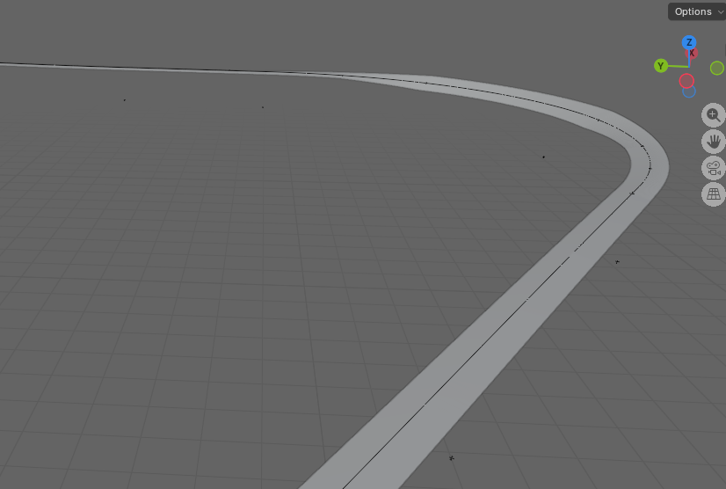
Figure 10.3-1 — Sectioned surface illustrating a superelevation transition

10.3.1 Breaklines
In the context of IfcSectionedSurface, a breakline is a line along the surface where the cross-slope changes abruptly — an edge of pavement, a shoulder break, the face of a curb. This usage is distinct from DTM breaklines, which force TIN triangulation to honor a feature edge. Here the term describes a topological feature of the swept surface itself: a ridge or valley line where adjacent surface facets meet at a non-tangent angle.
Breaklines arise from the tag mechanism when consecutive cross-sections have different numbers of segments. A widening lane introduces a new vertex at the distance along the directrix where the widening begins. Tags identify which vertices in one section correspond to vertices in the next, even when the two sections have different segment counts. A vertex present in one section but absent in the adjacent section causes the surface to initiate or terminate at that longitudinal position, which is the geometric definition of a breakline in this context. IfcOpenCrossProfileDef is the only profile that supports breaklines. Figure 10.3.1-1 illustrates a sectioned surface with breaklines resulting from cross-section topology changes along the route. IfcSectionedSolidHorizontal does not support the concept of breaklines.
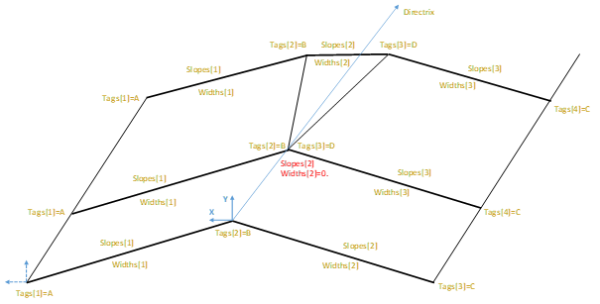
Figure 10.3.1-1 — Sectioned surface with breaklines at cross-section topology changes. (source bSI)
Figure 10.3.1-2 shows a sectioned surface inspired by Figure 10.3.1-1 with both a widening and narrowing of the surface.
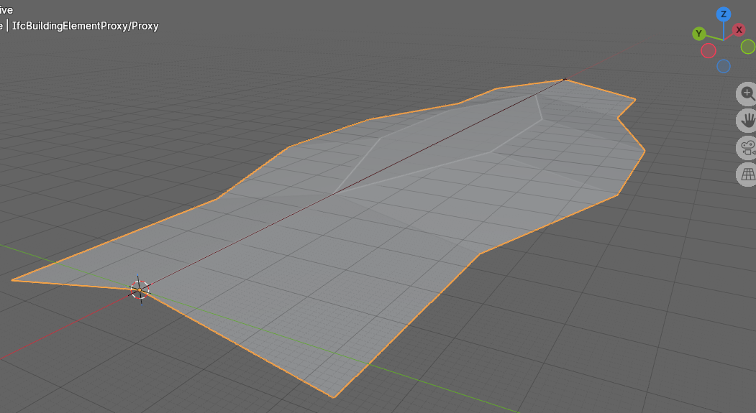
Figure 10.3.1-2 — Sectioned surface with breaklines at cross-section topology changes. This figure shows the surface widening and returning to its original width.
Although the IFC specification does not state this explicitly, the Slope and Width of an IfcOpenCrossProfileDef segment must be zero at the distance along the directrix where a breakline initiates or terminates. When a new feature vertex first appears — the start of a widening lane, for example — the cross-section at that distance must include the new tagged vertex with a zero-width segment. In Figure 10.3.1-1, this is why points B and D coincide in the second cross-section: the zero-width segment collapses those tagged vertices to the same position, establishing the breakline origin without introducing lateral extent. Without a zero-width segment at the breakpoint position, the surface has no defined starting position for the new feature and the geometry is ambiguous. The branching example in §10.6.1.3 illustrates this pattern for a surface where breaklines branch from the main cross-section.
The tag mechanism serves both breaklines and string lines simultaneously. A tag on a profile vertex identifies that vertex’s correspondence across sections with different topology and, when a matching IfcOffsetCurveByDistances guide curve exists, controls the vertex’s trajectory between sections. The two functions — topological correspondence and geometric guidance — share the same tag infrastructure.

10.3.2 String Lines
Within IfcSectionedSurface, string lines are implemented through the Tags attribute of IfcOpenCrossProfileDef. This attribute holds a list of $N+1$ labels — one per vertex of the open profile, where $N$ is the number of segments. An IfcOffsetCurveByDistances guide curve whose Tag matches one of these vertex labels takes control of that vertex’s trajectory along the surface.
The OffsetPoint attribute of IfcOpenCrossProfileDef positions the first tagged vertex in the directrix’s local coordinate system. Subsequent vertices are derived from there by accumulating the segment Widths and Slopes. It is unclear whether all tagged vertices participate in the matching process independently, allowing a surface to have some vertices guided by offset curves and others governed by linear interpolation between authored sections (see §10.5.2).

10.3.3 Cross-Section Coordinate System
The profiles of IfcSectionedSurface and IfcSectionedSolidHorizontal are defined in a local coordinate system established at each cross-section position by the corresponding IfcAxis2PlacementLinear. The axes of this local frame are:
- X — the lateral axis, pointing to the left of a traveler moving in the direction of increasing chainage.
- Y — the vertical axis, aligned with the Axis direction of IfcAxis2PlacementLinear (typically global vertical, $(0,0,1)$).
- Z — the extrusion direction, tangent to the directrix in the direction of increasing chainage.
The left-pointing X direction follows from the right-hand rule. Denoting the unit tangent as $\hat{t}$ and the Axis direction as $\hat{u}$:
$$\hat{x}=\hat{u}×\hat{t}$$
With $\hat{u}$ pointing up and $\hat{t}$ in the direction of travel, $\hat{x}$ points to the left, and the frame satisfies $\hat{x}×\hat{y}=\hat{z}$. Assigning X to the right would reverse this cross product, producing a left-handed system — incompatible with the extrusion direction occupying the +Z axis.
Contrast with drafting convention. When engineers draw a cross-section on paper, the conventional choice is X to the right and Y upward. The IFC cross-section coordinate system is the mirror image of this: X points to the left and Y remains upward. The visual appearance of the cross-section drawing is unchanged — features left of the alignment still appear on the left side of the drawing — but the X axis arrow points in the opposite direction. The practical consequence is that positive X profile coordinates are to the left of the alignment centerline, and negative X coordinates are to the right. Engineers accustomed to computing profile widths with positive values to the right must reverse the sign when authoring IFC profile geometry. The OffsetPoint of IfcOpenCrossProfileDef and the vertex coordinates in IfcCartesianPointList2D (for IfcSectionedSolidHorizontal) are both expressed in this left-X frame.

10.4 IfcSectionedSolidHorizontal
IfcSectionedSolidHorizontal defines a solid by sweeping closed cross-sections along a directrix curve. It follows the same fundamental structure as IfcSectionedSurface but produces a volumetric solid bounded by the swept faces and the cross-section planes at each end.
Attribute | Type | Description
Directrix | IfcCurve | The curve along which sections are swept
CrossSectionPositions | LIST [2:?] OF IfcAxis2PlacementLinear | Positions along the directrix at which sections are placed
CrossSections | LIST [2:?] OF IfcProfileDef | Closed cross-section profiles, one per position
Table 10.4-1 — IfcSectionedSolidHorizontal attributes
As with IfcSectionedSurface, the solid is generated by sweeping only between the defined CrossSectionPositions. It does not extend to the head or tail of the Directrix (see §10.5.5). The CrossSectionPositions and CrossSections lists must be equal in length, and the position expressions must not use longitudinal offsets.
Cross-sections are typically IfcArbitraryClosedProfileDef profiles. The profile outline is defined as an IfcIndexedPolyCurve referencing an IfcCartesianPointList2D. Profile points are listed in counter-clockwise order when viewed from the direction the profile normal points. The IfcCartesianPointList2D.TagList attribute assigns a label to each point in the coordinate list, enabling the string line mechanism of §10.2. Guide curve hosting and tag scoping follow the same sibling-representation construction described for IfcSectionedSurface in §10.5.2, demonstrated through IfcSectionedSolidHorizontal examples in §10.6.2.5 and §10.6.2.6.
For a note on a documentation error in the profile orientation specification for this entity, see §10.5.6.

10.4.1 Rotations
Cross-section rotation accommodates superelevation — the banking of a road or rail cross-section along a curve. IfcSectionedSolidHorizontal supports two approaches.
Single superelevation applies a uniform rotation to the entire cross-section at each defined position along the directrix. IfcDerivedProfileDef expresses this rotation, with its ParentProfile referencing the base (unrotated) profile. Each entry in CrossSections can reference its own IfcDerivedProfileDef instance with a different rotation angle, allowing the rotation to vary along the directrix while the underlying profile shape remains constant.
Multiple independent superelevations apply when different parts of the cross-section rotate independently — for example, a divided highway where left and right carriageways have different cross-slopes, or a cross-section with a varying median shape. In this case each CrossSection is a distinct profile instance. The tagged points in IfcCartesianPointList2D.TagList and their corresponding IfcOffsetCurveByDistances guide curves control where each point travels independently along the route. The guide curves effectively encode the superelevation variation for each tagged feature point without requiring explicit rotation parameters.

10.5 Specification Gaps and Implementation Notes

10.5.1 Design History: The Guided Sweep Proposal
This section documents the origin of the tag-based guide curve mechanism used throughout this chapter. §10.5.2 and §10.5.3 rely on it as evidence of the specification writers’ intended construction — not as historical background to a still-open question, but as the basis for stating that construction directly.
The tag-based guide curve mechanism described in this chapter originates from buildingSMART issue bSI-InfraRoom/IFC-Specification #118, “[IFC Tunnel] Guided sweep representation” [9], opened to address a requirement for sectioned sweeps with varying profiles whose paths between profiles could be described in a non-linear manner. Two competing EXPRESS formalizations were drafted and posted to the issue (guided_sweep_1.txt, guided_sweep_2.txt), alongside a discussion document (2021-08-11_GuidedSweeps.pdf). An intermediate proposal described guiding curves independently as IfcSegmentedReferenceCurve instances positioned using IfcPointByDistanceExpression; the mechanism that ultimately shipped in the schema instead uses IfcOffsetCurveByDistances, though both approaches share the same underlying IfcPointByDistanceExpression-based referencing.
One considered formalization, IfcLinearlyReferencedProfileDef, was opposed during review specifically because it conflicted with the assumption, used throughout the schema, that IfcProfileDef is defined in a local x-y plane suitable for arbitrary extrusions and lofts — a reviewer objected that it was unclear how an IfcExtrudedAreaSolid would even be constructed from such a profile, and that the proposal “messes with too many well established concepts.”
The mechanism that was adopted instead — tag matching between profile vertices and an independently-defined guide curve — was accepted with its principal weakness stated explicitly by its own proposer:
The downside, however, is that the IfcCartesianPoint of the profile and the corresponding IfcPointByDistanceExpression of the GuidingCurve must be linked explicitly and might have slightly diverging locations. Consistency must be ensured/checked by the implementors, potentially by defining an upper threshold for the acceptable distance between them.
This confirms that the redundancy discussed in §10.5.3 is a known and accepted trade-off, not an oversight: the specification writers deliberately left consistency between a tagged vertex’s authored coordinate and its guide curve’s path as an implementer responsibility, with no schema-level enforcement proposed or adopted.
The resolution that ultimately closed the issue favored a simpler approach over a dedicated new profile-definition entity: a review comment pointed to the existing pattern of carrying an Axis (2D reference geometry) and a Body (swept solid geometry) as separate representations on the same product — as already used on IfcWall — as precedent for describing guiding curves and swept geometry as siblings rather than inventing new geometry types to carry them.

10.5.2 Guide Curve Hosting and Tag Resolution
Guide curves belong as Items in a second IfcShapeRepresentation — RepresentationIdentifier = "Axis", RepresentationType = "GeometricCurveSet" — that is a sibling entry, alongside the representation holding the surface or solid, within the same IfcProductDefinitionShape.Representations list. This is the Axis/Body pattern already used elsewhere in IFC (for example, on IfcWall) and is the construction described in §10.5.1. Guide curves hosted this way are scoped to the IfcProductDefinitionShape they belong to, so tags need only be unique within that scope.
This does not close every case, however: if a model author places more than one IfcSectionedSurface or IfcSectionedSolidHorizontal across the representations of a single IfcProductDefinitionShape — schema-legal — representation scoping alone cannot determine which guide curves belong to which surface. Implementations should avoid this configuration.
Even under this construction, no IFC attribute, inverse relationship, or STEP entity identifier points from a tagged vertex to the guide curve that controls it — the only link is the shared string value of Tag. Because every guide curve for a surface or solid is collected into the same IfcProductDefinitionShape, resolving a guided vertex only requires comparing tags among that representation’s Items, not searching the entire model. However, a model-wide search may be required (depending on the implementation) to find all the IfcRepresentations that contain the surface or solid as an IfcRepresentationItem. From there the owning IfcProductDefinitionShape (either directly or by traversing IfcRepresentationMap -> IfcMappedItem -> IfcShapeRepresentation) can be interrogated for the sibling "Axis"/"GeometricCurveSet" representation.

10.5.3 Consistency Between Authored Coordinates and Guide Curves
A guided vertex’s position is defined twice, through two independent mechanisms: once by the profile’s authored coordinate, and once by the string line’s own geometry. When a cross-section vertex is authored at a specific position and a guide curve with a matching tag passes through a different position for the same cross-section, the two descriptions disagree. The mechanism’s own proposer (§10.5.1) stated plainly that the two “must be linked explicitly and might have slightly diverging locations,” with consistency to be “ensured/checked by the implementors, potentially by defining an upper threshold for the acceptable distance between them.” The intent was never that these two descriptions could legitimately diverge and be arbitrated by some precedence rule; it was that they are supposed to coincide, and keeping them so is an authoring responsibility, not a question a consuming application resolves case by case.
What remains a genuine, unresolved limitation is that this consistency has no schema-level enforcement: the specification provides no mechanism, tolerance value, or validation rule for detecting when an authored coordinate and its guide curve have drifted apart. A model can therefore still carry a defect — a divergence beyond whatever tolerance the authoring tool intended — that no consuming application can distinguish from a small, accepted numerical difference. Interoperability issues that follow from such a defect (visualization, surface area and volume estimates, clash detection) are a data-quality problem in the authored file, not a case of the specification failing to state which value is authoritative.

10.5.4 Partial Guide Curve Coverage
The IFC specification does not define what happens when a tagged cross-section vertex has no corresponding guide curve. The ambiguity is meaningful: if a tagged vertex with no matching guide curve falls back to linear interpolation between authored sections, then guide curves and linear interpolation can be freely mixed within the same surface or solid — some vertices precisely guided, others interpolated. If instead every tagged vertex is required to have a matching guide curve, models must supply redundant zero-offset guide curves for vertices whose trajectory is already linear (as in the centerline vertex of §10.6.1.4 and §10.6.2.5). The practical use case for mixing is clear: exterior edge vertices follow string line guide curves through a curved widening while interior breakline vertices use linear interpolation — combining the geometric precision of string lines with the simplicity of template-based sections. An implementation agreement is needed to confirm that a tagged vertex with no matching guide curve is treated as unguided and linearly interpolated, rather than as a modeling error.

10.5.5 Extent Along the Directrix
IfcSectionedSurface and IfcSectionedSolidHorizontal are bounded by their CrossSectionPositions — geometry is generated by sweeping only between the first and last defined position and does not extend to the head or tail of the Directrix. Figure 8.8.3.35.C in the IFC specification incorrectly depicts the solid extending to the head and tail of the Directrix when CrossSectionPositions are at interior distances, contradicting the specification text. The practical consequence of such extension would be severe: multiple IfcSectionedSolidHorizontal instances modeling sequential prisms along the same alignment — pavement layers, cut sections, fill sections — would each extend to the full alignment endpoints and overlap one another. Implementers should follow the specification text, not the figure.
Guide curve extent follows the opposite rule. The IfcOffsetCurveByDistances specification states that if the defined offset values do not span the full extent of the basis curve, the offsets implicitly continue with the same value toward the head and tail. For guide curves this means a constant offset string line — such as the edge of a uniform-width shoulder — can be expressed with a single IfcPointByDistanceExpression without requiring offset values at every cross-section position. The two behaviors are independent: guide curves extend implicitly because they control interpolation within the surface or solid’s defined span, not because they extend that span.

10.5.6 Cross-Section Orientation: Default Axis Direction
Each IfcAxis2PlacementLinear entry in CrossSectionPositions defines the local coordinate system at which its corresponding cross-section is placed. The Axis attribute specifies the local “up” direction — the Z-axis of that coordinate system — which determines how the cross-section is oriented in 3D space. As discussed in §8.3.2, the default value of Axis when the attribute is omitted is not unambiguously defined in the IFC schema.
Historical context. During early development of IfcSectionedSolidHorizontal under IFC4x3, the Axis direction at each cross-section position was envisioned as always vertical — (0, 0, 1) in global coordinates. As the standard evolved through RC1–RC4 and ADD1, this assumption was replaced with an author-controlled IfcAxis2PlacementLinear allowing Axis to be specified explicitly per cross-section position. The resolved specification permits both interpretations, but the default when Axis is omitted remains undefined (see §8.3.2).
Geometric consequence. On a flat (zero-grade) alignment the two interpretations produce identical results. On a graded alignment they diverge:
- Axis = (0, 0, 1). The cross-section “up” direction is always global vertical. Cross-section faces are plumb — their planes are perpendicular to the horizontal projection of the directrix, not to the 3D curve tangent. For infrastructure design this is the natural interpretation: end views and cross-sections are in a vertical plane, heights are measured vertically, widths are measured horizontally.
- Axis perpendicular to the 3D tangent. The cross-section “up” direction tilts with the grade, remaining in the vertical plane containing the 3D tangent. Cross-section faces are truly perpendicular to the 3D curve. On a graded alignment the faces lean forward or backward relative to the direction of travel, producing a different solid with different volume and cross-sectional area at any given distance. This interpretation yields the same solid that IfcExtrudedAreaSolid would produce for the same profile swept along the same path.
On alignments with cant, the Axis = (0,0,1) interpretation would exclude the cross-section rotation from the sweep, requiring it to be explicitly constructed into the IfcSectionedSurface profile or the IfcSectionedSolidHorizontal section rotation mechanism. The other interpretation would allow for cant-defined rotation to occur by simply using the default axis direction, as discussed in §10.6.1.1 and §10.6.2.1.
Figures 10.5.6-1 and 10.5.6-2 show the retaining wall example of §10.6.2.4 swept along a 10% graded directrix. In Figure 10.5.6-1, Axis is supplied explicitly as (0, 0, 1) at each cross-section position and the end face is plumb. Figure 10.5.6-2 shows the same scenario with Axis omitted, rendered by two different IFC viewers that have adopted opposite defaults: the upper half uses the perpendicular-to-3D-tangent interpretation; the lower half uses (0, 0, 1). The divergence is most apparent at the start and end of the wall, where the two viewers produce noticeably different face orientations from an identical input file.
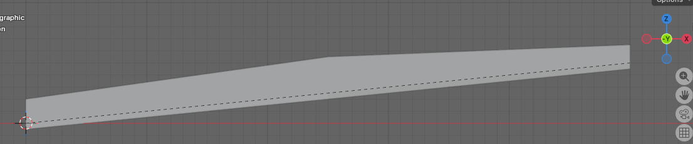
Figure 10.5.6-1 — Elevation view of IfcSectionedSolidHorizontal on a 10% graded alignment with Axis = (0, 0, 1): end face is vertical (plumb).
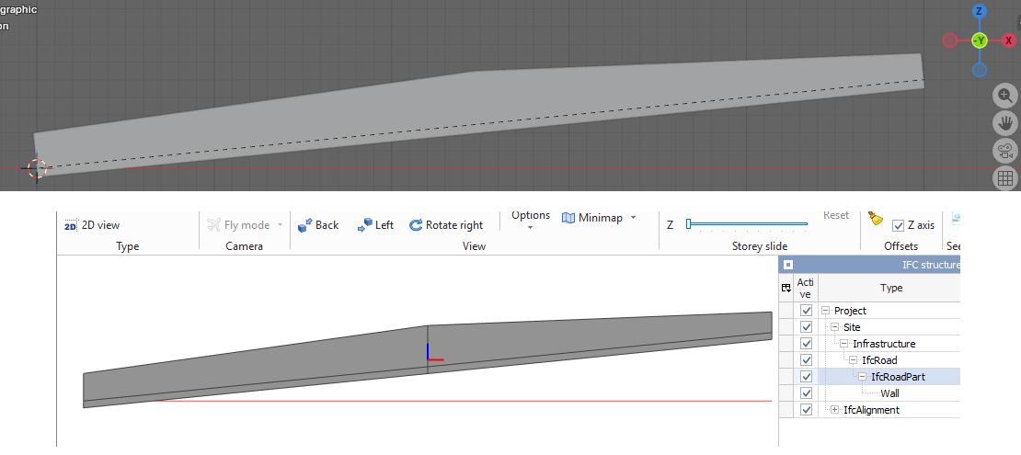
Figure 10.5.6-2 — The same IfcSectionedSolidHorizontal model (retaining wall, 10% grade, Axis omitted) rendered by two IFC viewers: the upper half assumes Axis perpendicular to the 3D tangent (inclined end face); the lower half assumes Axis = (0, 0, 1) (plumb end face).
Practical consequences. The discrepancy extends beyond geometry. Quantity takeoffs derived from these two solids yield different volumes — the differing end-face angles shift the amount of material at each terminus, and the effect grows with grade steepness. A bill-of-materials or payment verification workflow can produce measurably different results from the same model file depending solely on which viewer performed the calculation.
Clash detection is similarly affected. The two solids occupy different regions of 3D space: an element near a wall endpoint may show as clear in one viewer and conflicting in another. A clash report’s findings become tool-dependent, with nothing in the model file to signal the ambiguity.
In construction, the disagreement extends to physical work. Formwork geometry, excavation limits, and bearing surface angles at the wall ends all differ between interpretations. A contractor working from one viewer’s output and an inspector referencing another’s may reach opposite conclusions about what was designed — each correctly reading what their own tool shows.
Recommendation. Until such time as this discrepancy can be resolved, authors should always supply Axis explicitly in every IfcAxis2PlacementLinear entry within CrossSectionPositions. While this is onerous and redundant for cant alignments, it will accurately convey the modeling intent.

10.5.7 Profile Orientation Documentation Error
The specification for IfcSectionedSolidHorizontal states:
The profile X axis is the direction of RefDirection from IfcAxis2PlacementLinear, and the profile Y axis is the direction of Axis.
This is incorrect. The profile is defined in a 2D XY plane and has a normal — the axis perpendicular to that plane — which determines how the profile is oriented in 3D space when swept along the directrix. It is that normal, not the profile X axis, that is the direction of RefDirection. When RefDirection is omitted from IfcAxis2PlacementLinear it defaults to the curve tangent direction. If the profile X axis were to align with the tangent, the profile plane would lie parallel to the sweep direction rather than perpendicular to it, producing degenerate geometry. The correct behavior is that the profile normal aligns with RefDirection (or the curve tangent when RefDirection is absent), placing the profile face perpendicular to the sweep path.
The specification for IfcSectionedSurface states this correctly: “the profile normal is derived from the associated IfcAxis2PlacementLinear.” The IfcSectionedSolidHorizontal documentation should be read consistently with the IfcSectionedSurface text. This error is documented in buildingSMART issues IFC4.x-IF #147 and IFC4.x-development #1010 [6].

10.6 Example Models
The following example models illustrate the concepts of this chapter in progressively more complex configurations, organized by entity type.

10.6.1 IfcSectionedSurface

10.6.1.1 Minimal Definition
The file IfcSectionedSurface.ifc demonstrates IfcSectionedSurface with an IfcSegmentedReferenceCurve as the Directrix. The alignment is a 50 m Bloss transition with a matching cant transition from zero to 500 mm right-rail elevation — exaggerated to make the banking clearly visible. The cross-section is a single flat segment spanning the 1.5 m track gauge placed at both ends of the alignment; the IfcSegmentedReferenceCurve rotates the profile frame continuously with cant, so the banking arises entirely from the directrix rather than the profile geometry.
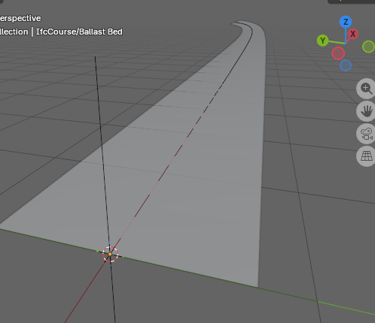
Figure 10.6.1.1-1 — IfcSectionedSurface (ballast bed top surface, 1.5 m track gauge) swept along an IfcSegmentedReferenceCurve directrix. The 50 m Bloss cant transition banks the surface from level at the start to 500 mm right-rail elevation at the end.

10.6.1.2 Superelevation
The file IfcSectionedSurface_superelevation.ifc is a template-based IfcSectionedSurface illustrating a superelevation transition, shown in Figure 10.3-1. The surface is defined by cross-sections at discrete positions along a Directrix, with linear interpolation between them. No guide curves are used. This is the simplest configuration and produces adequate geometry when the variation between sections is itself linear — which is the case for uniform superelevation rotation. The model also includes IfcReferent instances marking the superelevation events along the alignment.

10.6.1.3 Sectioned Surface with Branching
The file IfcSectionedSurface_with_branching.ifc is shown in Figure 10.3.1-2. It is based on the breakline example given in the IfcSectionedSurface documentation, enhanced to show both a widening and a subsequent narrowing of the section — a median or auxiliary lane that emerges from the main roadway and then returns.

10.6.1.4 String Lines — Guide Curves Sharing the Directrix
The file IfcSectionedSurface_with_stringlines_shared_basiscurve.ifc demonstrates guide curves offset directly from the surface’s own Directrix: each guide curve’s BasisCurve is Main-Line, the same curve the surface sweeps along. This contrasts with §10.6.1.5, where the guide curves instead follow independent curve geometry unrelated to the Directrix. Guide curves here are hosted using the sibling-representation construction §10.5.1 and §10.5.2 identify as the intended one.
The directrix is a 200 m straight alignment (Main-Line) with a flat vertical profile. The symmetric open profile has two segments and three tagged vertices: A (left edge), B (centerline), and C (right edge), each with a corresponding IfcOffsetCurveByDistances guide curve sharing Main-Line as its BasisCurve. Only two cross-sections are authored — one at each end of the surface. The guide curves carry all intermediate geometry: guide curves A and C define a variable-width surface, both edges beginning at ±30 m, widening to ±45 m at the 100 m midpoint, and returning to ±30 m at 200 m; guide curve B holds the centerline at a constant zero offset throughout. Without the guide curves, linear interpolation between the two end sections would produce a uniform 30 m width along the full 200 m — the guide curves are what create the widening.
Note: Main-Line cannot itself serve as the guide curve for the centerline vertex: IfcAlignment does not have a Tag attribute. Guide curve B is therefore an IfcOffsetCurveByDistances with a zero lateral offset from the alignment, existing solely to carry the tag "B" — though this may not be required if IFC allows a mix of guide curves and linear interpolation to define a sectioned surface or solid. This ambiguity is discussed in §10.5.4.
The three tagged IfcOffsetCurveByDistances instances are collected into a second IfcShapeRepresentation — RepresentationIdentifier = "Axis", RepresentationType = "GeometricCurveSet" — that is a sibling entry, alongside the "Body"/SectionedSurface representation holding the IfcSectionedSurface, in the same IfcPavement’s IfcProductDefinitionShape.Representations list. Because that IfcProductDefinitionShape is only ever reachable through the rooted IfcPavement, the guide curves inherit a traceable path to a rooted entity — see §10.5.2 for the general technique. Because all three guide curves belong to this single IfcProductDefinitionShape, tag matching is unambiguously scoped: tags "A", "B", and "C" need only be unique within this representation, not globally across the model — whether or not a guide curve’s BasisCurve happens to match the Directrix, as it does for all three here.
Figure 10.6.1.4-1 shows the expected geometry of this example.
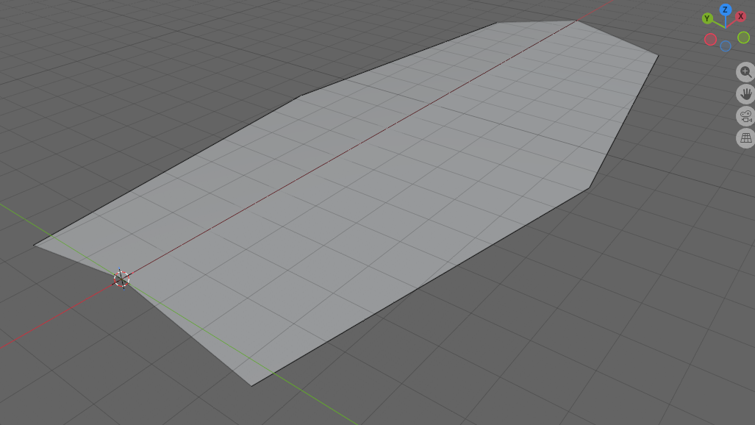
Figure 10.6.1.4-1 — Expected geometry of IfcSectionedSurface with string line guide curves. This rendering has been synthesized to illustrate the correct geometry; no viewer capable of resolving string line guide curves has been found at the time of writing.
Figure 10.6.1.4-2 shows the resulting entity structure: two sibling shape representations under one IfcProductDefinitionShape.
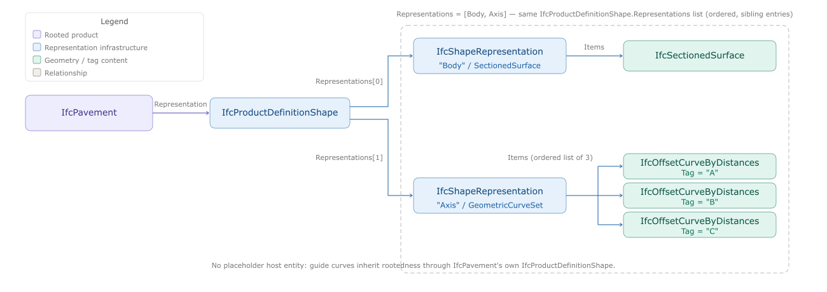
Figure 10.6.1.4-2 — Guide curve rootedness via sibling representation: the surface and its three guide curves hang off the same IfcProductDefinitionShape.
§10.6.2.5 demonstrates the same technique applied to the IfcSectionedSolidHorizontal counterpart of this example; see Figure 10.6.2.5-1 for comparison.

10.6.1.5 String Lines — Independent Guide Curves
The file IfcSectionedSurface_with_stringlines_independent_guide_curves.ifc takes a different approach: the edge string lines follow independent curve geometry — circular arcs — rather than parametric offsets from the centerline. Main-Line is a 200 m straight alignment. The left and right edge curves start tangent-parallel to Main-Line, offset ±30 m from the centerline, and curve away from it at a 1010 m radius — the radius that puts each arc exactly ±50 m from centerline, the width authored on the cross-section there, at the point 200 m forward, matching Main-Line’s own endpoint. Their arc length is 205 m, a bit longer than the ~201.3 m strictly needed to reach that point: a guide curve may run past what’s required (§10.5.5); only falling short is a defect. Unlike Main-Line, the edge curves are not IfcAlignment products at all — each is a bare IfcGradientCurve, built directly from IfcCurveSegment/IfcCircle entities with no semantic alignment layer (IfcAlignmentHorizontal/Vertical, segments, or nesting) above it, referenced only as the BasisCurve of an IfcOffsetCurveByDistances. The guide curves for tags "A" and "C" are zero-offset curves from these bare edge curves; the guide curve for tag "B" is a zero-offset from Main-Line. All three are hosted in a sibling "Axis" IfcShapeRepresentation alongside the surface’s "Body" representation, as in §10.6.1.4.
Although the guide curves for tags "A" and "C" have a different BasisCurve than the surface Directrix, this has no effect on tag scoping here: all three guide curves are hosted in the same sibling "Axis" representation as the surface, so scoping is governed by that shared IfcProductDefinitionShape (§10.5.2) regardless of whether a guide curve’s BasisCurve matches the Directrix.
This configuration is the most conceptually faithful to the idea of string lines — each edge path is an independent geometric entity. The edge arcs’ radius is fixed entirely by the requirement that each pass through the correct point at Main-Line’s endpoint. Getting that arithmetic right is the model author’s responsibility: nothing in the specification checks that an independently-parameterized guide curve reaches the correct offset at the correct distance, and a model that gets it wrong carries a defect of the same kind discussed in §10.5.3.
Figure 10.6.1.5-1 shows the expected geometry of this example.
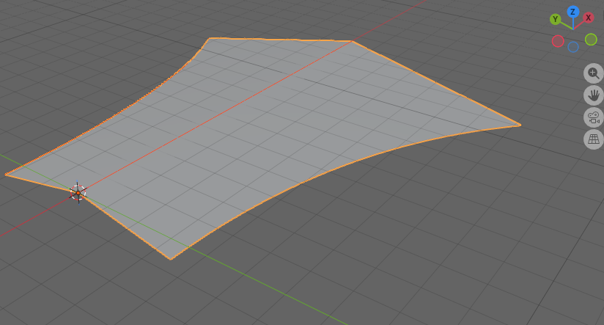
Figure 10.6.1.5-1 — Expected geometry of IfcSectionedSurface_with_stringlines_independent_guide_curves.ifc. This rendering has been synthesized to illustrate the correct geometry; no viewer capable of resolving string line guide curves has been found at the time of writing.

10.6.1.6 String Lines — Dense Section Approximation
The file IfcSectionedSurface_with_stringlines_dense_section_approximation.ifc reproduces the same edge geometry as §10.6.1.5 — a straight centerline with curved edges defined by 1010 m radius arcs — but using the template approach rather than guide curves. Cross-section widths at four evenly-spaced stations are computed analytically from the arc geometry, and the resulting IfcOpenCrossProfileDef instances embed the exact width at each station — deliberately few, so the piecewise-linear approximation error remains visible rather than vanishing as more sections are added. This example retains the true edge geometry — Left_Edge and Right_Edge, ordinary IfcAlignment instances with real circular-arc geometry — not as functioning guide curves (this is a pure template-approach model; nothing here references them by Tag), but purely so Figure 10.6.1.6-2 has an exact curve to compare the template-approximated surface against. Figure 10.6.1.6-1 shows the resulting surface, widening along its length according to the four analytically computed cross-sections.
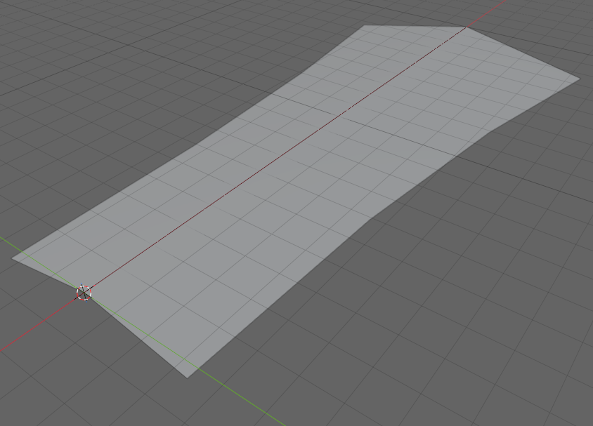
Figure 10.6.1.6-1 — Sectioned surface with four cross-sections approximating curved edge geometry; the edge paths between them are piecewise-linear, not the true arc.
Figure 10.6.1.6-2 zooms in on the far-right corner of the surface, where the gap between the exact circular arc guide curve (shown in orange) and the piecewise-linear surface edge is most visible. With only four sections, the approximation error is perceptible at the scale of the model.
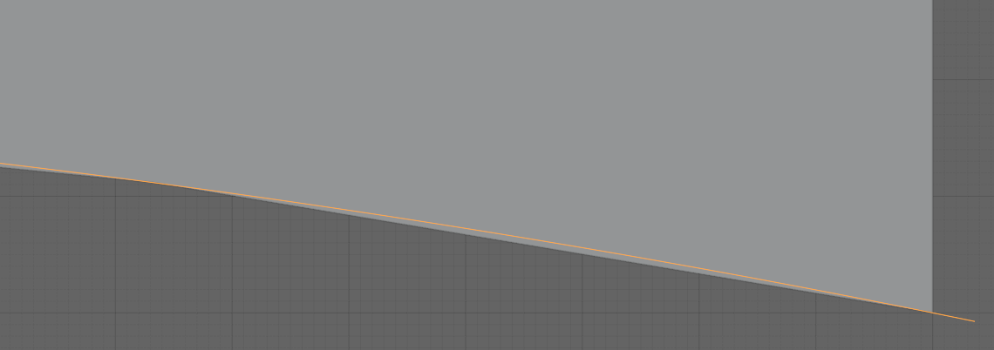
Figure 10.6.1.6-2 — Zoomed view of the far-right corner showing the gap between the piecewise-linear surface edge and the exact circular arc guide curve (orange). The error is largest at the midpoint between cross-sections.
This example illustrates the trade-off between the two approaches. The template approach with dense sections can approximate curved edge geometry to any desired tolerance, but requires explicit computation of profile widths at each station and produces a model with many cross-section instances. The string line approach of §10.6.1.5 requires only two sections and lets the guide curves carry the geometry exactly — but only if the model author gets the underlying arc geometry exactly right (§10.5.3); the template approach here sidesteps that precision requirement by sampling the known curve directly, at the cost of only approximating it.

10.6.2 IfcSectionedSolidHorizontal

10.6.2.1 Minimal Definition
The file IfcSectionedSolidHorizontal.ifc is the solid counterpart to §10.6.1.1, using the same IfcSegmentedReferenceCurve directrix (50 m Bloss transition with exaggerated cant) and the same two-section minimal structure. The open surface profile is replaced by a closed trapezoidal ballast bed cross-section — 1.8 m wide at the base, 1.5 m at the top, and 0.25 m deep — with no profile rotation, superelevation, or guide curves.
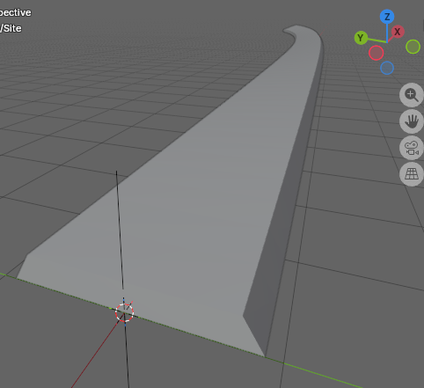
Figure 10.6.2.1-1 — IfcSectionedSolidHorizontal (trapezoidal ballast bed, 1.5 m top width) swept along an IfcSegmentedReferenceCurve directrix. The 50 m Bloss cant transition banks the solid from level at the start to 500 mm right-rail elevation at the end.

10.6.2.2 Single Superelevation
The file IfcSectionedSolidHorizontal_single_superelevation.ifc demonstrates the IfcDerivedProfileDef superelevation approach described in §10.4.1. The cross-slope transitions from flat (0%) at station 0 m to a 10% superelevation at station 50 m, with the geometry engine interpolating linearly between the two defined positions.
The alignment is a 50 m straight line due East at zero grade with no cant. The directrix is therefore an IfcGradientCurve — no IfcSegmentedReferenceCurve is needed because the superelevation is encoded entirely in the profile rotation rather than in the alignment cant.
The base cross-section is a 60 m wide trapezoid — vertices (-30, 0), (30, 0), (29.5, 0.5), (-29.5, 0.5), encoded as an IfcArbitraryClosedProfileDef — exaggerated in width relative to §10.6.2.1’s rail ballast bed to make the rotation clearly visible. A single instance of this base profile is shared by both cross-section positions; each position wraps it in its own IfcDerivedProfileDef whose IfcCartesianTransformationOperator2D carries the rotation.
The rotation angle is $θ=\tan^{-1}(e)$, where $e$ is the cross-slope (rise/run): $θ=0$ at station 0 m and $θ≈{5.71}^{∘}$ at station 50 m. The geometry engine interpolates the rotation linearly between the two positions.

10.6.2.3 Crown Cross-Section with Superelevation
The file IfcSectionedSolidHorizontal_superelevation.ifc is the solid counterpart to IfcSectionedSurface_superelevation.ifc. It demonstrates IfcSectionedSolidHorizontal with a distinct IfcArbitraryClosedProfileDef at each cross-section position, each directly encoding the cross-slope geometry for that station. The alignment structure, station pattern, and superelevation progression match the surface example; the difference is that the cross-section here is a closed solid profile rather than an open surface profile.
The alignment is a tangent–arc–tangent sequence: a 600 m leading straight, a 300 m radius circular arc of 585 m arc length, and a 600 m trailing straight, at a constant 0% grade starting at elevation 30 m. The directrix is an IfcGradientCurve. Start station is 3000 m.
Each cross-section is a V-shaped pavement slab 60 m wide and 0.5 m thick. The crown point is at the profile origin $(0,0)$ — the top centerline. From the crown, the road surface slopes to each shoulder at a rate defined by the superelevation state at that station. The soffit is 0.5 m vertically below each top-surface point. There are no beveled edges.
Six IfcArbitraryClosedProfileDef instances — one per position — directly encode the cross-slope at each station, mirroring the six IfcOpenCrossProfileDef instances in the surface counterpart. Without guide curves, vertex trajectories between stations are linearly interpolated; explicit guide curve control is illustrated in §10.6.2.5 and §10.6.2.6.

10.6.2.4 Retaining Wall with Variable Section
Two files demonstrate IfcSectionedSolidHorizontal with a cross-section whose shape transforms along the alignment:
- IfcSectionedSolidHorizontal_retaining_wall_explicit_axis.ifc — Axis = (0, 0, 1) supplied explicitly at each CrossSectionPosition; cross-section faces are plumb (Figure 10.5.6-1).
- IfcSectionedSolidHorizontal_retaining_wall_implicit_axis.ifc — Axis omitted; the resulting orientation is implementation-defined (Figure 10.5.6-2).
The alignment is a 50 m straight grade at 10% due East. Three cross-sections are defined — at 0 m, 25 m, and 50 m — and the geometry engine interpolates linearly between them. The cross-section is a retaining wall with footing; the stem height varies from 2.0 m at the start, to 3.0 m at the midpoint, and back to 1.5 m at the end. The footing width also varies: 2.0 m at the start and end, widening to 2.5 m at the midpoint, while the toe and wall thickness remain constant throughout. See §10.5.6 for a discussion of the Axis direction and its geometric consequences.

10.6.2.5 String Lines — Guide Curves Sharing the Directrix
The file IfcSectionedSolidHorizontal_with_stringlines_shared_basiscurve.ifc demonstrates guide curves controlling tagged vertices of an IfcArbitraryClosedProfileDef, replacing the IfcOpenCrossProfileDef.Tags mechanism of the surface with IfcCartesianPointList2D.TagList. It is the solid counterpart to IfcSectionedSurface_with_stringlines_shared_basiscurve.ifc (§10.6.1.4), using the same sibling-representation technique — the construction §10.5.1 and §10.5.2 identify as the intended one — rather than a contrasting alternative.
The directrix is the same 200 m straight alignment (Main-Line) at flat grade. Two cross-section positions are authored — one at each end. Six guide curves — bare IfcOffsetCurveByDistances instances tagged "A_top", "B_top", "C_top", "A_bot", "B_bot", "C_bot" — share Main-Line as their BasisCurve, the same curve as the solid Directrix. Because all six belong to this single IfcProductDefinitionShape, tag matching is unambiguously scoped (see §10.5.2) regardless of that shared BasisCurve. The top guide curve offsets are unchanged from §10.6.1.4’s A/B/C: A_top and C_top widen from ±30 m to ±45 m at the 100 m midpoint and return; B_top holds the crown at zero offset throughout. The soffit guide curves (A_bot, B_bot, C_bot) follow the same lateral path as their top counterparts, offset a further 1 m downward to hold the slab thickness constant.
The six tagged IfcOffsetCurveByDistances instances are collected into a second IfcShapeRepresentation — RepresentationIdentifier = "Axis", RepresentationType = "GeometricCurveSet" — that is a sibling entry, alongside the "Body"/"SolidModel" representation holding the IfcSectionedSolidHorizontal, in the same IfcPavement’s IfcProductDefinitionShape.Representations list. Because that IfcProductDefinitionShape is only ever reachable through the rooted IfcPavement, the guide curves inherit a traceable path to a rooted entity — see §10.5.2 for the general technique, and for the gap that arises if multiple sectioned entities were to share one IfcProductDefinitionShape. Figure 10.6.2.5-1 illustrates the resulting entity structure; compare it with Figure 10.6.1.4-2, which shows the same sibling-representation structure applied to the surface counterpart.
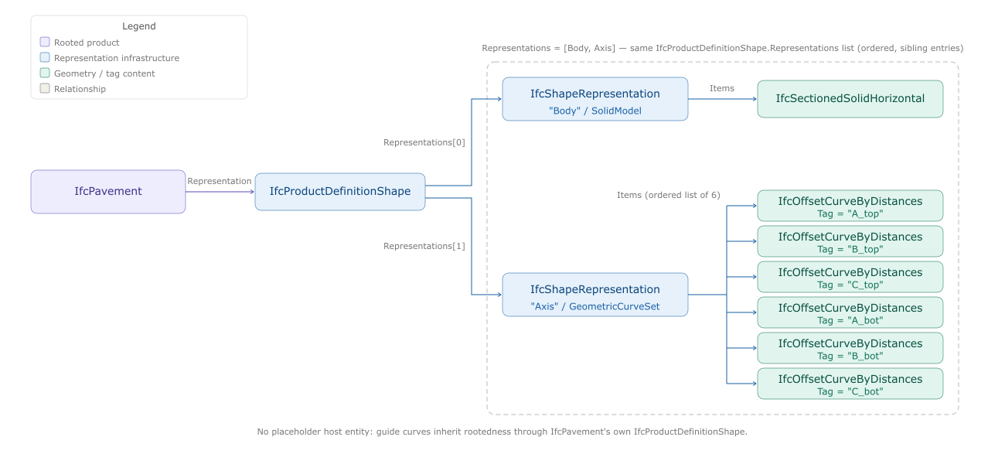
Figure 10.6.2.5-1 — Guide curve rootedness via sibling representation: the solid and its six guide curves hang off the same IfcProductDefinitionShape.
The closed cross-section is a V-shaped pavement slab 60 m wide (nominal) and 1 m thick, with a 20% crown slope. Tags are assigned through IfcCartesianPointList2D.TagList: all six vertices carry matching guide curve tags — "A_top", "B_top", "C_top" on the top surface and "A_bot", "B_bot", "C_bot" on the soffit — so every vertex, top and bottom, follows its own guide curve.
Key difference from the surface counterpart. In IfcOpenCrossProfileDef, the Tags attribute is a list of vertex labels on the open profile. In IfcArbitraryClosedProfileDef, there is no Tags attribute; vertex labels are carried by IfcCartesianPointList2D.TagList. Both attributes achieve the same match — an offset curve’s Tag is compared against the vertex label, and matching vertices are guided. A vertex with a tag that matches no guide curve is treated as unguided — its position is linearly interpolated between its authored positions at the CrossSectionPositions — though the specification does not explicitly confirm this behavior (see §10.5.2).

10.6.2.6 String Lines — Independent Guide Curves
The file IfcSectionedSolidHorizontal_with_stringlines_independent_guide_curves.ifc is the solid counterpart to IfcSectionedSurface_with_stringlines_independent_guide_curves.ifc (§10.6.1.5), using the identical edge-curve construction. As in §10.6.2.5, guide curves are hosted in a sibling "Axis" IfcShapeRepresentation (§10.5.2); the difference here is that the "A_top"/"C_top" guide curves have a BasisCurve independent of the solid Directrix, rather than sharing it.
The directrix is the same 200 m straight Main-Line alignment at flat grade — a real IfcAlignment product, unlike the edge geometry described next. Two bare edge curves define the edge paths, built the same way as §10.6.1.5’s — an IfcGradientCurve composed directly from IfcCurveSegment/IfcCircle entities, with no IfcAlignment product above it:
- Left edge curve — a 205 m circular arc with radius 1010 m, curving left, starting at $(0, +30)$ m from the origin.
- Right edge curve — a 205 m circular arc with radius 1010 m (curving right; the direction is encoded by the sign of the segment’s arc length, not the radius), starting at $(0, -30)$ m from the origin.
Both edge curves carry a constant-height vertical profile at $-\frac{1}{2}×30×0.2=-3 m$, placing each shoulder 3 m below the crown at the start. The tag-carrying guide curves are bare, zero-offset IfcOffsetCurveByDistances entities: "A_top" references the left edge curve as its BasisCurve, "B_top" references Main-Line, and "C_top" references the right edge curve — all three placed in this file’s own sibling "Axis" representation. Only the top vertices are guided; the "A_bot", "B_bot", and "C_bot" tags on the soffit match no guide curve and fall back to linear interpolation.
As in §10.6.1.5, an independent BasisCurve has no effect on tag scoping here — scoping is governed by shared representation membership (§10.5.2), not by whether BasisCurve matches Directrix.
Two profiles are authored: cs1 at distance 0 m (half-width 30 m) and cs2 at distance 200 m (half-width 50 m) — the width the edge curves are sized to reach exactly at that distance (§10.6.1.5).

Chapter 11 — Precision and Tolerance

11.0 Introduction
Alignment geometry is rarely mathematically perfect. Design parameters are rounded to convenient values, segment coordinates are computed independently by different tools, and transition curve ordinates are approximated by numerical integration — all of which introduce small discrepancies at segment joints. Alignments derived from historical sources carry additional uncertainty from the original survey or drafting. IFC provides mechanisms for both declaring the intended geometric continuity at segment joints and communicating the tolerance within which that continuity should be evaluated.
The primary declaration mechanism is IfcCurveSegment.Transition, which specifies the intended relationship between the end of one segment and the start of the next. Table 11.0-1 lists the available transition codes.
Transition Value | Description
CONTINUOUS | The segments join but no condition on their tangents is implied.
CONTSAMEGRADIENT | The segments join and their tangent vectors or tangent planes are parallel and have the same direction at the joint; equality of derivative is not required.
CONTSAMEGRADIENTSAMECURVATURE | For a curve, the segments join, their tangent vectors are parallel and in the same direction and their curvatures are equal at the joint: equality of derivatives is not required. For a surface this implies that the principle curvatures are the same and the principle directions are coincident along the common boundary.
DISCONTINUOUS | The segments do not join. This is permitted only at the boundary of the curve or surface to indicate that it is not closed.
Table 11.0-1 — IfcCurveSegment transition codes
Figure 11.0-1 illustrates the various transition types.
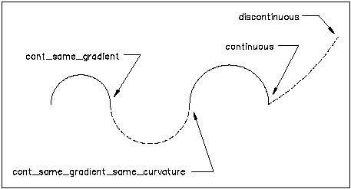
Figure 11.0-1 — Illustration of segment transition types
These transition codes declare intent, not guarantee. Adjacent segment end and start points may not exactly line up in position, gradient, or curvature for several reasons:
- Rounded design parameters. Designers routinely round curve parameters — radius, arc length, tangent bearing — to convenient values. Geometry computed from those rounded values does not land exactly on the next segment’s stored start point.
- Independent segment computation. Each segment’s coordinates are often computed independently from its own parameters rather than chained forward from the previous segment’s computed end. Floating-point rounding differences between two independent computations of the same nominal point produce small gaps or overlaps at joints.
- Numerical integration of transition curves. The x/y ordinates at the end of a spiral are transcendental integrals — Fresnel integrals for Clothoids, analogous forms for Bloss, Cosine, and the other spiral types — that different software approximates with different precision. The same nominal parameters can yield slightly different endpoint coordinates depending on the tool that produced them.
- Unit conversion. Converting between feet and meters, or between degrees/minutes/seconds and decimal degrees, introduces rounding that propagates to all downstream coordinates.
- Legacy source fidelity. Alignments derived from historical plan sheets, right-of-way plats, or field surveys carry the measurement uncertainty inherent in the original source material. Many times, the accuracy is “good enough” for its purpose.
Pset_Tolerance indicates the acceptable tolerance under which the calculated end point of a preceding segment would be considered geometrically continuous with the provided start point of the following segment. No implementation agreement exists for how its properties should be used; the OverallTolerance property is recommended. Similarly, Pset_Uncertainty indicates the uncertainty inherent in historical information gleaned from plan sets and other historic sources, and carries no implementation agreement; the LinearUncertainty property is recommended. As a fallback if Pset_Tolerance is not provided, tolerance can be taken from IfcGeometricRepresentationContext.Precision.

11.1 Handling Geometry Mismatches at Segment Joints
The IFC specification is silent on how an implementation should respond when the computed end point of one segment does not exactly match the stored start point of the next, even when a CONTSAMEGRADIENT or CONTSAMEGRADIENTSAMECURVATURE transition is declared.
Mismatches are inevitable in practice. They are especially common in alignments derived from historical sources, where design parameters were rounded for readability on paper plan sheets. Tangent bearings are a typical case: a bearing recorded in degrees-minutes-seconds with the seconds term truncated to a whole number introduces a small angular error whose positional effect accumulates over the length of the tangent run. Segment lengths and curve delta angles are similarly simplified — rounded to the nearest foot, or to a convenient angle. Each segment is computed independently from its own rounded parameters, and the positional differences at joints can reach non-trivial magnitudes. The BPaimio–Kupittaa railway alignment in Chapter 12 is a real-world example: its IfcGeometricRepresentationContext.Precision is set to 0.1 m, reflecting exactly this kind of plan-rounding heritage. Critically, the gaps exist only in the data — the physical railway has no abrupt offsets or kinks at segment boundaries. The infrastructure is continuous; the apparent discontinuity is an artifact of parameter rounding in the original record or the inherent limitations of the surveying techniques used to capture it.
Several reconciliation strategies are possible; the right choice depends on the application’s purpose:
- Accept and evaluate as-is. Each segment is evaluated from its own stored start point. Gaps and overlaps at joints are ignored. The declared transition code is taken as a statement of design intent rather than a geometric guarantee. This is the most faithful reading of the file and is appropriate for applications whose primary task is geometry display or quantity take-off where sub-meter positional accuracy is sufficient.
- Chain forward (snap). The computed end point of each segment is carried forward as the start point of the next, overriding the stored value. This produces a geometrically continuous chain but subtly distorts the individual segment parameters. It is appropriate when downstream processing requires strict continuity — for example, when constructing a composite curve for clash detection or BIM integration — provided the caller understands the parameters have been adjusted.
- Interpolate across the gap. A blending zone is constructed at each joint to smooth over the mismatch. This is geometrically the most forgiving approach but adds complexity, introduces geometry not present in the original design, and is difficult to implement consistently. It is rarely the right choice for engineering applications.
- Reject or warn. Files in which a declared continuous transition is violated beyond a threshold are flagged. This is appropriate for authoring and validation tools whose role is to enforce data quality. The warning should report the mismatch magnitude so the sender can investigate its source.
No single strategy is universally correct. A staking or track geometry application demands accuracy that the accept-as-is strategy cannot provide; a visualisation tool has no need to chain-forward. Implementations should document which strategy they apply and, where possible, expose it as a configurable option.

11.2 IfcGeometricRepresentationContext.Precision
IfcGeometricRepresentationContext.Precision declares the intended coordinate precision of the model — the smallest meaningful distance in the model’s unit system. It is the appropriate fallback when Pset_Tolerance is not attached to the alignment.
The precision value varies widely depending on the source and purpose of the model. A freshly computed design model may carry a precision of 10⁻⁵ m or smaller, consistent with double-precision floating-point arithmetic. A model converted from historical plan data — such as the BPaimio–Kupittaa example — may carry 0.1 m, reflecting the resolution of the original source.
An implementation reading an alignment should retrieve this value and use it to contextualise segment joint mismatches: a gap smaller than the declared precision is likely a rounding artefact and should be treated accordingly; a gap that substantially exceeds it warrants investigation.

Chapter 12 — Alignment Geometry Testset

12.1 Background
The test cases in this chapter are inspired by the alignment test sets developed by Andreas Pinzenöhler for the buildingSMART Germany chapter’s BIM Fit Check competition [7], and by the EnrichIFC4x3 reference implementation developed by Peter Bonsma and published in the IFC-Rail-Unit-Test-Reference-Code repository. Both bodies of work established the principle of pairing semantic IFC files with independently computed reference coordinates as a practical validation strategy.
The goal of this testset is to give implementors a concrete, mechanically verifiable check for their alignment geometry code. Each test case is deliberately simple: a single 100 m segment of one curve type, with known input parameters and published reference coordinates sampled at 1 m intervals. Each test case is provided in three unit variants — SI meters, US survey feet, and international feet — making the set a direct check for unit-conversion correctness as well as geometric accuracy.

12.2 Testset Structure
The testset provides each test case in three complementary forms, together with plots for visual inspection, all located under the testset/ folder in this repository.
testset/
├── Alignment-semantic-testset/ # Semantic IFC files (no geometry)
├── Alignment-geometry-testset/ # IFC files with geometric representations
├── Alignment-reference-testset/ # Reference coordinate tables
└── Alignment-plots/ # SVG plots for visual inspection
All four folders share the same internal hierarchy: alignment type then curve type subfolder.
Table 12.2-1 — Curve type subfolders by alignment type
Alignment type | Curve type subfolders
HorizontalAlignment | Line, CircularArc, Clothoid, BlossCurve, CosineCurve, HelmertCurve, SineCurve, VienneseBend
VerticalAlignment | ConstantGradient, ParabolicArc, CircularArc
CantAlignment | ConstantCant, LinearTransition, BlossCurve, CosineCurve, HelmertCurve, SineCurve, VienneseBend

12.2.1 Unit Systems
Every test case is provided in three unit variants, identified by the {Unit} token at the end of each filename:
Token | Unit | Conversion to meters
Meter | SI meter | 1.0 (exact)
SurveyFoot | US survey foot | 1200 / 3937 ≈ 0.304 800 609 … m
IntlFoot | International foot | 0.3048 m (exact)
All dimensional quantities in each IFC file — segment lengths, curve radii, elevations, cant values, RailHeadDistance, and spiral coefficients — are expressed in the declared project unit. Gradients are dimensionless percentage values and are identical across all three variants. The reference coordinates are likewise in project units, so a SurveyFoot file contains distances and positions in survey feet.

12.2.2 Semantic IFC Files
The semantic IFC files express the design intent of each alignment through IfcAlignmentSegment subtypes (IfcAlignmentHorizontalSegment, IfcAlignmentVerticalSegment, IfcAlignmentCantSegment). No geometric representation (IfcCurveSegment) is attached. These files are useful for testing the semantic layer of an implementation: can the software read the alignment parameters, classify the segment type, and display or export the design intent without requiring geometric evaluation? They also serve as inputs for testing geometric representation generation — an implementation can construct its own geometry IFC files from the semantic definitions and benchmark the result against the reference geometry files in Alignment-geometry-testset/.
File naming. Each filename is prefixed with the alignment type — Horizontal, Vertical, or Cant — so the alignment type is unambiguous without inspecting the file or its folder path. All numeric tokens in the filename (length, radii) use meter-based values regardless of unit system, so the same filename prefix identifies the same physical alignment across all three unit variants.
Horizontal and cant:
Horizontal_{CurveType}_{Length}_{StartRadius}_{EndRadius}_{Unit}.ifc
Cant_{CurveType}_{Length}_{StartRadius}_{EndRadius}_{Unit}.ifc
The radius tokens use inf and -inf for infinite radius (straight tangent). Positive radii denote left curves; negative radii denote right curves.
Examples: - Horizontal_Clothoid_100.0_inf_300_Meter.ifc — Clothoid entry spiral, R = ∞ → +300 m, SI units - Horizontal_Clothoid_100.0_inf_300_SurveyFoot.ifc — same alignment, US survey feet - Horizontal_HelmertCurve_100.0_-300_-1000_Meter.ifc — Helmert arc-to-arc, R = −300 → −1000 m - Cant_BlossCurve_100.0_-inf_-300_Meter.ifc — Bloss cant entry spiral, right curve
Vertical:
Vertical_{CurveType}_{Length}_{StartHeight}_{StartGrade}_{EndGrade}_{Unit}.ifc
Examples: - Vertical_ParabolicArc_100.0_10.0_0.5_-1.0_Meter.ifc — parabolic crest, +0.5 % to −1.0 %, starting at elevation 10.0 m - Vertical_ConstantGradient_100.0_10.0_-0.5_-0.5_Meter.ifc — constant descent at −0.5 %

12.2.3 Geometry IFC Files
The geometry IFC files extend the semantic files with IfcCurveSegment-based geometric representations attached to each layout curve (IfcCompositeCurve, IfcGradientCurve, IfcSegmentedReferenceCurve). Each geometric curve also carries a zero-length terminator segment that marks the end of the parametric domain.
The primary purpose of these files is to validate an implementation’s mapping from semantic to geometric alignment definitions — specifically, whether the IfcAlignmentSegment attributes are correctly translated into the corresponding IfcCurveSegment representations. They also provide everything needed to evaluate the alignment curve at any point along its length, making them the input for coordinate comparison against the reference values in Alignment-reference-testset/.
File naming. Geometry files carry the same name as their semantic counterpart with Generated_ prepended, distinguishing machine-generated files from the hand-authored semantic definitions:
Generated_Horizontal_{CurveType}_{Length}_{StartRadius}_{EndRadius}_{Unit}.ifc
Generated_Vertical_{CurveType}_{Length}_{StartHeight}_{StartGrade}_{EndGrade}_{Unit}.ifc
Generated_Cant_{CurveType}_{Length}_{StartRadius}_{EndRadius}_{Unit}.ifc

12.2.4 Reference Coordinates
The reference coordinate files are CSV tables of coordinates sampled at every 1 m of horizontal distance along each alignment, from 0.0 m to 100.0 m inclusive (101 rows per file). Their purpose is to provide concrete values that any implementation can compare its output against, independent of the IFC files. The file format and column definitions are described in §12.4.
Vertical and cant alignment folders each contain an additional 3D/ subfolder with a second set of reference files in the same 13-column format used for real-world alignments (§12.4.2). These 3D files are produced by evaluating the combined 3D curve (IfcGradientCurve for vertical, IfcSegmentedReferenceCurve for cant) at the same 101 sample points. They let an implementor validate the complete evaluation pipeline — not just the component-plane output — against controlled, single-component synthetic geometry.
The following excerpt shows the first five rows of HorizontalAlignment/BlossCurve/Horizontal_BlossCurve_100.0_300_1000_Meter.csv — a Bloss arc-to-arc transition from R = +300 m to R = +1000 m:
dist_along,X,Y,RefDir_dx,RefDir_dy
0.000000,0.000000,0.000000,1.000000,0.000000
1.000000,0.999998,0.001667,0.999994,0.003333
2.000000,1.999985,0.006666,0.999978,0.006665
3.000000,2.999950,0.014995,0.999950,0.009994
4.000000,3.999882,0.026652,0.999911,0.013318
At the start of the segment the position is at the origin, the tangent points due East (RefDir_dx = 1, RefDir_dy = 0), and the curve is already bending left — the Y coordinate and RefDir_dy both increase as the alignment curves away from the initial straight.
File naming. Reference CSV files use the same name as the corresponding semantic IFC file with the .ifc extension replaced by .csv:
Horizontal_{CurveType}_{Length}_{StartRadius}_{EndRadius}_{Unit}.csv
Vertical_{CurveType}_{Length}_{StartHeight}_{StartGrade}_{EndGrade}_{Unit}.csv
Cant_{CurveType}_{Length}_{StartRadius}_{EndRadius}_{Unit}.csv

12.2.5 Plots
The Alignment-plots/ folder contains plots for visual inspection, organized into three subfolders that mirror the alignment type structure:
- HorizontalAlignment/{type}/ — one plan-view plot per horizontal file.
- VerticalAlignment/{type}/ — one elevation profile plot per vertical file.
- CantAlignment/{type}/ — one two-panel plot per cant file, pairing the cant profile with its matching horizontal plan view.
Figure 12.2.5-1 shows a representative example: a Helmert arc-to-arc transition from R = +300 m to R = +1000 m. The upper panel shows the horizontal plan view; the middle panel shows the corresponding cant profile; the lower panel shows the cross-slope direction.
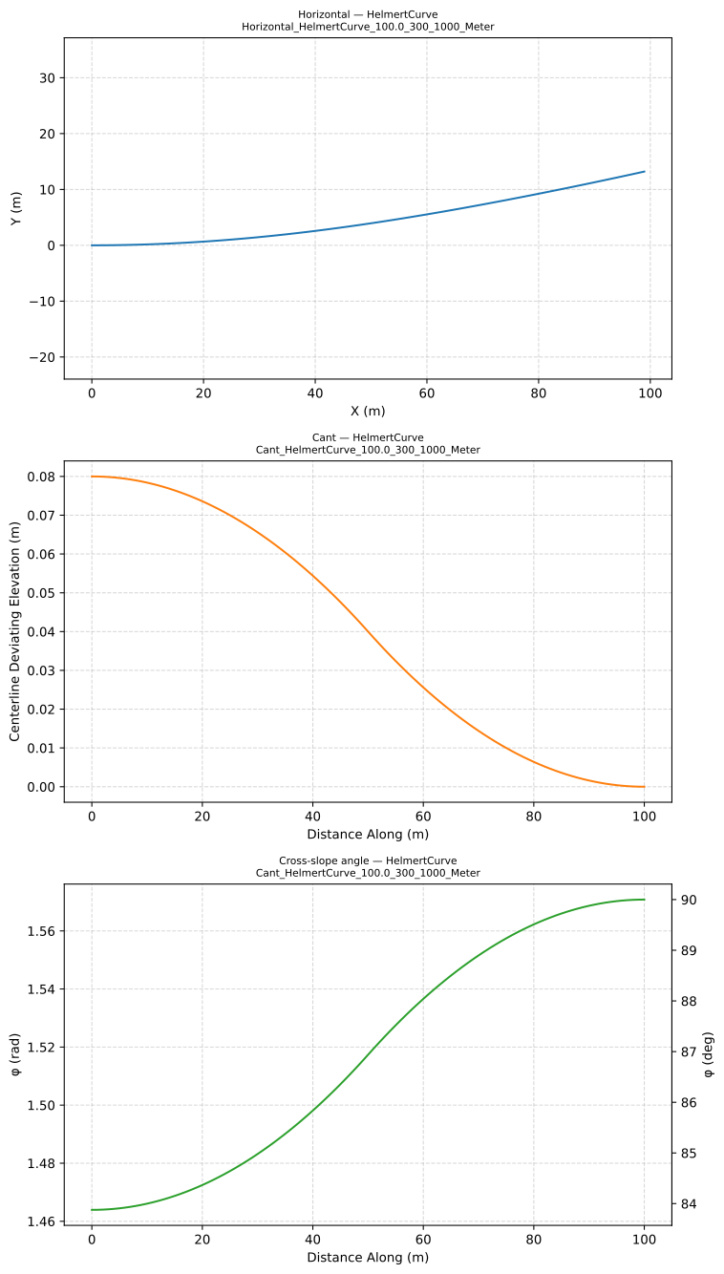
Figure 12.2.5-1 — Combined horizontal and cant plot for Cant_HelmertCurve_100.0_300_1000_Meter.

12.3 Test Cases
The test cases are organized by alignment component — horizontal, vertical, and cant — and each component is tested in isolation. Horizontal cases contain no vertical or cant layouts. Vertical cases use a straight horizontal to avoid introducing horizontal curvature. Cant cases use a flat zero-grade vertical for the same reason. This isolation strategy means that discrepancies in the reference coordinates can be attributed unambiguously to a single geometric component. Real-world alignments combining all three components are covered in Section 12.3.4.

12.3.1 Horizontal Alignment
All horizontal segments are 100 m long. These cases contain only a horizontal layout — no vertical or cant layouts are present — so any coordinate discrepancy is attributable entirely to horizontal curve evaluation. Table 12.3.1-1 summarises the curve types and case counts. All six transition types share the same eight geometry cases shown in Table 12.3.1-2.
Table 12.3.1-1 — Horizontal curve types
Curve type | IFC predefined type | Cases
Line | LINE | 1
Circular arc | CIRCULARARC | 4
Clothoid | CLOTHOID | 8
Bloss curve | BLOSSCURVE | 8
Cosine curve | COSINECURVE | 8
Helmert curve | HELMERTCURVE | 8
Sine curve | SINECURVE | 8
Viennese bend | VIENNESEBEND | 8
Table 12.3.1-2 — Horizontal transition cases (applied to all six transition types)
Start radius | End radius | Description
∞ | +300 m | Entry spiral — straight to tight left arc
+300 m | ∞ | Exit spiral — tight left arc to straight
∞ | −300 m | Entry spiral — straight to tight right arc
−300 m | ∞ | Exit spiral — tight right arc to straight
+300 m | +1000 m | Arc-to-arc — tighter to looser (left)
+1000 m | +300 m | Arc-to-arc — looser to tighter (left)
−300 m | −1000 m | Arc-to-arc — tighter to looser (right)
−1000 m | −300 m | Arc-to-arc — looser to tighter (right)
Viennese bend note: The Viennese bend (VIENNESEBEND) is unique among horizontal transition types: its geometric representation requires cant parameters to be present. The VienneseBend files in HorizontalAlignment/VienneseBend/ therefore include all three alignment layouts (horizontal, vertical, and cant), with the same parameter values as the corresponding CantAlignment/VienneseBend/ files. When extracting horizontal coordinates, only the horizontal layout is evaluated; the vertical and cant layouts are present solely to satisfy the geometry generation requirement.

12.3.2 Vertical Alignment
All vertical segments are 100 m horizontal length, starting at an elevation of 10.0 m. Gradients are expressed in percent (e.g. 0.5 = 0.5 %).
Each vertical test file includes a horizontal layout consisting of a single straight LINE segment of the same length. A straight horizontal alignment satisfies the IFC schema constraint that a vertical layout must have an associated horizontal, while isolating the vertical geometry so results can be verified independently.
Table 12.3.2-1 — Vertical curve types
Curve type | IFC predefined type | Cases
Constant gradient | CONSTANTGRADIENT | 5
Parabolic arc | PARABOLICARC | 12
Circular arc | CIRCULARARC | 12
Note: Clothoid vertical curves are not included. See Chapter 3 for discussion.
The five constant gradient cases cover 0.0 %, ±0.5 %, and ±1.0 % grade. The twelve vertical transition cases cover the full range of sag and crest combinations across flat, ascending, and descending grade pairs.

12.3.3 Cant Alignment
All cant segments are 100 m horizontal length. The RailHeadDistance is 1.5 m for all cases.
Each cant file includes a matching horizontal layout of the corresponding curve type and a flat vertical layout at 0.0 % grade and elevation 0.0 m. The flat vertical isolates the cant geometry from vertical curvature, so reference coordinate errors reflect only the cant evaluation. Table 12.3.3-1 lists the cant curve types, their paired horizontal types, and case counts.
Table 12.3.3-1 — Cant curve types
Cant type | IFC predefined type | Paired horizontal type | Cases | Cant range
Constant cant | CONSTANTCANT | CIRCULARARC | 4 | 0.16 m constant
Linear transition | LINEARTRANSITION | CLOTHOID | 8 | 0.0 ↔ 0.16 m
Bloss curve | BLOSSCURVE | BLOSSCURVE | 8 | 0.0 ↔ 0.16 m
Cosine curve | COSINECURVE | COSINECURVE | 8 | 0.0 ↔ 0.16 m
Helmert curve | HELMERTCURVE | HELMERTCURVE | 8 | 0.0 ↔ 0.16 m
Sine curve | SINECURVE | SINECURVE | 8 | 0.0 ↔ 0.16 m
Viennese bend | VIENNESEBEND | VIENNESEBEND | 8 | 0.03 ↔ 0.10 m

12.3.4 Real-World Alignments
Four real-world alignments are provided as 3D test cases under testset/real-world-alignments/. Unlike the single-component cases in Sections 12.3.1–12.3.3, these exercise the complete evaluation pipeline — from combined horizontal, vertical, and (where present) cant layouts — and produce full 3D placement matrices at each sample point.

FHWA Bridge Geometry Manual
The first case is an alignment from Appendix B of the US Federal Highway Administration Bridge Geometry Manual (see Chapter 1). It combines horizontal and vertical layouts only — no cant is present — and exercises IfcGradientCurve evaluation. The alignment is approximately 12,337 ft (3,760 m) long and is expressed in international feet.
IFC file | testset/real-world-alignments/FHWA_Alignment.ifc
Reference coordinates | testset/real-world-alignments/FHWA_Alignment.csv
Alignment name | Unnamed Alignment
Project unit | International foot
3D curve type | IfcGradientCurve

FHWA Bridge Geometry Manual — Linear Placement Variant
A second variant of the FHWA alignment is provided to support validation of IfcLinearPlacement evaluation. It carries the same horizontal and vertical geometry as the base case and adds 124 IfcReferent objects, one at every 100 ft station from 100+00 to 223+00, each with a populated CartesianPosition fallback. Each IfcPointByDistanceExpression.BasisCurve is the alignment’s IfcGradientCurve, not the 2D horizontal composite curve, so DistanceAlong is measured along the gradient curve’s horizontal projection while the evaluated position carries the true 3D (graded) elevation. Linear placement is discussed in Chapter 8.
IFC file | testset/real-world-alignments/FHWA_Alignment_with_Linear_Placement.ifc
Reference coordinates | testset/real-world-alignments/FHWA_Alignment_with_Linear_Placement.csv
Alignment name | E-Line
Project unit | International foot
3D curve type | IfcGradientCurve
The reference CSV uses the same 13-column format as the other real-world alignment files (Section 12.4.2), but contains 124 rows rather than 101 — one row per IfcLinearPlacement, ordered by station distance rather than sampled at uniform intervals. An implementation validates its linear placement support by resolving each IfcLinearPlacement’s full placement (not merely evaluating the bare gradient curve at its DistanceAlong) and comparing the result against the matching row in the CSV.

FHWA Bridge Geometry Manual — Vertical Offset / PlacementRelTo Variant
A third variant of the FHWA alignment tests two mechanisms for shifting a linear placement vertically, contrasted in Chapter 8 section 8.3.3: IfcPointByDistanceExpression.OffsetVertical (measured perpendicular to the curve’s tangent, per section 8.2.1) versus IfcLinearPlacement.PlacementRelTo (a true elevation shift). At each of the same 124 100 ft stations as the Linear Placement Variant, four IfcReferent objects are provided:
- OffsetVertical = +2.5 / -2.5 (project units), PlacementRelTo omitted
- PlacementRelTo referencing a shared IfcLocalPlacement at z = +2.5 / −2.5, with OffsetVertical omitted
On a graded segment the two mechanisms diverge: OffsetVertical perturbs X and Y slightly (it is perpendicular to an inclined tangent, not to the global XY plane) and lands at an elevation that only approximates the intended ±2.5 ft shift, while PlacementRelTo leaves X and Y unchanged and lands at exactly the intended elevation.
CartesianPosition is populated on all four variants by resolving each placement’s full placement chain — including PlacementRelTo — so every CartesianPosition matches its corresponding row in the reference CSV. (This file was originally built while an implementation’s fallback logic evaluated only the immediate RelativePlacement and ignored PlacementRelTo; it continues to serve as a regression check for that behavior.)
IFC file | testset/real-world-alignments/FHWA_Alignment_LinearPlacement_VerticalOffset.ifc
Reference coordinates | testset/real-world-alignments/FHWA_Alignment_LinearPlacement_VerticalOffset.csv
Alignment name | E-Line
Project unit | International foot
3D curve type | IfcGradientCurve
Unlike the Linear Placement Variant, this file’s reference CSV is generated by fully resolving each IfcLinearPlacement — including OffsetVertical and, for the PlacementRelTo variants, the nested local placement — rather than by evaluating the bare 3D curve at DistanceAlong alone. This is necessary because the two variants being contrasted only differ in attributes that a bare curve evaluation would ignore. The CSV uses a long format instead of the 13-column format used elsewhere in this section: one row per IfcReferent (four rows per station — DistAlong, Variant, X, Y, Z, RefDir_dx/dy/dz, Y_dx/dy/dz, Axis_dx/dy/dz), identified by a Variant column (OffsetVertical+2.5, OffsetVertical-2.5, PlacementRelTo+2.5, PlacementRelTo-2.5).

BPaimio–Kupittaa
The second case is alignment 001 from the BPaimio–Kupittaa railway line in Finland. The IFC file was provided by the Finnish Transport Infrastructure Agency (Väylävirasto) and distributed as part of the buildingSMART Germany BIM Fit Check competition. It is a full 3D railway alignment including horizontal, vertical, and cant layouts, exercising the complete IfcSegmentedReferenceCurve evaluation pipeline. The alignment is approximately 25.6 km long and is expressed in SI meters with ETRS-TM35FIN coordinates.
IFC file | testset/real-world-alignments/BPaimio-Kupittaa_GK23_N2000_2020.ifc
Reference coordinates | testset/real-world-alignments/BPaimio-Kupittaa_GK23_N2000_2020.csv
Alignment name | 001
Project unit | Meter (ETRS-TM35FIN)
3D curve type | IfcSegmentedReferenceCurve
The horizontal layout contains ten Helmert transition curves (HELMERTCURVE). In the source data, these segments do not end exactly where the next segment starts. A Helmert curve evaluated from its design parameters, as defined in Section 2.7, ends 0.5–9.6 cm from the following segment’s StartPoint and 2.5–6.3 × 10⁻⁴ rad from its StartDirection. These gaps are a property of the design data, not of the evaluation, so the reference coordinates jump at those locations. The curve segments that follow each Helmert curve are placed at their own StartPoint.

Exit Turnout — Huni Valley Station
The third case is the mainline alignment of an exit turnout at Huni Valley Station on a Swiss railway line. The IFC file was created using IfcOpenShell from LandXML source data. It is a full 3D railway alignment including horizontal, vertical, and cant layouts, exercising the complete IfcSegmentedReferenceCurve evaluation pipeline. The alignment runs from station 84+521.000 to 88+524.656 (approximately 4003.656 m) and is expressed in SI meters with LV95 coordinates (Swiss national coordinate system). The horizontal layout consists of clothoid transitions and circular arcs; the vertical layout is a single flat constant-gradient segment; and the cant layout uses linear transitions and constant-cant segments with a rail head distance of 1.0 m.
IFC file | testset/real-world-alignments/Exit_Turnout_Huni_Valley_Station.ifc
Reference coordinates | testset/real-world-alignments/Exit_Turnout_Huni_Valley_Station.csv
Alignment name | Centerline
Project unit | Meter (LV95)
3D curve type | IfcSegmentedReferenceCurve

Reference coordinate format
All three CSV files are sampled at every whole metre of distance along the 3D curve, starting at 0, plus a final row at the end of the curve when it does not fall on a whole metre. The sampling interval is 1 m (SI) regardless of the project unit, so in FHWA_Alignment.csv (international feet) DistAlong advances by 3.280840 ft per row. All positions are in project units; direction components are dimensionless. The column definitions are given in Section 12.4.2.

12.4 Reference Coordinates

12.4.1 File Format
Each reference file contains 101 rows plus a header row. The rows are sampled at 1 m intervals of horizontal distance (0.0 m to 100.0 m), so dist_along values in SurveyFoot and IntlFoot files are not round numbers. All length columns (dist_along, X, Y) are in the project unit declared by the corresponding IFC file. Direction columns (RefDir_dx, RefDir_dy, RefDir_dz, Axis_dx, Axis_dy, Axis_dz) are dimensionless and identical across all three unit variants. The columns differ by alignment type.
Horizontal alignment — HorizontalAlignment/**/*.csv
Column | Description
dist_along | Distance along the alignment from the segment start (project units)
X | Easting in the alignment plane (project units)
Y | Northing in the alignment plane (project units)
RefDir_dx | X component of the forward tangent unit vector (RefDirection)
RefDir_dy | Y component of the forward tangent unit vector (RefDirection)
The segment starts at the origin (0, 0) with a forward tangent pointing due East (+X direction). RefDir_dx and RefDir_dy together form a unit vector; the tangent angle $θ=\tan^{-1}(dy/dx)$.
Vertical alignment — VerticalAlignment/**/*.csv
Column | Description
dist_along | Horizontal distance from the segment start (project units)
Y | Elevation (project units)
RefDir_dx | X component of the tangent direction ($cosθ$)
RefDir_dy | Y component of the tangent direction ($sinθ$, proportional to grade)
The parameter passed to the evaluator is horizontal distance, not arc length, even though SegmentLength in the IFC file stores the arc length of the curve. This is consistent with the IFC specification for IfcAlignmentVerticalSegment.HorizontalLength.
Cant alignment — CantAlignment/**/*.csv
Column | Description
dist_along | Distance along the horizontal alignment (project units)
Y | Track centerline deviating elevation due to cant (project units)
RefDir_dx | X (along) component of the forward tangent (RefDirection)
RefDir_dy | Y (left) component of the forward tangent; always 0.0
RefDir_dz | Z (up) component of the forward tangent; the sine of the slope of the deviating elevation
Axis_dx | X (along) component of the banked “up” axis vector
Axis_dy | Y (left) component of the banked “up” axis vector
Axis_dz | Z (up) component of the banked “up” axis vector
The direction columns are in the cant frame of Section 4.2: X along the alignment, Y to the left and Z up. The forward tangent rises and falls with the deviating elevation, so its Y component (RefDir_dy) is always 0.0; the column is kept to make that explicit. The banked axis is the cross-track “up” direction after applying the cant rotation about the forward tangent. Where the deviating elevation changes, the axis tilts back along the track (Axis_dx) by the slope so that it stays perpendicular to the tangent. Axis_dx is 0.0 where the deviating elevation is constant, and Axis_dz approaches 1.0 when cant is zero.

12.4.2 3D Alignment Reference Coordinates
Most of the 3D CSV files under testset/real-world-alignments/ are produced by evaluating the combined 3D curve (IfcGradientCurve or IfcSegmentedReferenceCurve) directly at each sample point. Each evaluation returns a 4 × 4 placement matrix; the CSV extracts all three orientation vectors and the position.
FHWA_Alignment_with_Linear_Placement.csv and FHWA_Alignment_LinearPlacement_VerticalOffset.csv (§12.3.4) instead resolve each IfcLinearPlacement’s full placement chain rather than sampling the bare 3D curve, so that the reference values actually exercise IfcLinearPlacement evaluation. FHWA_Alignment_with_Linear_Placement.csv uses the same 13-column format as the curve-sampled files, just ordered by station rather than sampled at uniform intervals. FHWA_Alignment_LinearPlacement_VerticalOffset.csv uses a 14-column layout with an added Variant column, since it contrasts four placement variants per station. Its other columns match the table below.
Column | Description
DistAlong | Distance along the 3D curve from the start (project units)
X | X coordinate of the point (project units)
Y | Y coordinate of the point (project units)
Z | Z (vertical) coordinate of the point (project units)
RefDir_dx | X component of the forward tangent unit vector
RefDir_dy | Y component of the forward tangent unit vector
RefDir_dz | Z component of the forward tangent unit vector
Y_dx | X component of the cross-track unit vector
Y_dy | Y component of the cross-track unit vector
Y_dz | Z component of the cross-track unit vector
Axis_dx | X component of the “up” axis unit vector
Axis_dy | Y component of the “up” axis unit vector
Axis_dz | Z component of the “up” axis unit vector
The three direction vectors (RefDir, Y, Axis) form an orthonormal right-handed frame at each point. For alignments without cant, Axis is perpendicular to the horizontal plane and Y_dz is zero. For railway alignments with cant, Axis is banked about the forward tangent and both Y_dz and Axis_dy become non-zero.

12.4.3 3D Synthetic Testset Coordinates
The 3D/ subfolders under Alignment-reference-testset/VerticalAlignment/ and …/CantAlignment/ contain combined 3D reference coordinates for each synthetic test case. Each file uses the same 13-column header as §12.4.2 and is sampled at the same 101 points (0–100 m at 1 m intervals in SI metres, reported in project units).
File naming follows the same convention as the 2D files, with the .ifc extension replaced by .csv:
VerticalAlignment/{CurveType}/3D/Vertical_{CurveType}_{Length}_{StartHeight}_{StartGrade}_{EndGrade}_{Unit}.csv
CantAlignment/{CurveType}/3D/Cant_{CurveType}_{Length}_{StartRadius}_{EndRadius}_{Unit}.csv
Curve evaluated. For vertical test cases (which include a straight horizontal layout), the evaluated curve is IfcGradientCurve. For cant test cases (which include a matching horizontal and a flat zero-grade vertical), the evaluated curve is IfcSegmentedReferenceCurve.
Interpreting the output. Because vertical test cases use a straight horizontal alignment, the X and Y position columns are collinear with distance along, and curvature appears only in the Z (elevation) column and the RefDir_dz component. Because cant test cases add a flat zero-elevation vertical to the same straight horizontal, Z is always 0.0 at position, but the Axis and Y vectors rotate about the forward tangent to reflect the applied cant. This isolation makes the 3D synthetic files a controlled integration check: a position error in X or Y points to a horizontal evaluation bug; an error in Z or RefDir_dz points to a vertical bug; an error in Axis_dy/Axis_dz (with correct position) points to a cant rotation bug.

12.5 Validation Guidance

12.5.1 What to Check
The three forms of the testset support three distinct validation activities:
Semantic round-trip. Read a semantic IFC file and verify that the IfcAlignmentSegment attributes (StartRadiusOfCurvature, EndRadiusOfCurvature, SegmentLength, PredefinedType, etc.) are correctly parsed and preserved. This test does not require any geometric evaluation.
Geometric representation. Verify that each IfcAlignmentSegment maps to the correct IfcCurveSegment parent curve type, placement, and zero-length terminator. This applies both when constructing a geometry IFC file from a semantic file and when reading a reference geometry file — in either case no numerical evaluation is required.
Geometric accuracy. Evaluate a geometry IFC alignment at 1 m intervals and compare the resulting coordinates against the reference values. This is the primary numerical test. For vertical and cant cases, compare both the component-plane 2D output (§12.4.1) and the full 3D placement matrix output (§12.4.3) to isolate pipeline bugs from component evaluation bugs.

12.5.2 Comparison Approach
Load a geometry IFC file, evaluate the alignment curve at $d=0.0,1.0,2.0,…,100.0$ meters, and compare each computed value against the corresponding row in the reference file.
The most useful comparisons are:
- Position (X, Y for horizontal; Y for vertical and cant) — the absolute coordinate values.
- Tangent direction (RefDir_dx, RefDir_dy) — the forward tangent components.
- Banked axis (Axis_dy, Axis_dz, cant only) — the cross-track “up” direction. Errors here indicate a problem in the cant rotation logic.

12.5.3 Cross-Unit Validation
Because the three unit variants encode the same physical alignment, they provide an independent check for unit-handling correctness that does not require any external ground truth. The procedure is:
- Evaluate the Meter, SurveyFoot, and IntlFoot variants of the same test case.
- Convert all SurveyFoot coordinates to meters by multiplying by 1200/3937.
- Convert all IntlFoot coordinates to meters by multiplying by 0.3048.
- Compare the three meter-equivalent result sets row by row.
If the implementation handles units correctly, the differences should be below 10⁻⁶ m at every sample point — consistent with double-precision floating-point rounding in the unit conversion arithmetic. Differences larger than 10⁻³ m, or differences that grow systematically with distance along the alignment, indicate a unit-handling defect.
This cross-unit check is most effective at isolating unit bugs from algorithmic bugs, because a geometric error will appear in all three variants while a unit error will appear only in the scaled variants.

Chapter 13 — References

References
[1] buildingSMART International, IFC4x3 ADD2: Industry Foundation Classes, Release IFC4X3_ADD2, buildingSMART International, 2023. [Online]. Available: https://standards.buildingsmart.org/IFC/RELEASE/IFC4_3/. Also published as ISO 16739-1:2024, International Organization for Standardization, Geneva, 2024.
[2] J. Corven, T. Eberhardt, B. Watson, B. Chavel, J. Mash, D. Paterson, and T. Anthony, Bridge Geometry Manual, Report No. FHWA-HIF-22-034, U.S. Federal Highway Administration, U.S. Department of Transportation, Washington, DC, 2022. [Online]. Available: https://www.fhwa.dot.gov/bridge/pubs/hif22034.pdf
[3] bSI RailwayRoom, IFC-Rail-Unit-Test-Reference-Code: Source Code and Synthetic Cases for IFC 4.3 Alignment Geometry Testing and Validation, GitHub. [Online]. Available: https://github.com/bSI-RailwayRoom/IFC-Rail-Unit-Test-Reference-Code. [Accessed: May 2026].
[4] buildingSMART International, IFC4.x-IF: IFC Implementers Forum, GitHub. [Online]. Available: https://github.com/buildingSMART/IFC4.x-IF. [Accessed: May 2026].
[5] buildingSMART International, ifc-gherkin-rules: Normative Rules for IFC Validation, GitHub. [Online]. Available: https://github.com/buildingSMART/ifc-gherkin-rules. [Accessed: May 2026].
[6] buildingSMART International, IFC4.x-development: Repository to Collect Updates to the IFC 4.3 Specification, GitHub. [Online]. Available: https://github.com/buildingSMART/IFC4.x-development. [Accessed: May 2026].
[7] Š. Jaud, A.-K. Birkenbeul, J. Braunes, R. Brice, C. Clemen, D. Hintz, C. Kautter, E. Kocher, C. Leverenz, A. Pinzenöhler, S. Rabe, R. Raacke, A. Schütz, R. Steyer, and B. Wehrle, BIM Fit Check — IFC Georeferencing & Alignment Exchanges, buildingSMART Deutschland, 2026. [Online]. Available: https://www.buildingsmart.de/buildingsmart/aktuelles/erkenntnisse-zu-ifc-und-bcf-aus-bim-fit-check-runden
[8] buildingSMART International, Validation Service, buildingSMART International. [Online]. Available: https://www.buildingsmart.org/users/services/validation-service/. [Accessed: May 2026].
[9] bSI InfraRoom, IFC-Specification: Infrastructure Room Repository for IFC Specification Development, GitHub. [Online]. Available: https://github.com/bSI-InfraRoom/IFC-Specification. [Accessed: July 2026].

Further Reading
[10] F. Dillen, “The Classification of Hypersurfaces of a Euclidean Space with Parallel Higher Order Fundamental Form,” Mathematische Zeitschrift, vol. 203, pp. 635–643, Springer-Verlag, 1990, doi: 10.1007/BF02570761.
[11] European Committee for Standardization, BS EN 13803:2017: Railway Applications — Track — Track Alignment Design Parameters — Track Gauges 1 435 mm and Wider, BSI Standards Publication, Brussels, 2017.
[12] M. O. Schmidt and K. W. Wong, Fundamentals of Surveying, 3rd ed., PWS Engineering, Boston, MA, 1985, ISBN 0-534-04161-2.
[13] C. H. Waldman, “The Polynomial Spiral and Beyond,” National Curve Bank, Deposit #125, 2013. [Online]. Available: https://nationalcurvebank.org/deposits/waldman4.html
[14] buildingSMART International, IFC Road Phase 2 — Candidate Standard, buildingSMART International, May 2020. [Online]. Available: https://www.buildingsmart.org/wp-content/uploads/2020/06/IR-CS-WP2-UML_Model_Report_Part-5_.pdf
[15] buildingSMART International, IFC Road Phase 2 — Conceptual Model, buildingSMART International. [Online]. Available: https://app.box.com/s/tsmjlt88w6ye0apbqlg5xkucu7hr6kky. [Accessed: June 2026].
[16] buildingSMART International, IFC Road Phase 2 — Conceptual Model: Annex I — Example Instance Diagrams, buildingSMART International. [Online]. Available: https://app.box.com/s/d3b6ua3ug047gglpp44sj7t3d84vlphl. [Accessed: June 2026].
[17] buildingSMART International, IFC Road Phase 2 — Conceptual Model: Annex II — Reading Guide, buildingSMART International. [Online]. Available: https://app.box.com/s/e1fy291xyv1ux5tzdyuadkup958x0bf6. [Accessed: June 2026].
[18] buildingSMART International, IFC Road Phase 2 — Prototypical Implementation, buildingSMART International. [Online]. Available: https://app.box.com/s/d7123nwhe1xr7vpwk1qucj22a3u8zjxu. [Accessed: June 2026].

Appendix A — LandXML to IFC Conversion

A.0 Introduction
LandXML 1.x is the dominant legacy format for civil alignment data; IFC 4x3 is the modern target. The goal of this chapter is to guide implementers through the decisions and pitfalls that arise during conversion, drawn from practical experience implementing LX2IFC, the author’s open-source LandXML to IFC conversion program. LX2IFC focuses on alignment conversion and is otherwise incomplete as a general-purpose LandXML to IFC conversion utility; it remains a work in progress.

A.1 Schema Conceptual Comparison
The following table provides a high-level mapping of the two data models.
LandXML | IFC 4x3
<Alignments> / <Alignment> | IfcAlignment nested under IfcProject via IfcRelAggregates
<CoordGeom> | IfcAlignmentHorizontal nested via IfcRelNests
<Profile> / <ProfAlign> | IfcAlignmentVertical nested via IfcRelNests
<Cant> | IfcAlignmentCant nested via IfcRelNests
<StaEquation> | IfcReferent with stationing attributes and properties
<Units> | IfcUnitAssignment in IfcProject
Table A.1-1 — LandXML to IFC schema conceptual comparison
The key conceptual difference between the two schemas is that LandXML defines geometry through PI and PVI points with derived curve parameters, whereas IFC defines geometry as explicit typed segments each carrying a start condition, length, and curve parameters.

A.2 Units
LandXML carries explicit unit declarations (<Metric>, <Imperial>) for linear and angular measure. IFC requires all geometry in SI base units (meters, radians) or with an explicit IfcConversionBasedUnit.
Read <Units> before processing any geometry — all coordinate values depend on it.
Linear units. Convert foot and US Survey foot to meters as needed. Note that the US Survey foot and the international foot are not the same:
$$1 \text{US Survey foot}=\frac{1200}{3937} \text{m}≈0.3048006 \text{m}$$
$$1 \text{international foot}=0.3048 \text{m (exact)}$$
Using the wrong conversion factor introduces a systematic error that compounds over long alignments.
Angular units. LandXML directions can be expressed in decimal degrees, grads, or radians. IFC angular units are declared in IfcUnitAssignment — the SI base unit is radians, but IfcConversionBasedUnit can declare degrees, grads, or any other angular unit. When constructing an IFC model from LandXML, the converter controls what angular unit the output model declares; declaring radians (the default) avoids an extra conversion step and is the most common choice.
Bearing convention. LandXML directions are azimuths measured clockwise from North. IFC plane angles are measured counter-clockwise from the positive X-axis (East). The conversion is
$$θ_{IFC}=\frac{π}{2}-θ_{bearing}$$
where $θ_{bearing}$ is in radians.

A.3 Horizontal Alignment

A.3.1 LandXML Horizontal Element Types
The LandXML <CoordGeom> element contains a sequence of <Line>, <Curve>, and <Spiral> child elements. Each maps to an IfcAlignmentSegment nested under IfcAlignmentHorizontal.

A.3.2 Direction from Geometry
LandXML lines and spirals often omit explicit direction attributes (Dir, DirStart) and rely on the geometry — start/end or start/PI points — to imply direction. IfcAlignmentHorizontalSegment.StartDirection is required. When the direction attribute is absent, compute it from the available geometry:
$$θ=atan2(Δy,Δx)$$
then apply the bearing-to-IFC plane angle conversion from Section A.2.

A.3.3 Circular Curve (<Curve> → CIRCULARARC)
<Curve> provides center, start, end, and radius. IFC requires the start point, the start direction (the tangent direction, not the radial direction), the signed radius, and the arc length.
Compute the tangent direction from the radial line by rotating 90°:
$$θ_{tangent}=atan2(y_{start}-y_{center}, x_{start}-x_{center})+\text{sign}⋅\frac{π}{2}$$
where $\text{sign}=+1$ for counter-clockwise (rot="ccw") and $\text{sign}=-1$ for clockwise (rot="cw"). The signed radius passed to IfcAlignmentHorizontalSegment follows the same sign convention.

A.3.4 Spiral Type Mapping
The following table maps LandXML spiType values to IfcAlignmentHorizontalSegmentTypeEnum.
LandXML spiType | IFC Type | Notes
clothoid | CLOTHOID | Direct mapping
bloss | BLOSSCURVE | Direct mapping
biquadratic | HELMERTCURVE | Direct mapping
biquadraticParabola | HELMERTCURVE | Equivalent to biquadratic
cubic | CUBIC | Direct mapping
cubicParabola | CUBIC | Equivalent to cubic
cosine | COSINECURVE | Direct mapping
sinusoid | SINECURVE | Direct mapping
sineHalfWave | COSINECURVE | Approximation — loss of fidelity, see note below
japaneseCubic | VIENNESEBEND | Direct mapping
revBiquadratic | — | IFC mapping unknown, log warning and skip
revBloss | — | IFC mapping unknown, log warning and skip
revCosine | — | IFC mapping unknown, log warning and skip
revSinusoid | — | IFC mapping unknown, log warning and skip
radioid | — | IFC mapping unknown, log warning and skip
weinerBogen | — | IFC mapping unknown, log warning and skip
Table A.3.4-1 — LandXML spiType to IFC type mapping
Note: The LandXML specification describes the sine half-wavelength spiral as an approximation of a cosine spiral. Mapping it to COSINECURVE is therefore reasonable but not exact. Implementations should log a warning when this substitution is made.

A.3.5 Radius Sign Convention
LandXML uses rot="cw" / rot="ccw" to indicate curve direction. IFC encodes direction in the sign of StartRadiusOfCurvature and EndRadiusOfCurvature: a positive value indicates a left turn (counter-clockwise) and a negative value indicates a right turn (clockwise).
$$\text{sign}=\left\{\begin{matrix}-1 & \text{if }rot=cw \\ +1 & \text{if }rot=ccw\end{matrix}\right.$$
Apply this sign to both StartRadiusOfCurvature and EndRadiusOfCurvature.

A.3.6 Infinite Radius
LandXML represents an infinite start or end radius by omitting the attribute or by supplying the value INF. IFC uses 0.0 in IfcAlignmentHorizontalSegment.StartRadius or EndRadiusOfCurvature to indicate an infinite radius. Substitute 0.0 whenever the LandXML value is absent or is INF.

A.4 Vertical Alignment

A.4.1 LandXML Vertical Data Model
LandXML represents vertical geometry as a sequence of PVI-based elements under <ProfAlign>: <PVI>, <ParaCurve>, <UnsymParaCurve>, and <CircCurve>. This is fundamentally different from IFC’s segment-based model, which requires an explicit start station, start elevation, start grade, end grade, and length for each segment.

A.4.2 PVI-Based to Segment-Based Conversion
The core translation challenge is that LandXML locates vertical curves by their PVI station and curve length, while IFC needs each segment’s start station explicitly. The conversion procedure is:
- Compute the entry grade from the PVI station and the previous PVI or curve endpoint.
- The start station of a symmetric parabolic curve is $\text{PVI station}-L/2$.
- The start elevation is computed by projecting back from the PVI along the entry grade: $e_{start}=e_{PVI}-g_{1}⋅L/2$.
- Gradient segments fill any gap between the end of one curve and the start of the next.

A.4.3 Symmetric Parabolic Arc (<ParaCurve> → PARABOLICARC)
This is the standard vertical curve case. Given PVI station $s_{PVI}$, PVI elevation $e_{PVI}$, curve length $L$, entry grade $g_{1}$, and exit grade $g_{2}$:
$$s_{start}=s_{PVI}-\frac{L}{2}$$
$$e_{start}=e_{PVI}-g_{1}\frac{L}{2}$$
Map to IfcAlignmentVerticalSegment with PredefinedType = PARABOLICARC, StartDistAlong = s_{start} - s_{alignment\_start}, StartHeight = e_{start}, StartGradient = g_1, EndGradient = g_2, HorizontalLength = L.

A.4.4 Asymmetric Parabolic Arc (<UnsymParaCurve> → Two PARABOLICARC Segments)
IFC has no asymmetric vertical curve type. The <UnsymParaCurve> must be split into two abutting PARABOLICARC segments. Given entry length $L_{in}$, exit length $L_{out}$, entry grade $g_{1}$, and exit grade $g_{2}$:
Compute the vertical offset from the composite curve to the PVI:
$$h=\frac{L_{in}⋅L_{out}⋅(g_{2}-g_{1})}{2(L_{in}+L_{out})}$$
The transition point between the two sub-curves occurs at the PVI station with elevation:
$$e_{transition}=e_{PVI}+h$$
The intermediate grade at the transition point is:
$$g_{mid}=g_{1}+\frac{2h}{L_{in}}$$
Create two PARABOLICARC segments: the first from the curve start to the PVI station with grades $g_{1}$ and $g_{mid}$, and the second from the PVI station to the curve end with grades $g_{mid}$ and $g_{2}$.

A.4.5 Circular Vertical Curve (<CircCurve> → CIRCULARARC)
LandXML provides the radius and arc length. IFC IfcAlignmentVerticalSegment for CIRCULARARC accepts the radius directly in the RadiusOfCurvature attribute. Compute the start station and elevation the same way as for a symmetric parabolic arc, using $L/2$ as the half-length. Note that this is an approximation — the true tangent length of a circular vertical curve is $T=Rtan(Δ/2)$ where $Δ=L/R$, which differs from $L/2$ except for small deflection angles.

A.4.6 Station to Distance Along
LandXML vertical profile elements are positioned by station. IfcAlignmentVerticalSegment.StartDistAlong is distance along the horizontal alignment measured from the alignment start — a continuous value with no breaks. These are not the same thing whenever station equations are present.
In the simplest case — no station equations — the conversion is:
$$\text{StartDistAlong}=s_{LandXML}-s_{alignment_start}$$
where $s_{alignment_start}$ is read from <Alignment staStart="...">.
When station equations are present, the station numbering is discontinuous: a gap or overlap at each equation point means a given station value does not map to a unique physical distance without knowing which zone it falls in. The conversion must walk the list of <StaEquation> elements in order, accumulating the physical distance up to each equation point, then apply the appropriate offset for the zone containing the target station. The staInternal attribute on <StaEquation> gives the continuous internal distance and can serve as a cross-check.

A.5 Cant

A.5.1 LandXML Cant Model
LandXML <Cant> uses <CantStation> points and <CantSegment> elements with left and right cant values at the start and end of each segment, along with a curve type designation.

A.5.2 Mapping to IfcAlignmentCant
Each <CantSegment> maps to an IfcAlignmentCantSegment with StartCantLeft, StartCantRight, EndCantLeft, EndCantRight, and PredefinedType. The cant segment type mapping follows the same spiral type table as horizontal alignment (Section A.3.4).

A.5.3 Rail Head Distance
IfcAlignmentCant.RailHeadDistance is the distance between rail heads (track gauge). In LandXML, this value is the gauge attribute on the <Cant> element:
<Cant name="001" gauge="1.524" rotationPoint="insideRail">
Map gauge directly to IfcAlignmentCant.RailHeadDistance. The value is in the model’s declared length units.

A.5.4 Rotation Point Mapping
The rotationPoint attribute on <Cant> indicates which point on the cross-section serves as the pivot for superelevation rotation. LandXML defines three values: insideRail, centerline, and outsideRail. The curvature attribute on each <CantStation> indicates whether the curve is clockwise (cw, right turn) or counter-clockwise (ccw, left turn), which determines which physical rail is on the inside or outside.
IfcAlignmentCantSegment has no explicit rotation point attribute. Instead, rotation point is encoded implicitly through the combination of StartCantLeft, StartCantRight, EndCantLeft, and EndCantRight values. A zero cant value on one side indicates the pivot is on that side; equal and opposite values indicate centerline rotation.
Table A.5.4-1 gives the IFC cant values in terms of the LandXML appliedCant magnitude $c$ for each combination of curvature and rotationPoint:
curvature | rotationPoint | CantLeft | CantRight
ccw (left turn, right = outside) | insideRail | $$0$$ | $$+c$$
ccw (left turn, right = outside) | centerline | $$-c/2$$ | $$+c/2$$
ccw (left turn, right = outside) | outsideRail | $$-c$$ | $$0$$
cw (right turn, left = outside) | insideRail | $$+c$$ | $$0$$
cw (right turn, left = outside) | centerline | $$+c/2$$ | $$-c/2$$
cw (right turn, left = outside) | outsideRail | $$0$$ | $$-c$$
Table A.5.4-1 — LandXML curvature and rotationPoint to IFC CantLeft/CantRight mapping
Apply the same logic to both the start and end values of each segment. The rotationPoint is constant for the entire <Cant> element; curvature and appliedCant are read from each <CantStation> and applied to the corresponding segment start and end positions.

A.6 Stationing and Station Equations

A.6.1 Start Station
The LandXML <Alignment staStart="..."> attribute gives the station at the beginning of the alignment. Map this to an IfcReferent with PredefinedType = STATION, with the station value stored in Pset_Stationing.Station. See Chapter 9 for the full IfcReferent and Pset_Stationing structure.

A.6.2 Station Equations (<StaEquation>)
LandXML <StaEquation> records station breaks where the back station and ahead station differ. Each equation maps to an additional IfcReferent. The relevant attributes are:
LandXML Attribute | Meaning
staBack | Station value before the equation (incoming)
staAhead | Station value after the equation (outgoing)
staInternal | Continuous internal station (no breaks)
Table A.6.2-1 — LandXML station equation attributes
Map each <StaEquation> to an IfcReferent as follows:
- staBack → Pset_Stationing.IncomingStation (the station value on the incoming side of the break)
- staAhead → Pset_Stationing.Station (the station value on the outgoing side)
- staInternal → the DistanceAlong value in IfcPointByDistanceExpression for the referent’s IfcLinearPlacement
staInternal is the continuous internal distance along the alignment with no station breaks. It is therefore the correct value to use as DistanceAlong — it maps directly to arc-length along the horizontal curve without any equation adjustment. If staInternal is absent, compute DistanceAlong by walking the equation list as described in Section A.4.6.
The resulting IfcReferent instances, including the starting station referent from A.6.1, are nested under the IfcAlignment via a dedicated IfcRelNests relationship in order of increasing DistanceAlong. See Chapter 9 for the complete IfcReferent structure, the nesting requirements, and the algorithm for converting station labels to DistanceAlong when equations are present.

Index

A
accuracy — 5.2, 11.0
arc length — 2.2, 3.2, 4.2, 5.5
arc length, offset curve — 5.2
angle point — 8.2.1.1
asymmetric parabolic arc — A.4.4
authoring versus consuming — 10.5.3
Axis (coordinate vector) — 4.1.2, 8.3.1

B
banking — see cant
Bloss transition curve
horizontal — 2.8, 2.8.1–2.8.3
cant — 4.6, 4.6.1–4.6.3
testset — 12.3.1, 12.3.3
breaklines — 10.3.1

C
cant alignment — 1.3, 4.0–4.12
cant coordinate system — 4.1.2
cant transition — 4.1.1, 4.1.3
CartesianPosition — 8.4
chainage — see DistanceAlong
circular arc
horizontal — 2.4, 2.4.1–2.4.3
vertical — 3.4, 3.4.1–3.4.3
LandXML — A.3.3, A.4.5
Clothoid (Euler spiral)
horizontal — 2.5, 2.5.1–2.5.3
vertical — 3.5
testset — 12.3.1, 12.3.3
closing segment — see zero-length segment
combined 3D alignment — 3.7, 4.10
concept template — 7.1, 7.3
constant cant — 4.3, 4.3.1–4.3.3
constant gradient — 3.3, 3.3.1–3.3.3
coordinate system
cant — 4.1.2
placement — 8.3
Cosine transition curve
horizontal — 2.9, 2.9.1–2.9.3
cant — 4.7, 4.7.1–4.7.3
testset — 12.3.1, 12.3.3
cross-section — 10.0–10.5
cross-track direction — 4.1.2
cubic transition curve — 2.6, 2.6.1–2.6.3
curvature — 2.2, Notation
curve segment evaluation algorithm
horizontal — 2.2
vertical — 3.2
cant — 4.2

D
default Axis direction — 8.3.2, 10.5.6
deviating elevation — 4.0, 4.1.2, Notation
directrix — 10.3, 10.4, 10.5
DistanceAlong — 8.2.1, 8.2.2, 9.2.5
DistanceAlong, station conversion — 8.2.2, 9.2.5, 9.2.6, A.4.6

E
edge of pavement — 5.0, 10.2
EnrichIfc4x3 — 4.11
Euler spiral — see Clothoid
example models
offset curves — 5.5
linear placement — 8.3.3
sectioned surfaces — 10.6.1
sectioned solids — 10.6.2

F
fallback Cartesian position — 8.4
Fresnel integrals — 2.5.1

G
gap equation — 9.2.3
gap, station undefined — 9.2.5, 9.2.6
geometric representation — 1.5, 2.1
grade — 3.3, Notation
grade-separated crossing — 9.5.2
guide curve — 10.2, 10.3, 10.5

H
Helmert transition curve
horizontal — 2.7, 2.7.1–2.7.3
cant — 4.5, 4.5.1–4.5.3
testset — 12.3.1, 12.3.3
horizontal alignment — 1.1, 2.0–2.13

I
IFC105 validation rule — 5.1, 10.5.2
IfcAlignment — 1.0, 1.4, 1.5, 5.2, 7.1
IfcAlignmentCant — 1.3, 4.0
IfcAlignmentHorizontal — 1.1, 2.0, 2.1
IfcAlignmentSegment — 1.4, 1.5.2
IfcAlignmentVertical — 1.2, 3.0, 3.1
IfcAxis2PlacementLinear — 8.2, 8.3
IfcCircle
horizontal — 2.4, 2.4.1
vertical — 3.4, 3.4.1
IfcCompositeCurve — 1.5, 1.5.1, 2.1
IfcConnectionPointEccentricity — 9.5.2
IfcConnectionPointGeometry — 9.5.2
IfcCurveSegment — 1.5, 1.5.2
IfcGradientCurve — 1.5.1, 3.7, 8.3.3
IfcIndexedPolyCurve — 6.1
IfcInterferenceSelect — 9.5.2
IfcLine
horizontal — 2.3, 2.3.1
vertical — 3.3, 3.3.1
IfcLinearPlacement — 8.2, 8.5
IfcOffsetCurveByDistances — 5.0, 5.1, 5.2, 5.3, 5.4, 5.5, 8.5
IfcPointByDistanceExpression — 5.0, 8.2
IfcPolyline — 6.1
IfcPolynomialCurve — 2.6, 2.7, 2.8, 2.9, 2.10, 2.11
IfcRailway — 9.5.2
IfcReferent — 9.1, 9.3, 9.3.4, 9.4, 9.5
IfcRelInterferesElements — 9.5.2
IfcRelNests — 9.3.1, 9.3.2, 9.3.4
IfcRelPositions — 9.4.1, 9.4.2, 9.5
IfcRelReferencedInSpatialStructure — 9.5.2
IfcRoad — 9.5.2
IfcSectionedSolidHorizontal — 10.4, 10.4.1, 10.6.2
IfcSectionedSurface — 10.3, 10.3.1, 10.3.2, 10.6.1
IfcSegmentedReferenceCurve — 1.5.1, 4.0, 4.2
implementation checklist
horizontal — 2.13
vertical — 3.9
cant — 4.13
linear placement — 8.7
referents and stationing — 9.6
implementation questions — 7.2
ImpliedOrder — 9.5.2
infinite radius — A.3.6
InterferenceType — 9.5.2
INTERSECTION referent — 9.5, 9.5.1
interpolation, offset values — 5.3
ISO 19148 — 8.6, 9.5.1

K
key-point referent — 9.3.4
horizontal (P.O.B., P.C., P.T., P.O.E.) — 9.3.4.1
vertical (V.P.O.B., P.V.C., P.V.T., V.P.O.E.) — 9.3.4.1

L
LandXML — Appendix A
horizontal mapping — A.3
vertical mapping — A.4
cant mapping — A.5
stationing — A.6
lane striping — 5.0
linear placement — 8.0–8.7
linear referencing — 8.6
linear transition (cant) — 4.4, 4.4.1–4.4.3
live model management — 7.3

M
matrix composition
horizontal — 2.2
vertical — 3.2
cant — 4.2
mixed-nesting problem — 9.3.2

N
notation — Notation chapter

O
offset curves — 5.0–5.5
offset sign convention — 5.1
OffsetLateral — 5.2, 8.2.1, 8.5.2
OffsetLongitudinal — 8.2.1.1
OffsetVertical — 8.2.1
overlap equation — 9.2.4
overlap, station ambiguity — 9.2.6

P
parabolic arc — 3.6, 3.6.1–3.6.3
LandXML — A.4.3, A.4.4
parent curve — 1.5.2, 2.1
parent/child structure — 7.1.1
PlacementRelTo — 8.1.2, 8.3.3
precision — 11.0
Product Relative Positioning — 9.4.1
Product Span Positioning — 9.4.2
profile (cross-section) — 10.1
profile orientation — 10.5.7
Pset_LinearReferencingMethod — 8.6.2, 8.6.3, 8.6.4
Pset_Stationing — 9.3.1, 9.3.4
PVI (point of vertical intersection) — 9.3.4, A.4.2

R
radius sign convention — 2.1, A.3.5
real-world alignments (testset) — 9.3.4.1, 12.3.4
reference coordinates — 12.2.4, 12.4
referent ordering — 9.3.1
referent placement (ObjectPlacement) — 9.3.3
representation scoping — 10.5.2
retaining wall — 10.6.2.4
RefDirection — 4.1.2, 8.3.1
rotation point — A.5.4

S
sectioned surfaces and solids — 10.0–10.6
specification gaps — 10.5
segment mapping — 1.6, 2.3.2, 2.4.2, 2.5.2, 2.6.2, 2.7.2, 2.8.2, 2.9.2, 2.10.2, 2.11.2
semantic definition — 1.4, 2.1
semantic vs. geometric — 1.4, 1.5, 9.4
sibling representation — 10.5.1, 10.5.2
sign convention
curvature — 2.1
offset — 5.0
radius (LandXML) — A.3.5
Sine transition curve
horizontal — 2.10, 2.10.1–2.10.3
cant — 4.8, 4.8.1–4.8.3
testset — 12.3.1, 12.3.3
spiral — see transition curves
start station — 9.2.1, A.6.1
station equations — 9.2.2–9.2.6, A.6.2
stationing — 9.2, 9.3.1, A.6
stringlines — 10.2, 10.3.2, 10.6.1.4–10.6.1.6, 10.6.2.5, 10.6.2.6
superelevation — see cant

T
Tag attribute — 5.4, 10.3
tangent direction — 4.1.2
testset — 12.1–12.5
file naming — 12.2
horizontal test cases — 12.3.1
vertical test cases — 12.3.2
cant test cases — 12.3.3
real-world cases — 12.3.4
validation guidance — 12.5
tolerance — 11.0
transition curves — 2.5–2.11
see also individual curve types
two-level placement — 2.7.2

U
units of measure — 1.7, 12.2.1, A.2
unreachable points — 8.2.1.1

V
validation — 5.1, 12.5
vertical alignment — 1.2, 3.0–3.8
Viennese Bend (VienneseBend)
horizontal — 2.11, 2.11.1–2.11.3
cant — 4.9, 4.9.1–4.9.3
testset — 12.3.1, 12.3.3

W
workflow, alignment reuse — 7.3, 7.3.1

Z
zero-length segment — 2.12, 2.12.1–2.12.2

