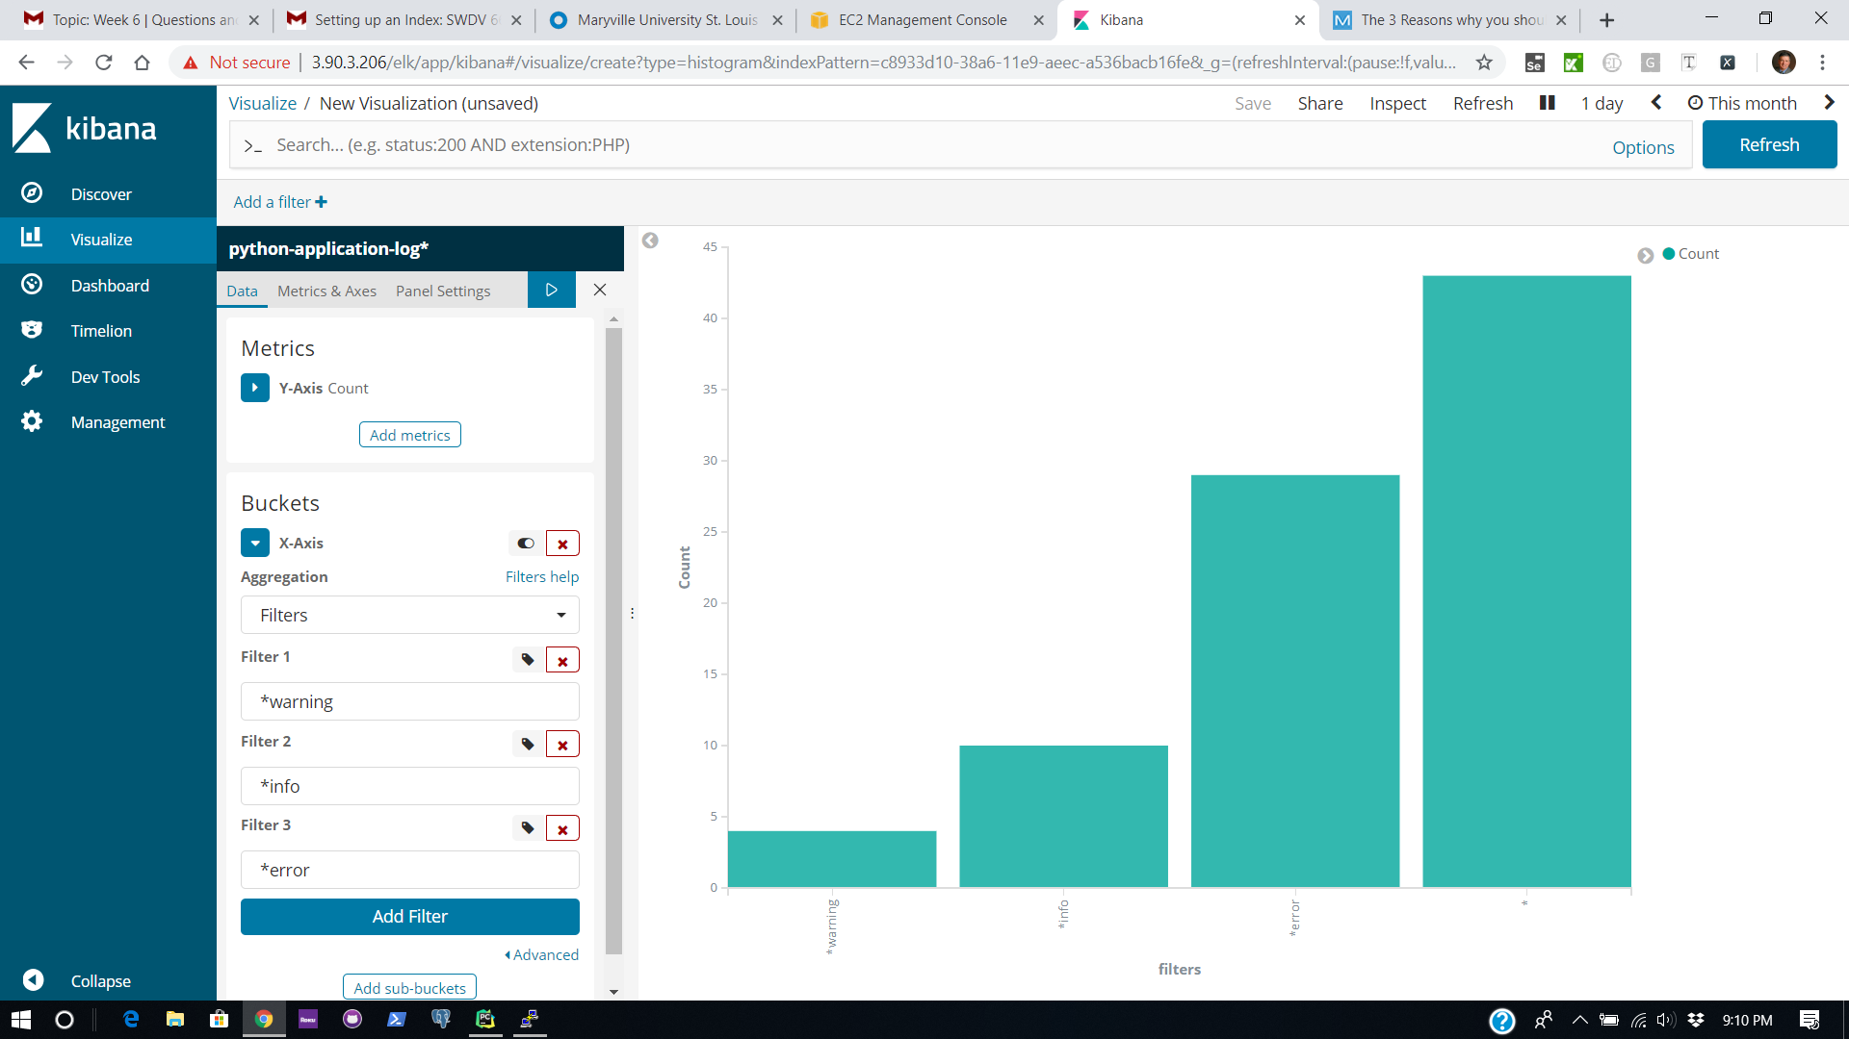

Graph showing the count of warning, info, error, and all messages

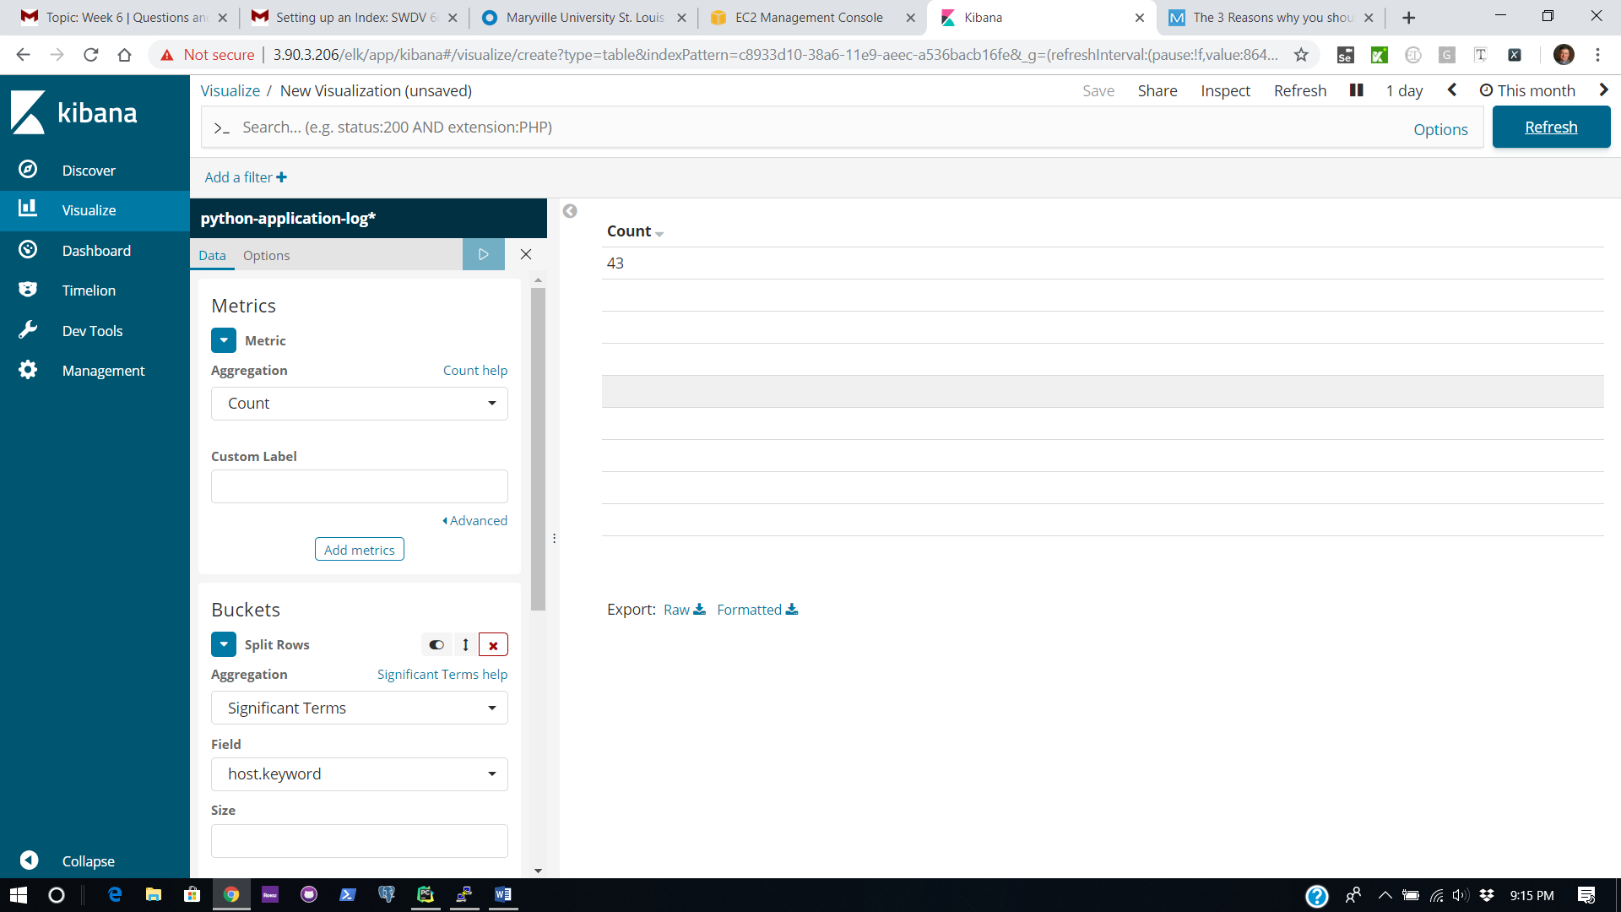

Table view showing a count based on host and logger name.

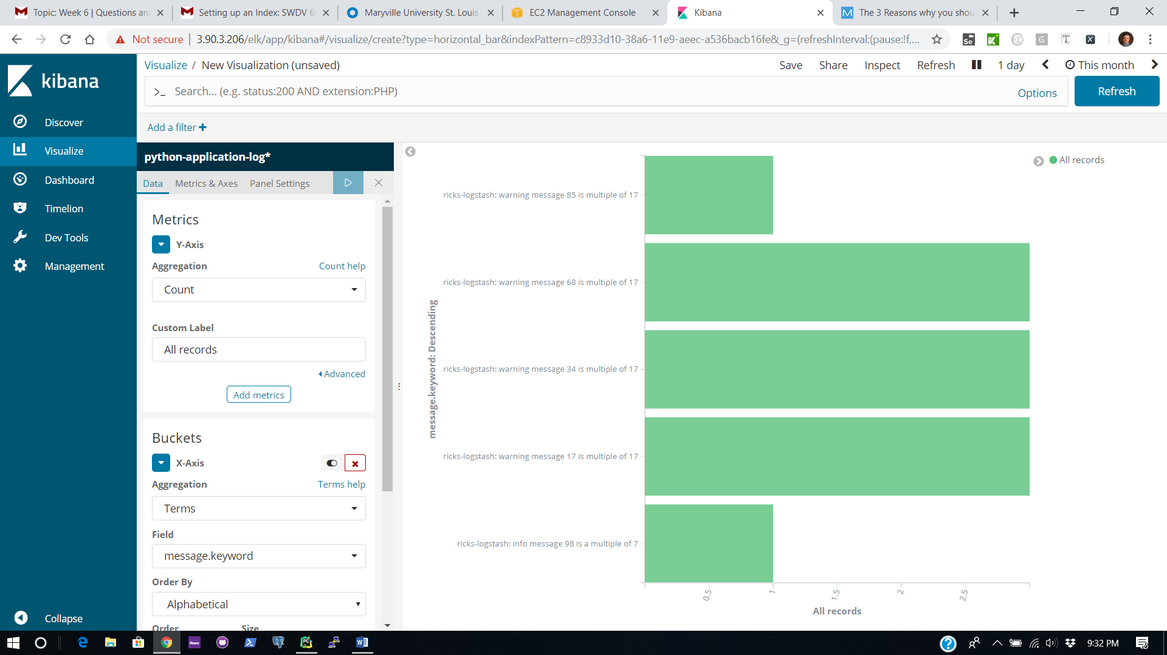

Screen showing some of the items I placed into the generic logger to catch additional info