Rick Colgan

April Adams

SWDV 620 2W 18/FA1

October 20, 2018

Semester Project: Testing

Testing for this project was primarily done through debugging first, and then testing to see if the right answers were given through manual calculations of the problem.

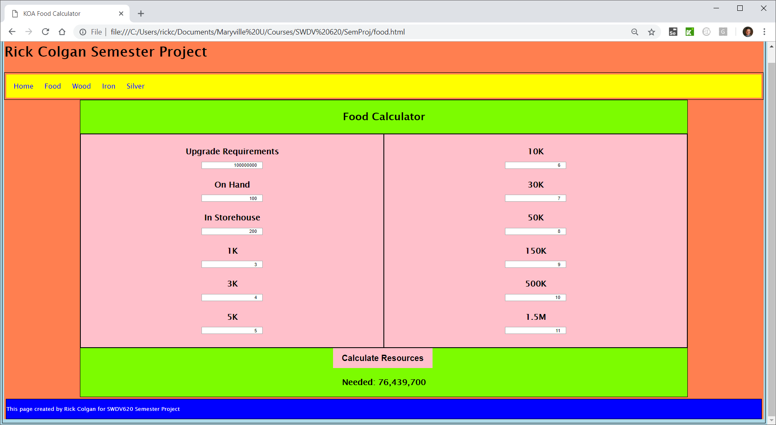

As you will note, the calculations are completed correctly. I can duplicate this for the wood, iron, and silver calculators as well, I just wasn’t sure if it was necessary in this instance. You will have access to the calculator and be able to test its accuracy.