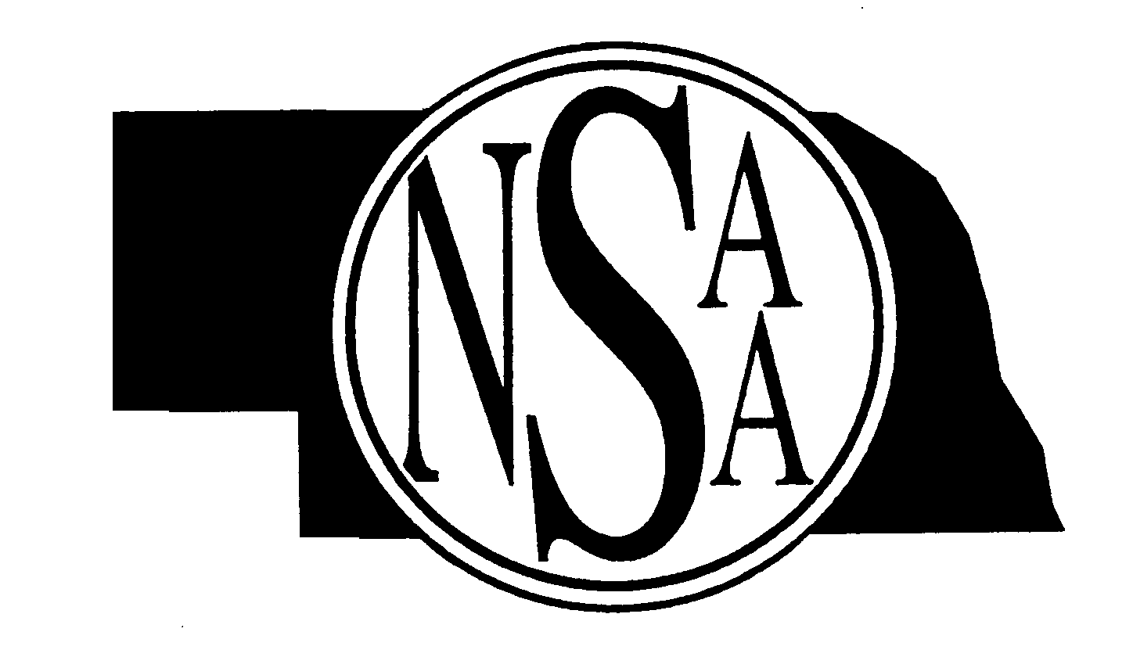NSAA STATE WRESTLING TOURNAMENT
NEW 2011 Time Schedule

Times are approximate--wrestling will progress when mats become available.

Thursday - February 17
Weigh-Ins | A and D | 8:00 A.M.
 | B and C | 3:00 P.M.
 | 1st Session
1st Round – 10 Mats | A and D | 9:30 A.M.
Quarterfinals – 10 Mats | A and D | Follows 1st Round
 | 2nd Session
1st Round – 10 Mats | B and C | 4:30 P.M.
Quarterfinals – 10 Mats | B and C | Follows 1st Round

Friday - February 18
Weigh-Ins | A and D | 8:00 A.M.
 | B and C | 11:00 A.M.
 | 3rd Session
1st Round Cons – 10 Mats | A and D | 9:30 A.M.
2nd Round Cons – 10 Mats | A and D | Follows 1st Round Cons.
 | 4th Session
1st Round Cons – 10 Mats | B and C | 12:30 P.M.
2nd Round Cons – 10 Mats | B and C | Follows 1st Round Cons.
 | 5th Session
Semifinals and 3rd Round Consolations – 8 Mats | All Classes | 5:00 P.M.

Saturday - February 19
Weigh-Ins | All Classes | 8:00 A.M.
 | 6th Session
Cons Semifinals – 8 Mats | All Classes | 9:30 A.M.
3rd & 5th Place Matches -  8 Mats | All Classes | Follows Consolation Semi-Finals
Finals – 4 Mats | All Classes | 2:30 P.M.


Word/Darin/State Wrestling/schedule2011

