All over the world today, celebrities, teens, and adults all have different preferences and trends in the makeup and fashion industry.  We were fortunate enough to be able to sit down with 2014 Beatrice High School graduate Albany Starman, who is currently working her way into the fashion industry at FIT (Fashion Institute of Technology) in New York City.  Albany answered some questions for us about the latest fashion trends and some of her personal views on fashion in our interview.

*What are you studying and how does it tie into fashion?*

**Miss. Starman said.. “I am majoring in Fashion Business Management, specializing in import buying and sourcing, and minoring in mathematics.  It is my responsibly to research and analyze last years history, the new upcoming trends, and trade barriers. I would then work with a product manager to decide which fabrics to use to best meet the needs of the garment and the consumer.”** 

*What do you think are the current and future trends in fashion?*

**Miss. Starman said… “Currently trending- This fall/winter is very 70's boho themed, incorporating a lot of neutral color palettes, bell bottom jeans, flowy shirts, lace, bell sleeves, velvet, and suede.  Upcoming trends- Fall/Winter 2016/17 is all about bright pops of color as surprise elements to the typical fall neutrals. Large collars, lace, pleats, geometrics, and retro inspired themes are being forecasted.”**

*What do you do for Kleinfeld? ( As seen on the TV network TLC)*

**Miss. Starman said… “I am assisting bridal consultants with their appointments. This includes learning the brides wants, helping pick dresses that fit those desires, pulling the dresses, putting the dresses on the brides, helping them complete the look (veil and shoes), reviewing contracts if they are planning to purchase, assisting the brides in the cash department, writing purchase orders, assisting during fittings, and attending trunk shows.”**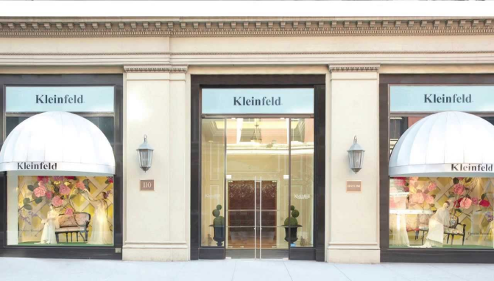

*What hobbies do you have that relate to the fashion industry?*

**Miss. Starman said… “I love to shop, which directly correlates to the fashion industry.  While I am shopping for things I want and like, I am also analyzing the clothing in each store, the store's aesthetic, and how they brought their story and trends to life in a way that is right for their customer. I also love to do styling and makeup. Styling opens me up to many different interests and preferences, allowing me to wardrobe looks specific to those needs and makeup allows me to be creative. I also like to scrapbook, which is another very creative and artsy hobby. All of these relate to the fashion industry because they are in some way a form of art and each one requires knowledge of trends, colors, shapes, patterns, and textures.”**

*What brand do you see as most popular?*

**Miss. Starman said… “Lifestyle: Michael Kors is by far the most popular lifestyle brand due to his many diffusion brands and his decision to begin IPOs in 2010. Michael's aesthetic is set for the woman who is constantly on the go, but still wants to be classy.  Luxury: Chanel is the most popular luxury brand due to the timelessness of all of the products. Chanel is very aspirational for most people and many other companies will knock off a Chanel design and style to adhere to the customers who can't purchase Chanel.”**

