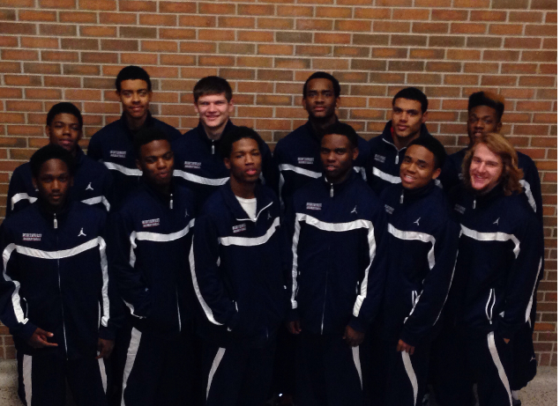

Front Row (L to R) Marcellis Minor, Deion Murray, Kameron Wayne, Finis Jones, Carlos Williams, Thomas Martig

Back Row (L to R) Charles Marion-Adkins, Troy Tegels, Trevor Belmont, Cleo Walker, DeAngelo Peak, Ronney Barnes