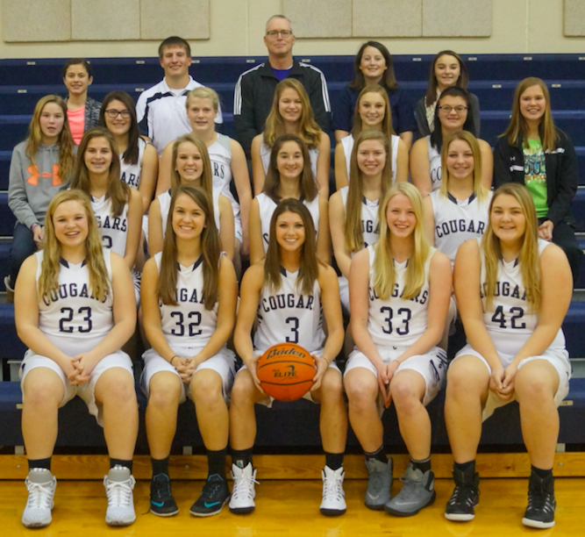

Cut line for the picture is as follows:

Front Row L-R: Brooklyn Mickey, Brynley Klein, MaKenna Sempek, Heidi Roesener, Jenni Pallas

2nd Row L-R: Alexis Eller, McKenna Anderson, April Walkup, Taylor Stratman, Samantha Theis

3rd Row L-R: St. Mgr. Erica Stratman, Emily Noyd, Mackinzie Cole, Morgan Stratman, Taylor Ostrom, Taylor Jones, St. Mgr. Savannah Anderson

Back Row L-R: St. Mgr. Amanda Giannou, Head Coach Mitch Boshart, Assistant Coach Kip Allison, Assistant Coach Johanna Nielsen, St. Mgr. Austyn Ostrom