2015 & 2016 LARGE ENSEMBLE SUPERIOR AWARD

**Order Form**

**Mail to: NSAA, 500 Charleston Street – Suite #1, Lincoln, NE 68508-1119**

The Nebraska School Activities Association provides a ribbon/medallion, with a pin attachment to individual members of Large Ensembles that receive a Superior rating from **all three judges**. The medallions will be stamped on the back and look like (sample below).

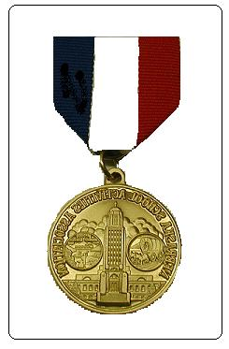

**Superior**

**District Music**

**(ensemble)**

**(year)**

Please use this form to order medallions. A separate order form must be completed for each Large Ensemble. Orders will not be taken by telephone. **Schools must place one order for all medallions and payment must accompany the order. We will not ship to individuals. The cost is $2.50 per medallion.**

# Large Ensemble Categories—(Please circle one.)

**Mens/Womens**

#### Band Mixed Chorus Madrigal/Chamber Choir Show Choir Orchestra Chorus Jazz Band Jazz Choir

Year

School __________ Need medallions by: (list specific date)

|  |  |
| --- | --- |
| **Total Number of Medallions** |  |
| **Total Medallion Cost ($2.50 x No. Ordered)** | **$** |
| **Shipping Costs:**  **1 Medallion----------------$2.00**  **2-4 Medallions------------$4.00**  **5-7 Medallions------------$6.00**  **8-50 Medallions-----------$8.00**  **51-100 Medallions--------$10.00**  **101-150 Medallions------$12.00**  **151 & over Medallions--$14.00** | **$** |
| **Total Payment Enclosed** | **$** |

##### FULL PAYMENT MUST BE INCLUDED WITH YOUR ORDER.

No medallions will be ordered until payment is received. No purchase orders accepted for medallions.

Order Authorized by:

Signature Position

Ship To:

Name Position

Mailing Address

### City State Zip