Garrison
Design & Architecture Reference — v1.0
Monterey Superior Court — IT Infrastructure | Powered by Gary
Status | Design complete — ready to build
Version | 1.0
Audience | Internal IT / shareable to partner agencies
Last updated | April 10, 2026

1. Purpose & Goals
Garrison is a local, on-premises LLM monitoring platform for Windows Server and Ubuntu Linux hosts. Its conversational agent — Gary — answers natural language questions about host health, logs, running services, open ports, user activity, and historical trends. All data stays within the agency network. No cloud services are involved.

Core goals
- Answer natural language queries about any monitored host in real time
- Monitor logs for errors, anomalies, and recurring patterns
- Track authentication events — logins, failed attempts, sudo activity
- Provide health snapshots — disk, memory, CPU, uptime, reachability
- Support historical trend queries via a local vector store (RAG)
- Discover and onboard new hosts on demand without pre-configuration
- Be packaged so any agency can deploy it with minimal setup

SENSITIVE DATA | All log data, credentials, and host information remain on the agency network. The LLM runs locally via Ollama. No queries or data leave the premises.

2. Architecture Overview
The system is organized into four layers. Each layer has a single responsibility and communicates only with the layers directly above and below it.

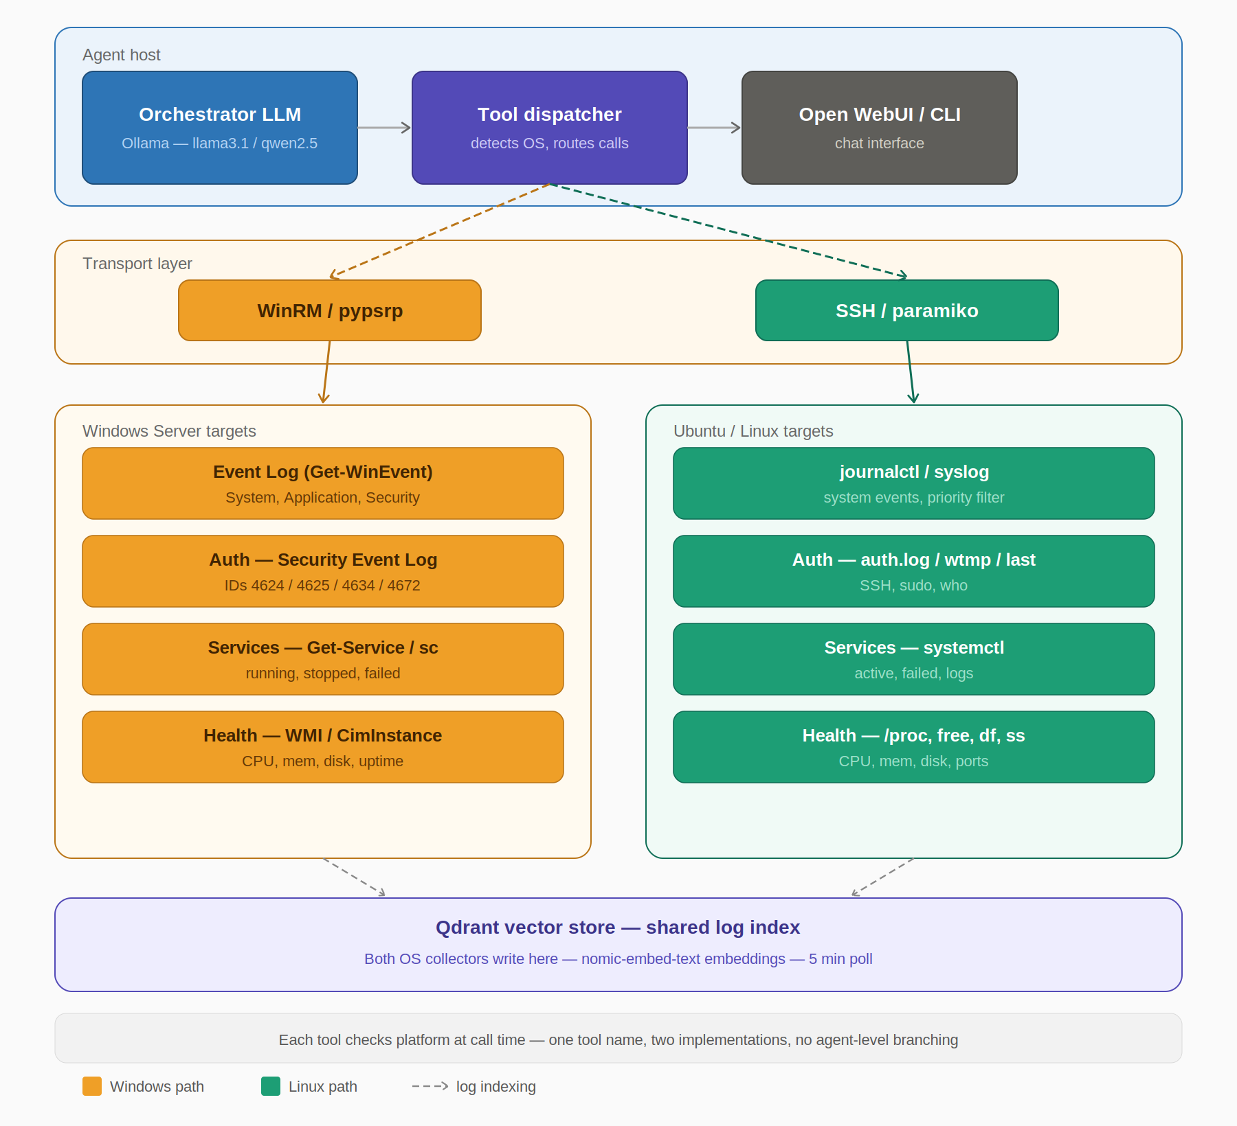
Figure 1 — Four-layer architecture: agent host, transport, target hosts (Windows + Linux), and shared Qdrant vector store

Layer 1 — Agent host
The machine running the LLM and agent logic. This can be a dedicated server or a workstation with sufficient RAM (16GB minimum, 32GB recommended for larger models).
- Ollama — serves the local LLM (llama3.1:8b default, qwen2.5:14b for better reasoning)
- LangChain ReAct agent — orchestrates tool calls based on user queries
- Open WebUI or CLI — the chat interface the operator uses

Layer 2 — Transport
Handles the protocol difference between Windows and Linux targets. Both are wrapped behind a HostConnection abstraction so the tools above never need to know which transport is in use.
- Windows: WinRM via pypsrp — PowerShell remoting over HTTPS (port 5986)
- Linux: SSH via paramiko — key-based auth (port 22)
- Local: direct subprocess — when the agent runs on the monitored host itself

Layer 3 — Tools (data collection)
Fourteen specialized tools the LLM can call. Each tool detects the target OS at call time and routes to the appropriate Windows or Linux implementation.

Tool | Implementation
get_recent_logs | journalctl (Linux) / Get-WinEvent System+App (Windows)
get_log_errors_summary | Grouped error counts by service, last N hours
search_logs | Full-text search across recent log entries
get_recent_logins | auth.log+last (Linux) / Event IDs 4624/4625 (Windows)
get_sudo_activity | journalctl sudo (Linux) / Event ID 4672 (Windows)
get_logged_in_users | who -a (Linux) / query user (Windows)
get_running_services | systemctl (Linux) / Get-Service (Windows)
get_failed_services | systemctl --failed (Linux) / Get-Service -Status Stopped
get_top_processes | ps aux (Linux) / Get-Process sorted by CPU (Windows)
get_open_ports | ss -tunlp (Linux) / Get-NetTCPConnection (Windows)
get_installed_software | dpkg/rpm (Linux) / Get-Package (Windows)
get_host_health | free+df+uptime (Linux) / CimInstance Win32_OS (Windows)
check_host_reachable | ping + TCP port check — both platforms
search_log_history | Qdrant semantic search over indexed log embeddings

Layer 4 — Vector store
Qdrant stores embedded log chunks from all monitored hosts. The background collector runs every 5 minutes, pulling new log entries, chunking them into 20-line blocks, embedding them via nomic-embed-text, and writing them to Qdrant.

3. Authentication Model
Authentication uses service accounts with static credentials stored in environment variables. This approach was chosen for simplicity, portability, and compatibility with non-domain-joined hosts.

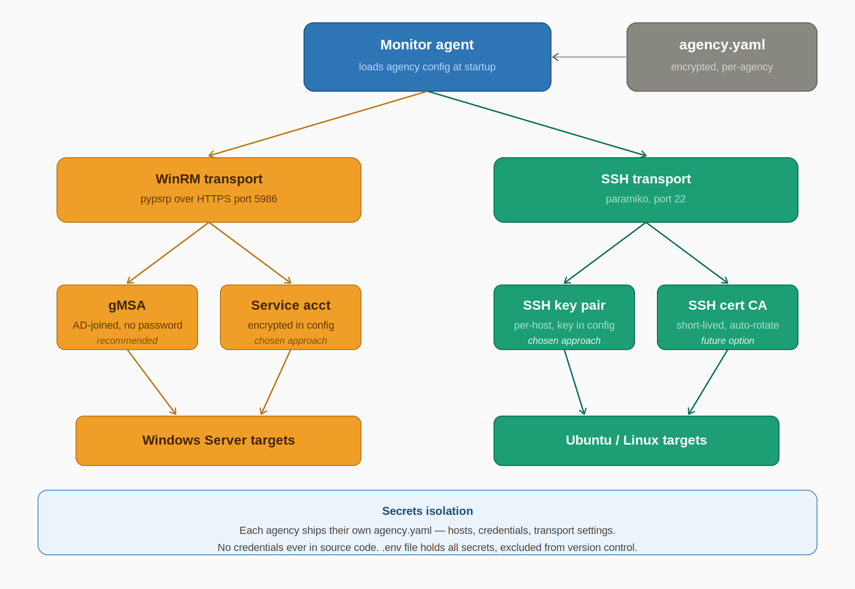
Figure 2 — Authentication paths: WinRM service account for Windows, per-host SSH key pairs for Linux

Design principles
- Credentials never appear in source code or agency.yaml
- Secrets live in a .env file only — excluded from version control via .gitignore
- agency.yaml references credential names (e.g. password_env: WIN_SVC_PASSWORD), not values
- Each agency maintains their own .env with no overlap with other agencies
- Per-host credential overrides are supported for DMZ hosts and one-offs

Windows — service account via WinRM
Create a dedicated svc_monitor local account on each Windows Server. Grant it read access to Event Log, WMI, and service query APIs.

Setup commands (run as Administrator on each Windows target):
Enable-PSRemoting -Force
net user svc_monitor <password> /add
net localgroup "Event Log Readers" svc_monitor /add
net localgroup "Performance Monitor Users" svc_monitor /add
Set-Item WSMan:\localhost\Client\TrustedHosts -Value "<agent-host-ip>"

DMZ / One-off hosts | Hosts that need different credentials use a host-level auth block in agency.yaml that overrides the defaults. The .env file holds the additional credential under a unique name (e.g. WIN_SVC_PASSWORD_DMZ01).

Linux — per-host SSH key pairs
Each Linux target gets its own dedicated SSH key pair. The private key lives on the agent host; the public key is deployed to the target.
# Generate a key per target (on agent host)
ssh-keygen -t ed25519 -f ~/.ssh/monitor_<hostname> -C "svc_monitor@<hostname>"

# On target — create service account and deploy key
useradd -m -s /bin/bash svc_monitor
mkdir -p /home/svc_monitor/.ssh
cat monitor_<hostname>.pub >> /home/svc_monitor/.ssh/authorized_keys
chmod 700 /home/svc_monitor/.ssh && chmod 600 /home/svc_monitor/.ssh/authorized_keys

4. Configuration

File layout
File | Purpose
agency.yaml | Host inventory, defaults, transport settings — safe to version control
agency.yaml.example | Template shipped with the code — no real values
.env | All secrets — NEVER committed, in .gitignore
.env.example | Template with placeholder values — shipped with code
discovered.yaml | Staging file — hosts found via discovery, pending promotion

agency.yaml structure
agency:
name: "Monterey Superior Court"

defaults:
windows:
transport: winrm
port: 5986
auth:
method: service_account
username: "svc_monitor"
password_env: "WIN_SVC_PASSWORD"
linux:
transport: ssh
port: 22
auth:
method: key
username: "svc_monitor"
key_path: "~/.ssh/monitor_{hostname}"

hosts:
- name: "fileserver01"
address: "192.168.10.20"
os: windows

- name: "dmz-web01"
address: "10.10.1.5"
os: windows
auth: # override for DMZ
username: "svc_monitor_dmz"
password_env: "WIN_SVC_PASSWORD_DMZ"

- name: "appserver01"
address: "192.168.10.30"
os: linux

5. Host Discovery
When a user asks about a host not in agency.yaml, the discover_host tool runs automatically, probing the host and attempting authentication with default credentials.

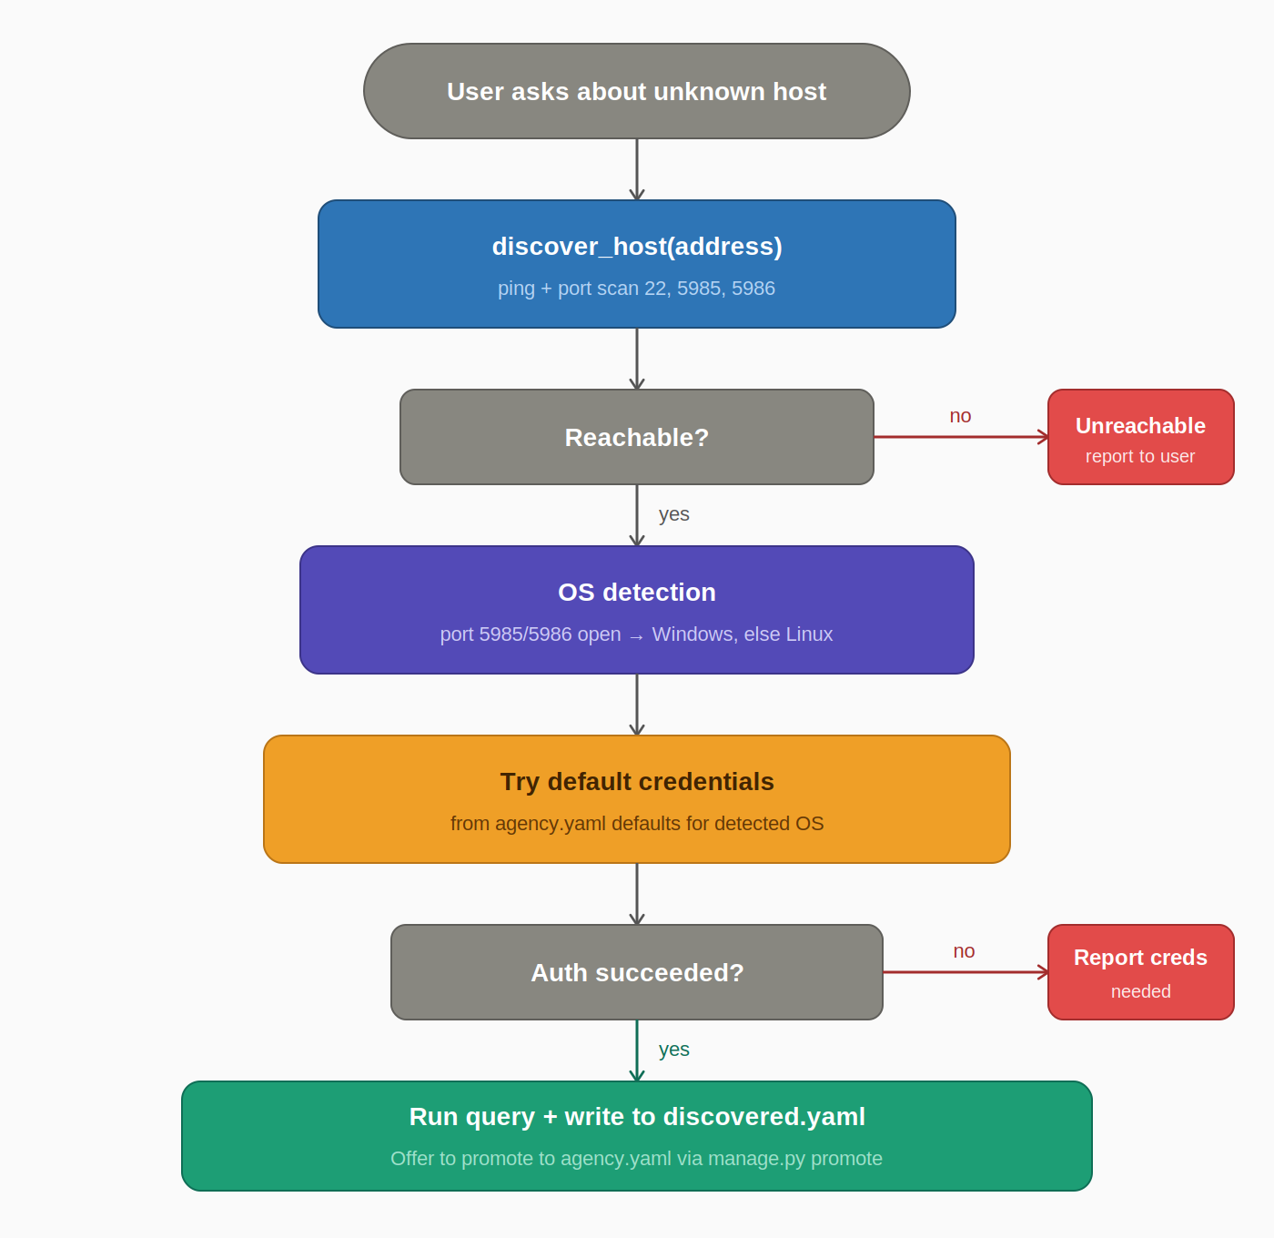
Figure 3 — Discovery flow: probe → OS detect → try credentials → stage in discovered.yaml

Discovery steps
- Step 1: Ping the target address — report immediately if unreachable
- Step 2: Probe ports 22, 5985, 5986 to determine OS
- Step 3: Try default credentials from agency.yaml defaults block
- Step 4a: Success — run original query, write to discovered.yaml, inform user
- Step 4b: Failure — report which credential is needed and what .env key to add

Staging and promotion
Discovered hosts are written to discovered.yaml — a staging file. They are NOT automatically added to agency.yaml.
# Promote a discovered host to main inventory
python manage.py promote fileserver99

# List all staged hosts pending review
python manage.py list-discovered

Why not auto-write? | Auto-writing to agency.yaml risks race conditions with the background collector, creates unexpected permanent entries from one-off queries, and muddies the audit trail. The staging approach keeps the main config clean and operator-controlled.

6. Windows vs Linux Tool Mapping
Each tool has two internal implementations selected at call time. The LLM calls the same tool name regardless of platform.

Capability | Windows | Linux
System logs | Get-WinEvent -LogName System/Application | journalctl --no-pager -p warning
Auth log | Get-WinEvent -LogName Security | auth.log, journalctl sshd
Login success | Event ID 4624 | last, wtmp
Login failure | Event ID 4625 + source IP | journalctl grep Failed
Admin login | Event ID 4672 | sudo activity in journal
Logged-in users | query user / qwinsta | who -a
Running services | Get-Service | Where Running | systemctl list-units --active
Failed services | Get-Service | Where Stopped | systemctl --failed
Top processes | Get-Process | Sort CPU -Desc | ps aux --sort=-%cpu
Open ports | Get-NetTCPConnection -State Listen | ss -tunlp
Installed software | Get-Package / winget list | dpkg -l / rpm -qa
Memory | Get-CimInstance Win32_OperatingSystem | free -h
Disk | Get-PSDrive / Get-Volume | df -h
Uptime | (gcim Win32_OS).LastBootUpTime | uptime -p
CPU load | Get-CimInstance Win32_Processor | /proc/loadavg

7. Historical Log Search (RAG)
For queries spanning hours or days, the agent uses retrieval-augmented generation against a Qdrant vector store populated by the background collector.

Collector
- Runs every 5 minutes on the agent host
- Polls both Windows (Get-WinEvent) and Linux (journalctl) targets
- Chunks log output into 20-line blocks with metadata (host, OS, timestamp)
- Embeds via nomic-embed-text in Ollama, writes to Qdrant with deduplication

RAG tool
- search_log_history(query, k=6) — semantic similarity search over all indexed chunks
- Returns top-k matching chunks with source host and collection timestamp
- Called automatically when the question implies historical context

Qdrant setup
docker run -d -p 6333:6333 --name qdrant \
-v $(pwd)/qdrant_data:/qdrant/storage qdrant/qdrant

8. Deployment & Setup

Prerequisites
- Python 3.11+ on the agent host
- Ollama installed — https://ollama.com/download
- Docker (for Qdrant)
- WinRM enabled on Windows targets — one-time setup per server
- svc_monitor account created on all targets

First-time setup
git clone <repo-url> && cd garrison
python3 -m venv venv && source venv/bin/activate
pip install -r requirements.txt
ollama pull llama3.1:8b && ollama pull nomic-embed-text
docker run -d -p 6333:6333 --name qdrant qdrant/qdrant
cp agency.yaml.example agency.yaml # fill in your hosts
cp .env.example .env # add credentials
python agent.py # start chatting

Model recommendations
Model | Size | Notes
llama3.1:8b | ~5 GB | Good default — fast, handles monitoring queries well
qwen2.5:14b | ~9 GB | Better reasoning — recommended for 32GB+ RAM
mistral:7b | ~4 GB | Lighter alternative if RAM is constrained
nomic-embed-text | ~274 MB | Embeddings only — required for RAG

9. Project File Layout
garrison/
├── agent.py Main entrypoint
├── manage.py CLI — promote, list-discovered
├── requirements.txt
├── agency.yaml.example
├── .env.example
├── .gitignore Excludes .env, agency.yaml, discovered.yaml
│
├── core/
│ ├── config.py Loads agency.yaml + .env
│ ├── connection.py HostConnection abstraction
│ └── discovery.py discover_host()
│
├── tools/
│ ├── log_tools.py
│ ├── auth_tools.py
│ ├── process_tools.py
│ ├── health_tools.py
│ └── rag_tool.py
│
└── collector/
├── indexer.py
└── garrison-collector.service

10. Build Order (Next Steps)
The design is complete. Build in this sequence — each step depends on the last.

Step | Component | Description
1 | core/connection.py | HostConnection abstraction + WinRM and SSH transport classes
2 | core/config.py | agency.yaml loader, .env resolver, defaults inheritance
3 | tools/ (all) | Cross-platform rewrites — Windows + Linux branch per tool
4 | core/discovery.py | discover_host() — ping, OS detect, try creds, write discovered.yaml
5 | manage.py | promote, list-discovered, validate-config CLI
6 | collector/indexer.py | Cross-platform log collector → Qdrant
7 | agent.py | Wire into LangChain ReAct agent — all tools registered
8 | Open WebUI | Optional — wrap agent in FastAPI for WebUI backend

CLAUDE.md reminder | When starting a build session in Claude Code, create a CLAUDE.md at the repo root with the architecture decisions and build order from this document. Claude Code will read it automatically at session start.

Appendix — Glossary
Term | Definition
Ollama | Local LLM runtime — serves models via REST API on the agent host.
LangChain ReAct | Agent framework — LLM reasons about which tools to call, calls them, observes results, repeats.
WinRM | Windows Remote Management — native remote shell protocol, HTTPS port 5986.
pypsrp | Python library for WinRM / PowerShell remoting — Windows transport layer.
paramiko | Python SSH library — Linux transport layer.
HostConnection | Internal abstraction wrapping transport + OS type so tools are platform-agnostic.
Qdrant | Open-source vector database — stores log embeddings for semantic search. Runs via Docker.
nomic-embed-text | Small embedding model run in Ollama — converts log chunks to vectors.
RAG | Retrieval-Augmented Generation — relevant log chunks retrieved from Qdrant before answering.
agency.yaml | Per-agency config file — host inventory and transport settings. No secrets.
.env | Environment variable file — all credentials. Never committed to version control.
discovered.yaml | Staging file for hosts found via discovery — reviewed before promotion.
svc_monitor | Dedicated service account name on all targets — least-privilege read-only access.
CLAUDE.md | File read by Claude Code at session start — carries architecture context across sessions.

