

**Capstone Project Documentation**

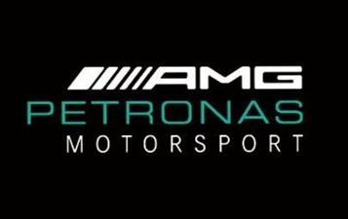

**Identify Formula One Driver through**

**Deep Learning**

Ricky Khanh Nguyen

3 December 2020

Contents

Introduction 3

Process overview 3

Problem statement 4

Industry 4

Stakeholders 4

Business Question 5

Data Question 5

Data science process 5

Data extraction 5

Images Preprocessing 5

Model Architecture 6

Modelling 7

Outcomes 7

Implementation 7

Data answer 7

Business answer 7

Recommendations to stakeholders 7

End-to-end solution 7

References 8

# 

# Introduction

Formula One is the world most popular motorsport with significant marketing exposure for car manufacture. The project objective is to improve the decision-making of the driver during the race. Thus, we are looking at the communication between the engineer and the driver. Hence, provide a solution and opportunity for improvement from this perspective.

# Process overview

The following diagram shows the overall end-to-end process for defining, designing and delivering the Capstone project.

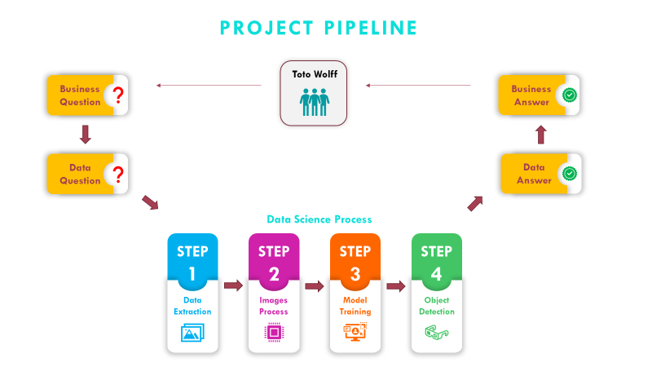

# Problem statement

The responsibility of the Formula One Engineer is tremendous during the race. They are required to monitor:

* Brake’s temperature
* Tyres condition
* Fuel consumption
* Engine & parts durability
* Racing Strategy
* Weather condition
* Speed and lap’s time at every track’s sectors
* X2 since there are always 2 drivers from each team
* Management of pit lane
* Regulations and compliances
* Inform driver on rival’ status

As the result, miscommunication happened between engineer and driver. Especially, when it come to rival status information.

# Industry

* FIA Formula One World Championship is the economically ninth most important sports industry
* Total revenue is estimated to be approx. $ 2 billion U.S dollars in 2019
* The highest class of international automobile racing with constant regulation adjustment and update.
* The goal is to be the 1st driver to reach the chequered flag.
* Re-fuel is prohibited which mean the main key factors to win the race are tyres and fuel consumption during the race.

# Stakeholders

The main stakeholder is the Mercedes AMG Petronas Formula One Team:

* Team Principle & CEO: Toto Wolff
* Managing Director: Andy Cowell
* Technical Director: James Allison
* Driver 1: Lewis Hamilton
* Driver 2: Valtteri Bottas

# Business Question

**“**How can we reduce miscommunication between the engineer and driver, thus improve the decision-making of the driver?**”**

# Data Question

**“**How can we use artificial intelligence to identify driver on the track**?”**

# Data science process

## Data extraction

* Images were extracted from recorded video and google search engine
* The data range between 2017-2019
* The pipeline is reusable to extract data from 2019 onward.

## Images Preprocessing

* Resize images to 600x900 pixels to preserve features and less computational power.
* Label bounding boxes for individual images with their respective classes.
* Normalization images by 255 to reduce the variance in pixel.
* Generate xml files with the coordinate of the bounding boxes from individual image.
* Transform xml files to csv files (Data frame format where each row is an image, and each column is a class label, coordination of xmin, xmax, ymin, ymax)
* Transform csv files to TFrecords which required as an input into Tensor flow model.

## Model Architecture

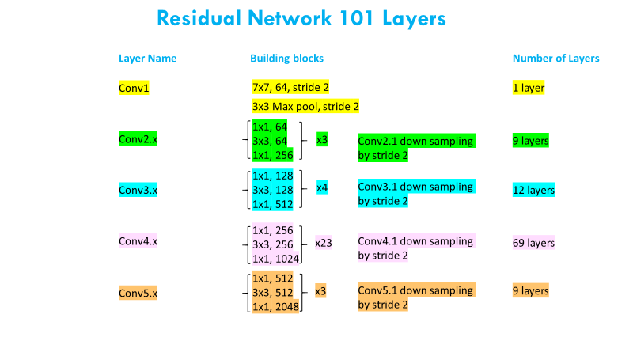

## Modelling

* The model took 24 hours of training
* The model was train on Window 10 OS with a single GPU
* The total loss graph indicated the model is consistent return the loss score of 0.4~0.6
* Compare detection speed with RCNN and Fast RCNN model.
* The optimal model in term of accuracy, computational power, and speed is Faster RCNN ResNet101.

## Outcomes

* The model correctly predicted F1 driver from different camera angles on unseen data.

## Implementation

* Have front and rear camera of the car to connected to a GPU computer.
* Provide an indicator on the car’s dashboard
* The model will compute on GPU then feed the result to the indicator
* Driver can observe the indicator to identify rival’ s status for decision-making.
* Engineer can also have this indicator on their control panel for strategy assessment.

# Data answer

* Take advantage of Computer Vision in object detection we can accurately identify driver on the track.
* Train faster-RCNN model to identify driver.

# Business answer

* Eliminate the rival status responsibility from engineer.

# Recommendations to stakeholders

* Depend on the objectives of the stakeholders. We can continue to train the model to improve accuracy.
* By taking advantage of the technology, we can improve decision-making of driver & engineer during the race

# End-to-end solution

* We are not reducing the miscommunication between engineer and driver. We have simply REMOVE it from the equation.
* Once the accuracy is optimal, we can incorporate the model directly into the car’s dashboard.
* The model will continuously inform the driver on his rival through real-time detection.

# References

Data Sources:

* 2012 Belgium Grand Prix
* 2018 Belgian Grand Prix
* 2018 Australian Grand Prix
* 2019 Singapore Grand Prix
* 2020 Emilia Romagna Grand Prix
* 2020 Turkish Grand Prix
* Google’s search

TensorFlow Git + Model:

* https://github.com/tensorflow/models
* Faster-RCNN ResNET101 v1 800x1333 COCO17 GPU-8
* Deep Residual Learning for Image Recognition Paper 2015 by Kaiming He, Xiangyu Zhang, Shaoqing Ren, Jian Sun from Microsoft Research
* Updated Tensorflow-v2 codes available on <https://github.com/RickFSA/Capstone_Object_Detection>

Request:

* Acquisition of source data & inference graph please forward request to [ricky.nguyen558@gmail.com](mailto:ricky.nguyen558@gmail.com)

Articles:

https://www.mercedesamgf1.com/en/news/2018/11/insight-the-trackside-engineers/

<https://www.theguardian.com/sport/2020/apr/16/f1-teams-fail-to-agree-budget-cap-reduction-as-race-cancellations-bite>.

<https://www.essentiallysports.com/what-are-the-budgets-for-all-10-formula-one-teams-2019/>

<https://en.wikipedia.org/wiki/Mercedes-Benz_in_Formula_One>

<https://www.motorsport.com/f1/news/turkish-gp-race-results-hamilton/4910492/>

<https://www.planetf1.com/news/daniel-ricciardo-turkish-gp-lottery/>

https://www.researchgate.net/figure/Schematic-illustration-of-Faster-R-CNN-architecture-A-ResNet-101-B-RPN-network-was_fig1_341729450

All product names, logos, brands, trademarks, and registered trademarks are property of their respective owners. All company, product and service names used in this presentation are for identification purposes only. Use of these names, trademarks and brands does not imply endorsement