Robert Bergers

I started off by downloading the toolchain from baking Pi

<http://www.emide.org/download.php>

Went to this link to understand emIDE

<http://emide.org/documentation_gettingstarted.html>

It seems as though what a toolchain is meant to do is take a group of functions and put them together into one file, then externally changes the program counter. This would allow a more complex project to use ARM assembly in controlled portions for different things, then return control to the c program.

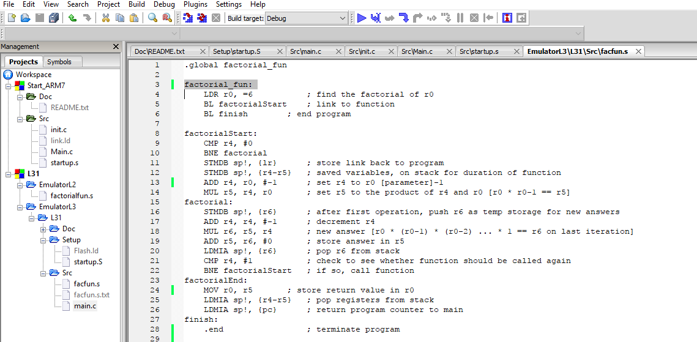

Changed the factorial function to try and match the syntax found in startup file

, then reading the following:

<http://infocenter.arm.com/help/index.jsp?topic=/com.arm.doc.dui0472e/Caciddae.html>

<https://maven.apache.org/guides/mini/guide-using-toolchains.html>

I understand that a toolchain executes portions of assembly code by manipulating the program counter and taking in data from registers as return values, which can then be used outside of the assembly program. I cannot find any sort of guide as to how to do this in emIDE however.