1. Set up the InitialContext

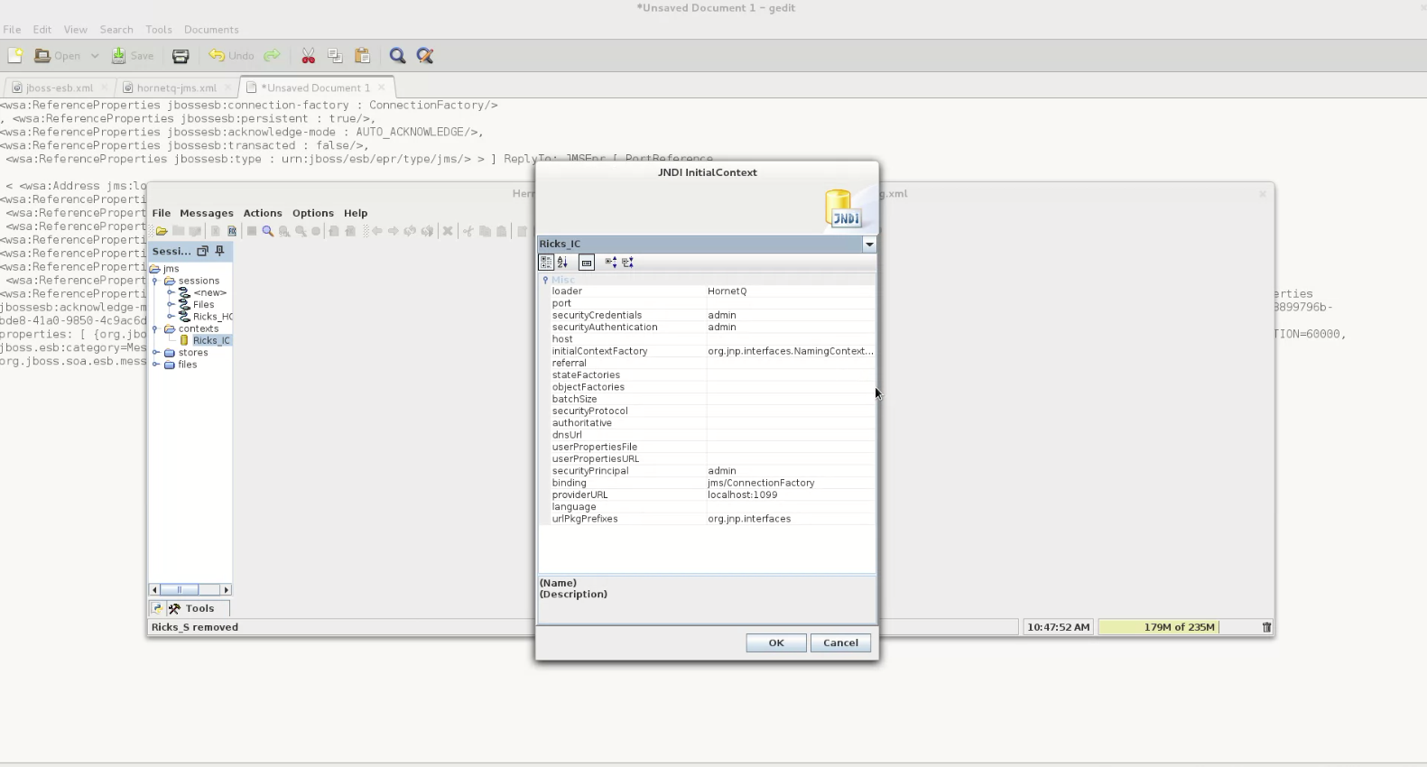

2. Click the Context to see what's there

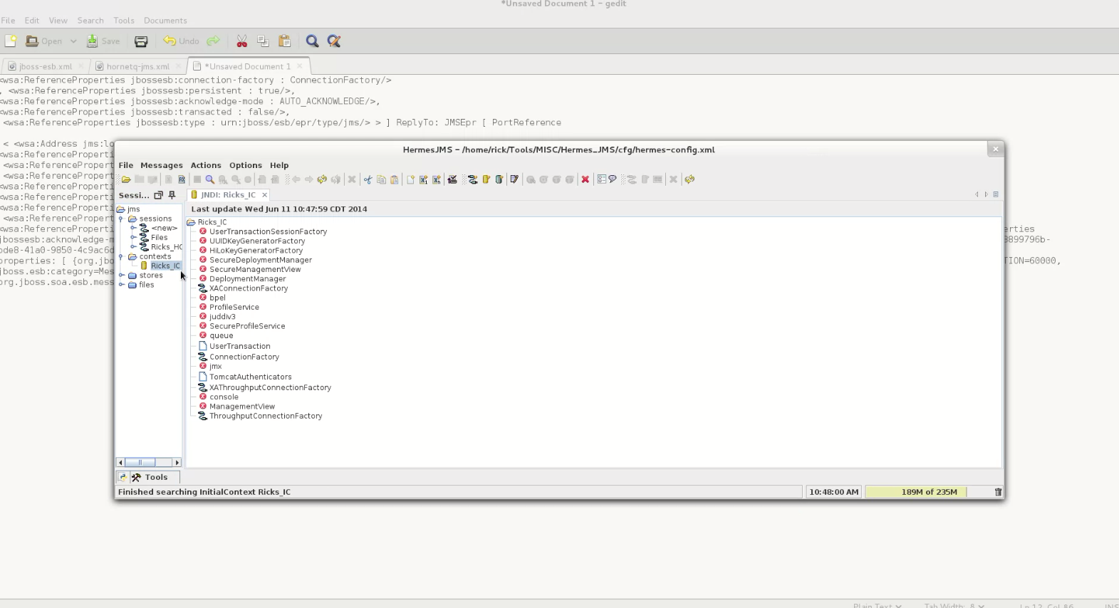

3. Make a new Session from the ConnectionFactory

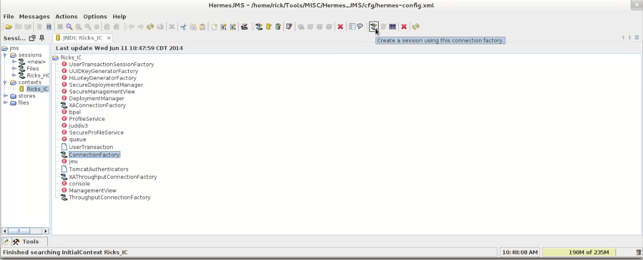
(Clicking that icon brings the dialogue. Enter a name, then click on the Session in the left pane and choose 'Edit'.)

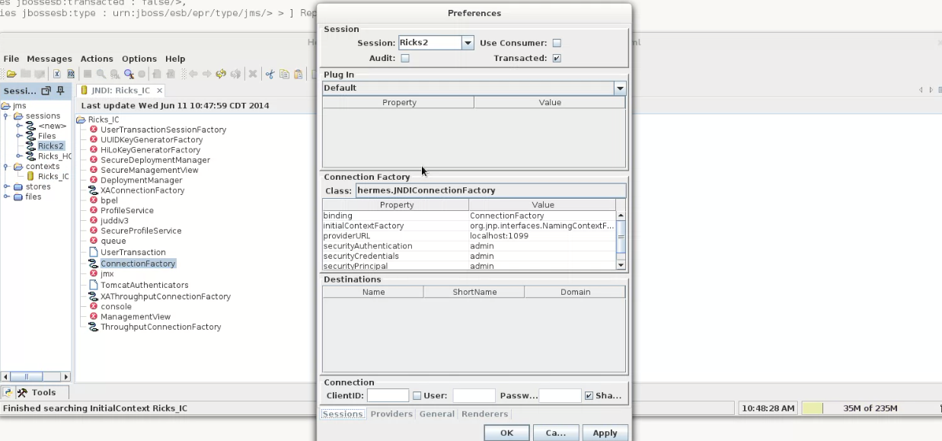
Right click 'Destinations' to add the queue, then click 'queues' in the left pane to see the messages.

