Running the ‘standalone JMS client’ example

This example will demonstrate HornetQ failover as it should occur.

Before starting, be sure to use a configuration file similar to the included ‘domain.xml’ for your Jboss EAP server domain. Note that it includes a few queue definitions and some security allowances for a group called ‘guest’.

You will need to add a user to the ‘guest’ group. In this example, we have used the add-user script in the Jboss/bin directory to add a user called ‘guestuser’ with password ‘Password1!’. Note that these credentials are used in the source code for the examples. (So if you choose different credentials, you will need to change the source code.)

The example requires several external .jar files that must be downloaded from the Red Hat maven repository. Please place these files in a convenient location and update the ‘run.sh’ script to suit your environment.

Start the jboss servers. (In this example, it is done with a Jboss domain that includes 2 embedded servers. The same experiment will work with different JMS topologies, but adjustments would need to be made to the host/port values configured in the client code.) Be sure you have added a user to the ‘guest’ group.

Start the run script. We should see messages produced and consumed.
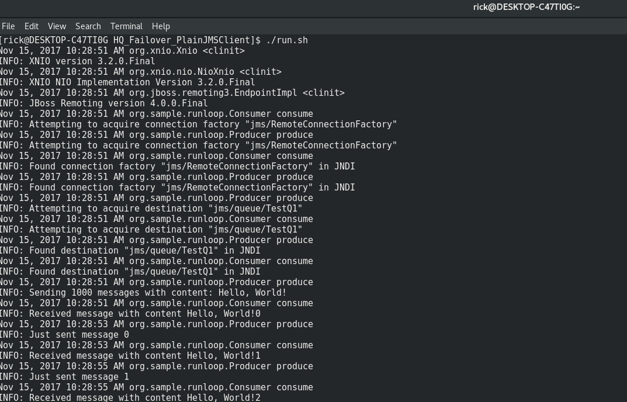

If you want to monitor message counts, these can be obtained from the CLI:

/host=master/server=server-one/subsystem=messaging/hornetq-server=default/jms-queue=TestQ1/:read-resource(recursive=false,proxies=false,include-runtime=true,include-defaults=true)

/host=master/server=server-two/subsystem=messaging/hornetq-server=default/jms-queue=TestQ1/:read-resource(recursive=false,proxies=false,include-runtime=true,include-defaults=true)

Stop the primary HornetQ server. (In this case, done with the Jboss console.)

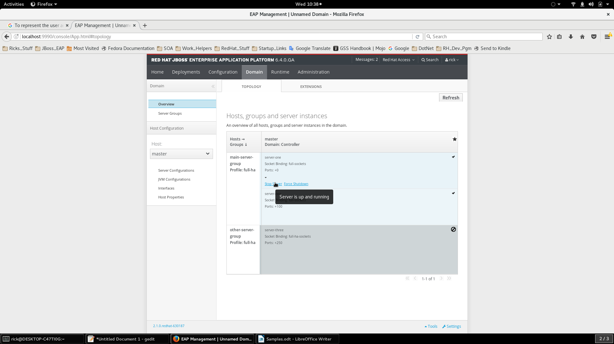

We should see a slight pause, then continued message production/consumption as the secondary server comes into use.
If we later re-start the server, it will again seamlessly fail over.

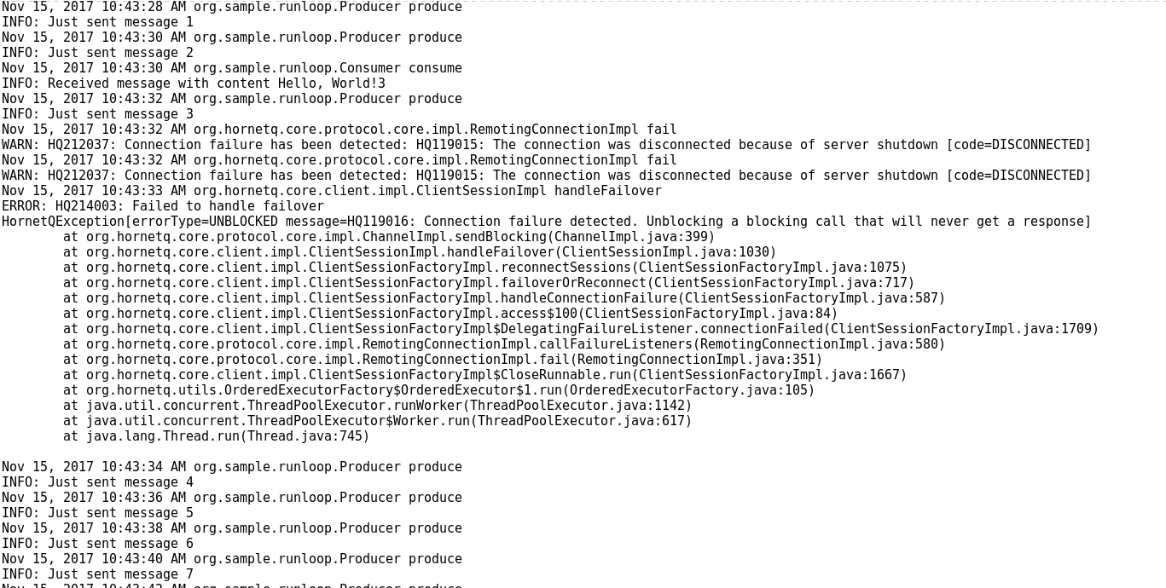

Please note the client-side code does not contain anything special, this behavior is part of the supplied HornetQ client components.

This is the desired behavior. When a primary HornetQ server fails, the backup seamlessly takes it’s place.
Spring Templates example

Start the jboss servers.

Start the Spring application.

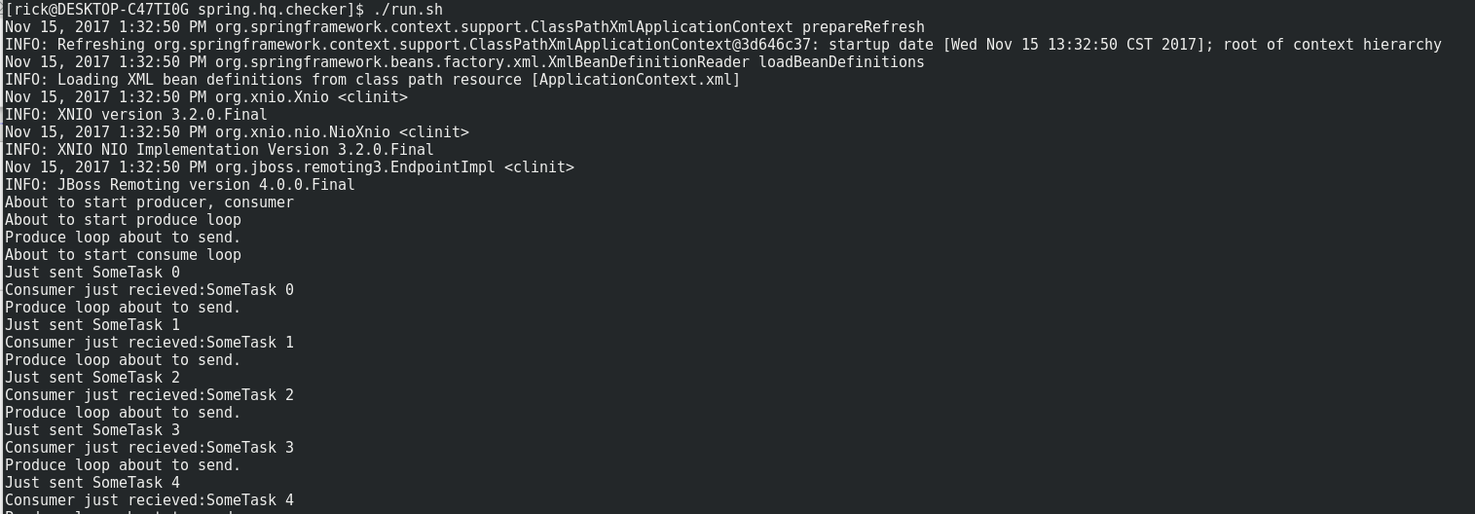
Now kill a server, as previously done with the plain Java example. We get a different result:

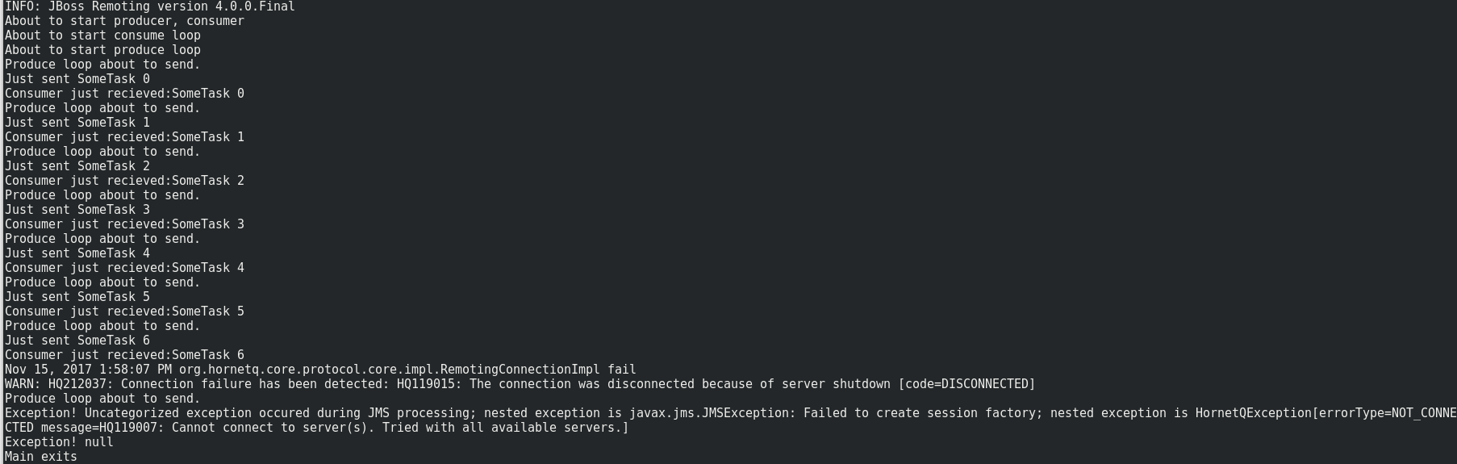
The client does not connect to the backup server, it fails.

