**Simplified Tire Debeading on Curb Impact Model**

*MECH 950 – Impact Engineering*

*Term Project Final Report*

Ricardo Jacome

December 14, 2017

**Abstract**

For crashworthiness applications, non-linear finite element analysis is performed to predict the behavior of vehicle parts under impact. In these applications, tires are usually one of the most important and difficult parts to model. A simple model was created on LS-DYNA to simulate a high speed tire impact on a curb. For this simulation, physical damage of the whole vehicle is relatively low compared to that of the tire. Material properties of rubber are explored in detail for this model. System modeling techniques are used to account for the vehicle influence on the tire. Model applications include investigating about reliability of parts and material testing for tires.

1. **Introduction**

In vehicle performance, tires have a crucial role for the safety and commodity of the user. A tire blow-out is simulated through finite element analysis to understand the behavior and reliability of the tire when high speed impact occurs into a curb and causes debeading (i.e. separation of rubber tire from rim). Tire components are made of a high variety of metals and polymers. For this impact scenario, simplifications were made to have a tire consisting of just rubber and steel materials. Steel components are Outer/Inner Rim, and Shaft. Rubber components are Sidewalls and the Tread. Other components of the impact scenario include the curb and the vehicle model. Curb was modeled with concrete materials. To take into account the vehicle’s effect on the tire, a quarter suspension model was implemented along with modeling simplifications. Modeling techniques go in depth regarding vibration/volume considerations, contacts and failure modes. The last sections involve model verification and results.

1. **Materials Overview**

Materials with the steel properties were modeled with a rigid material option, because the analysis focuses on high deformations of rubber rather than steel. Properties of steel are obtained from literature review, and are used to model the inner rim, outer rim and shaft component.

Rubber materials were investigated with three different material models. Rubber parameters such as density and Poisson’s ratio were kept the same for all material models. The models were simple elastic, visco-elastic and Mooney-Rivlin (MR) materials. Visco-elastic materials use parameters that are explored for tire purposes on [1]. MR model utilizes two constants into its imbedded strain energy density function. These constants are found with least square fit from uniaxial test data or from literature review [2]. Implementing a compression test simulation with a single solid element and load-curve provided from [3], software simulations were attempted to obtain these parameters. Based on the difference in coefficients, simulation comparisons were performed to test the behavior of the materials. The curb is modeled as a rigid material with standard concrete properties. Table 1 provides a summary of all the material properties used for the simulation, and Table 2 provides parameters on visco-elastic and MR materials.

Table 1. - Standard Material Properties

|  |  |  |  |
| --- | --- | --- | --- |
| Property | Steel | Rubber | Concrete |
| Modulus of Elasticity (GPa) | 210 | -------- | 85 |
| Mass Density (kg/mm3) | 5.05e-6 | 1.12e-6 | 2.4e-10 |
| Poisson’s Ratio | .30 | .49 | .15 |

Table 2. – Parameters for Material Models

|  |  |  |  |  |
| --- | --- | --- | --- | --- |
| Material Model | Parameters and Values | | | |
| Visco-elastic | K = .345 GPa | G0 = 0.69E-3 GPa | G1 = 0.45E-3 GPa | Decay Constant = .0108 |
| Mooney-Rivlin Load Curve (MRLC) | A = 0.2205E-3 | | B = 0.2075E-2 | |
| Mooney-Rivlin Lit Review (MRLR) | A = 0.606 | | B = 0.404 | |

1. **Model Components**

The following section explains the element details for every component on the simulation. For illustration purposes the initial model with all parts is shown in Figure 1. Standard dimensions of the tire are P215/55R17 which are the tire dimensions of a Sedan Nissan Altima.

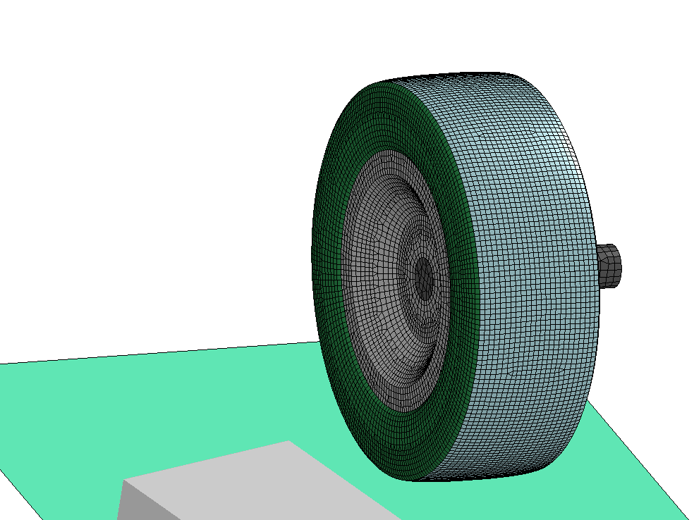

Curb

Tread

Shaft

Sidewall

Inner Rim

Figure 1. – Tire Model & Curb

***Outer Rim***

This part was modeled with shell elements and Belytschko-Tsay formulation which is the default option. Shell thickness is matched to that of the tread and sidewall so that a uniform attachment is created in between the parts. The outer rim is only made as a single layer of shell elements that go on top of the inner rim.

***Inner Rim***

Inner rim is made with shell elements and default element formulation. This part is constrained to the outer rim with a failure mode to produce debeading upon impact. The center of the inner rim has the shaft attached which serve as a follower.

***Shaft***

For this part, shell elements and default element formulation options are used because it is fully constrained with the inner rim. The purpose of the shaft is to simulate the effects of the vehicle mass and suspension system acting on the tire.

***Tread***

Shell elements with Bathe-Dvorkin formulations were used. This formulation falls into the fully integrated category which provides more accurate results than non-fully integrated. Bathe-Dvorkin formulation is the fastest out of the fully integrated methods. So, this element formulation was selected as the most appropriate to obtain high deformation data accurately and efficiently. High thickness (8 mm) is used to avoid instabilities that the rubber materials experience when subjected to load forces. Otherwise model tends to behave unrealistically or simply “blowing up”.

***Sidewall***

Tread and sidewall share the same shell element formulation and thickness. Special consideration is taken into the nodes of the sidewall because this part serves as the connection in between the outer rim and tread (i.e. it is the connection for the enclosed volume that the air is in).

***Curb***

To avoid consuming time on modeling the curb, shell elements were used to implement automatic meshing techniques. Since the material was defined to be rigid, the only special consideration for the curb design was to avoid sharp edges through the modeling of chamfers on the contacting edge. Boundary constraints were applied to fix the curb to the ground.

1. **Modeling Techniques**

***Vehicle Motion/Suspension/Constraints***

All parts described in previous sections were given an initial translational velocity of 100 km/h (27.78 mm/ms) and a rotational velocity of 0.083 rad/sec. The vehicle is assumed to not steer away from the curb, and to impact straight at an angle of about 70 degrees into the curb. After impacting, the wheel and sidewall experience a high shear force that separates them. Mathematically, mass-spring-damper system offer a simplification of tire dynamics. A similar approach was taken to simulate dynamic effects through a quarter suspension model shown in Figure 2. The approach imitates the degrees of freedom a real tire assembly has relative to the vehicle. To do this, a control arm was created to constraint rotational motions and a discrete element (with combined properties of spring and strut) was used as a suspension system.

After applying constraints to the quarter suspension model, the final product model stops the rotation of the tire ceasing realistic behavior. For this reason, it is believed that a simple quarter suspension model can be created but due to time limits, a simpler approach was taken to model the effects of the vehicle on the tire with a new constraint model.

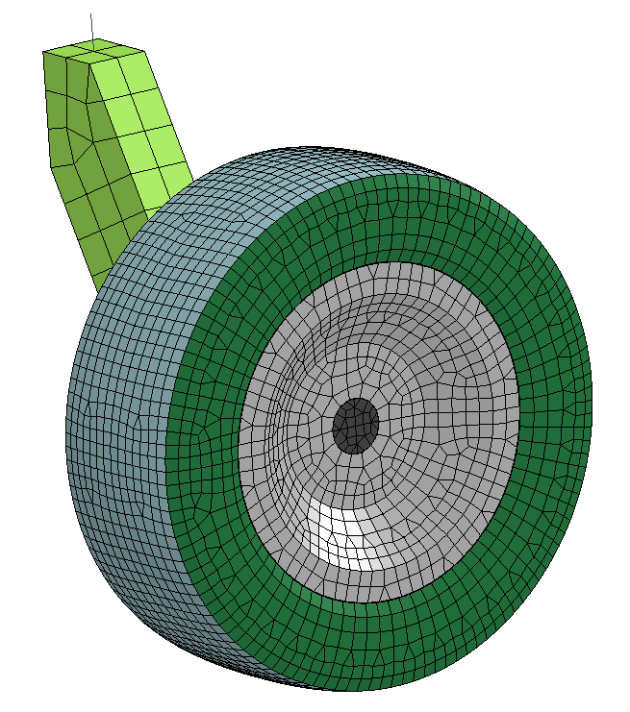 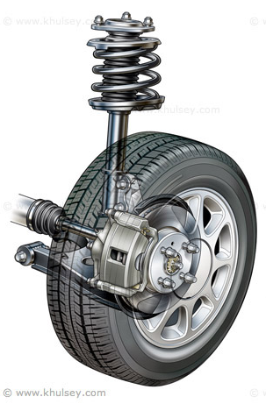

Tie Rod

Control Arm

Discrete Element

Spring & Strut

Control Arm

Figure 2. - Quarter Suspension Model Comparison

For the purpose of modeling a tire debeading, the following boundary conditions were applied and illustrated in Figure 3. A single node (i.e. black dot in Figure 3) acting on the middle of the shaft part was constrained on the transverse direction to account for the stability the control arm provides. So the tire is not capable of being detached or contracted inside of the vehicle. The control arm, being attached to the sway bar, provide a counter balance that prevents rotation on the rolling direction. This behavior is presented by a constraint on the rotation of the y-axis. To control the tire yaw angle, a vehicle has the steering knuckle connected to the tie rod which is part of the steering system of the vehicle. This simulation assumes that the vehicle maintains a firm steer causing no rotation on the vertical axis of tire during impact. So that a constraint on the vertical axis rotation is sufficient for representing the steering system. In impact cases, the time frame in which events occur is in the order of milliseconds. From this, it can be assumed that a high speed curb impact would not give enough time for the suspension to absorb most of the shock. By constraining the vertical direction of the wheel, it is possible to model this scenario where all damage occurs to the tire only. Furthermore, during curb impact, the vehicle’s weight is considerably high compared to that of the tire, so that constraining vertical motion going up was needed as well. The last condition is to account the longitudinal momentum given from the mass of the vehicle and the speed of the wheels. To do this, a concentrated mass of 375 kg was given to the node being constrained. This mass is representative of a quarter of the weight of a standard vehicle. Since, the motion on the vertical axis was constrained, no problems arise of the weight causing a lever effect on the tire.

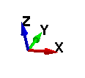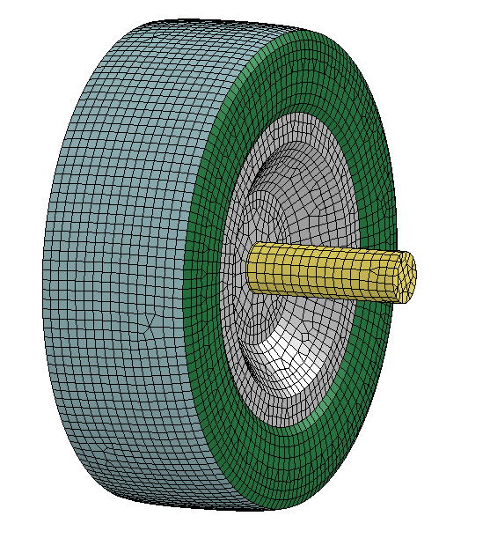

Figure 3. - Constraint Model with Degrees of Freedom

***Volume/Vibrations***

To model the air pressure inside of the tire, an airbag pressure model was used. The airbag definition uses two constants CN and $β$ for a mathematical model of pressure as a function of the ratio in between current and initial volume. These constants are obtained through literature, and standard models use values of .32E-3 for CN and 1 for $β$. Based on [4], the beta value is proportional to the internal air pressure, so values ranging from 1 to 10 are explored. The enclosed volume of the tire is defined by the tread, sidewall and outer rim which consist of only a layer of shells. This enclosed volume along with a cross-sectional view is shown in Figure 4.

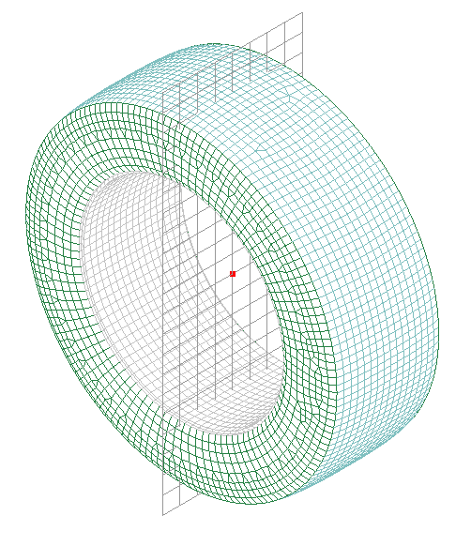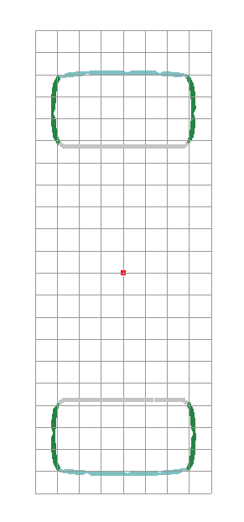

Figure 4 .- Enclosed Volume and Cross Sectional Area

Using both airbag models along with rubber materials, vibrations tend to appear causing instabilities. Relative damping function is used to damp out the vibrations of the rubber materials relative to the rigid body is moving with. In this case, rubber vibrations in both the tread and sidewall are damped out with respect to the outer rim.

***Contacts/Failure Mode***

Many contact definitions for non-linear analysis in finite elements exist. For the tire debeading two contacts are used. The first is an automatic single surface contact which is appropriate for self-contact that occurs in rubber along with the part-to-part contact that curb, tire and wheel have. To simulate debeading, a tiebreak contact is used. This creates a pressure constraint (similar to press fit) in between part’s surfaces. For this definition, the outer rim was selected as a slave and the inner rim as the master. This contact requires input values for tensile and shear failure in between surfaces. Since the effects of debeading are mostly shearing forces, the value for tensile failure was given a high value of 1E10 kN to neglect it. For shearing failure, different values can be applied depending on factors such as vehicle type, and tire size. For testing purposes, values ranging from 1 N to 10 kN were used.

1. **Material Verification Simulation**

A tire compression was performed for the three materials implemented. This compression involved giving a prescribed motion to the rim against a rigid wall shown in Figure 5. Testing demonstrated an unrealistic inflating behavior for the visco-elastic model and MRLC. Elastic and MRLR demonstrated a more realistic behavior. Both Elastic and MRLR show an inward curvature that is not realistic upon compression, MRLR shows less inward curvature, so that the material is selected for further study. It was found that increasing pressure on the airbag volume definition fixes the curvature problem as shown in Figure 6. Results from the single sided compression are shown in a force-deflection curve in Figure 7 for MRLR and MRLC. From graphical results it is noted that MRLC offers a more stable and linear behavior upon compression than MRLR, along with numerical values that correspond to average force-deflection curves. From compression testing, both MRLR and MRLC were chosen for Debeading Testing.

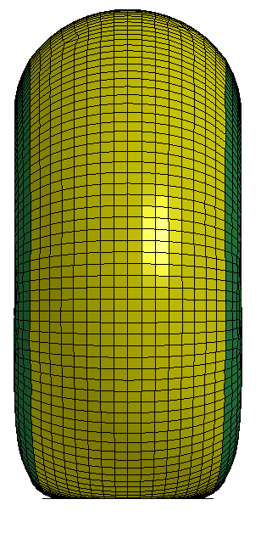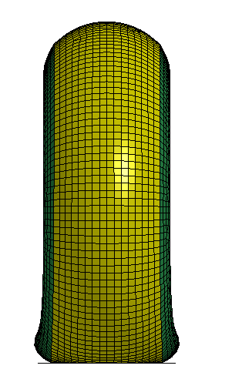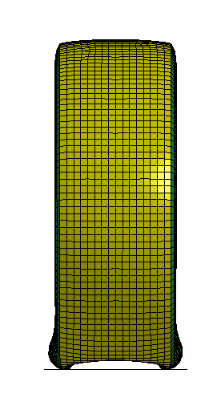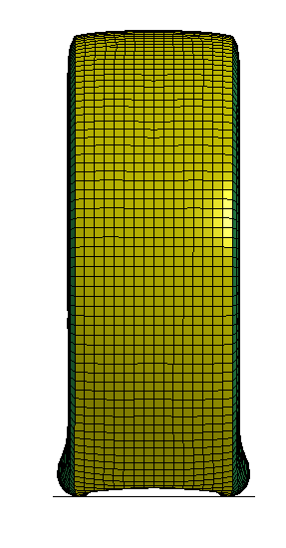

Visco-Elastic

MRLR

MRLC

Elastic

Figure 5. - Compression Test Results for Different Material Models at 18 ms

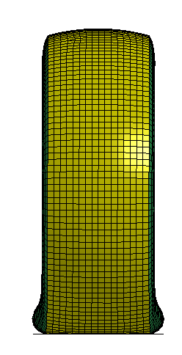

Beta = 10

Beta = 1

Figure 6. - Compression Test Results for Different Beta for MRLR model at 18 ms

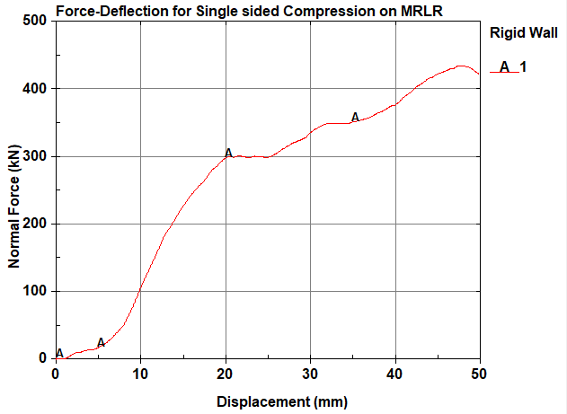

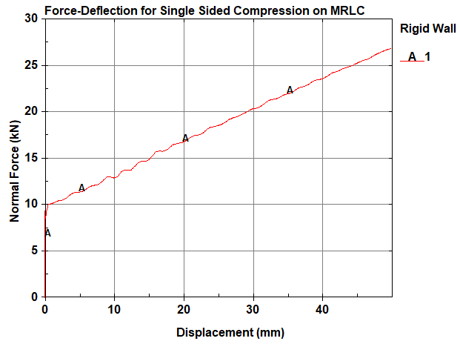

Figure 7. - Single Sided Compression Tests for MR-Models with Beta = 1

1. **Model Results**

A simulation of tire debeading compared with different beta values is shown in Figure 8. Deformations of the MRLR rubber materials show a realistic debeading behavior upon impact. Instabilities are shown when Beta =1 and the simulations time cuts before the full 70 ms run time. For Beta = 10 the tire comes to a stop after impacting which is the expected behavior of a vehicle impacting into a curb. Around 34 ms the tire and wheel components starting detaching due to the transverse shear acting on the tire due to the curb impact for both Beta values. The MRLC model shows instabilities at the same time as MRLR but this model does not simulate debeading even though the conditions of the model are the same.

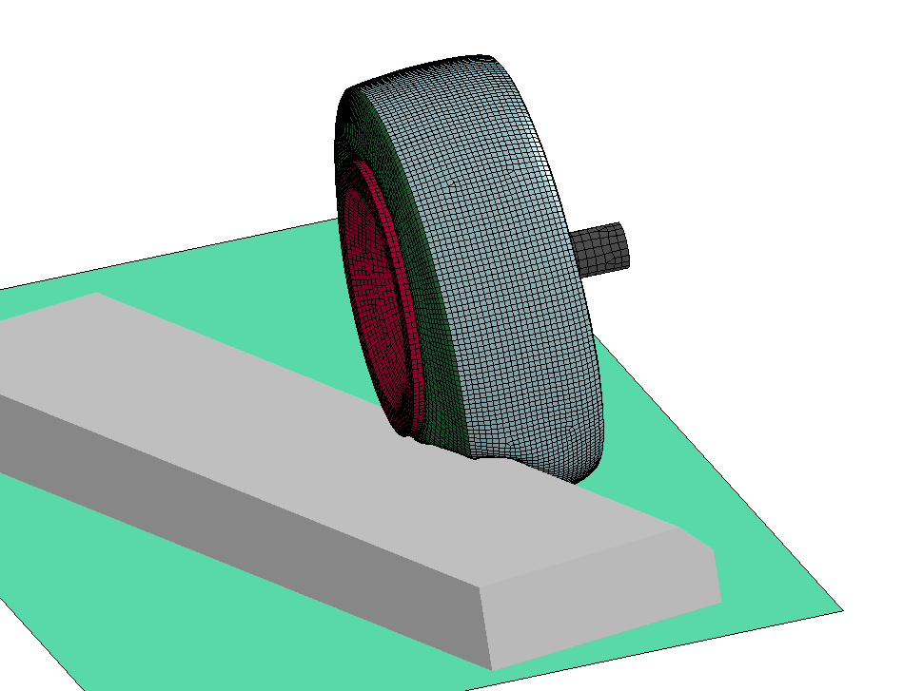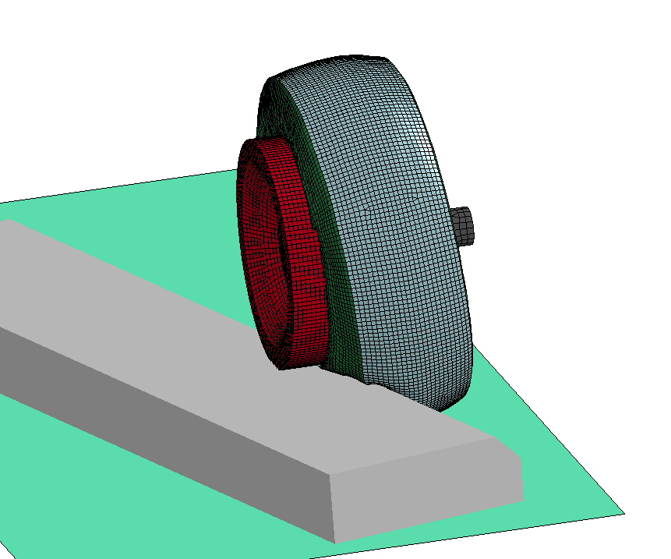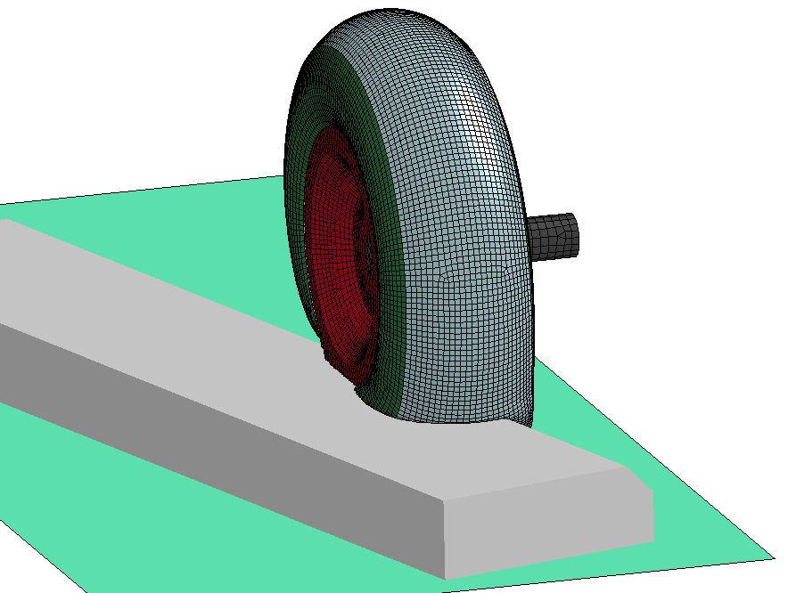

MRLC Beta = 1

Instabilities at t = 47 ms

MRLR Beta = 1

Instabilities at t = 47 ms

MRLR Beta = 10

No Instabilities

Figure 8. - Tire Debeading upon Impact on Curb

1. **Conclusions**

A tire model was developed to be impacted into a curb at high speed with non-linear finite element analysis. A suspension model was attempted but not successfully developed. A constraint model representative of the vehicle was used instead. Parameters studied were: materials, airbag pressure and contact definitions. Compression testing was used to study tire stability where MRLC shows the best fit. Both MRLC and MRLR materials were impacted into a curb. However, only the MRLR model showed debeading behavior. MR models need refinement to obtain realistic numerical results in the case of MRLR and visual simulation in the case of MRLC. Overall the constraint model can be used to further investigate the tire debeading with other materials/properties.

1. **References**

[1] S. Gusev, R. Ivanets, K. Klimau, S. Medvedev, V. Mozgalev, U. Ausianka, A. Petrouski, “Assessment of adequacy of behavior models of materials of a LS-DYNA package in relation to tasks of the tire industry”, Elsevier, The 20th International Conference: MMS 2015.

[2] Y. Cai, M. Zang, F. Duan, “Modeling and Simulation of Vehicle Responses to Tire Blowout”, Tire Science and Technology, TSTCA, Vol. 43, No 3. July-September 2015, pp. 242-258.

[3]J. M. Hill, A. I. Lee, “Large Elastic Compression of Finite Rectangular Blocks of Rubber”, Mech. Appl. Math., Vol. 42, Pt. 2, 1989.

[4] B. Gladman, “LS-DYNA Keyword User’s Manual”, Livermore Software Technology Corporation (LSTC), May 2007