**Discrete Curvature Approach for Trajectory Generation in Autonomous Vehicles**

**Ricardo Jacome**

Department of Mechanical Engineering

University of Nebraska-Lincoln, Lincoln, Nebraka, 68588

Email: rjacome@huskers.unl.edu

**Public Sector Author Name**

Position

XXStateXX Department of Transportation

Department (if applicable)

City, State or Country, Postcode

Email: abc@dot.gov

**Private Practitioner Author Name**

Position

Company

City, State or Country, Postcode

Email: enj@abc.com

Word Count: 6,250 words + 4 tables = 7,250 words

*Submitted [Submission Date]*

**ABSTRACT**

Technology has evolved up to the point where vehicle autonomy is becoming a possibility. Autonomous vehicles require a high degree of localization and use of external sensors for environment recognition. However, infrastructure technology is not at the same level as current vehicle innovations. This research proposes a method for creation, transmission, and guidance of a vehicle from purely infrastructure information. This paper is focused on a technique for generating a discrete curvature-dependent path from offline database information such as GPS or geographical scans. The technique is further developed with AASHTO guidelines to increase accuracy and comply with dynamic tire limits. Results showed that this method provides a reasonable guidance parameter for autonomous vehicles.

**Keywords:** Trajectory Generation, Path Generation, Curvature, AASHTO, V2I, Vehicle-to-Infrastructure

**INTRODUCTION**

The overall system consists of using Vehicle to Infrastructure (V2I) Communications to send the vehicle a path to follow any given curve. A controller needs to be developed to address the trajectory and modularity in any given sedan vehicle. This path is computed offline and stored in a transmitter that resides on infrastructures. This transmitter will send the desired path and a trajectory will be computed onboard. The transmission of the signal will be desired to be small as possible.

The following assumptions were considered:

* Vehicles contains enough technology to drive itself given a set amount of data (in this case, ideal heading angle, curvature)
* Method is not built considering collision avoidance, though it could be implemented
* Only sedan vehicles were studied, but can be extended to other vehicles
* Random animals and extreme accidents are ignored
* Anomalies in the road profile such as potholes are ignored
* Road is assumed to be in drivable conditions

The end goal of this project offers a backup system to detection sensors such as camera and lidar which will allow vehicles to travel under weather disruptions. To achieve this goal, the project was divided into three main parts. The first one is vehicle local trilateration, which establishes a vehicle position through transmission in between infrastructures and vehicles. The second part involves offline path generations and the minimization of data transmission of navigation data. The third part focuses on developing a controller to navigate with the road paths from the second part. For this paper, only the second part will be analyzed.

**METHODS**

**Problem Statement**

The problem formulation involves generating an offline path that minimizes the data size needed to traverse a curved road.

**Trajectory Generation Background**

In motion planning, a path is defined a set of possible ways a vehicle is allowed to go from Point A to Point B. While trajectory is defined as the profile needed to go through that path given different constraints. For example, many trajectories can lie inside of a given path as shown in Figure 1. Given constraints can be in the form of differential constraints from equations of motion, geometrical constraints or dynamic constraints from vehicle limits.

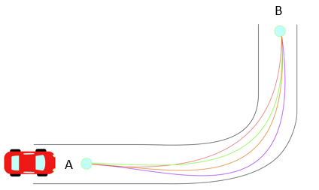

**Figure 1 Different Trajectories in a Given Path from Point A to Point B**

In autonomous vehicles, many techniques have been used to generate trajectories traversing curves that satisfy a set of given constraints [1] [2] [3]. Most common techniques involve using Euler-Lagrange equations to obtain fifth degree polynomials along with differential constraints [4] [5]. Other techniques generate trajectories from clothoids, curvature polynomials, and piece-wise functions [6] [7] [8]. These methods often need non-holonomic constraints which are defined as constraints on higher order derivatives of the positions (i.e. velocity and acceleration).

From literature review, the following criteria was selected to generate a path that solves the problem statement. The path generated needs to be:

* Able provide a smooth ride for the driver
* Independent of road markings or current infrastructure signs
* General enough so that different trajectories are used in other vehicles
* Able to transmit the least amount of data as possible
* Generated from any road type
* Independent of information from camera sensors or lidar sensor

The techniques cited before [1-8] are able to satisfy some the criteria that is being stated above. However, to generate the least amount of data transmitted as possible, a set of additional parameters needed to be considered. These were used to compare methods of path generation and develop a proposed solution. These parameters include:

* Computation time offline and online
* Size of transmitted data online
* Length of road section needed
* Dynamic constraints such as maximum acceleration and velocity
* Geometric constraints such as curvature and road geometry

From comparing techniques, it was noted how most boundary value problems such as [4] [5] offer solutions of analytical higher order equations, while others contain non-closed forms [2]. Consequently, high computation costs are needed to calculate trajectories during onboard operations. Solutions compared include coordinate and curvature polynomials of high order. These type of polynomial solutions introduce rounding and truncation errors that typically occur in machine operations [9] [10]. In autonomous vehicle operations, both accuracy and speed are essential for optimum performance. As accuracy of polynomial approximations increases by extending the operations of polynomial coefficients, its speed of transmission decreases. Decreasing the amount of coefficients provide non-compliant solutions, and the sensitivity of the coefficients is affected as well. This makes accuracy and speed of transmission an inverse relationship which should not be allowed for this V2I technology.

In this project, it was determined that size of data should be minimized during transmission per length segment. Through this analysis, it was noted that conventional path generation techniques onboard vehicles do not offer a reliable solution for infrastructure data transmission.

**Problem Solution**

An approach was selected for a discrete solution based on offline road geometry generation. Focused on its minimum data transmission.

**Mathematical Formulation**

A set of unit vectors known as Normal-Tangential (N-T) Coordinates is used for the formulation of this path. N-T coordinates have been used extensively in works that define curvilinear motion of particles in space [11]. For this project, a 2D Euclidean space is selected in which N-T coordinates will be used to represent the motion of vehicle’s center of mass traversing a curve as shown in Figure 2.

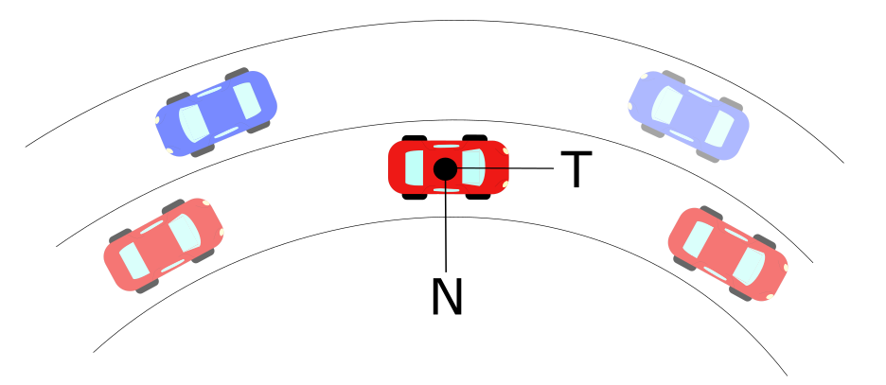

**Figure 2 Normal-Tangential Coordinates Example in Vehicle’s Center of Mass**

As the vehicle goes through the curve, it is limited to constraints provided by road geometry and friction limits on the vehicle tires [12] [13]. These limits are related to the acceleration a vehicle goes under circular motion, which is denoted as:

$a=\dot{v} T+{κv}^{2} N$ (1)

Where:

a = Total Acceleration of Vehicle (m/s2)

v = Tangential Velocity of Vehicle (m/s)

$κ$ = Curvature at an Instantaneous Point (m-1)

N =Normal Unit Vector

T= Tangential Unit Vector

Curvature can be defined analytically, physically and geometrically. It measures how fast the tangential unit vector T changes with respect to an instantaneous point in the curve. The inverse of curvature is known as radius of curvature ρ which indicates the radius of circumscribed circle at a point in a curve. By definition of N-T coordinates, a vector perpendicular to the curvature direction will provide a velocity tangent vector approximation. This velocity vector provides a heading angle to the desired trajectory that is needed to follow a road path.

This curvature can be expressed in a vector form that has a direction in the Normal Unit Vector shown in Figure 2. Derivations for defining curvature have been extensively developed in other works [11] [12]. The derivation of interest is explained in detail below.

*Discrete Curvature Formulation*

Let a scalene triangle with corners A, B, C have a circumscribed circle of radius R in Euclidean 2D space as shown in Figure 3.

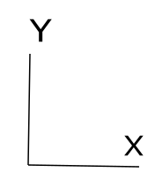 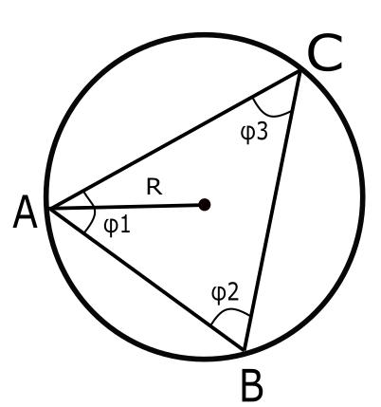

**Figure 3 Circumscribed Circle in Scalene Triangle**

If we let a vector D be the cross product in between the vectors AB and AC, the direction will be pointing out normal to the plane defined by the intersection of AB and AC. By definition of the magnitude for cross product:

$\left\|D\right\|= \left\|AB ×AC\right\|= \left\|AB\right\| \left\|AC\right\| \sin{ϕ_{1}}$ (2)

Let a vector E be the cross product of D with the vector AB, defining this new vector in the direction of ${ e}_{1}$ as shown in Figure 4. Let the magnitude of vector E be defined as:

$\left\|E\right\|=\left\|D×AB\right\|={\left\|AB\right\|}^{2}\left\|AC\right\| \sin{ϕ_{1}}$ (3)

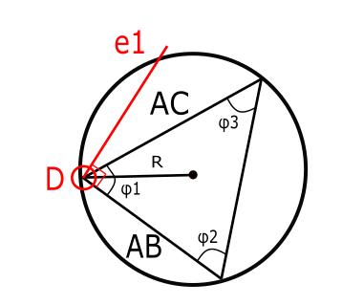

**Figure 4 Circumscribed Circle with Unit Vector $e_{1}$**

Similarly, let a vector F be the cross product of D with the vector AC, defining this new vector in the direction of $e_{2}$ as shown in Figure 5. Let the magnitude of vector E be defined as:

$\left\|F\right\|=\left\|D×AC\right\|=\left\|AB\right\|{\left\|AC\right\|}^{2} \sin{ϕ_{1}}$ (4)

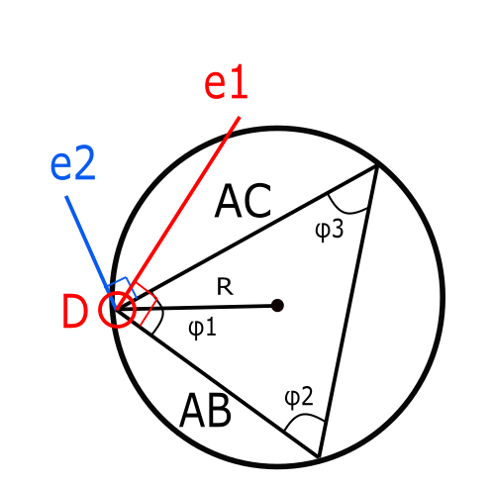

**Figure 5 Circumscribed Circle with Unit Vectors $e_{1}$ and $e_{2}$**

The unit vectors of $e_{1}$ and $e_{2}$ are defined by the following:

$e_{1}=\frac{E}{{\left\|AB\right\|}^{2}\left\|AC\right\|\sin{ϕ_{1}}}$ (5)

$e_{2}=\frac{F}{\left\|AB\right\|{\left\|AC\right\|}^{2}\sin{ϕ_{1}}}$ (6)

By definition, the midsection of any triangle’s side intersects with each other at a point P as shown in Figure. These intersecting lines denote two triangles with the same angle $ϕ_{1}$ in between the unit vectors and their corresponding midsections as shown in Figure 6 below.

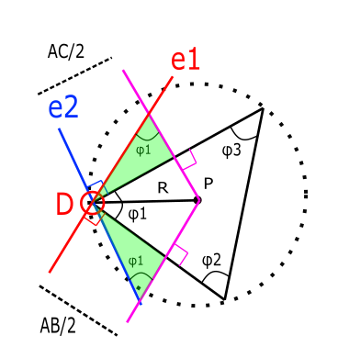

**Figure 6 Triangles Formed through Intersections of Unit Vectors**

From these triangles, it is possible to break the vector DP into components along unit vectors $e_{1}$ and $e_{2}$ to obtain a new definition of DP in a different set of coordinates as follows:

$DP_{1}=\frac{AC}{2\sin{ϕ_{1}}} e_{1}=\frac{E}{2{\left\|AB\right\|}^{2}\sin^{2}{ϕ_{1}}}$ (7)

$DP_{2}=\frac{-AB}{2\sin{ϕ_{1}}} e_{2}=\frac{-F}{2{\left\|AC\right\|}^{2}\sin^{2}{ϕ_{1}}}$ (8)

From our previous definition of the vector D, it is possible to simplify further:

$DP_{1}=\frac{{\left\|AC\right\|}^{2}E}{2{\left\|D\right\|}^{2}}$ (9)

$DP_{2}=\frac{{-\left\|AB\right\|}^{2}F}{2{\left\|D\right\|}^{2}}$ (10)

With these components, it is possible to obtain the magnitude as follows:

$DP= \frac{{\left\|AC\right\|}^{2}E}{2{\left\|D\right\|}^{2}}- \frac{{\left\|AB\right\|}^{2}F}{2{\left\|D\right\|}^{2}}$ (11)

$R= \frac{{\left\|AC\right\|}^{2}E-{\left\|AB\right\|}^{2}F}{2{\left\|D\right\|}^{2}}$ (12)

Using previous definitions of E and F:

$R= \frac{{\left\|AC\right\|}^{2}\left\|D×AB\right\|-{\left\|AB\right\|}^{2}\left\|D×AC\right\|}{2{\left\|D\right\|}^{2}}$ (13)

Using previous definition of D, it is possible to obtain the radius of the prescribed circle in terms of only the difference in between points A, B and C.

$R= \frac{{\left\|AC\right\|}^{2}\left\|(AB×AC)×AB\right\|-{\left\|AB\right\|}^{2}\left\|(AB×AC)×AC\right\|}{2{\left\|(AB×AC)\right\|}^{2}}$ (14)

Using the previous definition, it is possible to apply the formulation of R to differentially small arc segments as it is shown in Figure 7.

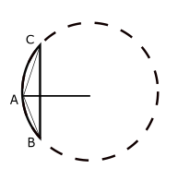

**Figure 7 Scalene Triangle in Arc-Segment**

By definition, the radius of this circumscribed circle is called radius of curvature, and its inverse is known as curvature denoted as:

$κ=\frac{1}{R}$ (15)

Through this definition, it is possible to extend the application of this discrete radius of curvature and applying it to long-discrete arc segments as shown in the Figure 8 below.

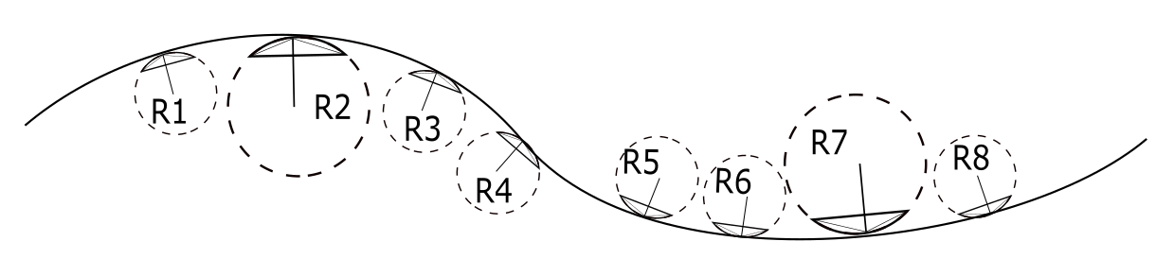

**Figure 8 Road Section with Discrete Sections**

Typical highway roads are designed based on AASHTO guidelines to provide a natural, easy-to-follow path for drivers, such that the lateral force increases and decreases gradually as the vehicle enters and leaves a circular curve [16]. This leads to an approach of curvature generation based on AASHTO road geometry to obtain heading angles. To develop this, the aforementioned definition of radius of curvature is used to obtain both its magnitude and direction [17]. The radius of curvature is computed from discrete points that represent coordinates of a road. To obtain different approximations, different methods to coordinates were used. The first method involved a base model of the road based on AASHTO guidelines. The second method involved using Google Earth coordinates.

**AASHTO Base Model**

This model consisted on strictly using AASHTO guidelines to design an ideal highway road for a vehicle traversing at constant 60 mph with the highest degree of elevation. The curve consisted of 5 different sections that can be classified as: straight section, entrance transition, constant radius curve, exit transition and straight section. Applying the discrete geometric approach to this curve, curvature vectors were plotted with respect to the road segments as shown in Figure 9. The curvature magnitude was plotted with respect to road segments to obtain a base curvature profile as shown in Figure 10.



**Figure 9 AASHTO Base Model: Road with Curvature Vectors**



**Figure 10 AASHTO Base Model: Curvature κ vs. Cumulative Curve Length**

With the curvature profile established, two different approaches were used to confirm the heading angle approximation. The first method involved obtaining the heading angle from the Discrete Curvature Formulation and add an orthogonal phase shift. The second method involved using the Heading Angle Integration Formulation which has been explored in different studies [15]. The results of both methods are shown in Figure 11 and Figure 12. Results on heading angles with respect to road segments are shown in Figure 13. These resulting angles were used as input data on a controller developed in [Michael].



**Figure 11 AASHTO Base Model: Orthogonal Phase Shift Approach**



**Figure 12 AASHTO Base Model: Numerical Integration Approach**



**Figure 13 AASHTO Base Model: Road with Velocity Vectors**

**Google Earth Model**

This model is based off a selection of points in Google Earth that represent a highway road with design speed of 60 mph. The points were picked as close as possible to resemble the road centerline of the highway. The road profile and resulting vectors from applying the aforementioned discrete geometry approach are shown in Figure 14. It is noticeable how the vector directions choose arbitrary tangent directions when the curve approaches a straight line section. The curvature magnitude with respect to length was also plotted in Figure 15 and it was observed that magnitude deviations increased considerably compared to the ideal AASHTO model.



**Figure 14 Google Earth Model: Road with Curvature Vectors**



**Figure 15 Google Earth Model: Curvature κ vs. Cumulative Curve Length**

The method was not efficient in calculating curvature magnitudes, but the direction of the heading angle obtained from the orthogonal phase shift still provided comparable results to those found by calculating with AASHTO as shown in Figure 16. Similarly, the resulting velocity vectors to guide the vehicle provide a suitable heading direction as shown in Figure 17. These resulting angles were used as input data on a controller developed in [Michael] to study the efficiency of navigating with this input information.



**Figure 16 Google Earth Model: Orthogonal Phase Shift Approach**



**Figure 17 Google Earth Model: Road with Velocity Vectors**

**CONCLUSIONS**

Nulla eu

**ACKNOWLEDGMENTS**

Nunc eros felis,

**AUTHOR CONTRIBUTIONS**

The authors confirm contribution to the paper as follows: study conception and design:

X. Author, Y. Author; data collection: Y. Author; analysis and interpretation of results: X.

Author, Y. Author. Z. Author; draft manuscript preparation: Y. Author. Z. Author. All

authors reviewed the results and approved the final version of the manuscript.

**REFERENCES**

1.M. Werling, J. Ziegler, K. Soren, and S. Thrun. Optimal Trajectory Generation for Dynamic Street Scenarios in a Frenet Frame*, 2010 IEEE International Conference on Robotics and Automation*.

2. A. Kelly, B. Nagy, Reactive Nonholonomic Trajectory Generation via Parametric Optimal Control, *2003 The International Journal of Robotics Research Vol. 22, No. 7–8, July–August 2003, pp. 583-601, Sage Publications*

3. Y. Sun, Z. Zhan, Y. Fang, L. Zheng, L. Wang, G. Guo, A Dynamic Local Trajectory Planning and Tracking Method for UGV Based on Optimal Algorithm, *2019 SAE Technical Paper 2019-01-0871*

4. A. Takahashi, T. Hongo, Y. Ninomiya, G. Sugimoto, Local Path Planning and Motion Control for AGV in Positioning, *1989 IEEE/RSJ International Workshop on Intelligent Robots and Systems*

5. A. Piazzi, C. Guarino lo Bianco, Quintic G2-Splines for Trajectory Planning of Autonomous Vehicles, *2000 IEEE Intelligent Vehicles Symposium*

6. D. Wilde, Computing Clothoid-Arc Segments for Trajectory Generation, *2009 IEEE*

7. H. Delingette, M. Hebert, K. Ikeuchi, Trajectory Generation with Curvature Constraint based on Energy Minimization, *1991 IEEE/RSJ International Workshop on Intelligent Robots and Systems*

8. B.K.P. Horn, The Curve of Least Energy, *1983 ACM Transactions on Mathematical Software Vol. 9 No. 4 Pages 441-460*

9. P. Guillaume, J. Schoukens, R. Pintelon, Sensitivity of Roots to Errors in the Coefficient of Polynomials Obtained by Frequency –Domain Estimation Methods, *1989 IEEE Transactions on Instrumenation and Measurement*

10. K. E. Atkinson, An Introduction to Numerical Analysis, *1989 John Wiley & Sons, 2nd ed, ISBN-13: 978-0471624899*

11. O. M. O’Reilly, Engineering Dynamics A Primer, *2010 Springer, 2nd ed, ISBN-13: 978-1441963598*

12. A.N. Pressley, Elementary Differential Geometry, *2010 Springer Undergraduate Mathematics Series, ISBN-13: 978-1848828902*

13. H. B. Pacejka, Tyre and Vehicle Dynamics, *2006, Elsevier Publisher, Butterworth-Heinemann, 2nd ed, ISBN-13: 978-0080970165*

14. T. D. Gillespie, Fundamentals of Vehicle Dynamics, *1992 Society of Automotive Engineers, International, ISBN-13: 978-1560911999*

15. M. P. do Carmo, Differential Geometry of Curves and Surfaces, *1976 Dover Publications, ISBN-13: 978-0486806990*

16. A Policy on Geometric Design of Highways and Streets, *2011 American Association of State Highwat and Transportantion Officials, 6th ed*

17. A. Mjaavatten, Curvature of a Discrete Curve in 3D Space, *2018*

18. M. Duhn, G. Parikh, J. Hourdos, I-94 Connected Vehicles Testbed Operations and Maintenance, *2019 Roadway Safety Institute, Minnesota Traffic Observatory Department of Civil, Enginronmental, and Geo-Engineering, Minneapolis, MN*

19. Druta, A. S. Alden, Implementation and Evaluation of a Buried Cable Animal Detection System and Deer Warning Sign, *2019 Virginia Transportation Research Council, Charlottesville, VA*

20. Taxonomy and Definitions for Terms Related to Driving Automation Systems for On-Road Motor Vehicles, *2018 SAE International*

21. William J. Hughes Technical Center, Global Positioning System (GPS) Standard Positioning Service (SPS) Performance Analysis Report, *2017*

22. S. Heinrich, Planning Universal On-Road Driving Strategies for Automated Vehicles, *2018 Springer, 1st ed, ISBN-13: 978-3658219536*

Appendix

A.1 – *Heading Angle Integration Formulation*

The arc-length s of a curve is defined as the length traveled by a certain amount of degrees $θ$ along a constant radius r. If s is sufficiently small, a triangle can be formed in between these three parameters, which are related through geometry:

$$\sin{θ}=\frac{s}{r}$$

Defining r as the radius of curvature at the specific arc-length and letting $r=ρ$.

$$\sin{θ}=\frac{s}{ρ}$$

By the previous assumption of small angles: $\sin{θ}=θ$

Which leads to

$θ=\frac{s}{ρ}$ (1)

Let the Curvature $κ$ be denoted as $ρ=1/κ$

Substituting this definition into equation (1)

$$θ=κs$$

Assuming a differential section for $θ$ and $s$. Rearranging for $κ$:

$$κ=\frac{dθ}{ds}$$

By separation of variables and integration

$$\int{κds}= \int{dθ}$$

Which concludes that the angle of orientation as a function of arc-length s can be found through numerical integration of the curvature as:

$$θ\left(s\right)= \int{κ\left(s\right)ds}$$