20XX-01-XXXX

Anti-Lock Brake System Acceleration Analysis with Wavelet Transforms

Author, co-author (Do NOT enter this information. It will be pulled from participant tab in MyTechZone)

Affiliation (Do NOT enter this information. It will be pulled from participant tab in MyTechZone)

Abstract

To present this testing, and signal analysis, the paper is organized in the following sections: Experimental Setup, Wavelet Formulation, Test Data Results, and Recommendations. Conclusions about ABS behavior under split surfaces, and efficiency of wavelet decomposition for acceleration during braking are provided.

Keywords: Acceleration Analysis, Signal Processing, Wavelet Transform, Anti-Lock Braking

Introduction

Motivation

Anti-Lock Braking Systems (ABS) serve to prevent vehicle locking by maintaining a proportional decrease in wheel speed to forward vehicle speed during braking events. Electronic Stability Control (ESC) systems take advantage of ABS to maintain a constant yaw direction to prevent spin out scenarios through applying different braking pressures to compensate for uneven surfaces. Extensive research has been performed evaluating models of ABS and ESC with successful implementations in vehicles [][][]. The performance of these systems rely entirely on the tire-road interaction that occurs while braking. For this reason, extensive research has been performed on determining appropriate coefficients of friction (COF), for multiple tire-surface interactions [][][].

However, there is minimum research on scenarios where the vehicle encounters two surfaces simultaneously or changes in friction surfaces. High speed scenarios where the vehicle is deviated from the highway road can force a driver to either maintain a split surface path or switching to a different road surface altogether. This lead to a study of split road surfaces with Wavelet Transforms conducted at the University of Nebraska – Lincoln (UNL).

Conventional methods for determining COF involve a full braking test in which the average acceleration (in g’s) of the braking event determines the COF for the corresponding tire-surface pair []. In this paper, this method is expanded upon the introduction of wavelets decomposition for acceleration data. In signal analysis, decomposition methods are used to filter out noise and preserve the nature of the true signal that the system has. The most common technique for this is Fourier Signal Decomposition, in which the signal is modeled through sinusoids and filtered through Fast Fourier Transforms (FFT). During braking events, the ideal acceleration profile has a ramp-up function followed by a constant, and a ramp-down function. These profiles are harder to model through Fourier Decomposition because of the noise present in the signal and the desired ideal profile (i.e. non-periodic, non-smooth profiles). For this reason, a different approach was obtained through the use of Wavelet Decomposition. The results show a promising method for acceleration profile filtering through the use of Coiflet Wavelet Filtering.

The remainder of this paper explains the baseline parameters for ABS profiles, describes the Wavelet Formulation to filter the acceleration data. The results obtained from the experimentation on split-surfaces are discussed, and the effectiveness of Coiflet Wavelet Filtering thereof. A section of Recommendations and Conclusions are offered for further investigation on Split-Surfaces, and Coiflet Filtering.

ABS Acceleration Profiles

ABS exerts braking forces at different frequencies in order to prevent wheel lock, which can lead to skidding and tire burn out. The forces actuated by ABS maintain a quasi-linear deceleration rate which depends on the relationship between the forward vehicle velocity and forward wheel rotational velocity. This is quantified, through the slip ratio defined as:

Where:

S = Slip Ratio

v = Forward Velocity of Vehicle (m/s)

= Wheel Speed (rad/s)

r = Wheel Radius (m)

In practice, the slip ratio should be kept in a range close to 20 percent to prevent wheel lock while maintaining maximum friction developed at each tire simultaneously []. During these events, the ideal acceleration profile determined by physics resembles Figure ###.



In general, the profile is dependent on the tire-road interactions []. Such that different tires and different road surfaces interact differently, changing parameters such as rise time, height, and fall time of the profile. However, the COF of the road varies greatly higher compared to that of the rubber tires (i.e. assuming not high-performance tires). In braking scenarios, rise time, and fall time differ while the amplitude of the signal maintains a constant slope. Maximum COF’s are determined to be the highest amplitude obtained from the acceleration profile. In practical applications, COF is the average over the range in which the acceleration holds a constant value (with acceleration measured in G’s).

Wavelet Filtering Formulation

The theory behind Wavelet Signal Decomposition is analogous to Fourier Series Decomposition, in which a signal is decomposed into a summation of base functions. In the case of Fourier series, sinusoids are the base functions. For Wavelets, the decomposition is arbitrary, and many base functions are available to model with []. The primary disadvantage of sinusoids is that simple discontinuities (i.e. sharp edges), are subject to Gibbs phenomena in which the signal reconstructions create artificial cusps which can only be avoided by infinite summations (i.e. not practical computationally) [].

The base function selected for the Wavelet Signal Decomposition is the Coiflet 2, which is shown in Figure ###. The selection was based upon having a function that can handle discontinuities, and the time series for this wavelet favors a non-equal rise time and fall time for the signal. This was taken into consideration to resemble the ideal acceleration profile under ABS braking.



The formulation of this filter utilized the MATLAB Wavelet Tool Analyzer, with it, the procedure can be summarized as follows:

* Obtain a Wavelet Decomposition using a Coiflet 2 Wavelet at a level 6 decomposition to obtain an approximation.
* Run a moving average filter with the Wavelet approximation that detects sudden changes in average values.
* Detect changes by a user defined threshold
* Store data that surpasses threshold
* Repeat

Experimental Setup

Testing was performed at Midwest Roadside Safety Facility testing grounds. The vehicle used was a 2007 Crown Victoria in which, friction testing parameters were evaluated in a previous study []. The testing equipment included a VC4000 data recording systems. ETC ETC. shown in Figure ###

To test ABS acceleration performance, 4 surface types were organized in 5 different braking scenarios. First, a full concrete (FC) baseline is used to measure standard ABS braking performance. The following two involves testing under full gravel (FG) and full sand (FS) surfaces. The last two were split gravel with concrete (SG), and split sand with concrete (SS). All test beds except for the concrete baseline, had a subsequent grass bed for the vehicle to keep braking. These tests are illustrated in Figure ###. Every test was repeated twice for reproducibility, which gives a total of 10 tests.

The data for each repeated test (i.e. 1-2, 3-4, etc.) was performed within the same run-trial to maintain a consistency with equipment calibration in between surface changes. Testing consisted of the following sections: speeding up to 55 mph, full brake to stop, idle stop, circle around to starting position, repeat.

Test Data Results

All tests can be divided into consecutive sections that align with the experimental testing procedure as shown in Figure ###. The results of the 10 tests is shown in Figures ### in the Appendix for ease of organizational flow. It can be noted for all tests that noise is considerably reduced from the original signal. A sample from the FC test is shown in Figure #### below.

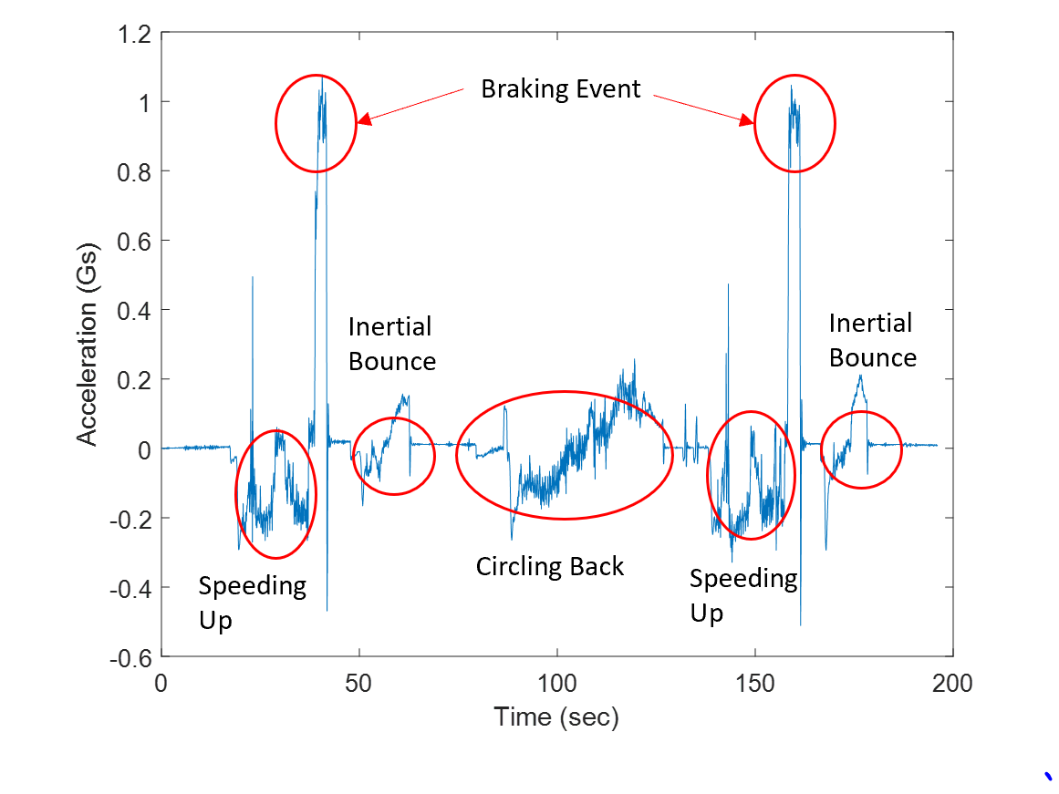

Full Concrete 1-2 Tests Signal Layout



Full Concrete 1-2 Tests Acceleration Raw and Filtered Signals

To verify that the acceleration did not lose any characteristic information after the Wavelet Decomposition, velocity profiles were numerically integrated for the raw data and the reconstructed approximation. Spline interpolation was utilized along with Simpson’s quadrature scheme to provide exact results which are shown in Figure ###. It is noticeable how the integrated Coiflet approximation matches the raw signal integrated profile.



Velocity Profile of FC1 Test (Top), and FC2 Test (Bottom)

Furthermore, a tabulation of all results is shown in Table ###.

|  |  |  |  |
| --- | --- | --- | --- |
| Test Name | Average COF | Literature Value | Relative Error |
| FC1 | 0.9224 | 1 | 7.76% |
| FC2 | 0.9168 | 1 | 8.32% |
| FG1 | 0.5206 | 0.55 | 5.35% |
| FG2 | 0.4709 | 0.55 | 14.38% |
| FS1 | 0.4428 | 0.55 | 19.49% |
| FS2 | 0.5595 | 0.55 | 1.73% |
| SG1 | 0.6327 | 0.7 | 9.61% |
| SG2 | 0.6513 | 0.7 | 6.96% |
| SS1 | 0.5891 | 0.61 | 3.43% |
| SS2 | 0.6039 | 0.61 | 1.00% |

Discussion/Recommendations

The study presented has the potential to be implemented in a distributed model of vehicle automization, but is not limited solely to

Summary/Conclusions

In conclusion, a method was proposed to calculate trajectories based on discrete

Appendix

 Full Concrete 1-2 Tests Acceleration Raw and Filtered Signals



Full Concrete 1-2 Tests Extracted Signal

 Full Gravel 3-4 Tests Acceleration Raw and Filtered Signals



Full Gravel 3-4 Tests Extracted Signals

 Full Sand 5-6 Tests Acceleration Raw and Filtered Signals



Full Sand 5-6 Tests Extracted Signals



Split Gravel 7-8 Tests Acceleration Raw and Filtered Signals



Split Gravel 7-8 Extracted Signals



Split Sand 9-10 Tests Acceleration Raw and Filtered Signals



Split Sand 9-10 Extracted Signals

References

1. Stolle, C., Jacome, R., and Sweigard, M., “Autonomous Technology, A Review - MATC Year One Report”, Internal Report, 2018.
2. Huetter, John. “IIHS: HLDI Estimates 24% of Fleet Had Backup Cameras, 17% Had Parking Sensors in 2016.” *Repairer Driven News* (blog), February 2, 2018. <https://www.repairerdrivennews.com/2018/02/02/iihs-hldi-estimates-24-of-fleet-had-backup-cameras-17-had-parking-sensors-in-2016/>.
3. HLDI Bulletin, “Compendium of HLDI collision avoidance research” vol. 35, No. 34: September 2018.
4. Benson, A.J., Tefft, B.C., Svancara, A.M., & Horrey, W.J. (2018). Potential Reductions in Crashes, Injuries, and Deaths from Large-Scale Deployment of Advanced Driver Assistance Systems (Research Brief). Washington, D.C.: AAA Foundation for Traffic Safety.
5. LaValle, Steven M. “Planning Algorithms,” 2006. <https://doi.org/10.1017/cbo9780511546877>.
6. Heinrich, S., “Planning Universal On-Road Driving Strategies for Automated Vehicles,” AutoUni – Schriftenreihe. Springer, 2018. <https://doi.org/10.1007/978-3-658-21954-3>.
7. Kelly, A., and Nagy, B., “Reactive Nonholonomic Trajectory Generation via Parametric Optimal Control.” I. J. Robotics Res. 22 (2003): 583–602. <https://doi.org/10.1177/02783649030227008>.
8. Dubins, L. E., “On Curves of Minimal Length with a Constraint on Average Curvature, and with Prescribed Initial and Terminal Positions and Tangents,” American Journal of Mathematics 79, no. 3 (1957): 497–516. <https://doi.org/10.2307/2372560>.
9. Ziegler, J., Bender, P., Dang, T., and Stiller, C., “Trajectory Planning for Bertha — A Local, Continuous Method.” In 2014 IEEE Intelligent Vehicles Symposium Proceedings, 450–57, 2014. <https://doi.org/10.1109/IVS.2014.6856581>.
10. Fox, C., “An Introduction to the Calculus of Variations. Courier Corporation,” 1987.
11. Takahashi, A., Hongo, T., Ninomiya, Y., and Sugimoto, G., “Local Path Planning And Motion Control For AGV In Positioning.” In Proceedings. IEEE/RSJ International Workshop on Intelligent Robots and Systems ’. (IROS ’89) ’The Autonomous Mobile Robots and Its Applications, 392–97, 1989. <https://doi.org/10.1109/IROS.1989.637936>.
12. Piazzi, A., and C. Guarino Lo Bianco. “Quintic G2-Splines for Trajectory Planning of Autonomous Vehicles.” In Proceedings of the IEEE Intelligent Vehicles Symposium 2000 (Cat. No.00TH8511), 198–203, 2000.
13. Sun, Y., Zhan, Z., Fang, Y., Zheng, L. et al., “A Dynamic Local Trajectory Planning and Tracking Method for UGV Based on Optimal Algorithm,” 2019-01–0871, 2019. <https://doi.org/10.4271/2019-01-0871>.
14. Wilde, D., “Computing Clothoid-Arc Segments for Trajectory Generation,” In 2009 IEEE/RSJ International Conference on Intelligent Robots and Systems, 2440–45, 2009. <https://doi.org/10.1109/IROS.2009.5354700>.
15. Delingette, H., M. Hebert, and K. Ikeuchi. “Trajectory Generation with Curvature Constraint Based on Energy Minimization.” In Proceedings IROS ’91:IEEE/RSJ International Workshop on Intelligent Robots and Systems ’91, 206–11 vol.1, 1991. <https://doi.org/10.1109/IROS.1991.174451>.
16. Werling, M., Ziegler, J., Soren, K., and Thrun, S., “Optimal Trajectory Generation for Dynamic Street Scenarios in a Frenet Frame,” In 2010 IEEE International Conference on Robotics and Automation, 987–93. Anchorage, AK: IEEE, 2010. <https://doi.org/10.1109/ROBOT.2010.5509799>.
17. Werling, M., Kammel, S., Ziegler, J., Groll, L., “Optimal Trajectories for Time-Critical Street Scenarios Using Discretized Terminal Manifolds.” The International Journal of Robotics Research 31, no. 3 (March 2012): 346–59. <https://doi.org/10.1177/0278364911423042>.
18. Sun, Y., Zhan, Z., Fang, Y., Zheng, L. et al., “A Dynamic Local Trajectory Planning and Tracking Method for UGV Based on Optimal Algorithm,” 2019-01–0871, 2019. <https://doi.org/10.4271/2019-01-0871>.
19. Gillespie, T. D. “Fundamentals of Vehicle Dynamics,” SAE Int. ISBN 1-56091-199-9, 1992.
20. Pacejka, H. B. Tyre and Vehicle Dynamics. Butterworth-Heinemann, 2006.
21. Carmo, Manfredo P. Do. Differential Geometry of Curves and Surfaces. 1 edition. Englewood Cliffs, N.J: Prentice-Hall, 1976.
22. Pressley, A. N. Elementary Differential Geometry. 2nd ed. Springer Undergraduate Mathematics Series. London: Springer-Verlag, 2010. <https://doi.org/10.1007/978-1-84882-891-9>.
23. O’Reilly, Oliver M. Engineering Dynamics: A Primer. Springer Science & Business Media, 2010.
24. A Policy on Geometric Design of Highways and Streets, (The Green Book) 6th Edition. American Association of State Highway, 2011.
25. Morral, J. F., and Talarico, R. J., “Side Friction Demanded and Margin of Safety on Horizontal Curves,” Journal of the Transportation Research Board, 1994, pp. 145-152.
26. Henry, J. J. “Evaluation of Pavement Friction Characteristics, a Synthesis of Highway Practice.” 2000, NCHRP Synthesis 291, 7p.
27. Are Mjaavatten (2019). Curvature of a 2D or 3D curve (https://www.mathworks.com/matlabcentral/fileexchange/69452-curvature-of-a-2d-or-3d-curve), MATLAB Central File Exchange. Retrieved May 24, 2019.
28. William J. Hughes Technical Center, “Global Positioning System (GPS) Standard Positioning Service (SPS) Performance Analysis Report,” Federal Aviation Administration, 2017.
29. Levien, R. L., “From Spiral to Spline: Optimal Techniques in Interactive Curve Design,” n.d., 191.
30. Akima, H. “A New Method of Interpolation and Smooth Curve Fitting based on Local Procedures,” J. ACM 17, no. 4 (October 1970): 589–602. <https://doi.org/10.1145/321607.321609>.
31. Heath, Michael T. Scientific Computing: An Introductory Survey, Revised Second Edition. SIAM, 2018.

Contact Information

Dr. Cody Stolle, Midwest Roadside Safety Facility, 2200 Vine St, Lincoln, NE 68503, Phone: (402) 472-4233, E-mail: [cstolle2@unl.edu](mailto:cstolle2@unl.edu)

Ricardo Jacome, Midwest Roadside Safety Facility, 2200 Vine St, Lincoln, NE 68503, E-mail: [rjacome@huskers.unl.edu](mailto:rjacome@huskers.unl.edu)

Michael Sweigard, Midwest Roadside Safety Facility, 2200 Vine St, Lincoln, NE 68503, E-mail: [mikesweigard@huskers.unl.edu](mailto:mikesweigard@huskers.unl.edu)

Acknowledgments

The research described in this paper is funded, by the Mid-America Transportation Center via a grant from the U.S. Department of Transportation’s University Transportation Centers Program, and this support is gratefully acknowledged. The contents reflect the views of the authors, who are responsible for the facts and the accuracy of the information presented herein, and are not necessarily representative of the sponsoring agencies.