20XX-01-XXXX

Anti-Lock Brake System Acceleration Analysis with Wavelet Transforms

Author, co-author (Do NOT enter this information. It will be pulled from participant tab in MyTechZone)

Affiliation (Do NOT enter this information. It will be pulled from participant tab in MyTechZone)

Abstract

In Run-off-Roads scenarios, vehicles can encounter multiple road surfaces between the two sides of the axle while braking. The efficiency for braking depends entirely on the friction level which is a function of both road and tire parameters. Research on multiple friction surfaces is limited to simulations with minimum in situ testing. This document investigates vehicle performance in terms of acceleration, under full braking for different split-surface scenarios. To characterize friction profiles during braking, a Wavelet Transform Filter approach is proposed. Testing results show that split-road conditions offer better braking performance, and prevent significant vehicle instability. Similarly, data analysis shows that Wavelet Transform Filter offers a reliable tool for characterizing multiple friction surfaces from acceleration data.

Keywords: Acceleration Analysis, Signal Processing, Wavelet Transform, Anti-Lock Braking, Vehicle Performance, Vehicle Stability.

Introduction

Motivation

Anti-Lock Braking Systems (ABS) serve to prevent vehicle locking by maintaining a proportional decrease in wheel speed to forward vehicle speed during braking events. Electronic Stability Control (ESC) systems take advantage of ABS to maintain a constant yaw direction to prevent spin out scenarios through applying different braking pressures to compensate for uneven surfaces. Extensive research has been performed evaluating models of ABS and ESC with successful implementations in vehicles [][][]. The performance of these systems rely entirely on the tire-road interaction that occurs while braking. For this reason, extensive research has been performed on determining appropriate coefficients of friction (COF), for multiple tire-surface interactions [][][].

However, there is minimum research on scenarios where the vehicle encounters two surfaces simultaneously or changes in friction surfaces. High speed scenarios where the vehicle is deviated from the highway road can force a driver to either maintain a split surface path or switching to a different road surface altogether. This lead to a study of split road surfaces with Wavelet Transforms conducted at the University of Nebraska – Lincoln (UNL).

Conventional methods for determining COF involve a full braking test in which the average acceleration (in g’s) of the braking event determines the COF for the corresponding tire-surface pair []. In this paper, this method is expanded upon the introduction of wavelets decomposition for acceleration data. In signal analysis, decomposition methods are used to filter out noise and preserve the nature of the true signal that the system has. The most common technique for this is Fourier Signal Decomposition, in which the signal is modeled through sinusoids and filtered through Fast Fourier Transforms (FFT). During braking events, the ideal acceleration profile has a ramp-up function followed by a constant, and a ramp-down function. These profiles are harder to model through Fourier Decomposition because of the noise present in the signal and the desired ideal profile (i.e. non-periodic, non-smooth profiles). For this reason, a different approach was obtained through the use of Wavelet Decomposition. The results show a promising method for acceleration profile filtering through the use of Coiflet Wavelet Filtering.

The remainder of this paper explains the baseline parameters for ABS profiles, describes the Wavelet Formulation to filter the acceleration data. The results obtained from the experimentation on split-surfaces are discussed, and the effectiveness of Coiflet Wavelet Filtering thereof. A section of Recommendations and Conclusions are offered for further investigation on Split-Surfaces, and Coiflet Filtering.

ABS Acceleration Profiles

ABS exerts braking forces at different frequencies in order to prevent wheel lock, which can lead to skidding and tire burn out. The forces actuated by ABS maintain a quasi-linear deceleration rate which depends on the relationship between the forward vehicle velocity and forward wheel rotational velocity. This is quantified, through the slip ratio defined as:

Where:

S = Slip Ratio

v = Forward Velocity of Vehicle (m/s)

= Wheel Speed (rad/s)

r = Wheel Radius (m)

In practice, the slip ratio should be kept in a range close to 20 percent to prevent wheel lock while maintaining maximum friction developed at each tire simultaneously []. During these events, the ideal acceleration profile determined by physics resembles Figure ###.



Figure 1. Ideal Acceleration Profile during Braking

In general, the profile is dependent on the tire-road interactions []. Such that different tires and different road surfaces interact differently, changing parameters such as rise time, height, and fall time of the profile. However, the COF of the road varies greatly higher compared to that of the rubber tires (i.e. assuming not high-performance tires). In braking scenarios, rise time, and fall time differ while the amplitude of the signal maintains a constant slope. Maximum COF’s are determined to be the highest amplitude obtained from the acceleration profile. In practical applications, COF is the average over the range in which the acceleration holds a constant value (with acceleration measured in G’s).

Wavelet Filtering Formulation

Wavelet Background

In data processing, signal waves are an oscillating function defined in time and space, such as sinusoids. These sinusoids are used as basis functions to construct any periodic signal. Such construction is known as a Fourier Series representation. This is done with a Fast Fourier Transform (FFT) to filter signals by finding the frequency content that represents the desired signal and removing all other frequencies that are categorized as noise. This method has limitations in terms of locating the time event of the frequencies captured. One primary disadvantage of sinusoids is that simple discontinuities (i.e. sharp edges), are subject to Gibbs phenomena in which the signal reconstructions create artificial cusps which can only be avoided by infinite summations (i.e. not practical computationally) []. For these reasons, wavelets were introduced to compensate for the limitations on representing signals with Fourier Series. Wavelets can be interpreted as a small wave with its energy concentrated in a position in time. These wavelets serve as the new basis functions that can decompose signals that are non-periodic while maintaining information about both frequency and time contents.

To exemplify a signal decomposition in wavelets, a Fourier series decomposition is shown in Figure ### for a direct comparison. Instead of sines and cosines, the wavelet decomposition is composed of two functions: The Scaling Function (or father wavelet) and the Wavelet Function (or mother wavelet). Similar to sines and cosines, both the scaling and wavelet functions are orthogonal functions that are linearly independent of each other.

Fourier Series Decomposition:

Wavelet Decomposition:

The coefficients c and d can be found through the principle of inner product for orthogonal functions. These coefficients receive the name of Discrete Wavelet Transform (DWT) Coefficients, which is analogous to the FFT Coefficients for signal decomposition. In general, the “d” coefficients serve to make a level of decomposition [1]. Instead of a basis function in the form of a sine or a cosine, wavelets have the advantage of an infinite range of Wavelet functions available for signal construction. In general, the scaling function has the following form below, where consists of scaling coefficients.

To define a Wavelet Function, the scaling function from before is used with a shift, along with some Wavelet Coefficients as shown below.

Wavelet Selection: Energy to Shannon Entropy

Selecting the appropriate Wavelet Function plays a crucial role into the degree of representation the filtered signal will have to the true signal. Different works have explored how to select a Wavelet Function based on techniques such as the Relative Wavelet Energy Criterion []. In this paper, the Energy to Shannon Entropy ratio is utilized as shown below [].

This ratio express the amount of signal energy contained per unit of disorder. The entropy is defined to be the degree of information available (including noise) for the signal, and the energy refers to the characteristics enclosing the true signal. Thus, the higher the ratio, the better approximation to the true signal.

Depending on the frequency at which the data is sampled, different levels of decomposition exists for different Wavelet Functions. Thus, a maximum level of decomposition of 6 was selected upon the sampling rate available during experimentation. A tabulation of the Energy to Shannon Entropy at 6 levels of decomposition for some candidates for Wavelet Function is shown in Table ###.

|  |  |  |  |  |  |
| --- | --- | --- | --- | --- | --- |
| Level | Haar | Coiflet2 | Daubechies2 | Meyer | Symlet2 |
| 1 | 0.66 | 0.01 | 0.04 | 0.01 | 0.04 |
| 2 | 6.64 | 0.56 | 1.18 | 0.07 | 1.18 |
| 3 | 221.29 | 43.88 | 52.24 | 94.63 | 52.24 |
| 4 | 1196.23 | 372.25 | 567.60 | 277.83 | 567.60 |
| 5 | 7887.28 | 9068.49 | 3120.70 | 3832.94 | 3120.70 |

The base function selected for the Wavelet Signal Decomposition is the Coiflet 2 based on the Energy to Shannon Entropy criterion, which is shown in Figure ###. Similarly, comparing this wavelet to the traditional sinusoids, Coiflets can handle discontinuities, and the time series for this wavelet favors a non-equal rise time and fall time for the signal. This was taken into consideration to resemble the ideal acceleration profile under ABS braking.



Figure 2. Sample Coiflet 2 Wavelet

A sample noisy signal is shown in Figure ### (top) that is subject to a Coiflet 2 Wavelet with a 3 level decomposition. Its DWT coefficients are then to approximate the reconstructed signal (bottom).

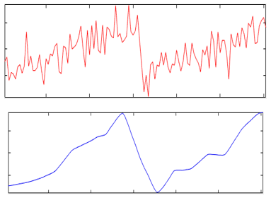

Figure 3. Raw Signal (top) and Reconstructed Signal Approximation with DWT Coefficients (bottom)

The formulation of this Wavelet Transform Filter utilized the MATLAB Wavelet Tool Analyzer, with it, the procedure can be summarized as follows:

* Obtain a Wavelet Decomposition using a Coiflet 2 Wavelet at a level 5 decomposition to obtain an approximation.
* Run a moving average filter with the Wavelet approximation that detects sudden brake changes with its average values.
* Detect changes by a user defined threshold
* Store data that surpasses threshold
* Repeat

Experimental Setup

Testing was performed at Midwest Roadside Safety Facility testing grounds. The vehicle used was a 2007 Crown Victoria in which, friction testing parameters were evaluated in a previous study []. The testing equipment included a DTS and a VC4000 data recording systems. Vehicle and instrumentation are shown in Figures ####. To capture changes in vehicle surface types, Go Pro Cameras were placed perpendicular to the vehicle braking direction.

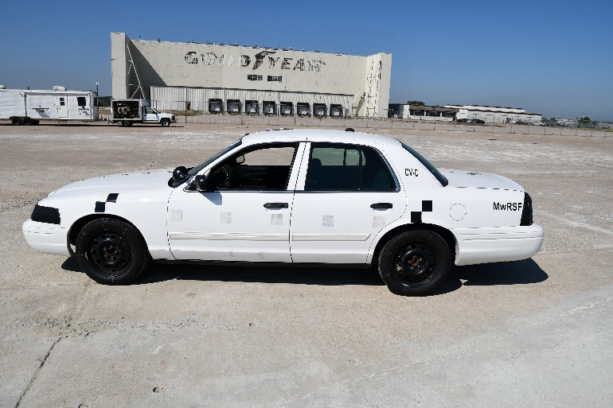

Figure 4. 2007 Ford Crown Victoria

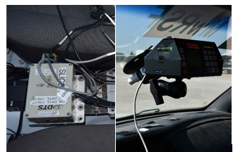

Figure 5. DTS Data Recording (Left), and VC4000 Data Recording (Right)

To test ABS acceleration performance, 4 surface types were organized in 5 different braking scenarios. First, a full concrete (FC) baseline is used to measure standard ABS braking performance. The following two involves testing under full gravel (FG) and full sand (FS) surfaces. The last two were split gravel with concrete (SG), and split sand with concrete (SS). All test beds except for the concrete baseline, had a subsequent grass bed for the vehicle to keep braking. These tests are illustrated in Figure ###, and the testing bed is shown in Figure ####. Every test was repeated twice for reproducibility, which gives a total of 10 tests.

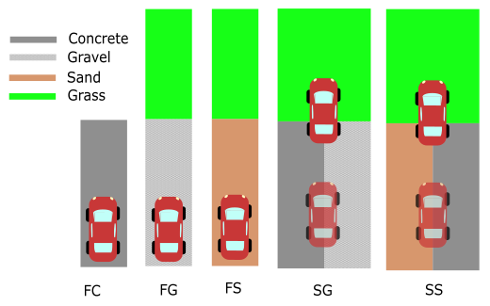

Figure 6. Testing Bed Illustration for different Surface Types

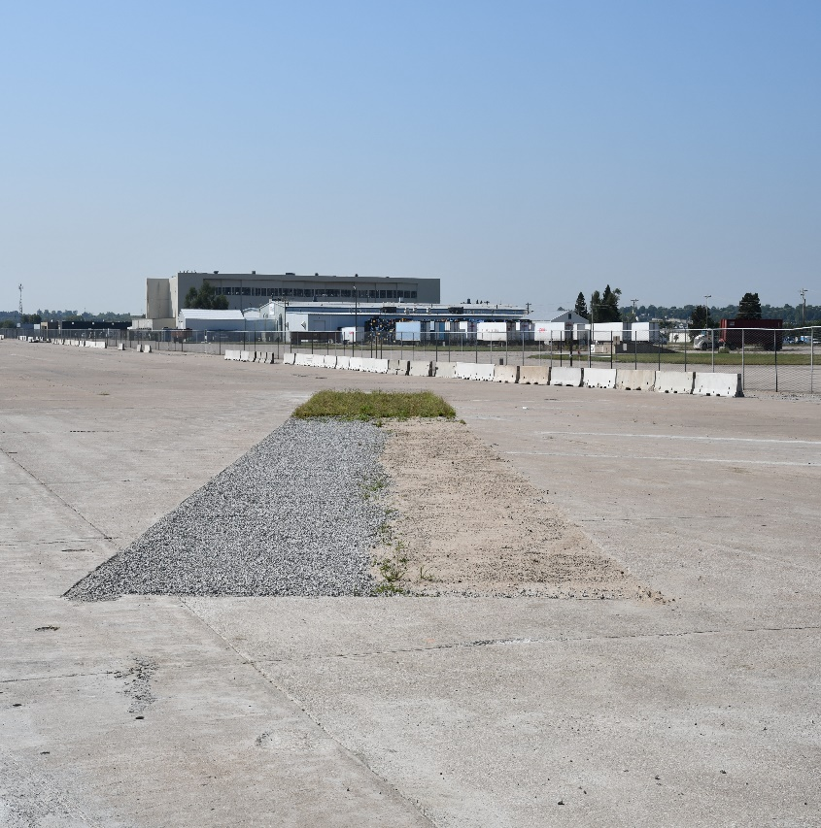

Figure 7. Surface Testing Bed

The data for each repeated test (i.e. 1-2, 3-4, etc.) was performed within the same run-trial to maintain a consistency with equipment calibration in between surface changes. Testing consisted of the following sections: speeding up to 55 mph, full brake to stop, idle stop, circle around to the starting position, and repeat. During all trials, the testing driver was instructed to maintain a firm steering to avoid and deviations of the vehicle. Moreover, the driver was instructed to press on full brake after the four wheels of the vehicle had entered the testing bed.

Test Data Results/Post-Processing

Raw Signal Analysis with Wavelet Approximation

All tests can be divided into consecutive sections that align with the experimental testing procedure as shown in Figure ###. The results of the 10 tests is shown in Figures ### in the Appendix for ease of organizational flow. It can be noted for all tests that noise is considerably reduced from the original signal. A sample from the FC test is shown in Figure #### with a filtered signal in Figure ###.

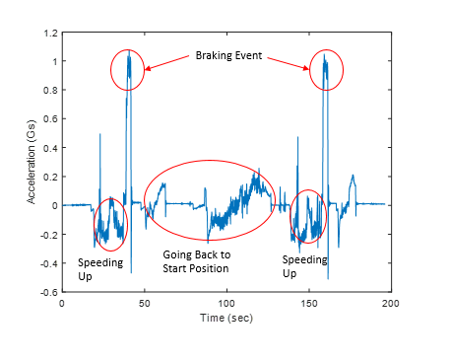

Figure 8. Full Concrete 1-2 Tests Signal Layout



Figure 9. Full Concrete 1-2 Tests Acceleration Raw and Filtered Signals

To verify that the acceleration did not lose any characteristic information after the Wavelet Decomposition, velocity profiles were numerically integrated for the raw data and the reconstructed approximation. Spline interpolation was utilized along with Simpson’s quadrature scheme to provide exact results which are shown in Figure ###. It is noticeable how the integrated Coiflet approximation matches the raw signal integrated profile.



Figure 10. Velocity Profile of FC1 Test (Top), and FC2 Test (Bottom)

After obtaining the Coiflet approximation and verifying the velocity profile consistency, a moving average with sudden rate change detection was used to characterize braking events. A sample code is given in Figure ### for determining braking accelerations. The code has a user defined threshold to vary the severity of the braking rate (i.e. high-speed vs low-speed braking). The detected braking rates during the FG Tests are given as an example in Figure ###.

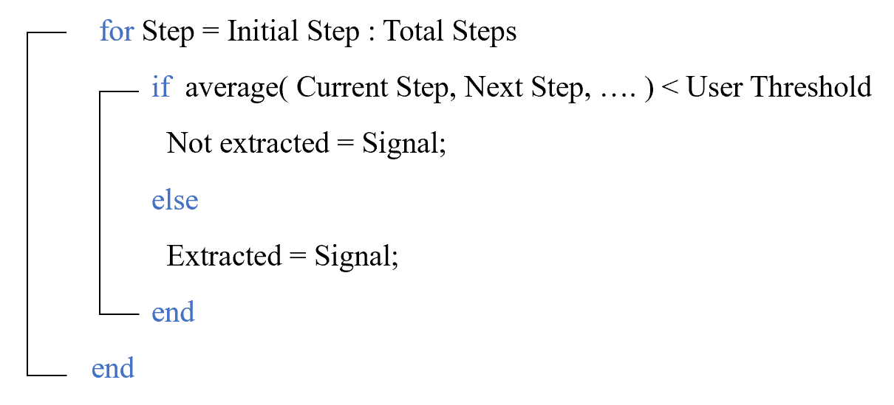

Figure 11. Braking Detection Pseudo-Code



Figure 12. Full Gravel 3-4 Test Braking Acceleration Detection

Using the extracted braking rate section, it is possible to analyze the quality of the Coiflet to detect the COF. The COF was obtained A tabulation of all results is shown in Table ### .Literature friction concrete values (FC) for the Crown Victoria have been calculated and extensively reviewed on []. It is worth noting that literature on testing friction coefficients of gravel and sand (FG and FS) are fairly limited [][][]. Thus, the literature values are subject to variability in tire-tread, and material-characteristics compared to those in this testing. Furthermore, sand and gravel surfaces are granular materials which means that precise repeatability for these tests is highly difficult. To estimate a value of the split coefficients (SG and SS), the average in between the concrete value and its respect pairs were used.

Table 1. Average COF with Literature Value Comparisons

|  |  |  |  |
| --- | --- | --- | --- |
| Test Name | Average COF | Literature Value | Relative Error |
| FC1 | 0.9224 | 0.9305 | 0.87% |
| FC2 | 0.9168 | 0.9305 | 1.47% |
| FG1 | 0.5206 | 0.55 | 5.35% |
| FG2 | 0.4709 | 0.55 | 14.38% |
| FS1 | 0.4428 | 0.55 | 19.49% |
| FS2 | 0.5595 | 0.55 | 1.73% |
| SG1 | 0.6327 | 0.74025 | 14.53% |
| SG2 | 0.6513 | 0.74025 | 12.02% |
| SS1 | 0.5891 | 0.74025 | 20.42% |
| SS2 | 0.6039 | 0.74025 | 18.42% |

Wavelet Transform vs Fourier Transform

Data obtained through the Wavelet Transform Approximation was compared to a Butterworth Filter data. The filter was designed as a low-pass, second-order Butterworth filter with a cutoff frequency of 3Hz. The cut-off frequency was selected by performing an FFT on the acceleration data as it is shown in Figure ###.



Figure 13. Fast Fourier Transform with Cut-off Frequency

Both Butterworth filtered signal and Coiflet approximation for the FG1 testing are shown in Figures ###. It is noticeable how the Coiflet avoids “oscillating” behavior and catches the overall trend of the acceleration data.



Figure 14. FG1 Acceleration Data and Butterworth Filtered Data



Figure 15. FG1 Acceleration Data and Coiflet Approximation

To correlate the Coiflet Approximation to the forward surface changes, a transition time was found in between the full braking event and a different surface (i.e. full gravel – full grass). This was performed by using the GoPro Cameras, in which the frame at which the four wheels of the vehicle entered a surface was selected. The time at which the vehicle entered the first test bed (i.e. gravel) was subtracted from the time it entered the second bed (i.e. grass). These results are tabulated in Table ####.

Table 2. Test Surface Transition Times

|  |  |
| --- | --- |
| Test Name | Transition Time |
| FC1 | 0.00 |
| FC2 | 0.00 |
| FG1 | 1.82 |
| FG2 | 2.03 |
| FS1 | 1.92 |
| FS2 | 1.72 |
| SG1 | 1.87 |
| SG2 | 2.25 |
| SS1 | 1.91 |
| SS2 | 1.81 |

To locate the braking event on the Coiflet Approximation, the Braking Detection Pseudo-Code was used, and the result for the FG1 test is shown in Figure ###.



Figure 16. Coiflet Approximation with Braking Detection

By locating the initial braking time, and adding the transition time (i.e. 1.82 seconds for FG1), it is possible to get an estimation on the surface change, which corresponds roughly to a periodic change in the Coiflet Approximation as shown in Figure.



Figure 17. Coiflet Approximation with Braking Detection

|  |  |
| --- | --- |
| Test Name | Transition Time |
| FC1 | 0.00 |
| FC2 | 0.00 |
| FG1 | 1.82 |
| FG2 | 2.03 |
| FS1 | 1.92 |
| FS2 | 1.72 |
| SG1 | 1.87 |
| SG2 | 2.25 |
| SS1 | 1.91 |
| SS2 | 1.81 |

Discussion

Observations from Table ### demonstrate that the COFs obtained through Coiflet approximations does show a low relative error compared to the literature review obtained through careful and recorded in-situ testing. However, the relative error obtained with the sand and gravel tests is considerably high. The majority of the sources for tire-gravel COF lead back to citation [] and tire-sand COFs from sources are mostly estimated through deductions than testing.

Thus, the literature COF from gravel and sand are considered to not be enough as a measure of error check for the efficiency in the Coiflet approximation. The split COFs get affected in a similar manner due to their direct relationship to gravel and sand COF. To compensate for this, a deviation from the mean was considered insteadof the literature values found for gravel and sand. An updated table is shown in Table ###.

Table 3. Updated Average COF with Literature Value Comparisons

|  |  |  |  |
| --- | --- | --- | --- |
| Test Name | Average COF | Literature Value | Relative Error |
| FC1 | 0.9224 | 0.9305 | 0.87% |
| FC2 | 0.9168 | 0.9305 | 1.47% |
| FG1 | 0.5206 | 0.49575 | 5.01% |
| FG2 | 0.4709 | 0.49575 | 5.01% |
| FS1 | 0.4428 | 0.50115 | 11.64% |
| FS2 | 0.5595 | 0.50115 | 11.64% |
| SG1 | 0.6327 | 0.713125 | 11.28% |
| SG2 | 0.6513 | 0.713125 | 8.67% |
| SS1 | 0.5891 | 0.715825 | 17.70% |
| SS2 | 0.6039 | 0.715825 | 15.64% |

Some reasons for the discrepancy in gravel data and sand data is presumed to the fact that tests were ran continuously (i.e. one after the other). Thus, the gravel and sand testing beds had a modified configuration for their second trial, this could have been avoided by flattening of the test beds after the first trial.

The highest relative error levels occur on sand bed testing types. This results do not discourage the use of Wavelets for data analysis. It can be noted that FS1 and FS2 had a considerable increase in friction in between tests. This could have been attributed to the sand being rearranged in a configuration that can give higher traction levels for any subsequent test. A similar phenomenon occurs with terrain surfaces being flattened by passer-by vehicles.

Recommendations/Future work

The presented method investigate a new filtering technique to obtain COF. This technique was tested during braking events for multiple road surface types. Better friction testing in between tire-sand and tire-gravel surfaces could contribute to this data analysis. Similarly, this testing could have benefitted from having flattened sand and gravel beds in between the repeated trials.

To contribute to this same type of testing. Future work of this project offers a stability analysis on vehicle dynamics. Giving special consideration to the yaw motion created by a counter-moment generated by difference in traction forces. Different considerations also include creating a testing bed scenario in which the vehicle has the ability to steer or maneuver in the split-testing beds.

Summary/Conclusions

Extensive research has been done into tire and vehicle dynamics. Many mathematical models such as the Magic Tire Model have been developed to study the relationship between loads to Wheel Slip. However, there is still variability in how to obtain the COF that Wheel Slip depends on.

This paper introduced a method to filter acceleration data during braking events, and being able to characterize different surface types. This method uses a Coiflet 2 Wavelet Approximation instead of the traditional FFT and Butterworth filter methods to avoid Gibbs phenomena and capture sharp changes. Data was obtained but difficult to compare to other sources to verify the results on sand and gravel surfaces. However, Coiflet approximations offered congruent results for the baseline concrete test bed, and a high correlation in between video analysis transition times.

%% Need to add a tabulation for the other tests, transition times, and make the graphs, such as Figure 16 and 17 for all tests..

References

1. Stolle, C., Jacome, R., and Sweigard, M., “Autonomous Technology, A Review - MATC Year One Report”, Internal Report, 2018.
2. J.J. Taborek, “Mechanics of Vehicles,” Machine Design, May 30-Dec. 26, 1957.
3. “Theory of Ground Vehicles”, J.Y. Wong
4. Stolle, C., et al. “Evaluation of Maximum Tire-Pavement Friction of Coefficients for a Ford Crown Victoria”

**Contact Information**

Dr. Cody Stolle, Midwest Roadside Safety Facility, 2200 Vine St, Lincoln, NE 68503, Phone: (402) 472-4233, E-mail: [cstolle2@unl.edu](mailto:cstolle2@unl.edu)

Ricardo Jacome, Midwest Roadside Safety Facility, 2200 Vine St, Lincoln, NE 68503, E-mail: [rjacome@huskers.unl.edu](mailto:rjacome@huskers.unl.edu)

Michael Sweigard, Midwest Roadside Safety Facility, 2200 Vine St, Lincoln, NE 68503, E-mail: [mikesweigard@huskers.unl.edu](mailto:mikesweigard@huskers.unl.edu)

Acknowledgments

The research described in this paper is funded, by the Mid-America Transportation Center via a grant from the U.S. Department of Transportation’s University Transportation Centers Program, and this support is gratefully acknowledged. The contents reflect the views of the authors, who are responsible for the facts and the accuracy of the information presented herein, and are not necessarily representative of the sponsoring agencies.