Wi-Fi Display Program
The Wi-Fi Display Program interfaces to the Keg Monitor program and the Wi-Fi Network. The Wi-Fi program in installed on an ESP32 D1 R32 board. The Arduino configuration for this board is defined on the first line of the main program. The Wi-Fi display programs uses an Asynchronous Web Server to host the web page display. This program also gets the time of day from a Network Time Protocol (NTP) server, sends emails, provides a Domain Name System (DNS) server, (so you don’t have to type in IP addresses), provides an Over the Air (OTA) program update capability and provides a Web Serial Interface for debugging. The following figure is a sample of what the main web page looks like.

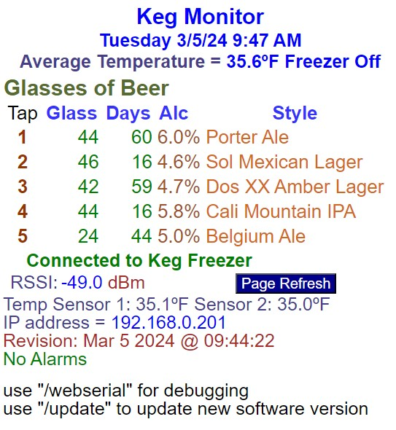
The first line is the title of the web page. The second line is the day of week, day/month/year date followed by the time of day (local time). The third line is the average temperature from the beer keg monitor program. The next lines provide information on the five taps. The information is the number of 12-ounce glasses left, the number of days the keg has been in the freezer, the alcohol percentage and the title or style of beer. The next shows if this program is receiving information from the Keg Monitor program.
The next line shows the Received Signal Strength Indicator (RSSI) in dBm. A level above -60 is very good. The signal normally needs to be above -80 dBm to connect to the Wi-Fi. The Page Refresh button just refreshes the page to get the latest information.
The next line displays the temperature sensor values in the freezer. Depending on how many you have installed this line will either have none or three values. The next line is the IP Address. This is a reserved address that I have forwarded to the internet for access away from home. If this address changes I know there is something wrong with my router.
The next line is the software build data and time. The next three lines show alarms if they have occurred. The last two lines show how to upload a new program or look at the web serial interface. The Keg Monitor main display is accessed by typing in KegMonitor.local in your web browser. If you want to upload a program your type KegMonitor.local/update to get to the update program web page. You can also access the main page by typing in 192.168.0.201.

Passwords
You must edit the “Passwords.h” file for the program to work. This file contains network names, network passwords, email addresses, email passwords, DNS name and GMT offset. The file contains comments for all the required entries.

Time Variables
For the program to display local time you need to update the gmsOffset_sec variable. If you are west of Greenwich Mean Time (GMT) the values are negative and east, they are positive. On the internet find out your time offset from GMT. The offset is in seconds. In Los Angeles I am 8 hours (480 minutes) behind GMT, so the input is 480*60 to get seconds. We still have daylight savings time in Los Angeles, so I entered 3600 (1 hour) for daylightOffset_sec. If you are lucky enough to not have daylight savings time set this value to 0.

Network and Passwords
The following are the fields you must edit network names, passwords and Email addresses:
- ssid – is your Wi-Fi network name.
- password – Wi-Fi network password
- UseEmail – if you don’t want to use the email and text message feature set this to false.
- AUTHOR_EMAIL – this is the email that you use for your Arduino boards. Emails are sent from this account.
- AUTHOR_PASSWORD – this is the special App password you set up for Arduino boards. (See Emails and Text messages section.
- RECIPIENT_EMAIL1 – this is your main email account.
- RECIPIENT_EMAIL2 – this is for text messages.

KegMonitor.html
This file contains the Hyper Text Markup Language (HTML). This file is saved as KegMonitor.h to include the HTML instructions in code. When you edit the HTML file save a copy as KegMonitor.h. I like to use Notepad++ as my HTML editor. I include the HTML web page in my code instead of as a separate file because when you make changes you only must upload the firmware and not separate files. The top line is “const char indx_html[] = R"rawliteral(“ tells Arduino compiler to include the following text in a constant array named indx_html. The last line “)rawliteral";” tells the complier that this is the end of the character array. Do not remove either of these lines.
The HTML file has special pointers designated as ‘%’XX. These are used by the software to know where to insert information to be displayed on the web page.

HTML.ino
The HTML module handles building the web page. During setup the constant character array indx_html is copied to a dynamic array named HTML Page. During the copy process pointers are saved in an integer array named indx. Every time the web page is accessed pointers are replaced by text information and variable values. The build page function performs this action. Every time the refresh button is pressed the latest information is displayed.

Sever.in
This module handles the server requests. I used an asynchronous server library because the WebSerial library only works with an asynchronous server. Asynchronous servers uses interrupts to process server requests. So, if you use delay functions in your code the server requests will still be processed. The server is fast, and I have not had any problems. The /update and /webserial page requests are handled in the respective libraries.

Functions.ino
This module has general purpose functions including Initialize Wi-Fi and time of day.
I used the Arduino standard <TimeLib.h> library for time of day because it gives you more control over time-of-day handling. The time of day is read from an NTP server during setup. The software accesses two different NTP servers to get the time of day. When the time of day is received the onboard Real Time Clock is set to maintain the time. The software checks the time accuracy every day in the main loop.
The initialize Wi-Fi function connects to the local network. This function is where you can set the MAC address. Since Wi-Fi connection is the most important part of this program, the board will try to connect to the Wi-Fi for 5 minutes. The Wi-Fi connection is checked in the main loop every 5 minutes. If the connection has been lost the board attempts to reconnect to the Wi-Fi.

Serial.ino
The module handles the serial interface between this board and the Keg Monitor board. The web serial interface is also handled in the module.

Email and Text Messages
To send an email with this application you need to use an app password on Gmail. An app password is a 16-digit passcode that gives a less secure app or device permission to access your Google Account. App passwords can only be used with accounts that have 2-Step Verification turned on.
I recommend generating a new Gmail account for emails from your Arduino devices. You can set up a rule to forward these emails to your main email account and/or to send them to generate a text message.
My phone service provider is T-Mobile, so to send a text message from an email you type in the phone number and send it to tmomail.net (7145361998@tmomail.net).
When you get an email, the subject is “Alert from Keg Monitor”. Emails and text messages are sent for the following reasons.
"Keg Monitor: Temperature is too hot, above 40 degrees F.
"Keg Monitor: Temperature is too cold, below 30 degrees F.
"No communication with Keg Freezer for one hour"

Port Forwarding
You should be able to do an internet search to help you do port forwarding using your model router/modem. Basically, there are just two steps: 1) Set a static or reserved IP address for your device based upon the MAC address, 2) Forward the reserved IP address.
If you must replace your board, you can set the MAC address, so you don’t have to redo your router settings. The normal port for a web page is 80. But this did not work with my internet provider, so I used 8081 for the Keg Monitor.
To access your board, you use the internet service provider IP address and 8081 port number. For example, http://174.67.214.107:8081/. To find out your IP address, go to website https://www.myip.com/.

