Create app.js file.

From cmd line**, npm install**: this will create package.json file

From cmd line, **npm install express --save**: the --save inputs it into the package.json file

The carrot (^) : it’s going to take whatever current version is available.

The tilde (~) : any minor version change will be installed

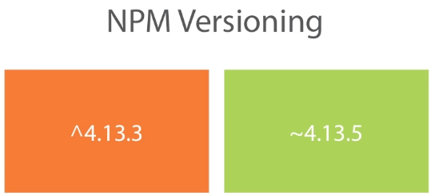

Or just type in the version you want:



In app.js, do an app.listen and assign it a port #.

To test, type **node app.js** at cmd line

Instead of having to type node app.js at cmd line, go to package.json and in the “script” bracket, type "start": "node app.js". Now, the app will run by typing npm start.

Bower:

Package manager for the web on the front end

NPM is the backend package manager

Bootstrap depends on jquery

Works like NPM in that you do bower install to install packages

Just like NPM has package.json, bower has bower.json

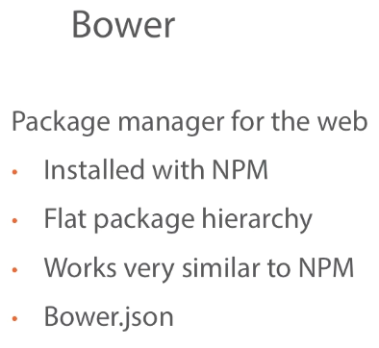

At the cmd prompt, type **npm install bower -g**. The g installs it globally.

Now type **bower init**

Next type, **bower install –save bootstrap**

At this point, Bower components are installed outside the public directory. How to change this to have bootstrap in public folder with other static css files:

Create file called .bowerrc with the follow in it. This is where bower is going to look for its configuration

{

"directory": "public/lib"

}

This is going to create a lib folder in the public directory and store copy bootstrap there. The purpose is to segregate the bower package from css.

Next delete bower components folder.

At cmd line type: **bower install --save boostrap**

Should see lib folder with bootstrap in it.

Next, need to go to index.html and make changes to the path. In this case:

From this:



To this 

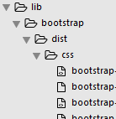

Do the same for any additional links. In this case the js and jquery at the bottom of html:

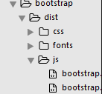



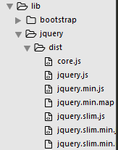



In this particular template, there is another piece (link) that needs attention.



But we’re going to have bootstrap handle this, so from the cmd, type **bower install font-awesome --save**

Check bower.json that font-awesome is in the dependencies.

Change the link path above:



