Python Loops Worksheet

In Python, loops are an important tool that allow developers to execute a block of code over and over as long as a condition holds true. This worksheet will allow you to practice a for loop and while loop.

**For Loop**

A for loop is ideal in a situation where you know exactly how many times you want the loop to run or you want to iterate over a collection.

To iterate for a specified number of times, use the built-in Python *range()* function.



**For Loop Tasks**

1. Write a for loop that will run five times and print “hello!” to the console five times
   1. Expected Output  
      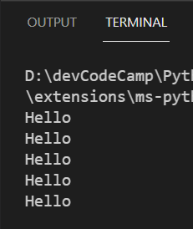
2. Write a for loop that counts from 0 to 10, with each number being print to the console one at a time
   1. Expected Output  
      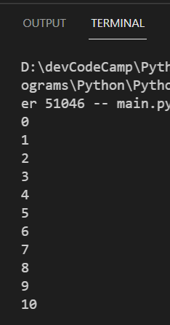
3. Write a for loop that counts from 10 to 0, with each number being print to the console one at a time. HINT: When calling the range function provide three arguments   
   “range(start number, stop number, step number)”
   1. Expected Output  
      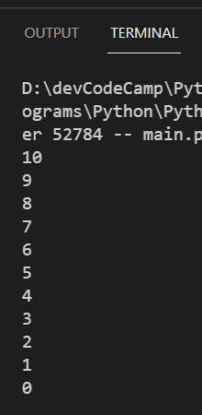
4. Write a for loop that will run as many times as a user wants, with each iteration printing “devCodeCamp” to the console. HINT: you will need to use the Python input() function to gather user input
   1. Expected Output if user chooses 4  
      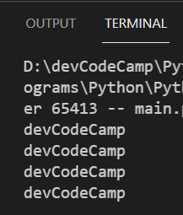
5. Write a for loop that will print each character of the string “Packers” to the console.
   1. Expected Output  
      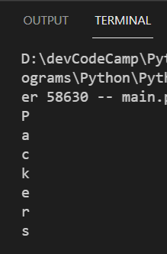
6. **CHALLENGE:** Fizz Buzz
   1. Write a program that prints every number from 0 to 100 to the console
   2. If a number is divisible by 3, print ‘fizz’ instead of the number
   3. If a number is divisible by 5, print ‘buzz’ instead of the number
   4. If a number is divisible by 3 and 5, print ‘fizzbuzz’ instead of the number

**While Loop**

A while loop is ideal in a situation where do you not know how many times you want the loop to run. Instead, the loop will continue to iterate as long as the condition remains to be true. Once the condition becomes false then the loop completes.

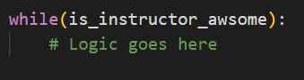

HINT: if isInstructorAwesome is set equal to true, make sure to have a way to set isInstructorAwesome equal to false somewhere inside the while loop to prevent an infinite loop from occurring

**While Loop Tasks**

1. Write a while loop that will run five times and print “hello!” to the console five times
   1. Expected Output  
      
2. Write a while loop that will prompt a user for their password and will continue to prompt the user until the typed in password is correct. If correct, print to the console “User Validated”
   1. Expected Output  
      