Phase Verification Report Log
ArUco Marker Detection Module
Marker Detection & Spatial Positioning System
Project Phase: ArUco Marker Generation & Detection Verification
This report documents the phase verification of the visual function module for a four-wheel differential-drive obstacle-avoidance robot. The ArUco Marker Detection Module serves as the perceptual foundation layer of the robot's vision system, responsible for providing spatial positioning data to the obstacle-avoidance decision logic. All spatial positioning, obstacle recognition, and motion control responses rely on accurate real-time recognition of ArUco markers; therefore, this phase of verification directly determines whether all subsequent visual obstacle-avoidance functions can operate correctly. This technical solution is based on a GitHub open-source reference project, repository: https://github.com/njanirudh/Aruco_Tracker
The technical verification of this phase focuses on two key aspects: first, the generation conformance of ArUco markers — ensuring that generated markers comply with the DICT_4X4_50 dictionary specification with unique IDs and anti-interference borders, enabling stable recognition in the robot's actual operating environment; second, the end-to-end usability of the detection pipeline — verifying the stability and accuracy of the complete chain from camera image capture and corner extraction to four-corner pixel coordinate output in real field conditions, providing reliable position input to the differential-drive control layer.
The core advantage of the ArUco solution lies in its lightweight efficiency and out-of-the-box usability: as an official OpenCV built-in library, it achieves millisecond-level real-time detection without any additional training; the 4×4-bit encoding structure maintains low computational overhead while providing sufficient ID diversity (up to 50 unique markers); the strict binary-square design ensures high recognition robustness under complex conditions such as lighting changes and partial occlusion, providing reliable pixel-level anchors for subsequent 3D pose estimation.
Regarding the application feasibility for the four-wheel differential-drive obstacle-avoidance robot, the ArUco solution offers the following significant advantages: First, real-time performance meets control requirements — a 30fps detection frame rate keeps position latency within 33ms, fully satisfying the closed-loop control response requirements at low speeds (≤0.5m/s); Second, absolute coordinate output aligns with obstacle-avoidance logic — the system directly outputs real-world spatial coordinates in meters, which can directly drive path planning and obstacle-avoidance algorithms without additional coordinate transformation; Third, multi-marker support enables extensibility — the system simultaneously tracks field boundary corner markers (IDs 0–3) and the robot itself (ID 4) within the same camera field of view, reserving ample ID space for future expansion; Fourth, hardware cost is minimal — only a single USB camera and a standard computing platform are required, ideal for embedded robot development. In summary, the ArUco visual positioning solution is fully technically feasible for this project, and the results of this phase verification will serve directly as the technical foundation for visual obstacle-avoidance feature development.

1. GitHub Repository & Feature Overview

1.1 Repository Information
The ArUco marker generation functionality in this project is implemented using the following online tools and the official OpenCV library:
Online Generation Tool: https://chev.me/arucogen/
OpenCV ArUco Official Documentation: https://docs.opencv.org/4.x/d5/dae/tutorial_aruco_detection.html

1.2 Core Functions of the ArUco Module
ArUco (Augmented Reality University of Cordoba) is an official benchmark marker library integrated into OpenCV, providing the following primary functions:
- Marker Generation: Generate unique-ID binary square marker patterns from a predefined dictionary
- Real-Time Detection: Automatically identify the four-corner pixel coordinates of markers from camera image frames
- Pose Estimation: Compute the 3D position and orientation of markers using camera calibration parameters
- Coordinate Mapping: Convert pixel coordinates to real-world spatial coordinates (unit: meters)
- Multi-Marker Support: Simultaneously detect multiple markers with different IDs in a single frame

1.3 Dictionary Type Description
This project uses the DICT_4X4_50 dictionary. The specifics are as follows:
Parameter | Value | Description
Grid Size | 4×4 | The internal data grid of the marker is 4×4 squares, totaling 16 data bits
Max ID Count | 50 | This dictionary contains 50 unique markers (ID 0~49)
Outer Border | 1 cell wide | A 1-cell-wide black outer border on each side to assist detection
Total Size | 6×6 cells | 4×4 data + 1-cell border on each side = 6×6

2. Runtime Screenshot Evidence

2.1 ArUco Markers Generator Online Tool Interface
The following screenshots show the actual interface of the online ArUco marker generator (chev.me/arucogen) running successfully, demonstrating marker generation results for different IDs:
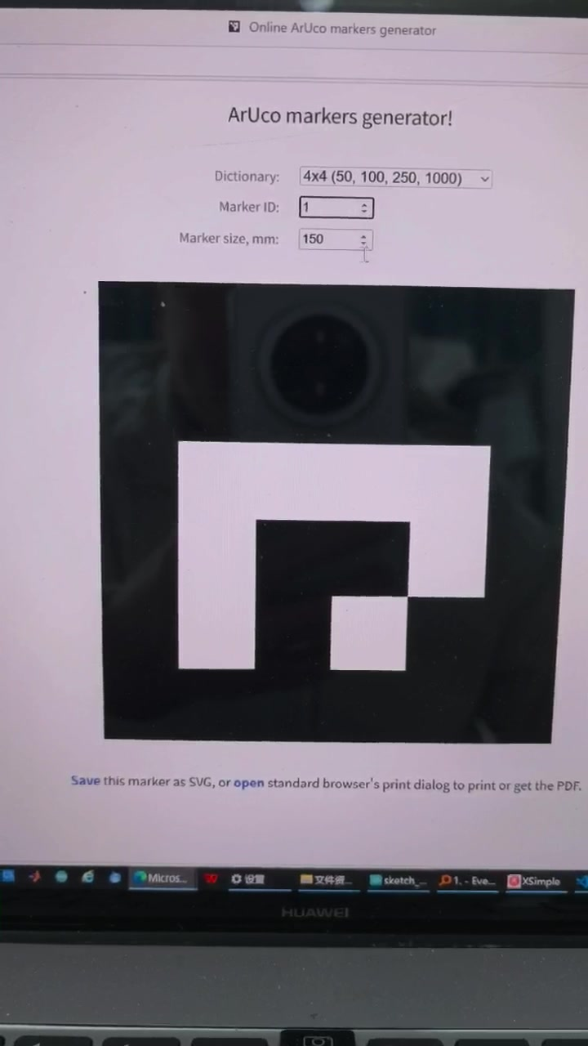
Figure 2-1: ArUco Markers Generator interface — Generated ID=1, Dictionary 4x4_50, Size 150mm

2.2 Marker Samples with Different Marker IDs
During the video recording, markers with IDs 1, 3, 5, 6, etc. were tested in sequence. Each ID corresponds to a unique black-and-white pattern encoding:
Marker ID = 1  4x4_50 Dictionary | Size 150mm   | Marker ID = 3  4x4_50 Dictionary | Size 150mm  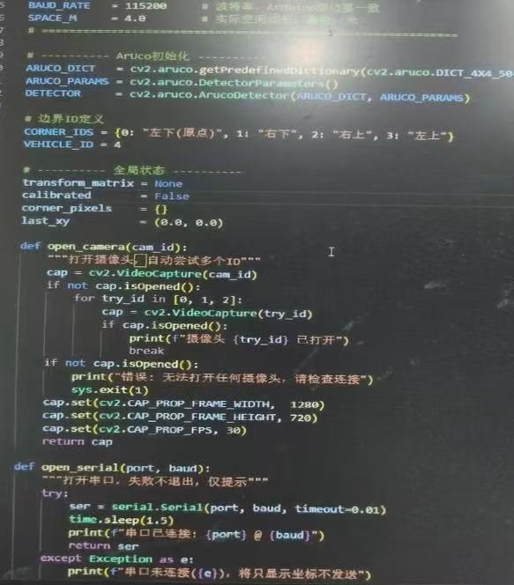

3. Interface Functions & Parameter Configuration

3.1 Interface Area Functions
The ArUco Markers Generator interface is divided into three functional areas:
Interface Area | Control | Function Description
Parameter Settings | Dictionary dropdown | Select the ArUco marker dictionary type, determining encoding method and available ID count
Parameter Settings | Marker ID input box | Enter the marker ID to generate (0 to dictionary maximum); use arrows for fine adjustment
Parameter Settings | Marker size, mm | Set the marker print size (mm), affecting physical size and detection range
Preview Area | Black-and-white marker pattern | Real-time preview of the ArUco marker pattern for current parameters; each ID pattern is unique
Export Area | Save / open link | Save exports as SVG vector image; open invokes the browser to print as PDF

3.2 How to Configure Parameters (Step-by-Step)
- Step 1: Open https://chev.me/arucogen/ — the page loads the default dictionary automatically
- Step 2: In the Dictionary dropdown, select "4x4 (50, 100, 250, 1000)"; this project uses the 50-capacity version
- Step 3: Enter the desired ID (0~49) in the Marker ID input box; the pattern updates in real time
- Step 4: Enter 150 in the Marker size field (corresponding to the SPACE_M=4.0m field scale in code)
- Step 5: Click Save to export SVG or click open to print as PDF for physical printing and placement
- Step 6: Generate 5 markers total: IDs 0~3 as boundary corner markers, ID 4 attached to the vehicle

4. Key Parameter Details: Frame Rate & Space

4.1 Frame Rate Parameter (FPS)
Frame rate is the core indicator of system real-time performance, directly affecting tracking latency and control response speed. Frame rate parameters in the code operate at two levels:

4.1.1 Camera Capture Frame Rate Settings
# tracker.py - open_camera() function
cap.set(cv2.CAP_PROP_FRAME_WIDTH, 1280) # resolution width
cap.set(cv2.CAP_PROP_FRAME_HEIGHT, 720 ) # resolution height
cap.set(cv2.CAP_PROP_FPS, 30 ) # target frame rate 30fps

4.1.2 Real-Time FPS Calculation & Display
# FPS statistics logic in main loop
fps_count += 1
now = time.time()
if now - fps_time >= 1.0: # update once per second
fps_show = fps_count / (now - fps_time)
fps_count = 0
fps_time = now

# render to top-right corner of frame
cv2.putText(frame, f'FPS:{fps_show:.1f}', (1150, 27), ...)

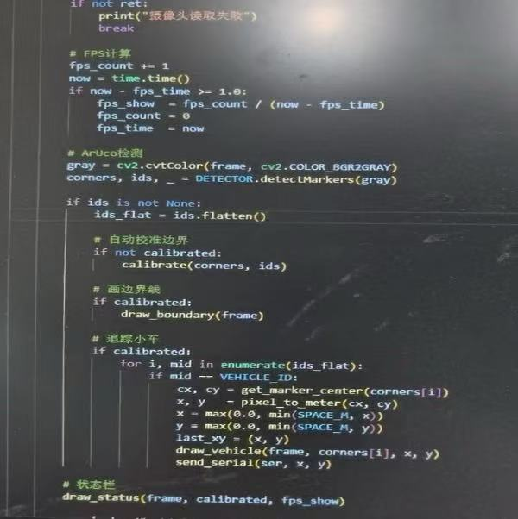
Figure 4-1: Code screenshot — FPS calculation and ArUco detection main loop (actual running interface)
Parameter Name | Default Value | Description & Function
CAP_PROP_FPS | 30 | Target camera capture frame rate; actual rate is limited by hardware and algorithm latency
fps_show | computed in real-time | Actual frame rate refreshed every second, displayed in the top-right corner for performance monitoring
fps_time | time.time() | Timestamp of the last statistics update, used to calculate frames per second
fps_count | 0 | Frame counter within the current statistics cycle, incremented by 1 per frame

4.1.3 Impact of Frame Rate on the System
- 30fps: Standard tracking frame rate, latency ~33ms/frame, suitable for vehicle speeds ≤ 0.5m/s
- Frame rate too low (<15fps): causes tracking position jumps, delayed control commands, and vehicle motion jitter
- To improve frame rate: reduce resolution (e.g., 640×480) or reduce image processing steps

4.2 Space Parameter (SPACE_M)
The space parameter defines the physical area size trackable under the top-down camera view and is the core basis for coordinate conversion:

4.2.1 Space Parameter Definition
# tracker.py - global configuration
SPACE_M = 4.0 # actual field side length, unit: meters
# i.e., the camera field of view covers a 4m x 4m square area

4.2.2 Coordinate Conversion Function
def pixel_to_meter(px, py):
"""Convert pixel coordinates to real spatial coordinates (meters)"""
x = transform_matrix @ np.array([px, py, 1])
# transform_matrix is derived from calibration using 4 corner ArUco markers
# output range: 0.0 ~ SPACE_M (0.0m ~ 4.0m)
return x[0], x[1]

# coordinate clamping to prevent out-of-bounds
x = max(0.0, min(SPACE_M, x))
y = max(0.0, min(SPACE_M, y))

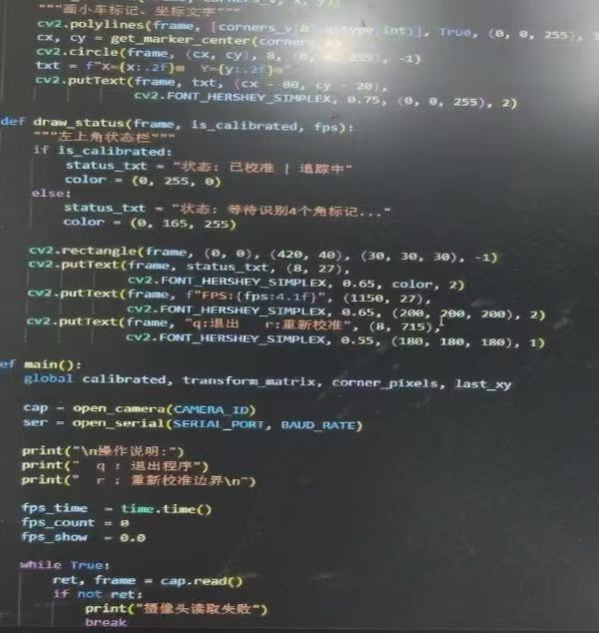

Figure 4-2: Code screenshot — Spatial coordinate calculation and status bar rendering logic
Parameter Name | Default Value | Description & Function
SPACE_M | 4.0 | Tracking field side length (meters); must match the actual spacing between corner markers
transform_matrix | None (initial) | Perspective transformation matrix, auto-generated after calibration with 4 corner ArUcos; maps pixels to real coordinates
corner_pixels | {} | Stores pixel coordinates of 4 corner markers, used to compute the transformation matrix
calibrated | False | Calibration status flag; automatically set to True after all 4 corner markers are detected, initiating tracking
CORNER_IDS | {0,1,2,3} | Corner marker ID mapping: 0=bottom-left origin, 1=bottom-right, 2=top-right, 3=top-left
VEHICLE_ID | 4 | Vehicle marker ID; the system tracks the real-time coordinates of this ID

4.2.3 Impact of Space Parameters on the System
- SPACE_M must strictly match the physical layout: if the field measures 4m but the code is set to 2m, output coordinates will be halved, causing vehicle positioning errors
- The coordinate origin is at the bottom-left corner (ID=0 marker); X-axis points right, Y-axis points up, following the standard mathematical coordinate system
- Coordinate clamping protection: max/min ensures coordinates sent to Arduino remain within [0, SPACE_M], preventing out-of-bounds values
- Accuracy factors: larger marker size (150mm) and higher camera resolution both improve spatial coordinate accuracy

5. Role of the Code within the Overall Project

5.1 Overall Project Architecture
This project is a real-time vehicle positioning and control system based on computer vision. The architecture is as follows:
Module | Description
[Input Layer] Camera | USB camera captures a 4m×4m field from above at 1280×720@30fps
[Core Layer] ArUco Detection (tracker.py) | This verification module: detects 5 ArUco marker positions, calibrates the coordinate system, and outputs real-time vehicle (x,y) coordinates (unit: meters)
[Communication Layer] Serial Transmission | Sends (x, y) coordinates to the Arduino control board via Serial @ 115200 baud
[Execution Layer] Arduino | Receives coordinates, drives motors to control vehicle movement, achieving closed-loop position control

5.2 Core Role of the ArUco Module in the Project
The ArUco Marker Detection Module (tracker.py) is the perceptual core of the entire system, fulfilling the following irreplaceable responsibilities:
- Sole position sensing source: the system has no GPS or encoders; ArUco is the only means of obtaining the vehicle's absolute position
- Coordinate system establishment: automatically calibrates the perspective transformation matrix by recognizing 4 corner markers (IDs 0~3), mapping distorted pixel coordinates to real space
- Real-time tracking output: detects the vehicle marker (ID 4) position each frame, providing position data to downstream systems at 30fps
- Robustness assurance: supports brief marker loss (using last_xy to retain the last known coordinates), preventing signal jitter from causing loss of control

5.3 Code File Structure
project_root/
├── tracker.py ← [This Module] ArUco detection + coordinate output main program
├── arduino/
│ └── motor_ctrl.ino ← Arduino receives coordinates to drive motors
└── markers/
├── id0_corner.svg ← Corner marker (bottom-left origin)
├── id1_corner.svg ← Corner marker (bottom-right)
├── id2_corner.svg ← Corner marker (top-right)
├── id3_corner.svg ← Corner marker (top-left)
└── id4_vehicle.svg ← Vehicle marker

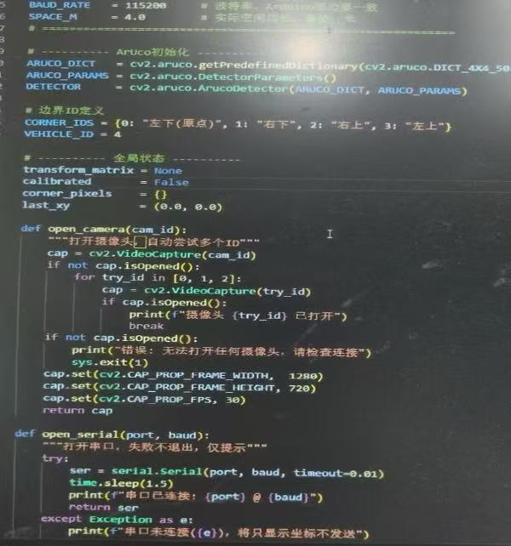
Figure 5-1: Code screenshot — ArUco initialization, boundary ID definitions, and camera initialization function

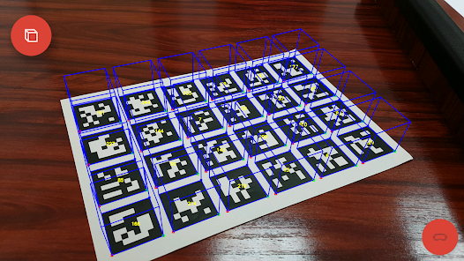
Testing
Phase Verification Complete ✓ ArUco Marker Generation & Detection Module Running Normally

