What is GARDE?
GARDE is a population clinical decision support platform. It screens family history in the electronic health record (EHR) and identifies patients who meet National Comprehensive Cancer Network (NCCN) criteria for genetic testing of Lynch syndrome and HBOC. Using a chatbot, GARDE facilitates population-based patient outreach, education, and access to genetic testing at scale.

How can GARDE help the genetic counseling team?
“With GARDE and the chatbot, we were able to customize patient interactions so that our patients still knew a human was involved in their care.”
--Genetic Counselor leader from an implementation site
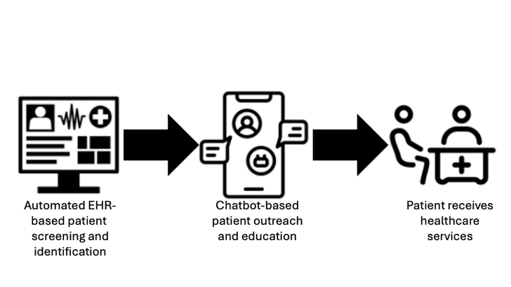
The demand for clinicians with genetics expertise is increasing and the supply of genetic counselors isn’t keeping pace with the growing demand. GARDE facilitates the population-based identification of high-risk patients based on data already available in the EHR. Patient outreach and education can occur through a customizable chatbot. Under a genetic counselor’s supervision, a genetic counseling assistant enters genetic test orders for patients who choose to pursue genetic testing. GARDE allows genetic counselors to focus on patients with more complex needs.
Figure 1 GARDE process

How can GARDE help my patients?
We anticipate that GARDE with a chatbot will allow genetic counselors to prioritize patient psychosocial needs over education and information-gathering tasks (see PMID: 33191601) while maintaining patient satisfaction with the care they receive (see PMCID: PMC8663668 and PMC11385050).

I’m concerned about GARDE having access to confidential patient information.
So are we. That’s why GARDE is designed to run on your organization’s servers. It doesn’t increase the risk of a security breach and your patients’ confidential information remains secure.

What kind of genetic tests are appropriate for patients identified by GARDE?
A patient’s genetic test is selected by a genetic counselor based on the same criteria the counselor uses to select the most appropriate genetic test for any patient. In previous research, a 34-36 gene pan-cancer panel was typically ordered on patients identified by GARDE.

How do patients identified by GARDE pay for genetic testing?
Patients identified by GARDE pay for genetic testing the same way as patients who are identified by a clinician.

Have other cancer genetic counseling teams used GARDE?
NCI supported a successful trial of GARDE at University of Utah Health and New York University Langone Health. With National Cancer Institute support, GARDE is being implemented at Medical University of South Carolina and Weil Cornell Medicine. The GARDE study team is happy to speak with you if you have questions that aren’t addressed here (GARDE@hci.utah.edu). Research publications demonstrating GARDE’s effectiveness can be found here.

