### SSMSuper

1, 功能点

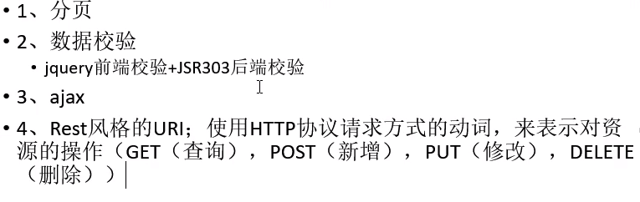

2, 技术点

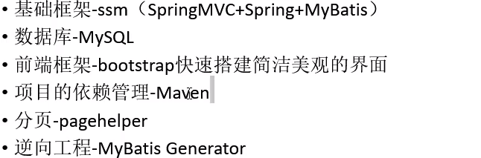

3, insertSelective不能插入空对象数据, 会报错

4, pageInfo 参数说明

|  |
| --- |
| System.*out*.println("当前页:" + pageInfo.getPageNum()); System.*out*.println("总页:" + pageInfo.getPages()); System.*out*.println("总记录数:" + pageInfo.getTotal()); System.*out*.println("连续显示的页码:" + pageInfo.getNavigatepageNums()); System.*out*.println("分页数据:" + pageInfo.getList()); |

5, 正确的Servlet-api依赖

|  |
| --- |
| <dependency>  <groupId>javax.servlet</groupId>  <artifactId>javax.servlet-api</artifactId>  <version>3.1.0</version>  <scope>provided</scope><!-- 范围为provided -->  </dependency> |

6, Ajax封装PUT请求失败的原因

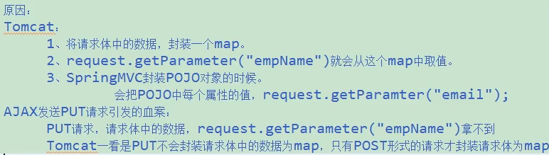

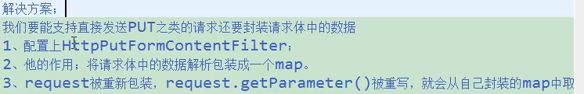

7, 获取dom原生值

