**Create a knowledge base**

1. Sign in to the [QnA Maker](https://www.qnamaker.ai/) portal.
2. Select **Create a knowledge base** from the top menu.

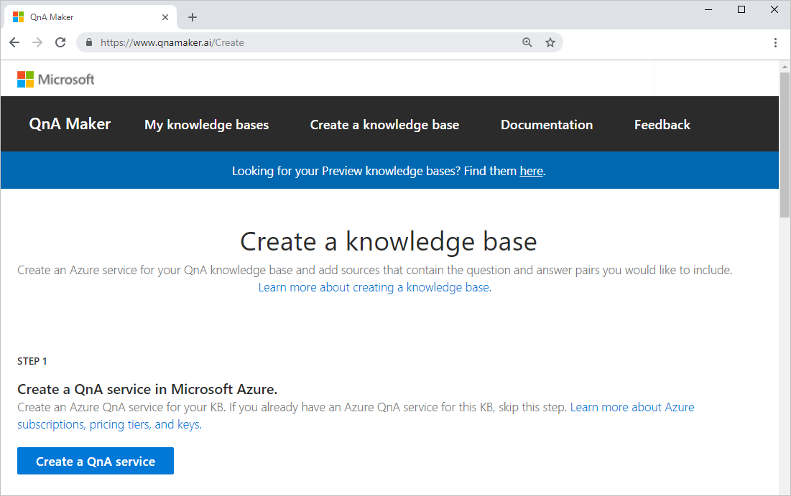

1. Skip the first step because you will use your existing QnA Maker service.
2. In the next step, select your existing settings:

| **Setting** | **Purpose** |
| --- | --- |
| Microsoft Azure Directory Id | Your *Microsoft Azure Directory Id* is associated with the account you use to sign into the Azure portal and the QnA Maker portal. |
| Azure Subscription name | Your billing account you created the QnA Maker resource in. |
| Azure QnA Service | Your existing QnA Maker resource. |

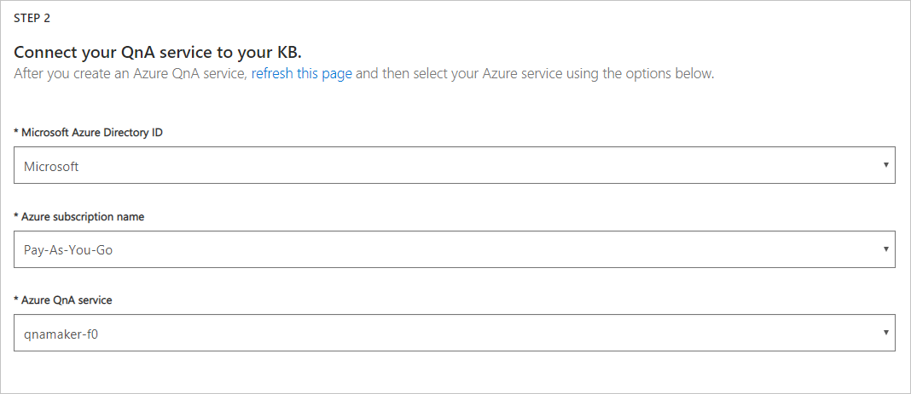

1. In the next step, Enter your knowledge base name, My Tutorial kb.

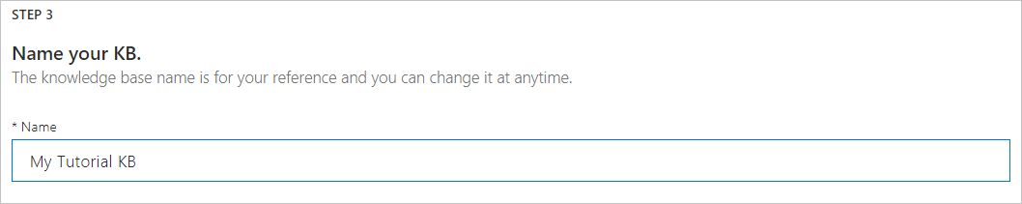

1. In the next step, populate your kb with the following settings:

| **Setting name** | **Setting value** | **Purpose** |
| --- | --- | --- |
| URL | http://bit.ly/nacs2019 | The contents of the FAQ at that URL are formatted with a question followed by an answer. QnA Maker can interpret this format to extract questions and the associated answers. |
| File | *not used in this tutorial* | This uploads files for questions and answers. |
| Chit-chat personality | The friend | This gives a friendly and casual personality to common questions and answers. You can edit these questions and answers later. |

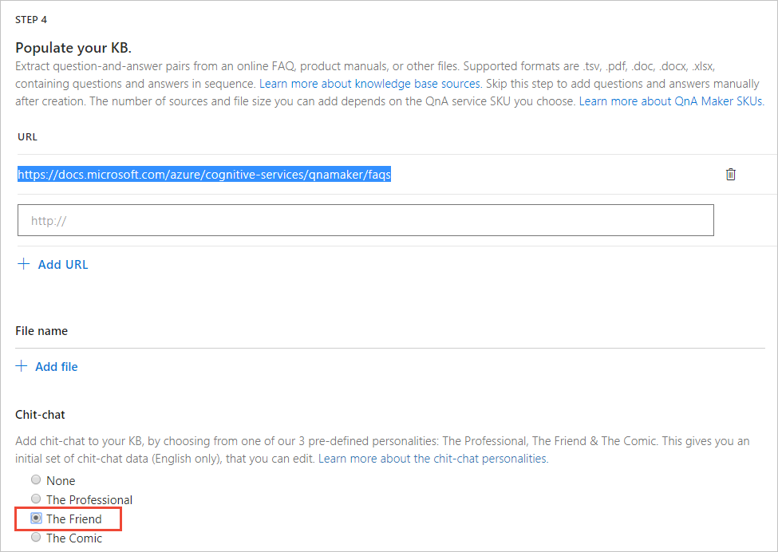

1. Select **Create your KB** to finish the creation process.

**Review KB, save, and train**

1. Review the questions and answers. The first page is questions and answers from the URL.

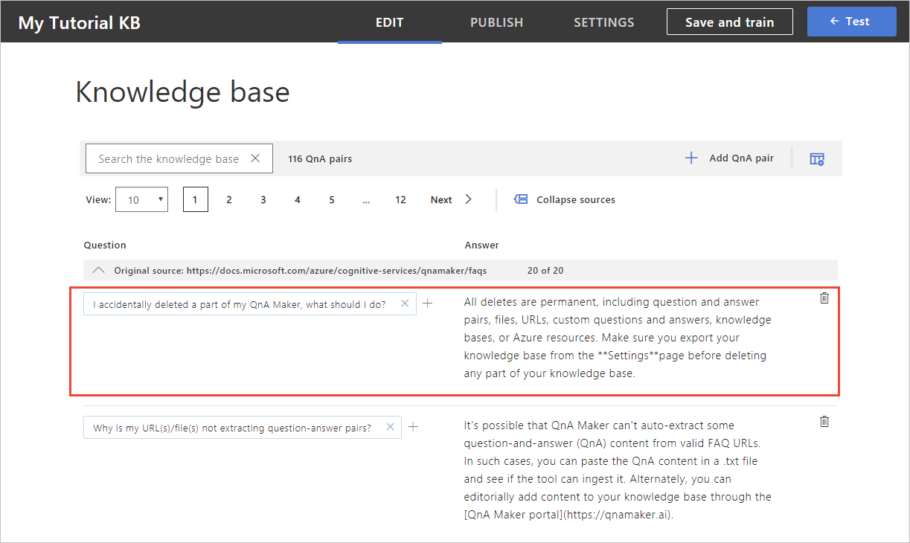

1. Select the last page of questions and answers from the bottom of the table. The page shows questions and answers from the Chit-chat personality.
2. From the toolbar above the list of questions and answers, select the metadata icon. This shows the metadata tags for each question and answer. The Chit-chat questions have the **editorial: chit-chat** metadata already set. This metadata is returned to the client application along with the selected answer. The client application, such as a chat bot, can use this filtered metadata to determine additional processing or interactions with the user.

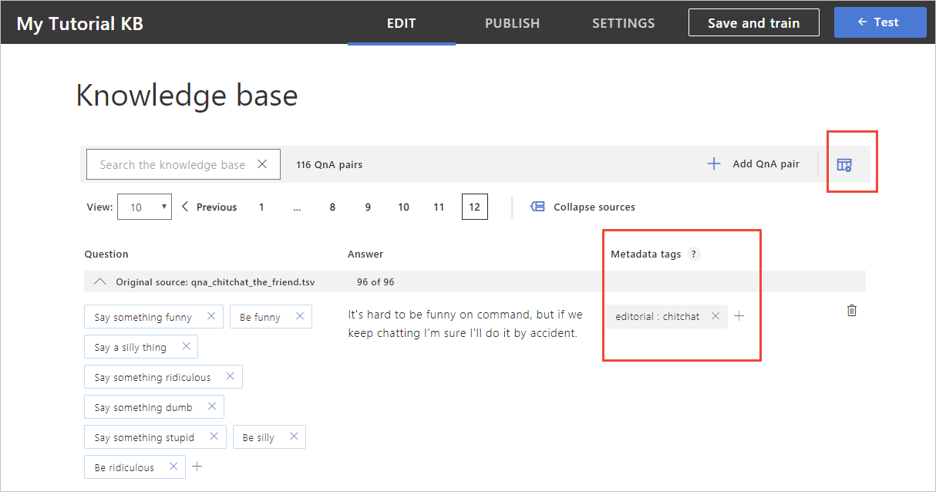

1. Select **Save and train** in the top menu bar.

**Publish to get KB endpoints**

Select the **Publish** button from the top menu. Once you are on the publish page, select **Publish**, next to the **Cancel** button.

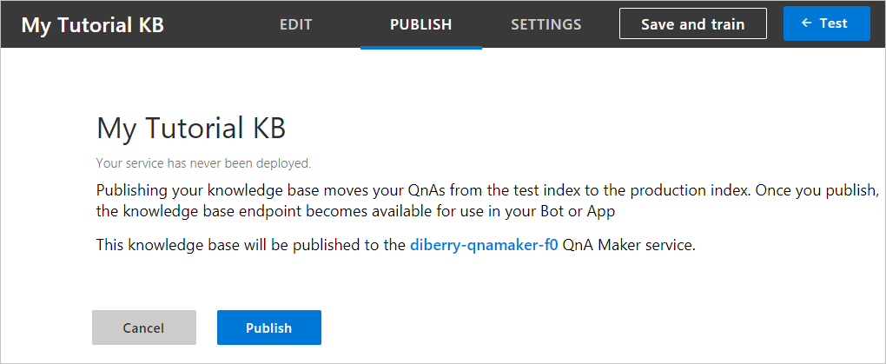 After the KB is published, the endpoint is displayed

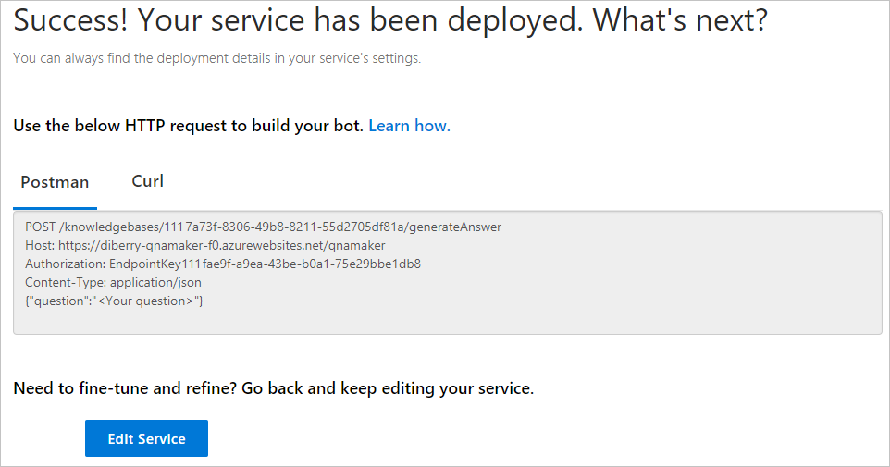

**Use curl to query for an FAQ answer**

1. Select the **Curl** tab.

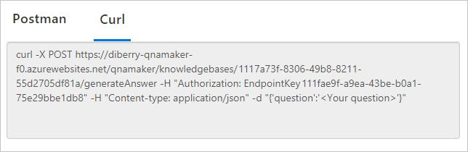

1. Copy the text of the **Curl** tab and execute in a Curl-enabled terminal or command-line. The authorization header's value includes the text Endpoint with a trailing space then the key.
2. Replace <Your question> with How large can my KB be?. This is close to the question, How large a knowledge base can I create?, but not exactly the same. QnA Maker applies natural language processing to determine that the two questions are the same.
3. Execute the CURL command and receive the JSON response including the score and answer.

% Total % Received % Xferd Average Speed Time Time Time Current

Dload Upload Total Spent Left Speed

100 581 100 543 100 38 418 29 0:00:01 0:00:01 --:--:-- 447{

"answers": [

{

"questions": [

"How large a knowledge base can I create?"

],

"answer": "The size of the knowledge base depends on the SKU of Azure search you choose when creating the QnA Maker service. Read [here](https://docs.microsoft.com/azure/cognitive-services/qnamaker/tutorials/choosing-capacity-qnamaker-deployment)for more details.",

"score": 42.81,

"id": 2,

"source": "https://docs.microsoft.com/azure/cognitive-services/qnamaker/faqs",

"metadata": []

}

]

}

QnA Maker is somewhat confident with the score of 42.81%.

**Use curl to query for a Chit-chat answer**

1. In the Curl-enabled terminal, replace How large can my KB be? with an bot conversation-ending statement from the user, such as Thank you.
2. Execute the CURL command and receive the JSON response including the score and answer.

% Total % Received % Xferd Average Speed Time Time Time Current

Dload Upload Total Spent Left Speed

100 525 100 501 100 24 525 25 --:--:-- --:--:-- --:--:-- 550{

"answers": [

{

"questions": [

"Thank you",

"Thanks",

"Thnx",

"Kthx",

"I appreciate it",

"Thank you so much",

"I thank you",

"My sincere thank"

],

"answer": "You're very welcome.",

"score": 100.0,

"id": 109,

"source": "qna_chitchat_the_friend.tsv",

"metadata": [

{

"name": "editorial",

"value": "chitchat"

}

]

}

]

}

Because the question of Thank you exactly matched a Chit-chat question, QnA Maker is completely confident with the score of 100. QnA Maker also returned all the related questions as well as the metadata property containing the Chit-chat metadata tag information.

**Use curl to query for the default answer**

Any question that QnA Maker is not confident in an answer receives the default answer. This answer is configured in the Azure portal.

1. In the Curl-enabled terminal, replace Thank you with x.
2. Execute the CURL command and receive the JSON response including the score and answer.

% Total % Received % Xferd Average Speed Time Time Time Current

Dload Upload Total Spent Left Speed

100 186 100 170 100 16 272 25 --:--:-- --:--:-- --:--:-- 297{

"answers": [

{

"questions": [],

"answer": "No good match found in KB.",

"score": 0.0,

"id": -1,

"metadata": []

}

]

}

QnA Maker returned a score of 0 which means no confidence but it also returned the default answer.