1112 Deep Learning – Homework 2

Due: 11:59 pm, 12/12, 2023

For the following questions, please upload the source code to Moodle and explain

the results in your report. Please submit your homework using the IPython Notebook (.ipynb), Python script (.py), and/or a PDF file (code needs to be turned in by .py

or .ipynb files).

If your computer doesn’t have a GPU, you can work on Google Colab.

# Classification task (Cat and Dog):

Please download the dataset using the following link:

[https://drive.google.com/drive/folders/12J0JtSrqrHAjt2_olcB3tLVL6WIKlq5l?usp=](https://drive.google.com/drive/folders/12J0JtSrqrHAjt2_olcB3tLVL6WIKlq5l?usp=sharing) [sharing](https://drive.google.com/drive/folders/12J0JtSrqrHAjt2_olcB3tLVL6WIKlq5l?usp=sharing). The dataset includes two files: train.zip and test.zip.

Utilize the training data to train two models, **AlexNet** and **ResNet**. After training, assess the performance of both models using the test data. Report the **accuracy** of the results obtained from testing. Additionally, please provide visualizations of the **training loss** changes for both models.

**AlexNet**

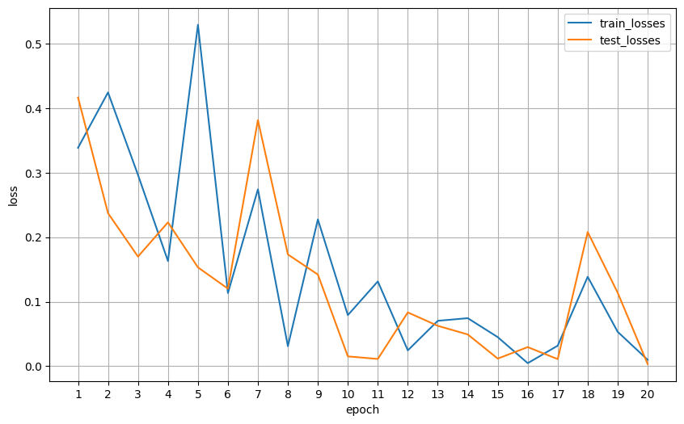

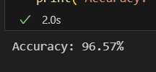

**ResNet**

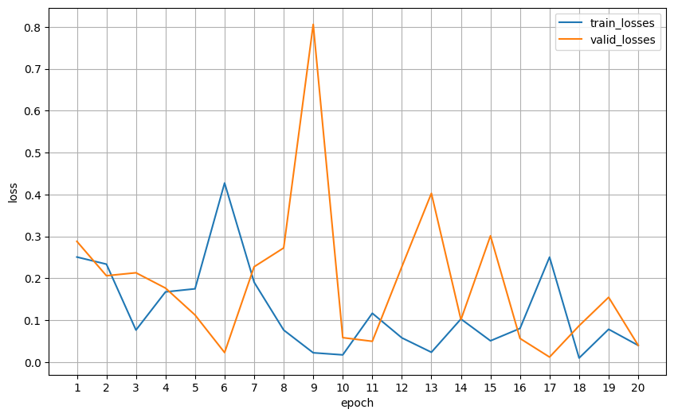

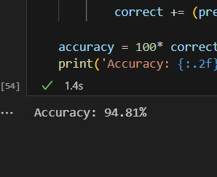

**the accuracy of the results**

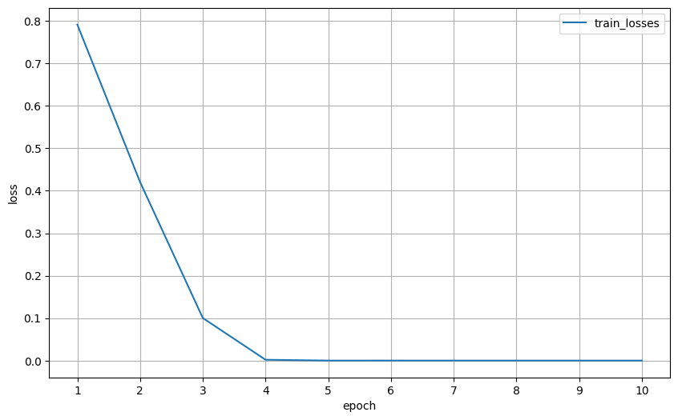

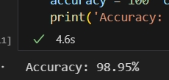

# Classification Task (MNIST - Multiple Classes):

Please download the dataset using the following code:

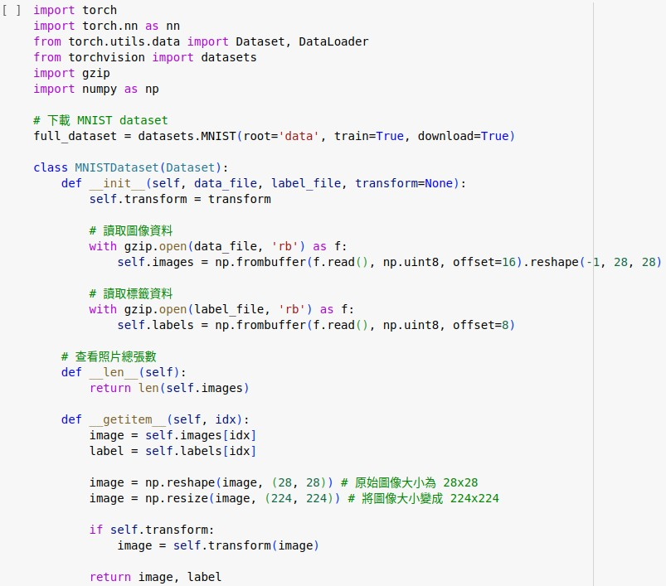

Follow the format of Question 1 and utilize the training data to train two different models, including **VGG** and a **CNN model you designed**. After training, assess the performance of both models using the test data. Report the **accuracy** of the

results obtained from testing. Additionally, please provide visualizations of the

**training loss** changes for both models.

