112753207 資科碩一 張詠軒

1(a.)

import numpy as np

import matplotlib.pyplot as plt

def Gaussian(x, mu, var): return np.exp(-(x - mu) **

                                        2.0 / (2.0 * var))/np.sqrt(2.0*np.pi*var)

def RandomSampleUniform(n, umax=1, kmax=100000):

    f = []

    for k in range(kmax):

        f.append(np.average(np.random.uniform(0, umax, n)))

    return f

# number n of random variables. For the CLT need n >~ 30.

nlist = [10, 100, 1000, 10000]

kmax = 100000  # number of drawings of the set (X_1, X_2, ..., X_n)

umax = 1  # uniform distribution from 0 to umax

varu = umax**2/12.0

muu = umax/2.0

xf = []

i = 1

nbins = 100

xrange = np.linspace(0, 1, num=nbins)

plt.figure(figsize=(15, 6))

plt.subplots_adjust(hspace=0.35)

for n in nlist:

    xf = RandomSampleUniform(n, umax, kmax)

    nd = np.random.normal(muu, np.sqrt(varu/n), kmax)

    plt.subplot(2, 3, i)

    i += 1

    plt.xlim(0, umax)

    if (i <= 4):

        plt.ylim(0, 2.5)

    elif (i == 5):

        plt.ylim(0, 5.0)

    elif (i == 6):

        plt.ylim(0, 8.5)

    else:

        plt.ylim(0, 15.0)

    plt.plot(xrange, Gaussian(xrange, muu, varu/n),

             color='#c42d41', alpha=0.8, linewidth=2, label=" CLT ")

    plt.hist(xf, nbins, density=True, color='#42aaf4',

             alpha=0.9, label=" n = %d " % (n))

    plt.hist(nd, nbins, density=True, color='#c42d41', alpha=0.2)

    plt.legend(loc="upper left")

plt.suptitle('CLT demonstrated for a uniform distribution')

plt.show()

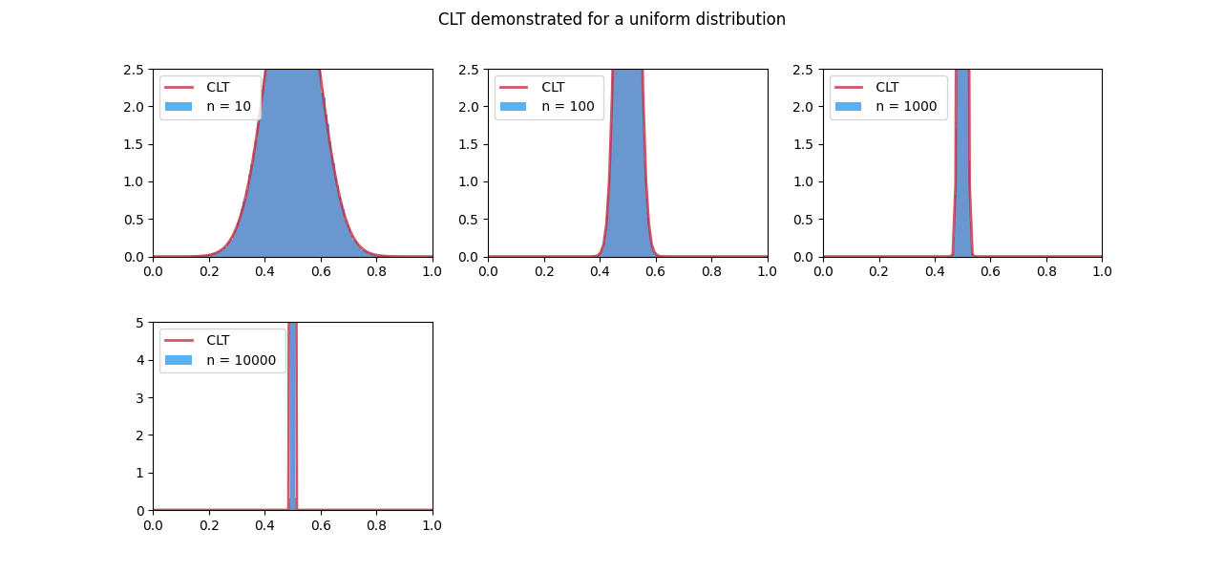

1(b.) 改成Exponential distribution(指數分布)

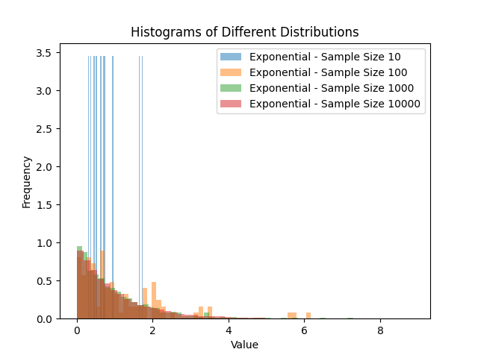

2.

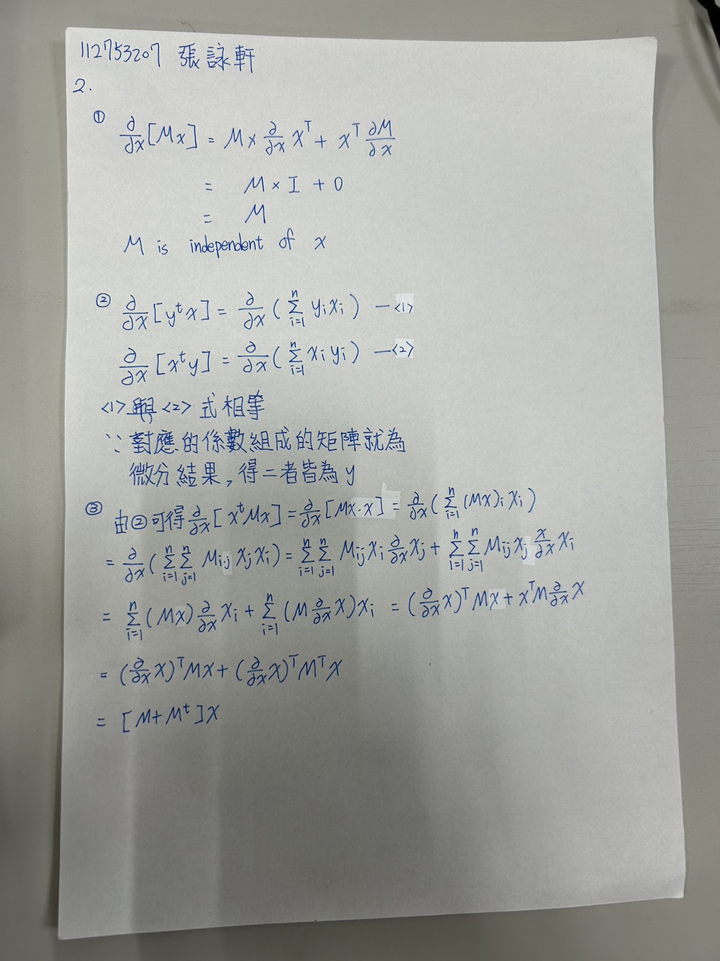

3.

